Name: Sujit Kumar Datta

ID: 22201946

E

Set

**BRAC University** Semester: Fall 2023

Course Code: CSE250 Circuits and Electronics Section: 26

Faculty: AGS, ERD

Assessment: Lab Test

Duration: 30 minutes

Date: December 4, 2023

Full Marks: 10

1. Insert the screenshots of schematic diagrams (simulation commands must be visible).

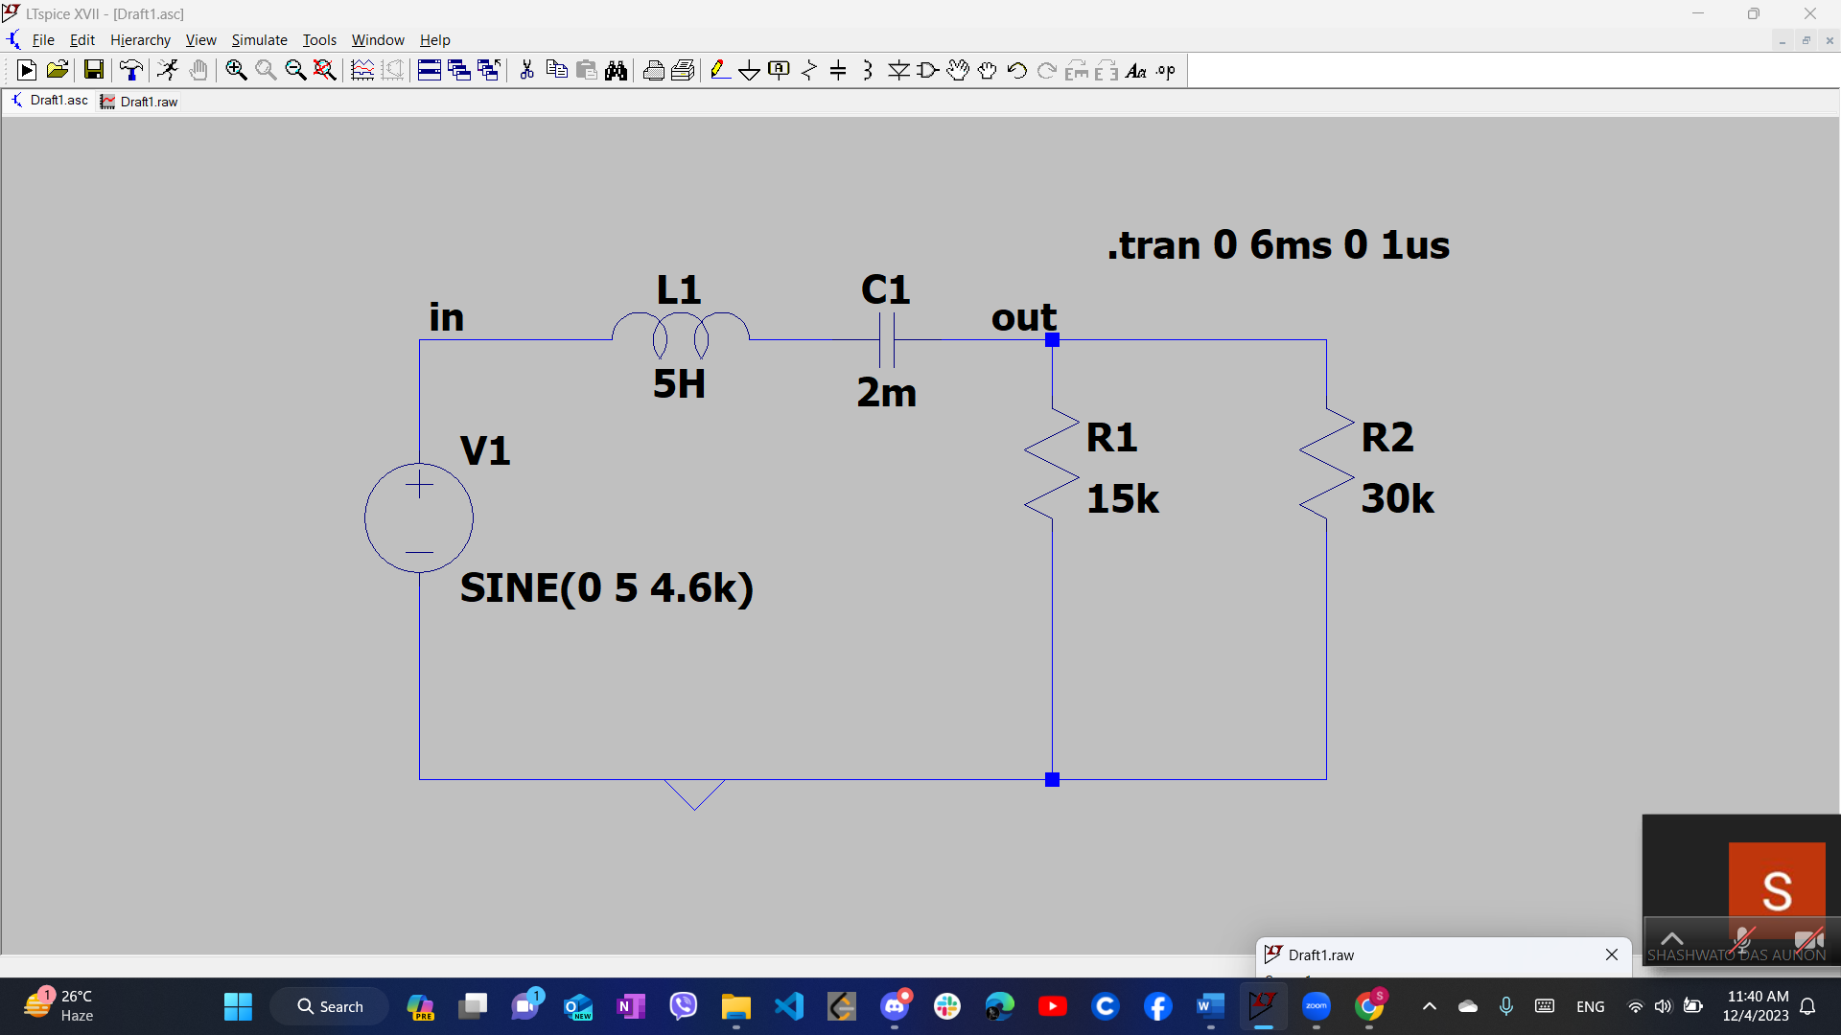

1. Insert the screenshots of output graphs (if any).

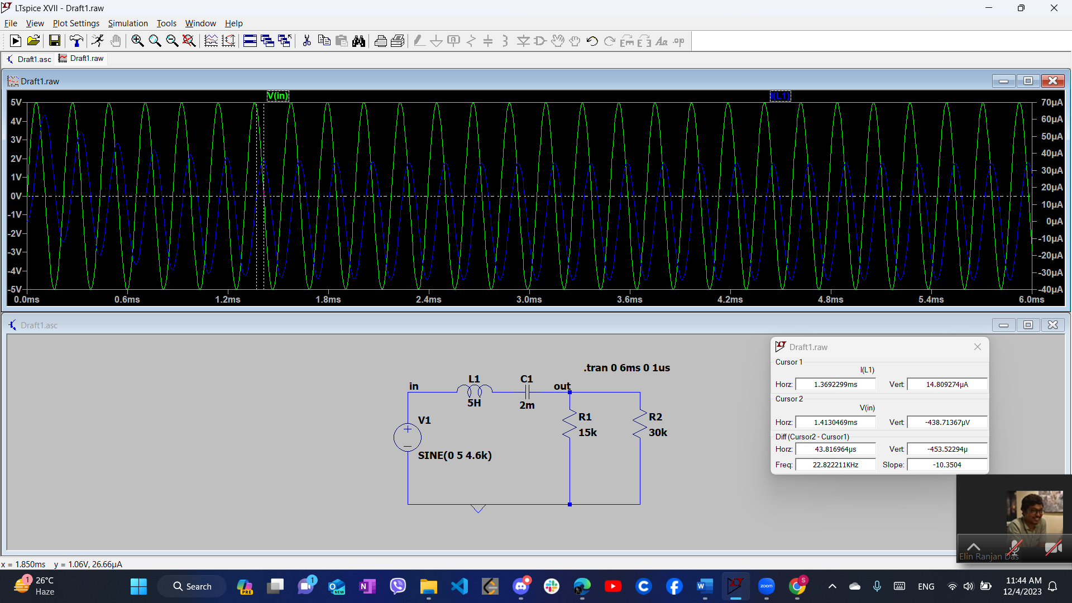

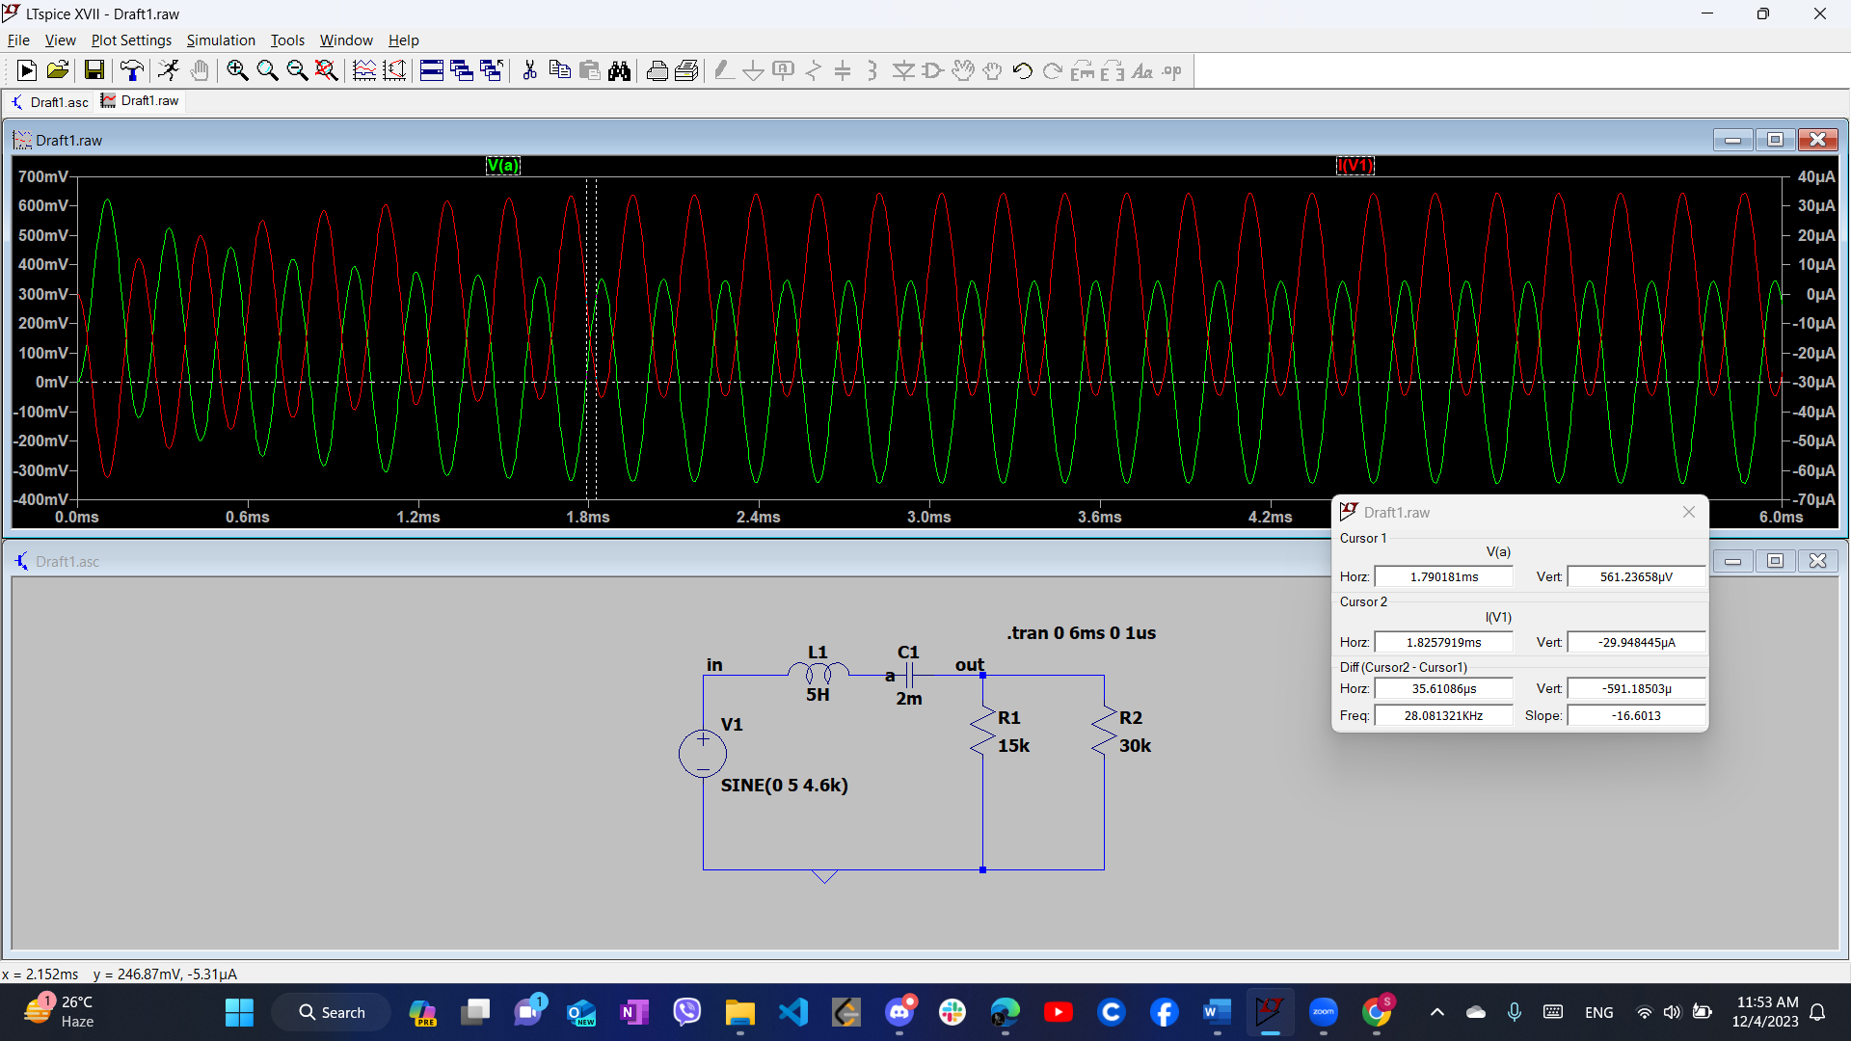

1. Write down the answer values (if any).

Phase difference = 72.5652 degree

Phase difference = 90 degree

1. **Submit the docx/pdf file and the zip file in the form provided.**

**You can convert a docx file by going to File>Export>Create PDF/XPS.**