**SESSION 10 ASSIGNMENT 2**

* Copying the file from local to HDFS.

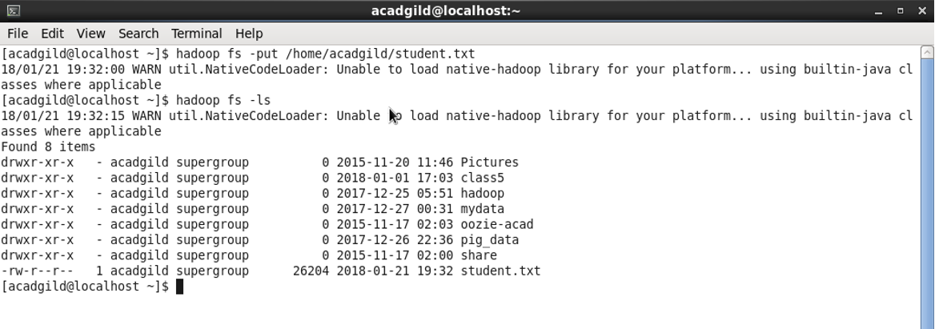

* Set jars of HBase to the Pig class path

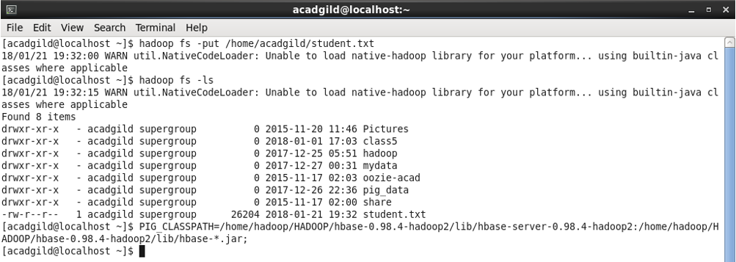

* start HBase shell and create a table

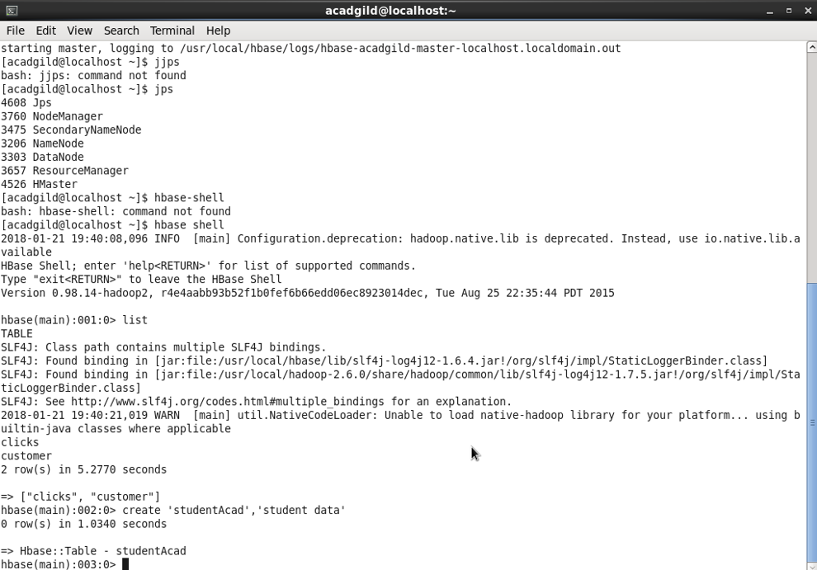

* Start Pig to load the data from hbase using Pig Scripts and Load the data from file system

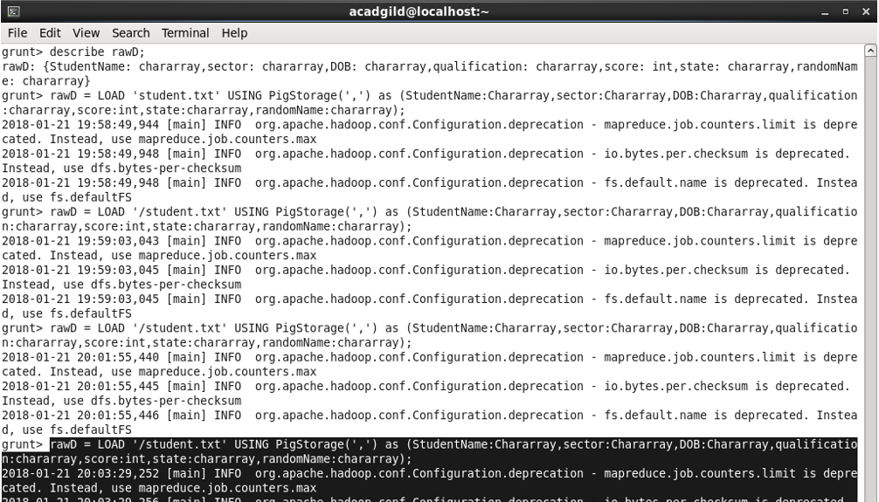

* transfer the data inside HBase by STORE command.

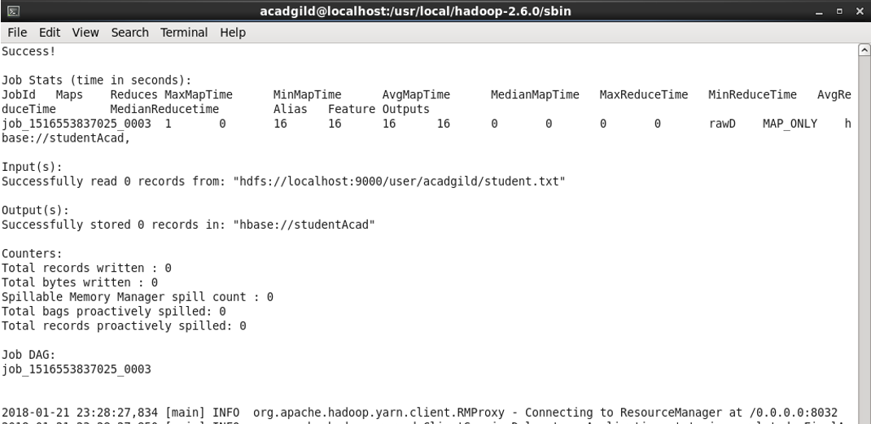

* Scan table command and results

