**TASK – 1**

* **IMPORT FROM MYSQL TO HDFS**

1. **Created database and table in MySql**

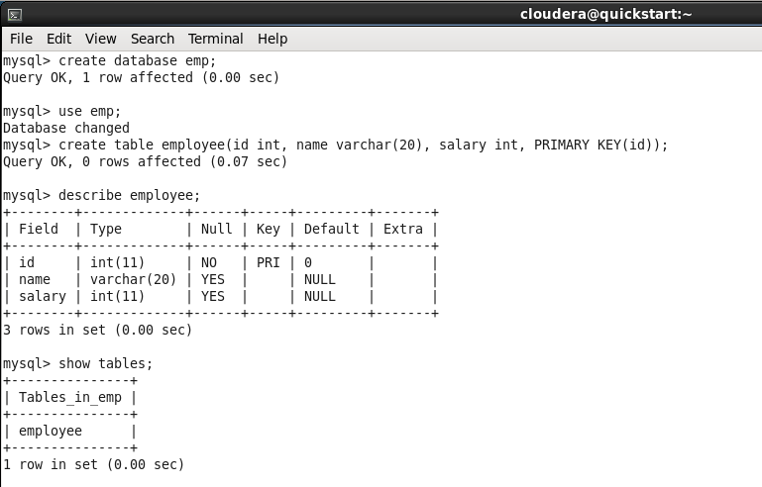

1. **Inserting data into employee table in MySql**

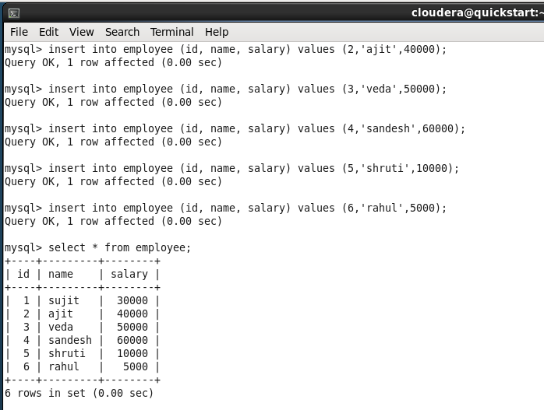

1. **Running Sqoop import command to import the employee table data into HDFS**

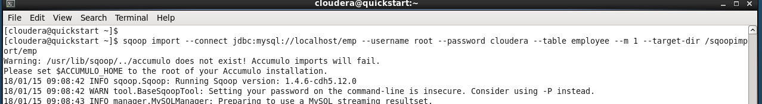

1. **The data is successfully imported into HDFS**

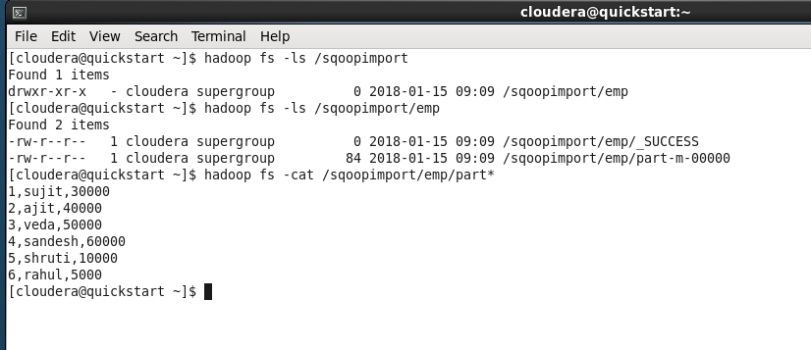

* **EXPORT FROM HDFS TO MYSQL**

1. **Created new empty table in Mysql**
2. **Ran sqoop export command to export the HDFS file data into the Mysql table**

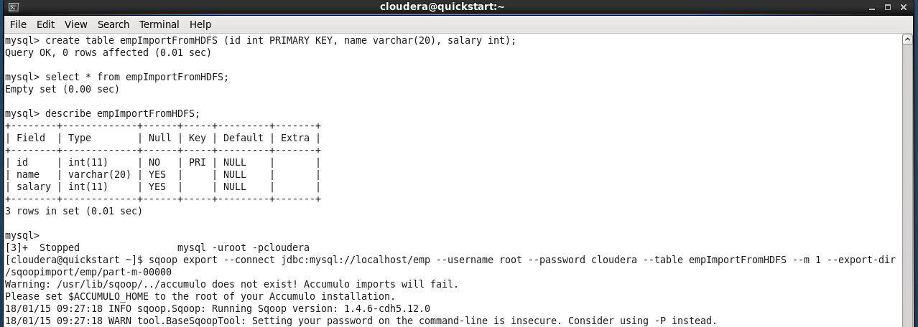

1. **Data exported into Mysql successfully**

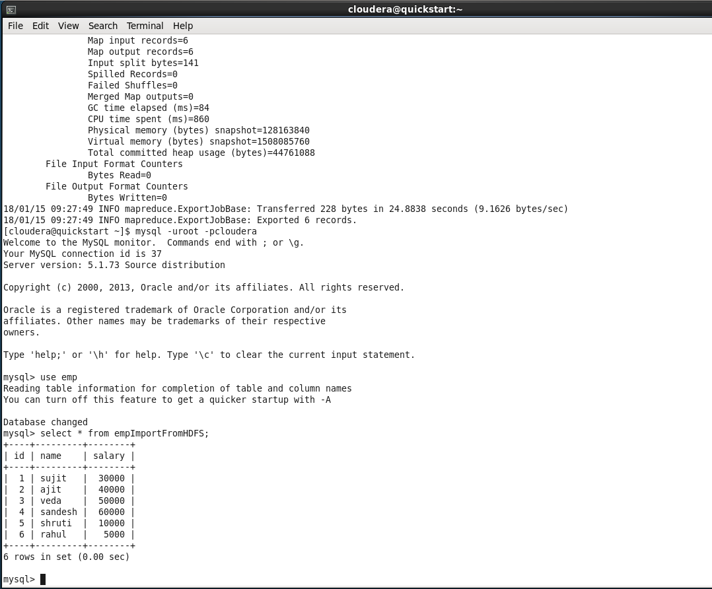

**TASK – 2**

* **IMPORT FROM MYSQL TO HIVE**

1. **Sqoop command to import data from Mysql To Hive**

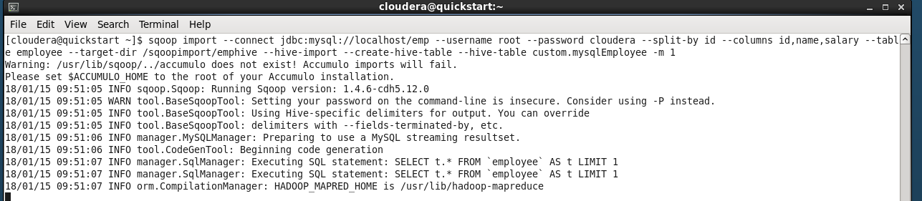

1. **The data is successfully imported from Mysql to Hive**

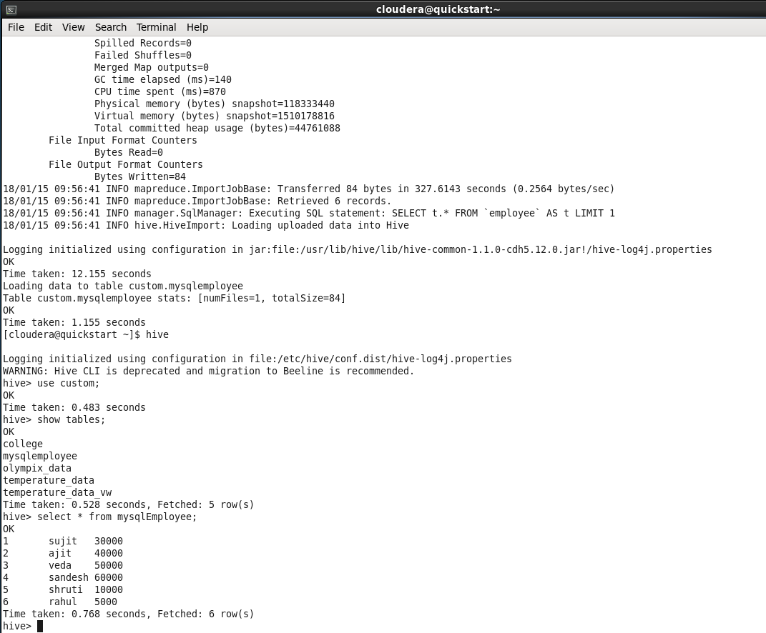

* **EXPORT FROM HIVE TO MYSQL**

1. **Empty table created in Mysql**

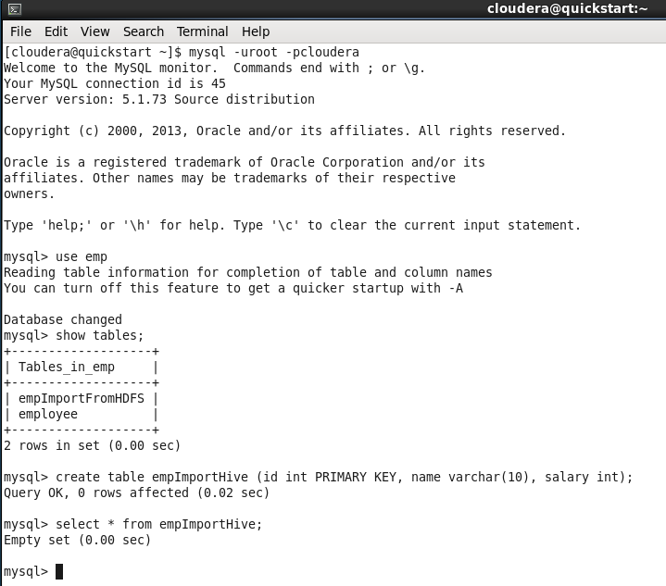

1. Sqoop command to export the data from HIVE to Mysql

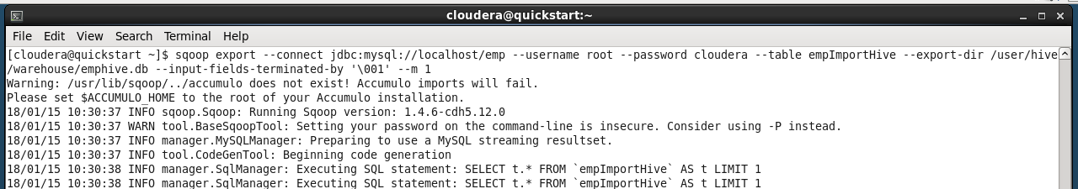

1. Hive data successfully exported to Mysql

