1. **Mysql table data**

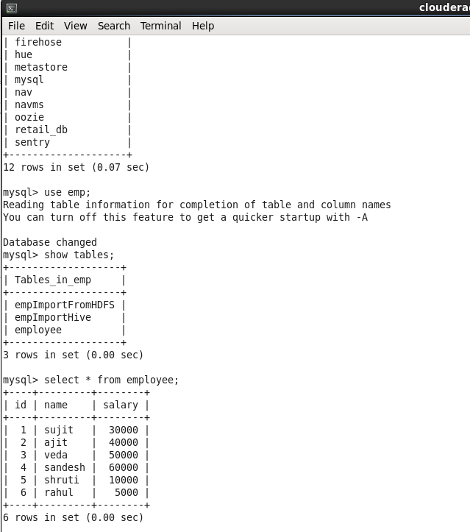

1. **Sqoop command to Initally load data to Hive table**

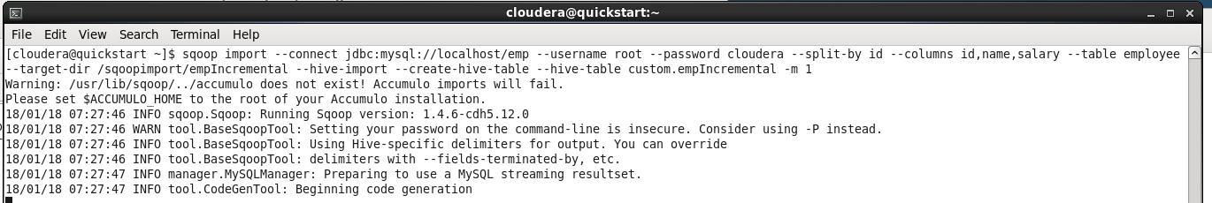

1. **Intial load data inserted into Hive table from Mysql table**

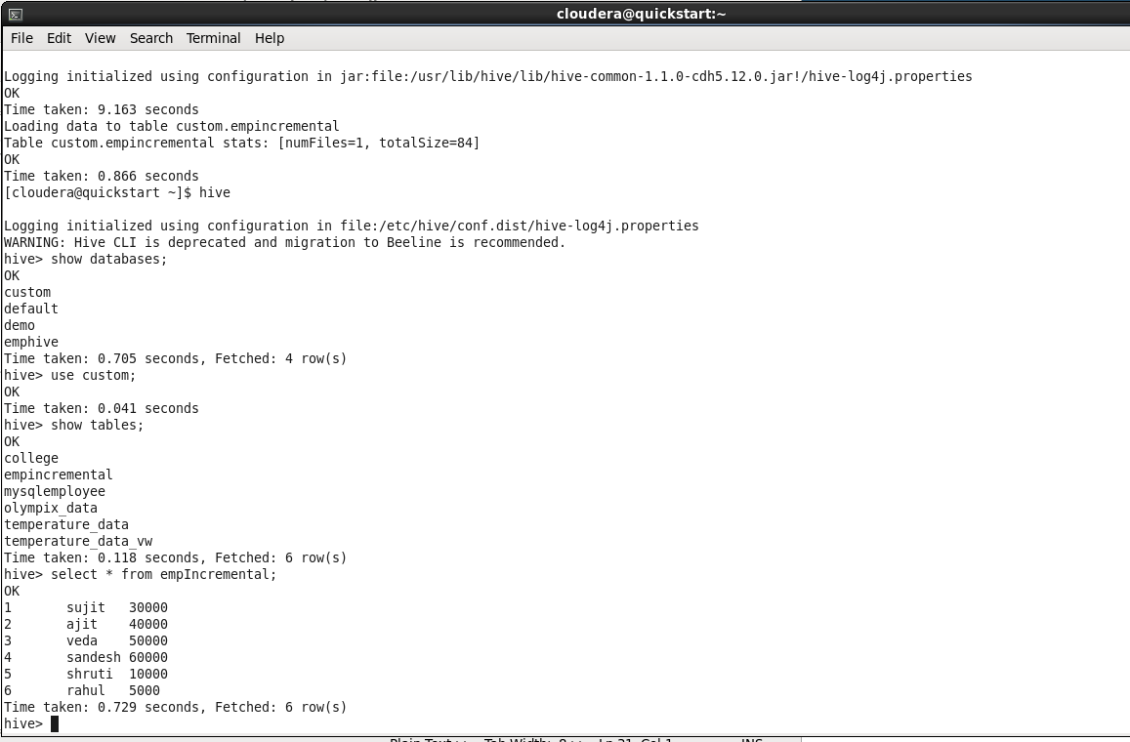

1. **Inserting new values/data into the Mysql table**

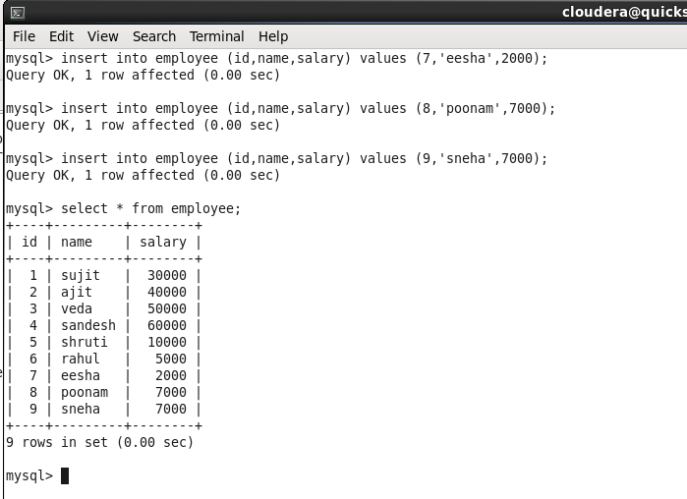

1. **Incremental sqoop command to load new values/data from Mysql to Hive table**

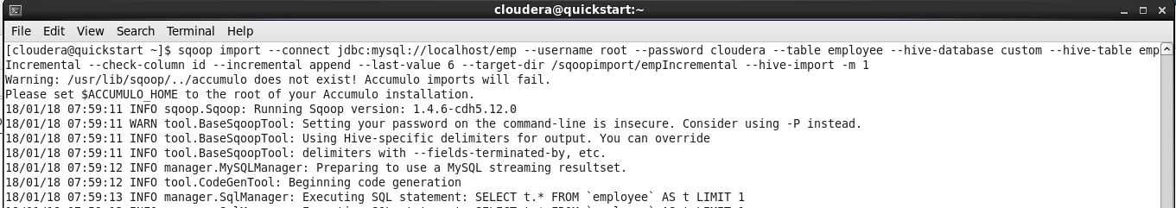

1. **Incremental load command inserted new values from Mysql to Hive table**

