**Session 11 Assignment 3**

1. Login to twitter

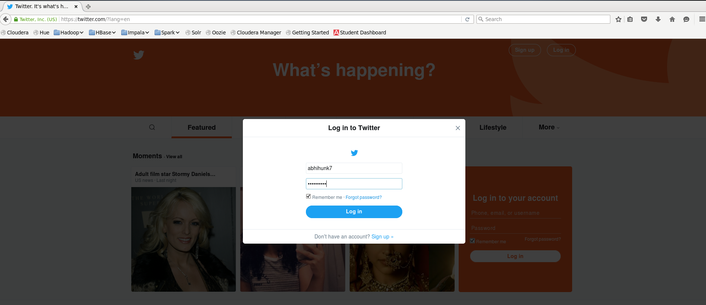

1. Go to “<https://apps.twitter.come/app>” and create new app

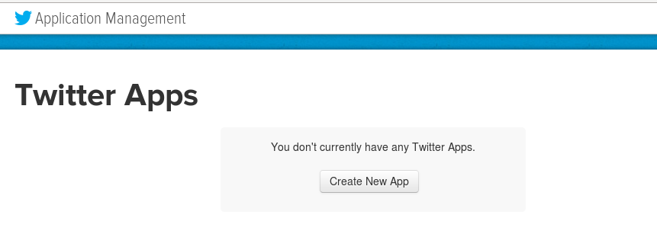

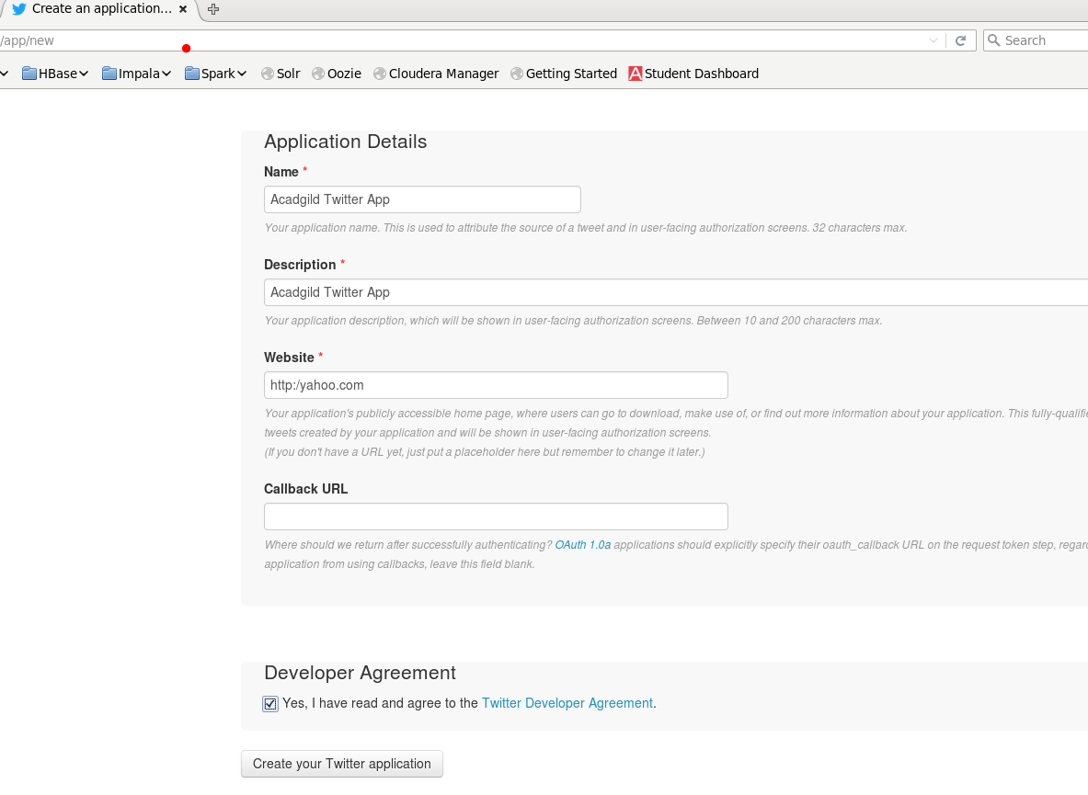

1. Go to “Keys and Access Tokens” tab and copy the “Consumer Key” and “Consumer Secrete Code”

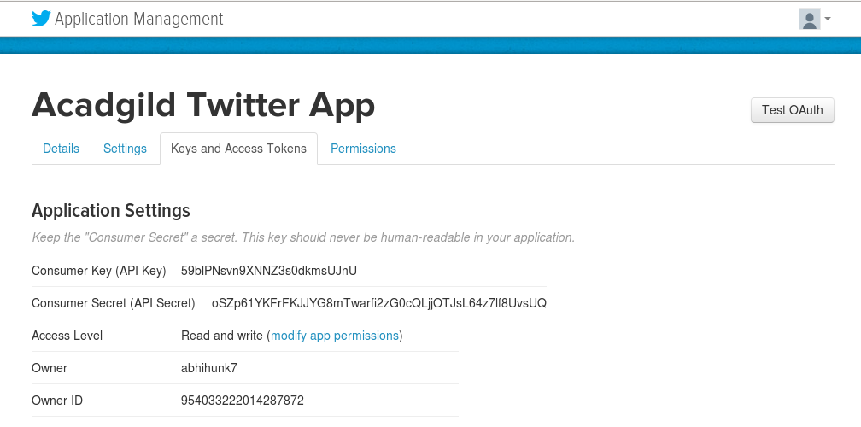

1. Click on the “Create My Access Token” button

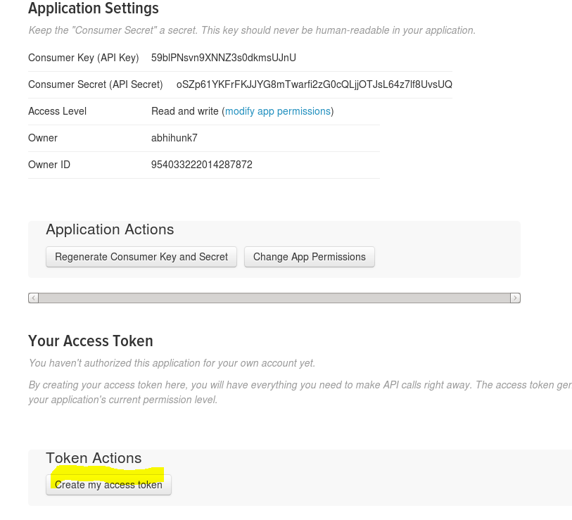

1. Copy “Access Token” and Access Token Secrete”

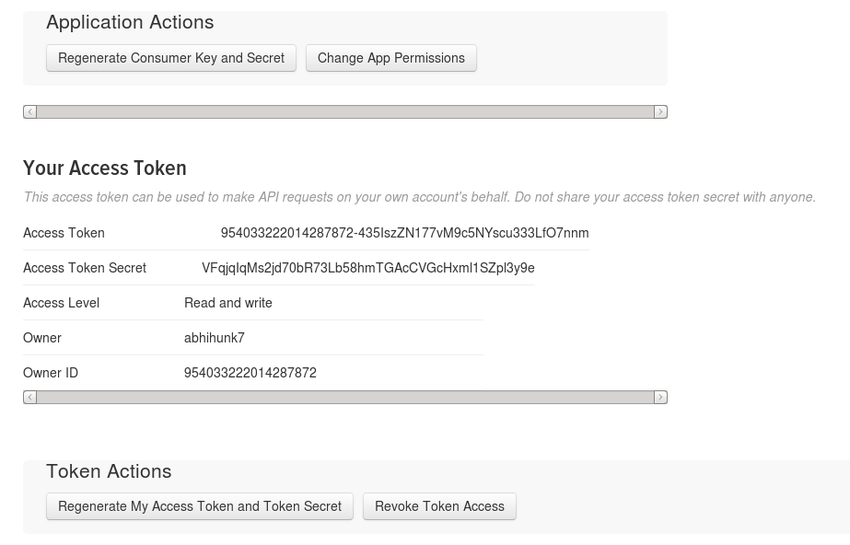

1. Create a new file in “/usr/lib/flume-ng/conf” directory and Copy the flume configuration code from the link “<https://drive.google.com/open?id=0B1QaXx7tpw3Sb3U4LW9SWlNidkk>” and paste it in the new file.
2. Update the flume configuration code with the copied “Consumer Key”, “Consumer Secrete Code”, “Access Token” and Access Token Secrete” in above steps.

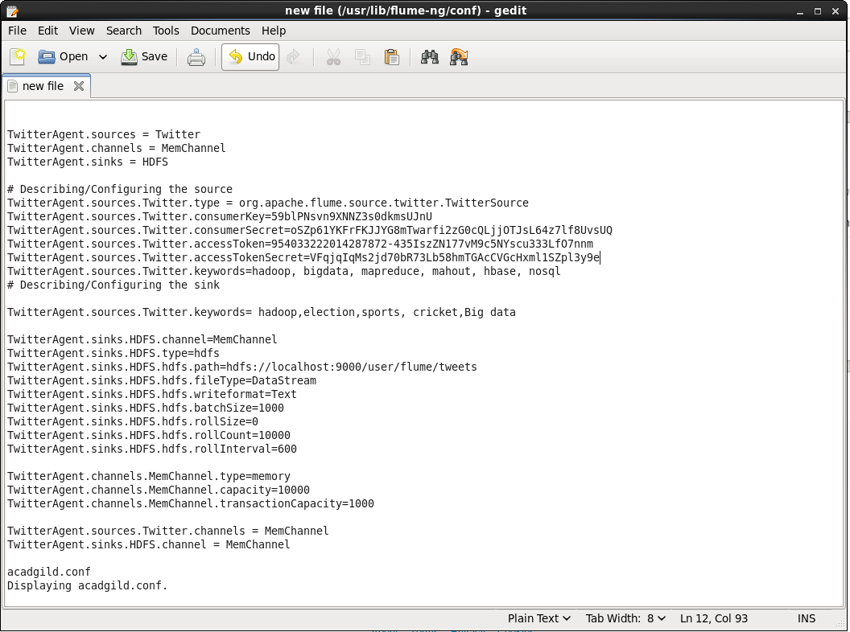

1. Create new directory “/user/flume/tweets” in HDFS

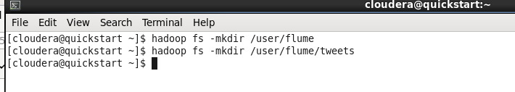

1. Use below command to fetch twitter data into HDFS custer

**flume-ng agent -n TwitterAgent -f /usr/lib/flume-ng/conf/flume.conf**

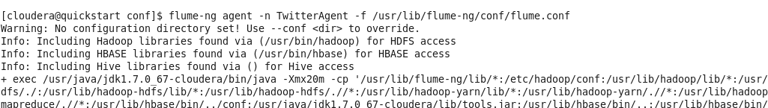

1. The above will start fetching the Twitter data into HDFS cluster

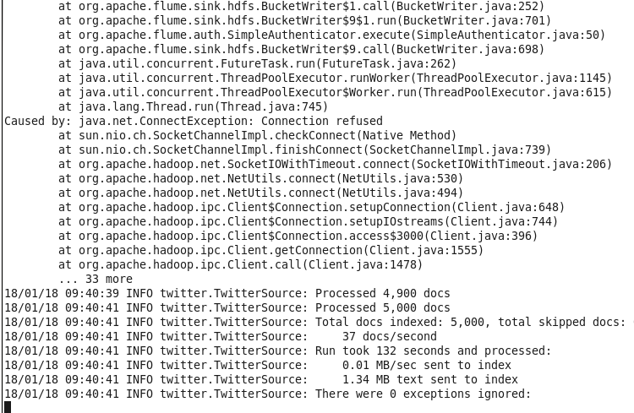

1. Check the Twitter data in HDFS using command

Hadoop fs -cat /user/flume/tweets/FlumeData.1512080342345

