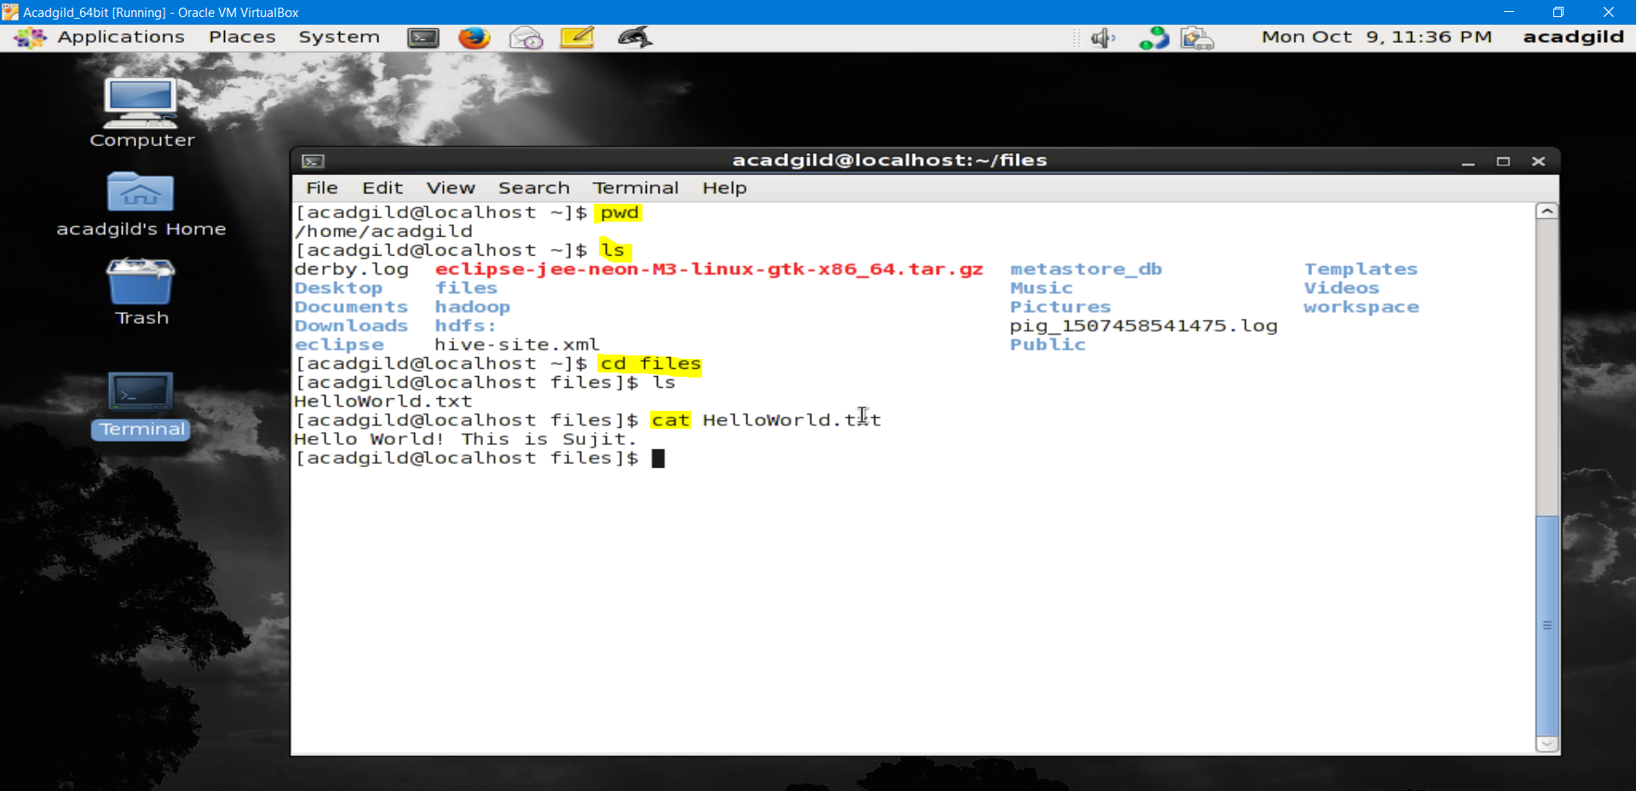

1. pwd : print work directory – shows the full pathname of the current working directory
2. ls : list, show all of the directories and files under a given file system
3. cd : change directory - will allow the user to change between file directories.

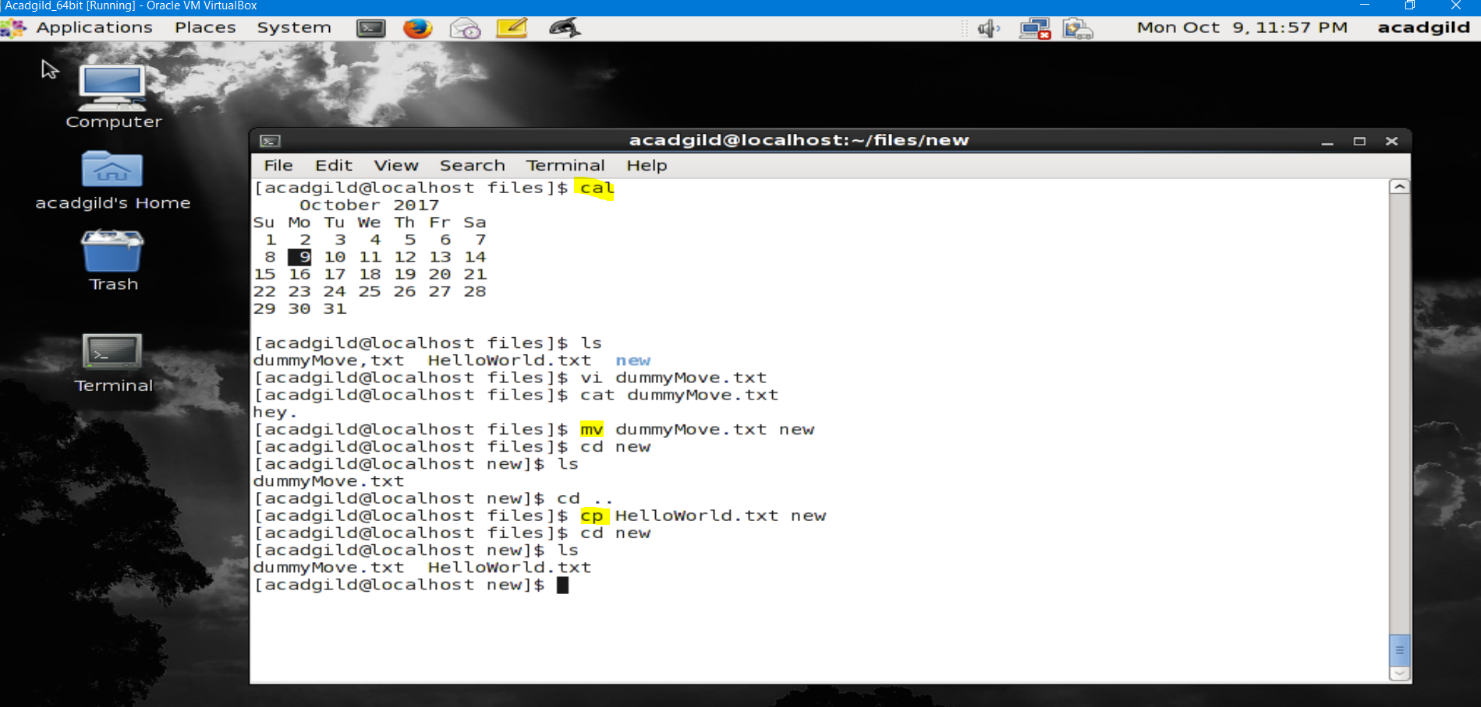

1. cal : calender, shows the current calendar
2. mv: move - allows a user to move a file to another folder or directory
3. cp: copy - allows a user to copy a file to another folder or directory

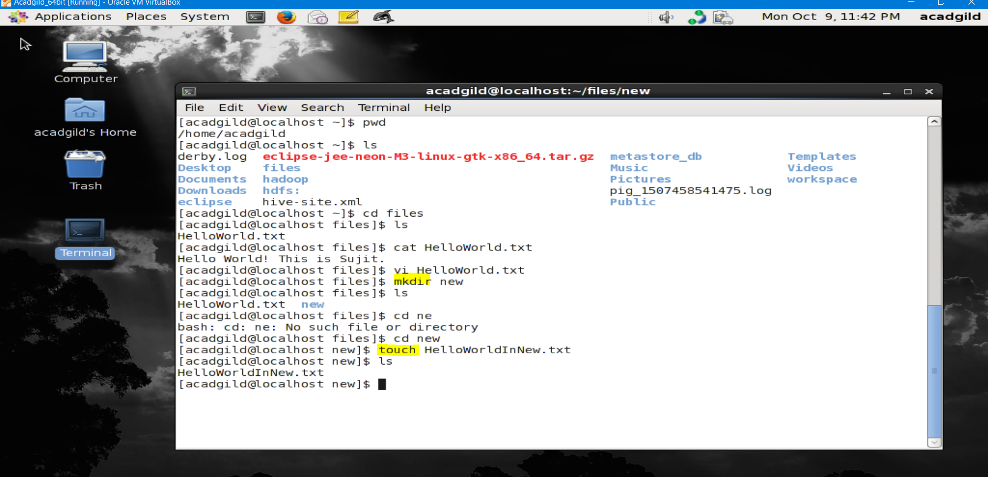

1. mkdir : make directory - command allows the user to make a new directory.
2. Touch : the make file command. Allows user to create a file

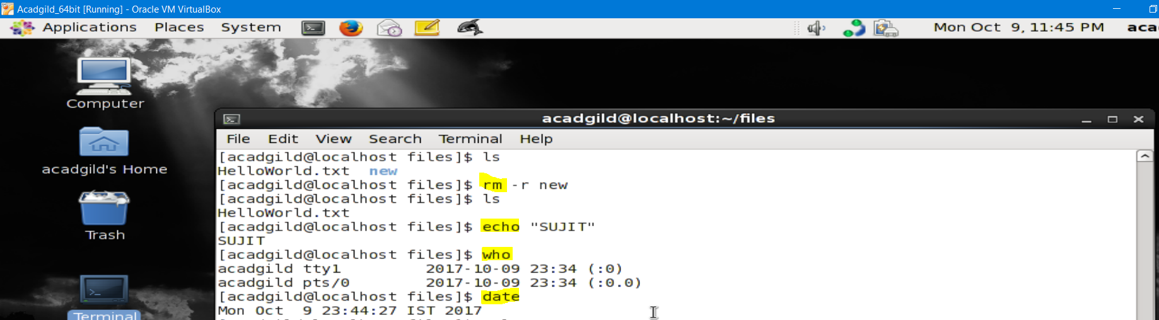

1. rm: remove - command allows the user to remove an existing file or directory
2. echo : to display the message
3. who: who displays a list of users who are currently logged into the computer.
4. Date : displays current date

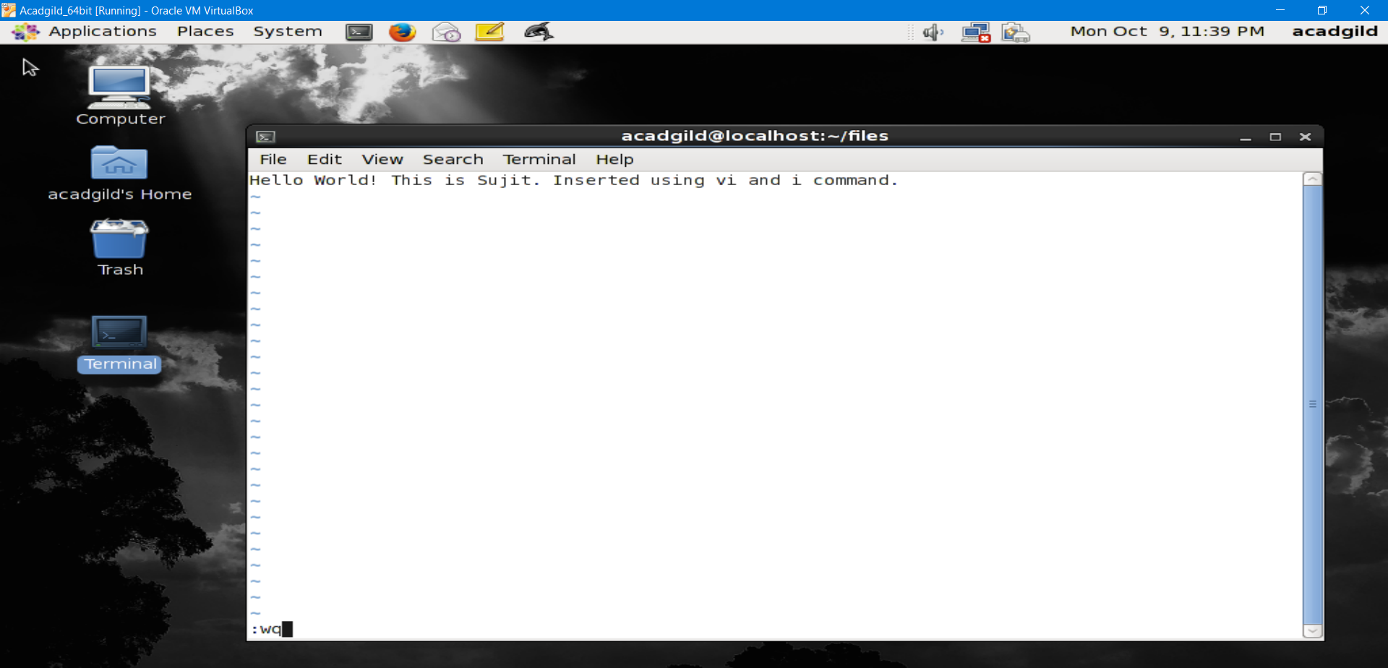

1. vi: it is a text editor on the unix terminal

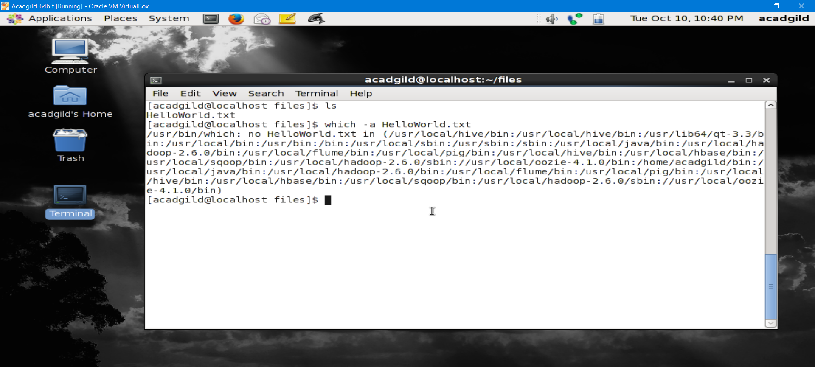

1. which : it is used to identify the location of executables.