## Question 1 - Answer

* load_data = load '/hadooplocal/pig/Pokemon.csv' using PigStorage(',') as (sno:int, name:chararray, type1:chararray, type2:chararray, total:int, hp:int, attack:int, defence:int, spAttack:int, spDefence:int, speed:int);
* qualPlayers = filter load_data by defence>55;

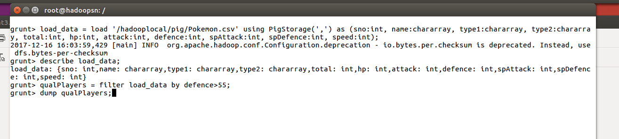

* dump qualPlayers;

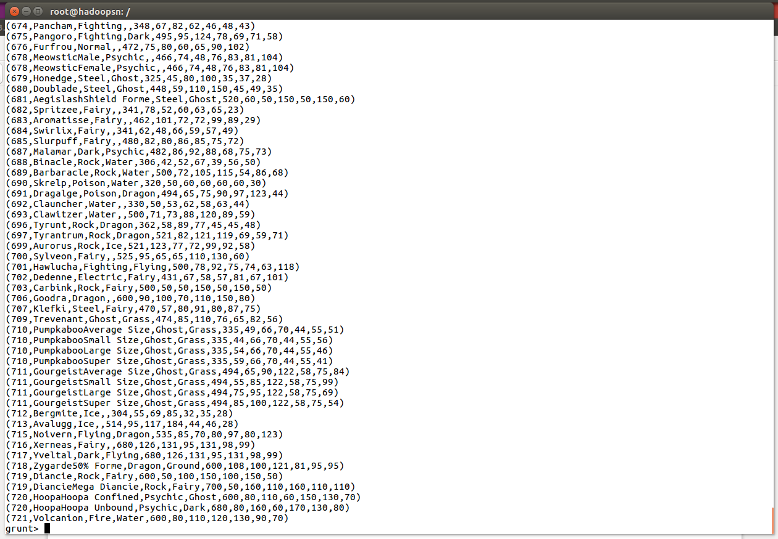

## Question 2 - Answer

* groupQualPlayers = group qualPlayers all;
* noQualPlayers = foreach groupQualPlayers generate COUNT(qualPlayers);
* dump noQualPlayers;

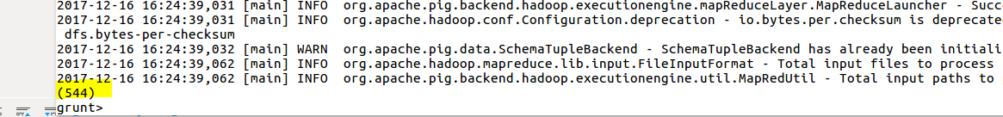

## Question 3 - Answer

* randomNum = foreach qualPlayers generate RANDOM(),name,type1,type2,total,hp,attack,defence,spAttack,spDefence,speed;

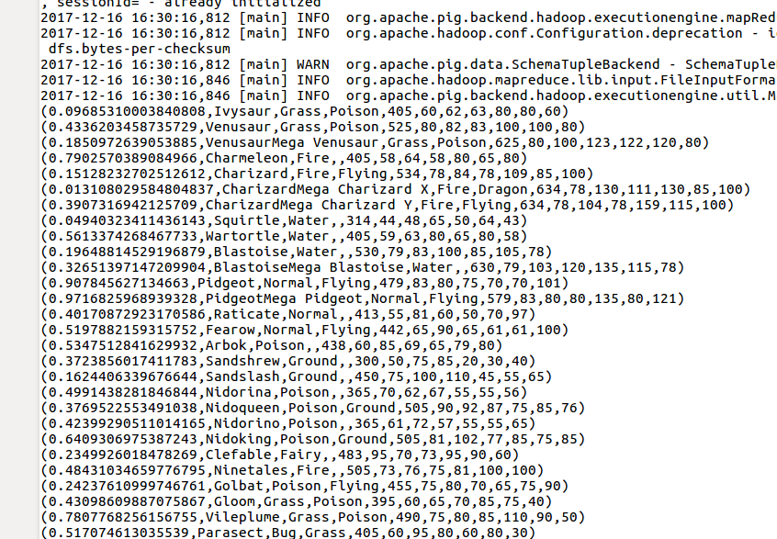

## Question 4 - Answer

* randomDesc = order randomNum by $0 desc;
* dump randomDesc;

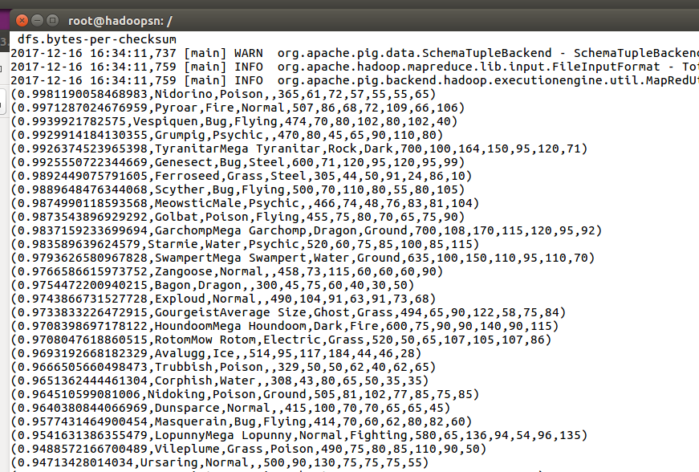

## Question 5 - Answer

* randomNum2 = foreach qualPlayers generate RANDOM(),name,type1,type2,total,hp,attack,defence,spAttack,spDefence,speed;
* randomNum2Desc = order randomNum2 by $0 desc;
* dump randomNum2Desc;

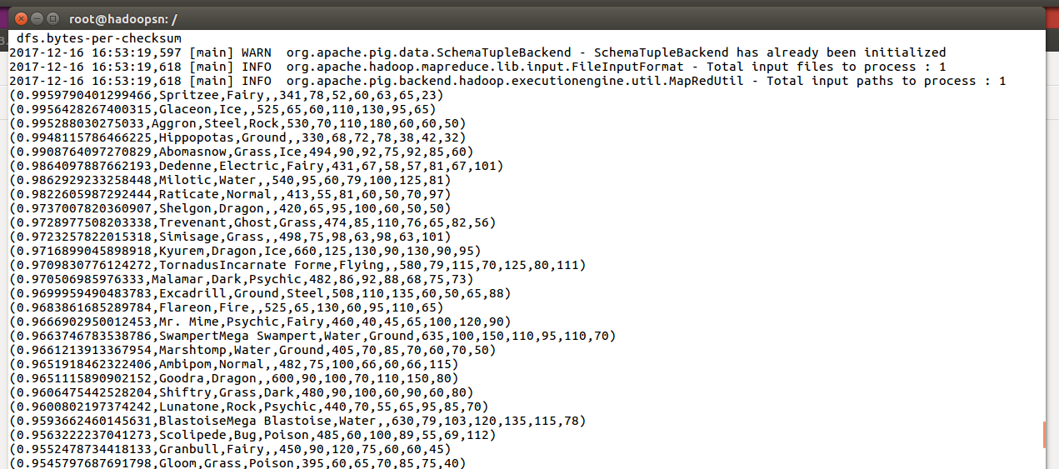

## Question 6 - Answer

* limitRandomNum = limit randomDesc 5;

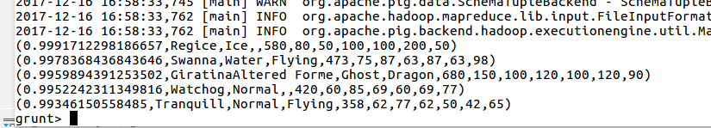

* limitRandomNum2 = limit randomNum2Desc 5;

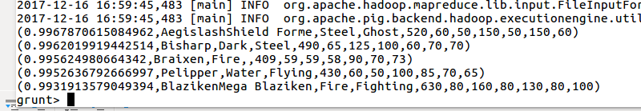

## Question 7 - Answer

* limitRandomNum_namehp = foreach limitRandomNum generate $1,hp;
* limitRandomNum2_namehp = foreach limitRandomNum generate $1,hp;
* dump limitRandomNum_namehp;

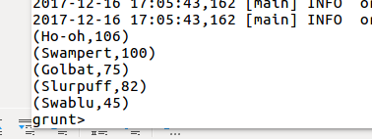

* dump limitRandomNum2_namehp;

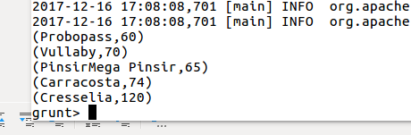

* STORE limitRandomNum_namehp into '/hadooplocal/pig/Player1.txt';
* STORE limitRandomNum2_namehp into '/hadooplocal/pig/Player2.txt';

