**TASK – 1**

hbase(main):022:0> version

1.2.0-cdh5.12.0, rUnknown, Thu Jun 29 04:42:07 PDT 2017

hbase(main):023:0> create 'clicks', {NAME=>'hits', VERSION=>5}

Unknown argument ignored for column family hits: 1.8.7

0 row(s) in 2.7950 seconds

=> Hbase::Table - clicks

hbase(main):025:0> describe 'clicks'

Table clicks is ENABLED

clicks

COLUMN FAMILIES DESCRIPTION

{NAME => 'hits', DATA_BLOCK_ENCODING => 'NONE', BLOOMFILTER => 'ROW', REPLICATION_SCOPE => '0', VERSIONS => '1', COMPRESSION => 'NONE', MIN_VERSIONS => '0', TTL => 'FOREVER',

KEEP_DELETED_CELLS => 'FALSE', BLOCKSIZE => '65536', IN_MEMORY => 'false', BLOCKCACHE => 'true'}

1 row(s) in 0.3640 seconds

hbase(main):026:0> list

TABLE

clicks

1 row(s) in 0.1510 seconds

=> ["clicks"]

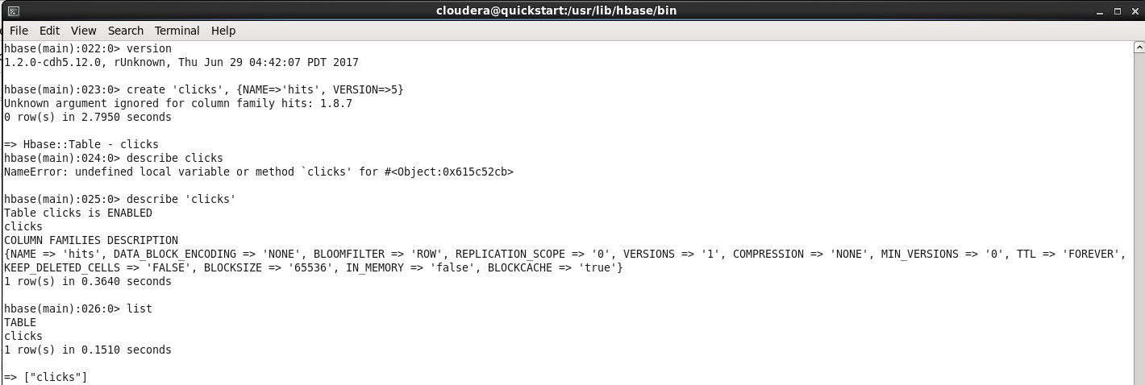

**TASK – 2**

hbase(main):021:0> put 'clicks', '192,168,63,1', 'hits:Names','AJAY'

0 row(s) in 0.0090 seconds

hbase(main):022:0> put 'clicks', '192,168,63,2', 'hits:Names','SUJIT'

0 row(s) in 0.0160 seconds

hbase(main):023:0> put 'clicks', '192,168,63,3', 'hits:Names','SANDESH'

0 row(s) in 0.0040 seconds

hbase(main):024:0> put 'clicks', '192,168,63,4', 'hits:Names','SHRUTHI'

0 row(s) in 0.0090 seconds

hbase(main):025:0> put 'clicks', '192,168,63,5', 'hits:Names','VEDA'

0 row(s) in 0.0080 seconds

hbase(main):026:0> put 'clicks', '192,168,63,6', 'hits:Names','VANDANA'

0 row(s) in 0.0040 seconds

hbase(main):027:0> scan 'clicks'

ROW COLUMN+CELL

192,168,63,1 column=hits:Names, timestamp=1515753814822, value=AJAY

192,168,63,2 column=hits:Names, timestamp=1515753826050, value=SUJIT

192,168,63,3 column=hits:Names, timestamp=1515753835897, value=SANDESH

192,168,63,4 column=hits:Names, timestamp=1515753845812, value=SHRUTHI

192,168,63,5 column=hits:Names, timestamp=1515753856315, value=VEDA

192,168,63,6 column=hits:Names, timestamp=1515753865256, value=VANDANA

6 row(s) in 0.0210 seconds

hbase(main):032:0> alter 'clicks', NAME=>'hits', VERSIONS=>4

Updating all regions with the new schema...

1/1 regions updated.

Done.

0 row(s) in 2.0110 seconds

hbase(main):033:0> put 'clicks', '192,168,63,1', 'hits:Names','AGASTYA'

0 row(s) in 0.0690 seconds

hbase(main):034:0> put 'clicks', '192,168,63,4', 'hits:Names','VIRAT'

0 row(s) in 0.0420 seconds

hbase(main):035:0> scan 'clicks', {VERSIONS=>4}

ROW COLUMN+CELL

192,168,63,1 column=hits:Names, timestamp=1515754681122, value=AGASTYA

192,168,63,1 column=hits:Names, timestamp=1515753814822, value=AJAY

192,168,63,2 column=hits:Names, timestamp=1515753826050, value=SUJIT

192,168,63,3 column=hits:Names, timestamp=1515753835897, value=SANDESH

192,168,63,4 column=hits:Names, timestamp=1515754701918, value=VIRAT

192,168,63,4 column=hits:Names, timestamp=1515753845812, value=SHRUTHI

192,168,63,5 column=hits:Names, timestamp=1515753856315, value=VEDA

192,168,63,6 column=hits:Names, timestamp=1515753865256, value=VANDANA

6 row(s) in 0.0730 seconds

hbase(main):036:0> alter 'clicks', NAME=>'hits', VERSIONS=>3

Updating all regions with the new schema...

0/1 regions updated.

1/1 regions updated.

Done.

0 row(s) in 3.0420 seconds

hbase(main):037:0> put 'clicks', '192,168,63,2', 'hits:Names','ABHISHESK'

0 row(s) in 0.0570 seconds

hbase(main):038:0> scan 'clicks', {VERSIONS=>3}

ROW COLUMN+CELL

192,168,63,1 column=hits:Names, timestamp=1515754681122, value=AGASTYA

192,168,63,1 column=hits:Names, timestamp=1515753814822, value=AJAY

192,168,63,2 column=hits:Names, timestamp=1515754769030, value=ABHISHESK

192,168,63,2 column=hits:Names, timestamp=1515753826050, value=SUJIT

192,168,63,3 column=hits:Names, timestamp=1515753835897, value=SANDESH

192,168,63,4 column=hits:Names, timestamp=1515754701918, value=VIRAT

192,168,63,4 column=hits:Names, timestamp=1515753845812, value=SHRUTHI

192,168,63,5 column=hits:Names, timestamp=1515753856315, value=VEDA

192,168,63,6 column=hits:Names, timestamp=1515753865256, value=VANDANA

6 row(s) in 0.0500 seconds

