ITA05 – COMPUTER VISION
COMPUTER VISION-BASED AUTOMATED DEFECT DETECTION SYSTEM FOR INDUSTRIAL QUALITY INSPECTION

A. Assignment Information
Field |  | Details
Department | Computer Science and Engineering
Name | K Sujith Sai Vighnesh
Register Number | 192
Programme | Faculty of Engineering
Course Code & Name | ITA05 & Computer Vision
Academic Year / Batch | 2026-2027
Date of Issue | 20-08-2026
Date of Submission | 03-09-2026
Maximum Marks | 100

1. INTRODUCTION
Quality inspection is an essential part of modern manufacturing because defective products can result in material waste, customer complaints, production losses, and safety issues. Traditionally, product inspection is performed manually by trained workers who visually examine products for scratches, cracks, dents, missing components, surface irregularities, and other manufacturing defects.
Although manual inspection can be effective, it becomes difficult to maintain consistent performance when products must be inspected continuously on a high-speed production line. Human inspectors can experience fatigue, variation in judgment, and difficulty identifying very small or subtle defects.
Computer Vision provides an automated alternative by allowing a camera and software system to capture and analyze product images. The system can process the captured image, identify relevant visual characteristics, detect defective regions, and generate an automatic quality decision.
The proposed project investigates two major approaches for industrial defect detection:
- Traditional Computer Vision techniques
- Deep Learning-based Computer Vision techniques
The two approaches are compared based on detection accuracy, adaptability, computational requirements, training requirements, robustness, processing speed, and deployment suitability.
The final objective is to identify an approach that can satisfy the required detection accuracy of more than 95% while remaining sufficiently adaptable for real-world manufacturing conditions.
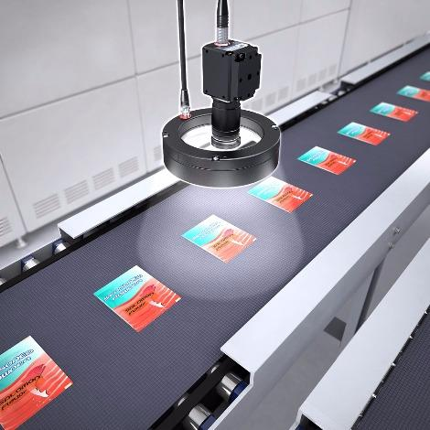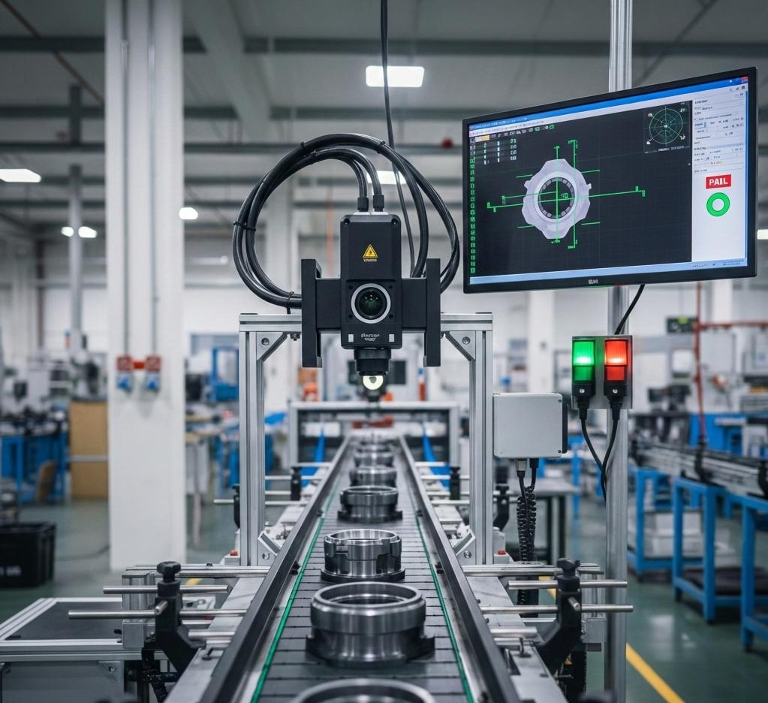
Figure 1. Conceptual representation of automated visual inspection on a manufacturing production line.

2. PROBLEM STATEMENT
A manufacturing company plans to deploy an automated Computer Vision-based defect detection system for inspecting products on a high-speed production line.
The system must detect subtle manufacturing defects with an accuracy greater than 95% and should remain reliable when there are variations in product appearance, illumination, orientation, and manufacturing batches.
Two approaches are being considered. Traditional Computer Vision methods provide fast processing and low computational requirements but generally depend on manually designed features and fixed rules. Therefore, their performance may decrease when the appearance or environmental conditions change.
Deep Learning methods can automatically learn complex visual features from training data and can provide better adaptability to variations. However, they require sufficient training data, computational resources, model training, and appropriate validation.
Therefore, the main problem addressed by this project is:
How can a Computer Vision-based defect detection system be designed to achieve high detection accuracy while remaining robust, computationally feasible, and adaptable to variations in industrial manufacturing conditions?

3. OBJECTIVES
The major objectives of the proposed system are:
- To study the application of Computer Vision in automated industrial quality inspection.
- To understand image formation, representation, sampling, quantization, and visual features relevant to defect detection.
- To preprocess product images using suitable image enhancement and filtering techniques.
- To identify and analyze defective regions within product images.
- To implement a Traditional Computer Vision-based defect detection baseline.
- To implement a Deep Learning-based defect detection approach.
- To compare both approaches using suitable evaluation metrics.
- To evaluate the effect of lighting, orientation, appearance, and other variations on detection performance.
- To determine whether the selected approach can satisfy the target accuracy of more than 95%.
- To analyze the computational and deployment requirements of the proposed system.
- To generate visual detection results and an automated inspection decision.
- To evaluate the industrial relevance of the proposed solution and its contribution to sustainable manufacturing.

4. INDUSTRIAL QUALITY INSPECTION USING COMPUTER VISION
In an automated manufacturing environment, products move through a production line and are captured by an industrial camera.
The general inspection process can be represented as:
Manufactured Product
↓
Production Line
↓
Camera/Image Acquisition
↓
Image Preprocessing
↓
Defect Detection
↓
Defect Classification
↓
Quality Decision
↓
PASS / DEFECTIVE
For example, consider a manufactured component containing a small surface crack.
A human inspector may visually examine the component and decide whether it is acceptable. In the proposed system, the camera captures the component and the Computer Vision model analyzes the image automatically.
Example:
Input:
Metal component image
Detected:
Surface crack
Confidence:
96.4%

Decision:
DEFECTIVE
The system can therefore provide a consistent and repeatable inspection process.
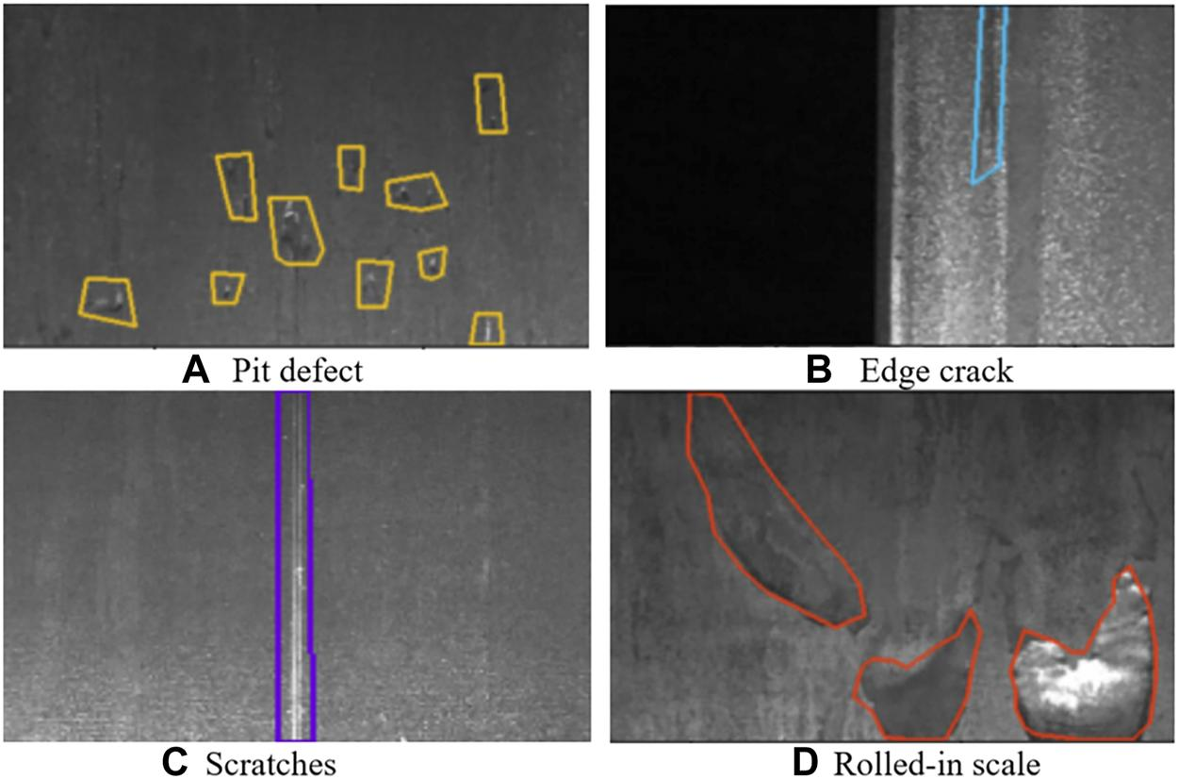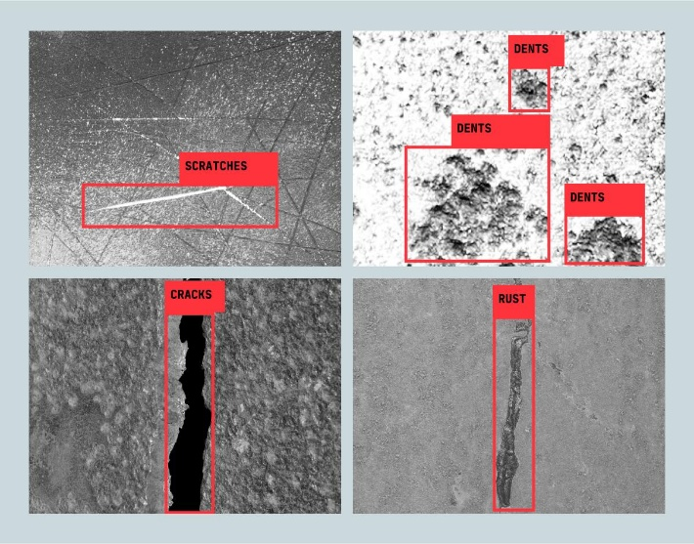
Figure 2. Example of an industrial product containing a manufacturing defect.

5. FUNCTIONAL REQUIREMENTS
The proposed system should satisfy the following functional requirements.
5.1 Image Acquisition
The system should accept images captured using an industrial camera or a suitable image dataset.
5.2 Image Preprocessing
The system should improve the quality of input images using resizing, noise reduction, normalization, and illumination correction.
5.3 Defect Detection
The system should identify whether a product contains a defect.
5.4 Defect Localization
Where suitable annotations are available, the system should identify the location of the defective region.
5.5 Defect Classification
The system should identify the defect category when sufficient labeled data is available.
5.6 Confidence Estimation
The system should provide a confidence value associated with its prediction.
5.7 Quality Decision
The system should classify the product as:
PASS
or
DEFECTIVE
5.8 Result Visualization
Detected regions should be visually displayed using bounding boxes, labels, masks, or other suitable representations.

5.9 Performance Evaluation
The system should calculate suitable evaluation metrics such as:
- Accuracy
- Precision
- Recall
- F1-score
- False Negative Rate
- Inference Time
- mAP, where applicable

6. NON-FUNCTIONAL REQUIREMENTS
The proposed system should also satisfy several non-functional requirements.
Accuracy
The system should target detection performance greater than 95%.
Speed
The system should process images quickly enough to support near-real-time industrial inspection.
Robustness
The system should remain effective under reasonable variations in:
- Lighting
- Orientation
- Scale
- Product appearance
- Manufacturing batch
Scalability
The system should allow additional defect categories or product types to be incorporated in future versions.
Reliability
The system should minimize false-negative predictions because undetected defects may reach customers.
Maintainability
The software should be modular so that preprocessing, detection, evaluation, and reporting components can be updated independently.

7. COMPUTER VISION FUNDAMENTALS
7.1 Image Formation
An image is generated when light reflected from an object reaches a camera sensor. The sensor converts the received light into electrical signals, which are then represented digitally as image pixels.
In industrial inspection, the quality of image formation depends on:
- Camera resolution
- Lighting
- Camera position
- Lens characteristics
- Object distance
- Surface reflectivity
Proper image acquisition is important because poor-quality images can reduce the performance of subsequent detection algorithms.
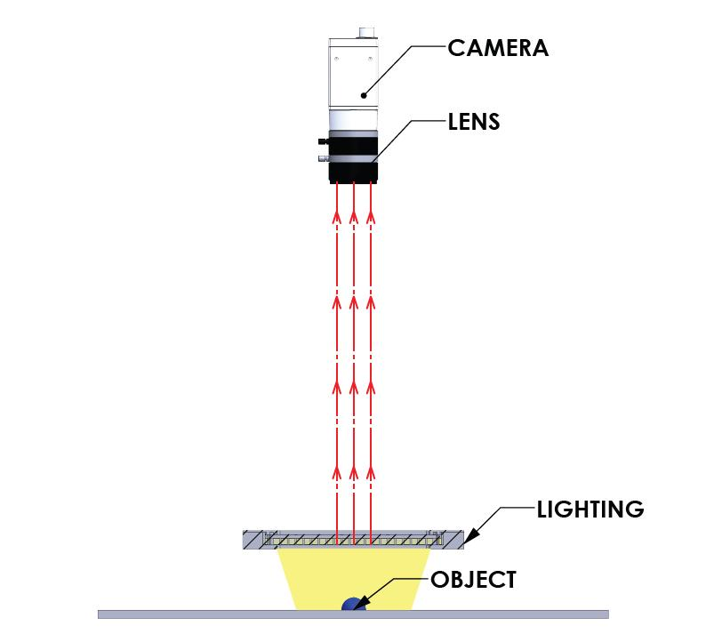
Figure 3. Image acquisition process in an industrial inspection system.

7.2 Image Representation
A digital image consists of pixels arranged in rows and columns.
For a grayscale image, each pixel represents an intensity value.
For an 8-bit grayscale image:
Minimum intensity = 0
Maximum intensity = 255
where:
0 → Black
255 → White
A color image commonly uses three channels:
Red
Green
Blue
This representation allows Computer Vision algorithms to analyze visual information numerically.

7.3 Sampling
Sampling refers to converting a continuous image into a discrete grid of pixels.
For example:
Continuous Image
↓
Sampling
↓
640 × 640 pixel image
Higher spatial resolution allows smaller defects to be represented more clearly, but it also increases computational requirements.
Therefore, image resolution must be selected according to the smallest defect that needs to be detected and the available processing resources.

7.4 Quantization
Quantization converts continuous intensity values into discrete numerical values.
For example, an 8-bit image represents intensity using:
256 possible levels
0 – 255
Higher bit depth can represent more intensity levels, but standard industrial image-processing systems commonly use 8-bit or higher representations depending on the camera and application.

7.5 Image Features
Important visual features for defect detection include:
- Edges
- Texture
- Shape
- Color
- Intensity
- Contours
- Local patterns
For example, a crack may produce a strong local edge, while a surface defect may create a different texture pattern compared with a normal product surface.
Traditional Computer Vision algorithms manually extract such features, whereas Deep Learning models can learn useful features automatically from training data.

8. IMAGE PREPROCESSING
Raw camera images may contain noise, uneven illumination, different resolutions, and other variations.
Therefore, preprocessing is performed before defect analysis.
The proposed preprocessing pipeline is:
Original Image
↓
Resize
↓
Noise Removal
↓
Illumination Correction
↓
Contrast Enhancement
↓
Normalization
↓
Processed Image
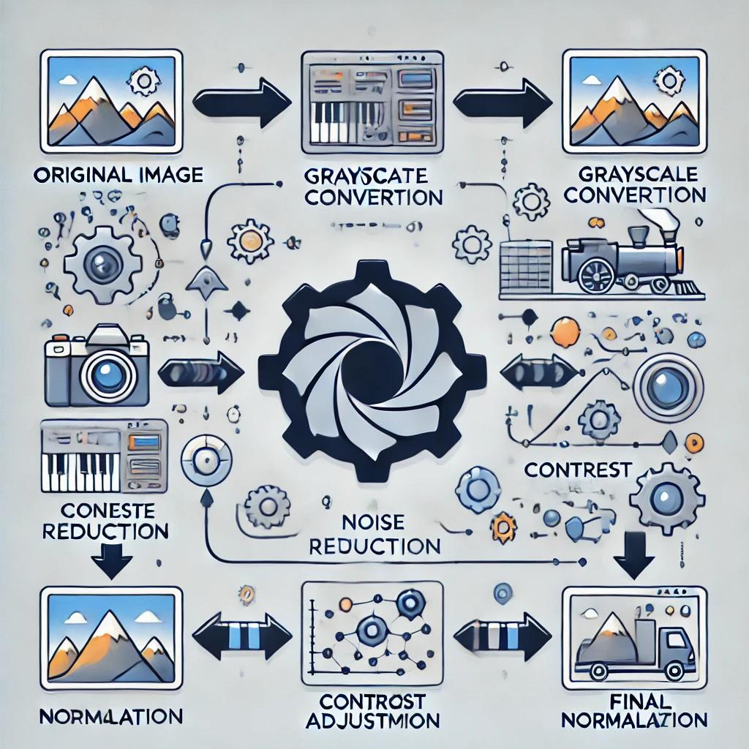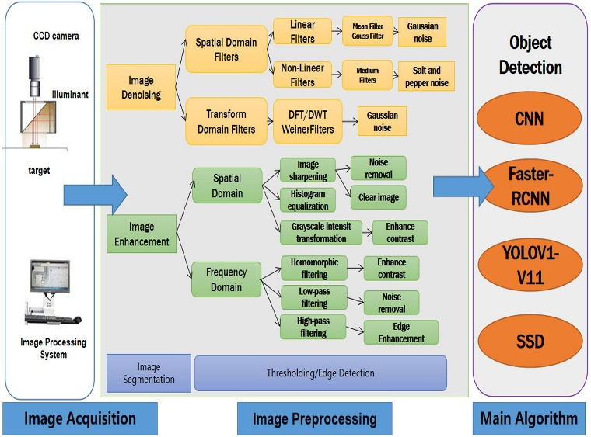
Figure 4. Proposed image preprocessing pipeline.

8.1 Image Resizing
Images obtained from different sources may have different dimensions.
For example:
1920 × 1080
↓
640 × 640
Resizing provides a consistent input format for the detection model.
However, excessive resizing can remove important details. Therefore, the selected resolution should preserve small defect patterns while maintaining reasonable computational requirements.

8.2 Noise Removal
Images may contain noise caused by:
- Camera sensors
- Environmental conditions
- Transmission
- Low illumination
Filtering techniques such as Gaussian filtering or median filtering can be used to reduce unwanted noise.
For example:
Noisy Image
↓
Gaussian / Median Filter
↓
Cleaner Image

8.3 Illumination Correction
Lighting variation is a major challenge in industrial inspection.
A component may appear different under bright and dark illumination even though the physical product has not changed.
Therefore, illumination correction can be applied to reduce the effect of uneven lighting.
Possible techniques include:
- Histogram Equalization
- CLAHE
- Background estimation
- Intensity normalization
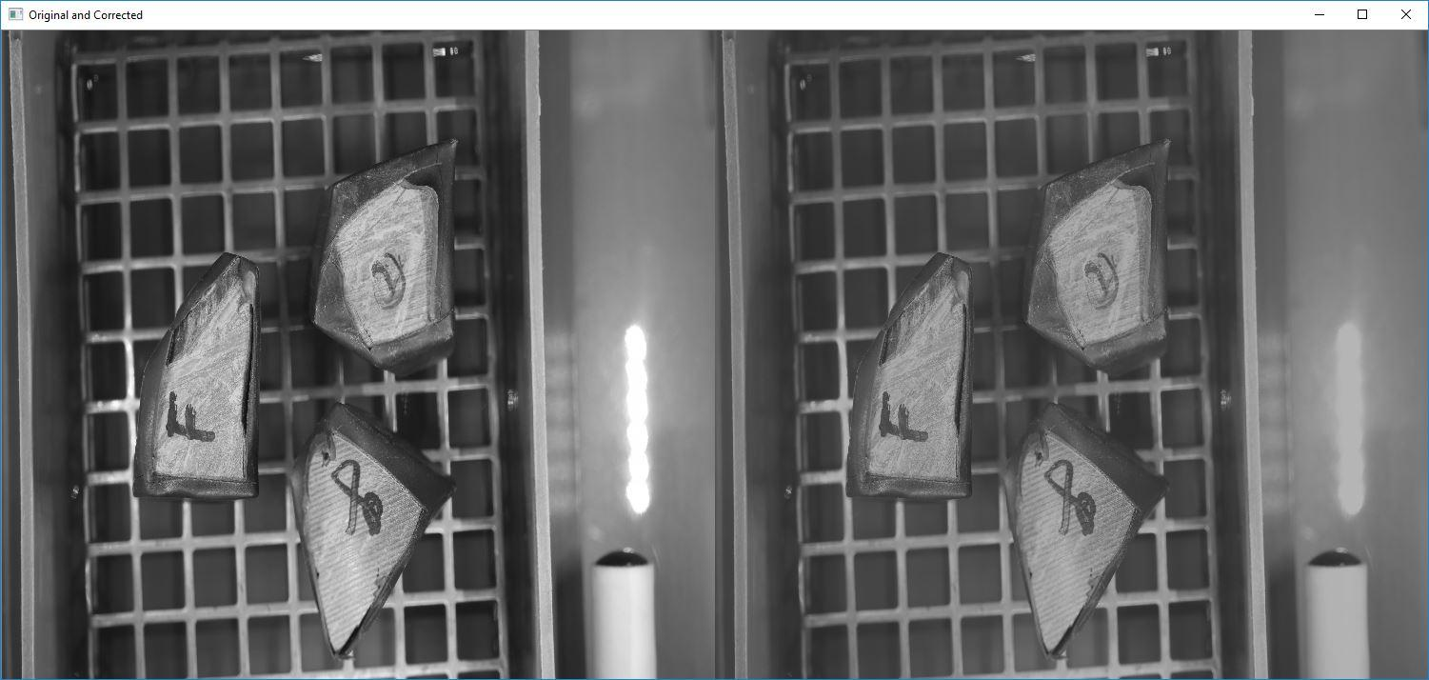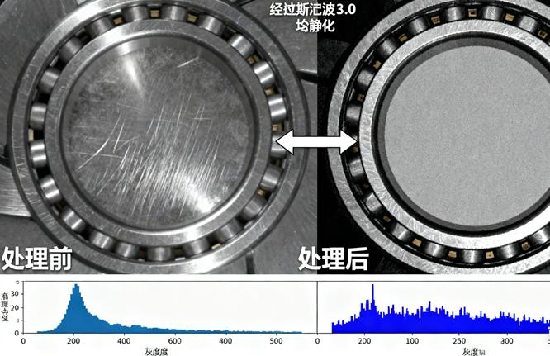
Figure 5. Effect of illumination correction on an industrial image.

8.4 Contrast Enhancement
Contrast enhancement increases the distinction between relevant image regions.
For example, if a crack is only slightly darker than the surrounding surface, contrast enhancement may make the defect easier to identify.

8.5 Normalization
Pixel intensities can be normalized before model processing.
For an image intensity $I$, normalization can be expressed as:
$$I_{normalized}=\frac{I}{255}$$
for an 8-bit image.
This converts the approximate pixel range from:
0 – 255
to:
0 – 1

9. SEGMENTATION AND DEFECT REGION ANALYSIS
Segmentation separates relevant image regions from the background or identifies possible defect regions.
Traditional segmentation methods include:
- Thresholding
- Otsu thresholding
- Edge detection
- Region-based segmentation
- Morphological operations
For example:
Original Image
↓
Thresholding
↓
Binary Image
↓
Morphological Processing
↓
Candidate Defect Regions
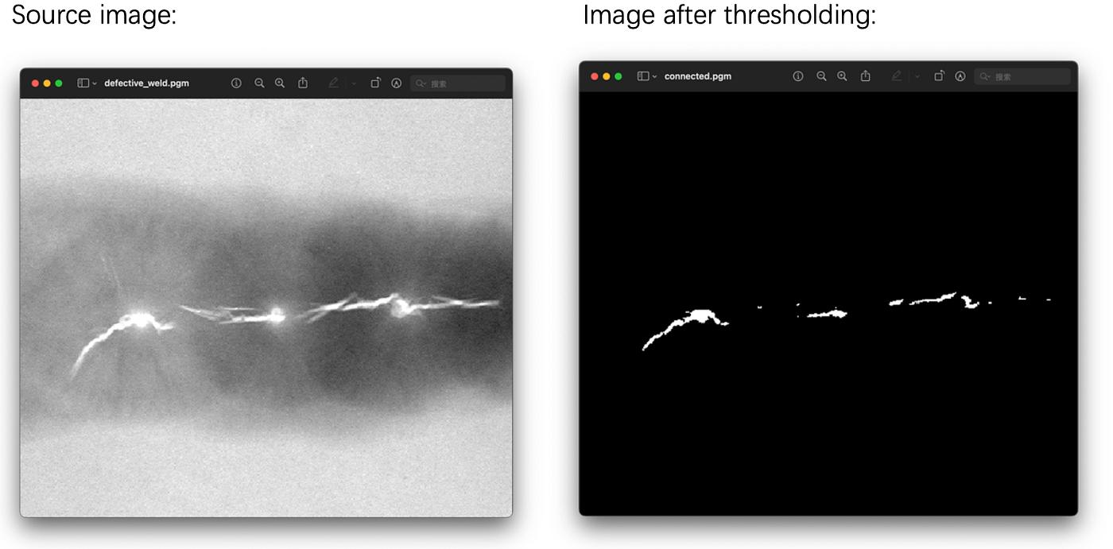
Figure 6. Example of defect-region segmentation.

10. TRADITIONAL COMPUTER VISION APPROACH
Traditional Computer Vision uses manually designed image-processing rules and features.
The proposed baseline consists of:
Input Image
↓
Grayscale Conversion
↓
Gaussian Filtering
↓
Edge Detection
↓
Thresholding
↓
Morphological Operations
↓
Feature Extraction
↓
Defect Decision

10.1 Edge Detection
Defects such as cracks and scratches may generate strong intensity changes.
Edge operators identify these changes.
For example, gradient magnitude can be represented as:
$$G=\sqrt{G_{x}^{2}+G_{y}^{2}}$$
where:
- $G_{x}$represents horizontal intensity changes.
- $G_{y}$represents vertical intensity changes.
Canny edge detection can be used to obtain an edge map.
Example:
Original Product
↓
Canny Edge Detection
↓
Edges corresponding to
surface structures/defects
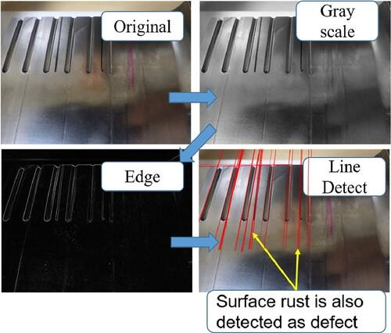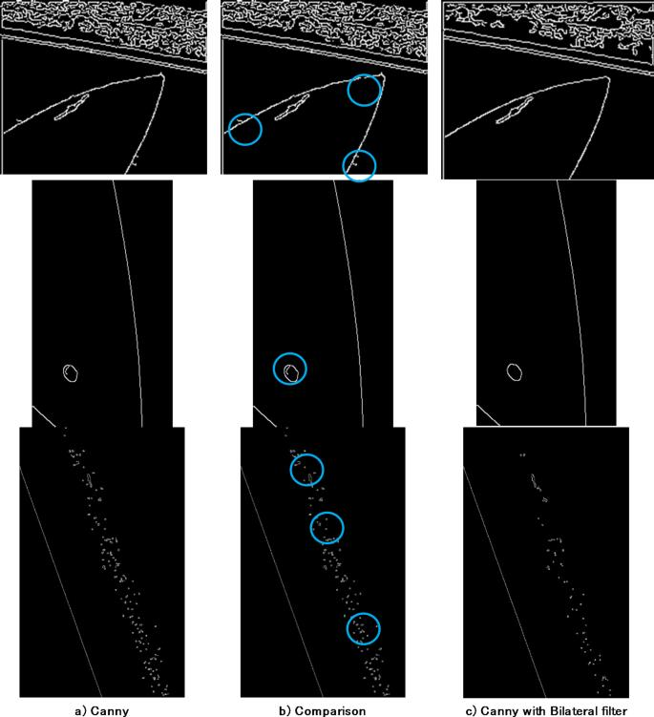
Figure 7. Edge detection output for identifying potential defect boundaries.

10.2 Thresholding
Thresholding converts an image into separate regions based on pixel intensity.
A simple binary threshold can be represented as:
$$B\left(x , y\right)=\left\{\begin{matrix}1, & I\left(x , y\right)>T \\ 0, & I\left(x , y\right)≤T\end{matrix}\right.$$
where $T$is the selected threshold.
Thresholding can be useful when the defect has a significant intensity difference from the surrounding product.

10.3 Morphological Operations
Morphological operations improve segmented regions.
Common operations include:
Opening
Used to remove small unwanted regions.
Closing
Used to fill small gaps.
These operations can improve the quality of candidate defect regions.

10.4 Traditional Feature Extraction
Traditional systems may extract:
- Edge density
- Contour area
- Perimeter
- Shape
- Texture
- Intensity statistics
For example, a region with unusually high edge density compared with a normal surface may be considered a possible defect.
However, manually selected features may not generalize well when product appearance changes significantly.

11. DEEP LEARNING APPROACH
Deep Learning uses neural networks to automatically learn visual representations from training images.
Instead of manually defining every defect feature, the model learns useful patterns from examples.
The general process is:
Training Images
↓
Preprocessing
↓
Data Augmentation
↓
Deep Learning Model
↓
Feature Learning
↓
Defect Prediction
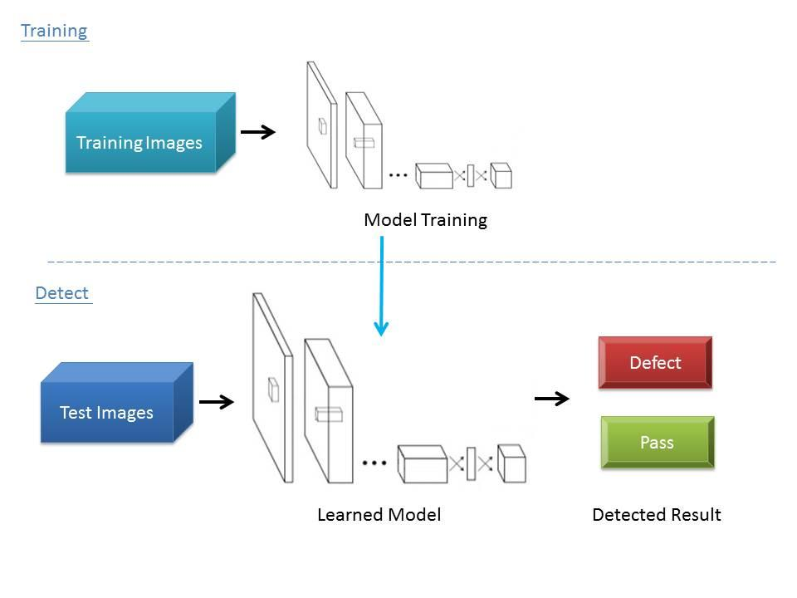
Figure 8. Conceptual workflow of Deep Learning-based defect detection.

11.1 Convolutional Neural Networks
A Convolutional Neural Network (CNN) can learn hierarchical visual features.
A simplified representation is:
Input Image
↓
Convolution
↓
Feature Maps
↓
Pooling
↓
Deeper Features
↓
Classification / Detection
Early layers may learn simple patterns such as edges, while deeper layers can represent more complex shapes and textures.

11.2 Transfer Learning
Industrial datasets may contain fewer labeled images than large general-purpose datasets.
Transfer learning can address this limitation by starting with a model pretrained on a large image dataset and adapting it to the industrial defect dataset.
Advantages include:
- Reduced training time
- Better performance with limited data
- Faster convergence
- Reduced requirement for training a network from the beginning

11.3 Object Detection
If the dataset contains suitable localization annotations, an object detection model such as YOLO can be used.
The model can provide:
Defect Class
Bounding Box
Confidence Score
Example:
Scratch – 96.8%

┌─────────────────────────┐
│ │
│ PRODUCT │
│ │
│ ┌──────────────┐ │
│ │ SCRATCH │ │
│ │ 96.8% │ │
│ └──────────────┘ │
│ │
└─────────────────────────┘
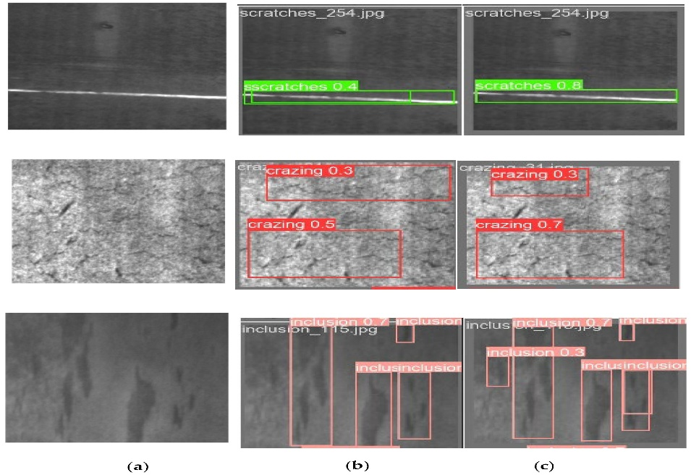
Figure 9. Sample output showing localization and confidence of a detected defect.

12. DATASET DESCRIPTION
The dataset used for this project will contain images representing manufactured products under normal and defective conditions.
The dataset should contain, where available:
- Normal product images
- Defective product images
- Defect categories
- Defect locations
- Different orientations
- Different illumination conditions
- Different product appearances
The dataset will be divided into:
Training Dataset
↓
Validation Dataset
↓
Testing Dataset
A possible division is:
Training → 70%
Validation → 20%
Testing → 10%
The exact dataset name, source, number of images, defect categories, and annotation format should be documented after the final dataset is selected.
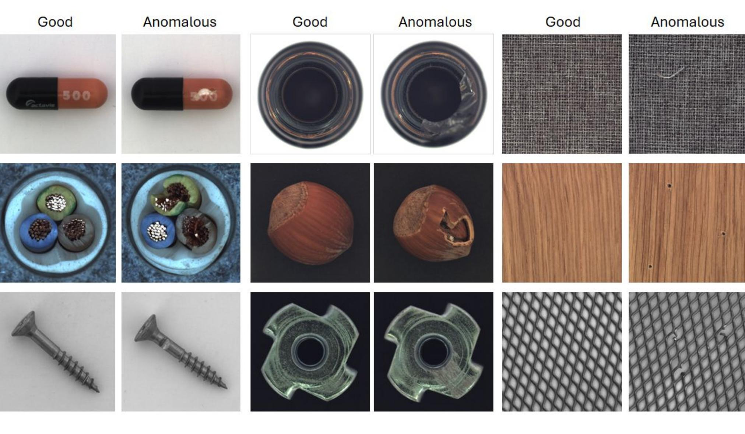
Figure 10. Representative samples from the selected industrial defect dataset.

13. DATA AUGMENTATION
Data augmentation is used to expose the model to different visual conditions.
Possible transformations include:
Original Image
│
├── Rotation
├── Scaling
├── Translation
├── Brightness variation
├── Contrast variation
└── Noise variation
For example, a defect appearing at one orientation should still be recognized when the component is rotated.
Similarly, brightness variation can help the model become more robust to changes in illumination.
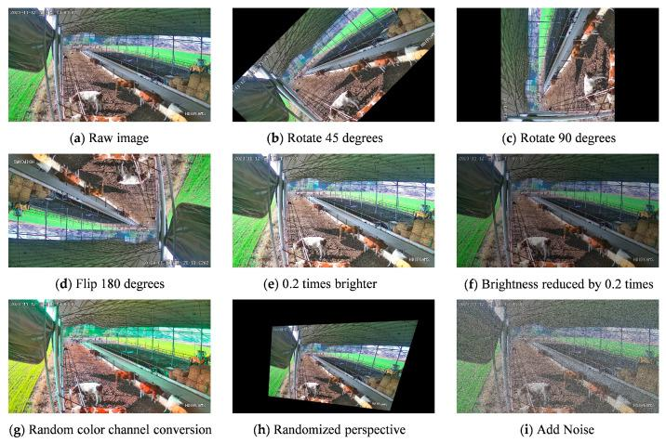
Figure 11. Examples of data augmentation used to improve robustness.

14. TRAINING AND VALIDATION PROCESS
The Deep Learning model will be trained using the training dataset.
The validation dataset will be used to monitor model performance during training.
The test dataset will be kept separate and used for final evaluation.
The process is:
Dataset
↓
Train / Validation / Test Split
↓
Preprocessing
↓
Augmentation
↓
Model Training
↓
Validation
↓
Hyperparameter Adjustment
↓
Final Model
↓
Testing
Important training parameters include:
- Number of epochs
- Batch size
- Learning rate
- Input image size
- Confidence threshold
- Model architecture
The final parameters will be reported based on the actual implementation.

15. PROPOSED SYSTEM ARCHITECTURE
The complete proposed architecture is:
PRODUCT
│
▼
IMAGE ACQUISITION
│
▼
PREPROCESSING
│
┌─────────────┼─────────────┐
▼ ▼ ▼
Resize Denoising Illumination
Correction
│ │ │
└─────────────┼─────────────┘
▼
DATA AUGMENTATION
│
▼
DEFECT ANALYSIS
│
┌──────────┴──────────┐
▼ ▼
Traditional CV Deep Learning
Baseline Model
│ │
▼ ▼
Defect Features Learned Features
│ │
▼ ▼
Prediction Prediction
│ │
└──────────┬──────────┘
▼
PERFORMANCE
COMPARISON
│
▼
FINAL APPROACH
│
▼
QUALITY DECISION
/ \
/ \
PASS DEFECTIVE
│
▼
Visual Report
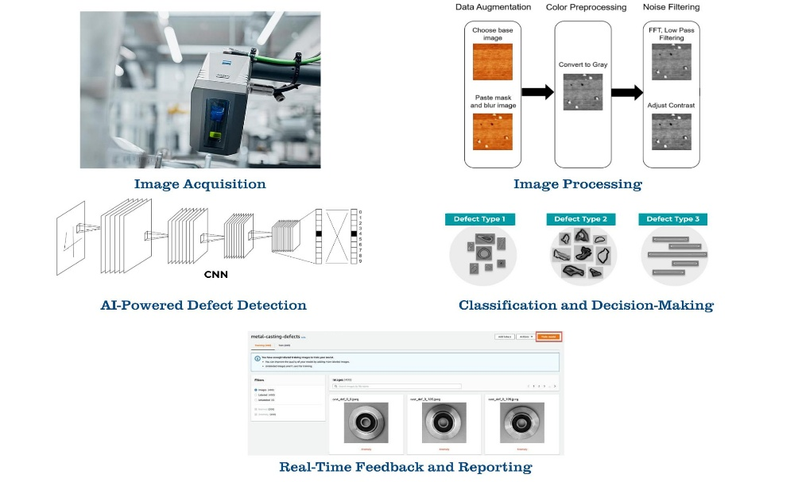
Figure 12. Proposed end-to-end architecture for the industrial defect detection system.

16. PSEUDOCODE
16.1 Main Inspection Algorithm
BEGIN

Load industrial defect dataset

Divide dataset into:
Training set
Validation set
Testing set

FOR each training image:

Resize image
Remove noise
Correct illumination
Normalize image
Apply data augmentation

END FOR

Implement Traditional Computer Vision baseline

Implement Deep Learning model

Train Deep Learning model using training dataset

Validate model using validation dataset

Evaluate both approaches using testing dataset

Calculate:

Accuracy
Precision
Recall
F1-score
False Negative Rate
Inference Time

IF localization annotations are available:

Calculate detection metrics
such as mAP

END IF

Test model under:

Normal lighting
Brightness variation
Contrast variation
Orientation variation
Scale variation

Compare Traditional CV and Deep Learning

Select the approach that provides the
best balance between accuracy,
adaptability and computational cost

FOR each new product image:

Capture image

Preprocess image

Apply selected model

Detect defect

Calculate confidence

IF defect detected THEN

Mark product as DEFECTIVE

Display defect location
Display defect class
Display confidence

ELSE

Mark product as PASS

END IF

Generate inspection result

END FOR

END

17. COMPARISON OF TRADITIONAL COMPUTER VISION AND DEEP LEARNING
Factor | Traditional Computer Vision | Deep Learning
Feature extraction | Manually designed | Automatically learned
Training requirement | Low | High
Dataset requirement | Relatively low | Higher
Computational requirement | Low | Medium to High
Accuracy on simple defects | Good | Good
Accuracy on complex defects | Limited | Generally better
Lighting adaptability | Limited | Better with suitable training
Orientation adaptability | Limited | Better with augmentation
Complex appearance | Difficult | Better suited
Processing speed | Very high | High depending on model
Model development | Rule-based | Data-driven
Scalability | Limited | High
Maintenance | Rules may need modification | Retraining/fine-tuning
Deployment | Easy | Requires suitable hardware
Best use case | Controlled environments | Variable industrial environments

18. ACCURACY–ADAPTABILITY TRADE-OFF
Traditional Computer Vision has an important advantage in computational efficiency.
For example, simple operations such as thresholding and edge detection can be executed rapidly on standard hardware.
However, traditional methods may depend heavily on fixed thresholds and manually selected features.
Consider the following example:
Condition 1:

Normal Surface → Intensity 160
Defect → Intensity 70
A threshold can easily separate the two.
However:
Condition 2:

Normal Surface → Intensity 105
Defect → Intensity 70
The same threshold may produce incorrect results.
Deep Learning approaches can learn more complex relationships from training data. If the training dataset includes variations in illumination, orientation, product appearance, and defect size, the model can become more robust to these conditions.
Therefore, there is a trade-off:
Traditional CV
Lower computation
+
Less training
↓
Lower adaptability

Deep Learning
Higher computation
+
More training data
↓
Higher adaptability
For the proposed industrial application, adaptability is important because the production environment is not perfectly static.

19. EVALUATION METRICS
19.1 Accuracy
Accuracy measures the proportion of correctly classified samples.
$$Accuracy=\frac{TP+TN}{TP+TN+FP+FN}$$
where:
- TP = True Positive
- TN = True Negative
- FP = False Positive
- FN = False Negative

19.2 Precision
Precision measures how many predicted defective products are actually defective.
$$Precision=\frac{TP}{TP+FP}$$

19.3 Recall
Recall measures how many actual defective products were successfully detected.
$$Recall=\frac{TP}{TP+FN}$$
Recall is particularly important for industrial inspection because missed defects can reach customers.

19.4 F1-score
F1-score combines precision and recall.
$$F1=2×\frac{Precision×Recall}{Precision+Recall}$$

19.5 False Negative Rate
The false-negative rate represents the proportion of actual defects that were missed.
$$FNR=\frac{FN}{TP+FN}$$
A low false-negative rate is desirable for quality-critical manufacturing.

19.6 Inference Time
Inference time measures how long the system takes to process one image.
$$Inference Time=\frac{Total Processing Time}{Number of Images}$$
This is important for determining whether the system can operate on a high-speed production line.

20. EXPERIMENTAL RESULTS
The final results will be obtained after implementing and testing both approaches.
20.1 Overall Performance
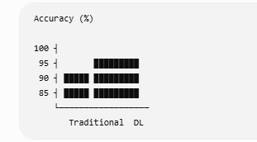
Figure 13. Experimental comparison between Traditional Computer Vision and Deep Learning.

21. TRAINING PERFORMANCE
The training process will be visualized using learning curves.
The following graphs should be generated:
- Training loss
- Validation loss
- Training accuracy
- Validation accuracy
- Precision
- Recall
- mAP, where applicable
[INSERT FIGURE 14 HERE – Training and validation curves]
Figure 14. Training and validation performance of the selected Deep Learning model.

22. CONFUSION MATRIX
A confusion matrix will be used to analyze classification performance.
Predicted
Normal Defect

Actual Normal TN FP

Actual Defect FN TP
The confusion matrix is especially useful for identifying false negatives.
[INSERT FIGURE 15 HERE – Actual confusion matrix generated from testing]
Figure 15. Confusion matrix of the defect detection model.

23. SAMPLE DETECTION RESULTS
The proposed system should generate visual results for both defective and non-defective products.
Example output:
Product ID: P001
Result: PASS
Confidence: [ACTUAL VALUE]
Defective example:
Product ID: P002
Result: DEFECTIVE
Defect: [ACTUAL CLASS]
Confidence: [ACTUAL VALUE]
[INSERT FIGURE 16 HERE – PASS sample detection]
Figure 16. Example of a correctly classified non-defective product.
[INSERT FIGURE 17 HERE – DEFECT sample detection]
Figure 17. Example of a detected defective product with localization and confidence score.

24. ROBUSTNESS ANALYSIS
To evaluate adaptability, the trained system will be tested under different conditions.
Test Condition | Accuracy | Recall | F1-score | Performance Change
Normal images | [RESULT] | [RESULT] | [RESULT] | Baseline
Increased brightness | [RESULT] | [RESULT] | [RESULT] | [RESULT]
Reduced brightness | [RESULT] | [RESULT] | [RESULT] | [RESULT]
Rotated images | [RESULT] | [RESULT] | [RESULT] | [RESULT]
Contrast variation | [RESULT] | [RESULT] | [RESULT] | [RESULT]
Scale variation | [RESULT] | [RESULT] | [RESULT] | [RESULT]
[INSERT FIGURE 18 HERE – Robustness/accuracy comparison graph]
Figure 18. Model performance under different illumination and orientation conditions.
This experiment directly evaluates the requirement that the system should adapt to variations in product appearance and environmental conditions.

25. COMPUTATIONAL AND DEPLOYMENT ANALYSIS
The performance of a model cannot be judged only by accuracy.
A manufacturing system must also consider:
Processing Speed
The model should process each product within the available production-line cycle time.
Hardware
Traditional CV can generally operate using relatively low computational resources. Deep Learning may benefit from GPU or edge acceleration.
Memory
The selected model should fit within the available hardware memory.
Reliability
The system should avoid silently passing uncertain or low-confidence products.
Model Maintenance
New defect types and manufacturing changes may require additional training or fine-tuning.
Edge Deployment
For real-time operation, the trained model can potentially be optimized using suitable model compression or inference frameworks.

26. INDUSTRIAL DEPLOYMENT WORKFLOW
The proposed system can eventually be deployed as:
PRODUCTION LINE
│
▼
INDUSTRIAL CAMERA
│
▼
EDGE COMPUTER
│
▼
IMAGE PREPROCESSING
│
▼
AI DEFECT MODEL
│
┌─────────┴─────────┐
▼ ▼
PASS DEFECT
│ │
▼ ▼
Continue Reject/
Production Alert
│
▼
Inspection Report
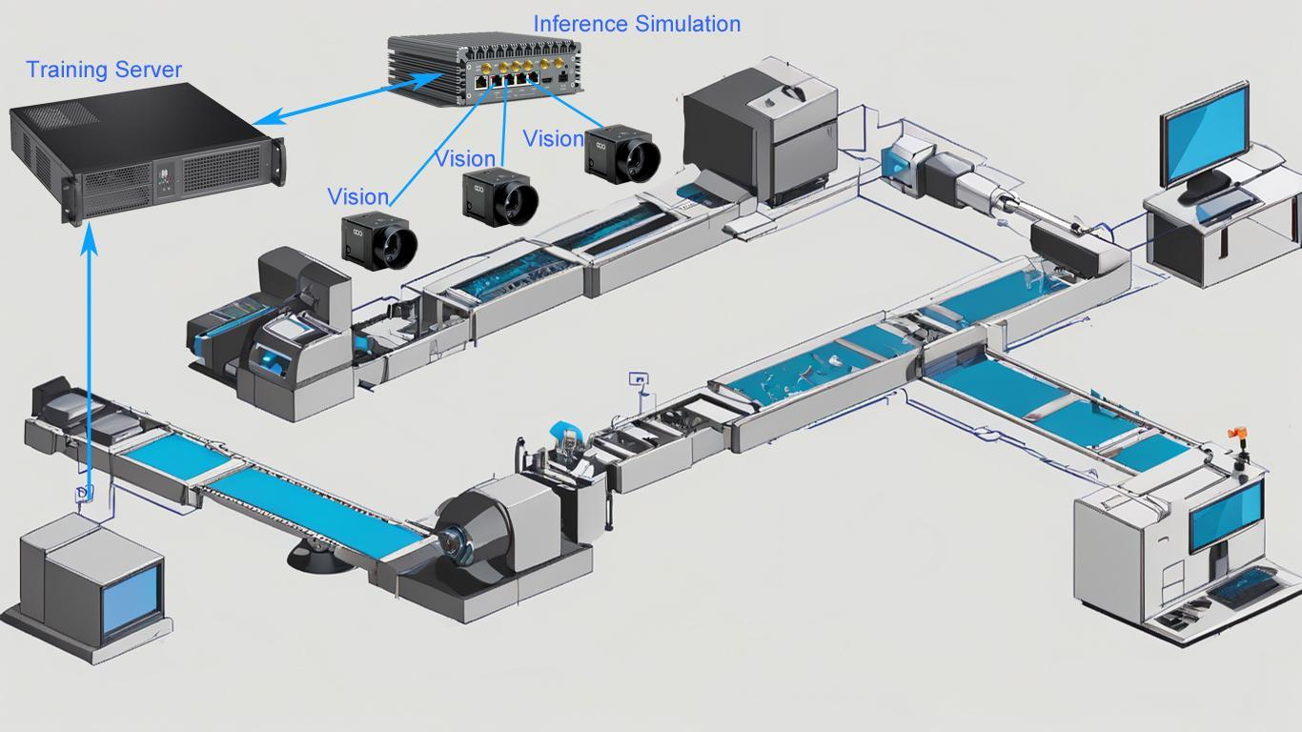
Figure 19. Proposed deployment architecture for automated industrial quality inspection.

27. DECISION AND MODEL SELECTION
Based on the experimental comparison, the final model will be selected according to:
- Detection accuracy
- Defect recall
- False-negative rate
- Adaptability
- Inference time
- Computational requirements
- Training requirements
- Deployment feasibility
The target is to achieve detection performance greater than 95% while maintaining acceptable inference speed.
If the Deep Learning model demonstrates substantially better accuracy and robustness while remaining within the computational requirements, it will be selected as the primary inspection model.
Traditional Computer Vision will remain useful as a baseline and may also be suitable for simpler inspection tasks where environmental conditions are highly controlled.

28. ADVANTAGES OF THE PROPOSED SYSTEM
The proposed system can provide several benefits:
Automated Inspection
Products can be analyzed automatically without requiring continuous manual inspection.
Consistent Decisions
The same computational process is applied to every image.
High-Speed Processing
Computer Vision can inspect products rapidly when implemented with suitable hardware.
Defect Localization
Deep Learning-based detection can identify the approximate location of defects.
Adaptability
Training with variations can improve robustness to changes in product appearance and illumination.
Reduced Waste
Early defect detection can reduce unnecessary processing of defective products.
Quality Improvement
Automated inspection can help reduce defective products reaching later production stages or customers.

29. LIMITATIONS
Despite its advantages, the proposed system has limitations.
Dataset Dependency
Deep Learning performance depends strongly on the quality and diversity of the training dataset.
Annotation Requirements
Object detection and segmentation models may require accurately labeled training data.
Computational Requirements
Deep Learning models may require greater computational resources than traditional CV.
Unseen Defects
A model may have difficulty detecting defect types that are significantly different from those represented in its training data.
Environmental Changes
Extreme lighting, camera movement, blur, occlusion, or unexpected production conditions may reduce performance.
Model Maintenance
New product designs or manufacturing processes may require additional training or fine-tuning.

30. FUTURE ENHANCEMENTS
Future versions of the system can include:
- Real-time industrial camera integration.
- Edge-device deployment.
- Automatic rejection mechanisms.
- Continuous model monitoring.
- Incremental learning for new defect types.
- Anomaly detection for previously unseen defects.
- Defect severity estimation.
- Integration with Manufacturing Execution Systems (MES).
- Production analytics dashboards.
- Automatic quality reports and defect statistics.
- Multi-camera inspection for different product surfaces.
- Model optimization for lower inference latency.

31. SDG MAPPING
SDG 9 – Industry, Innovation and Infrastructure
The proposed Computer Vision system supports intelligent industrial infrastructure by introducing automated AI-based quality inspection into manufacturing processes.
The system demonstrates how modern Computer Vision and Deep Learning can be applied to improve industrial automation and technological innovation.

SDG 12 – Responsible Consumption and Production
Automated defect detection can identify defective products earlier in the manufacturing process.
This can help reduce:
- Material waste
- Rework
- Scrap
- Energy consumption associated with defective production
Therefore, the project supports more responsible production practices.

SDG 8 – Decent Work and Economic Growth
The system can reduce repetitive visual inspection tasks and allow workers to focus on higher-value quality-control and production activities.
Automation can also improve manufacturing efficiency and contribute to productivity.

32. INDUSTRIAL RELEVANCE
The proposed system has applications in several manufacturing industries, including:
- Automotive component inspection
- Electronics manufacturing
- Metal component inspection
- Packaging inspection
- Semiconductor manufacturing
- Textile inspection
- Plastic component inspection
- Pharmaceutical packaging
- Consumer product manufacturing
For example, in an automotive component manufacturing plant, the system could inspect components for:
Scratch
Crack
Dent
Hole
Surface irregularity
Missing component
The ability to automatically detect such defects can improve quality consistency and reduce manual inspection workload.

33. CONCLUSION
This project presents a Computer Vision-based approach for automated industrial defect detection and quality inspection. The proposed system combines image acquisition, preprocessing, defect analysis, machine learning/deep learning, evaluation, and visualization into an automated inspection pipeline.
Traditional Computer Vision techniques provide important advantages such as low computational requirements, fast processing, and simple implementation. However, their dependence on manually designed rules and features can limit their ability to adapt to changes in illumination, orientation, product appearance, and manufacturing conditions.
Deep Learning provides a data-driven alternative in which the model learns complex visual patterns directly from training images. With appropriate preprocessing, data augmentation, training, and validation, Deep Learning can provide better adaptability to complex and variable defect patterns.
The two approaches will therefore be evaluated experimentally using common performance metrics such as accuracy, precision, recall, F1-score, false-negative rate, inference time, and detection metrics where applicable.
The final approach will be selected based on actual experimental performance rather than theoretical assumptions alone. The selected solution should provide the best balance between the required detection accuracy, adaptability, computational requirements, and real-world deployment constraints.
Overall, the proposed system demonstrates the role of Computer Vision in improving automated quality inspection and supports industrial innovation, responsible production, and efficient manufacturing.

34. STUDENT REFLECTION
This assignment provided an opportunity to understand how theoretical Computer Vision concepts can be applied to a practical industrial problem.
One of the major learning outcomes was understanding that successful defect detection does not depend only on selecting a highly accurate model. Image quality, preprocessing, dataset diversity, model training, evaluation metrics, computational requirements, and deployment conditions all influence the final system.
The comparison between Traditional Computer Vision and Deep Learning demonstrated an important engineering trade-off. Traditional methods can be computationally efficient and easier to implement, while Deep Learning requires greater training effort and computational resources but can provide better adaptability to complex visual patterns.
Another important learning outcome was understanding the importance of recall and false-negative rate in industrial inspection. Missing a defective product can be more costly than incorrectly rejecting a good product. Therefore, the final system should consider both accuracy and the consequences of incorrect decisions.
The project also demonstrated the importance of testing a model under different environmental conditions rather than evaluating it only on standard test images.

35. REFERENCES
The final reference list should contain the actual sources used for the dataset, algorithms, libraries, and theoretical concepts.
Recommended categories of references include:
- Computer Vision and Digital Image Processing textbooks.
- Peer-reviewed research papers on industrial defect detection.
- Research papers on CNN-based image classification.
- Research papers on object detection.
- Official OpenCV documentation.
- Official PyTorch/TensorFlow documentation, depending on implementation.
- Official documentation of the selected Deep Learning framework/model.
- Official dataset documentation.
- Research papers related to industrial anomaly detection.
- Recent research papers from the last three to five years related to automated visual inspection.

