AI WORKFLOW FOR SOCIAL MEDIA POSTING AUTOMATION

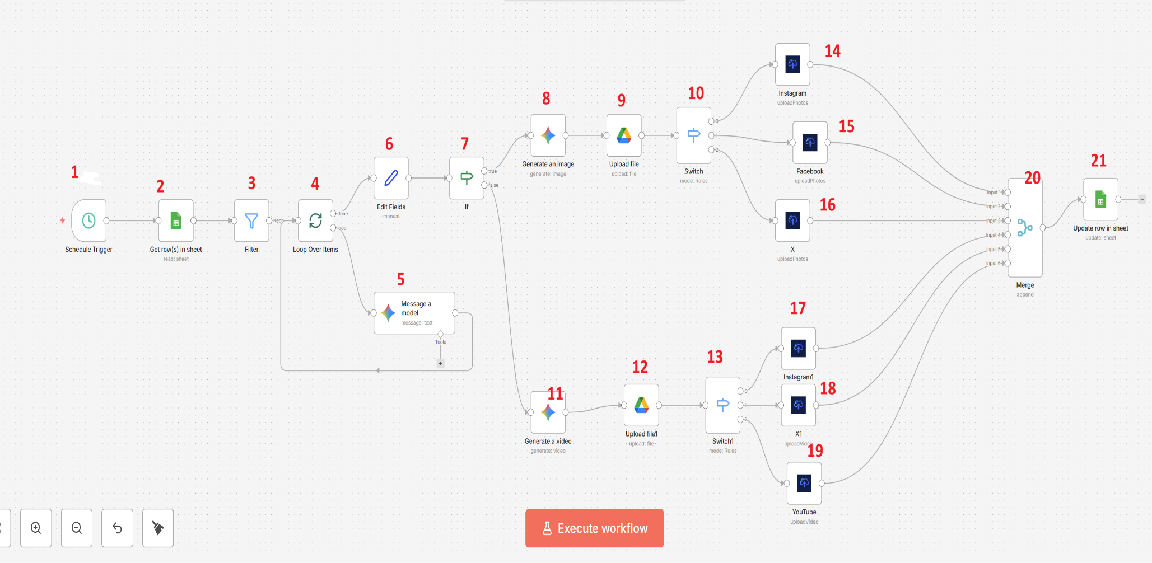

NODE 1- Schedule Trigger

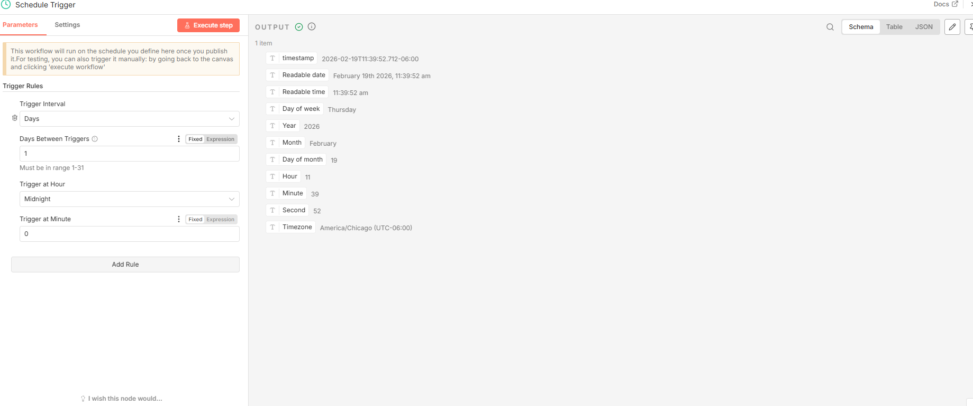

NODE 2- Google Sheets- Get Rows
(Make sure the Google Sheet IDEAS should be added to the Google Drive, format should be sheets and not .xlsx)

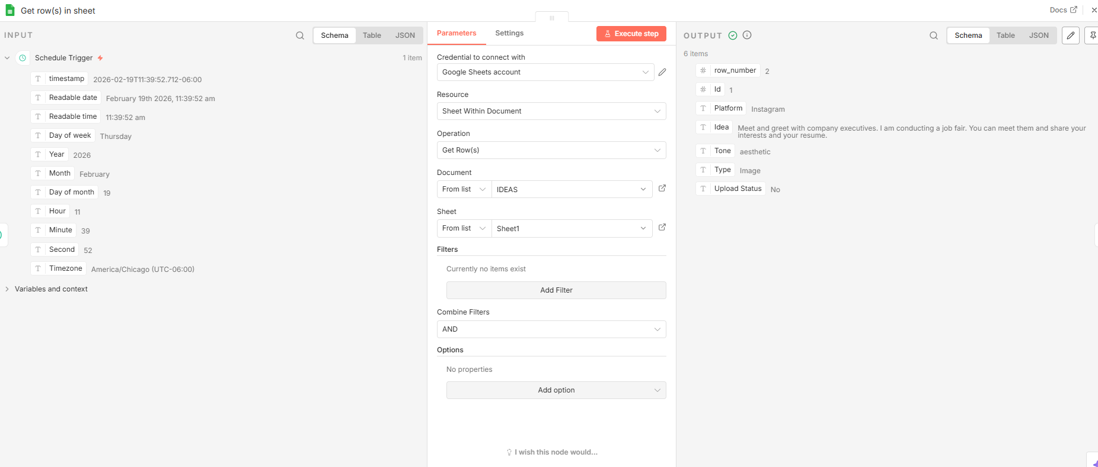
NODE 3- Filter
(Drag Upload status from “Get row(s)” to Conditions)
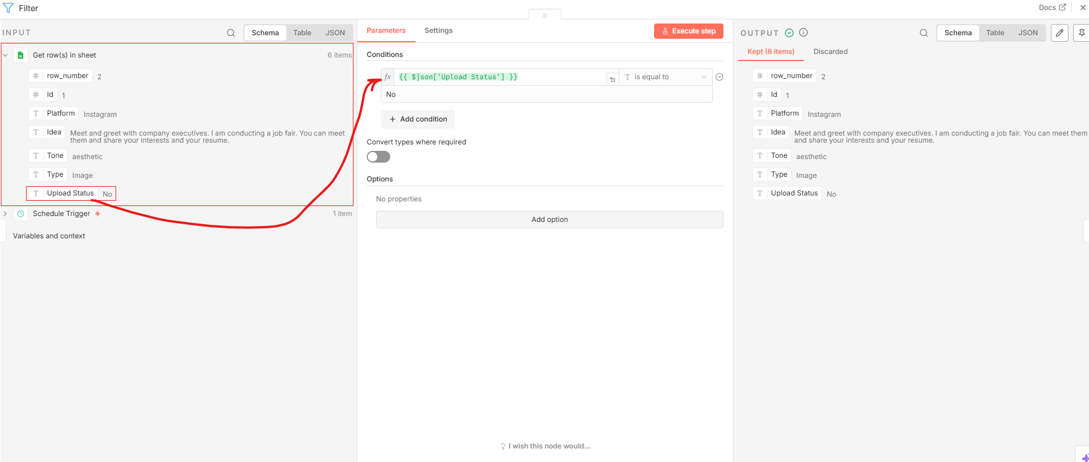
NODE 4- Loop Over Items

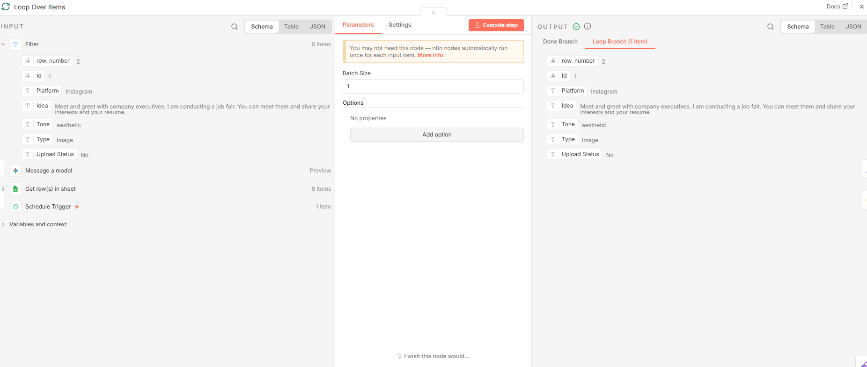
NODE 5- Google Gemini - Message a model
(Use the prompt uploaded on Blackboard)
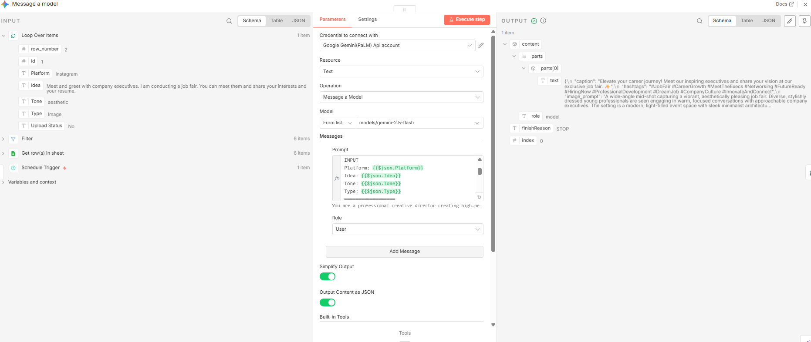

NODE 6- Edit Fields
(Drag Text from Message a Model)
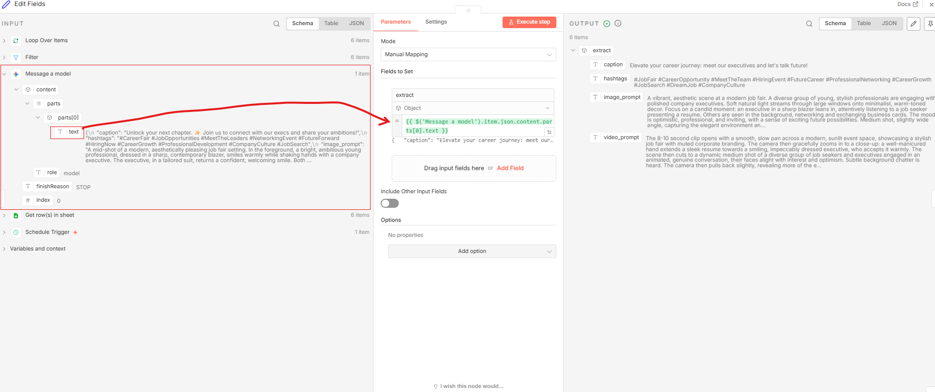

NODE 7- IF node
(Drag Type from Get row(s) in sheet)

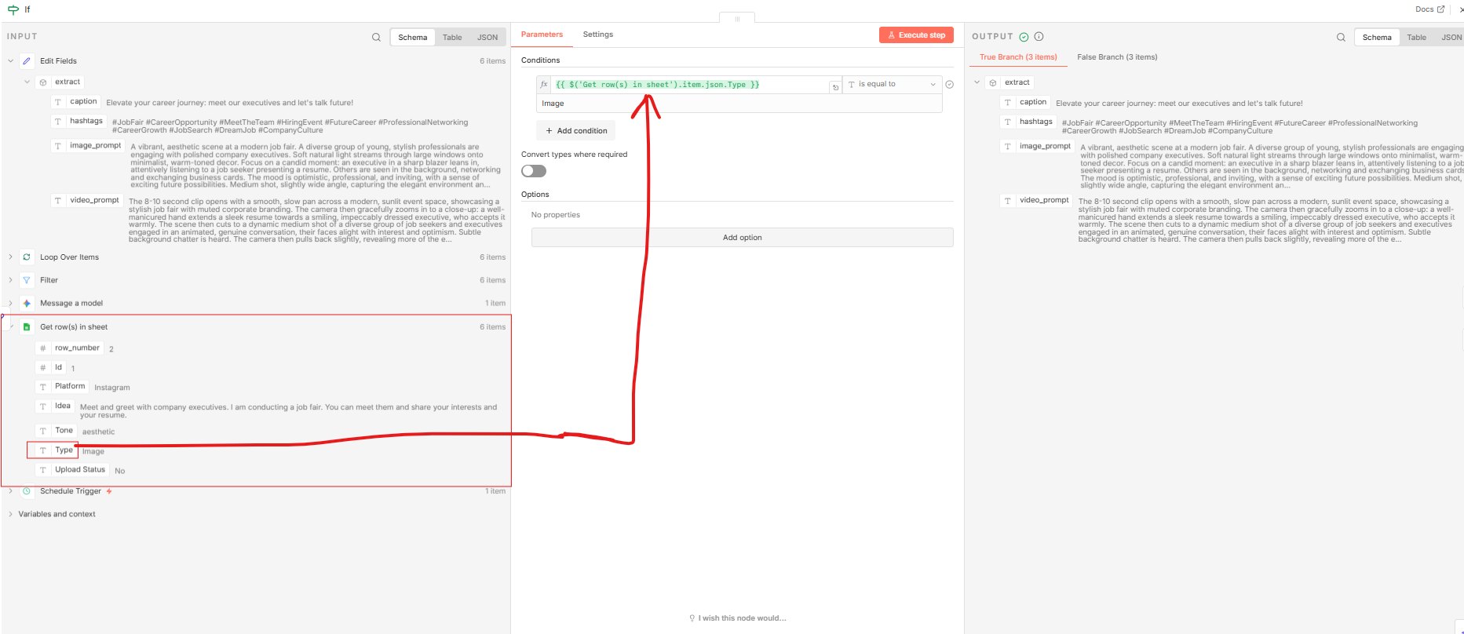
NODE 8- Google Gemini- Generate an Image
(Drag Image Prompt from IF node)

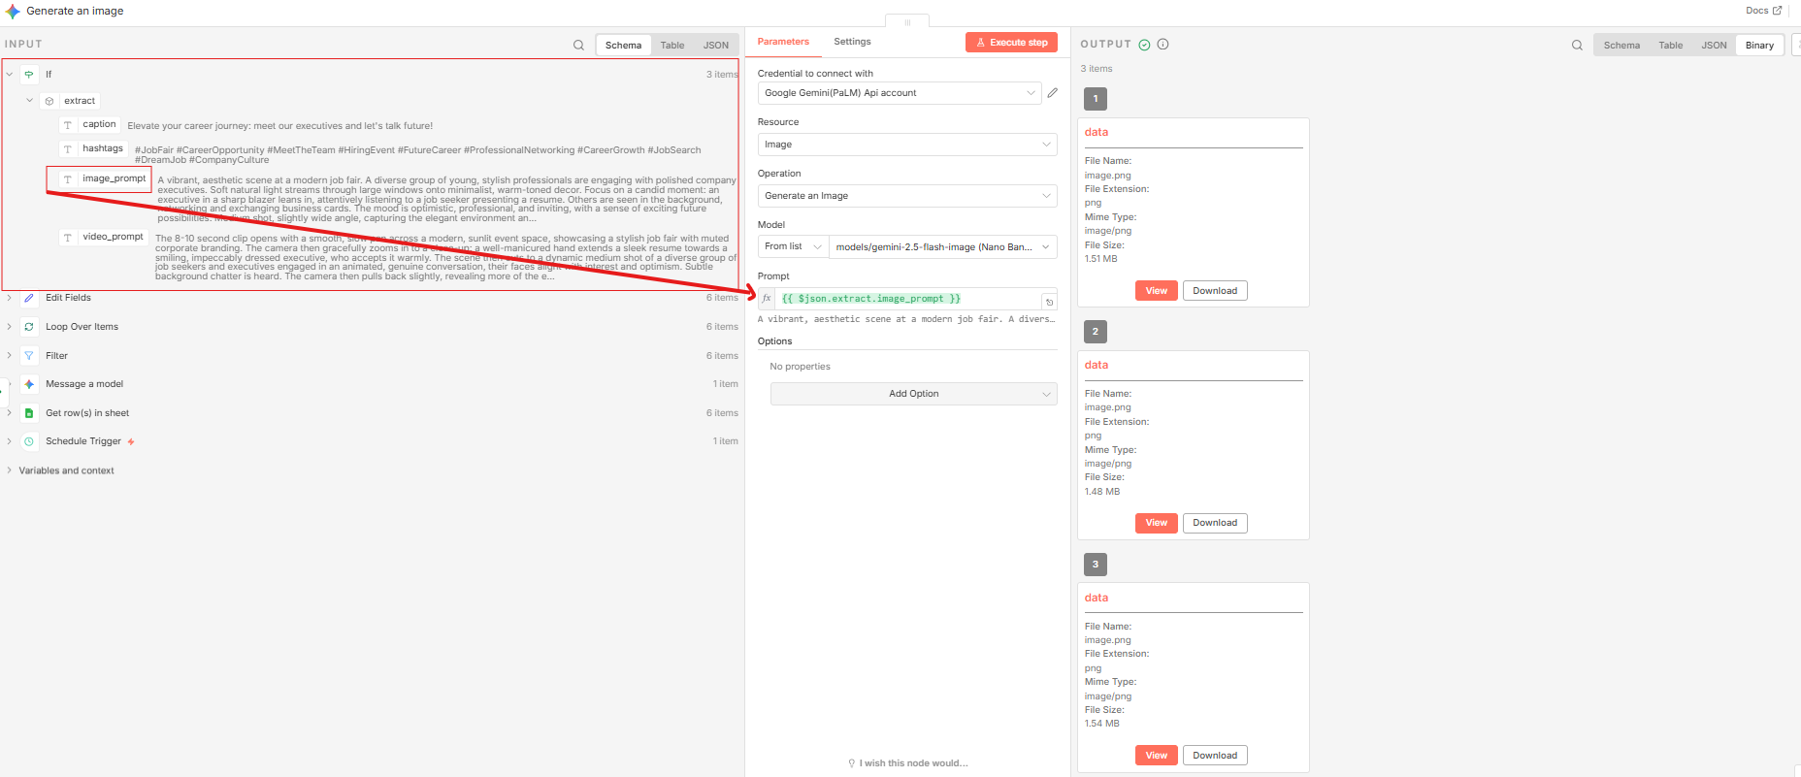
NODE 9- Google Drive - Upload File
1. Drag the id and file name from Generate an image. 2. Make sure the “Images” Folder is created on the drive and has given public editor access.

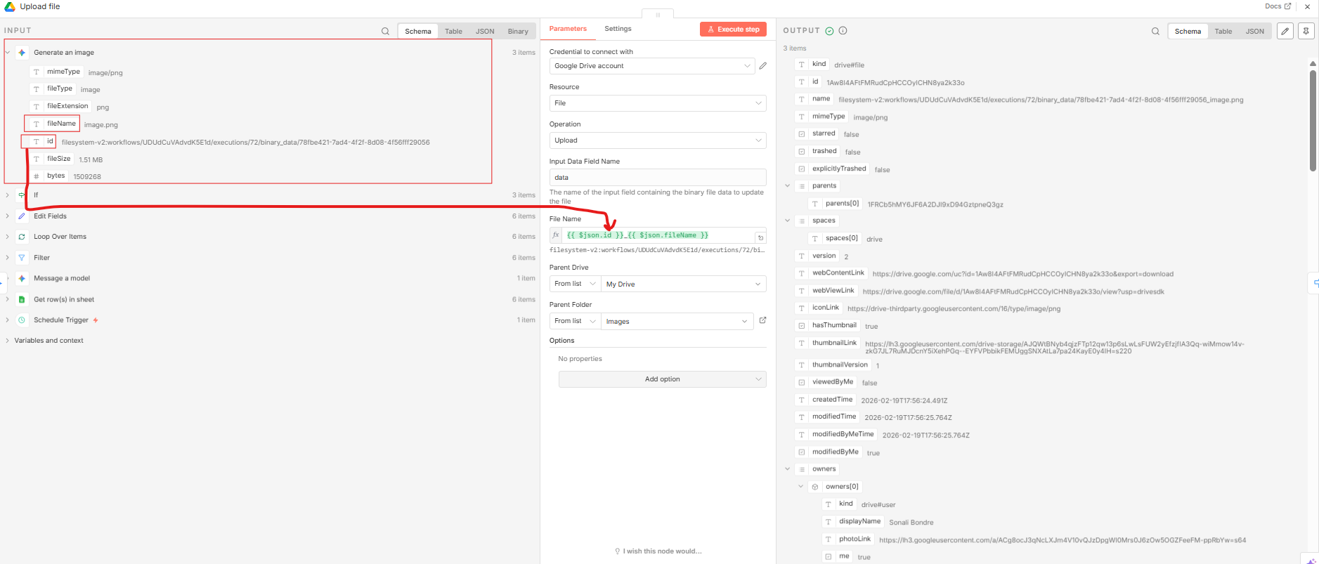
NODE 10- Switch – Instagram, Facebook, X
(Drag Platform from Get rows for each platform as shown in the image)
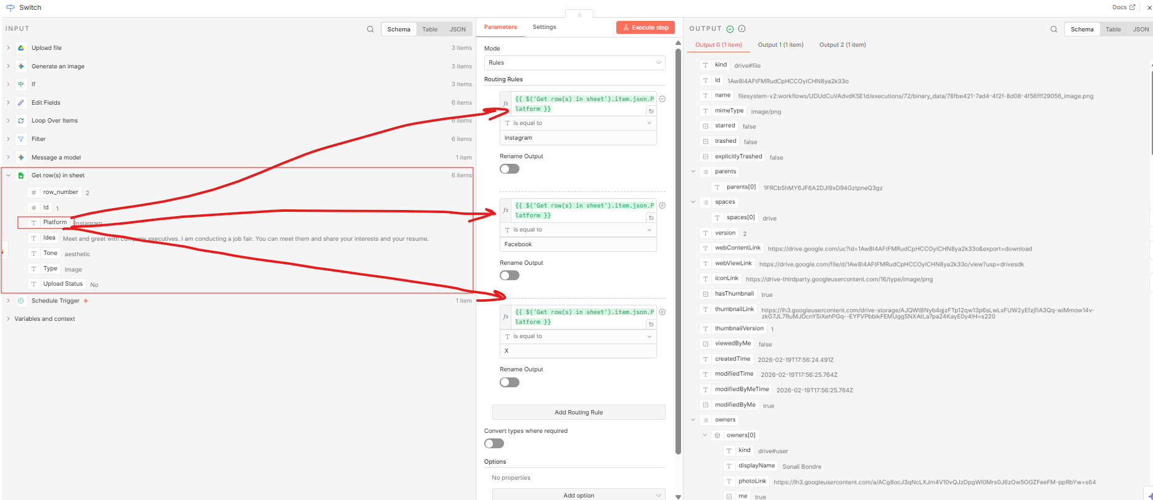
NODE 11- Google Gemini- Generate a Video
(Drag video_prompt from Edit Fields)
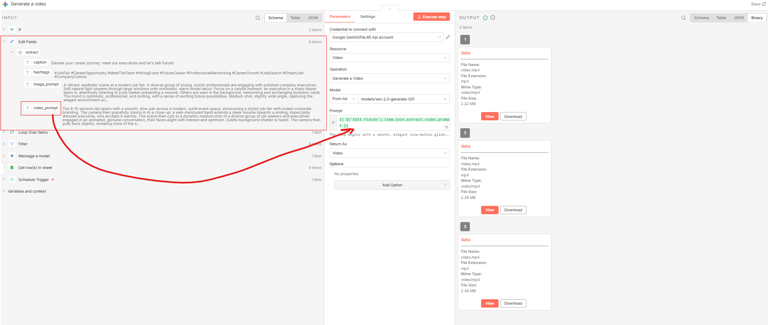

NODE 12- Google Drive- Upload File
1. Drag the id and file name from Generate a Video. 2. Make sure the “Videos” Folder is created on the drive and has given public editor access.

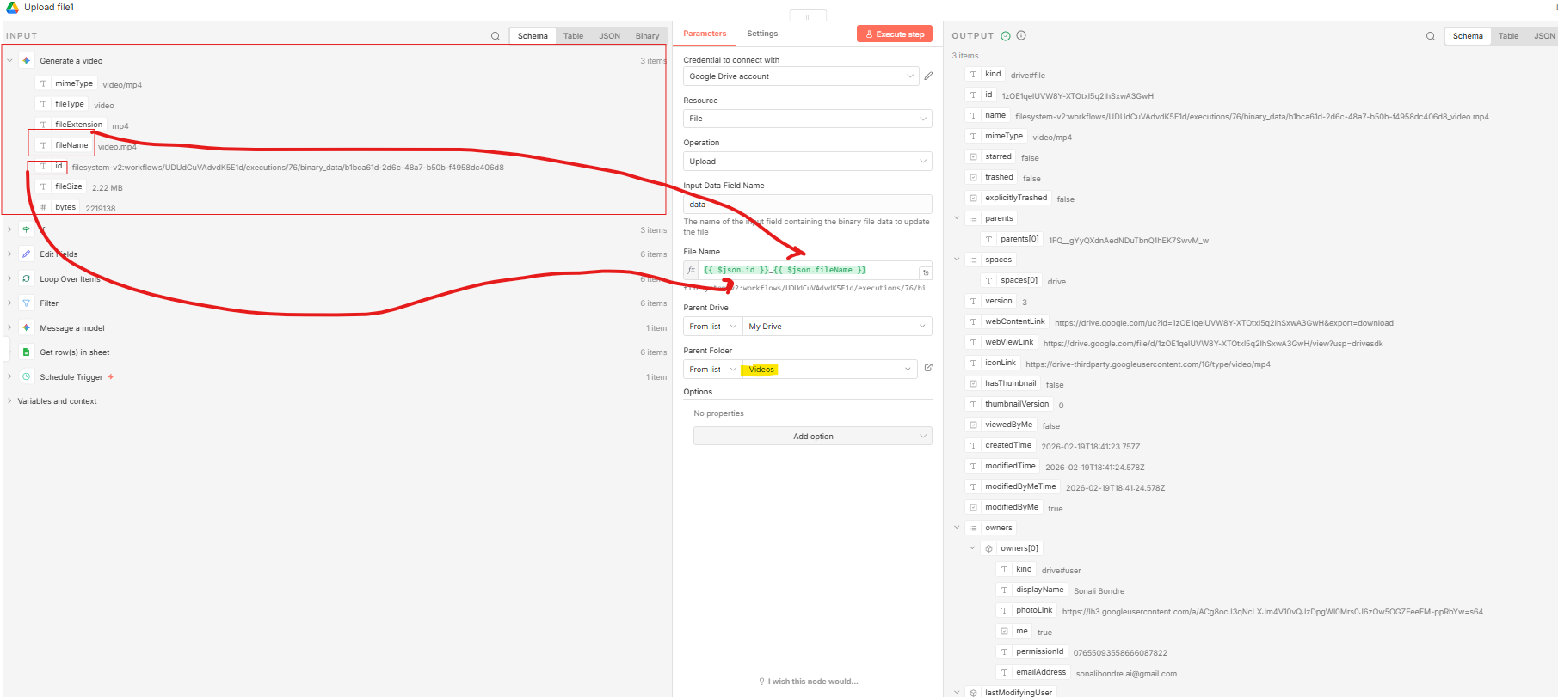

NODE 13- Switch (Instagram, X, YouTube)
(Drag Platform from Get rows for each platform as shown in the image)
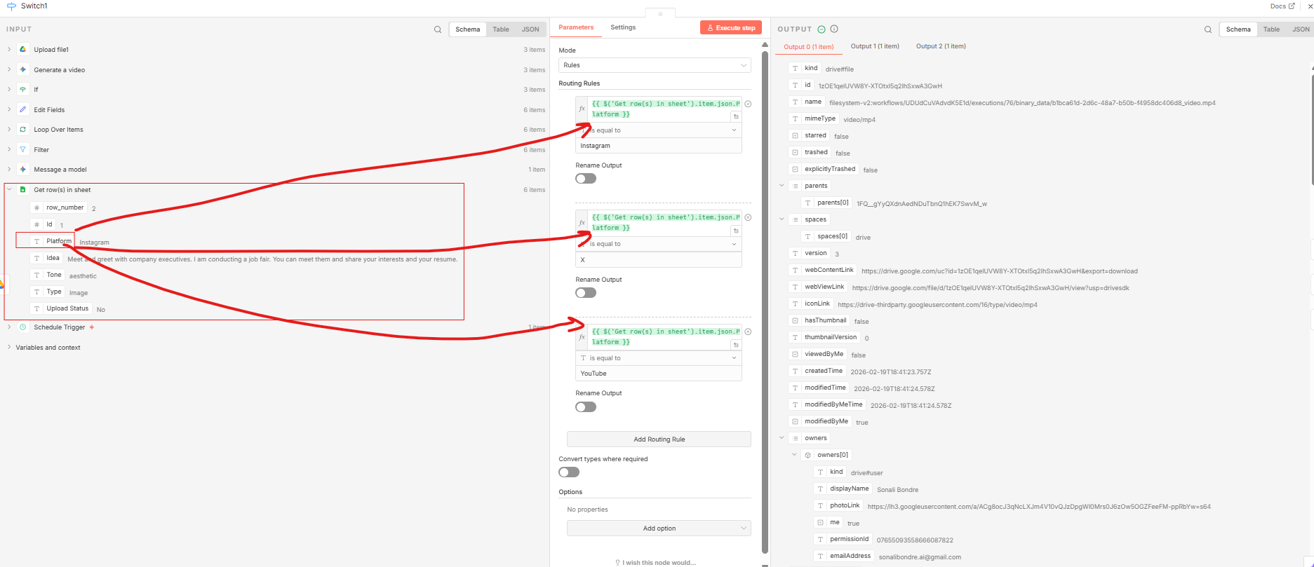
NODE 14- Upload Post- Upload photo(s) (Instagram)
- Make sure to “UPLOAD POST” setup is done. Refer “Set up Instructions for Social Media Posting Automation” file uploaded on Blackboard.
- Once done, you should be able to see the User Identifier Name in the dropdown menu. This is the same name/ID that you have created in the Upload post.
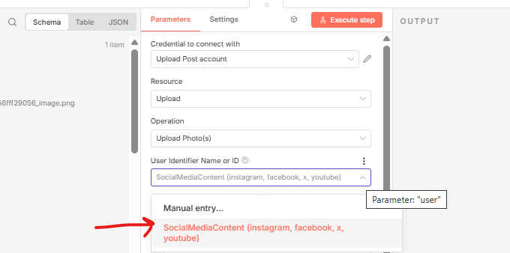

- Drag “webContentLink” from the Upload File to Photos as shown
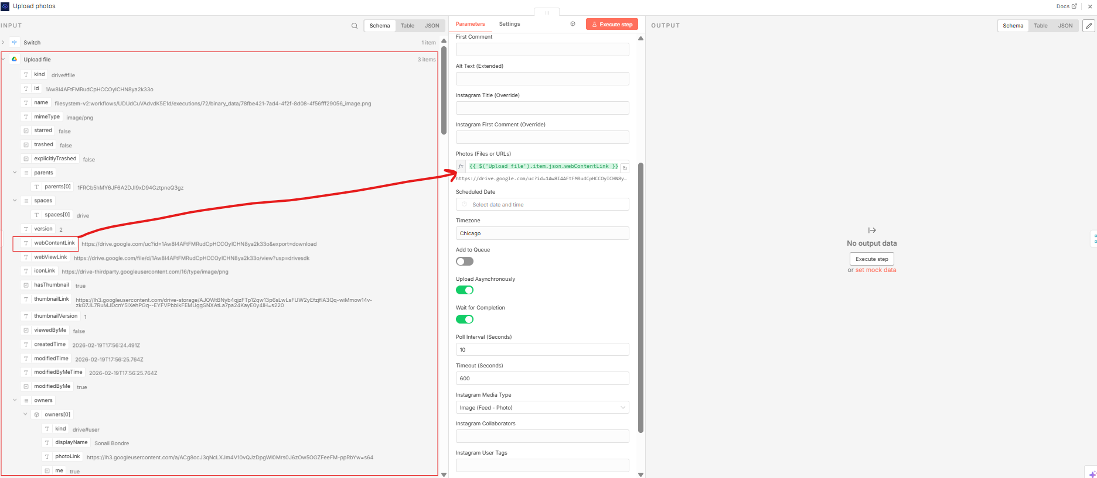

Drag “caption” and “hashtags” from Edit Fields to Title
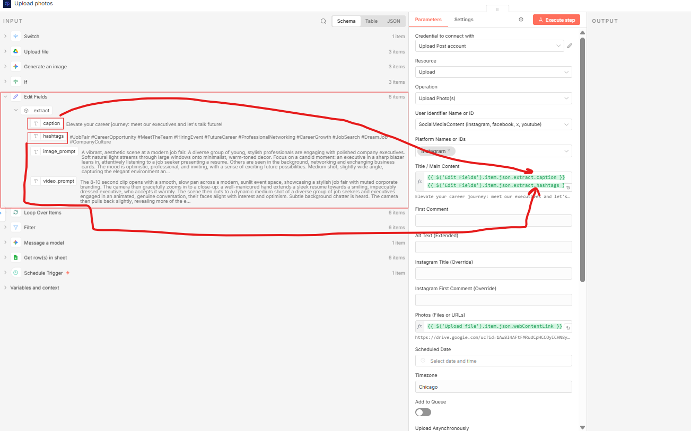
NODE 15- Upload Post – Upload photo(s) - Facebook
The same steps apply to Facebook, but when choosing the Platform names, select Facebook. Note: Make sure to follow the steps of creating the social media accounts that are mentioned in the “Set up Instructions for Social Media Posting Automation”.
Drag “webContentLink” from the Upload File to Photos, and drag “caption” and “hashtags” from Edit Fields to Title
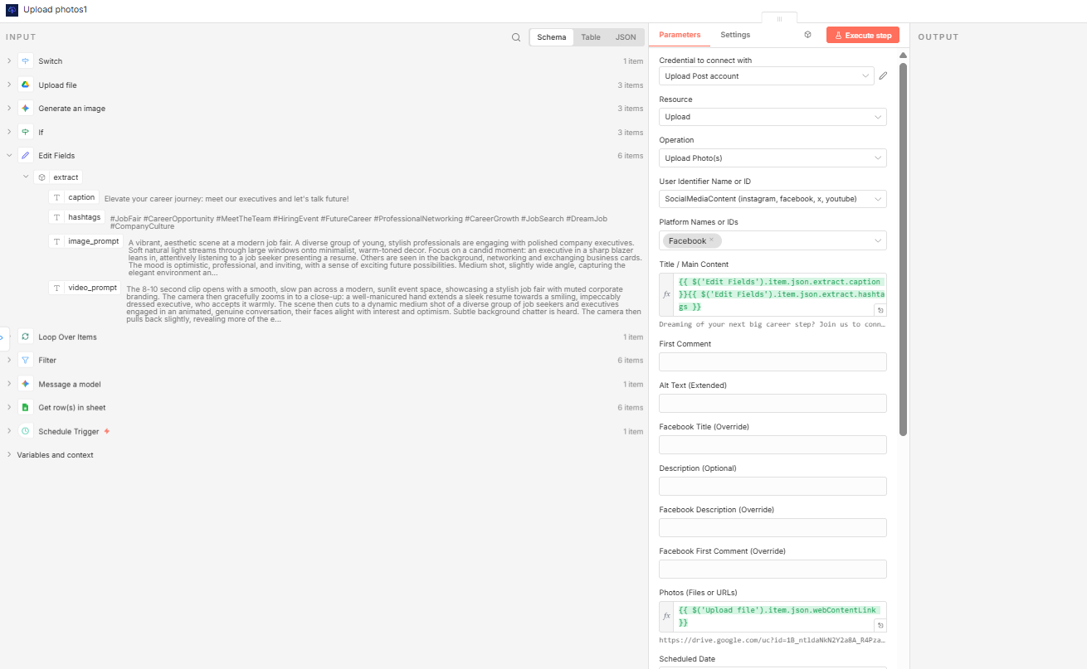

Also, at the bottom, you should be able to select the Facebook page from the dropdown.
Note: All instructions for Facebook page creation should be followed as outlined in the “Set up Instructions for Social Media Posting Automation” uploaded to Blackboard.

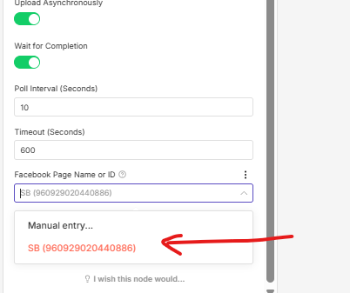

NODE 16- Upload Post –Upload photo(s) - X
The same steps apply to X, but when choosing Platform names, select X (Twitter). Note: Make sure to follow the steps of creating the social media accounts that are mentioned in the “Set up Instructions for Social Media Posting Automation”.
Drag “webContentLink” from the Upload File to Photos, and drag “caption” and “hashtags” from Edit Fields to Title
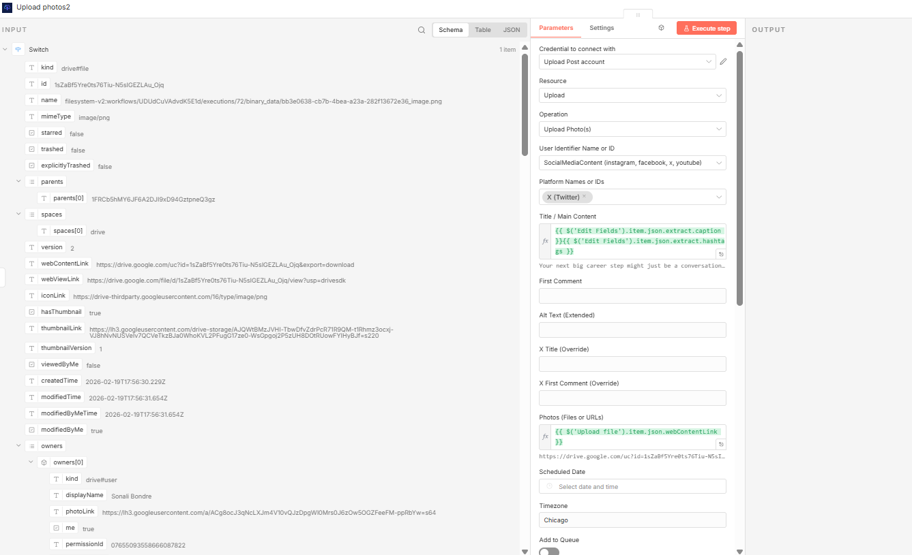

NODE 17- Upload Post- Upload a Video- Instagram
The same steps apply to Instagram Reel, but when choosing the Platform names, select Instagram. Note: Make sure to follow the steps of creating the social media accounts that are mentioned in the “Set up Instructions for Social Media Posting Automation”.
Drag “webContentLink” from the Upload File to “Video”, and drag “caption” and “hashtags” from Edit Fields to Title.
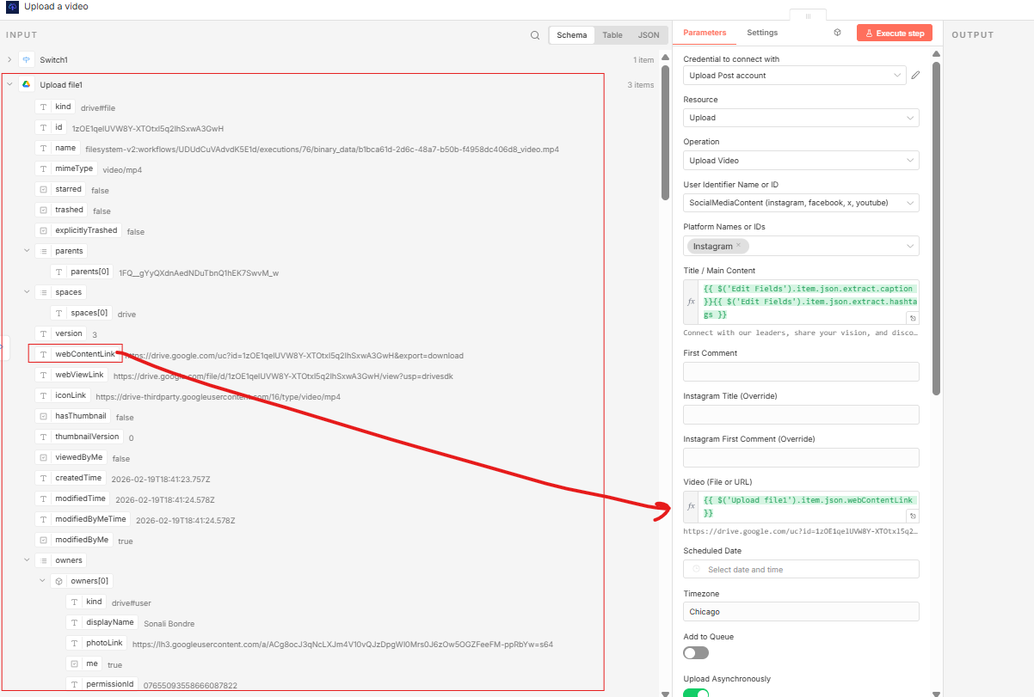

Make sure to select reels/video in the option at the bottom of the page.

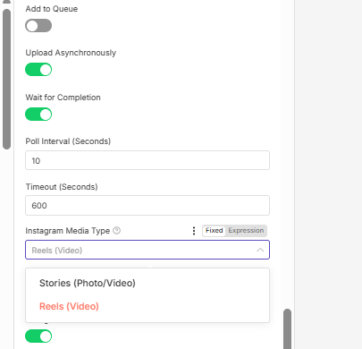

NODE 18-Upload Post- Upload a Video - X
Follow the same steps for X as followed in the Instagram reel/video upload. Drag “webContentLink” from the Upload File to “Video”, and drag “caption” and “hashtags” from Edit Fields to Title.

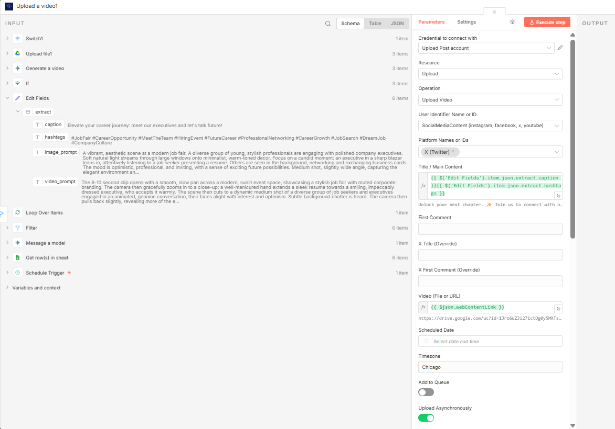

NODE 19- Upload Post- Upload a Video- Youtube
Note: Sometimes YouTube adds a word limit; hence, in this case, only the caption from the Edit fields has been dragged to the Title.
Drag “webContentLink” from the Upload File to “Video”,

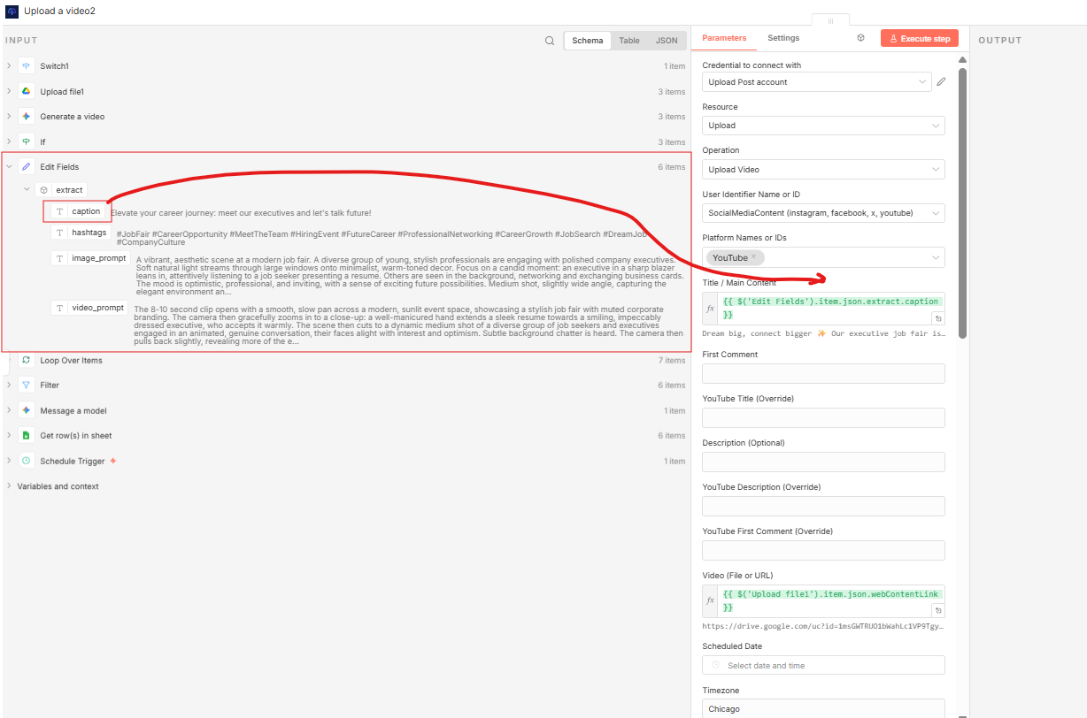

NODE 20- Merge- Append
Select a Merge node, in that select Append.

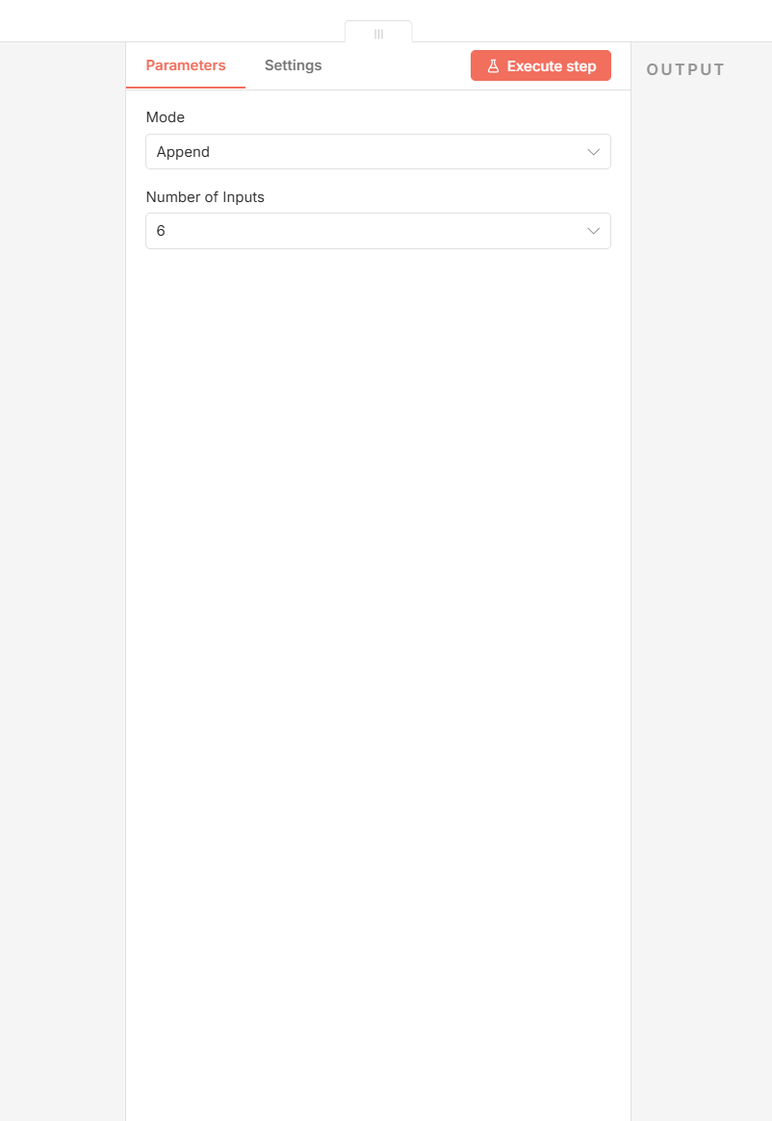

NODE 21- Google Sheets- Update Rows

