*CSE 561: Modeling & Simulation Theory and Applications*

Simulation & Analysis of Technical Support Center for Multinational Companies

Computer Science MS Computer Science MS

Shreyansh Khandelwal Bala Sujith Potineni

skhand17@asu.edu bpotinen@asu.edu

School of Computing and Augmented Intelligence

Arizona State University, Tempe, AZ, USA, 85281

**Synopsis:**

This project aims to model a technical support center. The objective of the model is to analyze a variety of request resolution and process metrics under different circumstances dependent on the parameters, precisely the number of technical requests, complexity of requests, specialized personnel demographics, and issue history. Our project intends to observe the characteristics of the operations under an influx of tasks based on fixed complexity and numeric distribution over time as the product knowledge base gets updated based on past resolutions. These results manage critical human resources, product complexity, and documentation aspects.

**Workflow:**

The below diagram illustrates a standard workflow for how a technical Support center operates.

* Assume that this depiction is done for Amazon Technical Support Center.
* Assume that Amazon has 2 major applications namely : Amazon.com and Amazon web services.
* Amazon.com offers a wide variety of products beyond books including electronics, apparel, furniture, food, toys, and more. Known for competitive pricing and fast shipping.
* Amazon Web Services ( AWS ) Offers over 200 cloud services including computing, storage, networking, database, analytics, application services, deployment, management, mobile, developer tools and more.
* Assuming that Customer A uses Amazon.com and Customer B uses Amazon Web Services.
* Let’s Assume that Customer A raises a customer case in Amazon Support Center against product Amazon.com
* Each Case is assigned with tags such as Priority and Severity and they can take values from 1 to 5.
* Let P = {1, 2, 3, 4, 5} represent the set of priority values, where 1 is highest priority and 5 is lowest priority.
* Let S = {1, 2, 3, 4, 5} represent the set of severity values, where 1 is highest severity and 5 is lowest severity.
* We can represent a customer case as an ordered pair (p, s) where p ∈ P and s ∈ S.
* For example:
* (1, 1) represents a customer case with the highest priority and severity.
* (3, 4) represents a customer case with medium priority and low severity.
* (5, 5) represents a customer case with the lowest priority and severity.
* The set of all possible customer cases is the Cartesian product P × S. This represents all priority and severity combinations.
* Here is one way to represent the technical support center routing mechanism in discrete mathematics:
* Let P = {low, medium, high} be the set of priority levels.
* Let L = {I, II, III} be the set of technician levels.
* We can represent the routing logic as a function f: P → L that maps priorities to technician levels:

f(low) = I

f(medium) = II

f(high) = III

* The function f represents the routing rules:

Low priority cases map to Level I

Medium priority cases map to Level II

High priority cases map to Level III

* We can represent the set of all possible case-level mappings as the relation R ⊆ P × L where:

R = {(low, I), (medium, II), (high, III)}

* This relation R captures the routing logic in discrete mathematical terms - it associates each priority level with its corresponding technician level.
* From the below diagram, one can see that there are two different support organizations, one that handle cases against Amazon.com and other that handles cases against Amazon Web Services.
* Here is an example of how service level agreements (SLAs) for customer cases could be defined against applications:
* Let A = {App1, App2, App3} be the set of applications supported.
* Let R = {High, Medium, Low} be the set of priority levels for customer cases.
* The SLA could then be defined as follows:
* For Amazon.com:

High-priority cases must be resolved within two days

Medium-priority cases must be settled within 15 days.

Low-priority cases must be resolved within 21 days.

* For Amazon Web Services:

High-priority cases must be resolved within one day.

Medium-priority issues must be acknowledged within seven days.

Low-priority cases must be settled within 15 days.

* More details on what we will plan to do will be provided in the preliminary report.

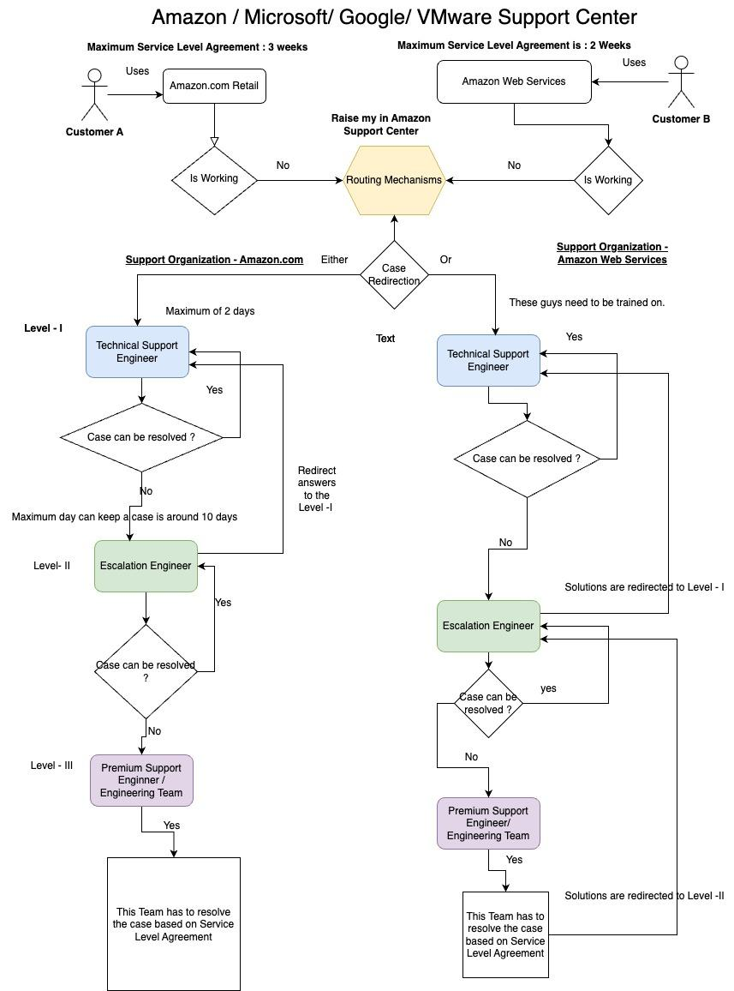

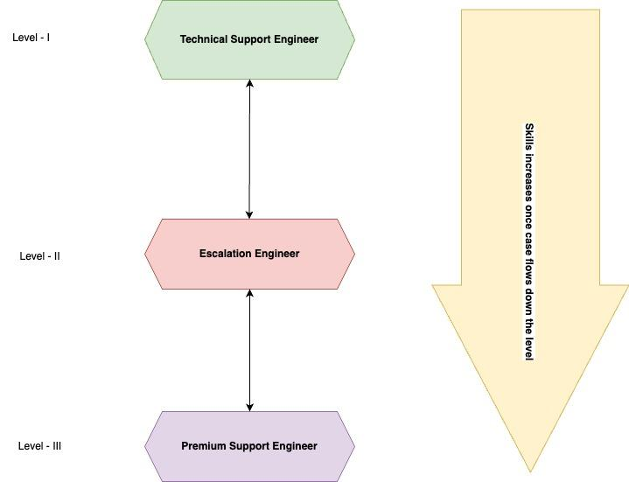

**Description:**

Technical Support is usually provided to assist businesses and customers with required hardware or software. A tech support representative will frequently need sensitive access to the user's (or organization's) network or device to provide this Support. Typically, customer requests are handled by different tech support levels based on the request type and complexity. For example, a request from a customer with a higher ARR purchase will have higher priority and is immediately assigned to higher level support irrespective of its complexity, unlike a standard customer request, which traverses through the lowest level support to the higher level. The typical levels of technical support classification are as follows:

* ***Level-I (Technical Support Engineer)***: This is the initial contact channel for a standard request. This Support is armed with a broad range of general knowledge and quickly aids in resolving most basic user problems from the base catalog, reducing run down-time.
* ***Level-II (Escalation Engineer)***: This level supporter will have better product knowledge, specialized skills, experience, and more inclination towards the incident.
* ***Level-III (Premium Support Engineer)***: The highest technical resources are accessed at this level to resolve the issue, and the staff possesses high technical expertise in accounting chief architects and engineering teams. They exclusively work on the root-cause analysis of the problem and make necessary updates on product documentation.

Common problems encountered by the technical support team are process inefficiencies, inadequate tools, lack of training, and rate of change by new technologies. These complications can be identified by observing the trends of ticket volumes, backlog, mean time to resolve, First contact resolution rate, and request resolution rate.

**Metrics:**

The most important properties of the environment involved in the experiment are:

* Distribution of customer requests inputted into a model based on priority, severity, and influx rate.
* Statistics of available technical support personnel.
* Probability of the knowledge base, including the request issue.
* Time taken to resolve the request (dependent on complexity and dataflow).
* Performance of overall of this support center = No of cases resolved within SLA / Total no of cases * 100
* Number of cases resolved by Level - III i.e., the Premium Support Center.
* Number of cases resolved by Level - II i.e., the Escalation Engineers.
* Number of cases resolved by Level - I i.e, The Technical Support Engineer.
* Average Resolution days taken to close a customer case.