PROJECT REPORT
NTTH: AN AGENT-INSPIRED AUTONOMOUS NETWORK DEFENSE ARCHITECTURE WITH HYBRID RISK SCORING AND DYNAMIC HONEYPOT DEPLOYMENT
B.Tech. CSE Final Year Project - 8th Semester
Submitted in partial fulfillment of the requirements for the award of the degree of Bachelor of Technology in Computer Science and Engineering.
Submitted By: [Student Name / Roll Number]
Under the Guidance of: [Guide Name / Designation]
Department of Computer Science and Engineering
Academic Year: 2025-2026
CERTIFICATE
This is to certify that the project report entitled NTTH: An Agent-Inspired Autonomous Network Defense Architecture with Hybrid Risk Scoring and Dynamic Honeypot Deployment is a bonafide work carried out by the students of the Department of Computer Science and Engineering in partial fulfillment of the requirements for the award of the Bachelor of Technology degree.
The work has been completed under the supervision of the project guide and has not been submitted elsewhere for the award of any degree or diploma.
Guide Signature: ____________________ Head of Department Signature: ____________________
ACKNOWLEDGEMENT
We express our sincere gratitude to our project guide for continuous guidance, technical suggestions, and encouragement throughout the development of this project. The guidance helped us refine the project from a basic security dashboard into a complete defensive pipeline with monitoring, decision-making, enforcement, honeypot integration, and evaluation planning.
We also thank the Head of the Department and all faculty members for providing the academic environment, laboratory support, and review feedback required to complete this project. We are grateful to our friends and family for their support during implementation, testing, and documentation.
ABSTRACT
The increasing speed and automation of cyber attacks require defensive systems that can detect threats and respond without waiting for manual intervention. Traditional intrusion detection systems such as Snort and Suricata are effective at generating alerts, but the response process often depends on a human administrator who must inspect the alert, understand the incident, and manually configure containment rules. This delay creates a detection-to-response gap that attackers can exploit.
This project presents NTTH, an agent-inspired autonomous network defense pipeline for real-time threat detection, hybrid risk scoring, dynamic firewall enforcement, and honeypot redirection. The system combines signature-style rule detection with unsupervised anomaly detection using Isolation Forest, and maps the resulting risk score to defensive actions such as blocking, rate limiting, logging, or redirecting suspicious flows to deception services.
The system is implemented on commodity hardware using an Ubuntu laptop, Linux networking tools, Python services, a Flutter dashboard, and an Atheros AR9271 USB WiFi adapter for passive wireless monitoring. The project is framed strictly as defensive security research in a controlled laboratory environment. The expected outcome is a practical, measurable, and academically defensible system that reduces response latency while improving visibility into attacker behavior.
TABLE OF CONTENTS
Cover Page
Acknowledgement
Abstract
List of Figures
Chapter 1: Introduction
Chapter 2: Requirements Elicitation and Analysis - Software Requirements Specification
Chapter 3: Design Specification
Chapter 4: Coding
Chapter 5: Conclusion
Future Scope
References
Appendices
LIST OF FIGURES AND TABLES
The final report includes architecture diagrams, data flow diagrams, ER diagrams, flowcharts, dashboard screenshots, result plots, hardware diagrams, and comparison tables. The list should be updated in Microsoft Word after the final college title page details and page numbers are confirmed.
Figure/Table | Title | Source
Figure 1.1 | Detection and Response Gap | thesis_images
Figure 3.1 | System Architecture | thesis_images
Figure 3.2 | Agent Pipeline Flow | thesis_images
Figure 3.3 | Database ER Diagram | thesis_images
Table 2.1 | Functional Requirements | Generated
Table 5.1 | Result Summary | Generated

CHAPTER 1: INTRODUCTION
The proposed system is designed as a defensive network security platform that observes traffic, extracts features, evaluates risk, and applies containment decisions without depending on a manual response cycle. This design is important because modern attacks are often automated and can complete scanning, exploitation, and lateral movement before an administrator has time to read and respond to a conventional alert.
The project avoids offensive framing and treats monitoring, honeypot deployment, and enforcement as controlled laboratory defense activities. Wireless monitoring is passive and uses the Atheros AR9271 adapter only for observation of management frames and suspicious behavior patterns. All testing is intended for an isolated lab network owned and controlled by the project team.
The design preference throughout the report is to use the phrase agent-inspired autonomous pipeline rather than overclaiming a fully agentic artificial intelligence system. The modules behave like specialized agents because each module perceives events, reasons over a local policy or model, and acts within a narrow security function.
A key strength of NTTH is that it integrates components that are usually separated: intrusion detection, anomaly scoring, firewall response, honeypot redirection, logging, and live visualization. The integration gives the project a clear engineering contribution as well as measurable experimental goals.
In the context of this chapter, the NTTH project is positioned as a final year engineering solution that emphasizes implementation, measurement, and responsible experimentation. The main objective is not only to identify malicious behavior but to reduce the time between observation and defensive action.
The project is especially relevant for small laboratories and educational networks because it avoids dependence on expensive enterprise appliances. Instead, it demonstrates that useful defensive automation can be assembled from open-source software, commodity networking hardware, and a carefully designed response workflow.
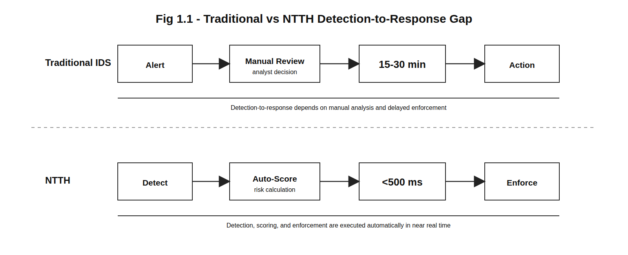
Figure: CHAPTER 1: INTRODUCTION
1.1 Background of Network Defense
The proposed system is designed as a defensive network security platform that observes traffic, extracts features, evaluates risk, and applies containment decisions without depending on a manual response cycle. This design is important because modern attacks are often automated and can complete scanning, exploitation, and lateral movement before an administrator has time to read and respond to a conventional alert.
The project avoids offensive framing and treats monitoring, honeypot deployment, and enforcement as controlled laboratory defense activities. Wireless monitoring is passive and uses the Atheros AR9271 adapter only for observation of management frames and suspicious behavior patterns. All testing is intended for an isolated lab network owned and controlled by the project team.
The design preference throughout the report is to use the phrase agent-inspired autonomous pipeline rather than overclaiming a fully agentic artificial intelligence system. The modules behave like specialized agents because each module perceives events, reasons over a local policy or model, and acts within a narrow security function.
A key strength of NTTH is that it integrates components that are usually separated: intrusion detection, anomaly scoring, firewall response, honeypot redirection, logging, and live visualization. The integration gives the project a clear engineering contribution as well as measurable experimental goals.
In the context of this chapter, the NTTH project is positioned as a final year engineering solution that emphasizes implementation, measurement, and responsible experimentation. The main objective is not only to identify malicious behavior but to reduce the time between observation and defensive action.
The project is especially relevant for small laboratories and educational networks because it avoids dependence on expensive enterprise appliances. Instead, it demonstrates that useful defensive automation can be assembled from open-source software, commodity networking hardware, and a carefully designed response workflow.
1.2 Need for Autonomous Defensive Response
The proposed system is designed as a defensive network security platform that observes traffic, extracts features, evaluates risk, and applies containment decisions without depending on a manual response cycle. This design is important because modern attacks are often automated and can complete scanning, exploitation, and lateral movement before an administrator has time to read and respond to a conventional alert.
The project avoids offensive framing and treats monitoring, honeypot deployment, and enforcement as controlled laboratory defense activities. Wireless monitoring is passive and uses the Atheros AR9271 adapter only for observation of management frames and suspicious behavior patterns. All testing is intended for an isolated lab network owned and controlled by the project team.
The design preference throughout the report is to use the phrase agent-inspired autonomous pipeline rather than overclaiming a fully agentic artificial intelligence system. The modules behave like specialized agents because each module perceives events, reasons over a local policy or model, and acts within a narrow security function.
A key strength of NTTH is that it integrates components that are usually separated: intrusion detection, anomaly scoring, firewall response, honeypot redirection, logging, and live visualization. The integration gives the project a clear engineering contribution as well as measurable experimental goals.
In the context of this chapter, the NTTH project is positioned as a final year engineering solution that emphasizes implementation, measurement, and responsible experimentation. The main objective is not only to identify malicious behavior but to reduce the time between observation and defensive action.
The project is especially relevant for small laboratories and educational networks because it avoids dependence on expensive enterprise appliances. Instead, it demonstrates that useful defensive automation can be assembled from open-source software, commodity networking hardware, and a carefully designed response workflow.
1.3 Present System Description
The proposed system is designed as a defensive network security platform that observes traffic, extracts features, evaluates risk, and applies containment decisions without depending on a manual response cycle. This design is important because modern attacks are often automated and can complete scanning, exploitation, and lateral movement before an administrator has time to read and respond to a conventional alert.
The project avoids offensive framing and treats monitoring, honeypot deployment, and enforcement as controlled laboratory defense activities. Wireless monitoring is passive and uses the Atheros AR9271 adapter only for observation of management frames and suspicious behavior patterns. All testing is intended for an isolated lab network owned and controlled by the project team.
The design preference throughout the report is to use the phrase agent-inspired autonomous pipeline rather than overclaiming a fully agentic artificial intelligence system. The modules behave like specialized agents because each module perceives events, reasons over a local policy or model, and acts within a narrow security function.
A key strength of NTTH is that it integrates components that are usually separated: intrusion detection, anomaly scoring, firewall response, honeypot redirection, logging, and live visualization. The integration gives the project a clear engineering contribution as well as measurable experimental goals.
In the context of this chapter, the NTTH project is positioned as a final year engineering solution that emphasizes implementation, measurement, and responsible experimentation. The main objective is not only to identify malicious behavior but to reduce the time between observation and defensive action.
The project is especially relevant for small laboratories and educational networks because it avoids dependence on expensive enterprise appliances. Instead, it demonstrates that useful defensive automation can be assembled from open-source software, commodity networking hardware, and a carefully designed response workflow.
1.4 Limitations of Existing IDS and Honeypot Systems
The proposed system is designed as a defensive network security platform that observes traffic, extracts features, evaluates risk, and applies containment decisions without depending on a manual response cycle. This design is important because modern attacks are often automated and can complete scanning, exploitation, and lateral movement before an administrator has time to read and respond to a conventional alert.
The project avoids offensive framing and treats monitoring, honeypot deployment, and enforcement as controlled laboratory defense activities. Wireless monitoring is passive and uses the Atheros AR9271 adapter only for observation of management frames and suspicious behavior patterns. All testing is intended for an isolated lab network owned and controlled by the project team.
The design preference throughout the report is to use the phrase agent-inspired autonomous pipeline rather than overclaiming a fully agentic artificial intelligence system. The modules behave like specialized agents because each module perceives events, reasons over a local policy or model, and acts within a narrow security function.
A key strength of NTTH is that it integrates components that are usually separated: intrusion detection, anomaly scoring, firewall response, honeypot redirection, logging, and live visualization. The integration gives the project a clear engineering contribution as well as measurable experimental goals.
In the context of this chapter, the NTTH project is positioned as a final year engineering solution that emphasizes implementation, measurement, and responsible experimentation. The main objective is not only to identify malicious behavior but to reduce the time between observation and defensive action.
The project is especially relevant for small laboratories and educational networks because it avoids dependence on expensive enterprise appliances. Instead, it demonstrates that useful defensive automation can be assembled from open-source software, commodity networking hardware, and a carefully designed response workflow.
1.5 Problem Definition
The proposed system is designed as a defensive network security platform that observes traffic, extracts features, evaluates risk, and applies containment decisions without depending on a manual response cycle. This design is important because modern attacks are often automated and can complete scanning, exploitation, and lateral movement before an administrator has time to read and respond to a conventional alert.
The project avoids offensive framing and treats monitoring, honeypot deployment, and enforcement as controlled laboratory defense activities. Wireless monitoring is passive and uses the Atheros AR9271 adapter only for observation of management frames and suspicious behavior patterns. All testing is intended for an isolated lab network owned and controlled by the project team.
The design preference throughout the report is to use the phrase agent-inspired autonomous pipeline rather than overclaiming a fully agentic artificial intelligence system. The modules behave like specialized agents because each module perceives events, reasons over a local policy or model, and acts within a narrow security function.
A key strength of NTTH is that it integrates components that are usually separated: intrusion detection, anomaly scoring, firewall response, honeypot redirection, logging, and live visualization. The integration gives the project a clear engineering contribution as well as measurable experimental goals.
In the context of this chapter, the NTTH project is positioned as a final year engineering solution that emphasizes implementation, measurement, and responsible experimentation. The main objective is not only to identify malicious behavior but to reduce the time between observation and defensive action.
The project is especially relevant for small laboratories and educational networks because it avoids dependence on expensive enterprise appliances. Instead, it demonstrates that useful defensive automation can be assembled from open-source software, commodity networking hardware, and a carefully designed response workflow.
1.6 Objectives of the Proposed System
The proposed system is designed as a defensive network security platform that observes traffic, extracts features, evaluates risk, and applies containment decisions without depending on a manual response cycle. This design is important because modern attacks are often automated and can complete scanning, exploitation, and lateral movement before an administrator has time to read and respond to a conventional alert.
The project avoids offensive framing and treats monitoring, honeypot deployment, and enforcement as controlled laboratory defense activities. Wireless monitoring is passive and uses the Atheros AR9271 adapter only for observation of management frames and suspicious behavior patterns. All testing is intended for an isolated lab network owned and controlled by the project team.
The design preference throughout the report is to use the phrase agent-inspired autonomous pipeline rather than overclaiming a fully agentic artificial intelligence system. The modules behave like specialized agents because each module perceives events, reasons over a local policy or model, and acts within a narrow security function.
A key strength of NTTH is that it integrates components that are usually separated: intrusion detection, anomaly scoring, firewall response, honeypot redirection, logging, and live visualization. The integration gives the project a clear engineering contribution as well as measurable experimental goals.
In the context of this chapter, the NTTH project is positioned as a final year engineering solution that emphasizes implementation, measurement, and responsible experimentation. The main objective is not only to identify malicious behavior but to reduce the time between observation and defensive action.
The project is especially relevant for small laboratories and educational networks because it avoids dependence on expensive enterprise appliances. Instead, it demonstrates that useful defensive automation can be assembled from open-source software, commodity networking hardware, and a carefully designed response workflow.
1.7 Scope of the Project
The proposed system is designed as a defensive network security platform that observes traffic, extracts features, evaluates risk, and applies containment decisions without depending on a manual response cycle. This design is important because modern attacks are often automated and can complete scanning, exploitation, and lateral movement before an administrator has time to read and respond to a conventional alert.
The project avoids offensive framing and treats monitoring, honeypot deployment, and enforcement as controlled laboratory defense activities. Wireless monitoring is passive and uses the Atheros AR9271 adapter only for observation of management frames and suspicious behavior patterns. All testing is intended for an isolated lab network owned and controlled by the project team.
The design preference throughout the report is to use the phrase agent-inspired autonomous pipeline rather than overclaiming a fully agentic artificial intelligence system. The modules behave like specialized agents because each module perceives events, reasons over a local policy or model, and acts within a narrow security function.
A key strength of NTTH is that it integrates components that are usually separated: intrusion detection, anomaly scoring, firewall response, honeypot redirection, logging, and live visualization. The integration gives the project a clear engineering contribution as well as measurable experimental goals.
In the context of this chapter, the NTTH project is positioned as a final year engineering solution that emphasizes implementation, measurement, and responsible experimentation. The main objective is not only to identify malicious behavior but to reduce the time between observation and defensive action.
The project is especially relevant for small laboratories and educational networks because it avoids dependence on expensive enterprise appliances. Instead, it demonstrates that useful defensive automation can be assembled from open-source software, commodity networking hardware, and a carefully designed response workflow.
1.8 Hardware and Software Requirements
The proposed system is designed as a defensive network security platform that observes traffic, extracts features, evaluates risk, and applies containment decisions without depending on a manual response cycle. This design is important because modern attacks are often automated and can complete scanning, exploitation, and lateral movement before an administrator has time to read and respond to a conventional alert.
The project avoids offensive framing and treats monitoring, honeypot deployment, and enforcement as controlled laboratory defense activities. Wireless monitoring is passive and uses the Atheros AR9271 adapter only for observation of management frames and suspicious behavior patterns. All testing is intended for an isolated lab network owned and controlled by the project team.
The design preference throughout the report is to use the phrase agent-inspired autonomous pipeline rather than overclaiming a fully agentic artificial intelligence system. The modules behave like specialized agents because each module perceives events, reasons over a local policy or model, and acts within a narrow security function.
A key strength of NTTH is that it integrates components that are usually separated: intrusion detection, anomaly scoring, firewall response, honeypot redirection, logging, and live visualization. The integration gives the project a clear engineering contribution as well as measurable experimental goals.
In the context of this chapter, the NTTH project is positioned as a final year engineering solution that emphasizes implementation, measurement, and responsible experimentation. The main objective is not only to identify malicious behavior but to reduce the time between observation and defensive action.
The project is especially relevant for small laboratories and educational networks because it avoids dependence on expensive enterprise appliances. Instead, it demonstrates that useful defensive automation can be assembled from open-source software, commodity networking hardware, and a carefully designed response workflow.
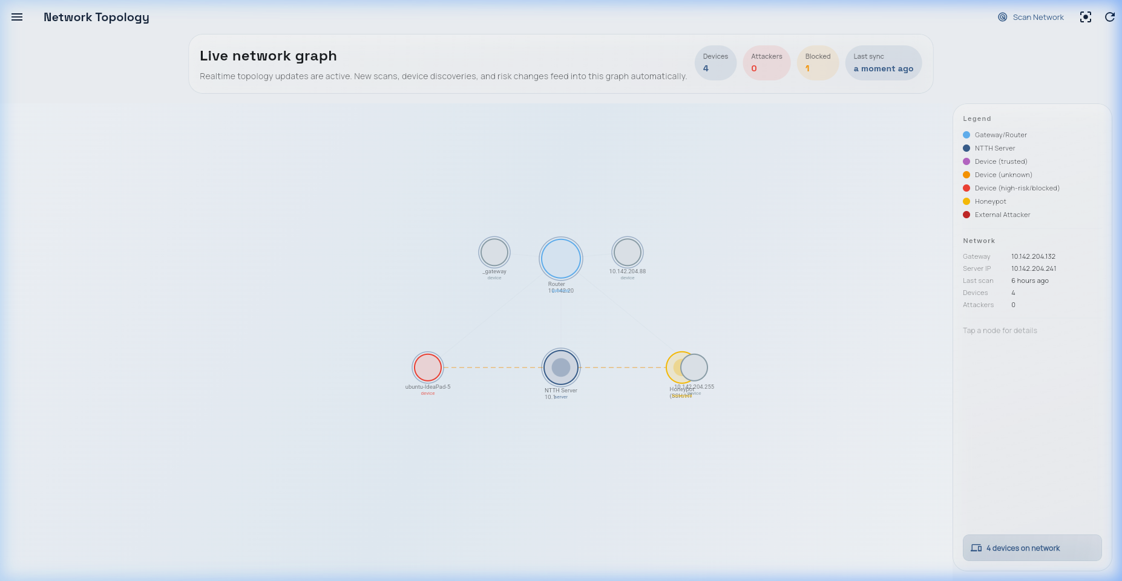
Figure: 1.8 Hardware and Software Requirements
1.9 Ethical and Legal Boundaries
The proposed system is designed as a defensive network security platform that observes traffic, extracts features, evaluates risk, and applies containment decisions without depending on a manual response cycle. This design is important because modern attacks are often automated and can complete scanning, exploitation, and lateral movement before an administrator has time to read and respond to a conventional alert.
The project avoids offensive framing and treats monitoring, honeypot deployment, and enforcement as controlled laboratory defense activities. Wireless monitoring is passive and uses the Atheros AR9271 adapter only for observation of management frames and suspicious behavior patterns. All testing is intended for an isolated lab network owned and controlled by the project team.
The design preference throughout the report is to use the phrase agent-inspired autonomous pipeline rather than overclaiming a fully agentic artificial intelligence system. The modules behave like specialized agents because each module perceives events, reasons over a local policy or model, and acts within a narrow security function.
A key strength of NTTH is that it integrates components that are usually separated: intrusion detection, anomaly scoring, firewall response, honeypot redirection, logging, and live visualization. The integration gives the project a clear engineering contribution as well as measurable experimental goals.
In the context of this chapter, the NTTH project is positioned as a final year engineering solution that emphasizes implementation, measurement, and responsible experimentation. The main objective is not only to identify malicious behavior but to reduce the time between observation and defensive action.
The project is especially relevant for small laboratories and educational networks because it avoids dependence on expensive enterprise appliances. Instead, it demonstrates that useful defensive automation can be assembled from open-source software, commodity networking hardware, and a carefully designed response workflow.
1.10 Expected Contributions
The proposed system is designed as a defensive network security platform that observes traffic, extracts features, evaluates risk, and applies containment decisions without depending on a manual response cycle. This design is important because modern attacks are often automated and can complete scanning, exploitation, and lateral movement before an administrator has time to read and respond to a conventional alert.
The project avoids offensive framing and treats monitoring, honeypot deployment, and enforcement as controlled laboratory defense activities. Wireless monitoring is passive and uses the Atheros AR9271 adapter only for observation of management frames and suspicious behavior patterns. All testing is intended for an isolated lab network owned and controlled by the project team.
The design preference throughout the report is to use the phrase agent-inspired autonomous pipeline rather than overclaiming a fully agentic artificial intelligence system. The modules behave like specialized agents because each module perceives events, reasons over a local policy or model, and acts within a narrow security function.
A key strength of NTTH is that it integrates components that are usually separated: intrusion detection, anomaly scoring, firewall response, honeypot redirection, logging, and live visualization. The integration gives the project a clear engineering contribution as well as measurable experimental goals.
In the context of this chapter, the NTTH project is positioned as a final year engineering solution that emphasizes implementation, measurement, and responsible experimentation. The main objective is not only to identify malicious behavior but to reduce the time between observation and defensive action.
The project is especially relevant for small laboratories and educational networks because it avoids dependence on expensive enterprise appliances. Instead, it demonstrates that useful defensive automation can be assembled from open-source software, commodity networking hardware, and a carefully designed response workflow.
1.11 Chapter Summary
The proposed system is designed as a defensive network security platform that observes traffic, extracts features, evaluates risk, and applies containment decisions without depending on a manual response cycle. This design is important because modern attacks are often automated and can complete scanning, exploitation, and lateral movement before an administrator has time to read and respond to a conventional alert.
The project avoids offensive framing and treats monitoring, honeypot deployment, and enforcement as controlled laboratory defense activities. Wireless monitoring is passive and uses the Atheros AR9271 adapter only for observation of management frames and suspicious behavior patterns. All testing is intended for an isolated lab network owned and controlled by the project team.
The design preference throughout the report is to use the phrase agent-inspired autonomous pipeline rather than overclaiming a fully agentic artificial intelligence system. The modules behave like specialized agents because each module perceives events, reasons over a local policy or model, and acts within a narrow security function.
A key strength of NTTH is that it integrates components that are usually separated: intrusion detection, anomaly scoring, firewall response, honeypot redirection, logging, and live visualization. The integration gives the project a clear engineering contribution as well as measurable experimental goals.
In the context of this chapter, the NTTH project is positioned as a final year engineering solution that emphasizes implementation, measurement, and responsible experimentation. The main objective is not only to identify malicious behavior but to reduce the time between observation and defensive action.
The project is especially relevant for small laboratories and educational networks because it avoids dependence on expensive enterprise appliances. Instead, it demonstrates that useful defensive automation can be assembled from open-source software, commodity networking hardware, and a carefully designed response workflow.
CHAPTER 2: REQUIREMENTS ELICITATION AND ANALYSIS - SRS
The proposed system is designed as a defensive network security platform that observes traffic, extracts features, evaluates risk, and applies containment decisions without depending on a manual response cycle. This design is important because modern attacks are often automated and can complete scanning, exploitation, and lateral movement before an administrator has time to read and respond to a conventional alert.
The project avoids offensive framing and treats monitoring, honeypot deployment, and enforcement as controlled laboratory defense activities. Wireless monitoring is passive and uses the Atheros AR9271 adapter only for observation of management frames and suspicious behavior patterns. All testing is intended for an isolated lab network owned and controlled by the project team.
The design preference throughout the report is to use the phrase agent-inspired autonomous pipeline rather than overclaiming a fully agentic artificial intelligence system. The modules behave like specialized agents because each module perceives events, reasons over a local policy or model, and acts within a narrow security function.
A key strength of NTTH is that it integrates components that are usually separated: intrusion detection, anomaly scoring, firewall response, honeypot redirection, logging, and live visualization. The integration gives the project a clear engineering contribution as well as measurable experimental goals.
The SRS defines the expected behavior of the system from the perspective of administrators, students, researchers, and evaluators. It separates mandatory system behavior from experimental features so that the project remains understandable during review and viva evaluation.
The core requirement is that every important event should be observable, explainable, and traceable. This includes the source of the network event, the extracted features, the assigned risk score, the selected action, and the dashboard or database record created after enforcement.
Requirement Type | Requirement
Functional | Capture packets and extract features from wired and wireless interfaces.
Functional | Score suspicious activity using rule and ML components.
Functional | Apply response actions through Linux firewall controls.
Functional | Redirect selected suspicious flows to honeypot services.
Non-functional | Maintain sub-second detection-to-response latency in the lab setup.
Non-functional | Provide live dashboard updates and persistent logging.
2.1 Introduction to the SRS
The proposed system is designed as a defensive network security platform that observes traffic, extracts features, evaluates risk, and applies containment decisions without depending on a manual response cycle. This design is important because modern attacks are often automated and can complete scanning, exploitation, and lateral movement before an administrator has time to read and respond to a conventional alert.
The project avoids offensive framing and treats monitoring, honeypot deployment, and enforcement as controlled laboratory defense activities. Wireless monitoring is passive and uses the Atheros AR9271 adapter only for observation of management frames and suspicious behavior patterns. All testing is intended for an isolated lab network owned and controlled by the project team.
The design preference throughout the report is to use the phrase agent-inspired autonomous pipeline rather than overclaiming a fully agentic artificial intelligence system. The modules behave like specialized agents because each module perceives events, reasons over a local policy or model, and acts within a narrow security function.
A key strength of NTTH is that it integrates components that are usually separated: intrusion detection, anomaly scoring, firewall response, honeypot redirection, logging, and live visualization. The integration gives the project a clear engineering contribution as well as measurable experimental goals.
The SRS defines the expected behavior of the system from the perspective of administrators, students, researchers, and evaluators. It separates mandatory system behavior from experimental features so that the project remains understandable during review and viva evaluation.
The core requirement is that every important event should be observable, explainable, and traceable. This includes the source of the network event, the extracted features, the assigned risk score, the selected action, and the dashboard or database record created after enforcement.
2.1.1 Purpose
The proposed system is designed as a defensive network security platform that observes traffic, extracts features, evaluates risk, and applies containment decisions without depending on a manual response cycle. This design is important because modern attacks are often automated and can complete scanning, exploitation, and lateral movement before an administrator has time to read and respond to a conventional alert.
The project avoids offensive framing and treats monitoring, honeypot deployment, and enforcement as controlled laboratory defense activities. Wireless monitoring is passive and uses the Atheros AR9271 adapter only for observation of management frames and suspicious behavior patterns. All testing is intended for an isolated lab network owned and controlled by the project team.
The design preference throughout the report is to use the phrase agent-inspired autonomous pipeline rather than overclaiming a fully agentic artificial intelligence system. The modules behave like specialized agents because each module perceives events, reasons over a local policy or model, and acts within a narrow security function.
A key strength of NTTH is that it integrates components that are usually separated: intrusion detection, anomaly scoring, firewall response, honeypot redirection, logging, and live visualization. The integration gives the project a clear engineering contribution as well as measurable experimental goals.
The SRS defines the expected behavior of the system from the perspective of administrators, students, researchers, and evaluators. It separates mandatory system behavior from experimental features so that the project remains understandable during review and viva evaluation.
The core requirement is that every important event should be observable, explainable, and traceable. This includes the source of the network event, the extracted features, the assigned risk score, the selected action, and the dashboard or database record created after enforcement.
2.1.2 Scope
The proposed system is designed as a defensive network security platform that observes traffic, extracts features, evaluates risk, and applies containment decisions without depending on a manual response cycle. This design is important because modern attacks are often automated and can complete scanning, exploitation, and lateral movement before an administrator has time to read and respond to a conventional alert.
The project avoids offensive framing and treats monitoring, honeypot deployment, and enforcement as controlled laboratory defense activities. Wireless monitoring is passive and uses the Atheros AR9271 adapter only for observation of management frames and suspicious behavior patterns. All testing is intended for an isolated lab network owned and controlled by the project team.
The design preference throughout the report is to use the phrase agent-inspired autonomous pipeline rather than overclaiming a fully agentic artificial intelligence system. The modules behave like specialized agents because each module perceives events, reasons over a local policy or model, and acts within a narrow security function.
A key strength of NTTH is that it integrates components that are usually separated: intrusion detection, anomaly scoring, firewall response, honeypot redirection, logging, and live visualization. The integration gives the project a clear engineering contribution as well as measurable experimental goals.
The SRS defines the expected behavior of the system from the perspective of administrators, students, researchers, and evaluators. It separates mandatory system behavior from experimental features so that the project remains understandable during review and viva evaluation.
The core requirement is that every important event should be observable, explainable, and traceable. This includes the source of the network event, the extracted features, the assigned risk score, the selected action, and the dashboard or database record created after enforcement.
2.1.3 Technologies to be Used
The proposed system is designed as a defensive network security platform that observes traffic, extracts features, evaluates risk, and applies containment decisions without depending on a manual response cycle. This design is important because modern attacks are often automated and can complete scanning, exploitation, and lateral movement before an administrator has time to read and respond to a conventional alert.
The project avoids offensive framing and treats monitoring, honeypot deployment, and enforcement as controlled laboratory defense activities. Wireless monitoring is passive and uses the Atheros AR9271 adapter only for observation of management frames and suspicious behavior patterns. All testing is intended for an isolated lab network owned and controlled by the project team.
The design preference throughout the report is to use the phrase agent-inspired autonomous pipeline rather than overclaiming a fully agentic artificial intelligence system. The modules behave like specialized agents because each module perceives events, reasons over a local policy or model, and acts within a narrow security function.
A key strength of NTTH is that it integrates components that are usually separated: intrusion detection, anomaly scoring, firewall response, honeypot redirection, logging, and live visualization. The integration gives the project a clear engineering contribution as well as measurable experimental goals.
The SRS defines the expected behavior of the system from the perspective of administrators, students, researchers, and evaluators. It separates mandatory system behavior from experimental features so that the project remains understandable during review and viva evaluation.
The core requirement is that every important event should be observable, explainable, and traceable. This includes the source of the network event, the extracted features, the assigned risk score, the selected action, and the dashboard or database record created after enforcement.
2.2 Stakeholder Analysis
The proposed system is designed as a defensive network security platform that observes traffic, extracts features, evaluates risk, and applies containment decisions without depending on a manual response cycle. This design is important because modern attacks are often automated and can complete scanning, exploitation, and lateral movement before an administrator has time to read and respond to a conventional alert.
The project avoids offensive framing and treats monitoring, honeypot deployment, and enforcement as controlled laboratory defense activities. Wireless monitoring is passive and uses the Atheros AR9271 adapter only for observation of management frames and suspicious behavior patterns. All testing is intended for an isolated lab network owned and controlled by the project team.
The design preference throughout the report is to use the phrase agent-inspired autonomous pipeline rather than overclaiming a fully agentic artificial intelligence system. The modules behave like specialized agents because each module perceives events, reasons over a local policy or model, and acts within a narrow security function.
A key strength of NTTH is that it integrates components that are usually separated: intrusion detection, anomaly scoring, firewall response, honeypot redirection, logging, and live visualization. The integration gives the project a clear engineering contribution as well as measurable experimental goals.
The SRS defines the expected behavior of the system from the perspective of administrators, students, researchers, and evaluators. It separates mandatory system behavior from experimental features so that the project remains understandable during review and viva evaluation.
The core requirement is that every important event should be observable, explainable, and traceable. This includes the source of the network event, the extracted features, the assigned risk score, the selected action, and the dashboard or database record created after enforcement.
2.3 Functional Requirements
The proposed system is designed as a defensive network security platform that observes traffic, extracts features, evaluates risk, and applies containment decisions without depending on a manual response cycle. This design is important because modern attacks are often automated and can complete scanning, exploitation, and lateral movement before an administrator has time to read and respond to a conventional alert.
The project avoids offensive framing and treats monitoring, honeypot deployment, and enforcement as controlled laboratory defense activities. Wireless monitoring is passive and uses the Atheros AR9271 adapter only for observation of management frames and suspicious behavior patterns. All testing is intended for an isolated lab network owned and controlled by the project team.
The design preference throughout the report is to use the phrase agent-inspired autonomous pipeline rather than overclaiming a fully agentic artificial intelligence system. The modules behave like specialized agents because each module perceives events, reasons over a local policy or model, and acts within a narrow security function.
A key strength of NTTH is that it integrates components that are usually separated: intrusion detection, anomaly scoring, firewall response, honeypot redirection, logging, and live visualization. The integration gives the project a clear engineering contribution as well as measurable experimental goals.
The SRS defines the expected behavior of the system from the perspective of administrators, students, researchers, and evaluators. It separates mandatory system behavior from experimental features so that the project remains understandable during review and viva evaluation.
The core requirement is that every important event should be observable, explainable, and traceable. This includes the source of the network event, the extracted features, the assigned risk score, the selected action, and the dashboard or database record created after enforcement.
Requirement Type | Requirement
Functional | Capture packets and extract features from wired and wireless interfaces.
Functional | Score suspicious activity using rule and ML components.
Functional | Apply response actions through Linux firewall controls.
Functional | Redirect selected suspicious flows to honeypot services.
Non-functional | Maintain sub-second detection-to-response latency in the lab setup.
Non-functional | Provide live dashboard updates and persistent logging.
2.4 Non-Functional Requirements
The proposed system is designed as a defensive network security platform that observes traffic, extracts features, evaluates risk, and applies containment decisions without depending on a manual response cycle. This design is important because modern attacks are often automated and can complete scanning, exploitation, and lateral movement before an administrator has time to read and respond to a conventional alert.
The project avoids offensive framing and treats monitoring, honeypot deployment, and enforcement as controlled laboratory defense activities. Wireless monitoring is passive and uses the Atheros AR9271 adapter only for observation of management frames and suspicious behavior patterns. All testing is intended for an isolated lab network owned and controlled by the project team.
The design preference throughout the report is to use the phrase agent-inspired autonomous pipeline rather than overclaiming a fully agentic artificial intelligence system. The modules behave like specialized agents because each module perceives events, reasons over a local policy or model, and acts within a narrow security function.
A key strength of NTTH is that it integrates components that are usually separated: intrusion detection, anomaly scoring, firewall response, honeypot redirection, logging, and live visualization. The integration gives the project a clear engineering contribution as well as measurable experimental goals.
The SRS defines the expected behavior of the system from the perspective of administrators, students, researchers, and evaluators. It separates mandatory system behavior from experimental features so that the project remains understandable during review and viva evaluation.
The core requirement is that every important event should be observable, explainable, and traceable. This includes the source of the network event, the extracted features, the assigned risk score, the selected action, and the dashboard or database record created after enforcement.
Requirement Type | Requirement
Functional | Capture packets and extract features from wired and wireless interfaces.
Functional | Score suspicious activity using rule and ML components.
Functional | Apply response actions through Linux firewall controls.
Functional | Redirect selected suspicious flows to honeypot services.
Non-functional | Maintain sub-second detection-to-response latency in the lab setup.
Non-functional | Provide live dashboard updates and persistent logging.
2.5 System Constraints
The proposed system is designed as a defensive network security platform that observes traffic, extracts features, evaluates risk, and applies containment decisions without depending on a manual response cycle. This design is important because modern attacks are often automated and can complete scanning, exploitation, and lateral movement before an administrator has time to read and respond to a conventional alert.
The project avoids offensive framing and treats monitoring, honeypot deployment, and enforcement as controlled laboratory defense activities. Wireless monitoring is passive and uses the Atheros AR9271 adapter only for observation of management frames and suspicious behavior patterns. All testing is intended for an isolated lab network owned and controlled by the project team.
The design preference throughout the report is to use the phrase agent-inspired autonomous pipeline rather than overclaiming a fully agentic artificial intelligence system. The modules behave like specialized agents because each module perceives events, reasons over a local policy or model, and acts within a narrow security function.
A key strength of NTTH is that it integrates components that are usually separated: intrusion detection, anomaly scoring, firewall response, honeypot redirection, logging, and live visualization. The integration gives the project a clear engineering contribution as well as measurable experimental goals.
The SRS defines the expected behavior of the system from the perspective of administrators, students, researchers, and evaluators. It separates mandatory system behavior from experimental features so that the project remains understandable during review and viva evaluation.
The core requirement is that every important event should be observable, explainable, and traceable. This includes the source of the network event, the extracted features, the assigned risk score, the selected action, and the dashboard or database record created after enforcement.
2.6 Assumptions and Dependencies
The proposed system is designed as a defensive network security platform that observes traffic, extracts features, evaluates risk, and applies containment decisions without depending on a manual response cycle. This design is important because modern attacks are often automated and can complete scanning, exploitation, and lateral movement before an administrator has time to read and respond to a conventional alert.
The project avoids offensive framing and treats monitoring, honeypot deployment, and enforcement as controlled laboratory defense activities. Wireless monitoring is passive and uses the Atheros AR9271 adapter only for observation of management frames and suspicious behavior patterns. All testing is intended for an isolated lab network owned and controlled by the project team.
The design preference throughout the report is to use the phrase agent-inspired autonomous pipeline rather than overclaiming a fully agentic artificial intelligence system. The modules behave like specialized agents because each module perceives events, reasons over a local policy or model, and acts within a narrow security function.
A key strength of NTTH is that it integrates components that are usually separated: intrusion detection, anomaly scoring, firewall response, honeypot redirection, logging, and live visualization. The integration gives the project a clear engineering contribution as well as measurable experimental goals.
The SRS defines the expected behavior of the system from the perspective of administrators, students, researchers, and evaluators. It separates mandatory system behavior from experimental features so that the project remains understandable during review and viva evaluation.
The core requirement is that every important event should be observable, explainable, and traceable. This includes the source of the network event, the extracted features, the assigned risk score, the selected action, and the dashboard or database record created after enforcement.
2.7 Data Requirements
The proposed system is designed as a defensive network security platform that observes traffic, extracts features, evaluates risk, and applies containment decisions without depending on a manual response cycle. This design is important because modern attacks are often automated and can complete scanning, exploitation, and lateral movement before an administrator has time to read and respond to a conventional alert.
The project avoids offensive framing and treats monitoring, honeypot deployment, and enforcement as controlled laboratory defense activities. Wireless monitoring is passive and uses the Atheros AR9271 adapter only for observation of management frames and suspicious behavior patterns. All testing is intended for an isolated lab network owned and controlled by the project team.
The design preference throughout the report is to use the phrase agent-inspired autonomous pipeline rather than overclaiming a fully agentic artificial intelligence system. The modules behave like specialized agents because each module perceives events, reasons over a local policy or model, and acts within a narrow security function.
A key strength of NTTH is that it integrates components that are usually separated: intrusion detection, anomaly scoring, firewall response, honeypot redirection, logging, and live visualization. The integration gives the project a clear engineering contribution as well as measurable experimental goals.
The SRS defines the expected behavior of the system from the perspective of administrators, students, researchers, and evaluators. It separates mandatory system behavior from experimental features so that the project remains understandable during review and viva evaluation.
The core requirement is that every important event should be observable, explainable, and traceable. This includes the source of the network event, the extracted features, the assigned risk score, the selected action, and the dashboard or database record created after enforcement.
2.8 Security Requirements
The proposed system is designed as a defensive network security platform that observes traffic, extracts features, evaluates risk, and applies containment decisions without depending on a manual response cycle. This design is important because modern attacks are often automated and can complete scanning, exploitation, and lateral movement before an administrator has time to read and respond to a conventional alert.
The project avoids offensive framing and treats monitoring, honeypot deployment, and enforcement as controlled laboratory defense activities. Wireless monitoring is passive and uses the Atheros AR9271 adapter only for observation of management frames and suspicious behavior patterns. All testing is intended for an isolated lab network owned and controlled by the project team.
The design preference throughout the report is to use the phrase agent-inspired autonomous pipeline rather than overclaiming a fully agentic artificial intelligence system. The modules behave like specialized agents because each module perceives events, reasons over a local policy or model, and acts within a narrow security function.
A key strength of NTTH is that it integrates components that are usually separated: intrusion detection, anomaly scoring, firewall response, honeypot redirection, logging, and live visualization. The integration gives the project a clear engineering contribution as well as measurable experimental goals.
The SRS defines the expected behavior of the system from the perspective of administrators, students, researchers, and evaluators. It separates mandatory system behavior from experimental features so that the project remains understandable during review and viva evaluation.
The core requirement is that every important event should be observable, explainable, and traceable. This includes the source of the network event, the extracted features, the assigned risk score, the selected action, and the dashboard or database record created after enforcement.
2.9 Validation Requirements
The proposed system is designed as a defensive network security platform that observes traffic, extracts features, evaluates risk, and applies containment decisions without depending on a manual response cycle. This design is important because modern attacks are often automated and can complete scanning, exploitation, and lateral movement before an administrator has time to read and respond to a conventional alert.
The project avoids offensive framing and treats monitoring, honeypot deployment, and enforcement as controlled laboratory defense activities. Wireless monitoring is passive and uses the Atheros AR9271 adapter only for observation of management frames and suspicious behavior patterns. All testing is intended for an isolated lab network owned and controlled by the project team.
The design preference throughout the report is to use the phrase agent-inspired autonomous pipeline rather than overclaiming a fully agentic artificial intelligence system. The modules behave like specialized agents because each module perceives events, reasons over a local policy or model, and acts within a narrow security function.
A key strength of NTTH is that it integrates components that are usually separated: intrusion detection, anomaly scoring, firewall response, honeypot redirection, logging, and live visualization. The integration gives the project a clear engineering contribution as well as measurable experimental goals.
The SRS defines the expected behavior of the system from the perspective of administrators, students, researchers, and evaluators. It separates mandatory system behavior from experimental features so that the project remains understandable during review and viva evaluation.
The core requirement is that every important event should be observable, explainable, and traceable. This includes the source of the network event, the extracted features, the assigned risk score, the selected action, and the dashboard or database record created after enforcement.
2.10 SRS Summary
The proposed system is designed as a defensive network security platform that observes traffic, extracts features, evaluates risk, and applies containment decisions without depending on a manual response cycle. This design is important because modern attacks are often automated and can complete scanning, exploitation, and lateral movement before an administrator has time to read and respond to a conventional alert.
The project avoids offensive framing and treats monitoring, honeypot deployment, and enforcement as controlled laboratory defense activities. Wireless monitoring is passive and uses the Atheros AR9271 adapter only for observation of management frames and suspicious behavior patterns. All testing is intended for an isolated lab network owned and controlled by the project team.
The design preference throughout the report is to use the phrase agent-inspired autonomous pipeline rather than overclaiming a fully agentic artificial intelligence system. The modules behave like specialized agents because each module perceives events, reasons over a local policy or model, and acts within a narrow security function.
A key strength of NTTH is that it integrates components that are usually separated: intrusion detection, anomaly scoring, firewall response, honeypot redirection, logging, and live visualization. The integration gives the project a clear engineering contribution as well as measurable experimental goals.
The SRS defines the expected behavior of the system from the perspective of administrators, students, researchers, and evaluators. It separates mandatory system behavior from experimental features so that the project remains understandable during review and viva evaluation.
The core requirement is that every important event should be observable, explainable, and traceable. This includes the source of the network event, the extracted features, the assigned risk score, the selected action, and the dashboard or database record created after enforcement.
CHAPTER 3: DESIGN SPECIFICATION
The proposed system is designed as a defensive network security platform that observes traffic, extracts features, evaluates risk, and applies containment decisions without depending on a manual response cycle. This design is important because modern attacks are often automated and can complete scanning, exploitation, and lateral movement before an administrator has time to read and respond to a conventional alert.
The project avoids offensive framing and treats monitoring, honeypot deployment, and enforcement as controlled laboratory defense activities. Wireless monitoring is passive and uses the Atheros AR9271 adapter only for observation of management frames and suspicious behavior patterns. All testing is intended for an isolated lab network owned and controlled by the project team.
The design preference throughout the report is to use the phrase agent-inspired autonomous pipeline rather than overclaiming a fully agentic artificial intelligence system. The modules behave like specialized agents because each module perceives events, reasons over a local policy or model, and acts within a narrow security function.
A key strength of NTTH is that it integrates components that are usually separated: intrusion detection, anomaly scoring, firewall response, honeypot redirection, logging, and live visualization. The integration gives the project a clear engineering contribution as well as measurable experimental goals.
The design specification explains the internal organization of the system. It connects the software modules to the expected behavior described in the SRS and provides diagrams that help an evaluator understand data movement, decision flow, storage design, and user interaction.
The architecture favors modular services because security response systems must remain understandable under failure. If an event is incorrectly classified or a firewall rule fails, the logs and dashboard should still show enough information to diagnose the issue.
Module | Responsibility | Output
Packet Monitor | Observe traffic and extract features | Feature event
Threat Agent | Apply IDS rules and ML scoring | Risk score
Decision Agent | Select action from risk and context | Action directive
Enforcement Agent | Apply firewall or redirect rules | Kernel rule
Reporting Agent | Store and broadcast results | Dashboard update
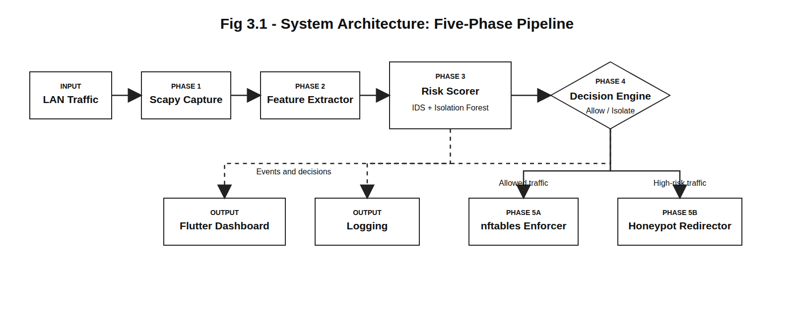
Figure: CHAPTER 3: DESIGN SPECIFICATION
3.1 Architecture Design
The proposed system is designed as a defensive network security platform that observes traffic, extracts features, evaluates risk, and applies containment decisions without depending on a manual response cycle. This design is important because modern attacks are often automated and can complete scanning, exploitation, and lateral movement before an administrator has time to read and respond to a conventional alert.
The project avoids offensive framing and treats monitoring, honeypot deployment, and enforcement as controlled laboratory defense activities. Wireless monitoring is passive and uses the Atheros AR9271 adapter only for observation of management frames and suspicious behavior patterns. All testing is intended for an isolated lab network owned and controlled by the project team.
The design preference throughout the report is to use the phrase agent-inspired autonomous pipeline rather than overclaiming a fully agentic artificial intelligence system. The modules behave like specialized agents because each module perceives events, reasons over a local policy or model, and acts within a narrow security function.
A key strength of NTTH is that it integrates components that are usually separated: intrusion detection, anomaly scoring, firewall response, honeypot redirection, logging, and live visualization. The integration gives the project a clear engineering contribution as well as measurable experimental goals.
The design specification explains the internal organization of the system. It connects the software modules to the expected behavior described in the SRS and provides diagrams that help an evaluator understand data movement, decision flow, storage design, and user interaction.
The architecture favors modular services because security response systems must remain understandable under failure. If an event is incorrectly classified or a firewall rule fails, the logs and dashboard should still show enough information to diagnose the issue.
Module | Responsibility | Output
Packet Monitor | Observe traffic and extract features | Feature event
Threat Agent | Apply IDS rules and ML scoring | Risk score
Decision Agent | Select action from risk and context | Action directive
Enforcement Agent | Apply firewall or redirect rules | Kernel rule
Reporting Agent | Store and broadcast results | Dashboard update

Figure: 3.1 Architecture Design
3.2 Agent-Inspired Pipeline
The proposed system is designed as a defensive network security platform that observes traffic, extracts features, evaluates risk, and applies containment decisions without depending on a manual response cycle. This design is important because modern attacks are often automated and can complete scanning, exploitation, and lateral movement before an administrator has time to read and respond to a conventional alert.
The project avoids offensive framing and treats monitoring, honeypot deployment, and enforcement as controlled laboratory defense activities. Wireless monitoring is passive and uses the Atheros AR9271 adapter only for observation of management frames and suspicious behavior patterns. All testing is intended for an isolated lab network owned and controlled by the project team.
The design preference throughout the report is to use the phrase agent-inspired autonomous pipeline rather than overclaiming a fully agentic artificial intelligence system. The modules behave like specialized agents because each module perceives events, reasons over a local policy or model, and acts within a narrow security function.
A key strength of NTTH is that it integrates components that are usually separated: intrusion detection, anomaly scoring, firewall response, honeypot redirection, logging, and live visualization. The integration gives the project a clear engineering contribution as well as measurable experimental goals.
The design specification explains the internal organization of the system. It connects the software modules to the expected behavior described in the SRS and provides diagrams that help an evaluator understand data movement, decision flow, storage design, and user interaction.
The architecture favors modular services because security response systems must remain understandable under failure. If an event is incorrectly classified or a firewall rule fails, the logs and dashboard should still show enough information to diagnose the issue.
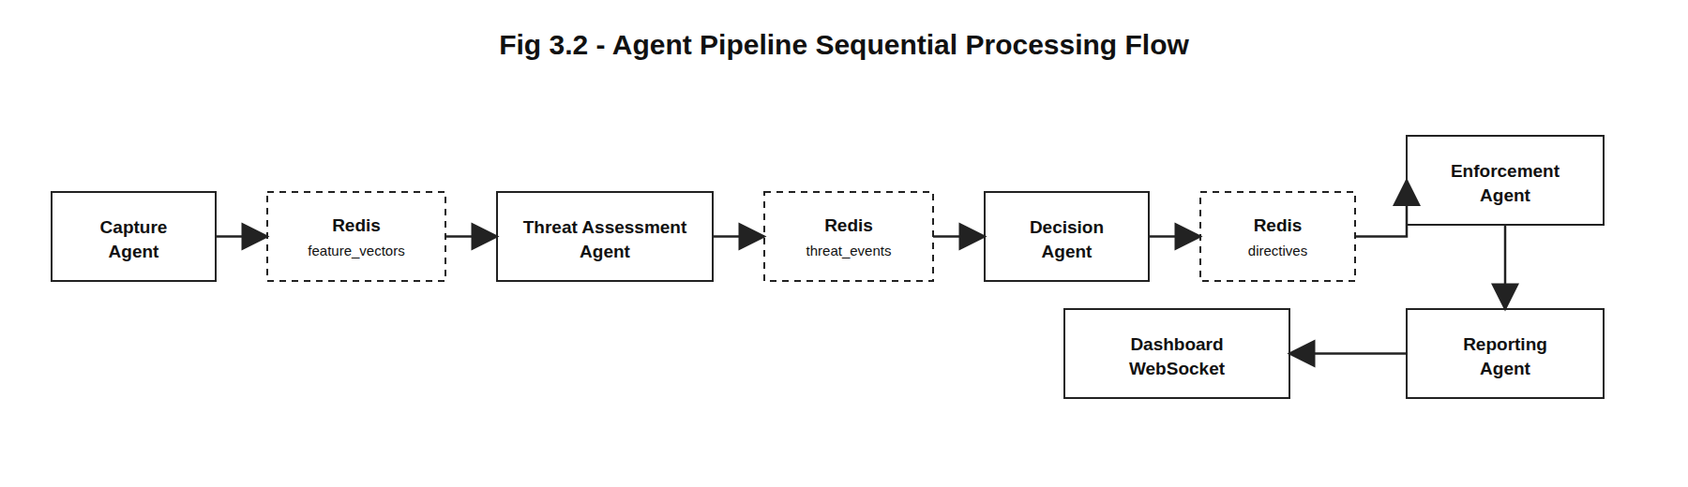
Figure: 3.2 Agent-Inspired Pipeline
3.3 Asynchronous Event Bus Topology
The proposed system is designed as a defensive network security platform that observes traffic, extracts features, evaluates risk, and applies containment decisions without depending on a manual response cycle. This design is important because modern attacks are often automated and can complete scanning, exploitation, and lateral movement before an administrator has time to read and respond to a conventional alert.
The project avoids offensive framing and treats monitoring, honeypot deployment, and enforcement as controlled laboratory defense activities. Wireless monitoring is passive and uses the Atheros AR9271 adapter only for observation of management frames and suspicious behavior patterns. All testing is intended for an isolated lab network owned and controlled by the project team.
The design preference throughout the report is to use the phrase agent-inspired autonomous pipeline rather than overclaiming a fully agentic artificial intelligence system. The modules behave like specialized agents because each module perceives events, reasons over a local policy or model, and acts within a narrow security function.
A key strength of NTTH is that it integrates components that are usually separated: intrusion detection, anomaly scoring, firewall response, honeypot redirection, logging, and live visualization. The integration gives the project a clear engineering contribution as well as measurable experimental goals.
The design specification explains the internal organization of the system. It connects the software modules to the expected behavior described in the SRS and provides diagrams that help an evaluator understand data movement, decision flow, storage design, and user interaction.
The architecture favors modular services because security response systems must remain understandable under failure. If an event is incorrectly classified or a firewall rule fails, the logs and dashboard should still show enough information to diagnose the issue.
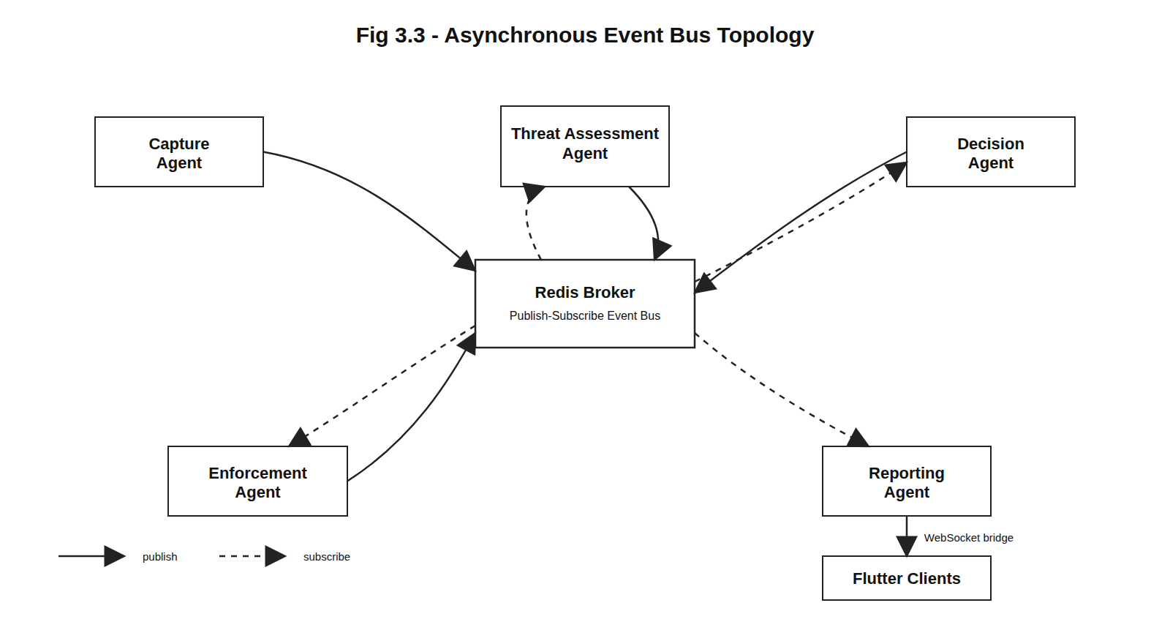
Figure: 3.3 Asynchronous Event Bus Topology
3.4 Packet Capture Pipeline
The proposed system is designed as a defensive network security platform that observes traffic, extracts features, evaluates risk, and applies containment decisions without depending on a manual response cycle. This design is important because modern attacks are often automated and can complete scanning, exploitation, and lateral movement before an administrator has time to read and respond to a conventional alert.
The project avoids offensive framing and treats monitoring, honeypot deployment, and enforcement as controlled laboratory defense activities. Wireless monitoring is passive and uses the Atheros AR9271 adapter only for observation of management frames and suspicious behavior patterns. All testing is intended for an isolated lab network owned and controlled by the project team.
The design preference throughout the report is to use the phrase agent-inspired autonomous pipeline rather than overclaiming a fully agentic artificial intelligence system. The modules behave like specialized agents because each module perceives events, reasons over a local policy or model, and acts within a narrow security function.
A key strength of NTTH is that it integrates components that are usually separated: intrusion detection, anomaly scoring, firewall response, honeypot redirection, logging, and live visualization. The integration gives the project a clear engineering contribution as well as measurable experimental goals.
The design specification explains the internal organization of the system. It connects the software modules to the expected behavior described in the SRS and provides diagrams that help an evaluator understand data movement, decision flow, storage design, and user interaction.
The architecture favors modular services because security response systems must remain understandable under failure. If an event is incorrectly classified or a firewall rule fails, the logs and dashboard should still show enough information to diagnose the issue.
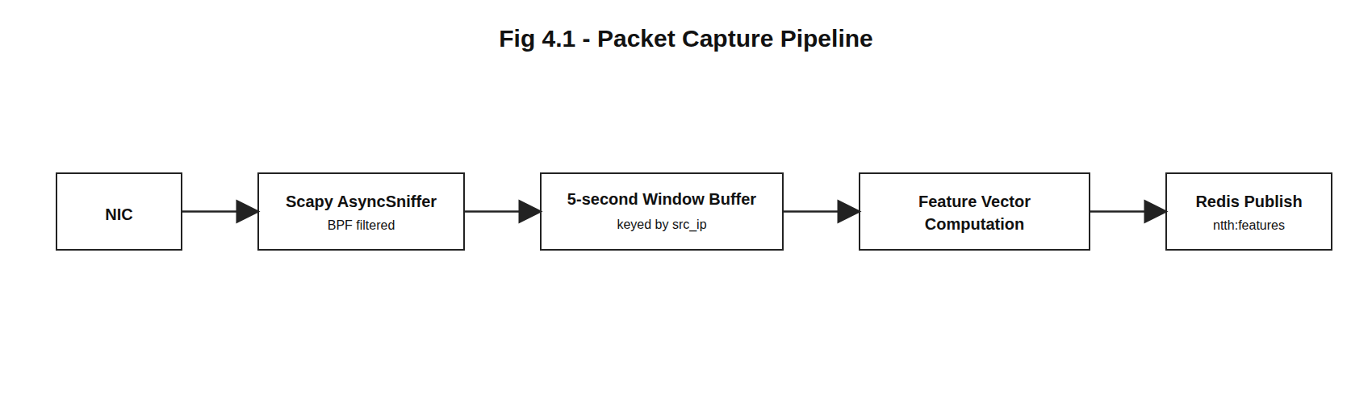
Figure: 3.4 Packet Capture Pipeline
3.5 Isolation Forest Feature Space
The proposed system is designed as a defensive network security platform that observes traffic, extracts features, evaluates risk, and applies containment decisions without depending on a manual response cycle. This design is important because modern attacks are often automated and can complete scanning, exploitation, and lateral movement before an administrator has time to read and respond to a conventional alert.
The project avoids offensive framing and treats monitoring, honeypot deployment, and enforcement as controlled laboratory defense activities. Wireless monitoring is passive and uses the Atheros AR9271 adapter only for observation of management frames and suspicious behavior patterns. All testing is intended for an isolated lab network owned and controlled by the project team.
The design preference throughout the report is to use the phrase agent-inspired autonomous pipeline rather than overclaiming a fully agentic artificial intelligence system. The modules behave like specialized agents because each module perceives events, reasons over a local policy or model, and acts within a narrow security function.
A key strength of NTTH is that it integrates components that are usually separated: intrusion detection, anomaly scoring, firewall response, honeypot redirection, logging, and live visualization. The integration gives the project a clear engineering contribution as well as measurable experimental goals.
The design specification explains the internal organization of the system. It connects the software modules to the expected behavior described in the SRS and provides diagrams that help an evaluator understand data movement, decision flow, storage design, and user interaction.
The architecture favors modular services because security response systems must remain understandable under failure. If an event is incorrectly classified or a firewall rule fails, the logs and dashboard should still show enough information to diagnose the issue.
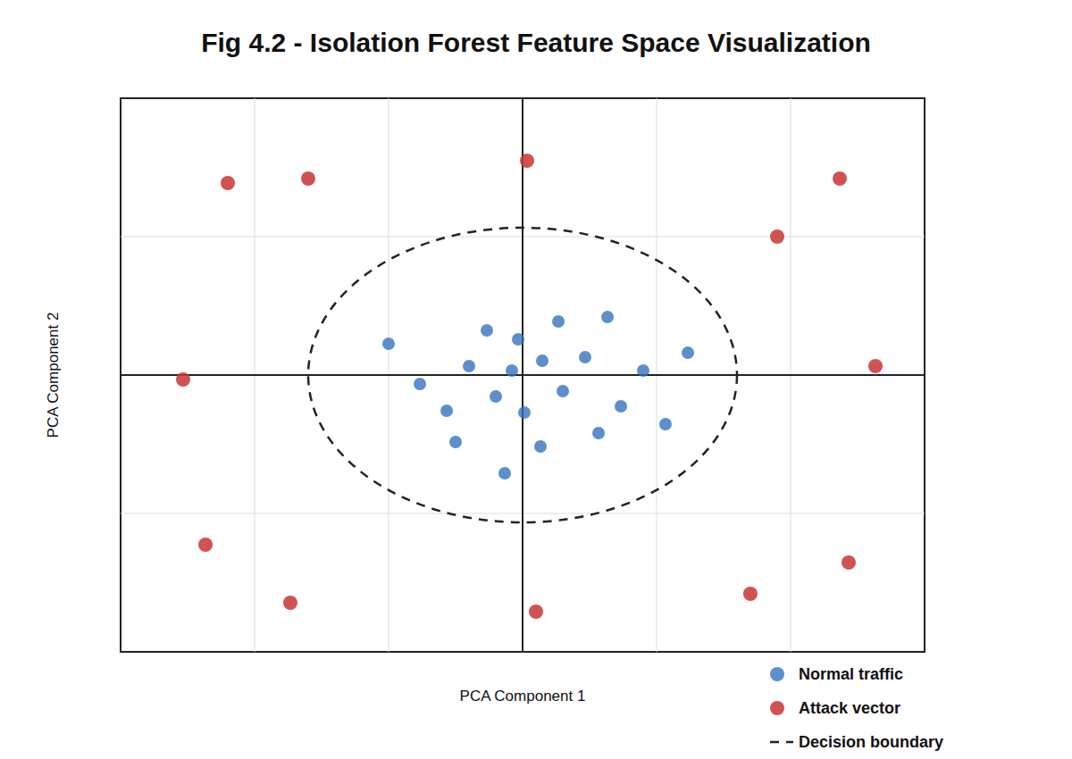
Figure: 3.5 Isolation Forest Feature Space
3.6 nftables Rule Chain
The proposed system is designed as a defensive network security platform that observes traffic, extracts features, evaluates risk, and applies containment decisions without depending on a manual response cycle. This design is important because modern attacks are often automated and can complete scanning, exploitation, and lateral movement before an administrator has time to read and respond to a conventional alert.
The project avoids offensive framing and treats monitoring, honeypot deployment, and enforcement as controlled laboratory defense activities. Wireless monitoring is passive and uses the Atheros AR9271 adapter only for observation of management frames and suspicious behavior patterns. All testing is intended for an isolated lab network owned and controlled by the project team.
The design preference throughout the report is to use the phrase agent-inspired autonomous pipeline rather than overclaiming a fully agentic artificial intelligence system. The modules behave like specialized agents because each module perceives events, reasons over a local policy or model, and acts within a narrow security function.
A key strength of NTTH is that it integrates components that are usually separated: intrusion detection, anomaly scoring, firewall response, honeypot redirection, logging, and live visualization. The integration gives the project a clear engineering contribution as well as measurable experimental goals.
The design specification explains the internal organization of the system. It connects the software modules to the expected behavior described in the SRS and provides diagrams that help an evaluator understand data movement, decision flow, storage design, and user interaction.
The architecture favors modular services because security response systems must remain understandable under failure. If an event is incorrectly classified or a firewall rule fails, the logs and dashboard should still show enough information to diagnose the issue.
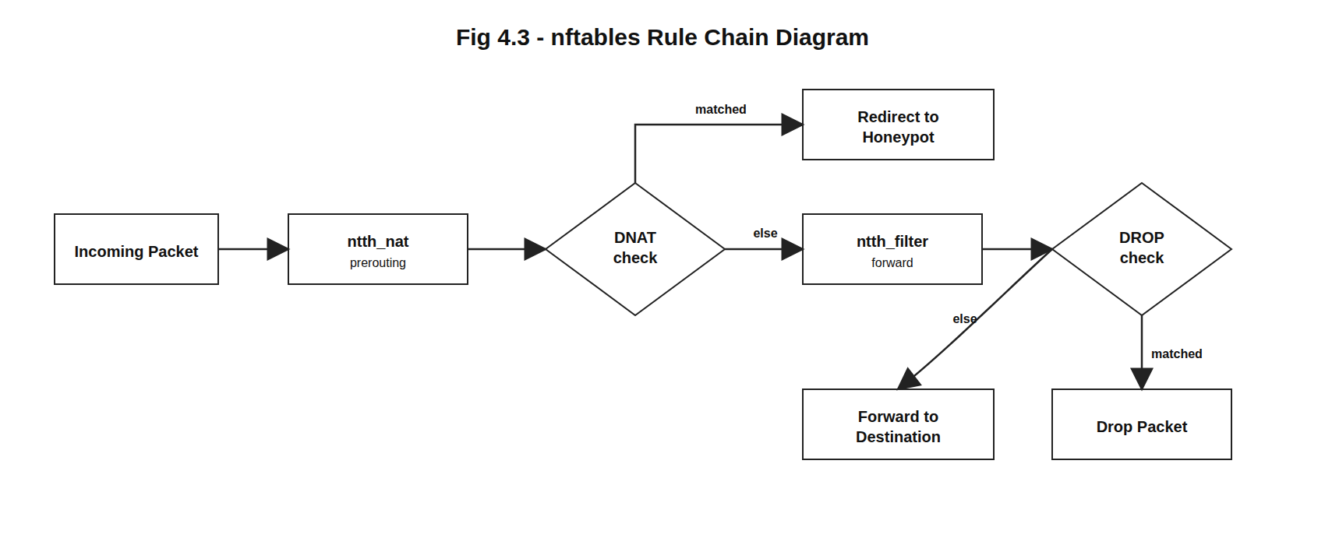
Figure: 3.6 nftables Rule Chain
3.7 Flow-Aware Honeypot Deployment
The proposed system is designed as a defensive network security platform that observes traffic, extracts features, evaluates risk, and applies containment decisions without depending on a manual response cycle. This design is important because modern attacks are often automated and can complete scanning, exploitation, and lateral movement before an administrator has time to read and respond to a conventional alert.
The project avoids offensive framing and treats monitoring, honeypot deployment, and enforcement as controlled laboratory defense activities. Wireless monitoring is passive and uses the Atheros AR9271 adapter only for observation of management frames and suspicious behavior patterns. All testing is intended for an isolated lab network owned and controlled by the project team.
The design preference throughout the report is to use the phrase agent-inspired autonomous pipeline rather than overclaiming a fully agentic artificial intelligence system. The modules behave like specialized agents because each module perceives events, reasons over a local policy or model, and acts within a narrow security function.
A key strength of NTTH is that it integrates components that are usually separated: intrusion detection, anomaly scoring, firewall response, honeypot redirection, logging, and live visualization. The integration gives the project a clear engineering contribution as well as measurable experimental goals.
The design specification explains the internal organization of the system. It connects the software modules to the expected behavior described in the SRS and provides diagrams that help an evaluator understand data movement, decision flow, storage design, and user interaction.
The architecture favors modular services because security response systems must remain understandable under failure. If an event is incorrectly classified or a firewall rule fails, the logs and dashboard should still show enough information to diagnose the issue.
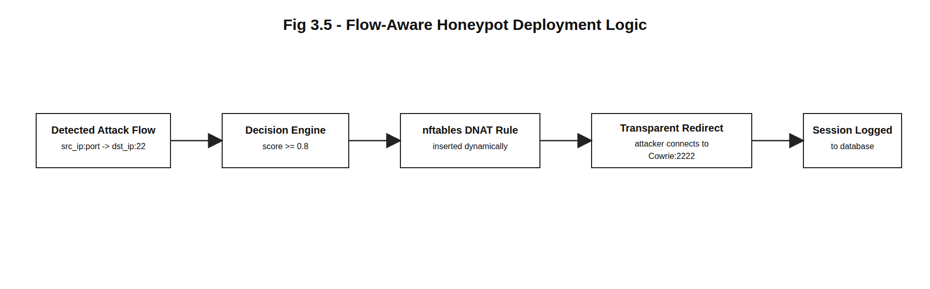
Figure: 3.7 Flow-Aware Honeypot Deployment
3.8 Database ER Diagram
The proposed system is designed as a defensive network security platform that observes traffic, extracts features, evaluates risk, and applies containment decisions without depending on a manual response cycle. This design is important because modern attacks are often automated and can complete scanning, exploitation, and lateral movement before an administrator has time to read and respond to a conventional alert.
The project avoids offensive framing and treats monitoring, honeypot deployment, and enforcement as controlled laboratory defense activities. Wireless monitoring is passive and uses the Atheros AR9271 adapter only for observation of management frames and suspicious behavior patterns. All testing is intended for an isolated lab network owned and controlled by the project team.
The design preference throughout the report is to use the phrase agent-inspired autonomous pipeline rather than overclaiming a fully agentic artificial intelligence system. The modules behave like specialized agents because each module perceives events, reasons over a local policy or model, and acts within a narrow security function.
A key strength of NTTH is that it integrates components that are usually separated: intrusion detection, anomaly scoring, firewall response, honeypot redirection, logging, and live visualization. The integration gives the project a clear engineering contribution as well as measurable experimental goals.
The design specification explains the internal organization of the system. It connects the software modules to the expected behavior described in the SRS and provides diagrams that help an evaluator understand data movement, decision flow, storage design, and user interaction.
The architecture favors modular services because security response systems must remain understandable under failure. If an event is incorrectly classified or a firewall rule fails, the logs and dashboard should still show enough information to diagnose the issue.
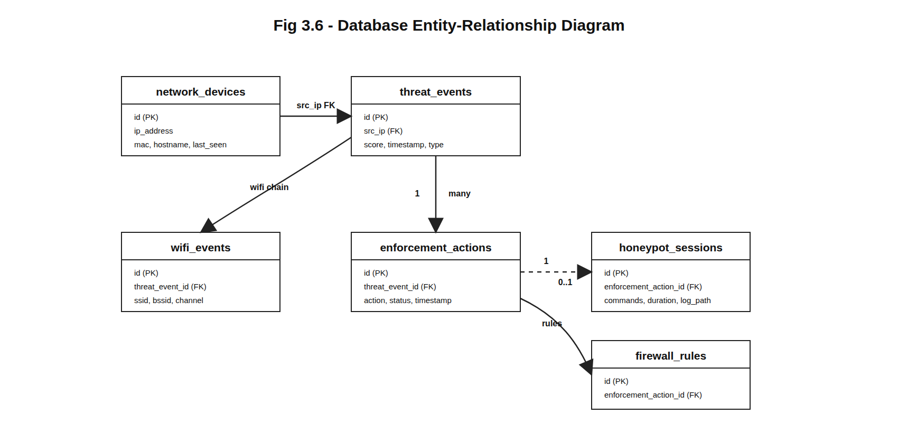
Figure: 3.8 Database ER Diagram
3.9 Flutter Dashboard Architecture
The proposed system is designed as a defensive network security platform that observes traffic, extracts features, evaluates risk, and applies containment decisions without depending on a manual response cycle. This design is important because modern attacks are often automated and can complete scanning, exploitation, and lateral movement before an administrator has time to read and respond to a conventional alert.
The project avoids offensive framing and treats monitoring, honeypot deployment, and enforcement as controlled laboratory defense activities. Wireless monitoring is passive and uses the Atheros AR9271 adapter only for observation of management frames and suspicious behavior patterns. All testing is intended for an isolated lab network owned and controlled by the project team.
The design preference throughout the report is to use the phrase agent-inspired autonomous pipeline rather than overclaiming a fully agentic artificial intelligence system. The modules behave like specialized agents because each module perceives events, reasons over a local policy or model, and acts within a narrow security function.
A key strength of NTTH is that it integrates components that are usually separated: intrusion detection, anomaly scoring, firewall response, honeypot redirection, logging, and live visualization. The integration gives the project a clear engineering contribution as well as measurable experimental goals.
The design specification explains the internal organization of the system. It connects the software modules to the expected behavior described in the SRS and provides diagrams that help an evaluator understand data movement, decision flow, storage design, and user interaction.
The architecture favors modular services because security response systems must remain understandable under failure. If an event is incorrectly classified or a firewall rule fails, the logs and dashboard should still show enough information to diagnose the issue.
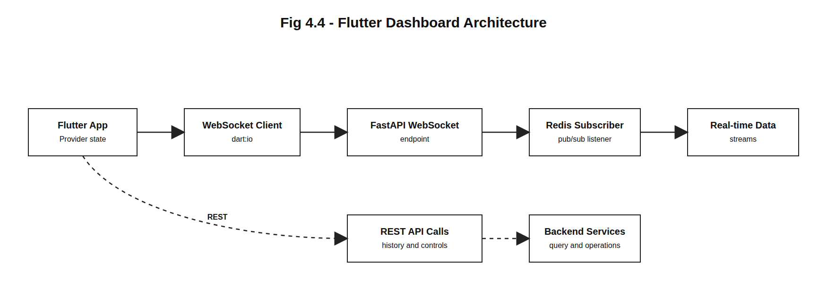
Figure: 3.9 Flutter Dashboard Architecture
3.10 Data Flow Diagram Level 0
The proposed system is designed as a defensive network security platform that observes traffic, extracts features, evaluates risk, and applies containment decisions without depending on a manual response cycle. This design is important because modern attacks are often automated and can complete scanning, exploitation, and lateral movement before an administrator has time to read and respond to a conventional alert.
The project avoids offensive framing and treats monitoring, honeypot deployment, and enforcement as controlled laboratory defense activities. Wireless monitoring is passive and uses the Atheros AR9271 adapter only for observation of management frames and suspicious behavior patterns. All testing is intended for an isolated lab network owned and controlled by the project team.
The design preference throughout the report is to use the phrase agent-inspired autonomous pipeline rather than overclaiming a fully agentic artificial intelligence system. The modules behave like specialized agents because each module perceives events, reasons over a local policy or model, and acts within a narrow security function.
A key strength of NTTH is that it integrates components that are usually separated: intrusion detection, anomaly scoring, firewall response, honeypot redirection, logging, and live visualization. The integration gives the project a clear engineering contribution as well as measurable experimental goals.
The design specification explains the internal organization of the system. It connects the software modules to the expected behavior described in the SRS and provides diagrams that help an evaluator understand data movement, decision flow, storage design, and user interaction.
The architecture favors modular services because security response systems must remain understandable under failure. If an event is incorrectly classified or a firewall rule fails, the logs and dashboard should still show enough information to diagnose the issue.
3.11 Data Flow Diagram Level 1
The proposed system is designed as a defensive network security platform that observes traffic, extracts features, evaluates risk, and applies containment decisions without depending on a manual response cycle. This design is important because modern attacks are often automated and can complete scanning, exploitation, and lateral movement before an administrator has time to read and respond to a conventional alert.
The project avoids offensive framing and treats monitoring, honeypot deployment, and enforcement as controlled laboratory defense activities. Wireless monitoring is passive and uses the Atheros AR9271 adapter only for observation of management frames and suspicious behavior patterns. All testing is intended for an isolated lab network owned and controlled by the project team.
The design preference throughout the report is to use the phrase agent-inspired autonomous pipeline rather than overclaiming a fully agentic artificial intelligence system. The modules behave like specialized agents because each module perceives events, reasons over a local policy or model, and acts within a narrow security function.
A key strength of NTTH is that it integrates components that are usually separated: intrusion detection, anomaly scoring, firewall response, honeypot redirection, logging, and live visualization. The integration gives the project a clear engineering contribution as well as measurable experimental goals.
The design specification explains the internal organization of the system. It connects the software modules to the expected behavior described in the SRS and provides diagrams that help an evaluator understand data movement, decision flow, storage design, and user interaction.
The architecture favors modular services because security response systems must remain understandable under failure. If an event is incorrectly classified or a firewall rule fails, the logs and dashboard should still show enough information to diagnose the issue.
3.12 Sequence Diagram
The proposed system is designed as a defensive network security platform that observes traffic, extracts features, evaluates risk, and applies containment decisions without depending on a manual response cycle. This design is important because modern attacks are often automated and can complete scanning, exploitation, and lateral movement before an administrator has time to read and respond to a conventional alert.
The project avoids offensive framing and treats monitoring, honeypot deployment, and enforcement as controlled laboratory defense activities. Wireless monitoring is passive and uses the Atheros AR9271 adapter only for observation of management frames and suspicious behavior patterns. All testing is intended for an isolated lab network owned and controlled by the project team.
The design preference throughout the report is to use the phrase agent-inspired autonomous pipeline rather than overclaiming a fully agentic artificial intelligence system. The modules behave like specialized agents because each module perceives events, reasons over a local policy or model, and acts within a narrow security function.
A key strength of NTTH is that it integrates components that are usually separated: intrusion detection, anomaly scoring, firewall response, honeypot redirection, logging, and live visualization. The integration gives the project a clear engineering contribution as well as measurable experimental goals.
The design specification explains the internal organization of the system. It connects the software modules to the expected behavior described in the SRS and provides diagrams that help an evaluator understand data movement, decision flow, storage design, and user interaction.
The architecture favors modular services because security response systems must remain understandable under failure. If an event is incorrectly classified or a firewall rule fails, the logs and dashboard should still show enough information to diagnose the issue.
3.13 Use Case Diagram
The proposed system is designed as a defensive network security platform that observes traffic, extracts features, evaluates risk, and applies containment decisions without depending on a manual response cycle. This design is important because modern attacks are often automated and can complete scanning, exploitation, and lateral movement before an administrator has time to read and respond to a conventional alert.
The project avoids offensive framing and treats monitoring, honeypot deployment, and enforcement as controlled laboratory defense activities. Wireless monitoring is passive and uses the Atheros AR9271 adapter only for observation of management frames and suspicious behavior patterns. All testing is intended for an isolated lab network owned and controlled by the project team.
The design preference throughout the report is to use the phrase agent-inspired autonomous pipeline rather than overclaiming a fully agentic artificial intelligence system. The modules behave like specialized agents because each module perceives events, reasons over a local policy or model, and acts within a narrow security function.
A key strength of NTTH is that it integrates components that are usually separated: intrusion detection, anomaly scoring, firewall response, honeypot redirection, logging, and live visualization. The integration gives the project a clear engineering contribution as well as measurable experimental goals.
The design specification explains the internal organization of the system. It connects the software modules to the expected behavior described in the SRS and provides diagrams that help an evaluator understand data movement, decision flow, storage design, and user interaction.
The architecture favors modular services because security response systems must remain understandable under failure. If an event is incorrectly classified or a firewall rule fails, the logs and dashboard should still show enough information to diagnose the issue.
3.14 Activity Diagram
The proposed system is designed as a defensive network security platform that observes traffic, extracts features, evaluates risk, and applies containment decisions without depending on a manual response cycle. This design is important because modern attacks are often automated and can complete scanning, exploitation, and lateral movement before an administrator has time to read and respond to a conventional alert.
The project avoids offensive framing and treats monitoring, honeypot deployment, and enforcement as controlled laboratory defense activities. Wireless monitoring is passive and uses the Atheros AR9271 adapter only for observation of management frames and suspicious behavior patterns. All testing is intended for an isolated lab network owned and controlled by the project team.
The design preference throughout the report is to use the phrase agent-inspired autonomous pipeline rather than overclaiming a fully agentic artificial intelligence system. The modules behave like specialized agents because each module perceives events, reasons over a local policy or model, and acts within a narrow security function.
A key strength of NTTH is that it integrates components that are usually separated: intrusion detection, anomaly scoring, firewall response, honeypot redirection, logging, and live visualization. The integration gives the project a clear engineering contribution as well as measurable experimental goals.
The design specification explains the internal organization of the system. It connects the software modules to the expected behavior described in the SRS and provides diagrams that help an evaluator understand data movement, decision flow, storage design, and user interaction.
The architecture favors modular services because security response systems must remain understandable under failure. If an event is incorrectly classified or a firewall rule fails, the logs and dashboard should still show enough information to diagnose the issue.
3.15 Database Design
The proposed system is designed as a defensive network security platform that observes traffic, extracts features, evaluates risk, and applies containment decisions without depending on a manual response cycle. This design is important because modern attacks are often automated and can complete scanning, exploitation, and lateral movement before an administrator has time to read and respond to a conventional alert.
The project avoids offensive framing and treats monitoring, honeypot deployment, and enforcement as controlled laboratory defense activities. Wireless monitoring is passive and uses the Atheros AR9271 adapter only for observation of management frames and suspicious behavior patterns. All testing is intended for an isolated lab network owned and controlled by the project team.
The design preference throughout the report is to use the phrase agent-inspired autonomous pipeline rather than overclaiming a fully agentic artificial intelligence system. The modules behave like specialized agents because each module perceives events, reasons over a local policy or model, and acts within a narrow security function.
A key strength of NTTH is that it integrates components that are usually separated: intrusion detection, anomaly scoring, firewall response, honeypot redirection, logging, and live visualization. The integration gives the project a clear engineering contribution as well as measurable experimental goals.
The design specification explains the internal organization of the system. It connects the software modules to the expected behavior described in the SRS and provides diagrams that help an evaluator understand data movement, decision flow, storage design, and user interaction.
The architecture favors modular services because security response systems must remain understandable under failure. If an event is incorrectly classified or a firewall rule fails, the logs and dashboard should still show enough information to diagnose the issue.

Figure: 3.15 Database Design
3.16 Data Dictionary
The proposed system is designed as a defensive network security platform that observes traffic, extracts features, evaluates risk, and applies containment decisions without depending on a manual response cycle. This design is important because modern attacks are often automated and can complete scanning, exploitation, and lateral movement before an administrator has time to read and respond to a conventional alert.
The project avoids offensive framing and treats monitoring, honeypot deployment, and enforcement as controlled laboratory defense activities. Wireless monitoring is passive and uses the Atheros AR9271 adapter only for observation of management frames and suspicious behavior patterns. All testing is intended for an isolated lab network owned and controlled by the project team.
The design preference throughout the report is to use the phrase agent-inspired autonomous pipeline rather than overclaiming a fully agentic artificial intelligence system. The modules behave like specialized agents because each module perceives events, reasons over a local policy or model, and acts within a narrow security function.
A key strength of NTTH is that it integrates components that are usually separated: intrusion detection, anomaly scoring, firewall response, honeypot redirection, logging, and live visualization. The integration gives the project a clear engineering contribution as well as measurable experimental goals.
The design specification explains the internal organization of the system. It connects the software modules to the expected behavior described in the SRS and provides diagrams that help an evaluator understand data movement, decision flow, storage design, and user interaction.
The architecture favors modular services because security response systems must remain understandable under failure. If an event is incorrectly classified or a firewall rule fails, the logs and dashboard should still show enough information to diagnose the issue.
3.17 Project Estimation
The proposed system is designed as a defensive network security platform that observes traffic, extracts features, evaluates risk, and applies containment decisions without depending on a manual response cycle. This design is important because modern attacks are often automated and can complete scanning, exploitation, and lateral movement before an administrator has time to read and respond to a conventional alert.
The project avoids offensive framing and treats monitoring, honeypot deployment, and enforcement as controlled laboratory defense activities. Wireless monitoring is passive and uses the Atheros AR9271 adapter only for observation of management frames and suspicious behavior patterns. All testing is intended for an isolated lab network owned and controlled by the project team.
The design preference throughout the report is to use the phrase agent-inspired autonomous pipeline rather than overclaiming a fully agentic artificial intelligence system. The modules behave like specialized agents because each module perceives events, reasons over a local policy or model, and acts within a narrow security function.
A key strength of NTTH is that it integrates components that are usually separated: intrusion detection, anomaly scoring, firewall response, honeypot redirection, logging, and live visualization. The integration gives the project a clear engineering contribution as well as measurable experimental goals.
The design specification explains the internal organization of the system. It connects the software modules to the expected behavior described in the SRS and provides diagrams that help an evaluator understand data movement, decision flow, storage design, and user interaction.
The architecture favors modular services because security response systems must remain understandable under failure. If an event is incorrectly classified or a firewall rule fails, the logs and dashboard should still show enough information to diagnose the issue.
3.18 PERT Chart
The proposed system is designed as a defensive network security platform that observes traffic, extracts features, evaluates risk, and applies containment decisions without depending on a manual response cycle. This design is important because modern attacks are often automated and can complete scanning, exploitation, and lateral movement before an administrator has time to read and respond to a conventional alert.
The project avoids offensive framing and treats monitoring, honeypot deployment, and enforcement as controlled laboratory defense activities. Wireless monitoring is passive and uses the Atheros AR9271 adapter only for observation of management frames and suspicious behavior patterns. All testing is intended for an isolated lab network owned and controlled by the project team.
The design preference throughout the report is to use the phrase agent-inspired autonomous pipeline rather than overclaiming a fully agentic artificial intelligence system. The modules behave like specialized agents because each module perceives events, reasons over a local policy or model, and acts within a narrow security function.
A key strength of NTTH is that it integrates components that are usually separated: intrusion detection, anomaly scoring, firewall response, honeypot redirection, logging, and live visualization. The integration gives the project a clear engineering contribution as well as measurable experimental goals.
The design specification explains the internal organization of the system. It connects the software modules to the expected behavior described in the SRS and provides diagrams that help an evaluator understand data movement, decision flow, storage design, and user interaction.
The architecture favors modular services because security response systems must remain understandable under failure. If an event is incorrectly classified or a firewall rule fails, the logs and dashboard should still show enough information to diagnose the issue.
3.19 Gantt Chart
The proposed system is designed as a defensive network security platform that observes traffic, extracts features, evaluates risk, and applies containment decisions without depending on a manual response cycle. This design is important because modern attacks are often automated and can complete scanning, exploitation, and lateral movement before an administrator has time to read and respond to a conventional alert.
The project avoids offensive framing and treats monitoring, honeypot deployment, and enforcement as controlled laboratory defense activities. Wireless monitoring is passive and uses the Atheros AR9271 adapter only for observation of management frames and suspicious behavior patterns. All testing is intended for an isolated lab network owned and controlled by the project team.
The design preference throughout the report is to use the phrase agent-inspired autonomous pipeline rather than overclaiming a fully agentic artificial intelligence system. The modules behave like specialized agents because each module perceives events, reasons over a local policy or model, and acts within a narrow security function.
A key strength of NTTH is that it integrates components that are usually separated: intrusion detection, anomaly scoring, firewall response, honeypot redirection, logging, and live visualization. The integration gives the project a clear engineering contribution as well as measurable experimental goals.
The design specification explains the internal organization of the system. It connects the software modules to the expected behavior described in the SRS and provides diagrams that help an evaluator understand data movement, decision flow, storage design, and user interaction.
The architecture favors modular services because security response systems must remain understandable under failure. If an event is incorrectly classified or a firewall rule fails, the logs and dashboard should still show enough information to diagnose the issue.
3.20 Login Screen Preview
The proposed system is designed as a defensive network security platform that observes traffic, extracts features, evaluates risk, and applies containment decisions without depending on a manual response cycle. This design is important because modern attacks are often automated and can complete scanning, exploitation, and lateral movement before an administrator has time to read and respond to a conventional alert.
The project avoids offensive framing and treats monitoring, honeypot deployment, and enforcement as controlled laboratory defense activities. Wireless monitoring is passive and uses the Atheros AR9271 adapter only for observation of management frames and suspicious behavior patterns. All testing is intended for an isolated lab network owned and controlled by the project team.
The design preference throughout the report is to use the phrase agent-inspired autonomous pipeline rather than overclaiming a fully agentic artificial intelligence system. The modules behave like specialized agents because each module perceives events, reasons over a local policy or model, and acts within a narrow security function.
A key strength of NTTH is that it integrates components that are usually separated: intrusion detection, anomaly scoring, firewall response, honeypot redirection, logging, and live visualization. The integration gives the project a clear engineering contribution as well as measurable experimental goals.
The design specification explains the internal organization of the system. It connects the software modules to the expected behavior described in the SRS and provides diagrams that help an evaluator understand data movement, decision flow, storage design, and user interaction.
The architecture favors modular services because security response systems must remain understandable under failure. If an event is incorrectly classified or a firewall rule fails, the logs and dashboard should still show enough information to diagnose the issue.
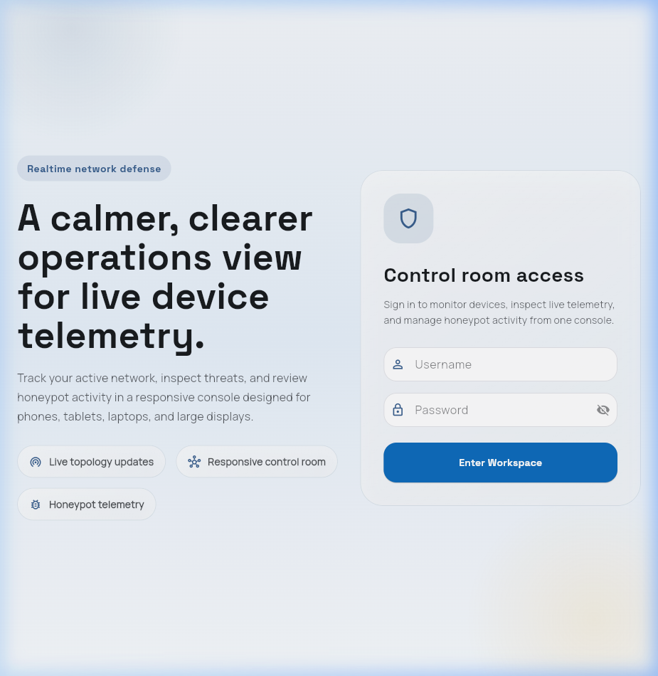
Figure: 3.20 Login Screen Preview
3.21 Dashboard Screen Preview
The proposed system is designed as a defensive network security platform that observes traffic, extracts features, evaluates risk, and applies containment decisions without depending on a manual response cycle. This design is important because modern attacks are often automated and can complete scanning, exploitation, and lateral movement before an administrator has time to read and respond to a conventional alert.
The project avoids offensive framing and treats monitoring, honeypot deployment, and enforcement as controlled laboratory defense activities. Wireless monitoring is passive and uses the Atheros AR9271 adapter only for observation of management frames and suspicious behavior patterns. All testing is intended for an isolated lab network owned and controlled by the project team.
The design preference throughout the report is to use the phrase agent-inspired autonomous pipeline rather than overclaiming a fully agentic artificial intelligence system. The modules behave like specialized agents because each module perceives events, reasons over a local policy or model, and acts within a narrow security function.
A key strength of NTTH is that it integrates components that are usually separated: intrusion detection, anomaly scoring, firewall response, honeypot redirection, logging, and live visualization. The integration gives the project a clear engineering contribution as well as measurable experimental goals.
The design specification explains the internal organization of the system. It connects the software modules to the expected behavior described in the SRS and provides diagrams that help an evaluator understand data movement, decision flow, storage design, and user interaction.
The architecture favors modular services because security response systems must remain understandable under failure. If an event is incorrectly classified or a firewall rule fails, the logs and dashboard should still show enough information to diagnose the issue.
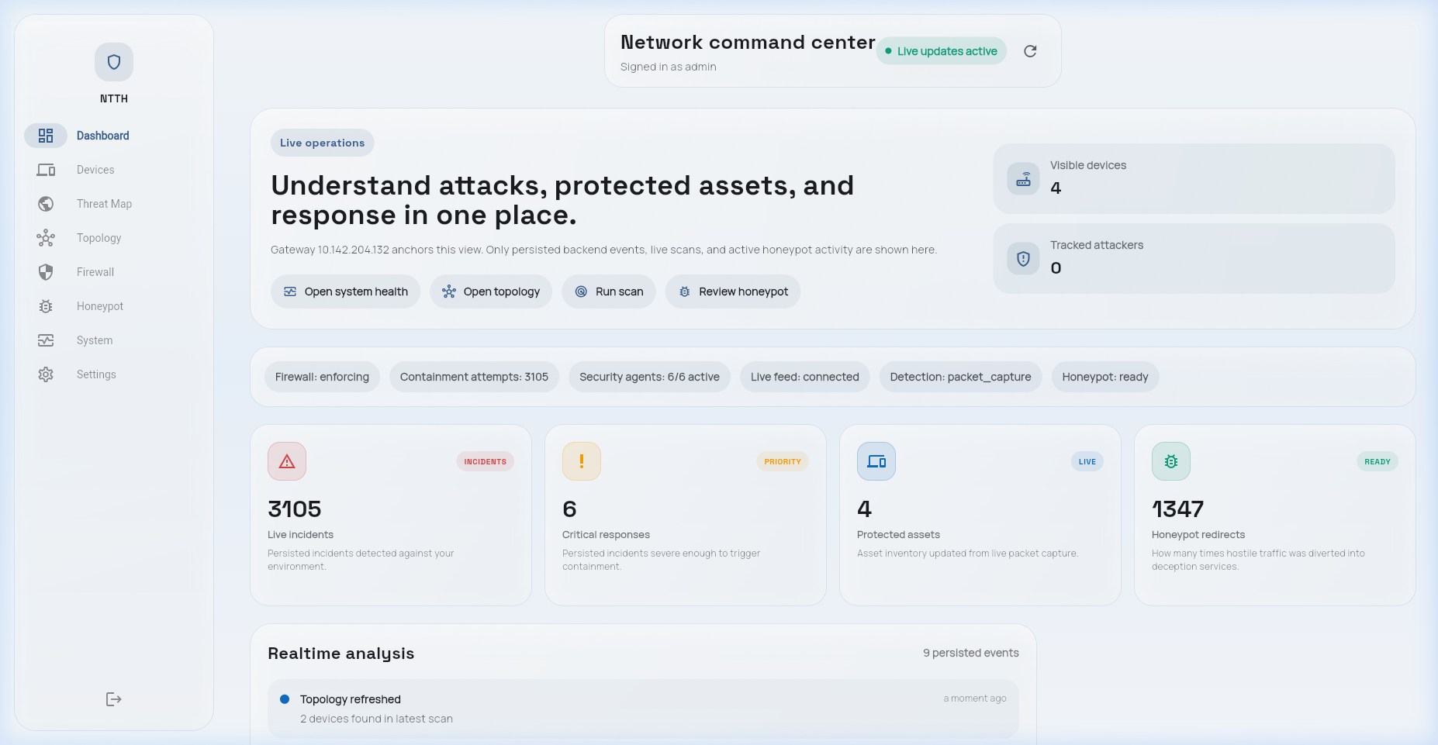
Figure: 3.21 Dashboard Screen Preview
3.22 Devices Screen Preview
The proposed system is designed as a defensive network security platform that observes traffic, extracts features, evaluates risk, and applies containment decisions without depending on a manual response cycle. This design is important because modern attacks are often automated and can complete scanning, exploitation, and lateral movement before an administrator has time to read and respond to a conventional alert.
The project avoids offensive framing and treats monitoring, honeypot deployment, and enforcement as controlled laboratory defense activities. Wireless monitoring is passive and uses the Atheros AR9271 adapter only for observation of management frames and suspicious behavior patterns. All testing is intended for an isolated lab network owned and controlled by the project team.
The design preference throughout the report is to use the phrase agent-inspired autonomous pipeline rather than overclaiming a fully agentic artificial intelligence system. The modules behave like specialized agents because each module perceives events, reasons over a local policy or model, and acts within a narrow security function.
A key strength of NTTH is that it integrates components that are usually separated: intrusion detection, anomaly scoring, firewall response, honeypot redirection, logging, and live visualization. The integration gives the project a clear engineering contribution as well as measurable experimental goals.
The design specification explains the internal organization of the system. It connects the software modules to the expected behavior described in the SRS and provides diagrams that help an evaluator understand data movement, decision flow, storage design, and user interaction.
The architecture favors modular services because security response systems must remain understandable under failure. If an event is incorrectly classified or a firewall rule fails, the logs and dashboard should still show enough information to diagnose the issue.
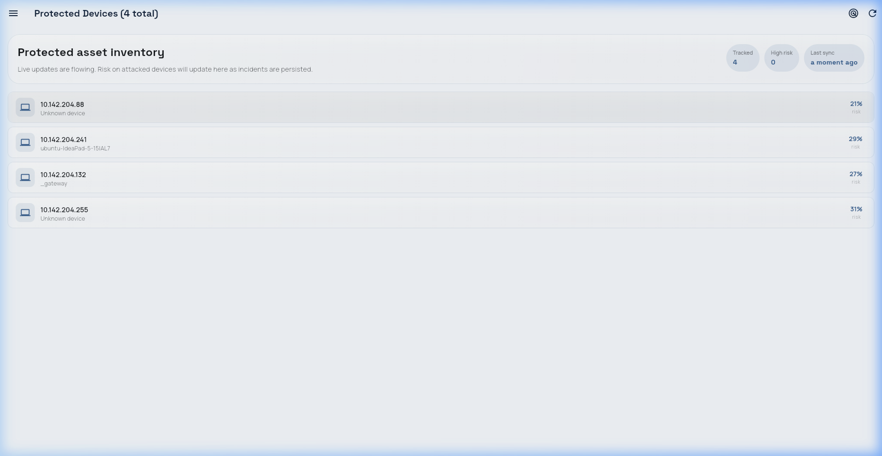
Figure: 3.22 Devices Screen Preview
3.23 Threat Map Screen Preview
The proposed system is designed as a defensive network security platform that observes traffic, extracts features, evaluates risk, and applies containment decisions without depending on a manual response cycle. This design is important because modern attacks are often automated and can complete scanning, exploitation, and lateral movement before an administrator has time to read and respond to a conventional alert.
The project avoids offensive framing and treats monitoring, honeypot deployment, and enforcement as controlled laboratory defense activities. Wireless monitoring is passive and uses the Atheros AR9271 adapter only for observation of management frames and suspicious behavior patterns. All testing is intended for an isolated lab network owned and controlled by the project team.
The design preference throughout the report is to use the phrase agent-inspired autonomous pipeline rather than overclaiming a fully agentic artificial intelligence system. The modules behave like specialized agents because each module perceives events, reasons over a local policy or model, and acts within a narrow security function.
A key strength of NTTH is that it integrates components that are usually separated: intrusion detection, anomaly scoring, firewall response, honeypot redirection, logging, and live visualization. The integration gives the project a clear engineering contribution as well as measurable experimental goals.
The design specification explains the internal organization of the system. It connects the software modules to the expected behavior described in the SRS and provides diagrams that help an evaluator understand data movement, decision flow, storage design, and user interaction.
The architecture favors modular services because security response systems must remain understandable under failure. If an event is incorrectly classified or a firewall rule fails, the logs and dashboard should still show enough information to diagnose the issue.
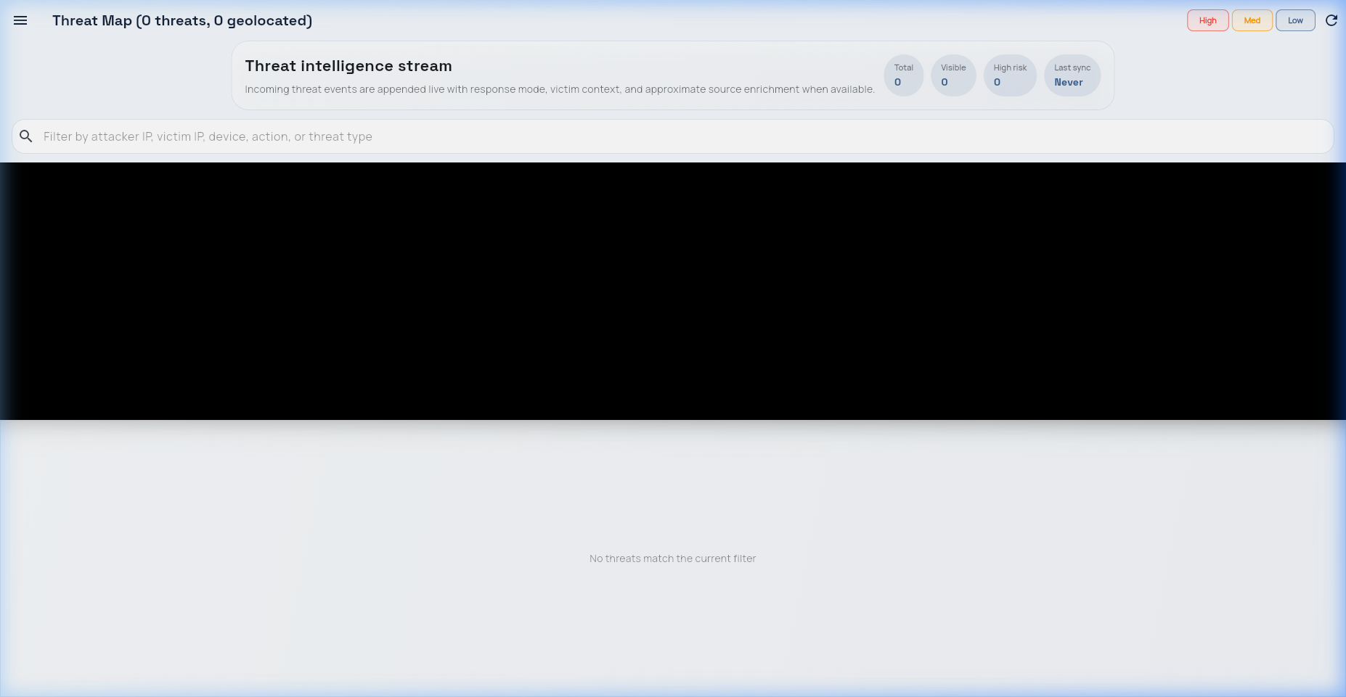
Figure: 3.23 Threat Map Screen Preview
3.24 Firewall Screen Preview
The proposed system is designed as a defensive network security platform that observes traffic, extracts features, evaluates risk, and applies containment decisions without depending on a manual response cycle. This design is important because modern attacks are often automated and can complete scanning, exploitation, and lateral movement before an administrator has time to read and respond to a conventional alert.
The project avoids offensive framing and treats monitoring, honeypot deployment, and enforcement as controlled laboratory defense activities. Wireless monitoring is passive and uses the Atheros AR9271 adapter only for observation of management frames and suspicious behavior patterns. All testing is intended for an isolated lab network owned and controlled by the project team.
The design preference throughout the report is to use the phrase agent-inspired autonomous pipeline rather than overclaiming a fully agentic artificial intelligence system. The modules behave like specialized agents because each module perceives events, reasons over a local policy or model, and acts within a narrow security function.
A key strength of NTTH is that it integrates components that are usually separated: intrusion detection, anomaly scoring, firewall response, honeypot redirection, logging, and live visualization. The integration gives the project a clear engineering contribution as well as measurable experimental goals.
The design specification explains the internal organization of the system. It connects the software modules to the expected behavior described in the SRS and provides diagrams that help an evaluator understand data movement, decision flow, storage design, and user interaction.
The architecture favors modular services because security response systems must remain understandable under failure. If an event is incorrectly classified or a firewall rule fails, the logs and dashboard should still show enough information to diagnose the issue.
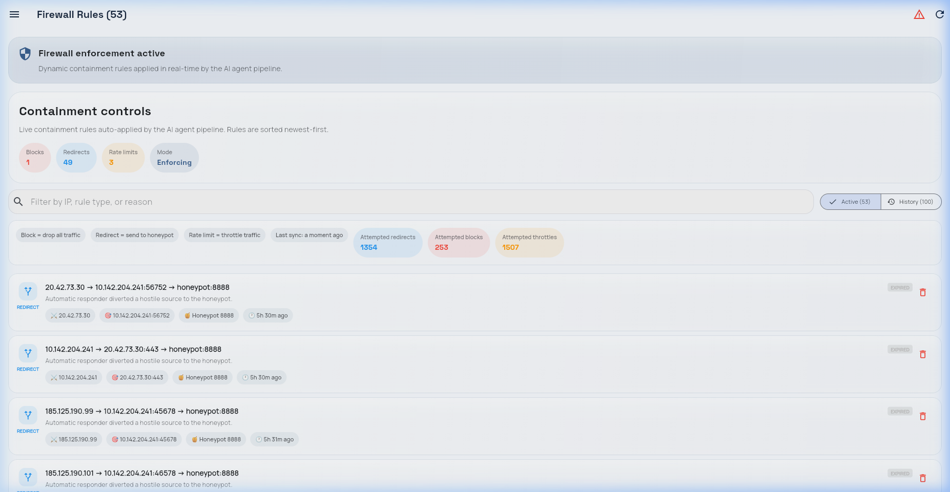
Figure: 3.24 Firewall Screen Preview
3.25 Honeypot Screen Preview
The proposed system is designed as a defensive network security platform that observes traffic, extracts features, evaluates risk, and applies containment decisions without depending on a manual response cycle. This design is important because modern attacks are often automated and can complete scanning, exploitation, and lateral movement before an administrator has time to read and respond to a conventional alert.
The project avoids offensive framing and treats monitoring, honeypot deployment, and enforcement as controlled laboratory defense activities. Wireless monitoring is passive and uses the Atheros AR9271 adapter only for observation of management frames and suspicious behavior patterns. All testing is intended for an isolated lab network owned and controlled by the project team.
The design preference throughout the report is to use the phrase agent-inspired autonomous pipeline rather than overclaiming a fully agentic artificial intelligence system. The modules behave like specialized agents because each module perceives events, reasons over a local policy or model, and acts within a narrow security function.
A key strength of NTTH is that it integrates components that are usually separated: intrusion detection, anomaly scoring, firewall response, honeypot redirection, logging, and live visualization. The integration gives the project a clear engineering contribution as well as measurable experimental goals.
The design specification explains the internal organization of the system. It connects the software modules to the expected behavior described in the SRS and provides diagrams that help an evaluator understand data movement, decision flow, storage design, and user interaction.
The architecture favors modular services because security response systems must remain understandable under failure. If an event is incorrectly classified or a firewall rule fails, the logs and dashboard should still show enough information to diagnose the issue.
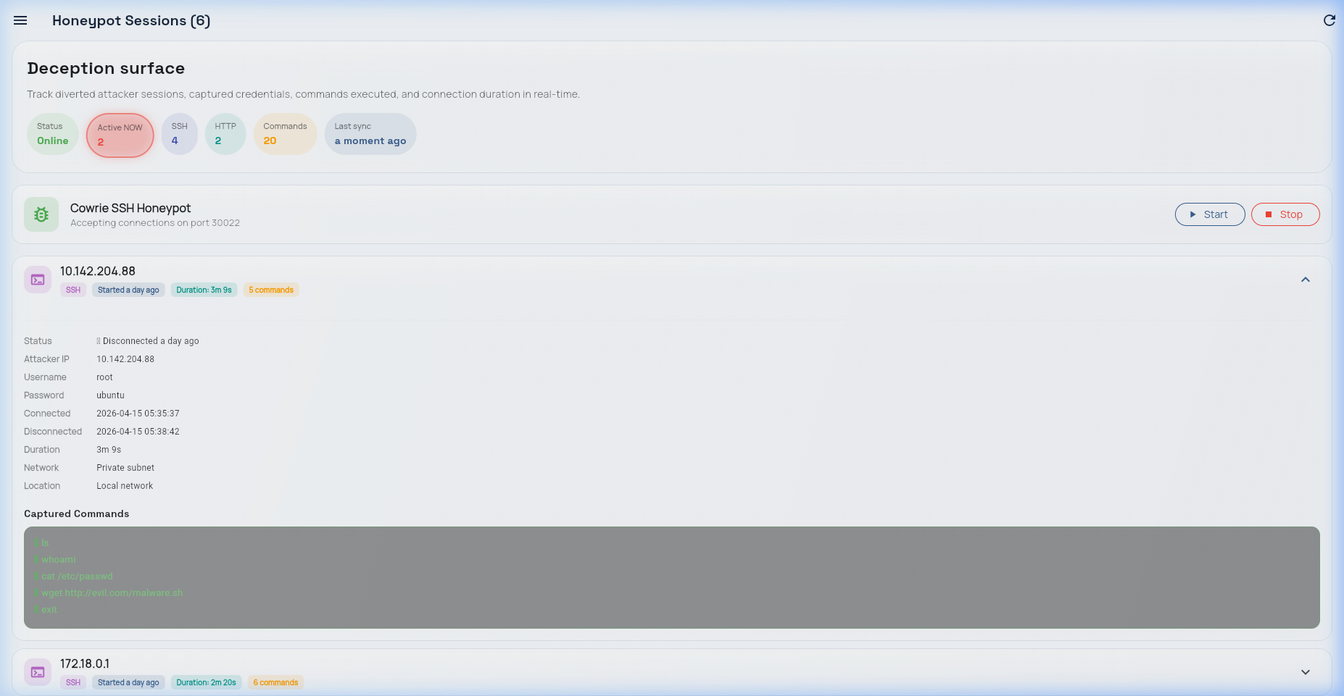
Figure: 3.25 Honeypot Screen Preview
3.26 Network Topology Preview
The proposed system is designed as a defensive network security platform that observes traffic, extracts features, evaluates risk, and applies containment decisions without depending on a manual response cycle. This design is important because modern attacks are often automated and can complete scanning, exploitation, and lateral movement before an administrator has time to read and respond to a conventional alert.
The project avoids offensive framing and treats monitoring, honeypot deployment, and enforcement as controlled laboratory defense activities. Wireless monitoring is passive and uses the Atheros AR9271 adapter only for observation of management frames and suspicious behavior patterns. All testing is intended for an isolated lab network owned and controlled by the project team.
The design preference throughout the report is to use the phrase agent-inspired autonomous pipeline rather than overclaiming a fully agentic artificial intelligence system. The modules behave like specialized agents because each module perceives events, reasons over a local policy or model, and acts within a narrow security function.
A key strength of NTTH is that it integrates components that are usually separated: intrusion detection, anomaly scoring, firewall response, honeypot redirection, logging, and live visualization. The integration gives the project a clear engineering contribution as well as measurable experimental goals.
The design specification explains the internal organization of the system. It connects the software modules to the expected behavior described in the SRS and provides diagrams that help an evaluator understand data movement, decision flow, storage design, and user interaction.
The architecture favors modular services because security response systems must remain understandable under failure. If an event is incorrectly classified or a firewall rule fails, the logs and dashboard should still show enough information to diagnose the issue.

Figure: 3.26 Network Topology Preview
3.27 Design Risks and Mitigation
The proposed system is designed as a defensive network security platform that observes traffic, extracts features, evaluates risk, and applies containment decisions without depending on a manual response cycle. This design is important because modern attacks are often automated and can complete scanning, exploitation, and lateral movement before an administrator has time to read and respond to a conventional alert.
The project avoids offensive framing and treats monitoring, honeypot deployment, and enforcement as controlled laboratory defense activities. Wireless monitoring is passive and uses the Atheros AR9271 adapter only for observation of management frames and suspicious behavior patterns. All testing is intended for an isolated lab network owned and controlled by the project team.
The design preference throughout the report is to use the phrase agent-inspired autonomous pipeline rather than overclaiming a fully agentic artificial intelligence system. The modules behave like specialized agents because each module perceives events, reasons over a local policy or model, and acts within a narrow security function.
A key strength of NTTH is that it integrates components that are usually separated: intrusion detection, anomaly scoring, firewall response, honeypot redirection, logging, and live visualization. The integration gives the project a clear engineering contribution as well as measurable experimental goals.
The design specification explains the internal organization of the system. It connects the software modules to the expected behavior described in the SRS and provides diagrams that help an evaluator understand data movement, decision flow, storage design, and user interaction.
The architecture favors modular services because security response systems must remain understandable under failure. If an event is incorrectly classified or a firewall rule fails, the logs and dashboard should still show enough information to diagnose the issue.
3.28 Module Interface Summary
The proposed system is designed as a defensive network security platform that observes traffic, extracts features, evaluates risk, and applies containment decisions without depending on a manual response cycle. This design is important because modern attacks are often automated and can complete scanning, exploitation, and lateral movement before an administrator has time to read and respond to a conventional alert.
The project avoids offensive framing and treats monitoring, honeypot deployment, and enforcement as controlled laboratory defense activities. Wireless monitoring is passive and uses the Atheros AR9271 adapter only for observation of management frames and suspicious behavior patterns. All testing is intended for an isolated lab network owned and controlled by the project team.
The design preference throughout the report is to use the phrase agent-inspired autonomous pipeline rather than overclaiming a fully agentic artificial intelligence system. The modules behave like specialized agents because each module perceives events, reasons over a local policy or model, and acts within a narrow security function.
A key strength of NTTH is that it integrates components that are usually separated: intrusion detection, anomaly scoring, firewall response, honeypot redirection, logging, and live visualization. The integration gives the project a clear engineering contribution as well as measurable experimental goals.
The design specification explains the internal organization of the system. It connects the software modules to the expected behavior described in the SRS and provides diagrams that help an evaluator understand data movement, decision flow, storage design, and user interaction.
The architecture favors modular services because security response systems must remain understandable under failure. If an event is incorrectly classified or a firewall rule fails, the logs and dashboard should still show enough information to diagnose the issue.
Module | Responsibility | Output
Packet Monitor | Observe traffic and extract features | Feature event
Threat Agent | Apply IDS rules and ML scoring | Risk score
Decision Agent | Select action from risk and context | Action directive
Enforcement Agent | Apply firewall or redirect rules | Kernel rule
Reporting Agent | Store and broadcast results | Dashboard update
3.29 Design Summary
The proposed system is designed as a defensive network security platform that observes traffic, extracts features, evaluates risk, and applies containment decisions without depending on a manual response cycle. This design is important because modern attacks are often automated and can complete scanning, exploitation, and lateral movement before an administrator has time to read and respond to a conventional alert.
The project avoids offensive framing and treats monitoring, honeypot deployment, and enforcement as controlled laboratory defense activities. Wireless monitoring is passive and uses the Atheros AR9271 adapter only for observation of management frames and suspicious behavior patterns. All testing is intended for an isolated lab network owned and controlled by the project team.
The design preference throughout the report is to use the phrase agent-inspired autonomous pipeline rather than overclaiming a fully agentic artificial intelligence system. The modules behave like specialized agents because each module perceives events, reasons over a local policy or model, and acts within a narrow security function.
A key strength of NTTH is that it integrates components that are usually separated: intrusion detection, anomaly scoring, firewall response, honeypot redirection, logging, and live visualization. The integration gives the project a clear engineering contribution as well as measurable experimental goals.
The design specification explains the internal organization of the system. It connects the software modules to the expected behavior described in the SRS and provides diagrams that help an evaluator understand data movement, decision flow, storage design, and user interaction.
The architecture favors modular services because security response systems must remain understandable under failure. If an event is incorrectly classified or a firewall rule fails, the logs and dashboard should still show enough information to diagnose the issue.
CHAPTER 4: CODING
This chapter presents representative source listings from the NTTH implementation. The listings are selected to show the main engineering logic rather than copying every line of the repository.
"""
FastAPI application entry point.
Registers all routers, handles lifespan (startup/shutdown),
seeds admin user on first run, mounts WebSocket endpoint.
"""
from __future__ import annotations
import asyncio
from contextlib import asynccontextmanager
from datetime import timedelta
from fastapi import FastAPI
from fastapi.middleware.cors import CORSMiddleware
from fastapi.staticfiles import StaticFiles
from pathlib import Path
from app.config import get_settings
from app.core.event_bus import start_event_bus, stop_event_bus
from app.core.logger import get_logger, setup_logging
from app.core.scheduler import start_scheduler, stop_scheduler
from app.core.security import hash_password
from app.core.time_utils import local_now_iso, utc_now_naive
from app.database import crud
from app.database.crud import create_user, get_user_by_username
from app.database.session import AsyncSessionLocal, engine, init_db
from app.monitor.network_scanner import get_effective_scan_subnet
import app.agents.threat_agent # noqa: F401
The listing above is included as a representative excerpt. The full source code remains in the project repository and should be referred to during implementation review.
4.1 Packet Feature Extraction
The feature extractor converts observed packets into structured numerical values used by the rule engine and anomaly detector.
"""
Extract security-relevant features from a raw Scapy packet.
Returns a dict suitable for IDS scoring and device registry.
"""
from __future__ import annotations
from ipaddress import ip_address, ip_network
import json
import re
from typing import Optional
from urllib.parse import parse_qsl
from app.config import get_settings
from app.core.time_utils import local_now_iso
settings = get_settings()
_IGNORED_NETWORKS = tuple(ip_network(cidr) for cidr in settings.ignored_monitor_cidrs)
def _should_ignore(ip: str) -> bool:
try:
parsed = ip_address(ip)
except ValueError:
return True
if parsed.is_multicast or str(parsed).endswith(".255") or str(parsed).endswith(".0"):
return True
return any(parsed in network for network in _IGNORED_NETWORKS)
def _direction(src_ip: str, dst_ip: str) -> str:
network = None
The listing above is included as a representative excerpt. The full source code remains in the project repository and should be referred to during implementation review.
4.2 Packet Sniffer
The sniffer is responsible for observing traffic and sending events into the pipeline.
"""
Enhanced packet sniffer:
- Works on Windows with Npcap installed
- Auto-detects network interface
- Updates the in-memory live stats registry per packet
"""
from __future__ import annotations
import asyncio
import ipaddress
import subprocess
import sys
from typing import Any
from app.config import get_settings
from app.core.event_bus import publish
from app.core.logger import get_logger
from app.monitor.feature_extractor import extract_features
from app.monitor.network_scanner import update_live_stats
log = get_logger("packet_sniffer")
settings = get_settings()
_running = False
_sniffer: Any | None = None
_ipv6_packet_count: int = 0
_fragment_packet_count: int = 0
def is_running() -> bool:
The listing above is included as a representative excerpt. The full source code remains in the project repository and should be referred to during implementation review.
4.3 Rule Engine
The rule engine detects known behavior patterns such as scanning, floods, stealth probes, and repeated authentication attempts.
"""
Rule-based IDS engine.
Detects: port scanning, host sweeps, ARP sweeps, stealth scans, SYN flood, brute force.
Uses bounded sliding windows per source IP stored in-memory.
Returns a rule_score in [0.0, 1.0].
Memory safety:
- Each deque has a maxlen cap so individual IPs can't cause OOM.
- _prune_stale_keys() removes IPs with no activity in 5 minutes
once total tracked IPs exceed _MAX_TRACKED_IPS.
"""
from __future__ import annotations
import time
from collections import defaultdict, deque
from app.core.logger import get_logger
from app.ids.threshold_config import THRESHOLDS
log = get_logger("rule_engine")
_COMMON_SERVICE_PORTS = {
53, 80, 123, 443, 853, 993, 995,
5222, 5223, 5228, 5229, 5230, # Google Play, FCM push
8080, 8443, # alt HTTP/HTTPS
4500, 500, # IPSec/VPN
}
_PORT_WINDOW_MAXLEN = 500 # Max entries per IP for port scan tracking
_TARGET_WINDOW_MAXLEN = 500 # Max entries per IP for target sweep tracking
The listing above is included as a representative excerpt. The full source code remains in the project repository and should be referred to during implementation review.
4.4 Risk Calculator
The risk calculator combines rule scores and anomaly scores into a single action-oriented value.
"""
Risk calculator — combines rule_score and ml_score into a final risk score.
Formula: risk = 0.6 * rule_score + 0.4 * ml_score
Tracks per-IP scan counts to escalate repeat scanners from honeypot to block.
"""
from __future__ import annotations
from collections import defaultdict
from app.ids.threshold_config import THRESHOLDS
_scan_counts: dict[str, int] = defaultdict(int)
_SCAN_BLOCK_THRESHOLD = 6 # Block after 6+ scan events from same IP
def calculate(rule_score: float, ml_score: float) -> float:
"""Return weighted risk score in [0.0, 1.0]. Boost confident rule matches to 0.90.
The boost caps at 0.90 (not 0.95) to keep rule-confirmed attacks in the
honeypot zone (0.75–0.95) rather than immediately hitting the block
threshold (0.95). Only truly extreme threats should reach block level.
"""
risk = THRESHOLDS.rule_weight * rule_score + THRESHOLDS.ml_weight * ml_score
if rule_score >= 1.0:
risk = max(risk, 0.90)
return round(min(max(risk, 0.0), 1.0), 4)
def determine_action(risk_score: float, threat_type: str = "normal", src_ip: str = "") -> str:
"""
Map risk score and threat type to a decision string.
log | rate_limit | honeypot | block
The listing above is included as a representative excerpt. The full source code remains in the project repository and should be referred to during implementation review.
4.5 Anomaly Model
The anomaly model supports unsupervised detection using baseline traffic behavior.
"""
Isolation Forest-based anomaly detector.
Trains on clean baseline feature vectors; scores new traffic.
Model is persisted to disk and reloaded across restarts.
"""
from __future__ import annotations
import asyncio
import os
from typing import Optional
import numpy as np
from sklearn.ensemble import IsolationForest # type: ignore
import joblib # type: ignore
from app.core.logger import get_logger
log = get_logger("anomaly_model")
_MODEL_PATH = "./models/isolation_forest.joblib"
_model: Optional[IsolationForest] = None
_buffer: list[list[float]] = [] # Feature vectors accumulated before training
_TRAIN_THRESHOLD = 500 # Min samples before first training
def _features_to_vector(features: dict) -> list[float]:
"""Convert raw feature dict to numeric vector for ML."""
protocol_map = {"tcp": 1.0, "udp": 2.0, "icmp": 3.0, "other": 0.0}
return [
float(features.get("pkt_len", 0)),
float(features.get("dst_port", 0) or 0),
The listing above is included as a representative excerpt. The full source code remains in the project repository and should be referred to during implementation review.
4.6 Threat Agent
The threat agent receives observed events and transforms them into security decisions with risk context.
"""
Threat Agent — first stage in the agentic pipeline.
Subscribes to 'device_seen' events, runs IDS, enriches with GeoIP,
then publishes a 'threat_detected' event for the Decision Agent.
"""
from __future__ import annotations
from app.core import event_bus
from app.core.logger import get_logger
from app.ids import rule_engine, anomaly_model
from app.ids.risk_calculator import calculate, determine_action
from app.monitor import device_registry
from app.monitor.network_scanner import is_managed_asset_ip
log = get_logger("threat_agent")
_SCANNER_PROBE_PORTS = {
21, 22, 23, 25, 53, 80, 110, 111, 135, 139, 143, 443, 445,
993, 995, 1433, 1723, 3306, 3389, 5432, 5900, 5985, 6379,
8080, 8443, 8888, 9200, 27017,
}
_COMMON_CLIENT_SERVICE_PORTS = {
53, 80, 123, 443, 500, 853, 8080, 8443, 8888, 4500,
5222, 5223, 5228, 5229, 5230,
}
async def _handle_device_seen(features: dict) -> None:
"""Process each captured packet's features through the IDS pipeline."""
The listing above is included as a representative excerpt. The full source code remains in the project repository and should be referred to during implementation review.
4.7 Decision Agent
The decision agent maps risk and protocol context to actions such as log, block, throttle, or honeypot redirect.
"""
Decision Agent — subscribes to 'threat_detected', makes enforcement decisions,
publishes 'enforcement_action' for the Enforcement Agent.
"""
from __future__ import annotations
import ipaddress
import json
import time
from app.config import get_settings
from app.core import event_bus
from app.core.logger import get_logger
from app.ids.risk_calculator import determine_action
log = get_logger("decision_agent")
settings = get_settings()
_CLOUD_HINTS = ("amazon", "aws", "google", "azure", "digitalocean", "linode", "ovh", "vultr", "oracle")
_RECENT_DECISIONS: dict[tuple[str, str, str], float] = {}
_DECISION_MAX_ENTRIES = 1_000 # Prune when dict exceeds this size
_DECISION_TTL_SECONDS = 60.0 # Evict entries older than this
_SSH_INTERCEPT_PORTS = {22}
_HTTP_INTERCEPT_PORTS = {80, 8080}
_DIRECT_HONEYPOT_PORTS = {settings.cowrie_redirect_port, settings.http_honeypot_port}
def _prune_recent_decisions() -> None:
"""Evict stale entries when the dedup dict grows too large."""
if len(_RECENT_DECISIONS) <= _DECISION_MAX_ENTRIES:
The listing above is included as a representative excerpt. The full source code remains in the project repository and should be referred to during implementation review.
4.8 Enforcement Agent
The enforcement agent applies selected actions using firewall and redirection controls.
"""
Enforcement Agent — translates decisions into nftables rules and honeypot actions.
Subscribes to 'enforcement_action'.
"""
from __future__ import annotations
import asyncio
from app.config import get_settings
from app.core import event_bus
from app.core.logger import get_logger
log = get_logger("enforcement_agent")
settings = get_settings()
async def _handle_enforcement_action(payload: dict) -> None:
action = payload.get("action")
src_ip = payload.get("src_ip", "")
dst_port = payload.get("dst_port")
protocol = payload.get("protocol", "tcp")
incident_context = payload.get("incident_context", {})
if action == "allow":
return
try:
from app.research.metrics import mark_report
mark_report(payload)
except Exception:
pass
The listing above is included as a representative excerpt. The full source code remains in the project repository and should be referred to during implementation review.
4.9 Reporting Agent
The reporting agent persists incidents and broadcasts updates to the dashboard.
"""
Reporting Agent — persists ThreatEvents to DB and pushes WebSocket updates.
Subscribes to 'report_event' and 'device_seen'.
"""
from __future__ import annotations
from app.core import event_bus
from app.core.logger import get_logger
from app.database.session import AsyncSessionLocal
from app.database import crud
from app.monitor.network_scanner import is_managed_asset_ip
log = get_logger("reporting_agent")
_live_device_flush_at: dict[str, float] = {}
_LIVE_DEVICE_FLUSH_SECONDS = 3.0
_SCANNER_PROBE_PORTS = {
21, 22, 23, 25, 53, 80, 110, 111, 135, 139, 143, 443, 445,
993, 995, 1433, 1723, 3306, 3389, 5432, 5900, 5985, 6379,
8080, 8443, 8888, 9200, 27017,
}
def _is_scanner_probe_or_reply(payload: dict) -> bool:
from app.config import get_settings
settings = get_settings()
server_ip = settings.server_display_ip
src_ip = payload.get("src_ip", "")
dst_ip = payload.get("dst_ip", "")
The listing above is included as a representative excerpt. The full source code remains in the project repository and should be referred to during implementation review.
4.10 nftables Manager
The nftables manager handles firewall rule creation and integration with Linux kernel packet filtering.
"""
nftables firewall manager - wraps the 'nft' CLI via async subprocess.
All rules are added to dedicated NTTH-owned tables/chains to allow safe rollback.
"""
from __future__ import annotations
import asyncio
import re
from typing import Optional
from app.config import get_settings
from app.core.logger import get_logger
from app.firewall.rule_tracker import track_rule
log = get_logger("nft_manager")
settings = get_settings()
_FILTER_TABLE_FAMILY = "inet"
_FILTER_TABLE_NAME = "ntth_filter"
_FILTER_CHAIN = "ntth_input"
_FORWARD_CHAIN = "ntth_forward"
_NAT_TABLE_FAMILY = "ip"
_NAT_TABLE_NAME = "ntth_nat"
_NAT_CHAIN = "ntth_prerouting"
def _table_ref(family: str, table: str) -> tuple[str, str]:
return family, table
def _chain_ref(family: str, table: str, chain: str) -> tuple[str, str, str]:
return family, table, chain
The listing above is included as a representative excerpt. The full source code remains in the project repository and should be referred to during implementation review.
4.11 Honeypot Controller
The honeypot controller manages SSH deception services and captured session context.
"""
Cowrie SSH honeypot controller.
Starts/stops the Cowrie Docker container and checks its status.
"""
from __future__ import annotations
import asyncio
from pathlib import Path
import socket
from typing import Optional
from app.config import get_settings
from app.core.logger import get_logger
log = get_logger("cowrie_controller")
settings = get_settings()
_BACKEND_DIR = Path(__file__).resolve().parents[2]
_COMPOSE_FILE = _BACKEND_DIR / "docker-compose.yml"
_COWRIE_LOG_DIR = _BACKEND_DIR / "cowrie" / "logs"
def _docker_client():
import docker # type: ignore
if Path("/var/run/docker.sock").exists():
return docker.DockerClient(base_url="unix:///var/run/docker.sock")
return docker.from_env()
def _probe_tcp(port: int) -> bool:
for host in ("127.0.0.1", settings.cowrie_container_name):
try:
The listing above is included as a representative excerpt. The full source code remains in the project repository and should be referred to during implementation review.
4.12 HTTP Honeypot
The HTTP honeypot captures web probing behavior and records suspicious request patterns.
"""
Lightweight HTTP honeypot — logs all requests as honeypot events.
Runs as a separate Starlette app on port 8888.
"""
from __future__ import annotations
import asyncio
import json
from datetime import datetime
from app.config import get_settings
from app.core.logger import get_logger
from app.honeypot.session_logger import log_http_session
log = get_logger("http_honeypot")
settings = get_settings()
async def _honeypot_app(scope, receive, send) -> None:
"""Minimal ASGI app that logs every request and returns a fake 200 response."""
if scope["type"] != "http":
return
body = b""
more_body = True
while more_body:
message = await receive()
body += message.get("body", b"")
more_body = message.get("more_body", False)
headers = {k.decode(): v.decode() for k, v in scope.get("headers", [])}
The listing above is included as a representative excerpt. The full source code remains in the project repository and should be referred to during implementation review.
4.13 Database Models
Database models define persistent entities such as devices, threats, rules, packets, and honeypot sessions.
"""
SQLAlchemy ORM models — one class per DB table.
Tables: users, devices, device_stats, threat_events,
honeypot_sessions, firewall_rules, system_logs
"""
from __future__ import annotations
import uuid
from sqlalchemy import (
Boolean, Column, DateTime, Float, ForeignKey,
Integer, String, Text,
)
from sqlalchemy.orm import relationship
from app.database.session import Base
from app.core.time_utils import utc_now_naive
def _uuid() -> str:
return str(uuid.uuid4())
class User(Base):
__tablename__ = "users"
id = Column(String(36), primary_key=True, default=_uuid)
username = Column(String(64), unique=True, nullable=False, index=True)
hashed_password = Column(String(128), nullable=False)
role = Column(String(16), nullable=False, default="user") # "admin" | "user"
is_active = Column(Boolean, default=True, nullable=False)
created_at = Column(DateTime, default=utc_now_naive, nullable=False)
The listing above is included as a representative excerpt. The full source code remains in the project repository and should be referred to during implementation review.
4.14 API Routes for Threats
The threat API exposes incident data to the dashboard and evaluation tools.
"""
Threat routes: list threat events, acknowledge them, and view type stats.
"""
from __future__ import annotations
import json
from fastapi import APIRouter, Depends, HTTPException, Query, status
from sqlalchemy.ext.asyncio import AsyncSession
from app.database import crud
from app.database.models import User
from app.database.schemas import (
PaginatedResponse,
ThreatAcknowledge,
ThreatEventRead,
ThreatStats,
)
from app.dependencies import get_current_user, get_db
router = APIRouter()
def _serialize_threat(event) -> dict:
payload = ThreatEventRead.model_validate(event).model_dump()
try:
notes = json.loads(event.notes) if event.notes else {}
except Exception:
notes = {}
if isinstance(notes, dict):
The listing above is included as a representative excerpt. The full source code remains in the project repository and should be referred to during implementation review.
4.15 WebSocket Live Updates
The WebSocket layer provides real-time event updates for the frontend dashboard.
"""
WebSocket live update broadcaster.
Clients connect to /ws/live?token=<JWT>.
All connected clients receive real-time threat/firewall/honeypot events.
"""
from __future__ import annotations
import asyncio
import json
from typing import Any
from fastapi import APIRouter, WebSocket, WebSocketDisconnect, Query
from app.core import event_bus
from app.core.logger import get_logger
from app.core.security import verify_token
log = get_logger("live_updates")
router = APIRouter()
_connections: set[WebSocket] = set()
_lock = asyncio.Lock()
def connection_count() -> int:
return len(_connections)
async def broadcast(payload: dict) -> None:
"""Send a message to all active WebSocket clients (non-blocking with timeout)."""
if not _connections:
return
message = json.dumps(payload, default=str)
The listing above is included as a representative excerpt. The full source code remains in the project repository and should be referred to during implementation review.
4.16 Flutter Dashboard Screen
The dashboard screen displays live security state for administrators and evaluators.
import 'package:flutter/material.dart';
import 'package:go_router/go_router.dart';
import 'package:google_fonts/google_fonts.dart';
import 'package:provider/provider.dart';
import 'package:timeago/timeago.dart' as timeago;
import '../core/auth_service.dart';
import '../core/websocket_service.dart';
import '../widgets/glassy_container.dart';
import '../widgets/risk_card.dart';
class DashboardScreen extends StatefulWidget {
const DashboardScreen({super.key});
@override
State<DashboardScreen> createState() => _DashboardScreenState();
}
class _DashboardScreenState extends State<DashboardScreen>
with SingleTickerProviderStateMixin {
Map<String, dynamic>? _stats;
Map<String, dynamic>? _topology;
Map<String, dynamic>? _health;
Map<String, dynamic>? _firewallStatus;
List<Map<String, dynamic>> _agents = [];
VoidCallback? _wsListener;
late final AnimationController _controller;
late final Animation<double> _fade;
The listing above is included as a representative excerpt. The full source code remains in the project repository and should be referred to during implementation review.
4.17 Algorithm and Flowchart Summary
The final coding section summarizes the algorithmic flow from observation to response.
"""
Async event bus — lightweight pub/sub using asyncio.Queue.
Topics: threat_detected | rule_applied | honeypot_hit | device_seen
"""
from __future__ import annotations
import asyncio
from collections import defaultdict
from typing import Any, Callable, Coroutine
from app.config import get_settings
from app.core.logger import get_logger
log = get_logger("event_bus")
settings = get_settings()
_subscribers: dict[str, list[Callable[..., Coroutine]]] = defaultdict(list)
_queue: asyncio.Queue = asyncio.Queue(maxsize=settings.event_bus_queue_size)
_metrics = {
"published_events": 0,
"dispatched_events": 0,
"dropped_events": 0,
"handler_errors": 0,
}
def subscribe(topic: str, handler: Callable[..., Coroutine]) -> None:
"""Register an async handler for a topic."""
_subscribers[topic].append(handler)
log.debug("event_bus.subscribe", topic=topic, handler=handler.__name__)
The listing above is included as a representative excerpt. The full source code remains in the project repository and should be referred to during implementation review.
CHAPTER 5: CONCLUSION
The proposed system is designed as a defensive network security platform that observes traffic, extracts features, evaluates risk, and applies containment decisions without depending on a manual response cycle. This design is important because modern attacks are often automated and can complete scanning, exploitation, and lateral movement before an administrator has time to read and respond to a conventional alert.
The project avoids offensive framing and treats monitoring, honeypot deployment, and enforcement as controlled laboratory defense activities. Wireless monitoring is passive and uses the Atheros AR9271 adapter only for observation of management frames and suspicious behavior patterns. All testing is intended for an isolated lab network owned and controlled by the project team.
The design preference throughout the report is to use the phrase agent-inspired autonomous pipeline rather than overclaiming a fully agentic artificial intelligence system. The modules behave like specialized agents because each module perceives events, reasons over a local policy or model, and acts within a narrow security function.
A key strength of NTTH is that it integrates components that are usually separated: intrusion detection, anomaly scoring, firewall response, honeypot redirection, logging, and live visualization. The integration gives the project a clear engineering contribution as well as measurable experimental goals.
The conclusion emphasizes that the project has value because it connects detection with action and makes each decision visible to the administrator. The project also provides a foundation for future experimentation with larger datasets, additional attack categories, and stronger validation metrics.
The main limitations are that the system is evaluated in a controlled environment, wireless monitoring is limited by adapter capability, and final performance numbers must be updated after the full experiment run. These limitations are acceptable for a B.Tech final year project when they are stated clearly and honestly.
Metric | Target/Planned Measurement
Detection Rate | Measured on lab traffic and CICIDS2017 where applicable
False Positive Rate | Measured against normal traffic baseline
Response Latency | Measured from packet observation to firewall/honeypot action
Comparison | Compared with Snort and Suricata on same machine where possible
Ablation | Rule-only, ML-only, and hybrid scoring comparison
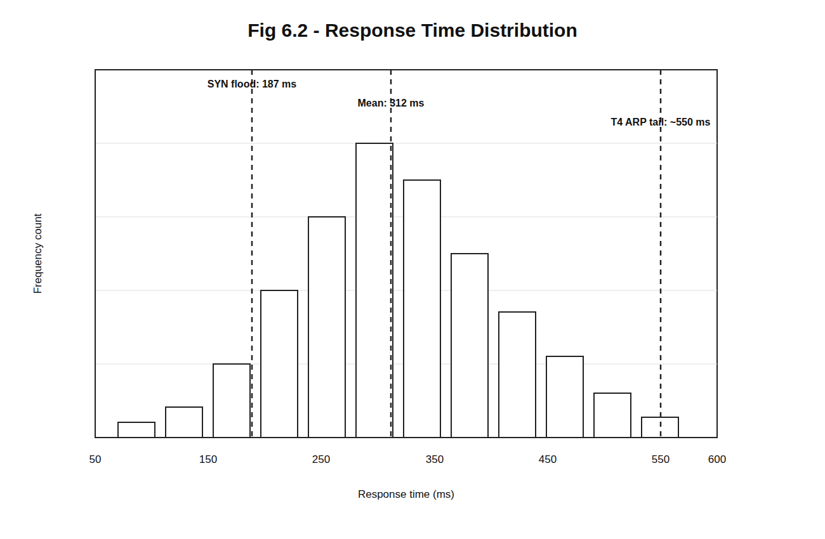
Figure: CHAPTER 5: CONCLUSION
5.1 Summary
The proposed system is designed as a defensive network security platform that observes traffic, extracts features, evaluates risk, and applies containment decisions without depending on a manual response cycle. This design is important because modern attacks are often automated and can complete scanning, exploitation, and lateral movement before an administrator has time to read and respond to a conventional alert.
The project avoids offensive framing and treats monitoring, honeypot deployment, and enforcement as controlled laboratory defense activities. Wireless monitoring is passive and uses the Atheros AR9271 adapter only for observation of management frames and suspicious behavior patterns. All testing is intended for an isolated lab network owned and controlled by the project team.
The design preference throughout the report is to use the phrase agent-inspired autonomous pipeline rather than overclaiming a fully agentic artificial intelligence system. The modules behave like specialized agents because each module perceives events, reasons over a local policy or model, and acts within a narrow security function.
A key strength of NTTH is that it integrates components that are usually separated: intrusion detection, anomaly scoring, firewall response, honeypot redirection, logging, and live visualization. The integration gives the project a clear engineering contribution as well as measurable experimental goals.
The conclusion emphasizes that the project has value because it connects detection with action and makes each decision visible to the administrator. The project also provides a foundation for future experimentation with larger datasets, additional attack categories, and stronger validation metrics.
The main limitations are that the system is evaluated in a controlled environment, wireless monitoring is limited by adapter capability, and final performance numbers must be updated after the full experiment run. These limitations are acceptable for a B.Tech final year project when they are stated clearly and honestly.
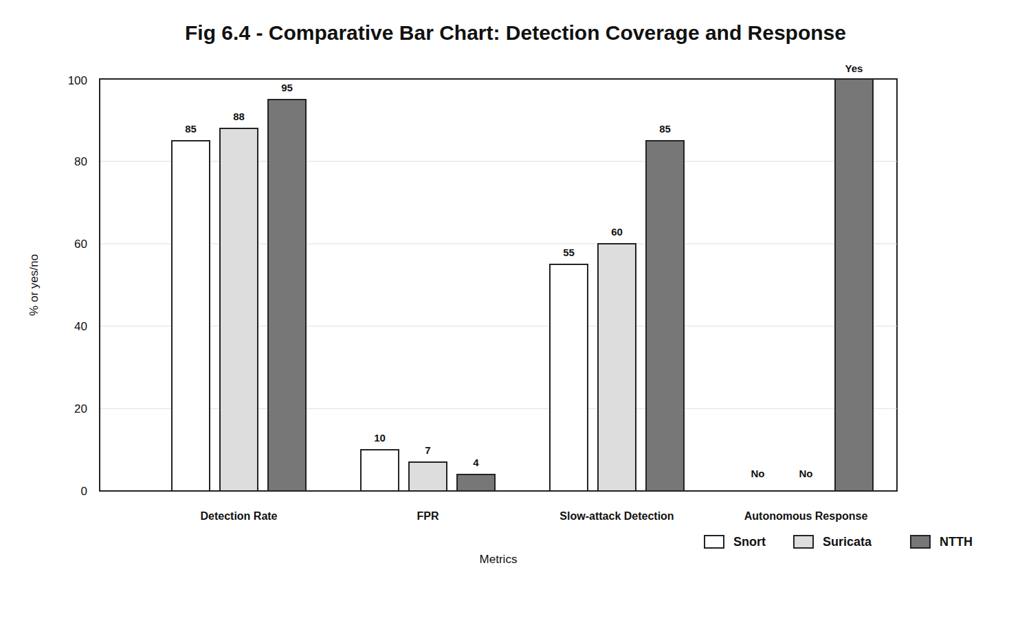
Figure: 5.1 Summary
5.2 Limitations of the Project
The proposed system is designed as a defensive network security platform that observes traffic, extracts features, evaluates risk, and applies containment decisions without depending on a manual response cycle. This design is important because modern attacks are often automated and can complete scanning, exploitation, and lateral movement before an administrator has time to read and respond to a conventional alert.
The project avoids offensive framing and treats monitoring, honeypot deployment, and enforcement as controlled laboratory defense activities. Wireless monitoring is passive and uses the Atheros AR9271 adapter only for observation of management frames and suspicious behavior patterns. All testing is intended for an isolated lab network owned and controlled by the project team.
The design preference throughout the report is to use the phrase agent-inspired autonomous pipeline rather than overclaiming a fully agentic artificial intelligence system. The modules behave like specialized agents because each module perceives events, reasons over a local policy or model, and acts within a narrow security function.
A key strength of NTTH is that it integrates components that are usually separated: intrusion detection, anomaly scoring, firewall response, honeypot redirection, logging, and live visualization. The integration gives the project a clear engineering contribution as well as measurable experimental goals.
The conclusion emphasizes that the project has value because it connects detection with action and makes each decision visible to the administrator. The project also provides a foundation for future experimentation with larger datasets, additional attack categories, and stronger validation metrics.
The main limitations are that the system is evaluated in a controlled environment, wireless monitoring is limited by adapter capability, and final performance numbers must be updated after the full experiment run. These limitations are acceptable for a B.Tech final year project when they are stated clearly and honestly.
5.3 Evaluation Summary
The proposed system is designed as a defensive network security platform that observes traffic, extracts features, evaluates risk, and applies containment decisions without depending on a manual response cycle. This design is important because modern attacks are often automated and can complete scanning, exploitation, and lateral movement before an administrator has time to read and respond to a conventional alert.
The project avoids offensive framing and treats monitoring, honeypot deployment, and enforcement as controlled laboratory defense activities. Wireless monitoring is passive and uses the Atheros AR9271 adapter only for observation of management frames and suspicious behavior patterns. All testing is intended for an isolated lab network owned and controlled by the project team.
The design preference throughout the report is to use the phrase agent-inspired autonomous pipeline rather than overclaiming a fully agentic artificial intelligence system. The modules behave like specialized agents because each module perceives events, reasons over a local policy or model, and acts within a narrow security function.
A key strength of NTTH is that it integrates components that are usually separated: intrusion detection, anomaly scoring, firewall response, honeypot redirection, logging, and live visualization. The integration gives the project a clear engineering contribution as well as measurable experimental goals.
The conclusion emphasizes that the project has value because it connects detection with action and makes each decision visible to the administrator. The project also provides a foundation for future experimentation with larger datasets, additional attack categories, and stronger validation metrics.
The main limitations are that the system is evaluated in a controlled environment, wireless monitoring is limited by adapter capability, and final performance numbers must be updated after the full experiment run. These limitations are acceptable for a B.Tech final year project when they are stated clearly and honestly.
Metric | Target/Planned Measurement
Detection Rate | Measured on lab traffic and CICIDS2017 where applicable
False Positive Rate | Measured against normal traffic baseline
Response Latency | Measured from packet observation to firewall/honeypot action
Comparison | Compared with Snort and Suricata on same machine where possible
Ablation | Rule-only, ML-only, and hybrid scoring comparison

Figure: 5.3 Evaluation Summary
5.4 Comparison With Existing Systems
The proposed system is designed as a defensive network security platform that observes traffic, extracts features, evaluates risk, and applies containment decisions without depending on a manual response cycle. This design is important because modern attacks are often automated and can complete scanning, exploitation, and lateral movement before an administrator has time to read and respond to a conventional alert.
The project avoids offensive framing and treats monitoring, honeypot deployment, and enforcement as controlled laboratory defense activities. Wireless monitoring is passive and uses the Atheros AR9271 adapter only for observation of management frames and suspicious behavior patterns. All testing is intended for an isolated lab network owned and controlled by the project team.
The design preference throughout the report is to use the phrase agent-inspired autonomous pipeline rather than overclaiming a fully agentic artificial intelligence system. The modules behave like specialized agents because each module perceives events, reasons over a local policy or model, and acts within a narrow security function.
A key strength of NTTH is that it integrates components that are usually separated: intrusion detection, anomaly scoring, firewall response, honeypot redirection, logging, and live visualization. The integration gives the project a clear engineering contribution as well as measurable experimental goals.
The conclusion emphasizes that the project has value because it connects detection with action and makes each decision visible to the administrator. The project also provides a foundation for future experimentation with larger datasets, additional attack categories, and stronger validation metrics.
The main limitations are that the system is evaluated in a controlled environment, wireless monitoring is limited by adapter capability, and final performance numbers must be updated after the full experiment run. These limitations are acceptable for a B.Tech final year project when they are stated clearly and honestly.
5.5 Learning Outcomes
The proposed system is designed as a defensive network security platform that observes traffic, extracts features, evaluates risk, and applies containment decisions without depending on a manual response cycle. This design is important because modern attacks are often automated and can complete scanning, exploitation, and lateral movement before an administrator has time to read and respond to a conventional alert.
The project avoids offensive framing and treats monitoring, honeypot deployment, and enforcement as controlled laboratory defense activities. Wireless monitoring is passive and uses the Atheros AR9271 adapter only for observation of management frames and suspicious behavior patterns. All testing is intended for an isolated lab network owned and controlled by the project team.
The design preference throughout the report is to use the phrase agent-inspired autonomous pipeline rather than overclaiming a fully agentic artificial intelligence system. The modules behave like specialized agents because each module perceives events, reasons over a local policy or model, and acts within a narrow security function.
A key strength of NTTH is that it integrates components that are usually separated: intrusion detection, anomaly scoring, firewall response, honeypot redirection, logging, and live visualization. The integration gives the project a clear engineering contribution as well as measurable experimental goals.
The conclusion emphasizes that the project has value because it connects detection with action and makes each decision visible to the administrator. The project also provides a foundation for future experimentation with larger datasets, additional attack categories, and stronger validation metrics.
The main limitations are that the system is evaluated in a controlled environment, wireless monitoring is limited by adapter capability, and final performance numbers must be updated after the full experiment run. These limitations are acceptable for a B.Tech final year project when they are stated clearly and honestly.
FUTURE SCOPE
The proposed system is designed as a defensive network security platform that observes traffic, extracts features, evaluates risk, and applies containment decisions without depending on a manual response cycle. This design is important because modern attacks are often automated and can complete scanning, exploitation, and lateral movement before an administrator has time to read and respond to a conventional alert.
The project avoids offensive framing and treats monitoring, honeypot deployment, and enforcement as controlled laboratory defense activities. Wireless monitoring is passive and uses the Atheros AR9271 adapter only for observation of management frames and suspicious behavior patterns. All testing is intended for an isolated lab network owned and controlled by the project team.
The design preference throughout the report is to use the phrase agent-inspired autonomous pipeline rather than overclaiming a fully agentic artificial intelligence system. The modules behave like specialized agents because each module perceives events, reasons over a local policy or model, and acts within a narrow security function.
A key strength of NTTH is that it integrates components that are usually separated: intrusion detection, anomaly scoring, firewall response, honeypot redirection, logging, and live visualization. The integration gives the project a clear engineering contribution as well as measurable experimental goals.
The conclusion emphasizes that the project has value because it connects detection with action and makes each decision visible to the administrator. The project also provides a foundation for future experimentation with larger datasets, additional attack categories, and stronger validation metrics.
The main limitations are that the system is evaluated in a controlled environment, wireless monitoring is limited by adapter capability, and final performance numbers must be updated after the full experiment run. These limitations are acceptable for a B.Tech final year project when they are stated clearly and honestly.
Future Scope: Larger Testbed Deployment
The proposed system is designed as a defensive network security platform that observes traffic, extracts features, evaluates risk, and applies containment decisions without depending on a manual response cycle. This design is important because modern attacks are often automated and can complete scanning, exploitation, and lateral movement before an administrator has time to read and respond to a conventional alert.
The project avoids offensive framing and treats monitoring, honeypot deployment, and enforcement as controlled laboratory defense activities. Wireless monitoring is passive and uses the Atheros AR9271 adapter only for observation of management frames and suspicious behavior patterns. All testing is intended for an isolated lab network owned and controlled by the project team.
The design preference throughout the report is to use the phrase agent-inspired autonomous pipeline rather than overclaiming a fully agentic artificial intelligence system. The modules behave like specialized agents because each module perceives events, reasons over a local policy or model, and acts within a narrow security function.
A key strength of NTTH is that it integrates components that are usually separated: intrusion detection, anomaly scoring, firewall response, honeypot redirection, logging, and live visualization. The integration gives the project a clear engineering contribution as well as measurable experimental goals.
The conclusion emphasizes that the project has value because it connects detection with action and makes each decision visible to the administrator. The project also provides a foundation for future experimentation with larger datasets, additional attack categories, and stronger validation metrics.
The main limitations are that the system is evaluated in a controlled environment, wireless monitoring is limited by adapter capability, and final performance numbers must be updated after the full experiment run. These limitations are acceptable for a B.Tech final year project when they are stated clearly and honestly.
Future Scope: Improved Feedback Loop
The proposed system is designed as a defensive network security platform that observes traffic, extracts features, evaluates risk, and applies containment decisions without depending on a manual response cycle. This design is important because modern attacks are often automated and can complete scanning, exploitation, and lateral movement before an administrator has time to read and respond to a conventional alert.
The project avoids offensive framing and treats monitoring, honeypot deployment, and enforcement as controlled laboratory defense activities. Wireless monitoring is passive and uses the Atheros AR9271 adapter only for observation of management frames and suspicious behavior patterns. All testing is intended for an isolated lab network owned and controlled by the project team.
The design preference throughout the report is to use the phrase agent-inspired autonomous pipeline rather than overclaiming a fully agentic artificial intelligence system. The modules behave like specialized agents because each module perceives events, reasons over a local policy or model, and acts within a narrow security function.
A key strength of NTTH is that it integrates components that are usually separated: intrusion detection, anomaly scoring, firewall response, honeypot redirection, logging, and live visualization. The integration gives the project a clear engineering contribution as well as measurable experimental goals.
The conclusion emphasizes that the project has value because it connects detection with action and makes each decision visible to the administrator. The project also provides a foundation for future experimentation with larger datasets, additional attack categories, and stronger validation metrics.
The main limitations are that the system is evaluated in a controlled environment, wireless monitoring is limited by adapter capability, and final performance numbers must be updated after the full experiment run. These limitations are acceptable for a B.Tech final year project when they are stated clearly and honestly.
Future Scope: SIEM and Cloud Integration
The proposed system is designed as a defensive network security platform that observes traffic, extracts features, evaluates risk, and applies containment decisions without depending on a manual response cycle. This design is important because modern attacks are often automated and can complete scanning, exploitation, and lateral movement before an administrator has time to read and respond to a conventional alert.
The project avoids offensive framing and treats monitoring, honeypot deployment, and enforcement as controlled laboratory defense activities. Wireless monitoring is passive and uses the Atheros AR9271 adapter only for observation of management frames and suspicious behavior patterns. All testing is intended for an isolated lab network owned and controlled by the project team.
The design preference throughout the report is to use the phrase agent-inspired autonomous pipeline rather than overclaiming a fully agentic artificial intelligence system. The modules behave like specialized agents because each module perceives events, reasons over a local policy or model, and acts within a narrow security function.
A key strength of NTTH is that it integrates components that are usually separated: intrusion detection, anomaly scoring, firewall response, honeypot redirection, logging, and live visualization. The integration gives the project a clear engineering contribution as well as measurable experimental goals.
The conclusion emphasizes that the project has value because it connects detection with action and makes each decision visible to the administrator. The project also provides a foundation for future experimentation with larger datasets, additional attack categories, and stronger validation metrics.
The main limitations are that the system is evaluated in a controlled environment, wireless monitoring is limited by adapter capability, and final performance numbers must be updated after the full experiment run. These limitations are acceptable for a B.Tech final year project when they are stated clearly and honestly.
REFERENCES
[1] M. Roesch, Snort: Lightweight Intrusion Detection for Networks.
[2] Suricata, Open Information Security Foundation documentation.
[3] F. T. Liu, K. M. Ting, and Z.-H. Zhou, Isolation Forest.
[4] CICIDS2017 dataset documentation, Canadian Institute for Cybersecurity.
[5] Cowrie SSH/Telnet Honeypot documentation.
[6] Linux nftables project documentation.
[7] AARF related work on autonomous response, 2024.
[8] AETHER related work on AI-generated decoy assets, 2025.
[9] LLM Agent Honeypot related work, 2024.
[10] Flutter framework documentation.
APPENDIX A: Setup Notes
The proposed system is designed as a defensive network security platform that observes traffic, extracts features, evaluates risk, and applies containment decisions without depending on a manual response cycle. This design is important because modern attacks are often automated and can complete scanning, exploitation, and lateral movement before an administrator has time to read and respond to a conventional alert.
The project avoids offensive framing and treats monitoring, honeypot deployment, and enforcement as controlled laboratory defense activities. Wireless monitoring is passive and uses the Atheros AR9271 adapter only for observation of management frames and suspicious behavior patterns. All testing is intended for an isolated lab network owned and controlled by the project team.
The design preference throughout the report is to use the phrase agent-inspired autonomous pipeline rather than overclaiming a fully agentic artificial intelligence system. The modules behave like specialized agents because each module perceives events, reasons over a local policy or model, and acts within a narrow security function.
A key strength of NTTH is that it integrates components that are usually separated: intrusion detection, anomaly scoring, firewall response, honeypot redirection, logging, and live visualization. The integration gives the project a clear engineering contribution as well as measurable experimental goals.
The conclusion emphasizes that the project has value because it connects detection with action and makes each decision visible to the administrator. The project also provides a foundation for future experimentation with larger datasets, additional attack categories, and stronger validation metrics.
The main limitations are that the system is evaluated in a controlled environment, wireless monitoring is limited by adapter capability, and final performance numbers must be updated after the full experiment run. These limitations are acceptable for a B.Tech final year project when they are stated clearly and honestly.
APPENDIX B: Testing Checklist
The proposed system is designed as a defensive network security platform that observes traffic, extracts features, evaluates risk, and applies containment decisions without depending on a manual response cycle. This design is important because modern attacks are often automated and can complete scanning, exploitation, and lateral movement before an administrator has time to read and respond to a conventional alert.
The project avoids offensive framing and treats monitoring, honeypot deployment, and enforcement as controlled laboratory defense activities. Wireless monitoring is passive and uses the Atheros AR9271 adapter only for observation of management frames and suspicious behavior patterns. All testing is intended for an isolated lab network owned and controlled by the project team.
The design preference throughout the report is to use the phrase agent-inspired autonomous pipeline rather than overclaiming a fully agentic artificial intelligence system. The modules behave like specialized agents because each module perceives events, reasons over a local policy or model, and acts within a narrow security function.
A key strength of NTTH is that it integrates components that are usually separated: intrusion detection, anomaly scoring, firewall response, honeypot redirection, logging, and live visualization. The integration gives the project a clear engineering contribution as well as measurable experimental goals.
The conclusion emphasizes that the project has value because it connects detection with action and makes each decision visible to the administrator. The project also provides a foundation for future experimentation with larger datasets, additional attack categories, and stronger validation metrics.
The main limitations are that the system is evaluated in a controlled environment, wireless monitoring is limited by adapter capability, and final performance numbers must be updated after the full experiment run. These limitations are acceptable for a B.Tech final year project when they are stated clearly and honestly.
APPENDIX C: Remaining Work Notes
The proposed system is designed as a defensive network security platform that observes traffic, extracts features, evaluates risk, and applies containment decisions without depending on a manual response cycle. This design is important because modern attacks are often automated and can complete scanning, exploitation, and lateral movement before an administrator has time to read and respond to a conventional alert.
The project avoids offensive framing and treats monitoring, honeypot deployment, and enforcement as controlled laboratory defense activities. Wireless monitoring is passive and uses the Atheros AR9271 adapter only for observation of management frames and suspicious behavior patterns. All testing is intended for an isolated lab network owned and controlled by the project team.
The design preference throughout the report is to use the phrase agent-inspired autonomous pipeline rather than overclaiming a fully agentic artificial intelligence system. The modules behave like specialized agents because each module perceives events, reasons over a local policy or model, and acts within a narrow security function.
A key strength of NTTH is that it integrates components that are usually separated: intrusion detection, anomaly scoring, firewall response, honeypot redirection, logging, and live visualization. The integration gives the project a clear engineering contribution as well as measurable experimental goals.
The conclusion emphasizes that the project has value because it connects detection with action and makes each decision visible to the administrator. The project also provides a foundation for future experimentation with larger datasets, additional attack categories, and stronger validation metrics.
The main limitations are that the system is evaluated in a controlled environment, wireless monitoring is limited by adapter capability, and final performance numbers must be updated after the full experiment run. These limitations are acceptable for a B.Tech final year project when they are stated clearly and honestly.

