Time series Forecast Proposal

Metrics: Impressions and Engagement rate

## Forecasts of the impression trends.:

The below graphs show the trend of impression for year 2022 and 2023 on daily and monthly frequency.

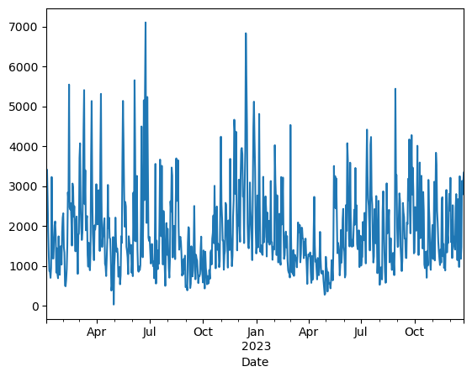

**Fig: Daily impressions for 2022 and 2023**

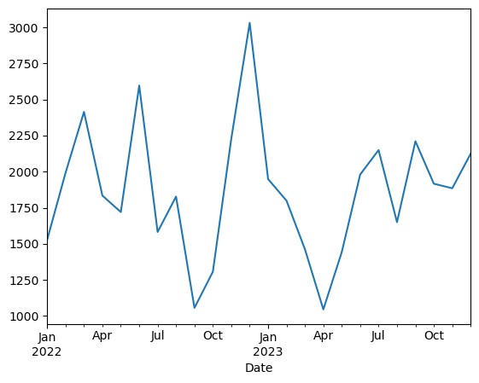

**Fig: Impression by month for 2022 and 2023**

Decomposition of impression data: when the above line is decomposed, we observe that there is a yearly seasonality and upward trend in the figure, but statistical as per Dicky-filler test says that the data is stationary without any trends.

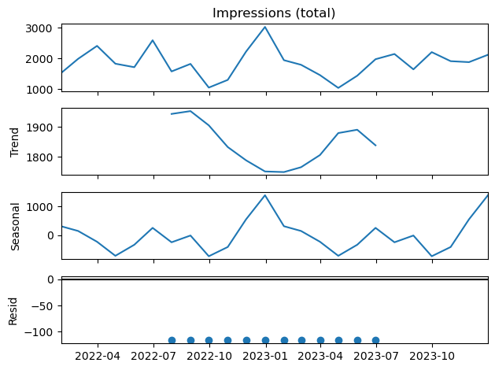

**Fig: Seasonal decomposition graph.**

Since we see a clear seasonality, the Seasonal ARIMA modeling is considered, with a best optimum seasonal order (P,D,Q,M) that were generated with Auto Arima method. The seasonal order considered here is Sarimax of (0,1,0)(1,1,1,12) with lowest AIC Value that is 176.295

The below is the graphical representation of model prediction and actual with forecast with 10 more months.

**Figure: Actual vs predicted vs forecast.**

The prediction of Impression with the model at 95 % confidence is as below:

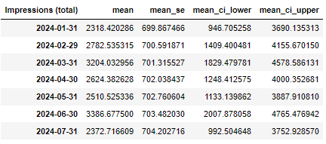

## Forecasts of the Engagement trends.:

The below graphs show the trend of Engagement rate for year 2022 and 2023 on daily and monthly frequency.

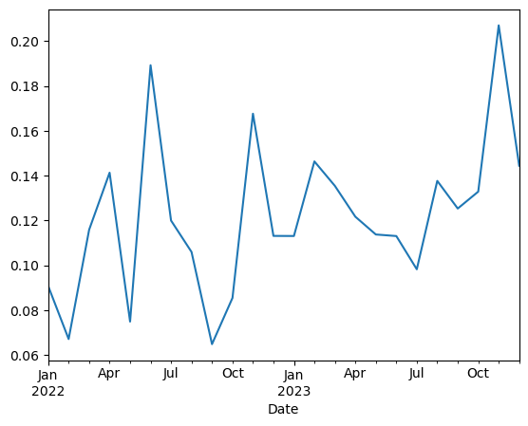

**Daily Engagement rate Monthly Engagement rate.**

**Decomposition of Engagement rate data:** when the above line is decomposed, we observe that there is a yearly seasonality and upward trend in the figure, but statistical as per Dicky-filler test says that the data is stationary without any trends.

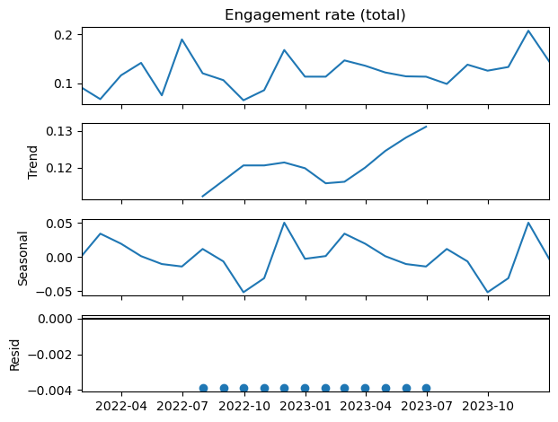

**Fig: Seasonal decomposition graph.**

Since we see a clear seasonal trend, the Seasonal ARIMA modeling is considered, with a best optimum seasonal order (P,D,Q,M) that were generated with Auto Arima method. The seasonal order considered here is Sarimax of (0,1,0)(0,1,0,12) with lowest AIC Value that is 27.035.

The below is the graphical representation of model prediction and actual with forecast with 10 more months.

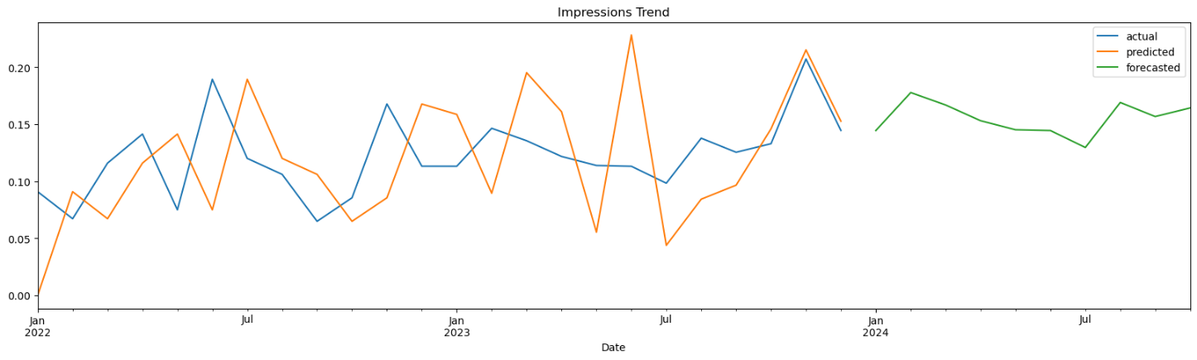

**Figure: Actual vs predicted vs forecast.**

The prediction of Impression with the model at 95 % confidence is as below:

