**Q1. Write a manual test case and then automate it to check whether space creation and deletion works for logged in users**.

**Ans:**

1. Check whether the user can load the URL.
2. Check whether the user can log in to the URL.
3. Check whether the logged user can create the Spaces.
4. Check whether the logged user can delete the Spaces.
5. Check whether the user can log out from the page.

**Q2. Verify the look and feel of the page (same page as for the manual and automated test cases creation) to ensure all elements are as per the screen capture in step 5 and create bug reports if you find any discrepancies.**

**Ans:** Issues in the UI when it compared with screen capture in step 5

1. The workflow is displayed in the 'Private space' also.
2. 'Public space' should be displayed on the first of the space list.

**Other issues:**

1. The news space is created while clicking on the ‘Private/Public Space’ button.
2. Success message is repeated while clicking on the ‘copy short link’ option.
3. Unable dislike the space from ‘Your liked items’ list.

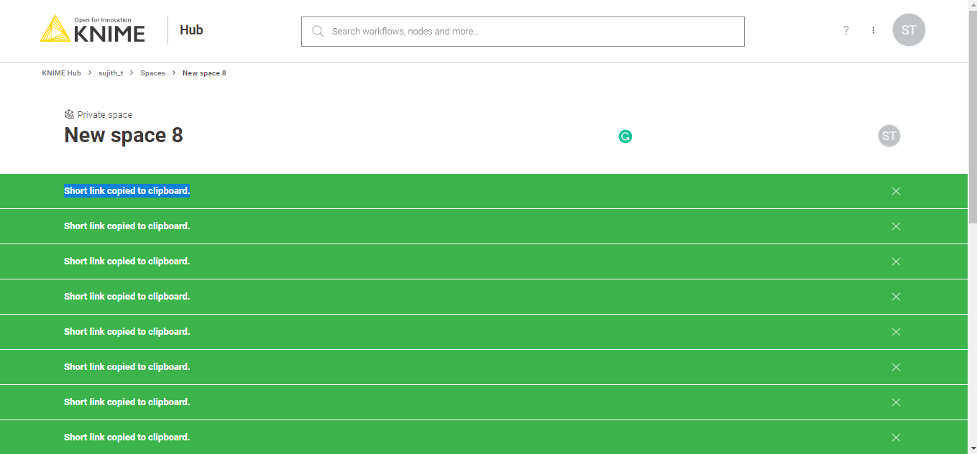

1. Unable to identify the liked spaces from the space list.
2. Liked indication is not showing.
3. Unwanted items were shown in the auto-suggestion of the filter.