Blockchain-Based E-Vault for Legal Records

In real world many types of Legal documents are exists and government are managing all this documents in a single centralized server. This servers will be managed by Admin and can be bribe to alter any legal document and there will be no direct way to detect such alteration. Another most important issue is cyber-attack where attackers can hack centralized server and may crash or steal data and in such situations all data will be lost.

To overcome from above issue we are planning to migrate legal or criminal documents management to Blockchain technology which has inbuilt support for data security, verification and decentralized storage.

Decentralized storage: Blockchain store each records in multiple nodes, so if one node down then services can be access from other working nodes

Data Security: each block stored in Blockchain is internally encrypted so data will be secured

Data Verification: Blockchain store each data as transaction/block and associate each block with unique hash code, while storing new record Blockchain will verify hash code of all previous blocks, if data not tamper then it will result into same hash code and verification get successful otherwise data tamper can be detected.

So by employing Blockchain technology we can provide all types of securities to Legal documents which cannot be fulfilled by existing tradition single centralized servers.

To manage data with Blockchain we need to design Smart Contract using Solidity programming which contains set of functions to store and get data from Blockchain. In below screen showing Smart contract code designed to manage legal documents.

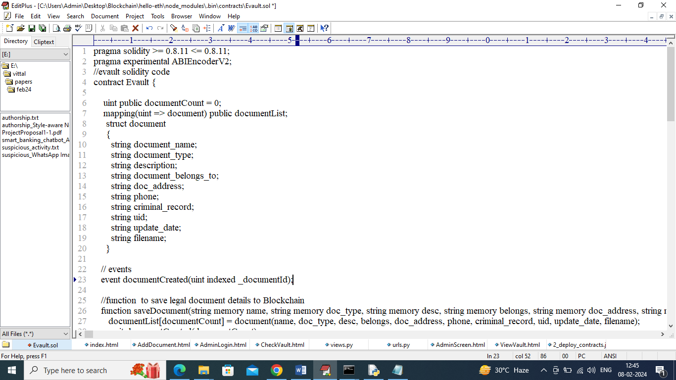

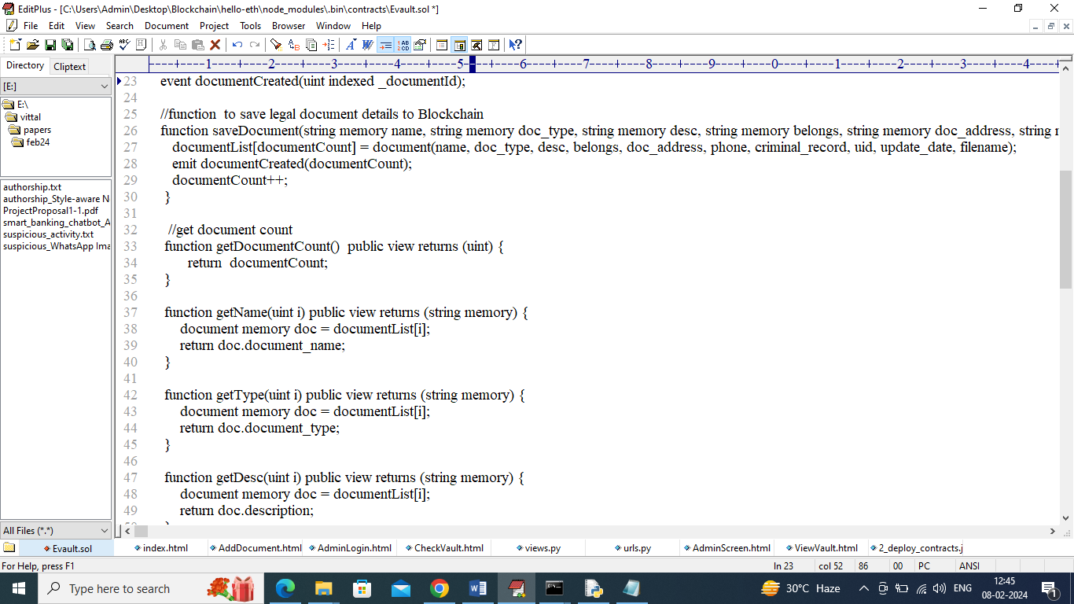

In above solidity code we define all required functions need to manage legal document values. Now we need to deploy above contract in Blockchain Ethereum tool to save and get data with security. To deploy contract we need to follow below steps

1. First go inside ‘hello-eth/node-modules/bin’ folder and then double click on ‘runBlockchain.bat’ file to get below screen
2. 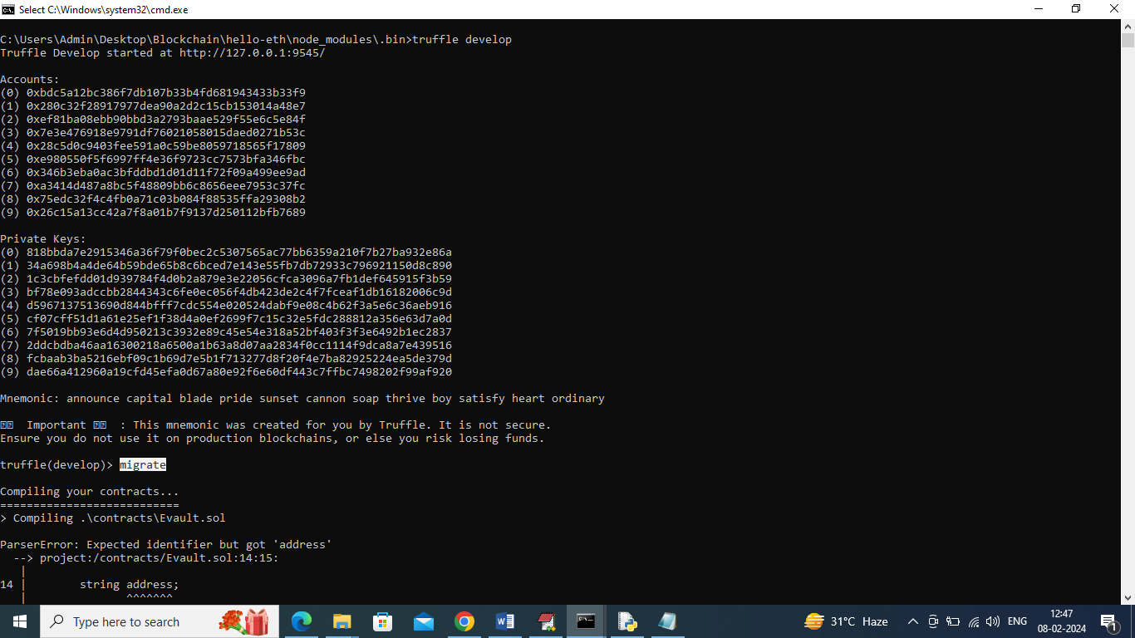
3. In above screen Ethereum started with default account and private keys and now type command as ‘migrate’ and press enter key to get below page
4. 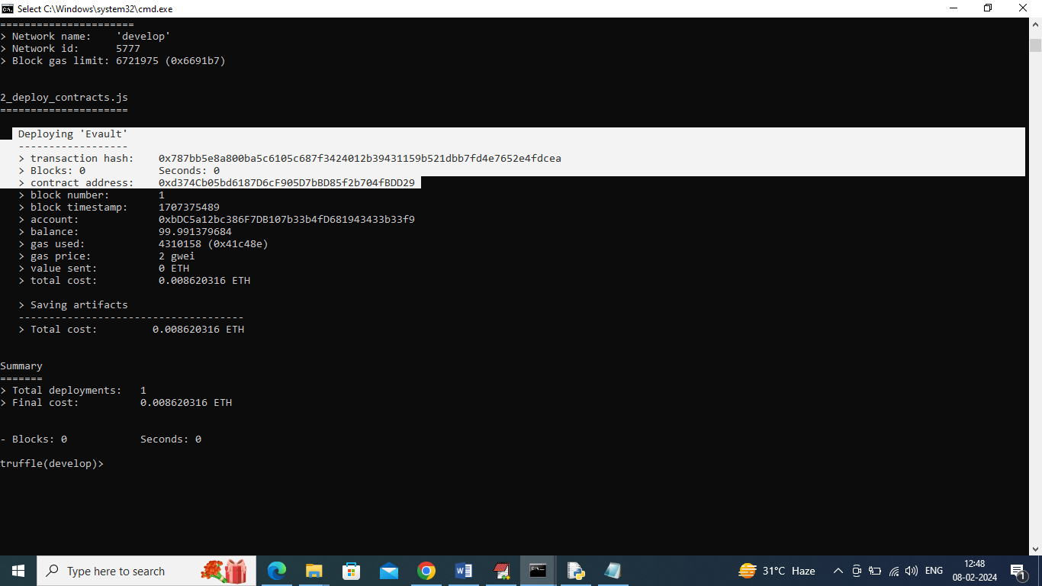
5. In above screen in white colour text can see ‘E-Vault’ contract deployed in Ethereum and got contract address also. This address we need to specify in python programming to call contract to save and get data. In below screen showing python code calling above contract
6. 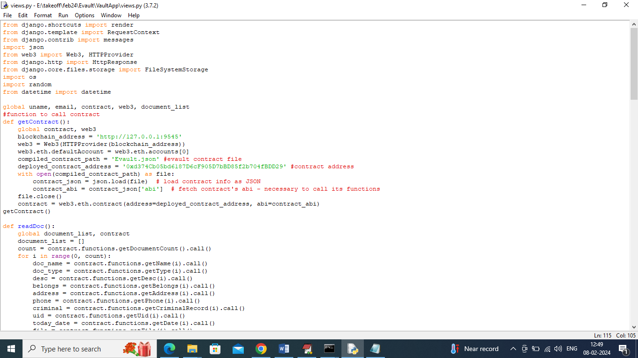
7. In above screen read red colour comments to know about contract calling in python.

SCREEN SHOTS

In above screens contract deployed and running and now double click on ‘run.bat’ file to start python server and get below page

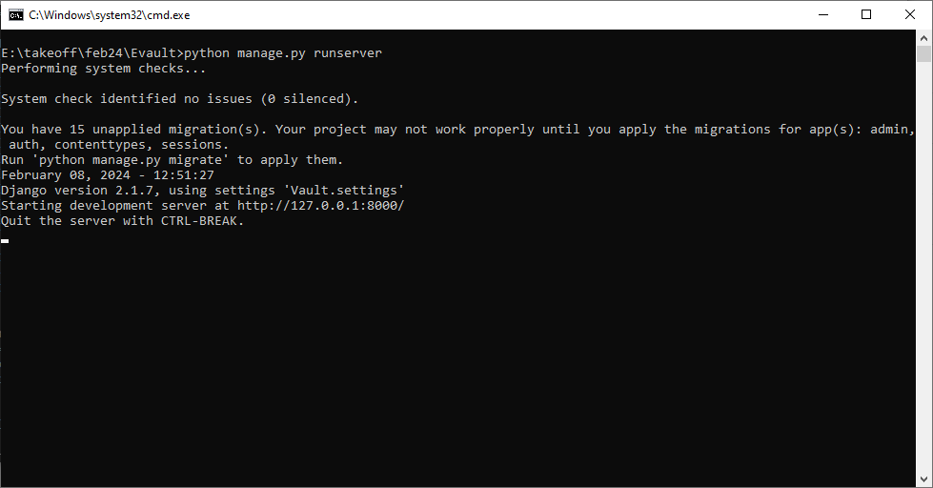

In above screen python server started and now open browser and enter URL as <http://127.0.0.1:8000/index.html> and then press enter key to get below page

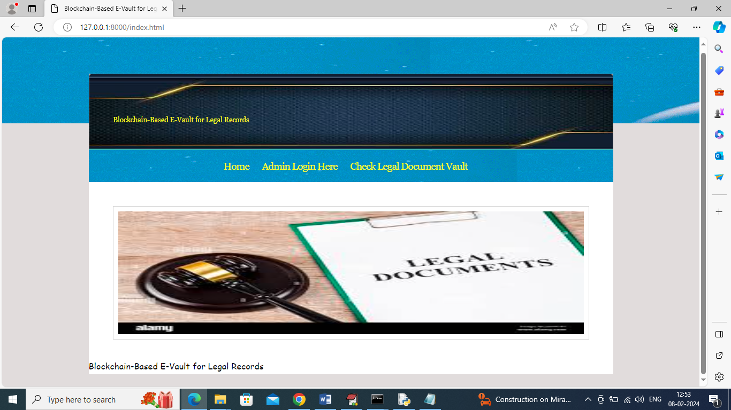

In above screen click on ‘Admin Login Here’ link to get below admin login page

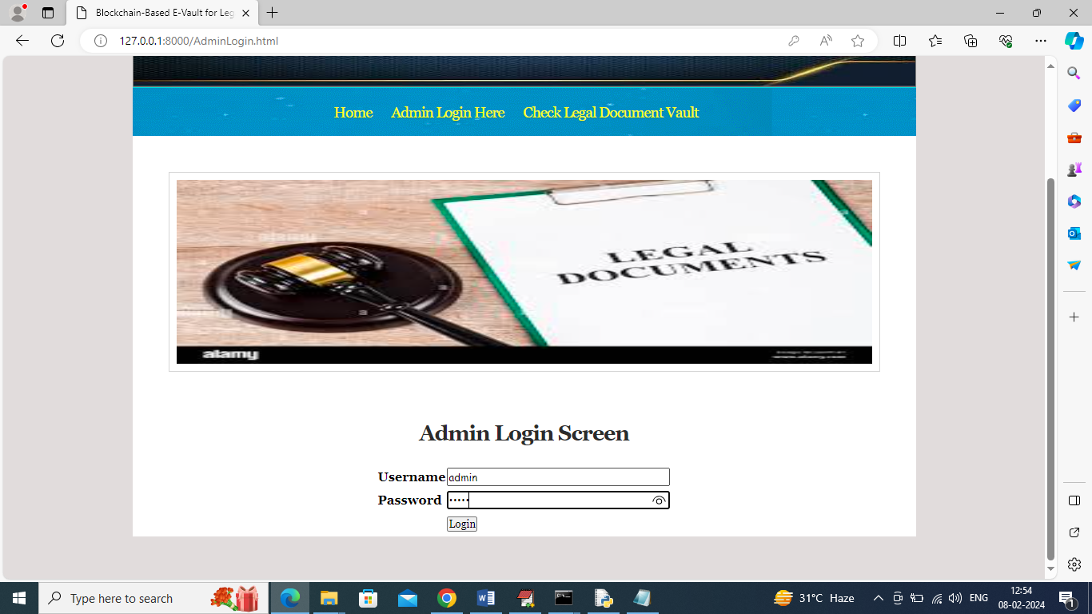

In above screen admin can login to system using username and password as ‘admin’ and then press button to get below page

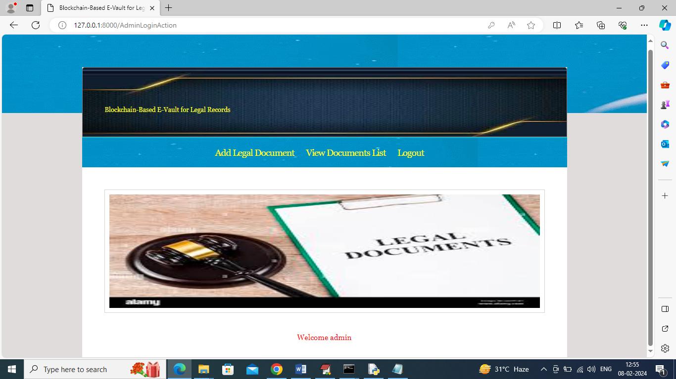

In above screen admin can click on ‘Add Legal Document’ link to add legal document details

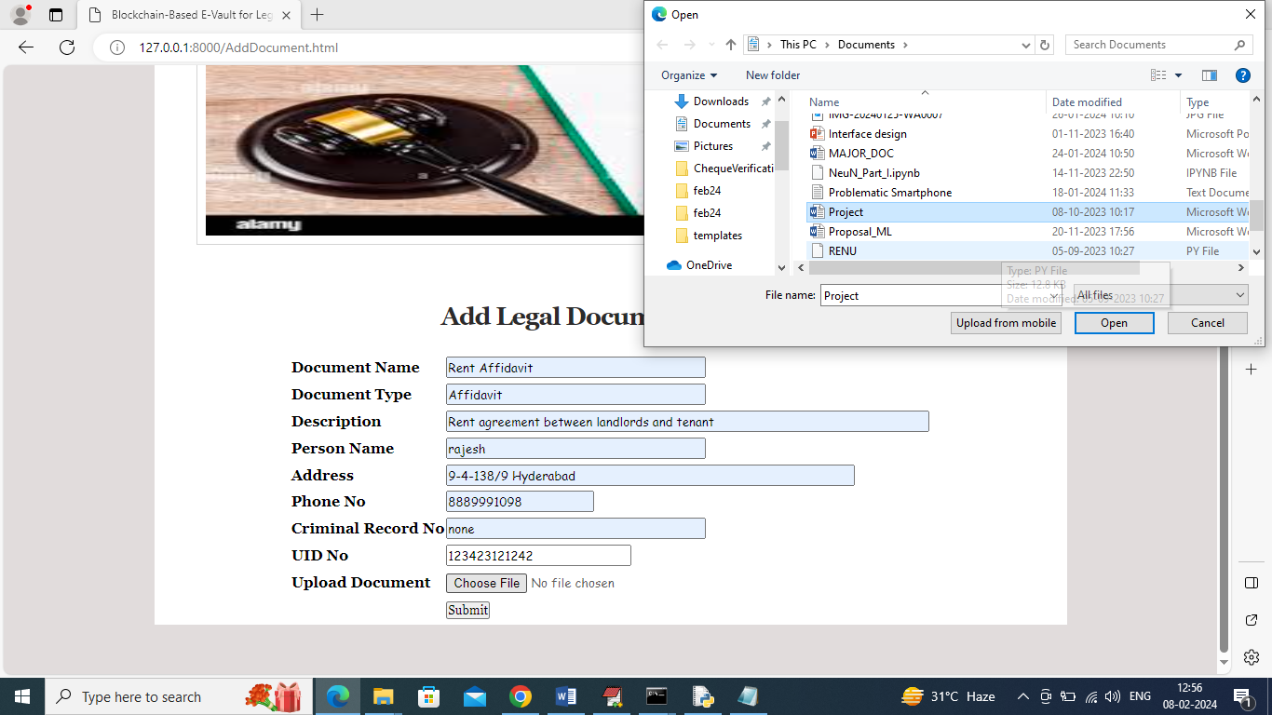

In above screen entering some type of Rent legal document details and then upload related document data and then click on ‘Submit’ button to save data in Blockchain and then will get below output

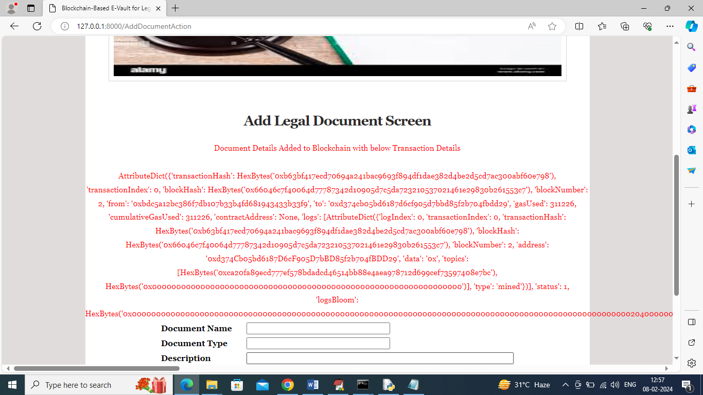

In above screen in red colour text can see all output returned from Blockchain after storage, normally will show transaction hash code but for you and your guide understanding we are displaying all details. In above output you can see Hash code and Block number as the core output. Now admin click on ‘View Document’ link to view all stored documents details in Blockchain

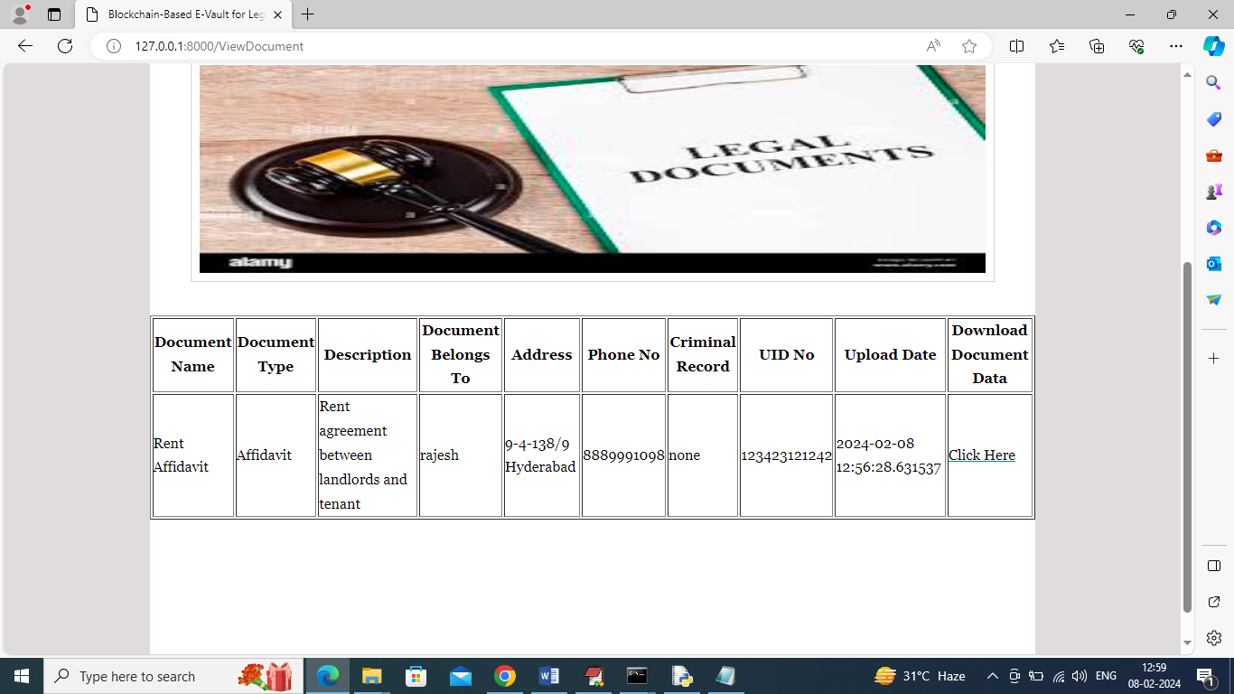

In above screen admin can view list of legal documents available in Blockchain and can click on ‘Click Here’ link to download associated document data file.

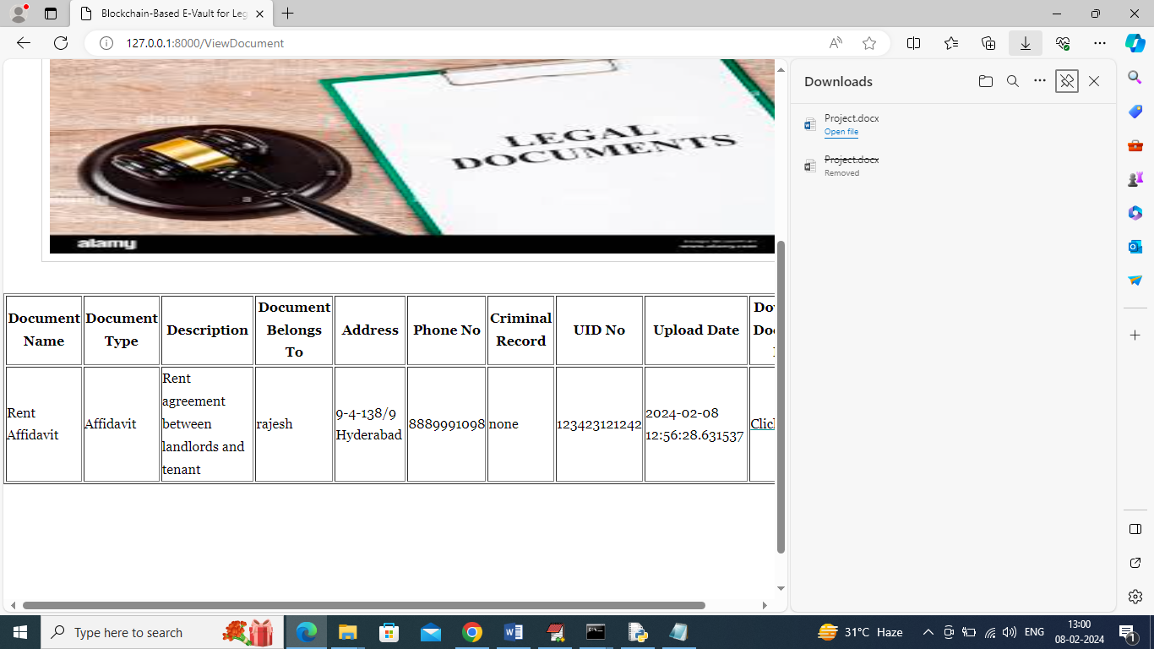

In above screen in right side panel can see downloading of associated data. Now logout and then normal users can view all available legal documents but we are granting to them to document details but cannot download associated data. In below screen normal users can search for legal documents

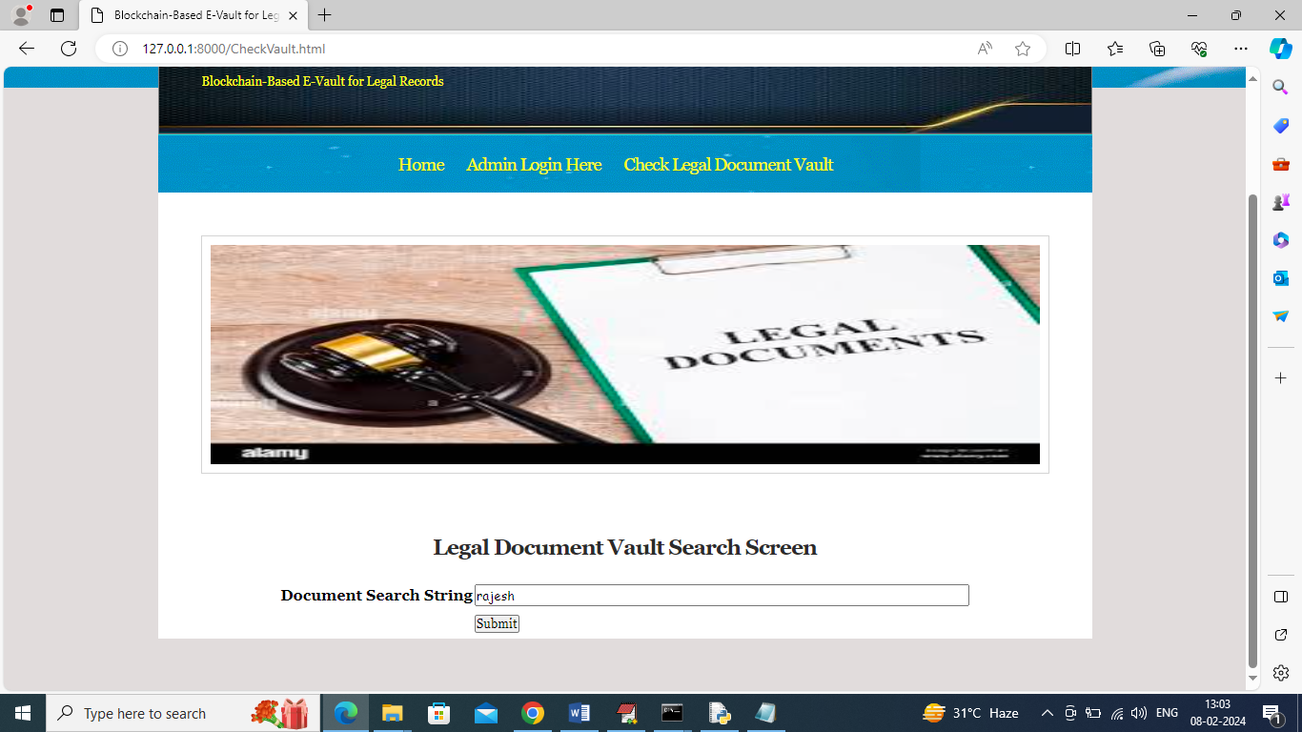

In above screen user can enter any string like person name about to search, document name or UID number or any other text. Entered input will be matched with available documents in Blockchain and get below result. In above screen I entered query as ‘rajesh’ means I want search any legal document exists on rajesh name

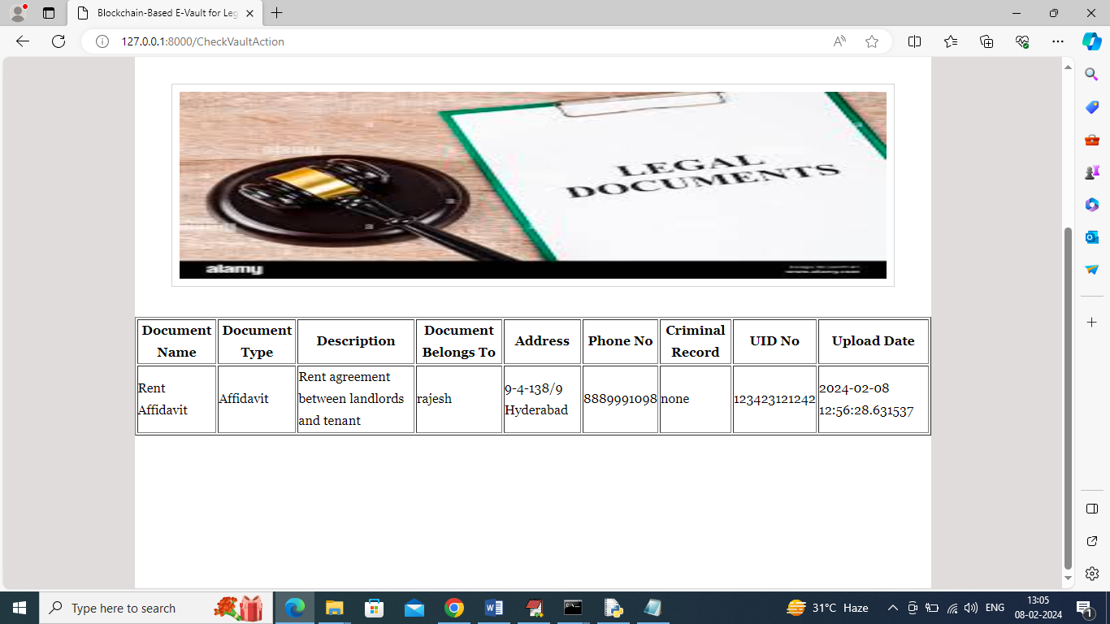

In above screen for given query user can see one search found and users are granting to view above details and cannot download associated legal document file.

So by using above screens you can manage all your documents in Blockchain.