**EX NO: 02 INVOICE FOR FOOD DELIVERY SYSTEM**

**DATE:23.06.2025**

**CODE:**

<!DOCTYPE html>

<html lang="en">

<head>

    <meta charset="UTF-8">

    <meta name="viewport" content="width=device-width, initial-scale=1.0">

    <title>Food Delivery</title>

</head>

<body>

    <div id="frame" style="width:60%;height:135vh;margin:auto;background-color:rgba(237,189,39,255);">

        <div style="display:flex;justify-content: space-between">

            <div>

                <h1 style="padding:10% 0 0 20%;color:white;text-shadow:3px 3px gray;width:150%;line-height: 130%;font-family: 'Arial Narrow', Arial, sans-serif;word-spacing:10px;letter-spacing: 3px;font-weight:bolder;font-size: 40px;">FRESH FOOD <br> DELIVERY</h1>

            </div>

            <div style="padding: 0 5% 0 0;">

                <img src="C:\Users\sujimini\OneDrive\RECORDS\banana.webp" width="500" height="250">

            </div>

        </div>

        <div id="frame1" style="width:90%;margin:auto;background-color: white;">

            <div style="display: flex;justify-content: space-between;">

                <div style="padding: 1% 0 0 5%;">

                    <h4 style="font-weight: bold;font-family:'Arial Narrow', Arial, sans-serif;line-height: 170%;letter-spacing: 1px;">BILLED TO:<br>Mr.Andy Jackson<br>22,San Pedro Street,Los Angeles,USA</h4>

                </div>

                <div style="padding-right: 5%;text-align: right;">

                    <h4 style="font-weight: bold;font-family: 'Arial Narrow', Arial, sans-serif;line-height: 170%;letter-spacing: 2px;"><span style="color:rgb(236, 177, 3)">INVOICE</span><br>#23456787</h4>

                </div>

            </div>

            <hr style="border:3px solid rgb(65, 20, 0);">

            <table style="padding:2% 10%;width:90%;text-align:center;border-collapse: collapse;margin:0 auto;margin-top: 3%;font-family: 'Arial Narrow', Arial, sans-serif;letter-spacing: 1px;">

                <tr style="background-color: rgb(236, 177, 3);">

                    <th style="padding-top: 10px; padding-bottom: 10px;">S.NO</th>

                    <th>DESCRIPTION</th>

                    <th>QTY</th>

                    <th>PRICE</th>

                    <th>AMOUNT</th>

                </tr>

                <tr style="background-color: rgb(219, 216, 211);">

                    <td style="padding-top: 10px; padding-bottom: 10px;">1</td>

                    <td>Bananas</td>

                    <td>3 kg</td>

                    <td>$3.00</td>

                    <td>$9.00</td>

                </tr>

                <tr style="background-color: rgb(219, 216, 211);">

                    <td style="padding-top: 10px; padding-bottom: 10px;">2</td>

                    <td>Pineapple</td>

                    <td>2 items</td>

                    <td>$7.00</td>

                    <td>$14.00</td>

                </tr>

                <tr style="background-color: rgb(219, 216, 211);">

                    <td style="padding-top: 10px; padding-bottom: 10px;">3</td>

                    <td>Avocado</td>

                    <td>5 items</td>

                    <td>$3.00</td>

                    <td>$15.00</td>

                </tr>

            </table>

            <div style="display: flex;justify-content: space-between;padding: 0% 10%;width:80%">

                <div>

                </div>

                <div style="display: flex;justify-content: space-between;width:25%">

                    <div>

                    <h4 style="font-weight: bold;font-family: 'Arial Narrow', Arial, sans-serif;line-height: 170%;color:rgb(236, 177, 3);text-align: right;letter-spacing: 1px;"> Sub Total <br>Tax<br>Total</h4>

                    </div>

                    <div>

                    <h4 style="font-weight: bold;font-family: 'Arial Narrow', Arial, sans-serif;line-height: 170%;color:rgb(236, 177, 3);letter-spacing: 1px;"> $38.00 <br>$2.00<br>40.00</h4>

                    </div>

                </div>

        </div>

        <hr style="border:3px solid rgb(65, 20, 0);margin-top:-1%;">

        <div style="margin-bottom: 5%;">

            <h4 style="font-family: 'Arial Narrow', Arial, sans-serif;font-weight: bold;padding-left: 5%;line-height: 170%;letter-spacing: 2px"><span style="color:rgb(236, 177, 3)">PAYMENT INFORMATION</span><br>Account Number : 6789 7856 4567 8427</h4>

        </div>

        <div style="display: flex;justify-content: space-between;padding: 0% 0 0 5%;width:90%">

            <div>

                <h1 style="color:rgb(236, 177, 3);font-family:'Arial Narrow', Arial, sans-serif;font-weight:bold;padding-left: 2%;width:150%;word-spacing: 6px;letter-spacing: 2px">THANK YOU!</h1>

            </div>

            <div>

                <p style="font-family: 'Arial Narrow', Arial, sans-serif;font-weight: bold;line-height: 170%;text-align: right;letter-spacing: 2px;">273 678 4573<br>www.freshfood.co</p>

            </div>

        </div>

    </div>

</body>

</html>

**OUTPUT:**

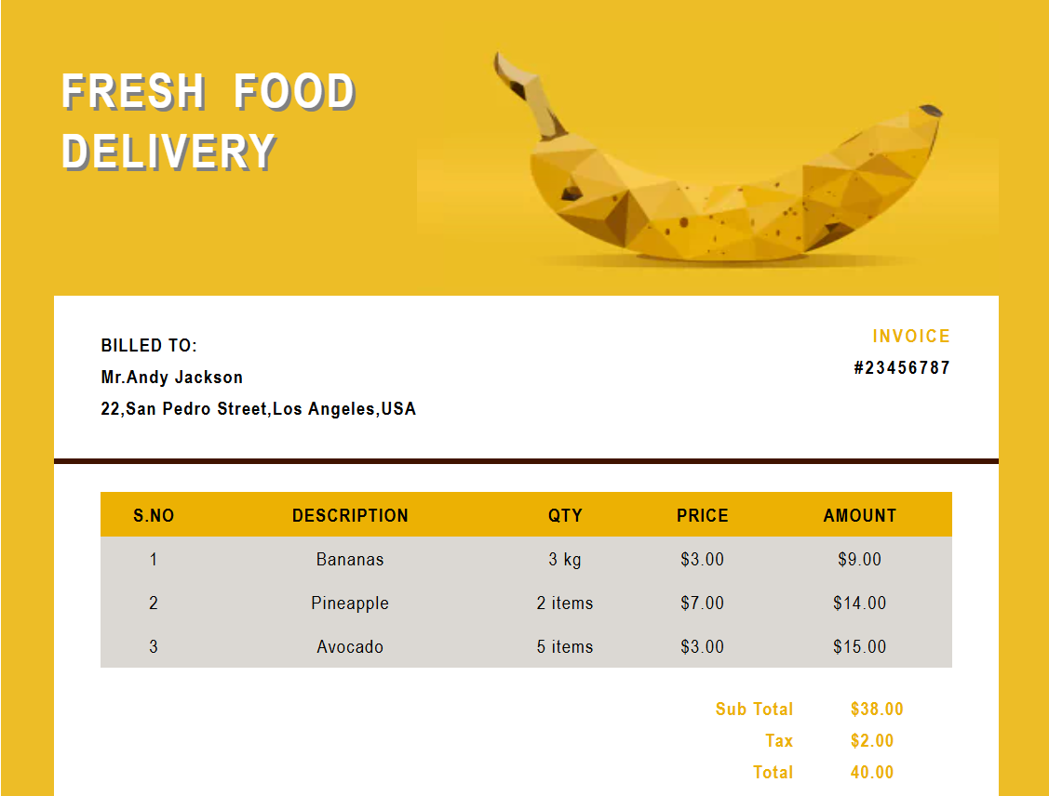

**CODE:**

<!DOCTYPE html>

<html lang="en">

<head>

    <meta charset="UTF-8">

    <meta name="viewport" content="width=device-width, initial-scale=1.0">

    <title>Document</title>

</head>

<body>

    <div style="width: 60%; margin: auto; background-color: white; padding: 2px; box-shadow: 0 0 10px rgba(0,0,0,0.1);height:90vha">

        <div style="display:flex;background-color: black;justify-content: space-between;height:30vh;">

            <div style="width:75%;margin-top: -35px;">

                <img src="C:\Users\sujimini\Downloads\sushi-removebg-preview.png" style="width: 500px; height: 350px; margin: 30px;padding:0 0 0 4% ;">

            </div>

            <div style="padding-right: 10%">

                <h1 style="font-family: 'Times New Roman', Times, serif;color:white;text-align: right;font-size: 40px;letter-spacing: 2px;line-height: 50px;"><span style="font-family:Arial, Helvetica, sans-serif;color:white;font-weight: 300;font-size: 25px">your logo</span><br>INVOICE</h1>

            </div>

        </div>

        <div style="display: flex;justify-content: space-between;width:90%">

        <div style="margin-top:7%;margin-left: 10%;width:70%">

            <p style="font-family: 'Times New Roman', Times, serif;font-size: 30px;font-weight: bolder;letter-spacing: 2px;line-height: 23px;" >Invoice to: Jack Reeves<br><span style="font-size: 20px;font-weight:500;letter-spacing: 1px">Remittence items and personal data notes</span></p>

        </div>

        <div style="display: flex;justify-content: space-evenly;width: 30%;margin-top: 3%;margin-right: 2px">

            <div style="text-align: left;font-weight: 600;font-family: 'Times New Roman', Times, serif;line-height: 23px;letter-spacing: 1px;">

                <p>Invoice No <br>Invoice Date <br>Issue Date <br>Account No </p>

            </div>

            <div style="text-align: left">

                <p style="font-weight: 600;font-family: 'Times New Roman', Times, serif;line-height: 23px;letter-spacing: 1px;">: 67845673<br>: 12.June.2025<br>: 20 June 2025<br>: 567987</p>

            </div>

        </div>

        </div>

        <table style="width:90%;margin:2% 3% 2% 3%;text-align:center;padding:2% ;border-collapse: collapse;margin-left:5%;letter-spacing: 2px;font-family: Arial, Helvetica, sans-serif;">

            <tr style="background-color: rgb(255, 115, 0);color:white">

                <th style="padding: 13px 0 13px 8px;font-weight: 100;">NO.</th>

                <th style="font-weight: 100;">ITEM DISCRIPTION</th>

                <th style="font-weight: 100;">PRICE</th>

                <th style="font-weight: 100;">QTY</th>

                <th style="font-weight: 100;">TOTAL</th>

            </tr>

            <tr style="border-bottom: 2px solid rgb(174, 165, 165);">

                <td style="padding: 13px 0 13px 8px;font-weight: 100;">1</td>

                <td style="font-weight: 100;">cost items</td>

                <td style="font-weight: 100;">$20.00</td>

                <td style="font-weight: 100;">1</td>

                <td style="font-weight: 100;">$20.00</td>

            </tr>

            <tr style="border-bottom: 2px solid rgb(174, 165, 165);">

                <td style="padding: 13px 0 13px 8px;font-weight: 100;">2</td>

                <td style="font-weight: 100;">cost items</td>

                <td style="font-weight: 100;">$20.00</td>

                <td style="font-weight: 100;">1</td>

                <td style="font-weight: 100;">$20.00</td>

            </tr>

            <tr style="border-bottom: 2px solid rgb(174, 165, 165);">

                <td style="padding: 13px 0 13px 8px;font-weight: 100;">3</td>

                <td style="font-weight: 100;">cost items</td>

                <td style="font-weight: 100;">$20.00</td>

                <td style="font-weight: 100;">1</td>

                <td style="font-weight: 100;">$20.00</td>

            </tr>

            <tr style="border-bottom: 2px solid rgb(174, 165, 165);">

                <td style="padding: 13px 0 13px 8px;font-weight: 100;">4</td>

                <td style="font-weight: 100;">cost items</td>

                <td style="font-weight: 100;">$20.00</td>

                <td style="font-weight: 100;">1</td>

                <td style="font-weight: 100;">$20.00</td>

            </tr>

            <tr style="border-bottom: 2px solid rgb(174, 165, 165);">

                <td style="padding: 30px 0 13px 8px;font-weight: 100;"></td>

            </tr>

        </table>

        <div style="display: flex;justify-content: space-between;width:100%">

            <div style="width:55%">

                <p STYLE="font-family:'Times New Roman', Times, serif;letter-spacing: 1px;margin-left:10%;font-size: small;"><span style="color:rgb(255, 94, 0);font-weight: bold;font-size: 20PX;">TERMS & CONDITIONS</span><br>Lorem ipsum dolor sit amet consectetur adipisicing elit. Repellendus itaque voluptas quibusdam nobis facere tempore est iusto temporibus doloremque animi iure cum, nisi, vel illo optio, ullam ipsam numquam mollitia.</p>

                <p STYLE="font-family:'Times New Roman', Times, serif;letter-spacing: 1px;margin-left:10%;font-size: small;"><span style="color:rgb(255, 94, 0);font-weight: bold;font-size: 20PX;">PAYMENT INFO :</span></p>

                <div style="display: flex;justify-content: space-evenly;width:50%;margin-left:7%;margin-top: -3%;">

                    <div style="width:50%">

                        <p STYLE="font-family:'Times New Roman', Times, serif;letter-spacing: 1px;margin-left:10%;font-size:13px;">Account no.<br>Name<br>Bank Detail</p>

                    </div>

                    <div style="width:70%;">

                        <p STYLE="font-family:'Times New Roman', Times, serif;letter-spacing: 1px;margin-left:10%;font-size:13px;">: 6589367584<br>: john<br>: 86595 36458 2846</p>

                    </div>

                </div>

                <div>

                    <p STYLE="font-family:'Times New Roman', Times, serif;letter-spacing: 1px;margin-left:9%;font-size: small;">Thank you for your careful filling and conformation</p>

                </div>

            </div>

            <div style="display:block;width:40%;margin-top:-1%;margin-right: 8%;">

            <div style="width:100%;margin-top: 2%;display:flex;margin-right: 4%;">

                <div style="width:100%">

                    <p STYLE="font-family:Arial, Helvetica, sans-serif;letter-spacing: 1px;margin-left:50%;font-size: 20px;line-height: 170%;">Sub total<br>Tax Rate</p>

                </div>

                <div style="width:40%">

                    <p STYLE="font-family:Arial, Helvetica, sans-serif;letter-spacing: 1px;margin-left:50%;font-size: 20px;line-height: 170%;">$80.00<br>$15</p>

                </div>

            </div>

            <div style="border: 3px solid rgb(255, 94, 0);width:80% ;margin-left: 30%;padding:1% -10% -20% 1%">

            <div style="width:100%;margin-top: -6%;display:flex;margin-right: 4%;padding-left: 2%;justify-content: space-around;">

                <div style="width:100%">

                    <p STYLE="font-family:Arial, Helvetica, sans-serif;letter-spacing: 1px;margin-left:9%;font-size: 20px;margin-bottom: -5%;margin-top:5%;line-height: 170%;"><span style="font-weight: bold;line-height: 300%;">Total</span></p>

                </div>

                <div style="width:40%">

                    <p STYLE="font-family:Arial, Helvetica, sans-serif;letter-spacing: 1px;margin-left:-25%;margin-bottom:-4%;margin-top:10%;font-size: 20px"><span style="font-weight: bold;line-height: 300%;">$95.00</span></p>

                </div>

            </div>

            </div>

            <div style="position: absolute;right:29.5%;bottom:-36%">

            <div style="width:200%;display: inline-block;margin-top: 10%;border-top:3px solid rgb(255, 94, 0);padding-bottom: 4px;">

                <p style="font-weight: 700;text-align: right;">Authorised sign</p>

            </div>

            </div>

            </div>

        </div>

    </div>

</body>

</html>

**OUTPUT:**

