**DevOps Training - Day 1**

**Installing Ubuntu on VirtualBox**

**Step 1: Download Required Files**

1. **Download VirtualBox** from the official website:  
   [VirtualBox Download](https://www.virtualbox.org/)
2. **Download Ubuntu ISO** from the official Ubuntu website:  
   [Ubuntu Download](https://ubuntu.com/download/desktop)

**Step 2: Install VirtualBox**

1. Open the downloaded VirtualBox installer.
2. Follow the on-screen instructions to complete the installation.
3. Once installed, launch VirtualBox.

**Step 3: Create a New Virtual Machine**

1. Click **New** in VirtualBox.
2. Enter a name (e.g., "Ubuntu VM").
3. Set the **Type** to **Linux**.
4. Set the **Version** to **Ubuntu (64-bit)**.
5. Click **Next**.

**Step 4: Allocate Memory (RAM)**

* Assign at least **2GB (2048 MB)** of RAM (Recommended: **4GB or more**).
* Click **Next**.

**Step 5: Create a Virtual Hard Disk**

1. Choose **Create a virtual hard disk now** → Click **Create**.
2. Select **VDI (VirtualBox Disk Image)** → Click **Next**.
3. Select **Dynamically allocated** → Click **Next**.
4. Set at least **25GB storage** (Recommended: **50GB or more**).
5. Click **Create**.

**Step 6: Attach Ubuntu ISO**

1. Select the created VM from the list.
2. Click **Settings** → **Storage**.
3. Under **Controller: IDE**, click **Empty**.
4. Click the **CD icon** on the right → Choose a disk file.
5. Select the downloaded **Ubuntu ISO** file.
6. Click **OK**.

**Step 7: Start the Virtual Machine**

1. Select your Ubuntu VM → Click **Start**.
2. The Ubuntu installer will launch. Follow the on-screen instructions to install Ubuntu.

**Setting Up Jenkins on Ubuntu VM**

**Step 1: Update Package Lists**

sudo apt update -y

**Step 2: Install Java (Required for Jenkins)**

sudo apt install -y openjdk-17-jdk

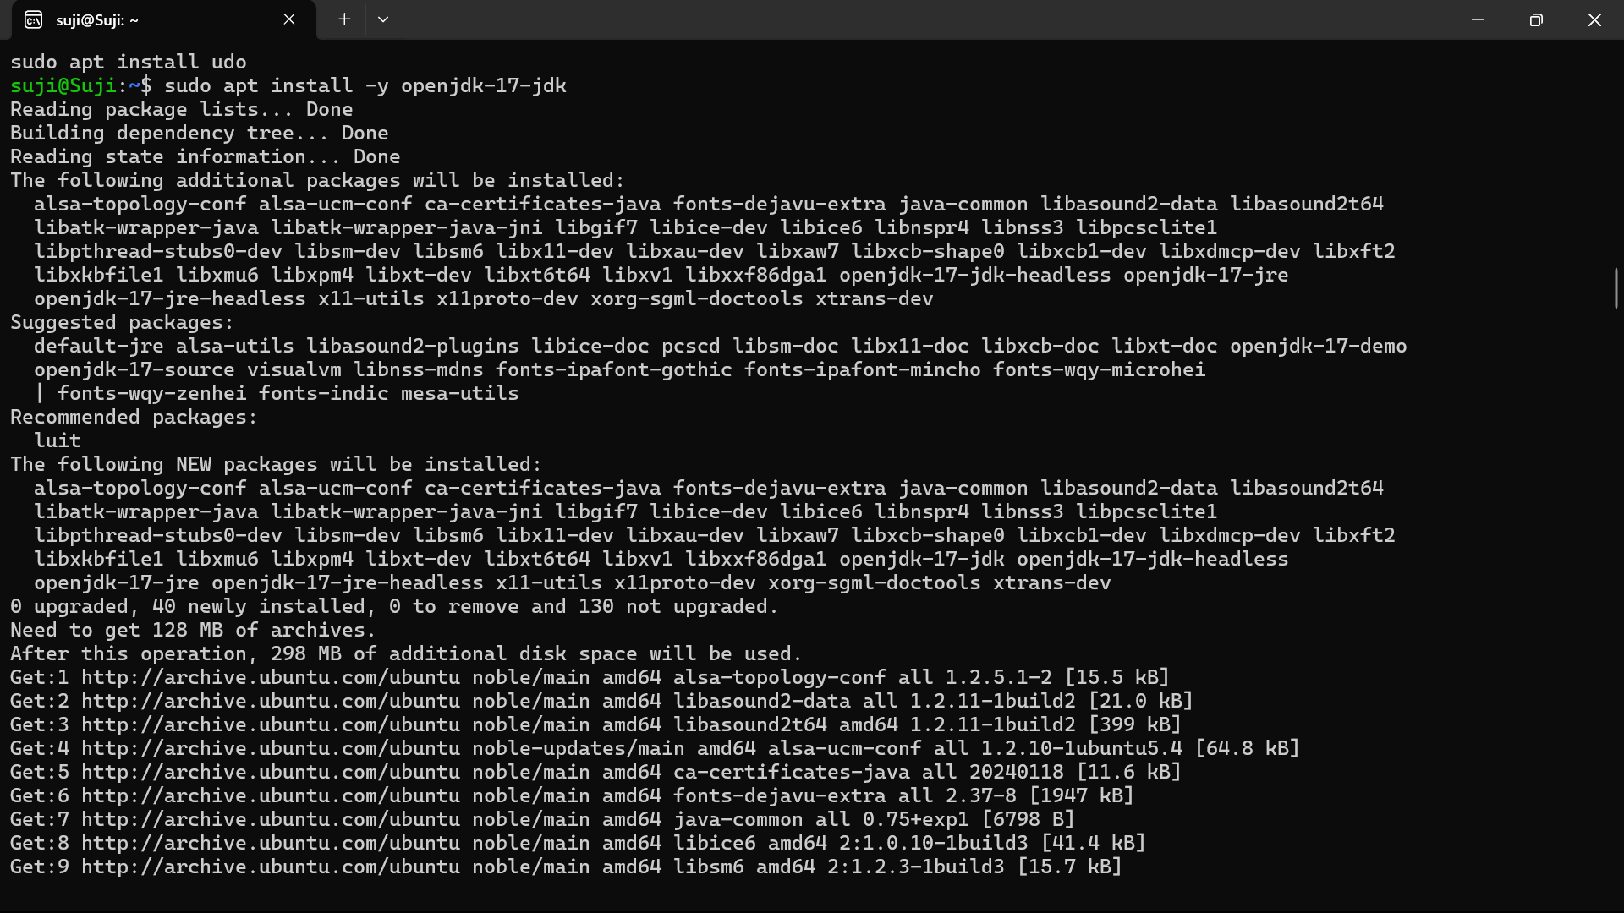

**Step 3: Verify Java Installation**

java -version

* Expected output:
* openjdk version "17.0.10" 2024-01-16
* OpenJDK Runtime Environment (build 17.0.10+0)

**Step 4: Add Jenkins Repository**

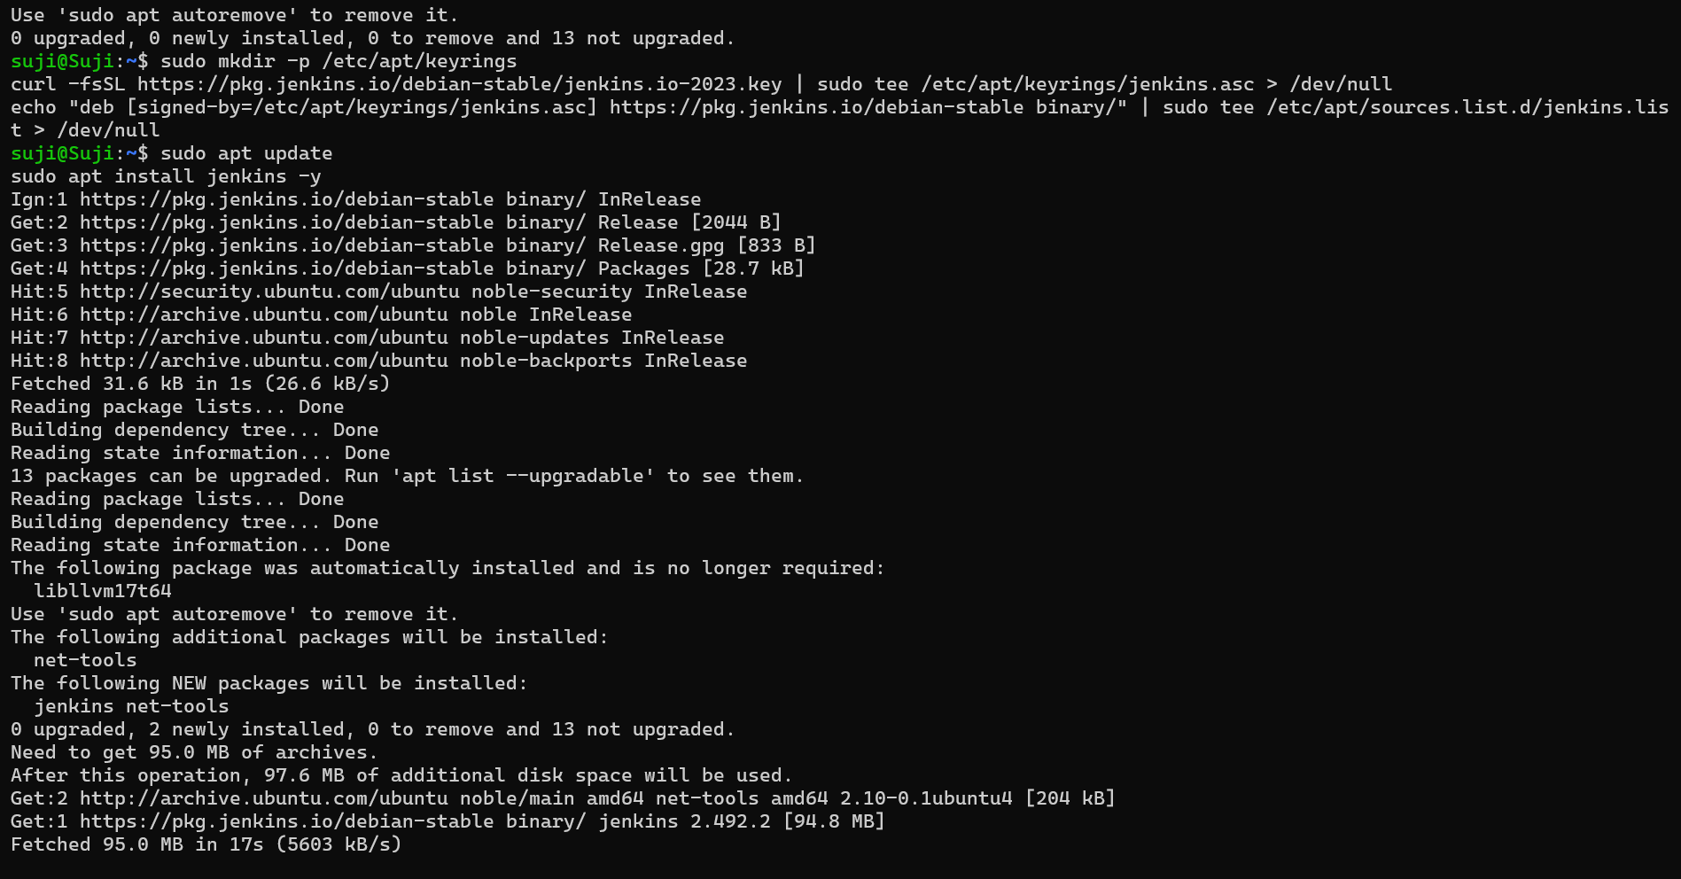

**4.1 Add Jenkins GPG Key**

wget -q -O- https://pkg.jenkins.io/debian-stable/jenkins.io-2023.key | sudo tee /usr/share/keyrings/jenkins-keyring.asc > /dev/null

**4.2 Add Jenkins Repository**

echo "deb [signed-by=/usr/share/keyrings/jenkins-keyring.asc] https://pkg.jenkins.io/debian-stable binary/" | sudo tee /etc/apt/sources.list.d/jenkins.list > /dev/null

**Step 5: Install Jenkins**

sudo apt update -y

sudo apt install -y jenkins

**Step 6: Start and Enable Jenkins Service**

sudo systemctl start jenkins

sudo systemctl enable jenkins

**Step 7: Check Jenkins Status**

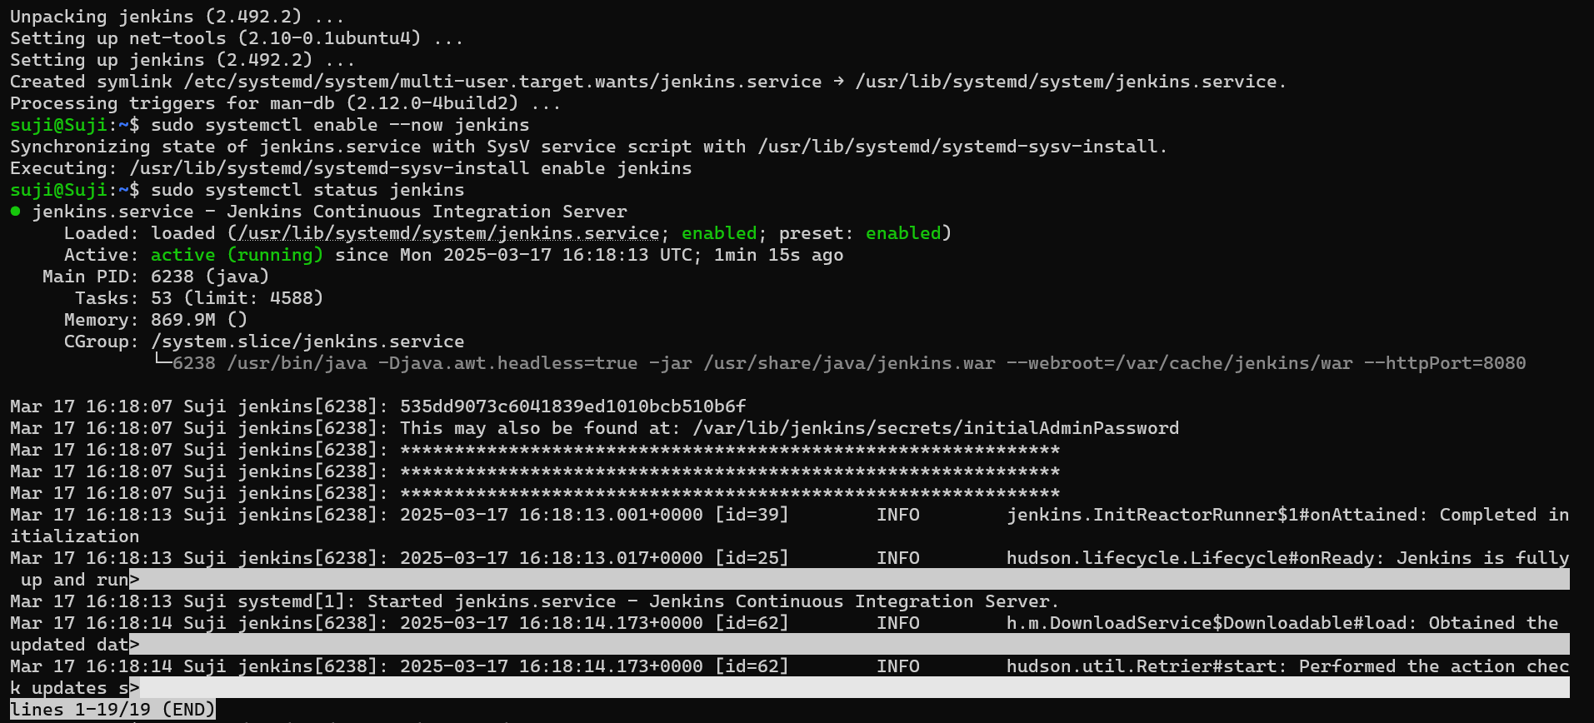

sudo systemctl status jenkins

* You should see **active (running)** if Jenkins is running properly.

**Step 8: Retrieve Jenkins Admin Password**

sudo cat /var/lib/jenkins/secrets/initialAdminPassword

* Copy this password and use it for the initial setup.

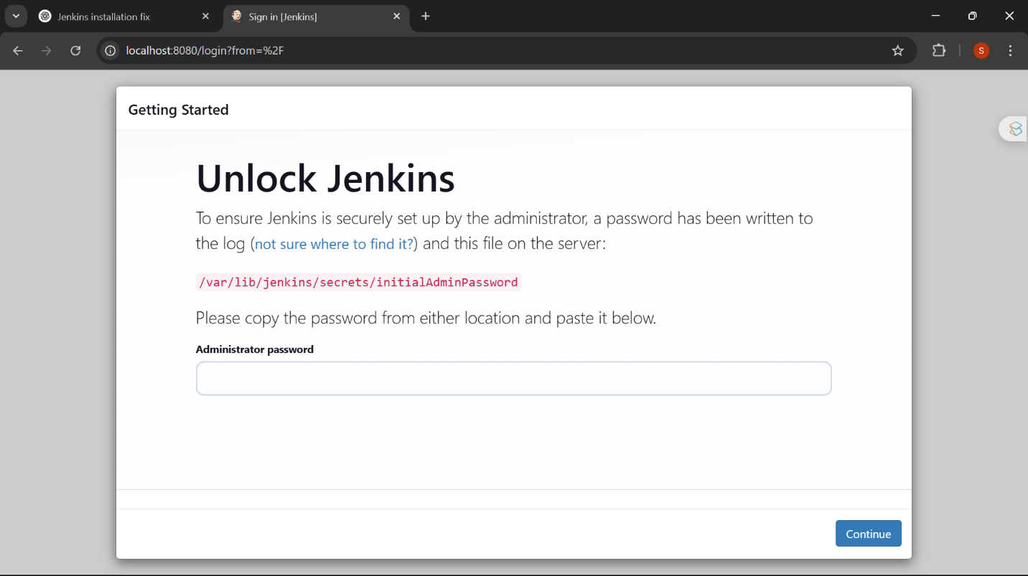

**Step 9: Access Jenkins Web Interface**

1. Open a browser and go to:  
   [**http://localhost:8080**](http://localhost:8080/) (or **http://<VM_IP>:8080** if using a remote server).
2. Enter the **admin password** retrieved in the previous step.
3. Choose **Install Suggested Plugins** (recommended) or manually select plugins.

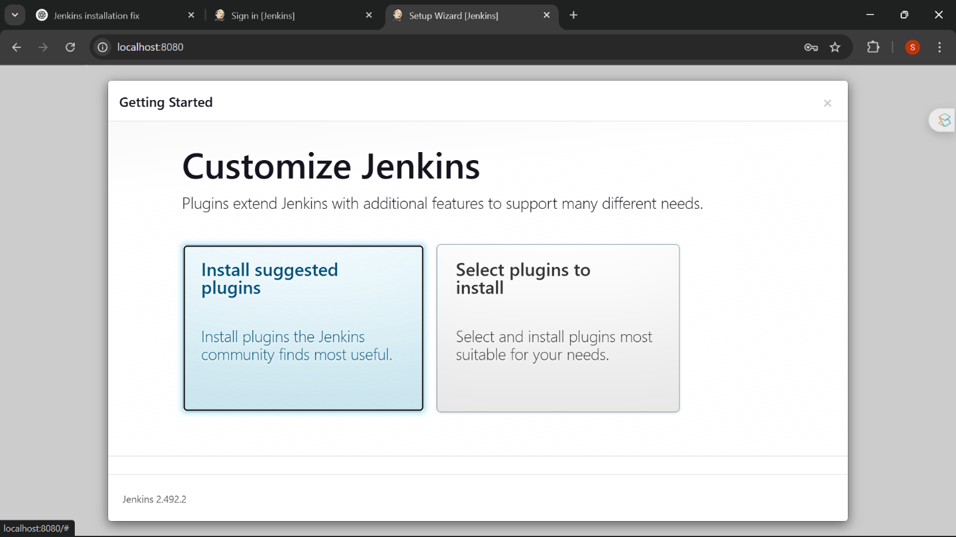

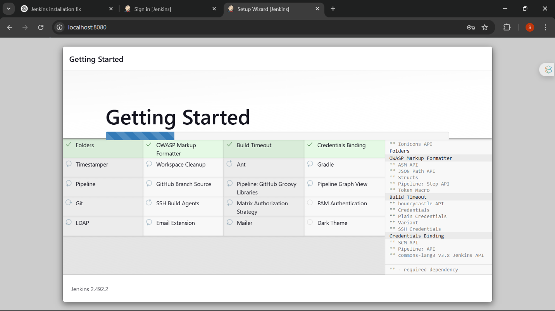

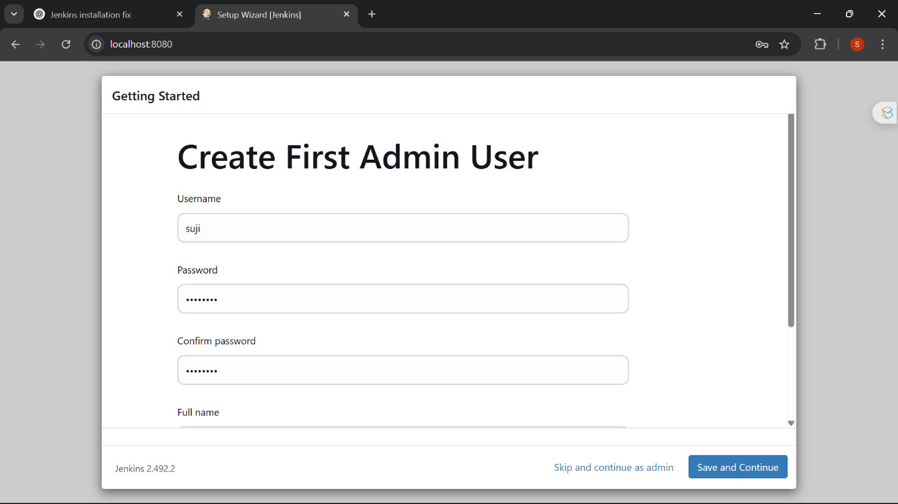

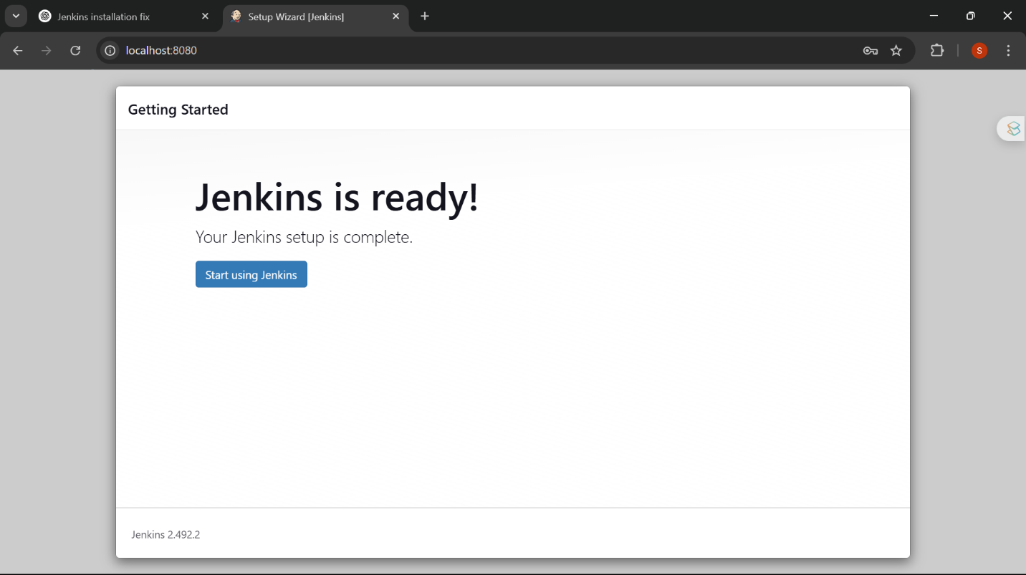

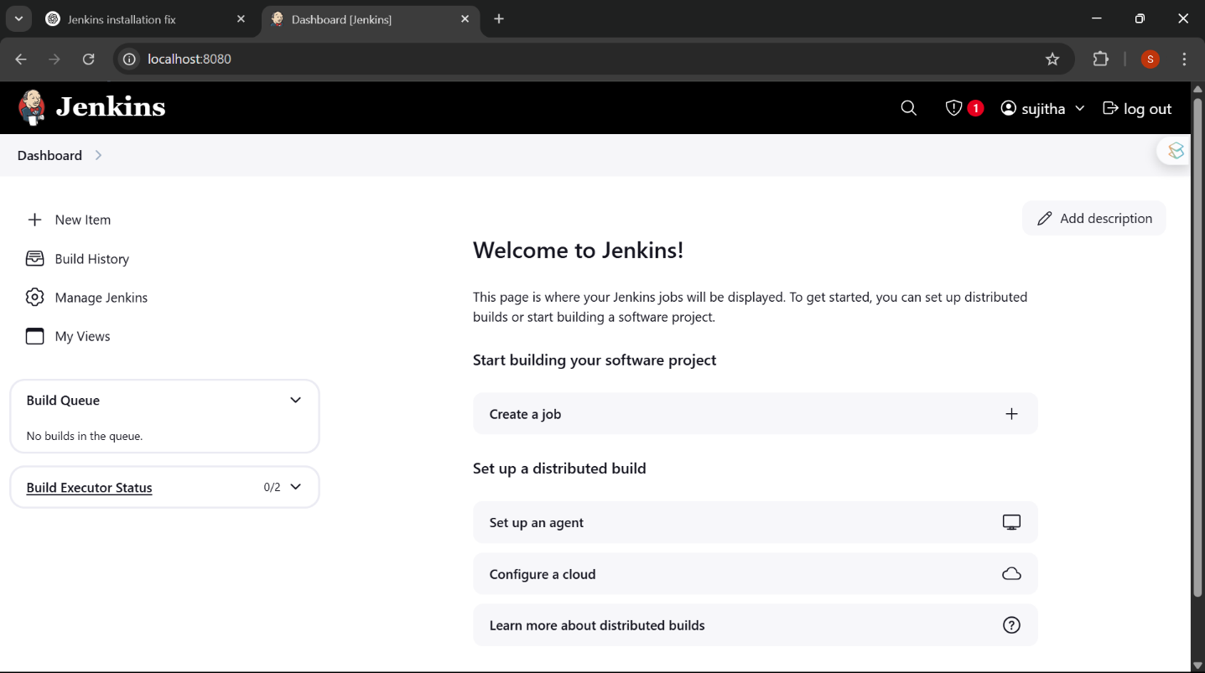

**Creating a Freestyle Job in Jenkins to Install Nginx**

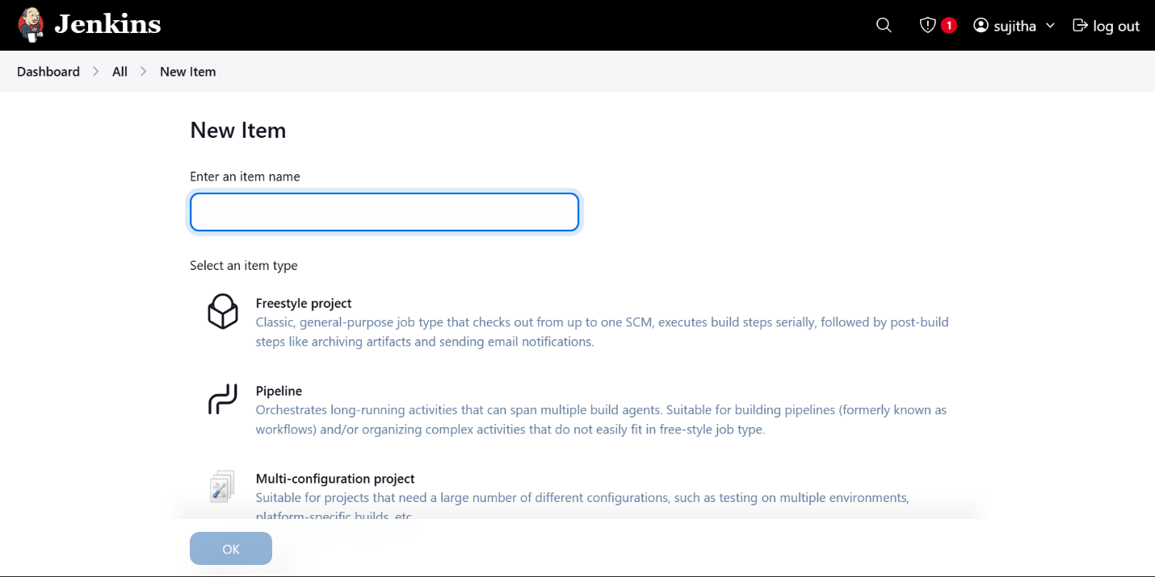

**Step 1: Create a New Freestyle Job**

1. Open Jenkins and click **New Item**.
2. Enter a name (e.g., "Install-Nginx").
3. Select **Freestyle Project**.
4. Click **OK**.

**Step 2: Configure the Job**

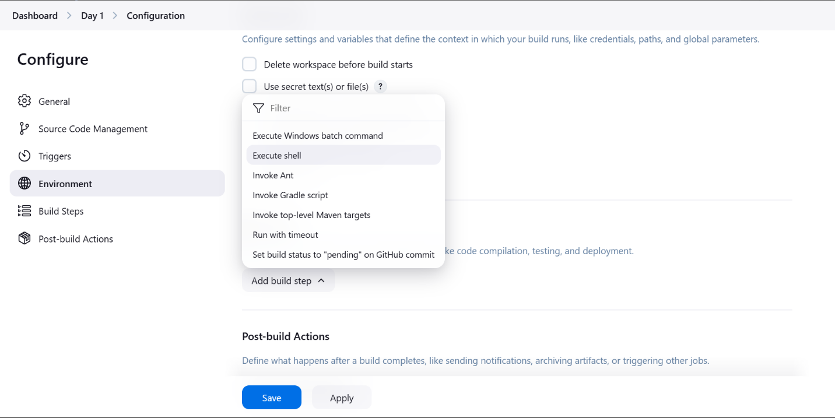

**Add Build Step**

1. Scroll down to **Build** → Click **Add build step** → Select **Execute shell**.
2. Paste the following script in the command box:

#!/bin/bash

echo "Updating package lists..."

sudo apt update -y

echo "Installing Nginx..."

sudo apt install -y nginx

echo "Starting Nginx service..."

sudo systemctl start nginx

echo "Enabling Nginx to start on boot..."

sudo systemctl enable nginx

echo "Nginx Installation Completed!"

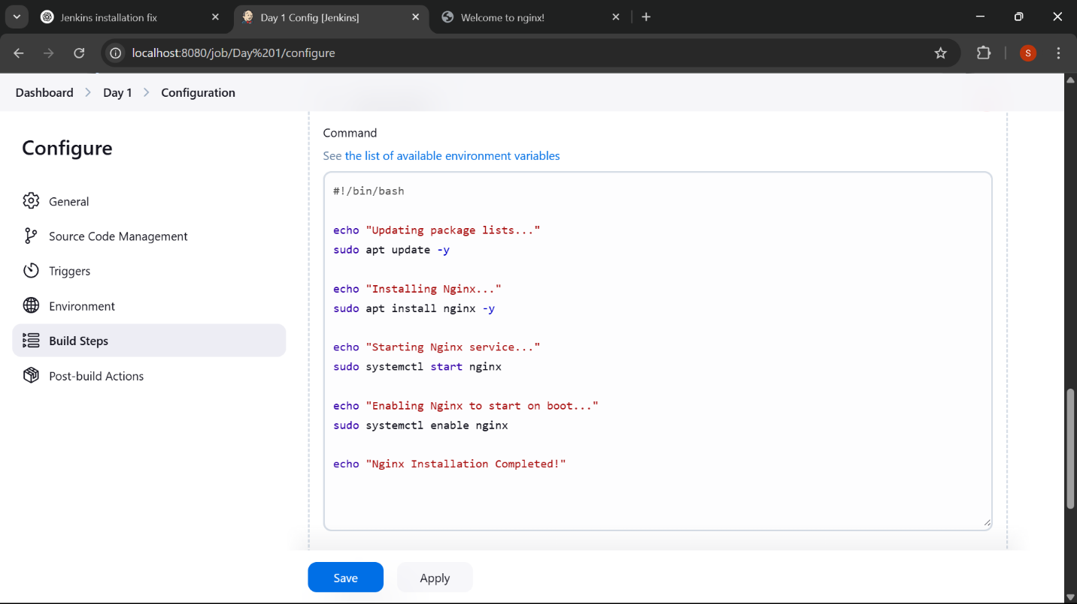

**Step 3: Save and Run the Job**

1. Click **Save**.
2. Click **Build Now**.
3. Check the **Console Output** to verify the installation.

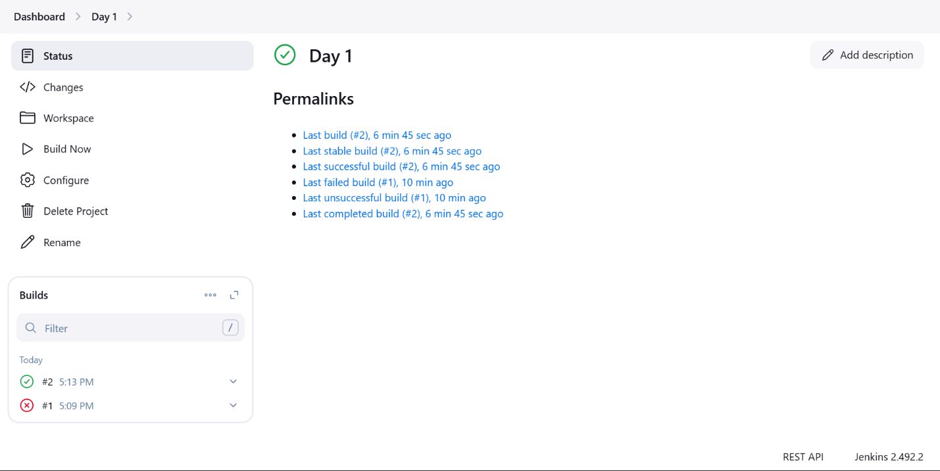

**Step 4: Verify the Installation**

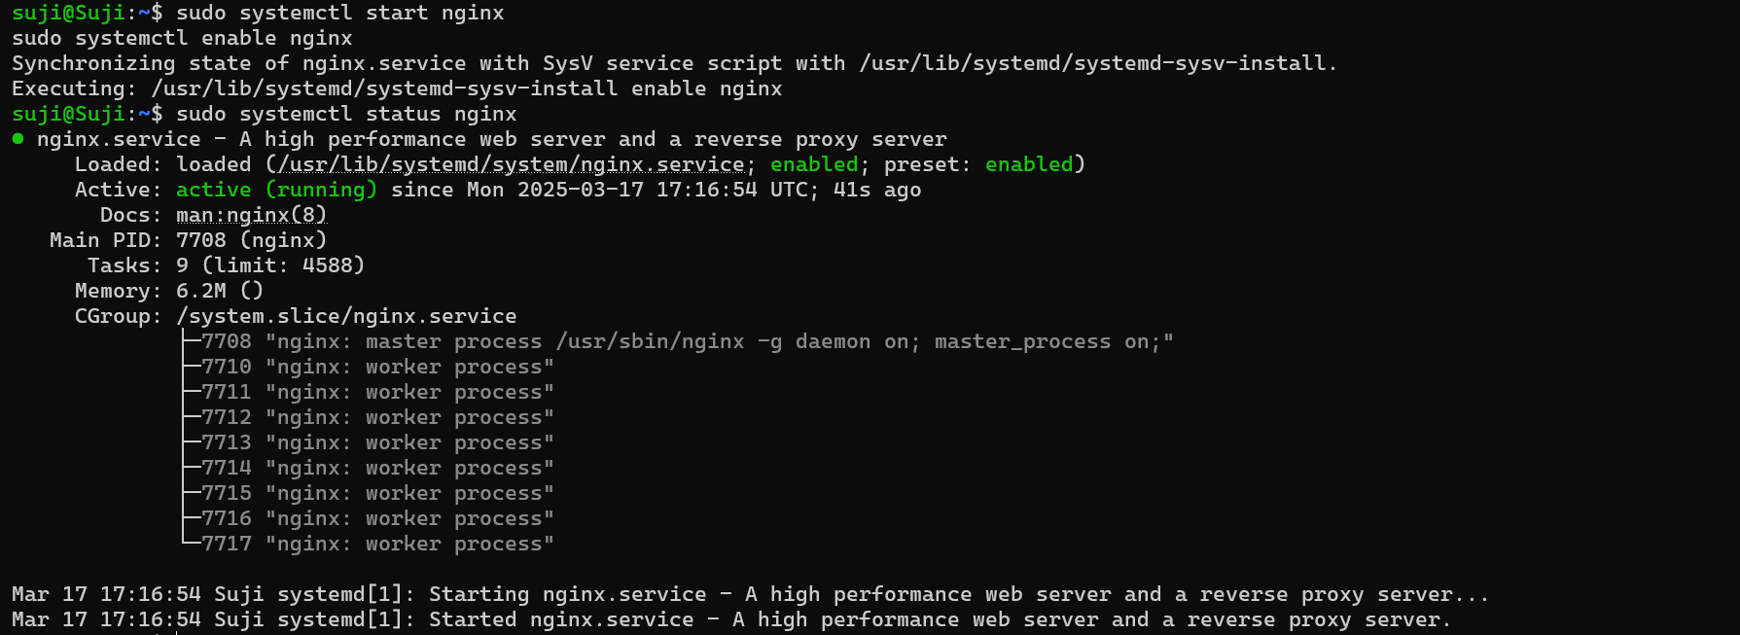

**Check Nginx Status**

systemctl status nginx

* If running, you should see **active (running)**.

**Open Nginx in Browser**

1. Open a browser and go to:
2. http://<VM_IP>
3. You should see the **default Nginx welcome page**.

