Day 12 – Creating Tables and Running SQL Queries
  - Air Quality Monitoring Database using MySQL Workbench

Objective
To create an air quality database with two related tables, insert sample data, and practise SQL queries including filtering, sorting, aggregate functions, GROUP BY, JOIN, pattern matching and subqueries.

1. Database and Table Setup

Step 1: Create the Database and the air_quality Table
Aim: Create a new database and a table to store air quality readings from monitoring stations.
Procedure:
1. Open MySQL Workbench and connect to the Local instance MySQL80.
2. Create the database air_quality_db and select it with the USE command.
3. Write the CREATE TABLE statement with Station_ID as the PRIMARY KEY.
4. Click the Execute (lightning) button or press Ctrl + Enter to run the query.
SQL Query:
CREATE DATABASE air_quality_db;
USE air_quality_db;
CREATE TABLE air_quality (
Station_ID VARCHAR(10) PRIMARY KEY,
City VARCHAR(50),
PM2_5 INT,
PM10 INT,
Temperature INT,
Humidity INT,
AQI_Category VARCHAR(30)
);
Output: The database and table are created successfully. Note: running CREATE TABLE a second time gives Error Code 1050 (Table 'air_quality' already exists), which only means the table is already present.
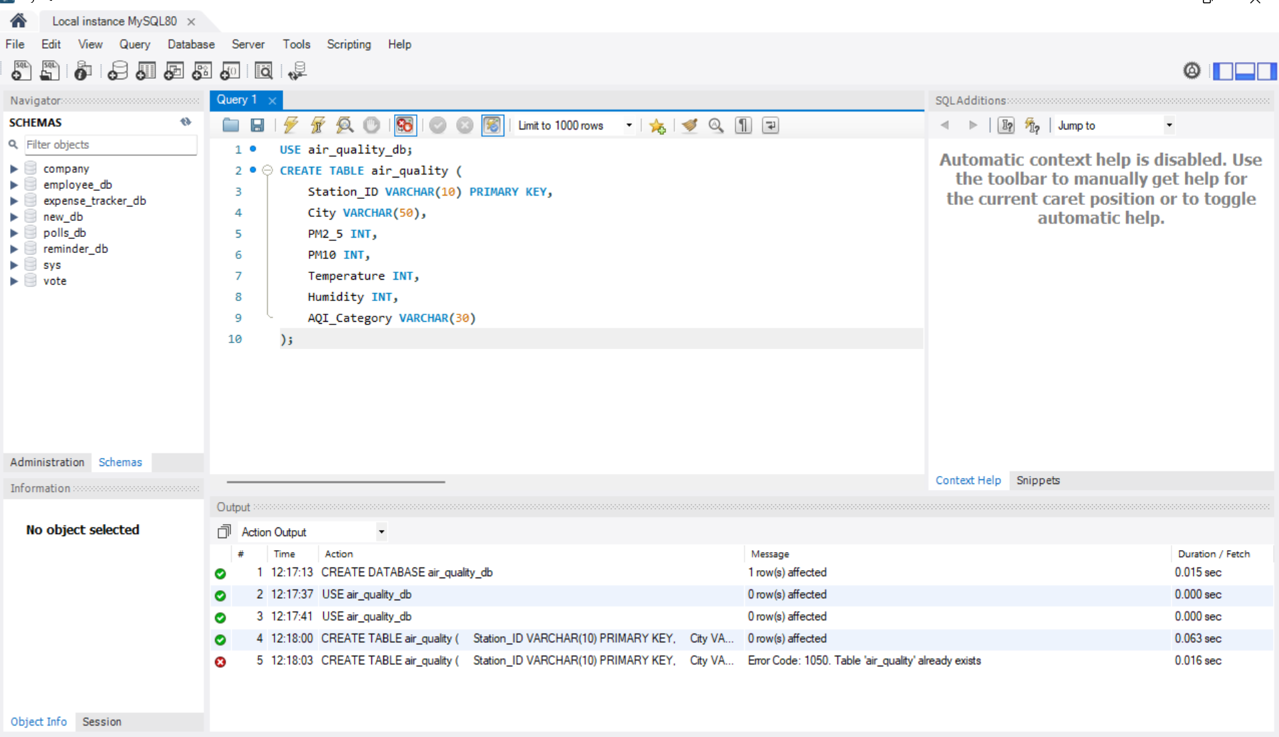
Figure 1: Output of Step 1

Step 2: Insert Records into the air_quality Table
Aim: Add sample air quality data for 12 monitoring stations.
Procedure:
1. Write an INSERT INTO statement listing all column names.
2. Add one row of values per station inside VALUES (...).
3. Click the Execute (lightning) button or press Ctrl + Enter to run the query.
SQL Query:
INSERT INTO air_quality
(Station_ID, City, PM2_5, PM10, Temperature, Humidity, AQI_Category)
VALUES
('ST101', 'Chennai', 42, 78, 32, 68, 'Moderate'),
('ST102', 'Coimbatore', 18, 35, 28, 55, 'Good'),
...
('ST112', 'Coimbatore', 15, 29, 27, 50, 'Good');
Output: 12 row(s) affected – Records: 12, Duplicates: 0, Warnings: 0.
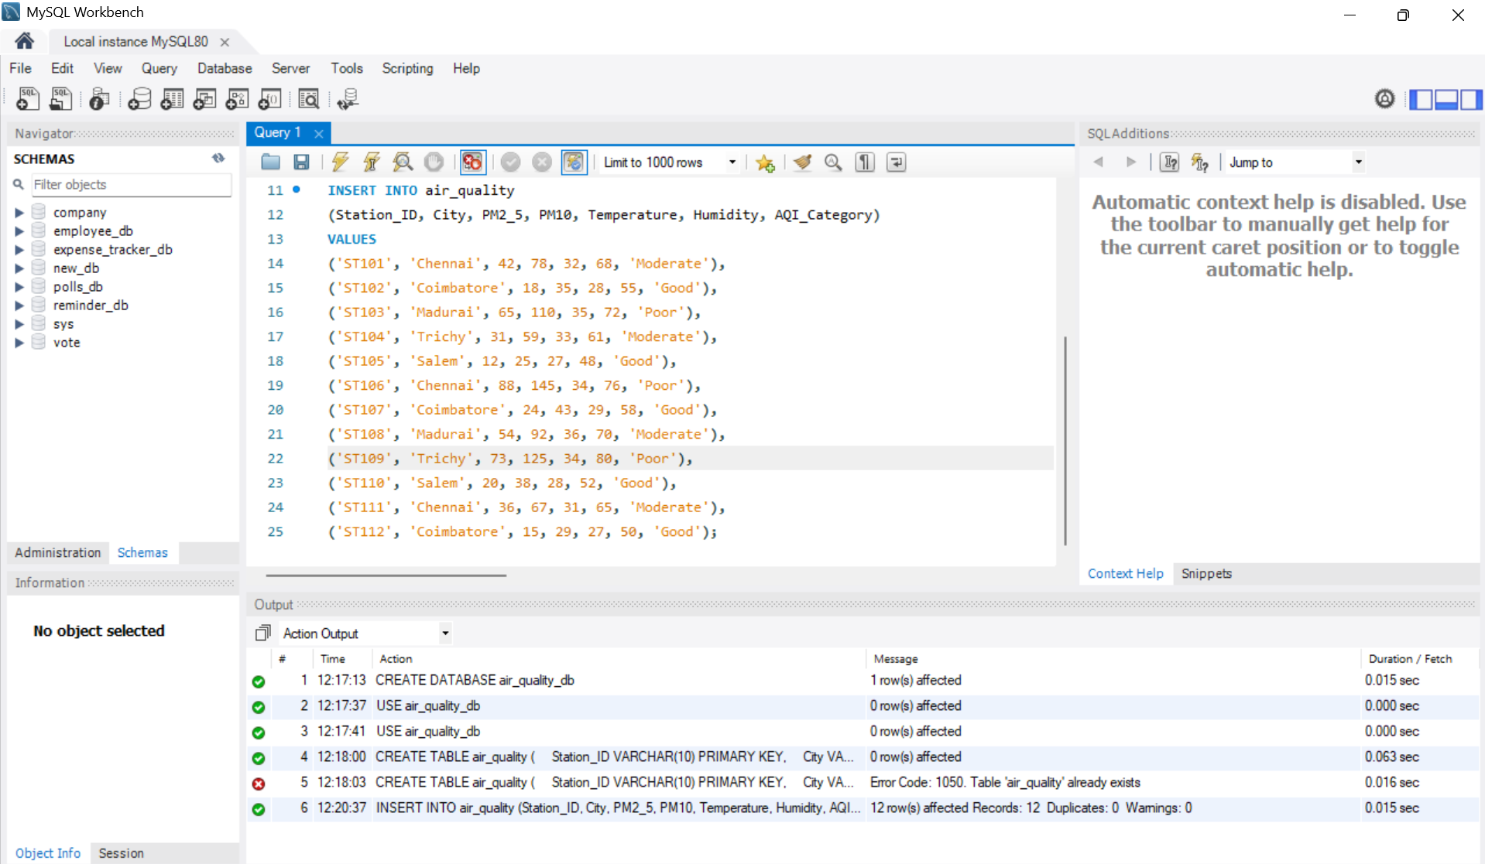
Figure 2: Output of Step 2

Step 3: View All Records
Aim: Display every row stored in the air_quality table.
Procedure:
1. Type the SELECT * query below the INSERT statement.
2. Select the query line and execute it.
SQL Query:
SELECT * FROM air_quality;
Output: All 12 records are shown in the Result Grid.
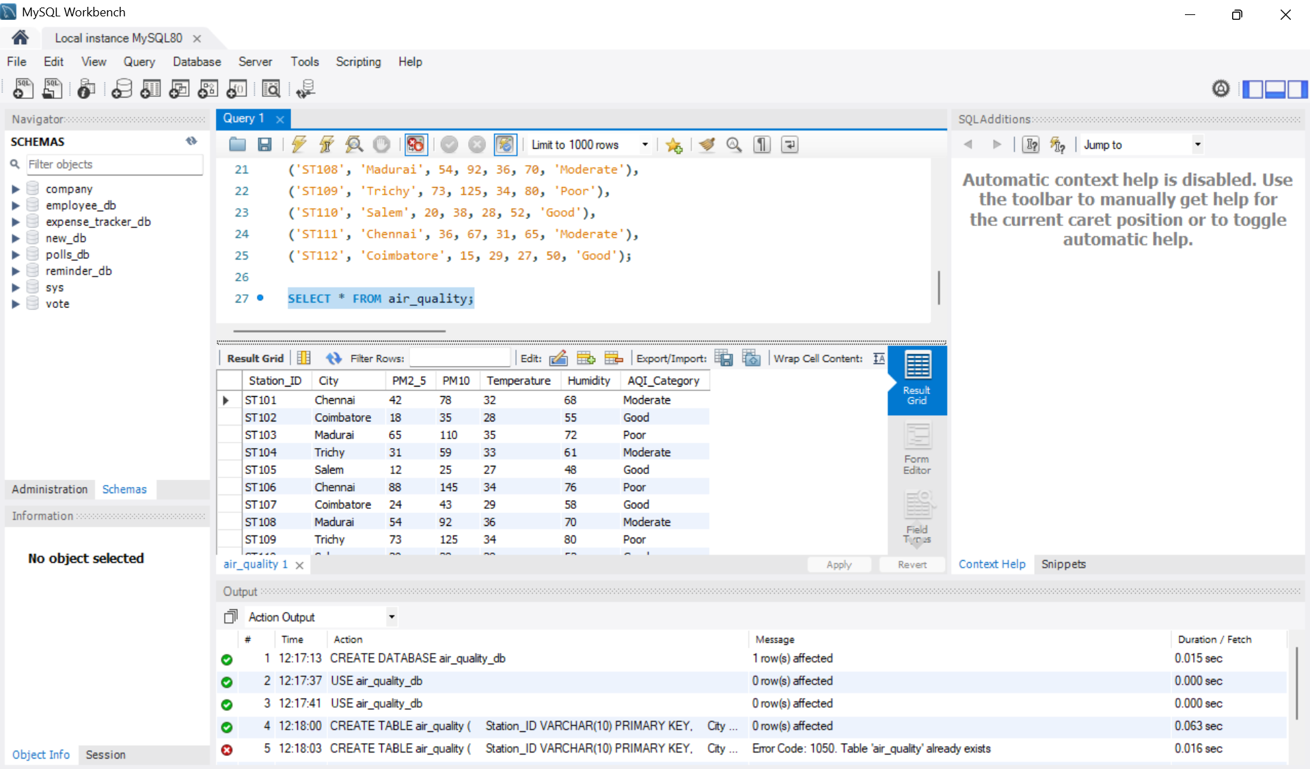
Figure 3: Output of Step 3

Step 4: Count the Total Number of Records
Aim: Use the COUNT() aggregate function to find how many rows are in the table.
Procedure:
1. Write the COUNT(*) query with the alias Total_Records.
2. Click the Execute (lightning) button or press Ctrl + Enter to run the query.
SQL Query:
SELECT COUNT(*) AS Total_Records
FROM air_quality;
Output: Total_Records = 12.
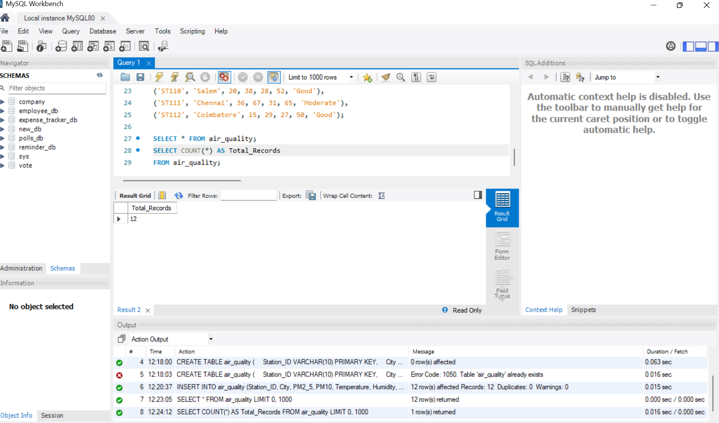
Figure 4: Output of Step 4

Step 5: Create the city_details Table
Aim: Create a second table holding state and monitoring zone details for each city.
Procedure:
1. Write the CREATE TABLE statement with City as the PRIMARY KEY.
2. Click the Execute (lightning) button or press Ctrl + Enter to run the query.
SQL Query:
CREATE TABLE city_details (
City VARCHAR(50) PRIMARY KEY,
State VARCHAR(50),
Monitoring_Zone VARCHAR(50)
);
Output: Table city_details is created (0 row(s) affected).
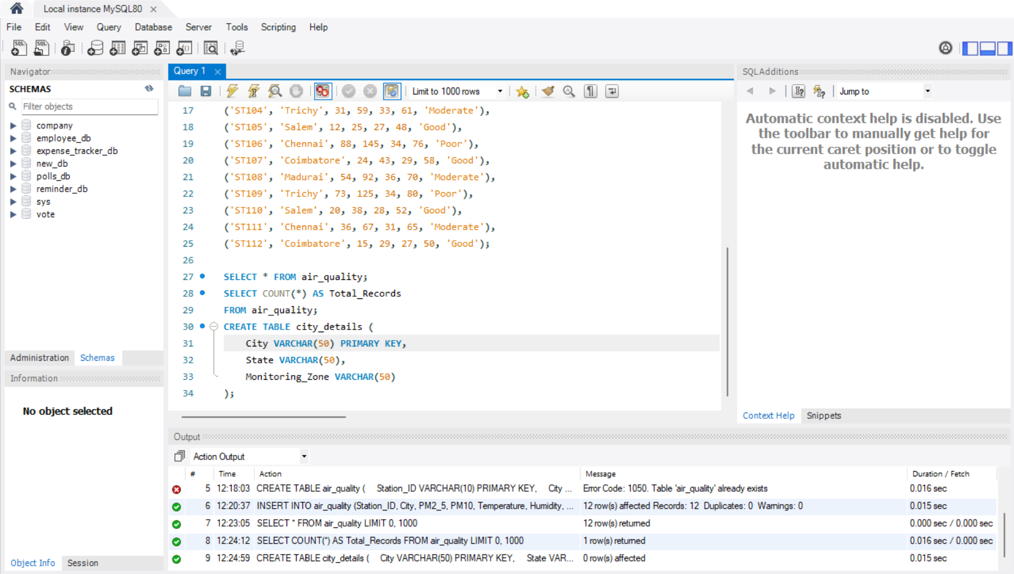
Figure 5: Output of Step 5

Step 6: Insert Records into city_details
Aim: Add state and zone information for the five cities.
Procedure:
1. Write the INSERT INTO statement for City, State and Monitoring_Zone.
2. Click the Execute (lightning) button or press Ctrl + Enter to run the query.
SQL Query:
INSERT INTO city_details
(City, State, Monitoring_Zone)
VALUES
('Chennai', 'Tamil Nadu', 'Coastal'),
('Coimbatore', 'Tamil Nadu', 'Western'),
('Madurai', 'Tamil Nadu', 'Southern'),
('Trichy', 'Tamil Nadu', 'Central'),
('Salem', 'Tamil Nadu', 'Northwestern');
Output: 5 row(s) affected – Records: 5, Duplicates: 0, Warnings: 0.
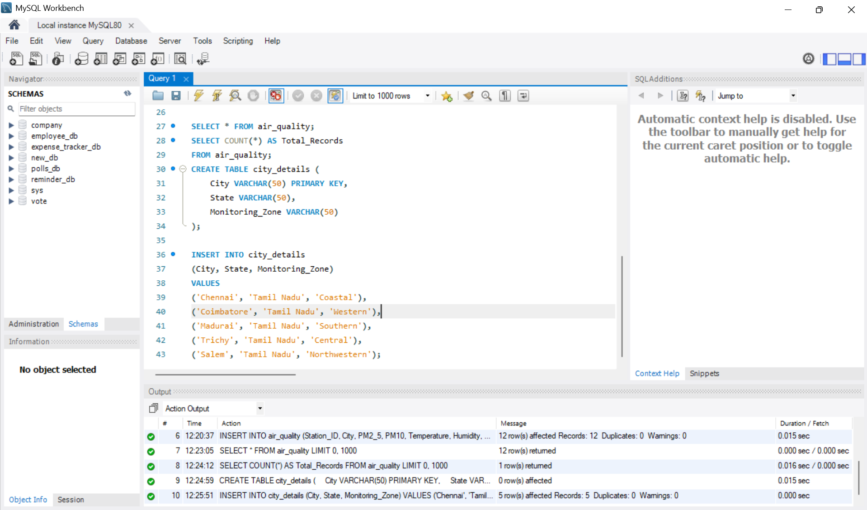
Figure 6: Output of Step 6

Step 7: View the city_details Table
Aim: Verify that the city records were inserted correctly.
Procedure:
1. Write the SELECT * query for city_details.
2. Click the Execute (lightning) button or press Ctrl + Enter to run the query.
SQL Query:
SELECT * FROM city_details;
Output: 5 rows returned showing City, State and Monitoring_Zone.
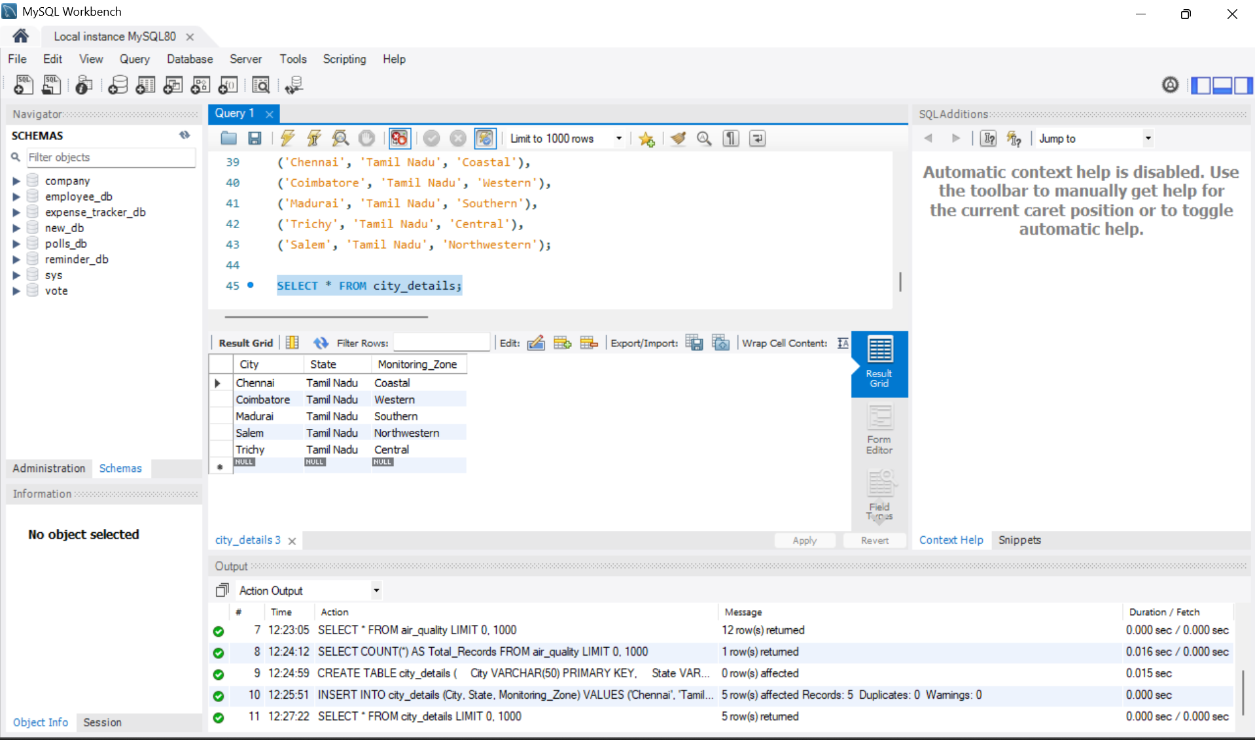
Figure 7: Output of Step 7

Step 8: List All Tables in the Database
Aim: Confirm that both tables exist in air_quality_db.
Procedure:
1. Type SHOW TABLES.
2. Click the Execute (lightning) button or press Ctrl + Enter to run the query.
SQL Query:
SHOW TABLES;
Output: Two tables are listed: air_quality and city_details.
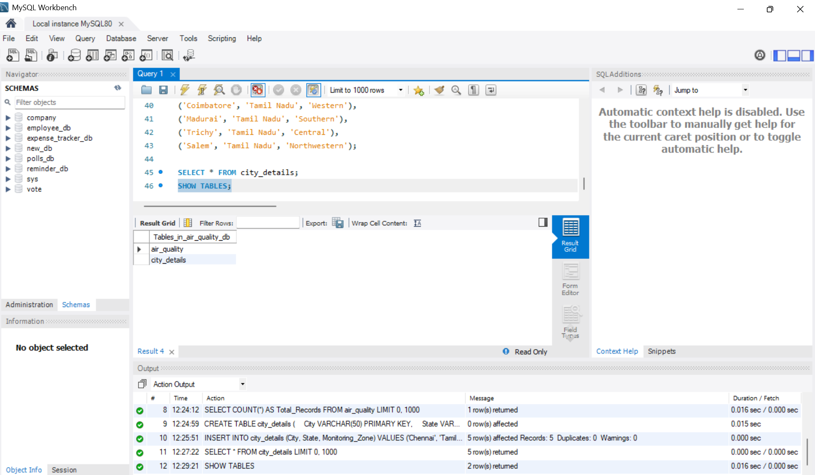
Figure 8: Output of Step 8

2. Filtering, Sorting and Aggregation

Step 9: Filter and Sort Using WHERE and ORDER BY
Aim: Find stations where PM2.5 is greater than 30, sorted from highest to lowest.
Procedure:
1. Select only Station_ID, City and PM2_5.
2. Add the condition PM2_5 > 30 in the WHERE clause.
3. Sort the result with ORDER BY PM2_5 DESC.
4. Click the Execute (lightning) button or press Ctrl + Enter to run the query.
SQL Query:
SELECT Station_ID, City, PM2_5
FROM air_quality
WHERE PM2_5 > 30
ORDER BY PM2_5 DESC;
Output: 7 rows returned, starting with ST106 (Chennai, 88).
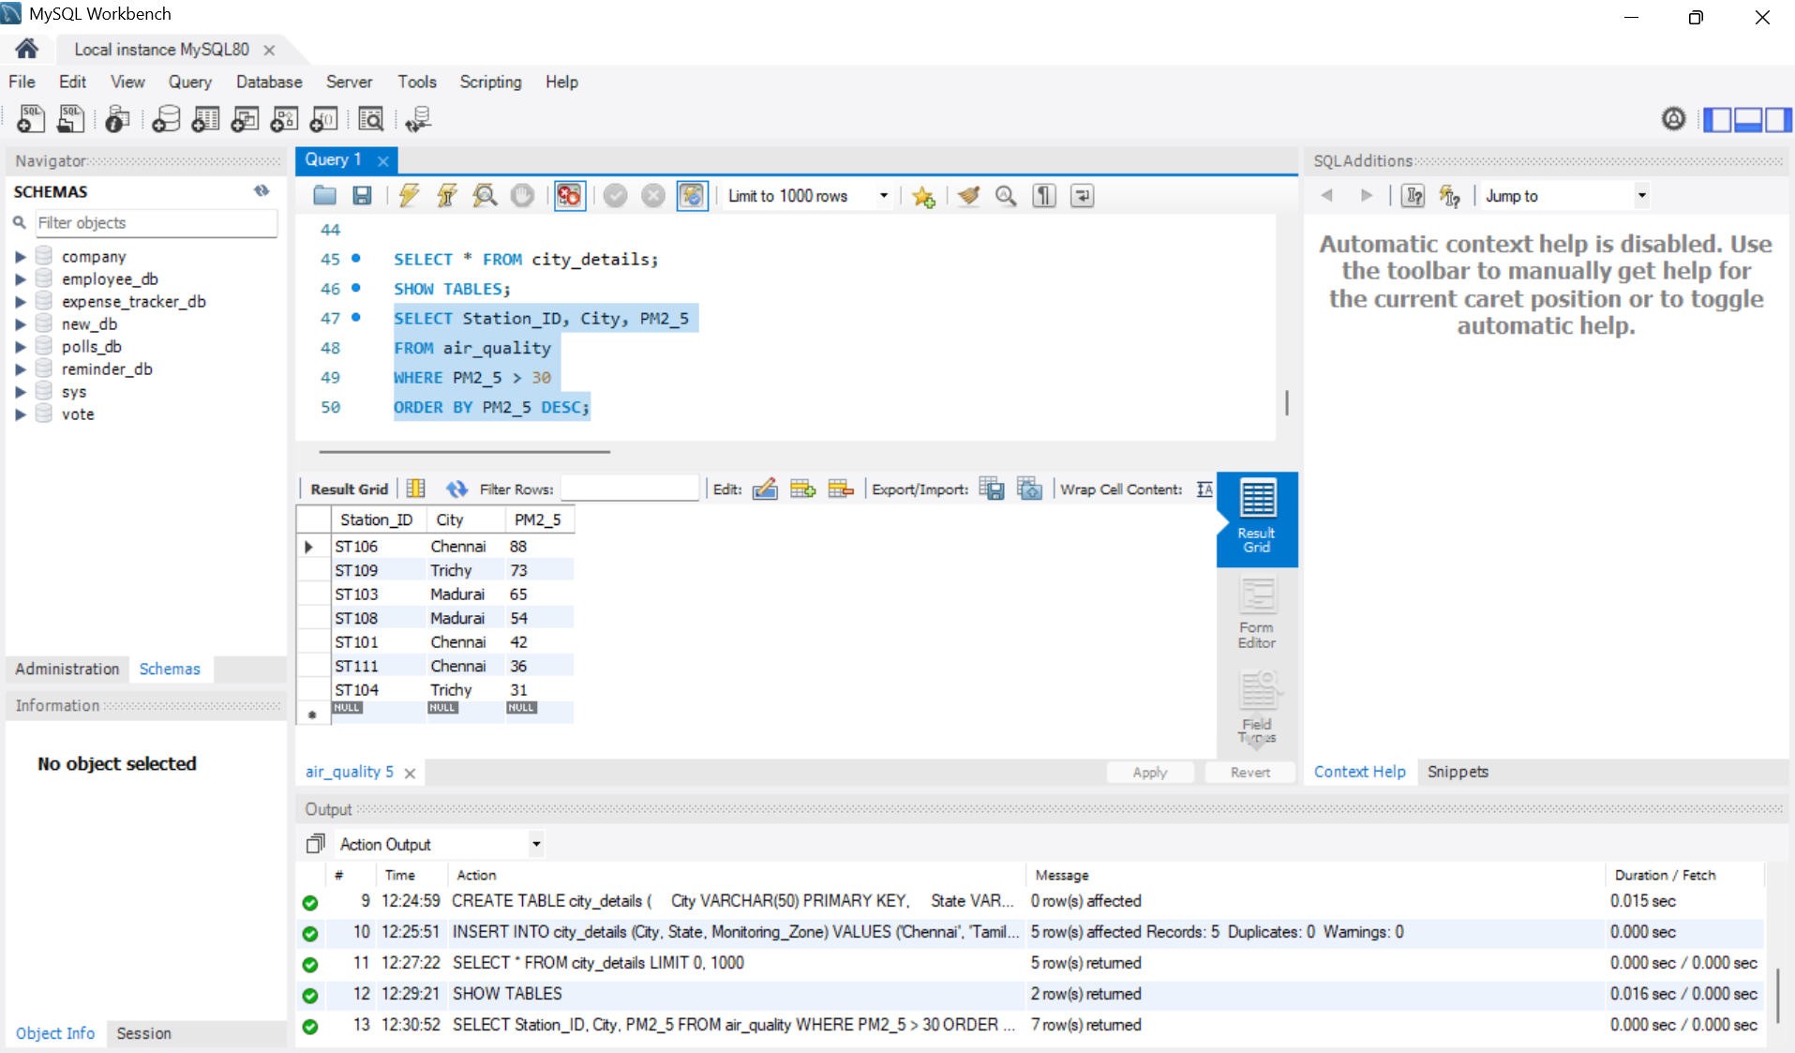
Figure 9: Output of Step 9

Step 10: Count Stations per City Using GROUP BY
Aim: Find how many monitoring stations each city has.
Procedure:
1. Use COUNT(*) with the alias Total_Stations.
2. Group the rows by City.
3. Sort by Total_Stations in descending order.
4. Click the Execute (lightning) button or press Ctrl + Enter to run the query.
SQL Query:
SELECT City, COUNT(*) AS Total_Stations
FROM air_quality
GROUP BY City
ORDER BY Total_Stations DESC;
Output: Chennai 3, Coimbatore 3, Madurai 2, Trichy 2, Salem 2.
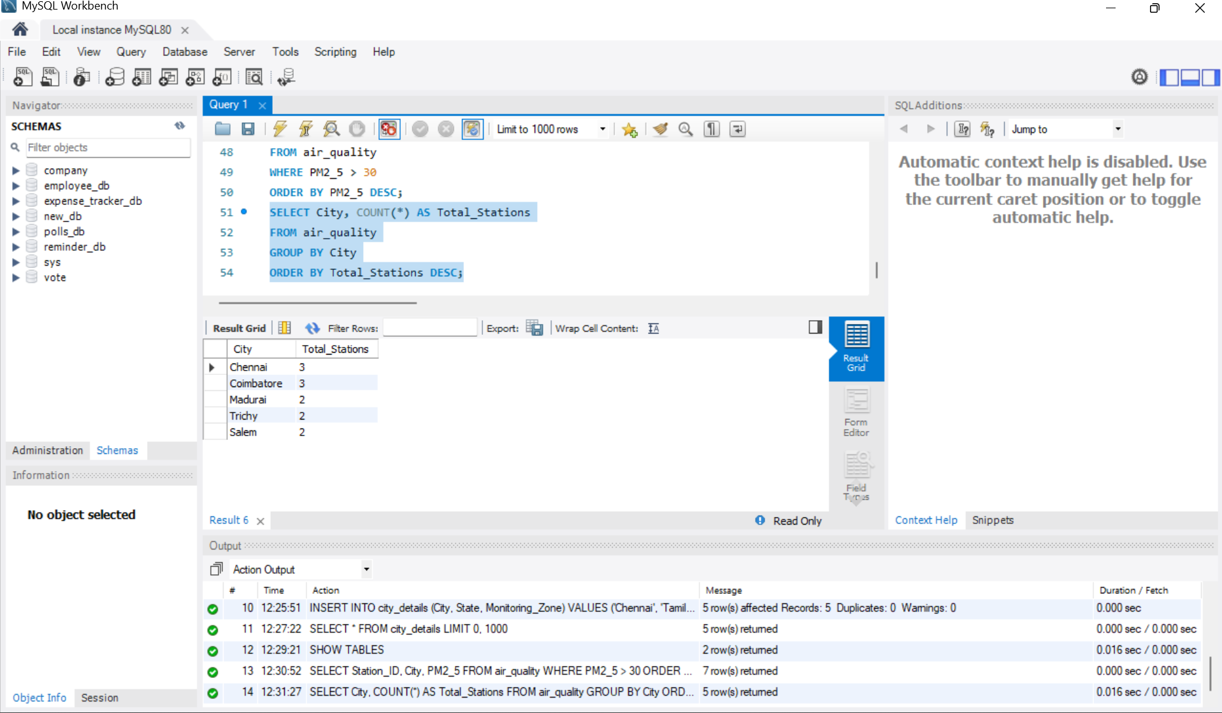
Figure 10: Output of Step 10

Step 11: Find the Average Temperature per City
Aim: Use the AVG() function with GROUP BY to calculate average temperature for each city.
Procedure:
1. Use AVG(Temperature) with the alias Average_Temperature.
2. Group the rows by City.
3. Filter the groups with HAVING to keep only the warmer cities.
4. Click the Execute (lightning) button or press Ctrl + Enter to run the query.
SQL Query:
SELECT City, AVG(Temperature) AS Average_Temperature
FROM air_quality
GROUP BY City
HAVING AVG(Temperature) > 30;
Output: 3 rows returned: Chennai 32.33, Madurai 35.50, Trichy 33.50.
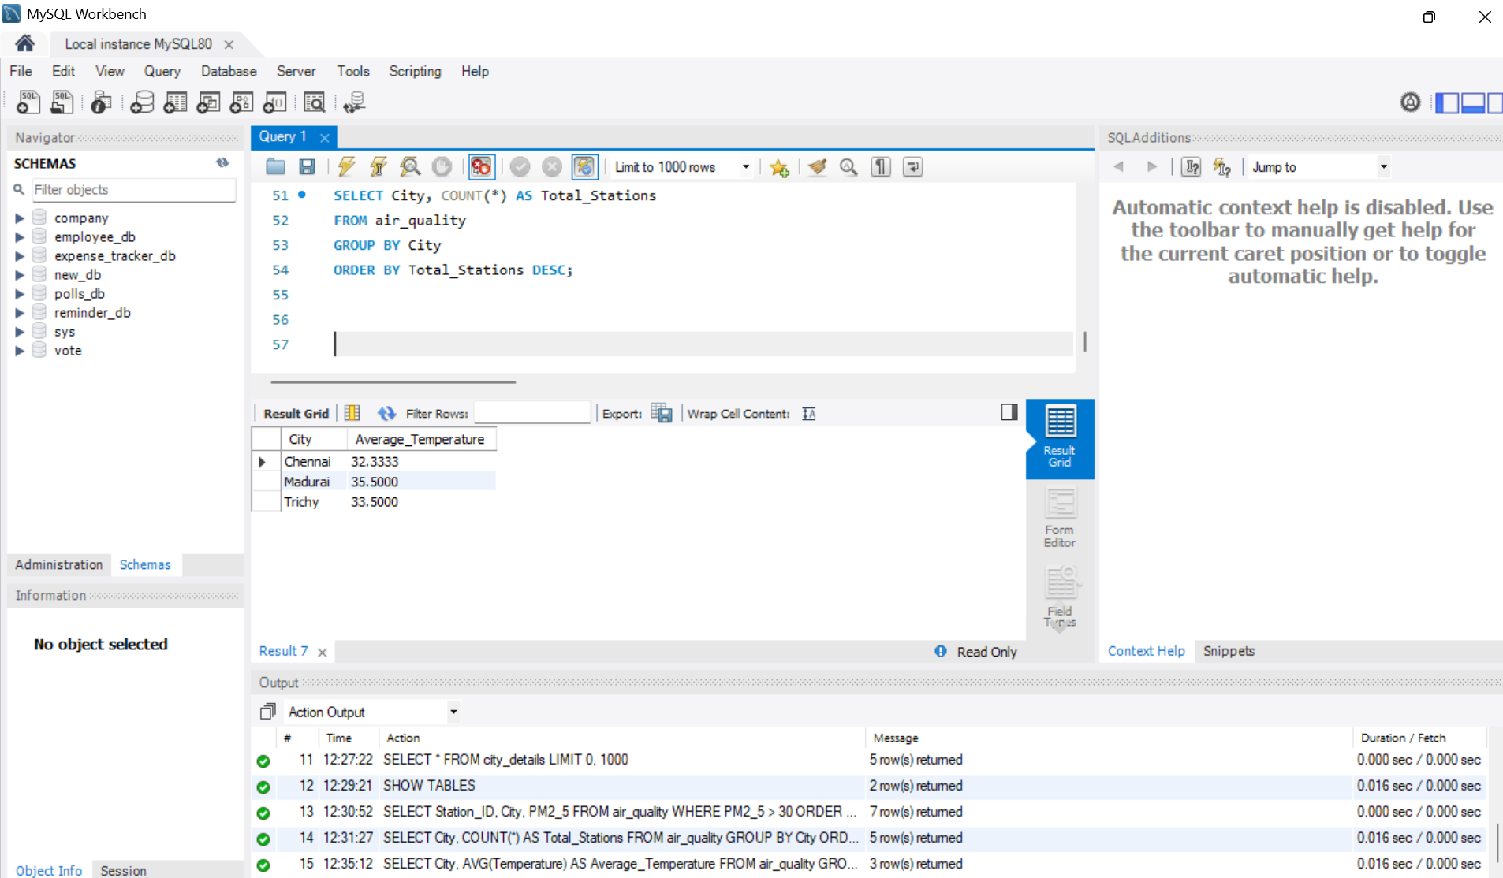
Figure 11: Output of Step 11

Step 12: Filter a Range Using BETWEEN
Aim: Display stations whose PM2.5 value lies between 20 and 60.
Procedure:
1. Write a SELECT * query.
2. Use WHERE PM2_5 BETWEEN 20 AND 60 (both values are included).
3. Click the Execute (lightning) button or press Ctrl + Enter to run the query.
SQL Query:
SELECT *
FROM air_quality
WHERE PM2_5 BETWEEN 20 AND 60;
Output: 6 rows returned.
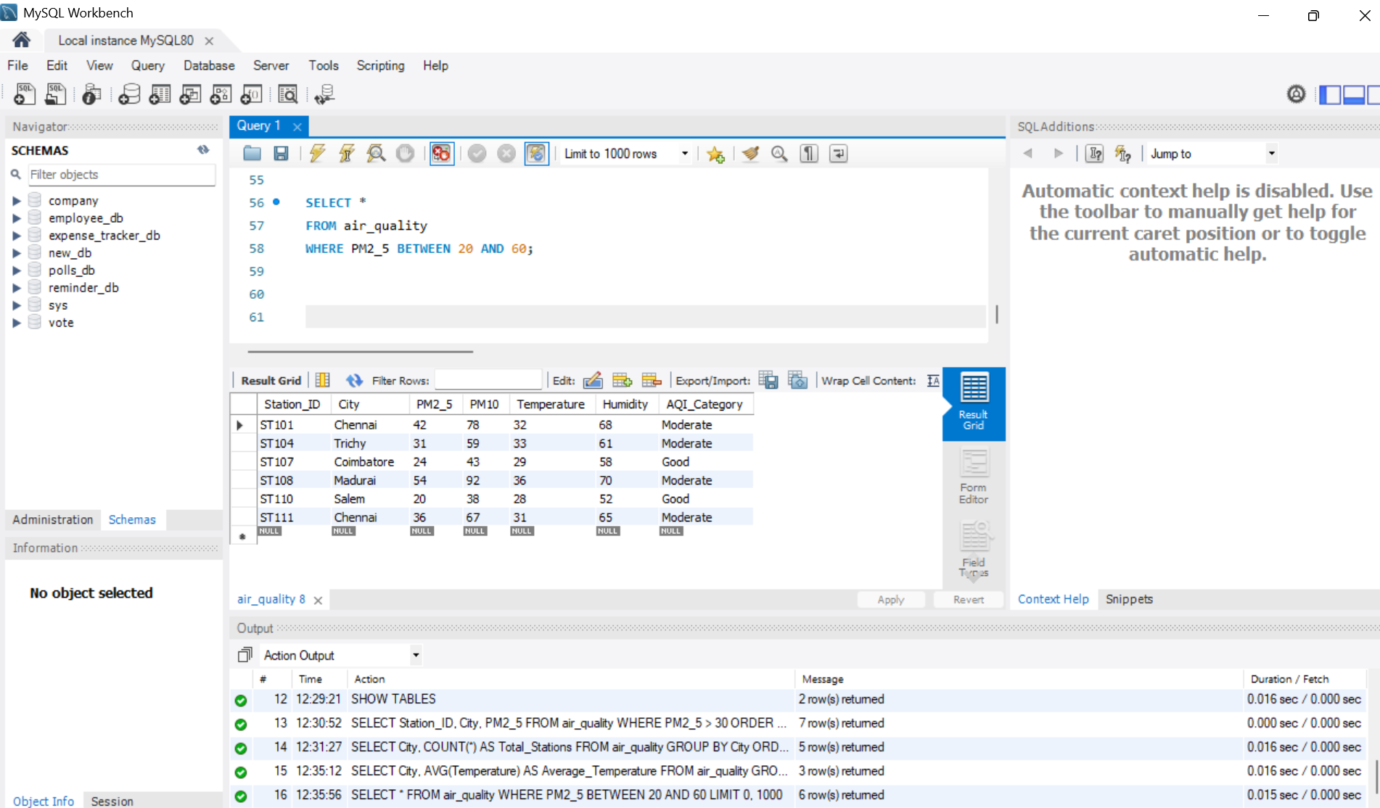
Figure 12: Output of Step 12

Step 13: Filter Multiple Values Using IN
Aim: Display records only for Chennai, Madurai and Salem.
Procedure:
1. Write a SELECT * query.
2. List the cities inside the IN ( ) operator.
3. Click the Execute (lightning) button or press Ctrl + Enter to run the query.
SQL Query:
SELECT *
FROM air_quality
WHERE City IN ('Chennai', 'Madurai', 'Salem');
Output: 7 rows returned.
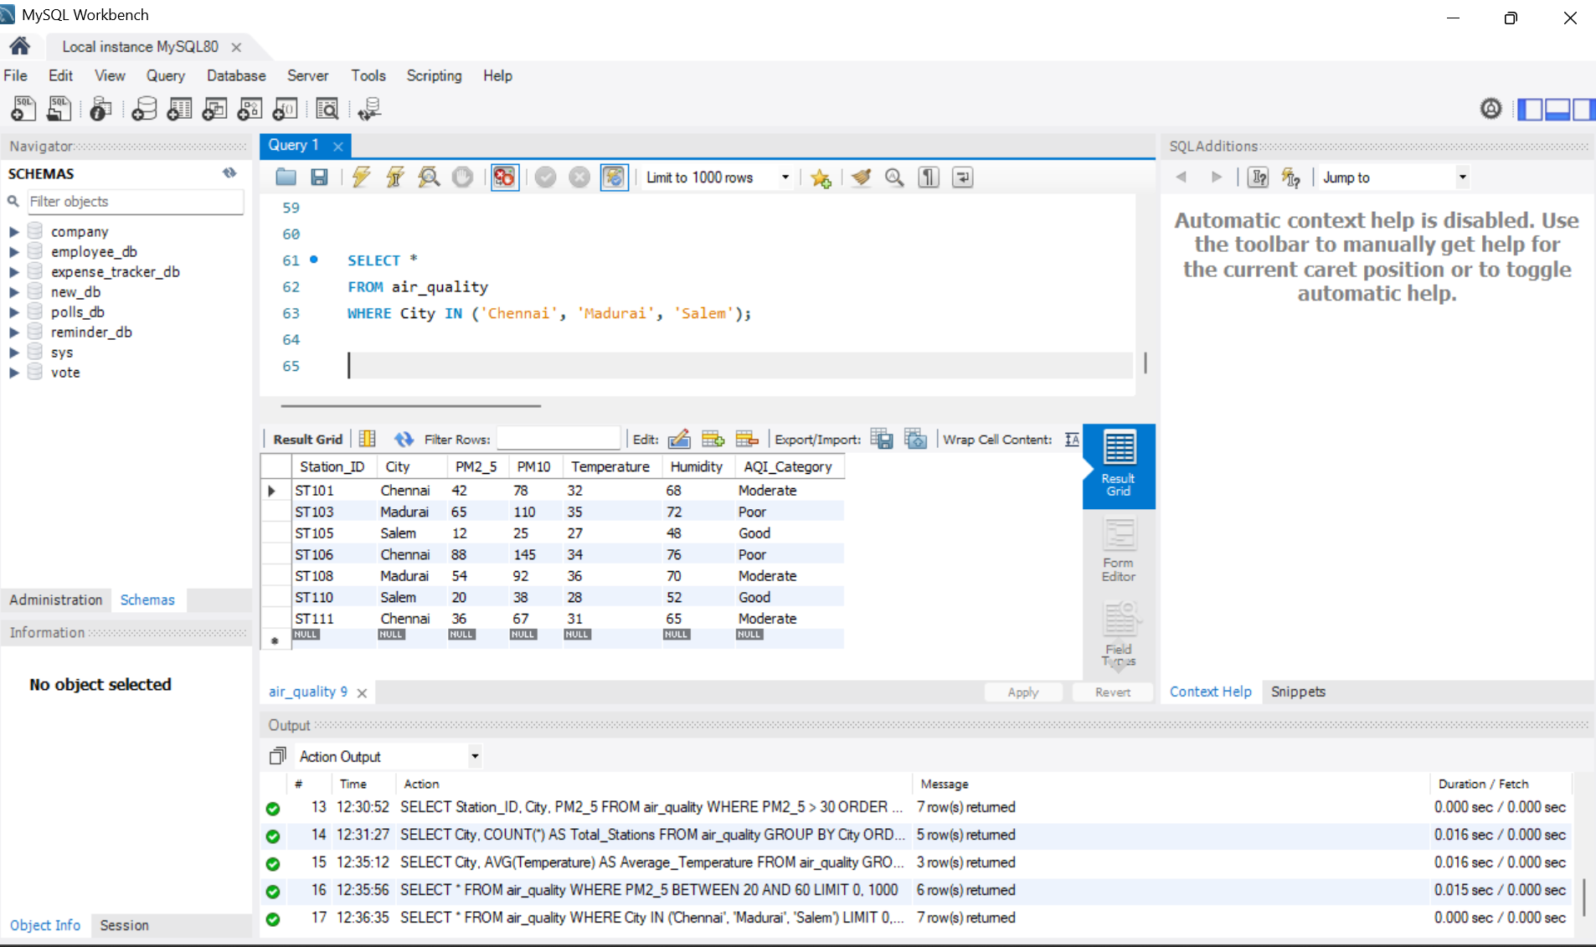
Figure 13: Output of Step 13

3. Joining Tables

Step 14: Combine Tables Using INNER JOIN
Aim: Join air_quality with city_details to show state and zone for stations in Coastal and Western zones.
Procedure:
1. Give the tables aliases: A for air_quality and C for city_details.
2. Join them ON A.City = C.City.
3. Filter zones with WHERE C.Monitoring_Zone IN ('Coastal', 'Western').
4. Click the Execute (lightning) button or press Ctrl + Enter to run the query.
SQL Query:
SELECT A.Station_ID, A.City, A.PM2_5,
C.State, C.Monitoring_Zone
FROM air_quality A
INNER JOIN city_details C
ON A.City = C.City
WHERE C.Monitoring_Zone IN ('Coastal', 'Western');
Output: 6 rows returned for Chennai (Coastal) and Coimbatore (Western) stations.
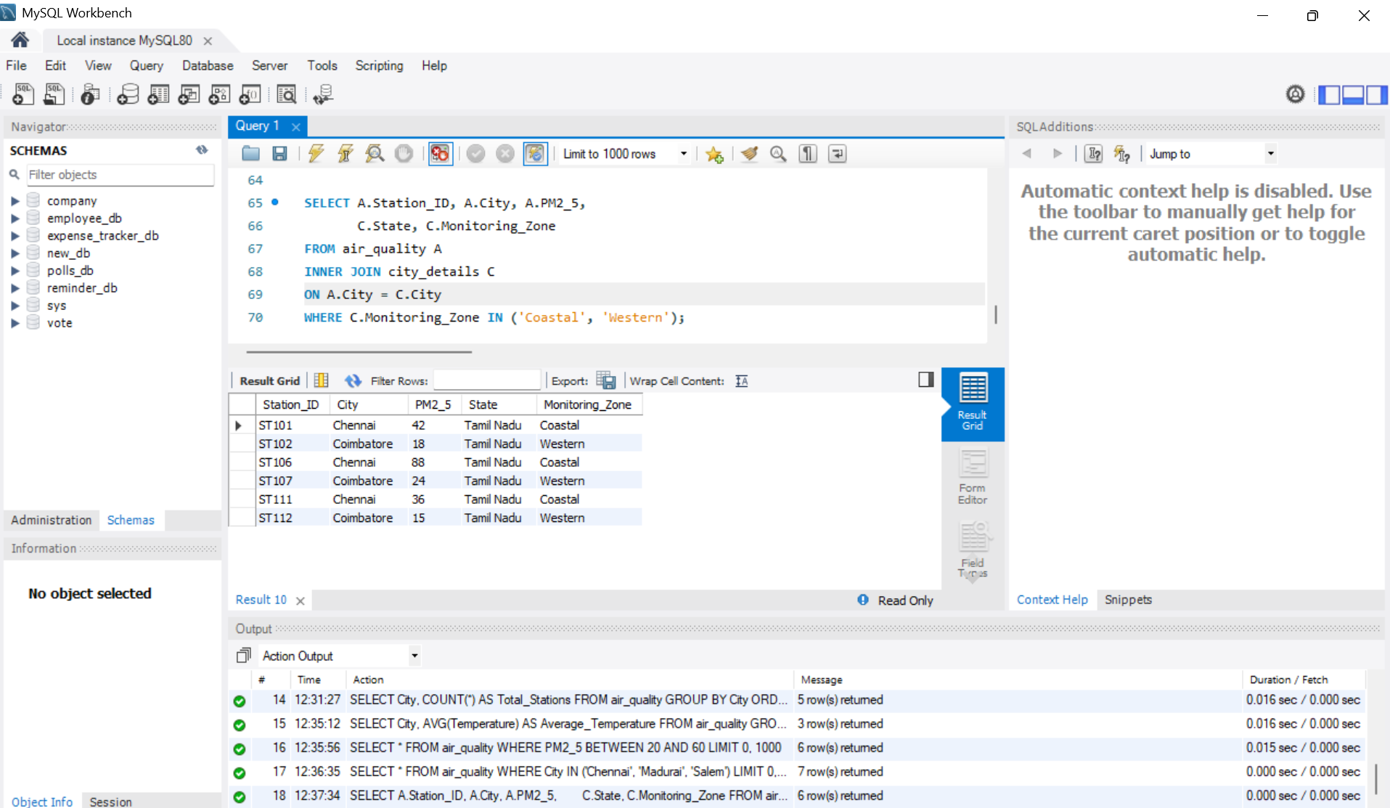
Figure 14: Output of Step 14

Step 15: Average PM10 per Monitoring Zone (JOIN + GROUP BY)
Aim: Calculate the average PM10 level for each monitoring zone.
Procedure:
1. Join air_quality and city_details on City.
2. Use AVG(A.PM10) with the alias Average_PM10.
3. Group the result by C.Monitoring_Zone.
4. Click the Execute (lightning) button or press Ctrl + Enter to run the query.
SQL Query:
SELECT C.Monitoring_Zone,
AVG(A.PM10) AS Average_PM10
FROM air_quality A
INNER JOIN city_details C
ON A.City = C.City
GROUP BY C.Monitoring_Zone;
Output: 5 rows returned; the Southern zone has the highest average PM10 (101.00).
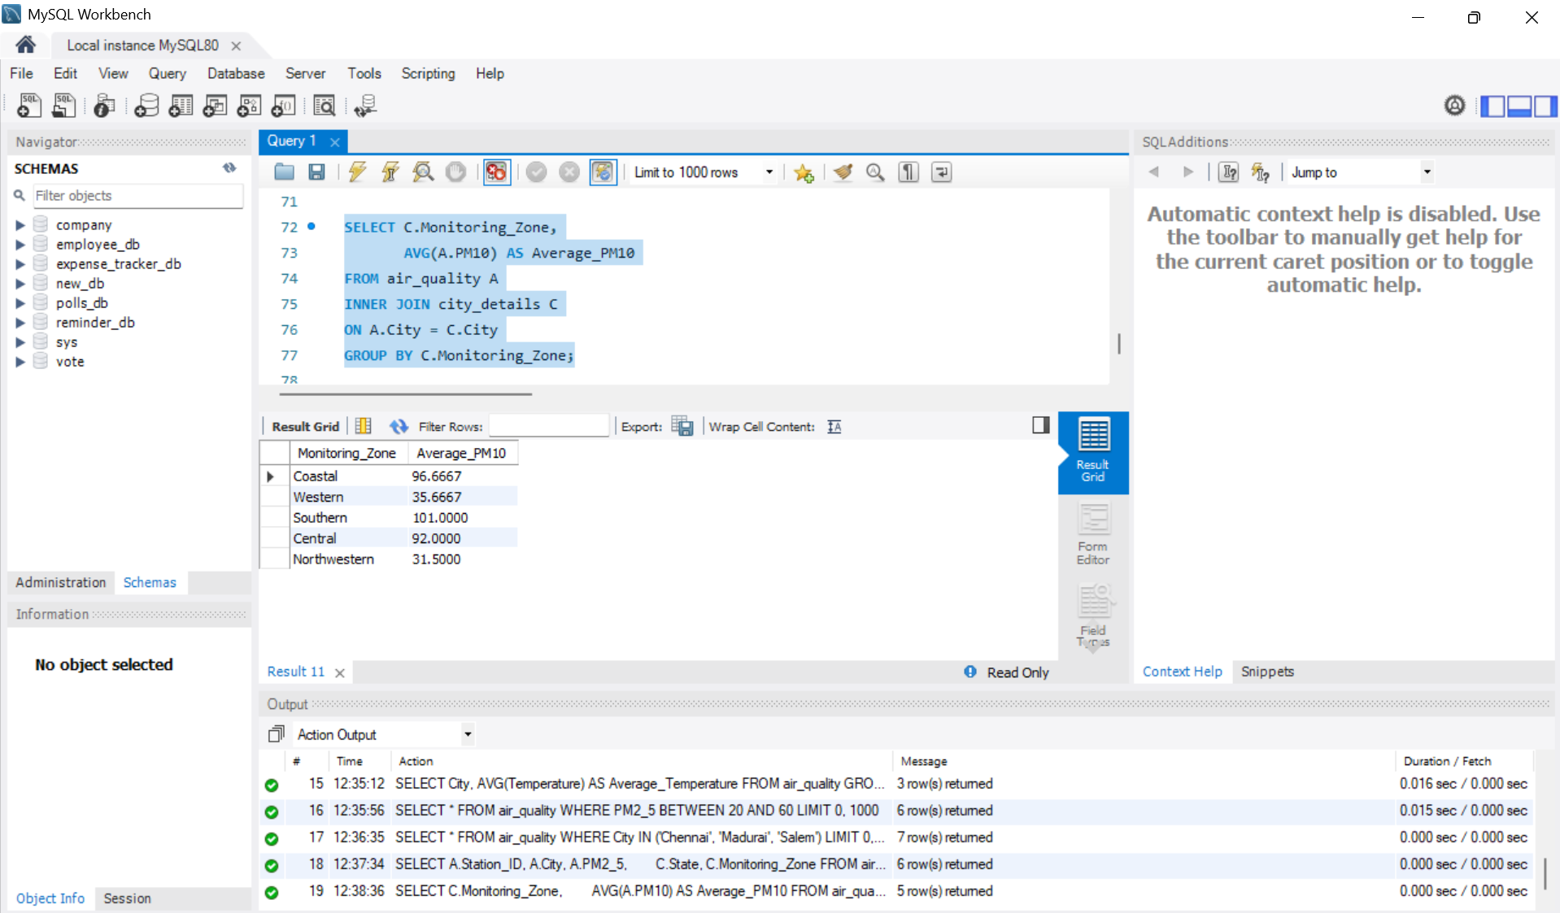
Figure 15: Output of Step 15

4. Advanced Queries

Step 16: Find Highest and Lowest PM2.5 per City
Aim: Use MAX() and MIN() to find the PM2.5 range in each city.
Procedure:
1. Use MAX(PM2_5) AS Highest_PM25 and MIN(PM2_5) AS Lowest_PM25.
2. Group the result by City.
3. Click the Execute (lightning) button or press Ctrl + Enter to run the query.
SQL Query:
SELECT City,
MAX(PM2_5) AS Highest_PM25,
MIN(PM2_5) AS Lowest_PM25
FROM air_quality
GROUP BY City;
Output: 5 rows returned, e.g. Chennai: highest 88, lowest 36.
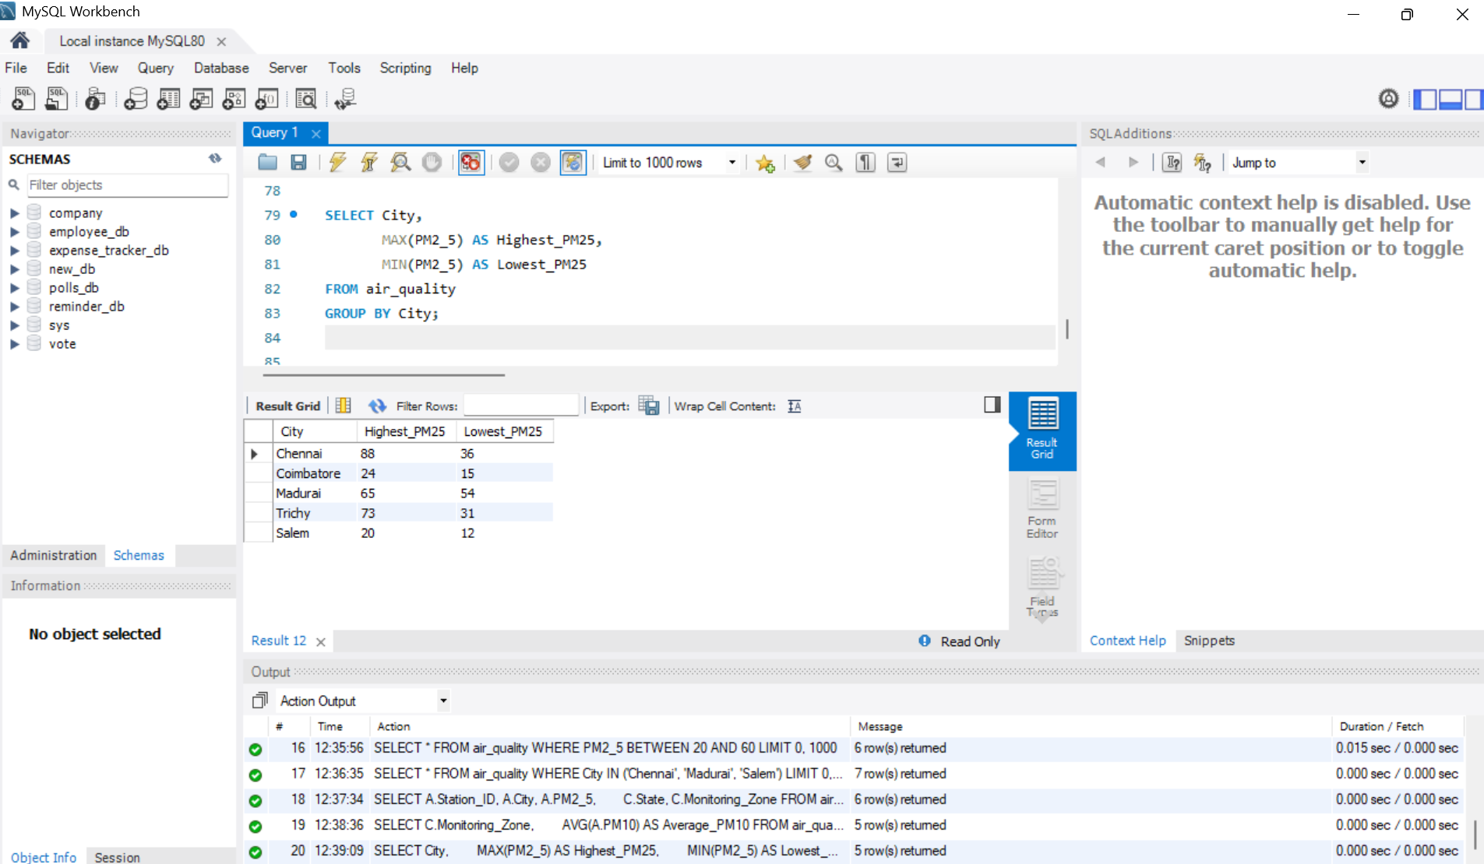
Figure 16: Output of Step 16

Step 17: Pattern Matching Using LIKE
Aim: Display cities whose names start with the letter 'C'.
Procedure:
1. Use WHERE City LIKE 'C%' (% matches any characters after C).
2. Sort with ORDER BY City ASC.
3. Click the Execute (lightning) button or press Ctrl + Enter to run the query.
SQL Query:
SELECT *
FROM air_quality
WHERE City LIKE 'C%'
ORDER BY City ASC;
Output: 6 rows returned for Chennai and Coimbatore.
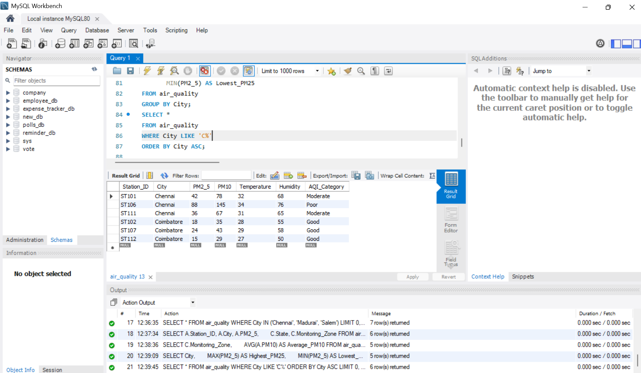
Figure 17: Output of Step 17

Step 18: Find the Most Polluted Station Using a Subquery
Aim: Find the station with the highest PM2.5 value using a nested query.
Procedure:
1. Write an inner query SELECT MAX(PM2_5) FROM air_quality.
2. Use it in the WHERE clause of the outer query.
3. Click the Execute (lightning) button or press Ctrl + Enter to run the query.
SQL Query:
SELECT Station_ID, City, PM2_5
FROM air_quality
WHERE PM2_5 = (
SELECT MAX(PM2_5)
FROM air_quality
);
Output: 1 row returned: ST106, Chennai, PM2.5 = 88.
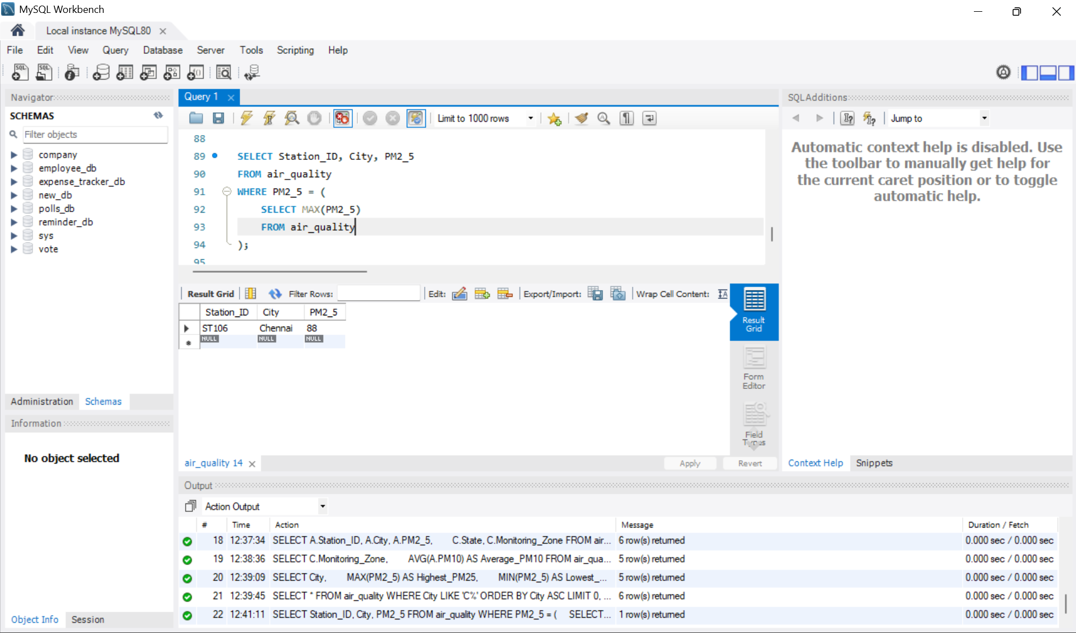
Figure 18: Output of Step 18

5. Summary
• Created the database air_quality_db with two tables: air_quality and city_details.
• Inserted 12 station records and 5 city records.
• Practised WHERE, ORDER BY, BETWEEN, IN, LIKE, GROUP BY, HAVING and aggregate functions (COUNT, AVG, MAX, MIN).
• Combined the two tables using INNER JOIN and found the most polluted station with a subquery.

