Power BI – Pharmacy Sales Data: Step-by-Step Guide

Overview
This guide shows how to load three pharmacy CSV files into Power BI Desktop, combine them in Power Query, add a calculated column, and set up table relationships.
Files used:
- 01_pharmacy_sales_yesterday.csv – SALE_ID, PRODUCT_NAME, CATEGORY, QUANTITY, UNIT_PRICE, CITY
- 02_pharmacy_customers.csv – SALE_ID, CUSTOMER_ID, CUSTOMER_NAME, AGE_GROUP, CITY, SALES_CHANNEL
- 03_pharmacy_products.csv – PRODUCT_NAME, CATEGORY, UNIT_PRICE, SUPPLIER_ID, STOCK_QTY, REORDER_LEVEL

Step 1: Import the Sales CSV File
1. Open Power BI Desktop.
2. On the Home tab, click Get data and choose Text/CSV.
3. Browse to 01_pharmacy_sales_yesterday.csv and click Open.
4. In the preview window, check the settings: File Origin = 1252: Western European (Windows), Delimiter = Comma, Data Type Detection = Based on first 200 rows.
5. Click Transform Data to open the file in Power Query Editor.
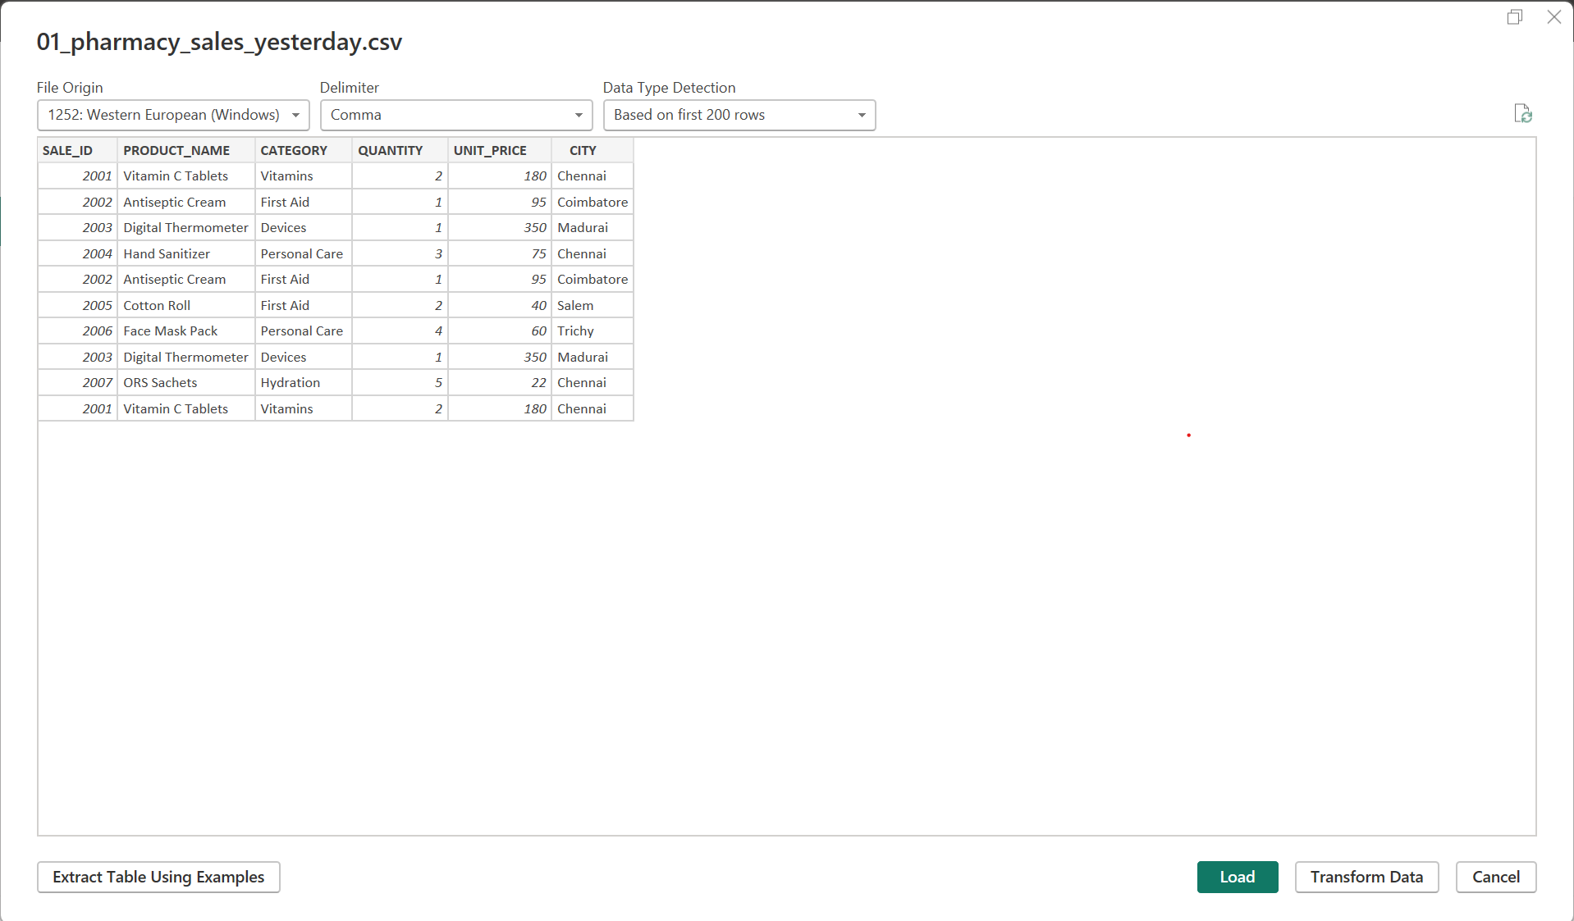
Figure 1: CSV preview window for 01_pharmacy_sales_yesterday.csv

Step 2: Review the Query in Power Query Editor
1. The sales table opens in Power Query Editor with 6 columns and 10 rows.
2. In the Query Settings pane on the right, look at Applied Steps. Power BI adds these automatically: Source, Promoted Headers and Changed Type.
3. Check that each column has the correct data type (123 = number, ABC = text).
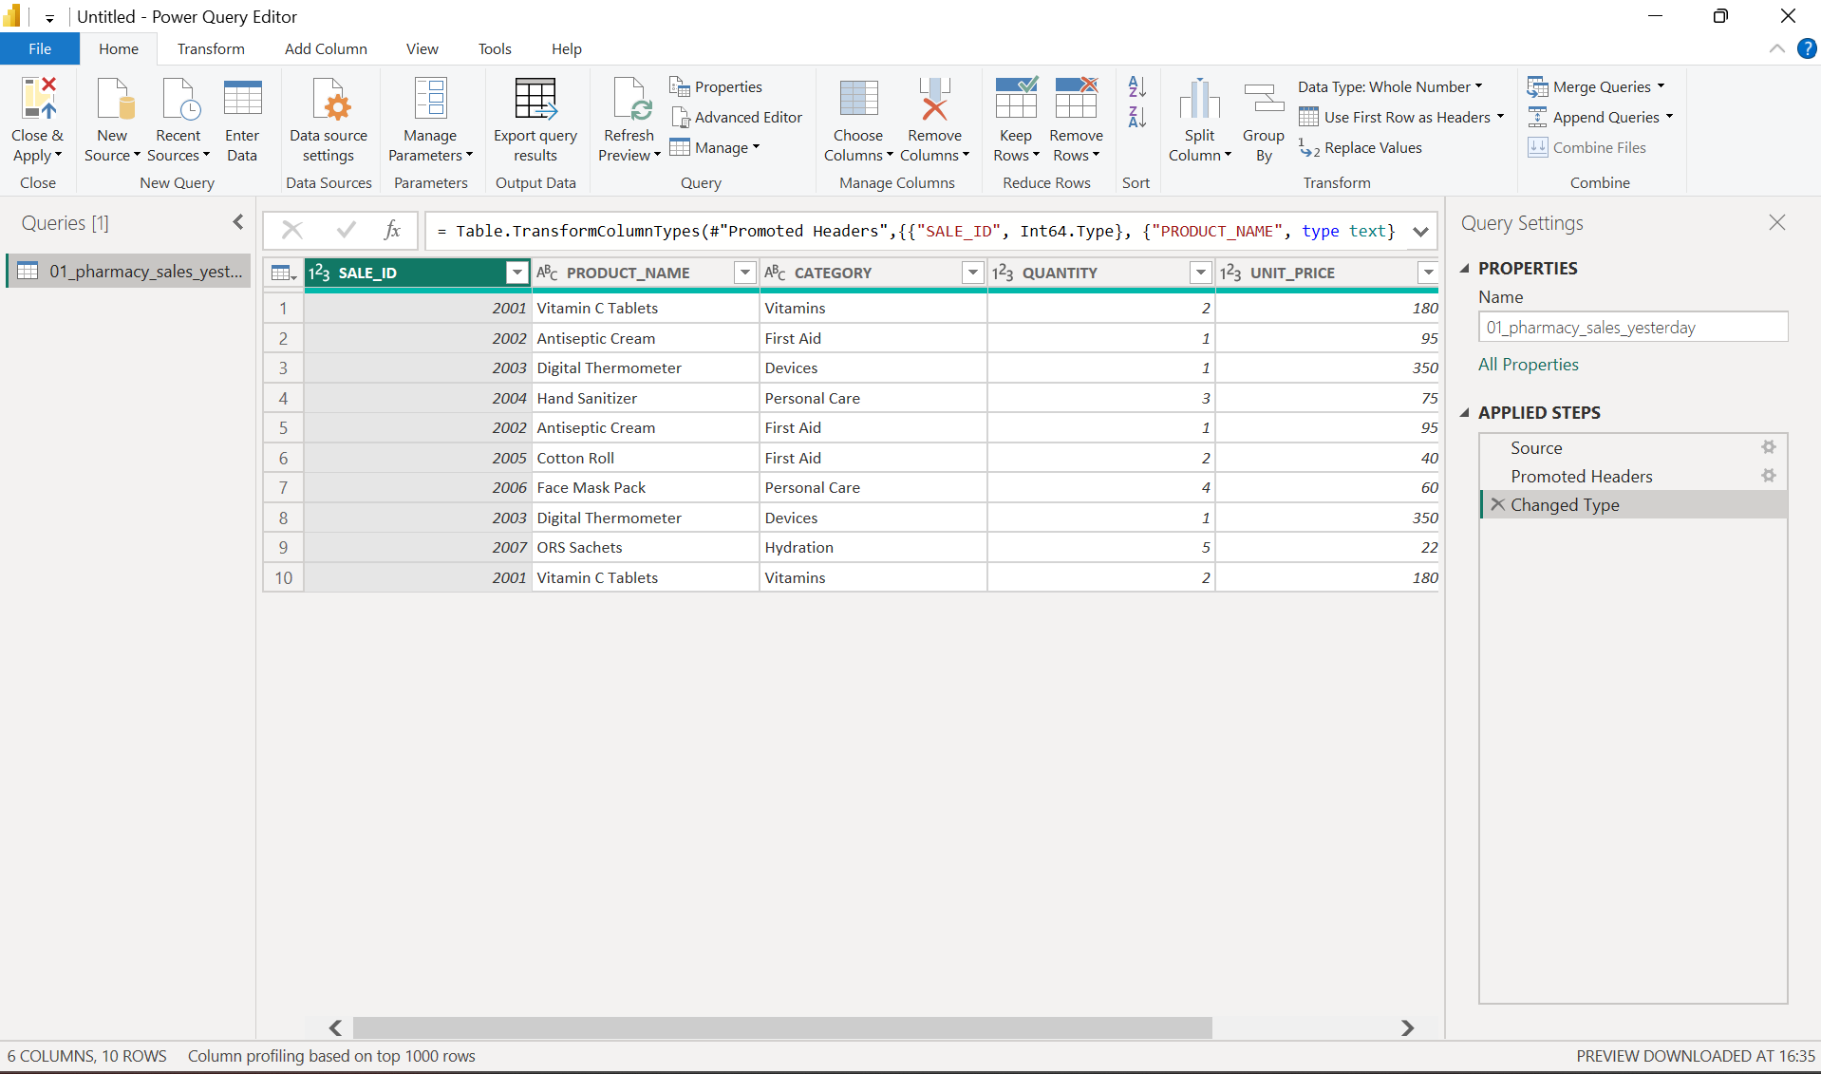
Figure 2: Sales query in Power Query Editor with applied steps

Step 3: Import the Customers and Products Files
1. On the Home tab in Power Query Editor, click New Source and choose Text/CSV.
2. Select 02_pharmacy_customers.csv and click OK.
3. Repeat the same steps for 03_pharmacy_products.csv.
4. All three queries now appear in the Queries pane on the left.
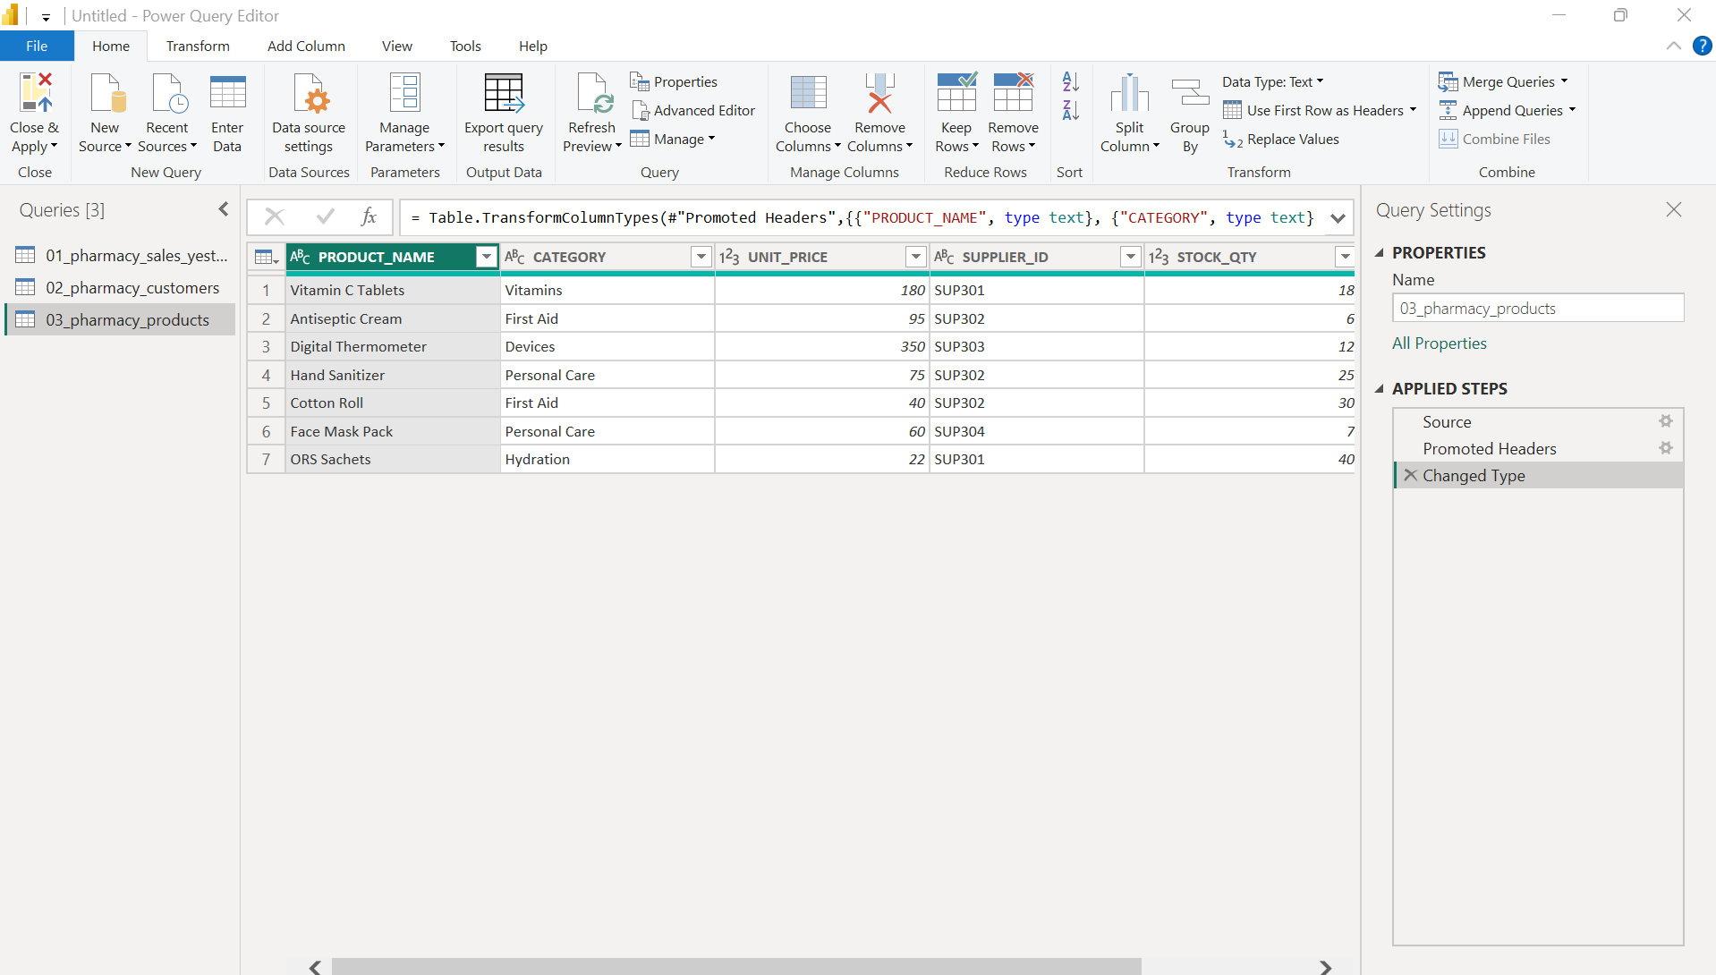
Figure 3: All three queries loaded – products query shown

Step 4: Merge Sales with Customers
1. In the Queries pane, select 01_pharmacy_sales_yesterday.
2. On the Home tab, click Merge Queries.
3. The Merge window opens with the sales table on top.
4. In the second drop-down, select 02_pharmacy_customers.
5. Click the SALE_ID column in the top table, then click the SALE_ID column in the bottom table.
6. Set Join Kind to Left Outer (all from first, matching from second).
7. Leave Use fuzzy matching unchecked.
8. Confirm the message at the bottom reads: The selection matches 10 of 10 rows from the first table.
9. Click OK.
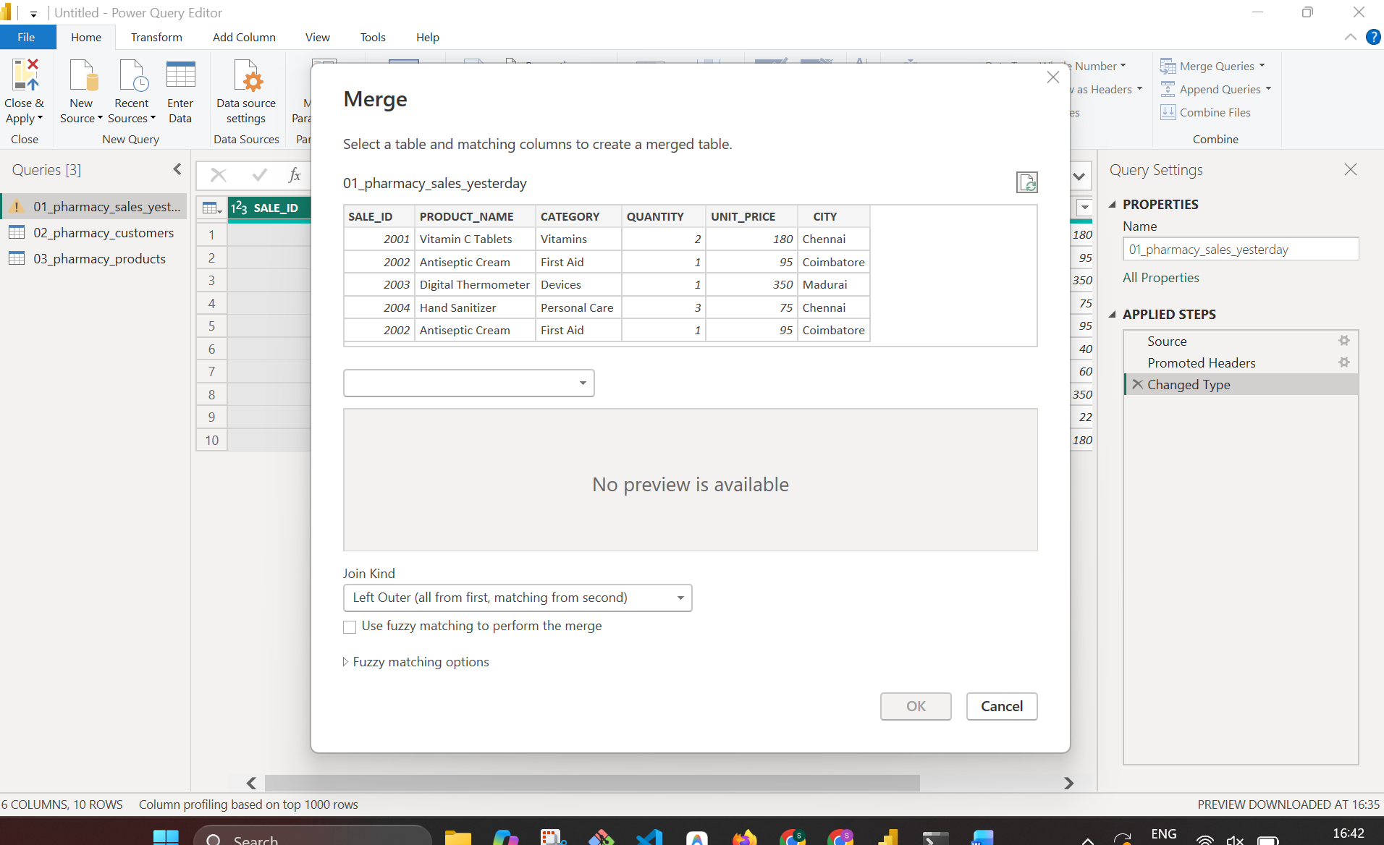
Figure 4: Merge window before selecting the second table
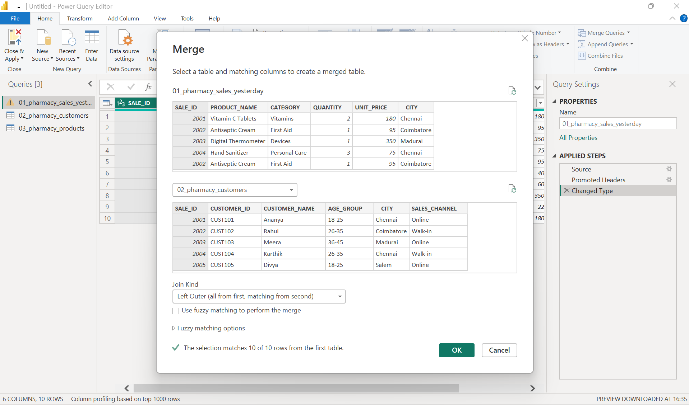
Figure 5: Merge window with SALE_ID selected in both tables

Step 5: Expand the Merged Column
1. A new column named 02_pharmacy_customers appears at the end of the table. Every cell shows the word Table.
2. A new step called Merged Queries is added to Applied Steps.
3. Click the expand icon (two arrows) on the right of the column header.
4. Untick all columns, then tick only AGE_GROUP.
5. Click OK.
6. The column is renamed 02_pharmacy_customers.AGE_GROUP and shows the age group for each sale.
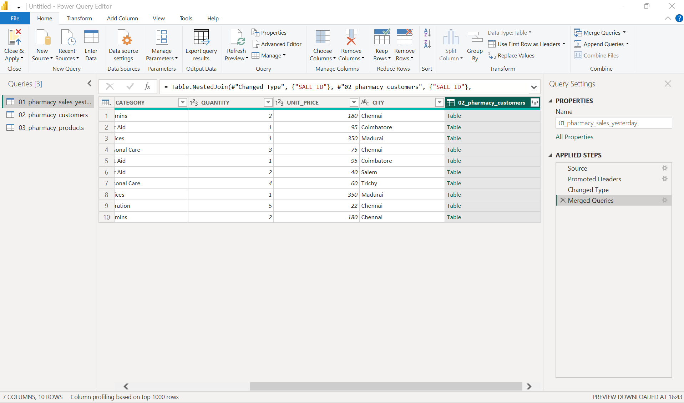
Figure 6: Merged column showing Table values
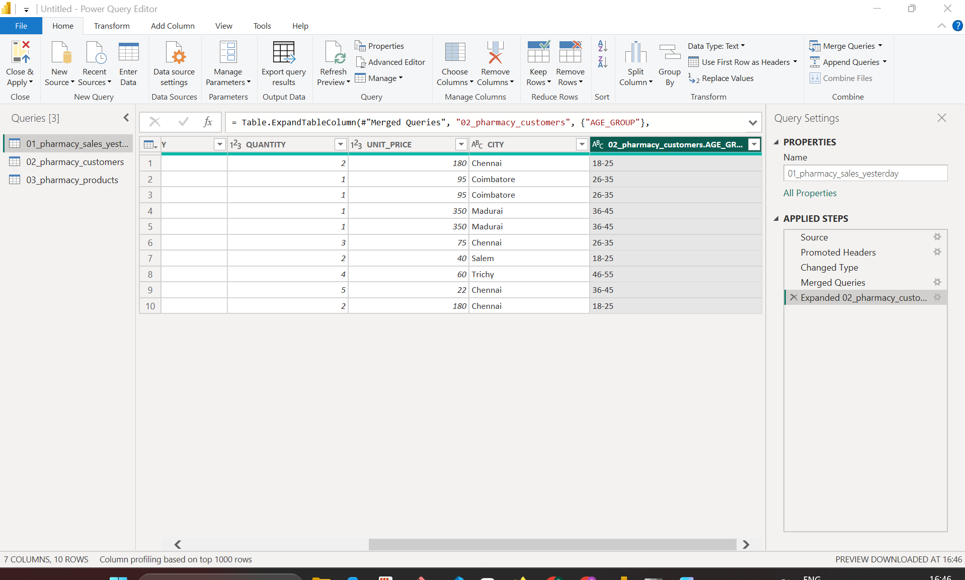
Figure 7: Expanded AGE_GROUP column

Step 6: Add a Custom Column for Total Amount
1. Go to the Add Column tab and click Custom Column.
2. In New column name, type TOTAL_AMOUNT.
3. In Custom column formula, enter: = [QUANTITY] * [UNIT_PRICE]
4. You can double-click a column name in Available columns (or click Insert) instead of typing it.
5. Check that the message No syntax errors have been detected appears.
6. Click OK.
7. The TOTAL_AMOUNT column is added and an Added Custom step appears in Applied Steps.
Tip: The new column type shows as ABC/123 (any). Click the type icon in the column header and change it to Whole Number or Decimal Number so it can be summed in reports.
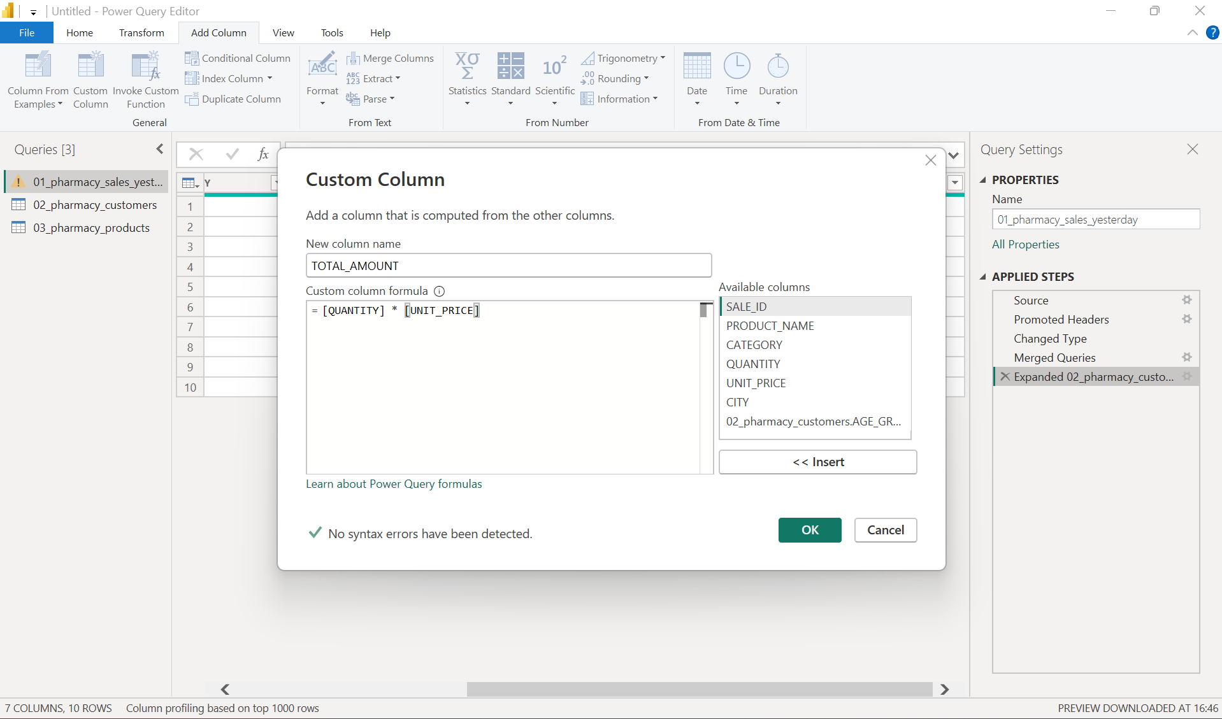
Figure 8: Custom Column window with the TOTAL_AMOUNT formula
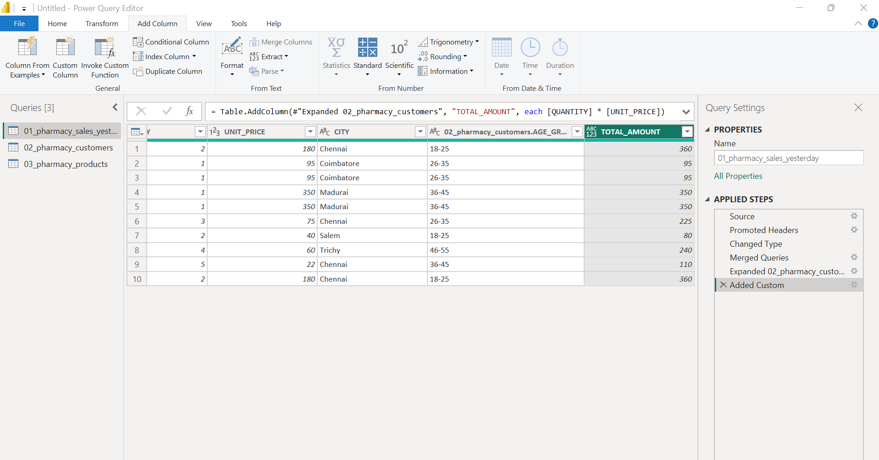
Figure 9: TOTAL_AMOUNT column added

Step 7: Close & Apply
1. On the Home tab in Power Query Editor, click Close & Apply.
2. Power BI loads all three tables into the data model.

Step 8: Check Relationships in Model View
1. Click the Model view icon on the left side bar.
2. The three tables are shown as cards with lines between them.
3. 01_pharmacy_sales_yesterday is in the middle, linked to 03_pharmacy_products on the left and 02_pharmacy_customers on the right.
4. The 1 and * marks on each line show a one-to-many relationship.
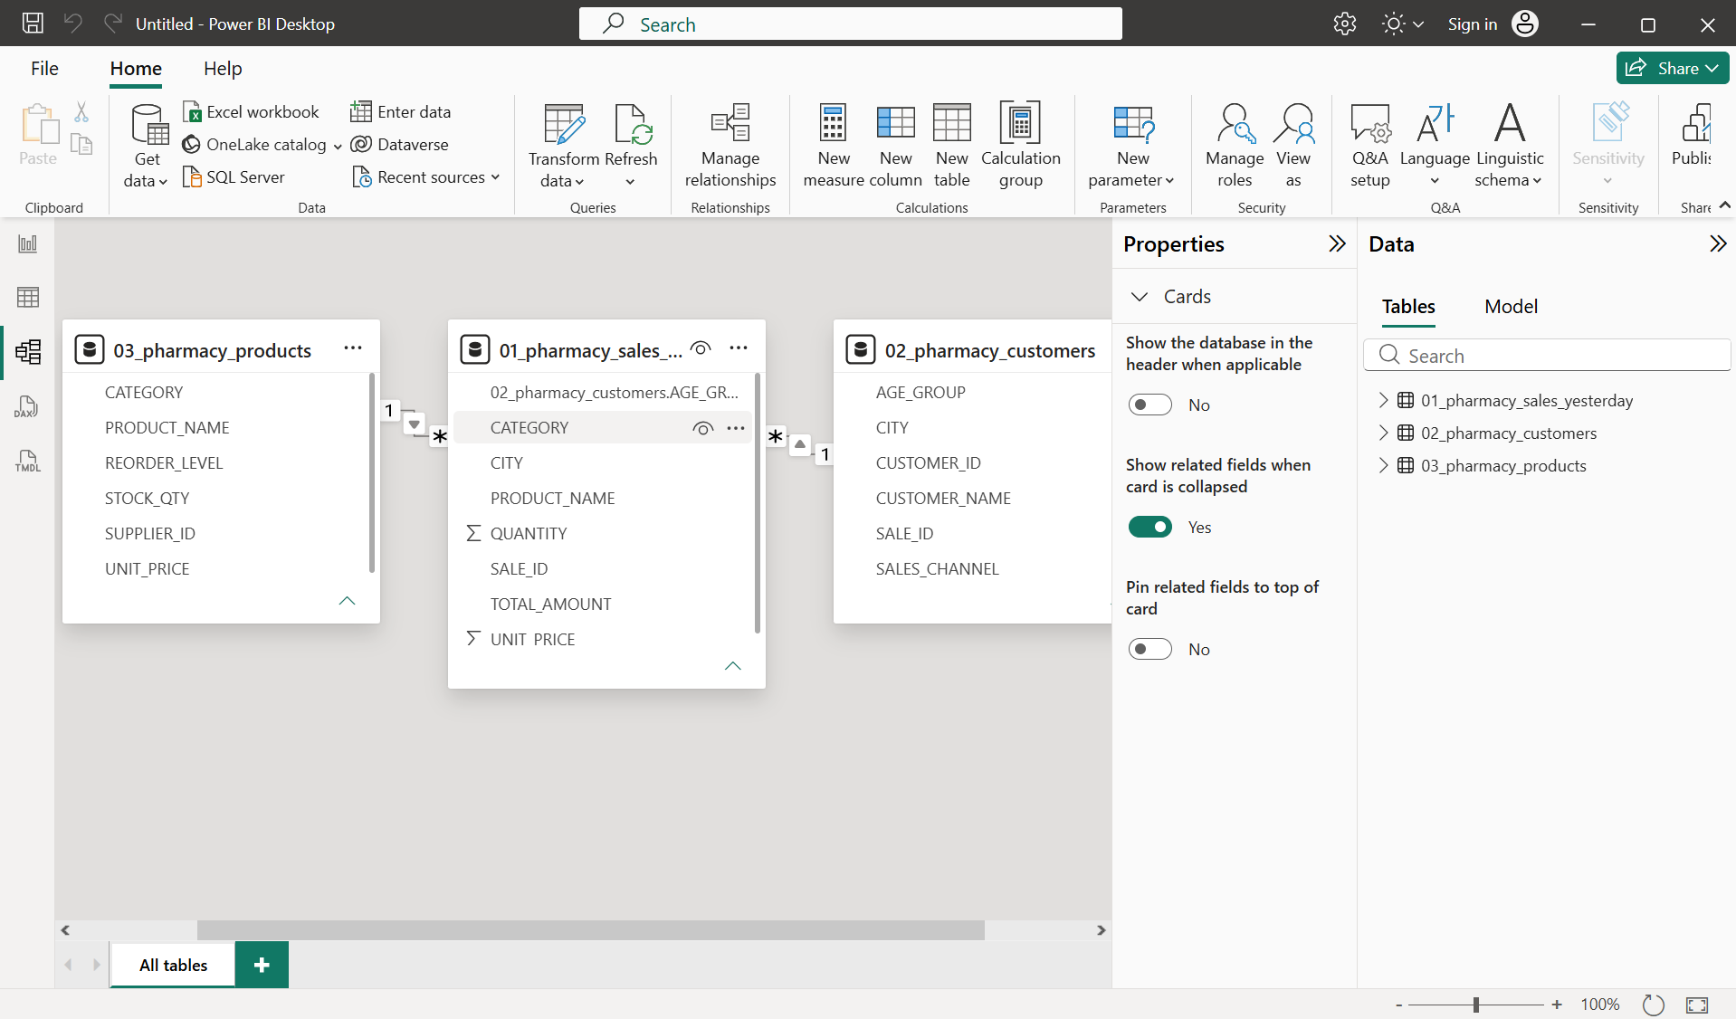
Figure 10: Model view showing relationships between the three tables

Step 9: Edit the Sales–Products Relationship
1. Double-click the line between 01_pharmacy_sales_yesterday and 03_pharmacy_products.
2. In the Edit relationship window, set From table to 01_pharmacy_sales_yesterday.
3. Select the PRODUCT_NAME column.
4. Set To table to 03_pharmacy_products and select PRODUCT_NAME.
5. Set Cardinality to Many to one (*:1).
6. Set Cross-filter direction to Single.
7. Make sure Make this relationship active is ticked.
8. Click Save.
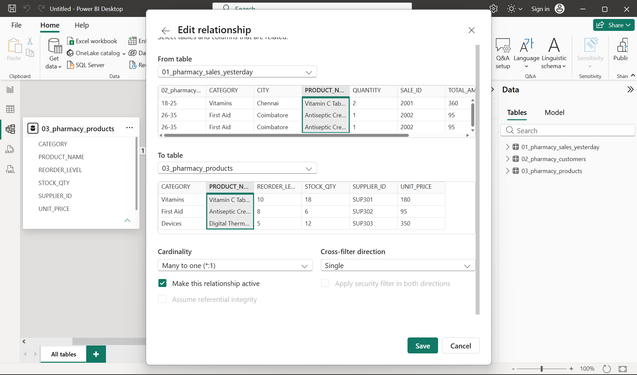
Figure 11: Edit relationship window – sales to products on PRODUCT_NAME

Step 10: Verify the Data in Table View
1. Click the Table view icon on the left side bar.
2. In the Data pane, select each table to check its contents.
3. 01_pharmacy_sales_yesterday should show the original columns plus 02_pharmacy_customers.AGE_GROUP and TOTAL_AMOUNT.
4. 02_pharmacy_customers should show 7 customers with their age group, city and sales channel.
5. 03_pharmacy_products should show 7 products with supplier, stock quantity and reorder level.
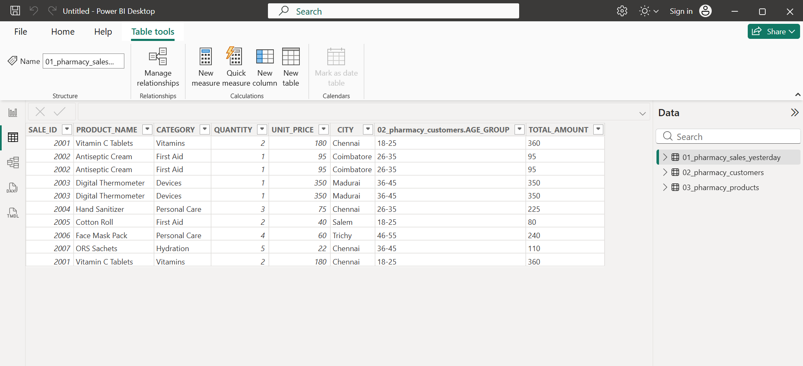
Figure 12: Sales table with AGE_GROUP and TOTAL_AMOUNT
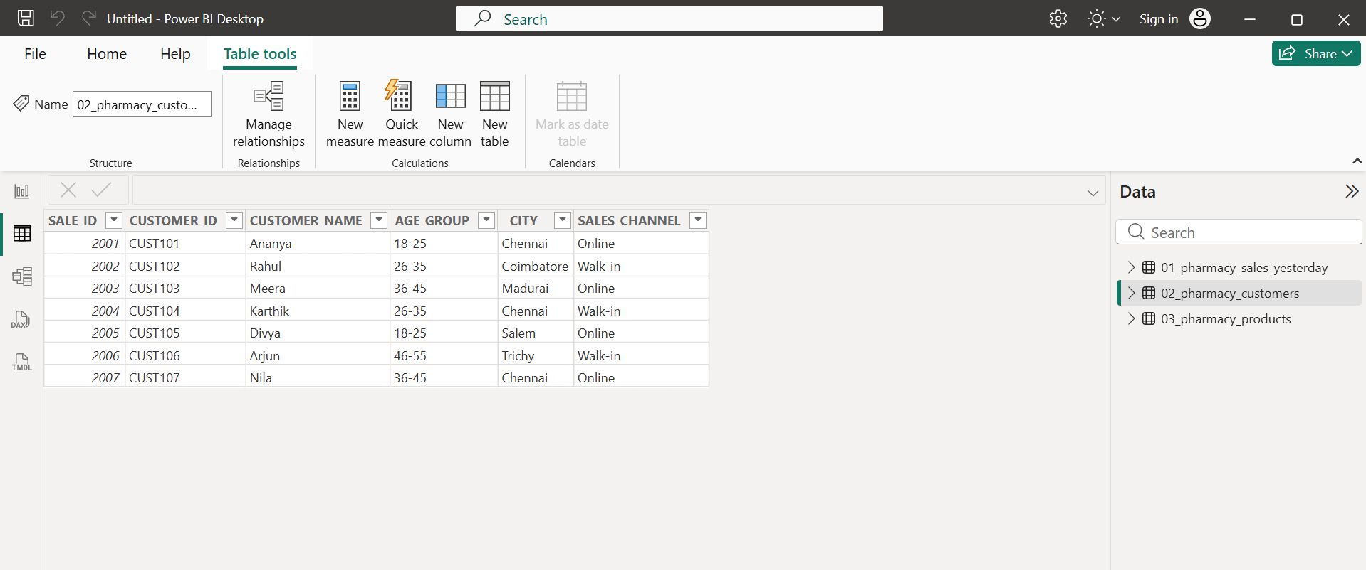
Figure 13: Customers table
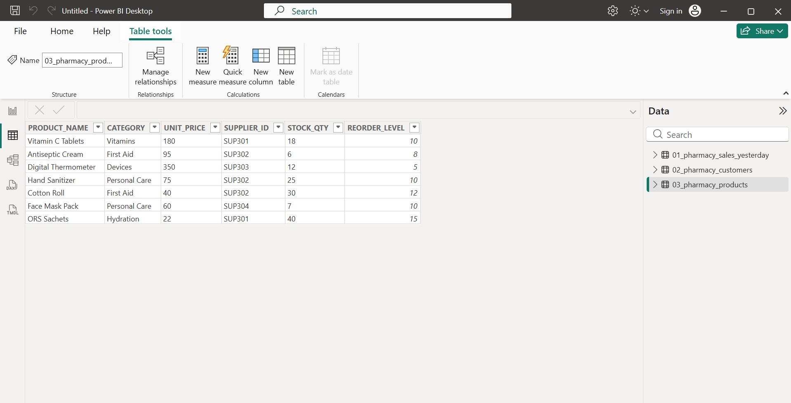
Figure 14: Products table

Summary
- Imported three CSV files into Power BI.
- Merged sales with customers on SALE_ID (Left Outer join) and expanded AGE_GROUP.
- Added TOTAL_AMOUNT = QUANTITY × UNIT_PRICE as a custom column.
- Loaded the data and set up relationships: sales to products on PRODUCT_NAME, sales to customers on SALE_ID.
- Verified all three tables in Table view.

