Snowflake – Pharmacy Sales Analytics: Step-by-Step Guide

Overview
This guide shows how to build a small pharmacy analytics setup in Snowflake. It covers creating a database, schema and warehouse, loading three CSV files through an internal stage, checking data quality, cleaning and transforming the data, running analysis queries, and finally cleaning up the objects that were created.
Objects created:
- Database: SUJITHA_PHARMACY_ANALYTICS_DB
- Schema: RAW
- Warehouse: SUJITHA_PHARMACY_WH (X-Small)
- Tables: PHARMACY_ORDERS, PHARMACY_CUSTOMERS, PHARMACY_PRODUCTS, PHARMACY_ORDERS_CLEANED, PHARMACY_SALES_TRANSFORMED, RANDOM_ORDERS
- File format: SUJITHA_PHARMACY_CSV_FORMAT
- Stage: SUJITHA_PHARMACY_STAGE
Files used: 01_pharmacy_orders.csv, 02_pharmacy_customers_snowflake.csv, 03_pharmacy_products_snowflake.csv
All SQL is written in one worksheet (Sujitha.sql) in Snowsight. To run a statement, select it and click the Run button (or press Ctrl + Enter).
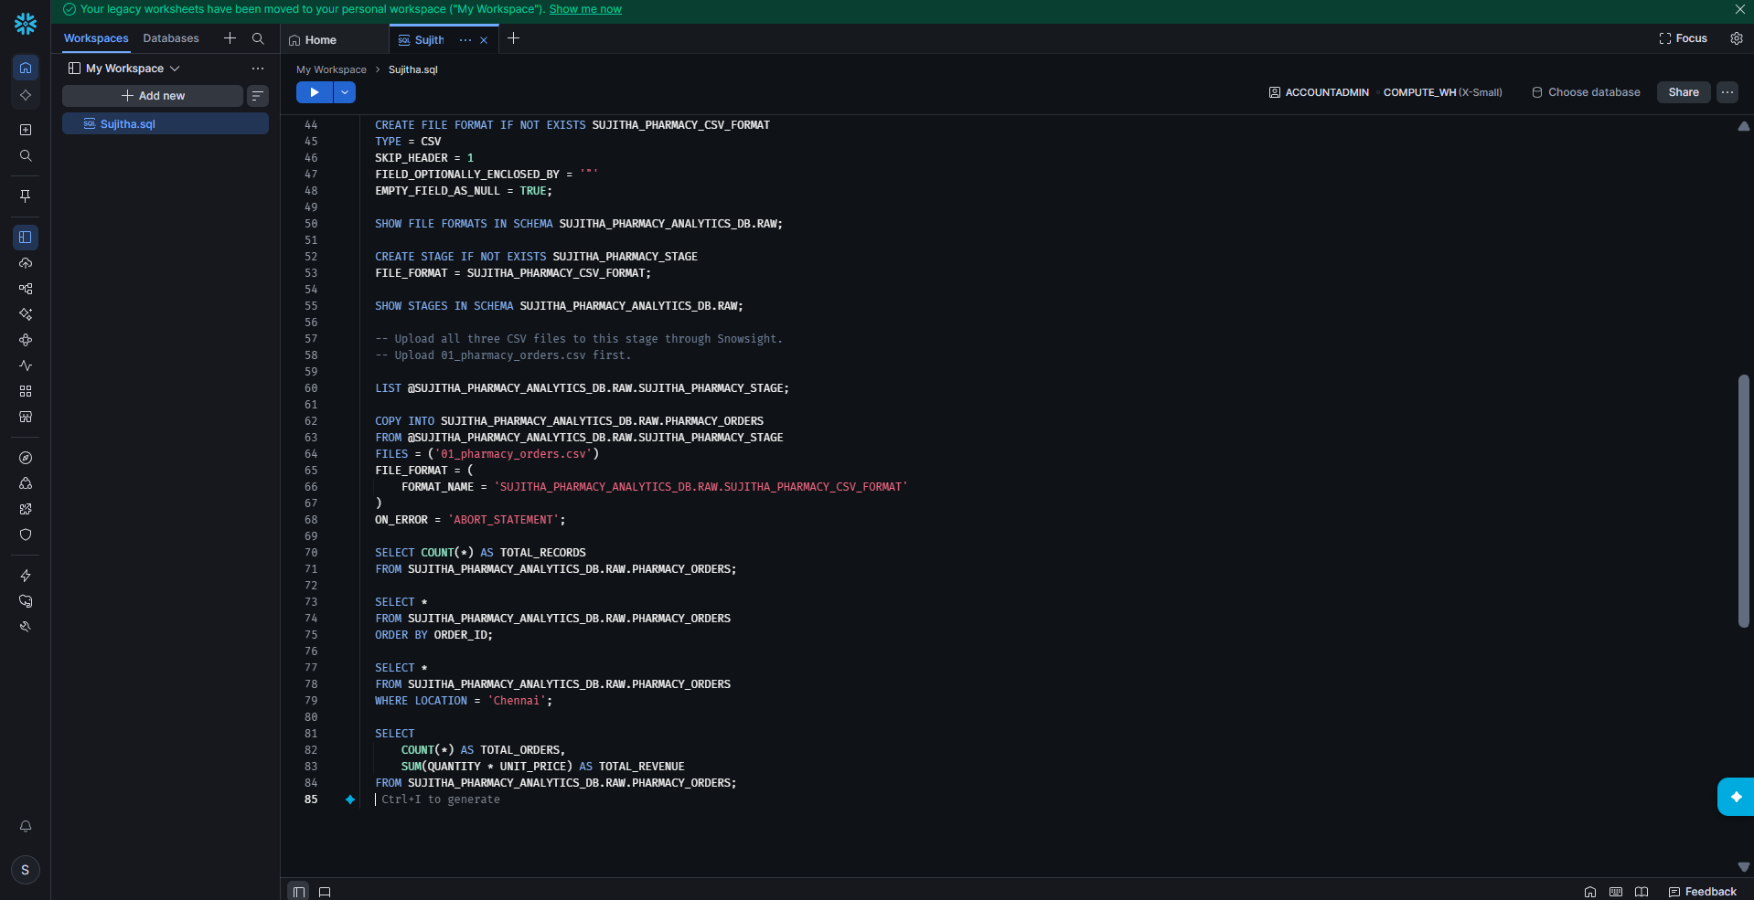
Figure 1: Worksheet showing part of the full SQL script

Part 1: Set Up the Environment

Step 1: Check the Current Session
1. Log in to Snowflake and open Projects > Workspaces.
2. Create a new SQL worksheet (named Sujitha.sql here).
3. Run the query below to see the current user, role, warehouse, database and schema.
4. The result shows user SUJITHA, role ACCOUNTADMIN and warehouse COMPUTE_WH. Database and schema are empty (null) because none is selected yet.
SELECT CURRENT_USER() AS USER_NAME,
CURRENT_ROLE() AS ACTIVE_ROLE,
CURRENT_WAREHOUSE() AS ACTIVE_WAREHOUSE,
CURRENT_DATABASE() AS ACTIVE_DATABASE,
CURRENT_SCHEMA() AS ACTIVE_SCHEMA;
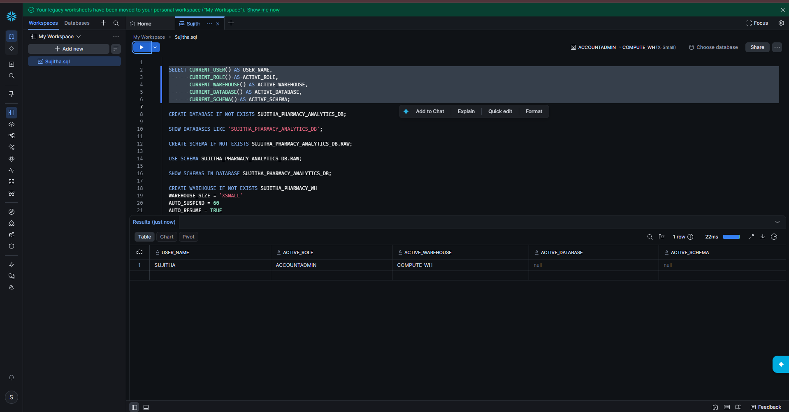
Figure 2: Current session details

Step 2: Create the Database
1. Run the CREATE DATABASE statement.
2. The result shows: Database SUJITHA_PHARMACY_ANALYTICS_DB successfully created.
3. Run SHOW DATABASES to confirm it exists.
CREATE DATABASE IF NOT EXISTS SUJITHA_PHARMACY_ANALYTICS_DB;

SHOW DATABASES LIKE 'SUJITHA_PHARMACY_ANALYTICS_DB';
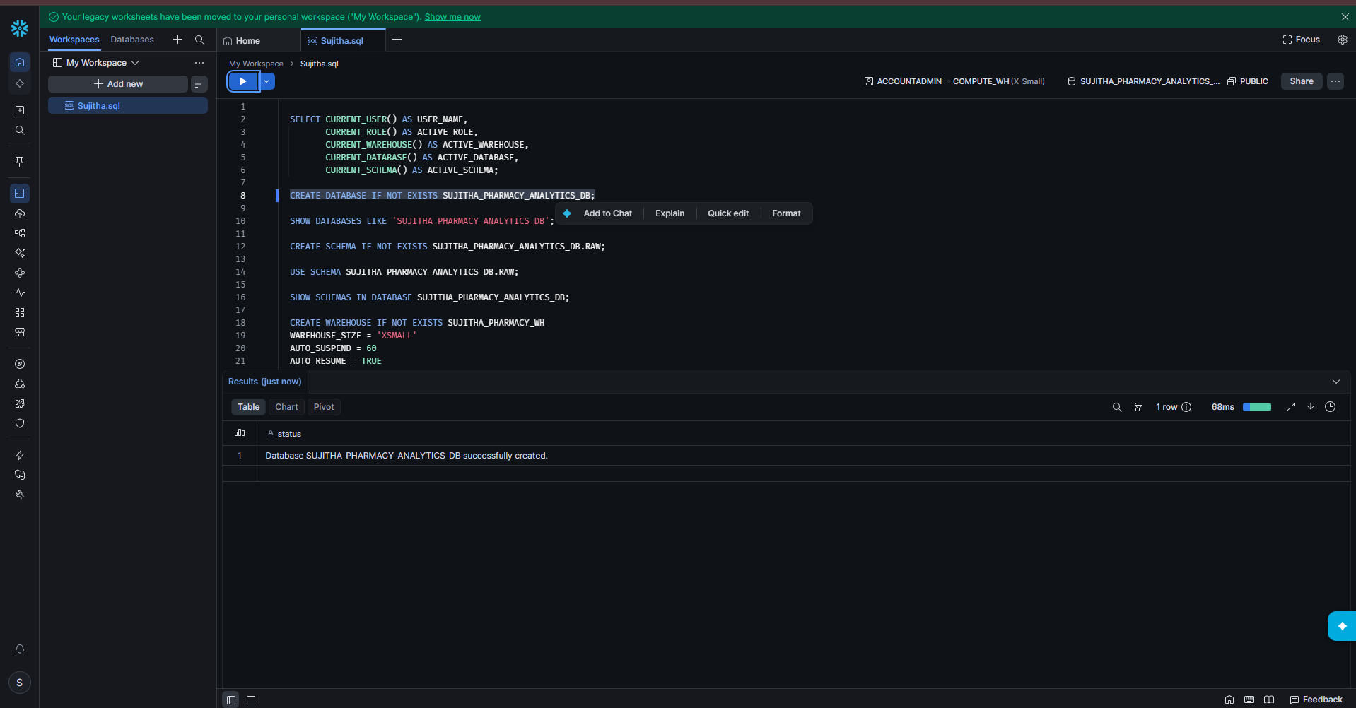
Figure 3: Database created
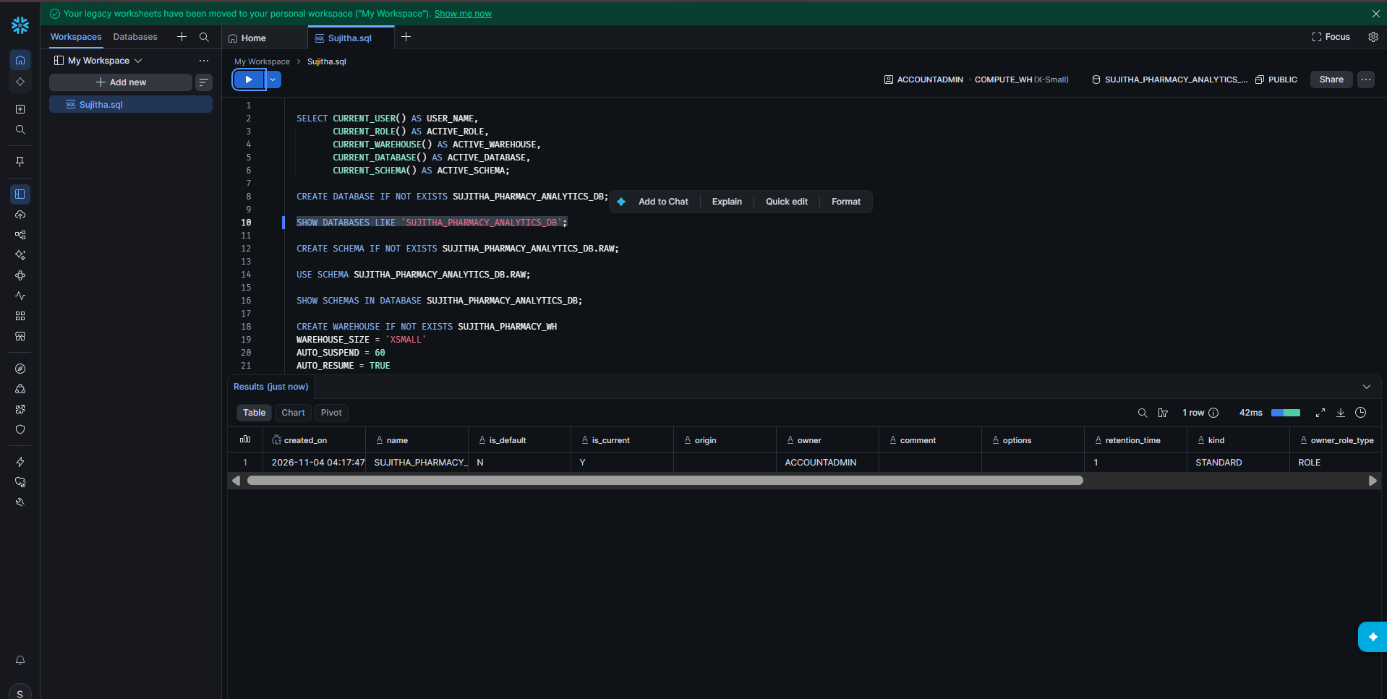
Figure 4: SHOW DATABASES result

Step 3: Create and Use the RAW Schema
1. Run CREATE SCHEMA. The result shows: Schema RAW successfully created.
2. Run USE SCHEMA to make RAW the active schema.
3. Run SHOW SCHEMAS to list all schemas in the database (INFORMATION_SCHEMA, PUBLIC and RAW).
CREATE SCHEMA IF NOT EXISTS SUJITHA_PHARMACY_ANALYTICS_DB.RAW;

USE SCHEMA SUJITHA_PHARMACY_ANALYTICS_DB.RAW;

SHOW SCHEMAS IN DATABASE SUJITHA_PHARMACY_ANALYTICS_DB;
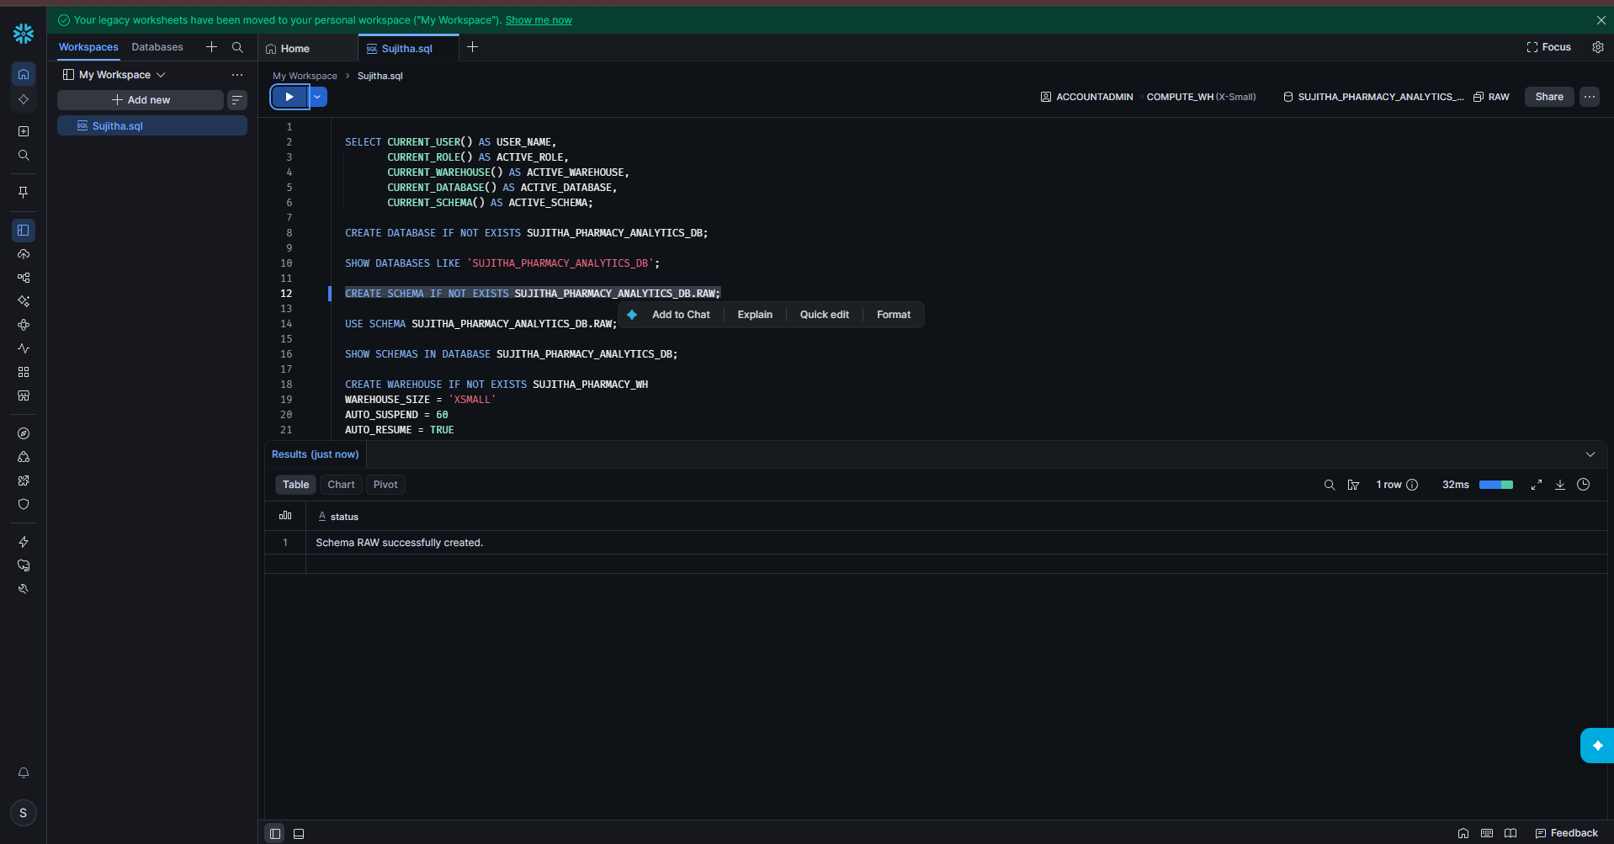
Figure 5: Schema RAW created
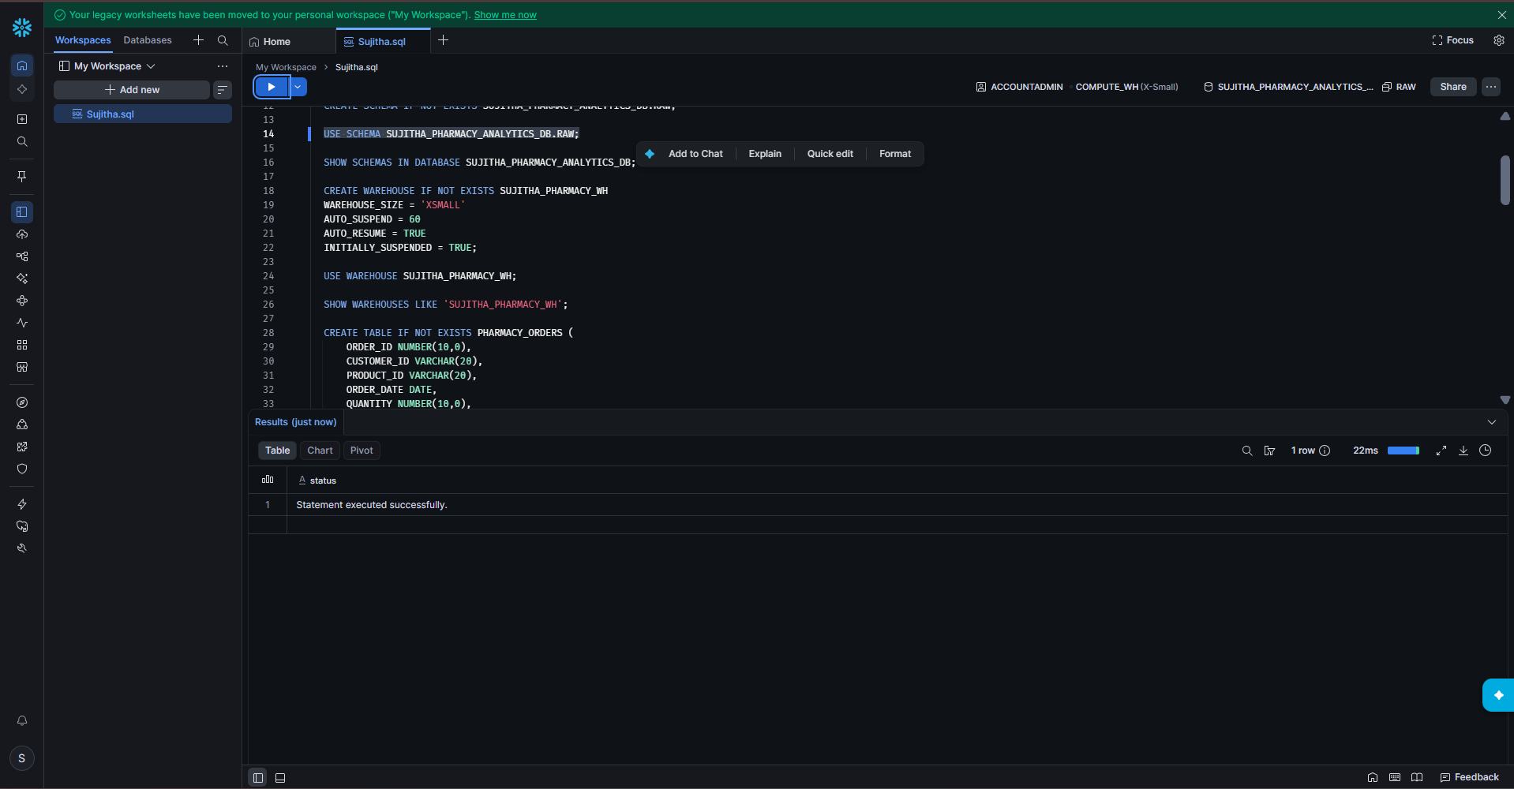
Figure 6: USE SCHEMA executed
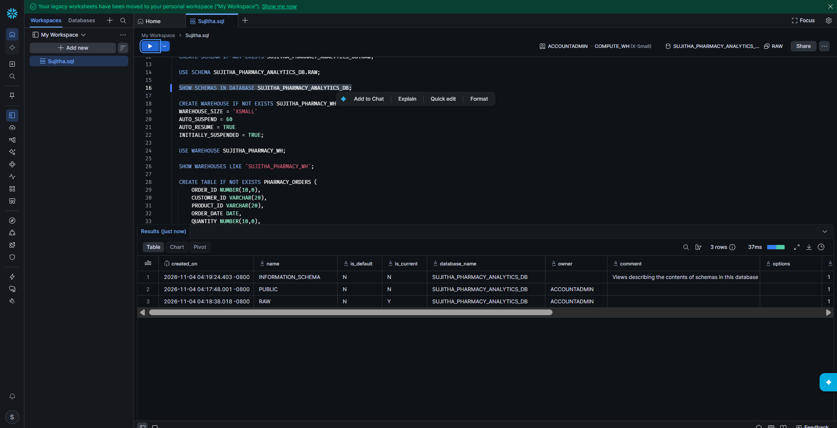
Figure 7: SHOW SCHEMAS result

Step 4: Create and Use the Warehouse
1. Run CREATE WAREHOUSE. Size is X-Small, it suspends after 60 seconds of inactivity and resumes automatically.
2. The result shows: Warehouse SUJITHA_PHARMACY_WH successfully created.
3. Run USE WAREHOUSE to make it the active warehouse.
4. Run SHOW WAREHOUSES to check its settings (state SUSPENDED, size X-Small, auto_suspend 60, auto_resume true).
CREATE WAREHOUSE IF NOT EXISTS SUJITHA_PHARMACY_WH
WAREHOUSE_SIZE = 'XSMALL'
AUTO_SUSPEND = 60
AUTO_RESUME = TRUE
INITIALLY_SUSPENDED = TRUE;

USE WAREHOUSE SUJITHA_PHARMACY_WH;

SHOW WAREHOUSES LIKE 'SUJITHA_PHARMACY_WH';
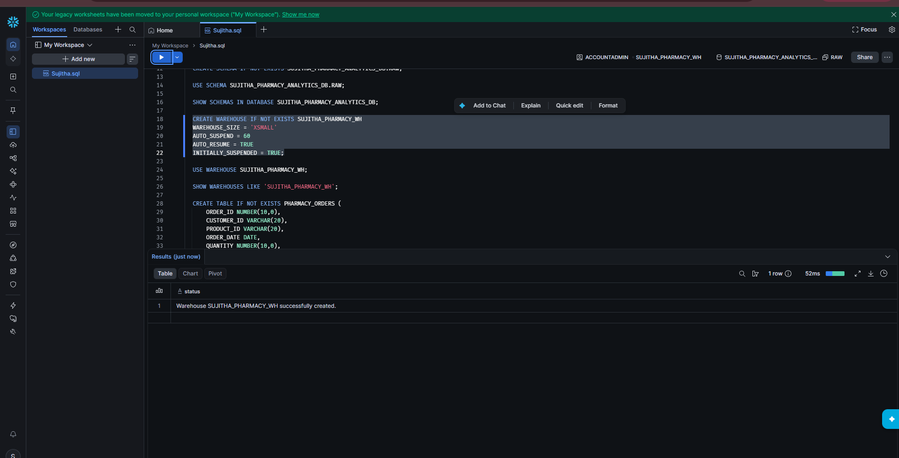
Figure 8: Warehouse created
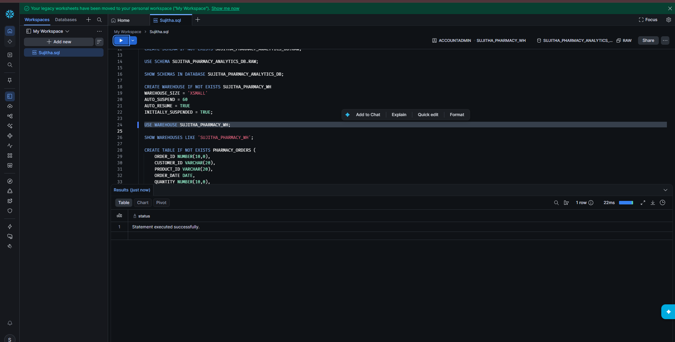
Figure 9: USE WAREHOUSE executed
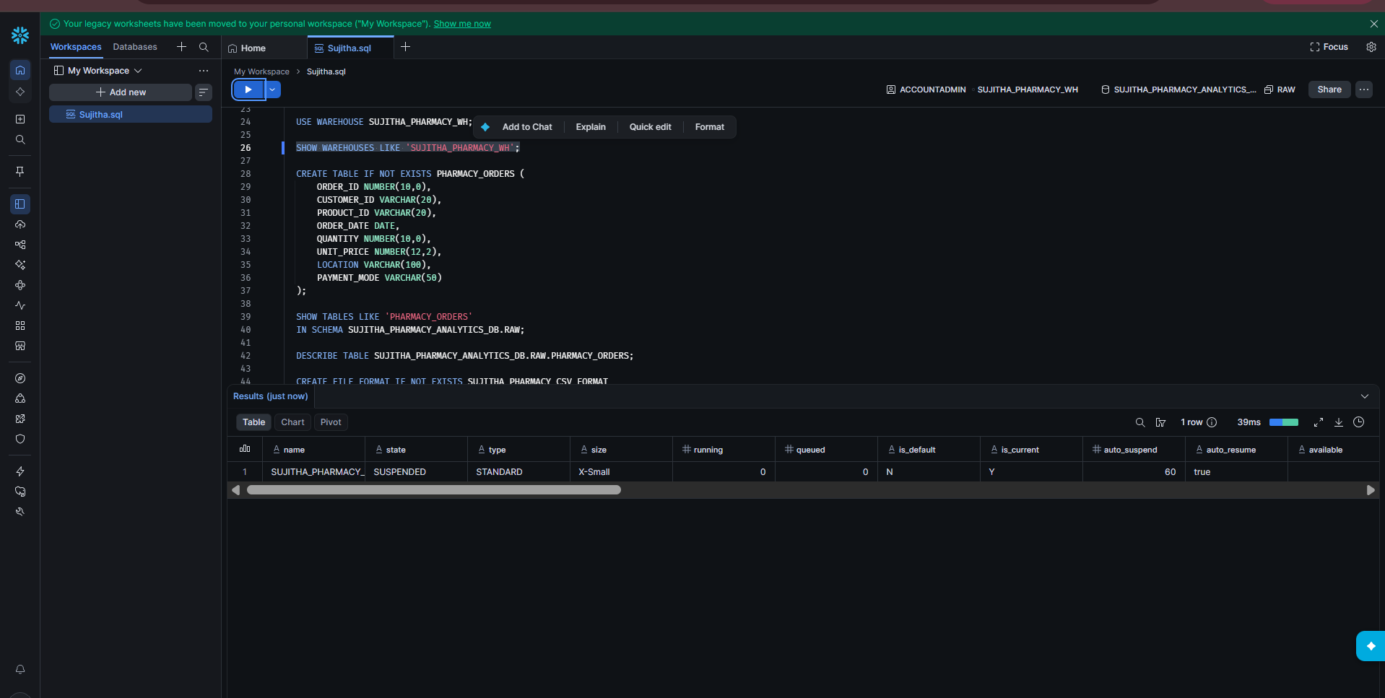
Figure 10: SHOW WAREHOUSES result

Part 2: Load the Orders Data

Step 5: Create the PHARMACY_ORDERS Table
1. Run the CREATE TABLE statement. The result shows: Table PHARMACY_ORDERS successfully created.
2. Run SHOW TABLES to confirm the table exists (0 rows for now).
3. Run DESCRIBE TABLE to see the 8 columns and their data types.
CREATE TABLE IF NOT EXISTS PHARMACY_ORDERS (
ORDER_ID NUMBER(10,0),
CUSTOMER_ID VARCHAR(20),
PRODUCT_ID VARCHAR(20),
ORDER_DATE DATE,
QUANTITY NUMBER(10,0),
UNIT_PRICE NUMBER(12,2),
LOCATION VARCHAR(100),
PAYMENT_MODE VARCHAR(50)
);

SHOW TABLES LIKE 'PHARMACY_ORDERS'
IN SCHEMA SUJITHA_PHARMACY_ANALYTICS_DB.RAW;

DESCRIBE TABLE SUJITHA_PHARMACY_ANALYTICS_DB.RAW.PHARMACY_ORDERS;
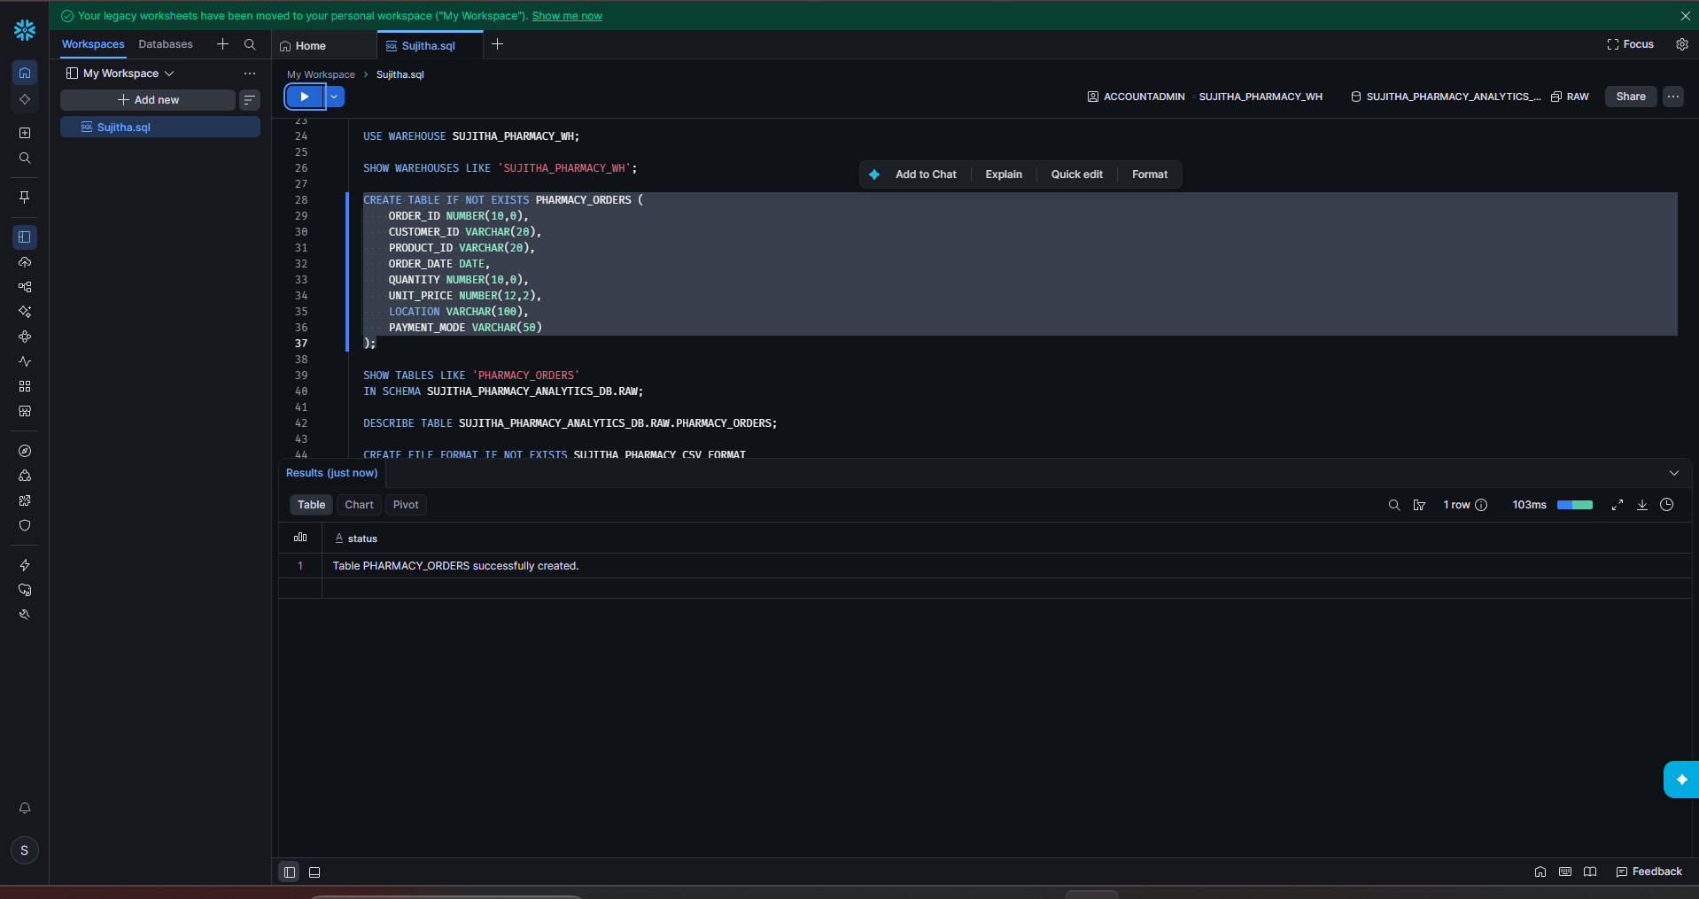
Figure 11: PHARMACY_ORDERS table created
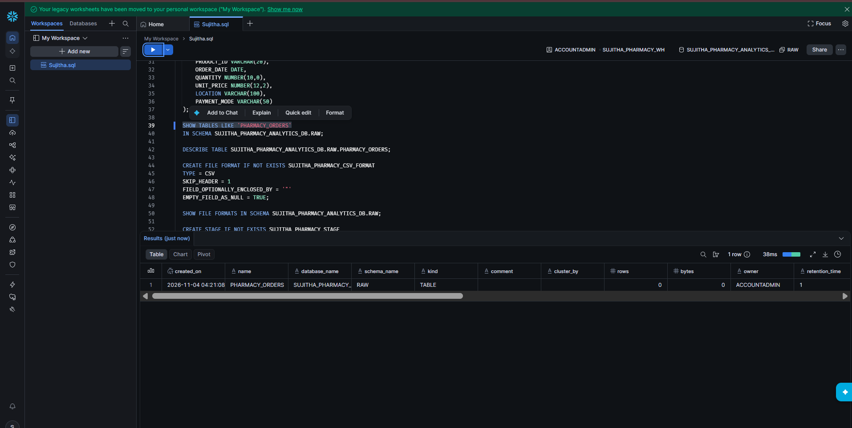
Figure 12: SHOW TABLES result
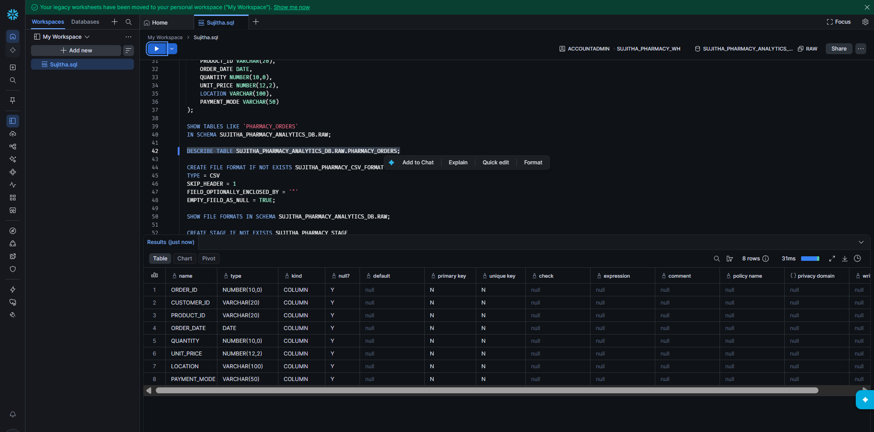
Figure 13: DESCRIBE TABLE result

Step 6: Create the CSV File Format
1. Run CREATE FILE FORMAT. It tells Snowflake the files are CSV, the first row is a header, values may be enclosed in double quotes, and empty fields should be loaded as NULL.
2. The result shows: File format SUJITHA_PHARMACY_CSV_FORMAT successfully created.
3. Run SHOW FILE FORMATS to confirm.
CREATE FILE FORMAT IF NOT EXISTS SUJITHA_PHARMACY_CSV_FORMAT
TYPE = CSV
SKIP_HEADER = 1
FIELD_OPTIONALLY_ENCLOSED_BY = '"'
EMPTY_FIELD_AS_NULL = TRUE;

SHOW FILE FORMATS IN SCHEMA SUJITHA_PHARMACY_ANALYTICS_DB.RAW;
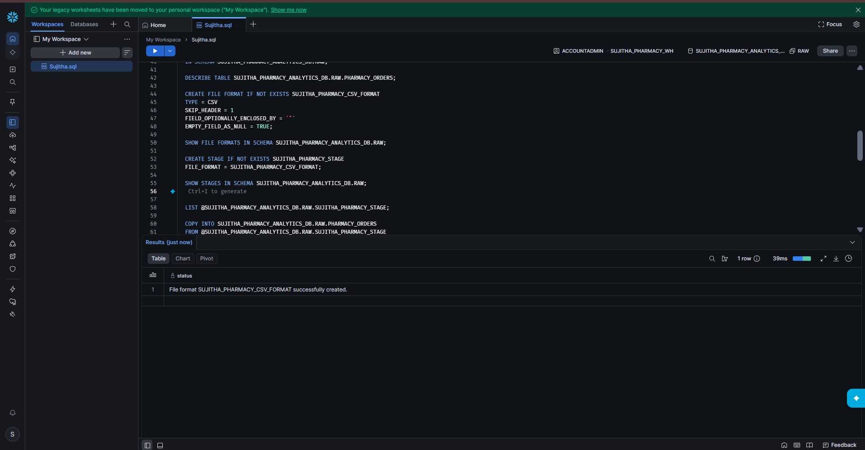
Figure 14: File format created

Step 7: Create the Internal Stage
1. Run CREATE STAGE. A stage is a storage area where files are uploaded before loading them into a table.
2. The result shows: Stage area SUJITHA_PHARMACY_STAGE successfully created.
3. Run SHOW STAGES to confirm (type INTERNAL).
CREATE STAGE IF NOT EXISTS SUJITHA_PHARMACY_STAGE
FILE_FORMAT = SUJITHA_PHARMACY_CSV_FORMAT;

SHOW STAGES IN SCHEMA SUJITHA_PHARMACY_ANALYTICS_DB.RAW;
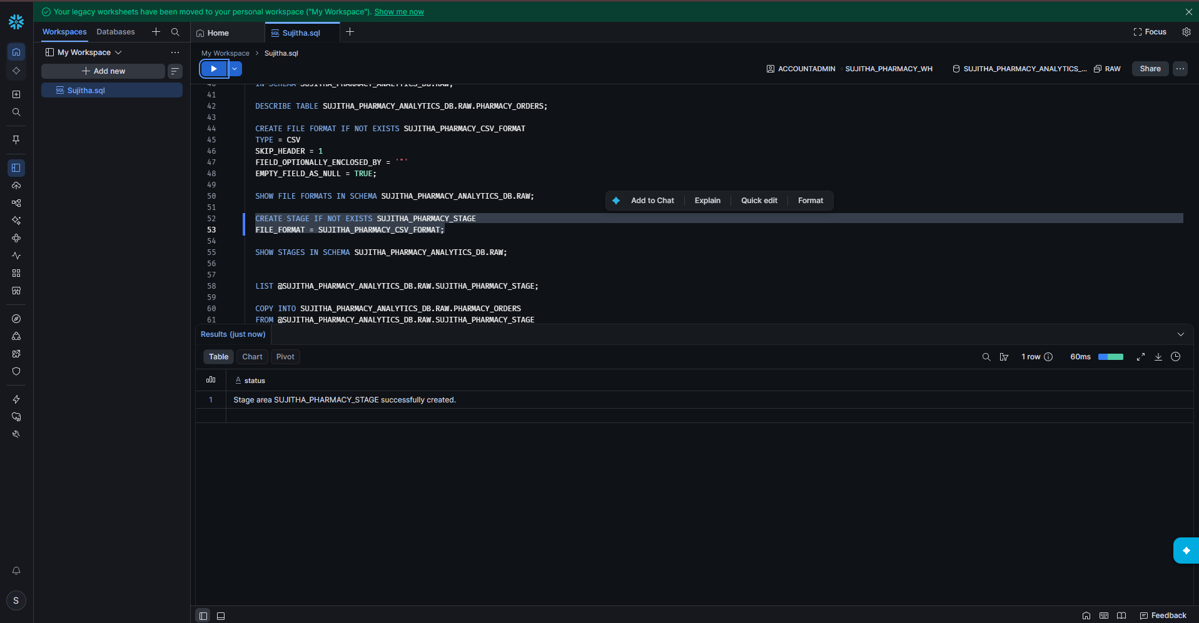
Figure 15: Stage created
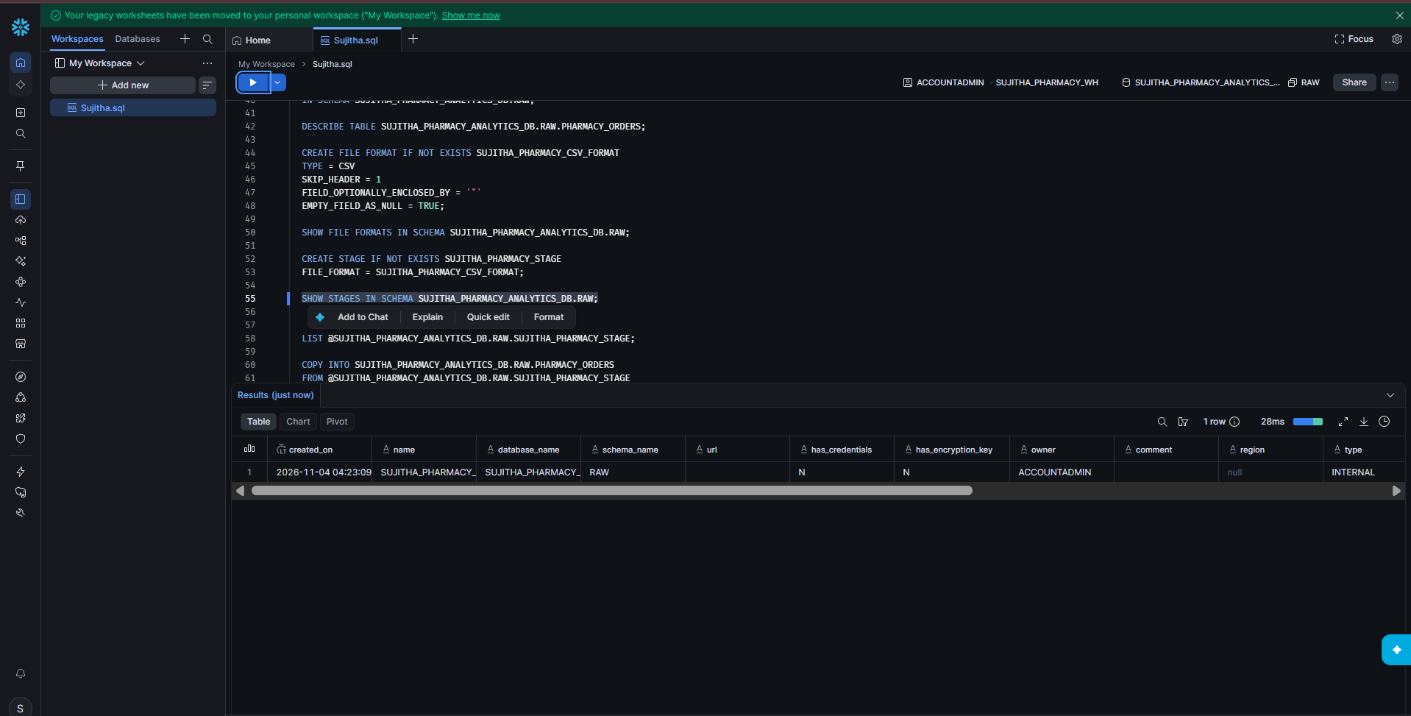
Figure 16: SHOW STAGES result

Step 8: Find the Stage in the Catalog
1. In the left menu, click Catalog to open Catalog explorer.
2. Expand Databases > SUJITHA_PHARMACY_ANALYTICS_DB. It contains three schemas: INFORMATION_SCHEMA, PUBLIC and RAW.
3. Click RAW. It contains three objects: PHARMACY_ORDERS (table), SUJITHA_PHARMACY_CSV_FORMAT (file format) and SUJITHA_PHARMACY_STAGE (stage).
4. Expand Stages and click SUJITHA_PHARMACY_STAGE. The stage is empty (No Files Added Yet).
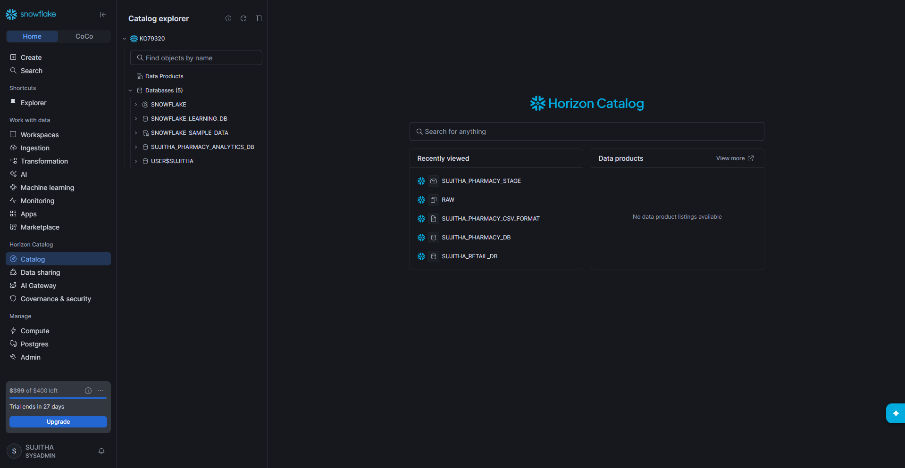
Figure 17: Catalog explorer home
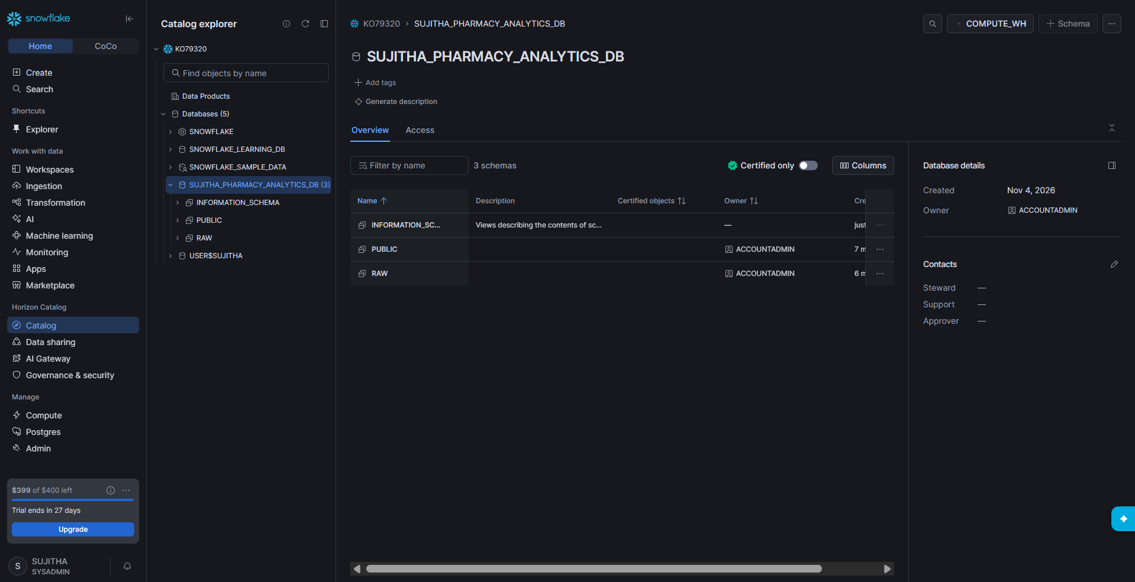
Figure 18: Database overview with three schemas
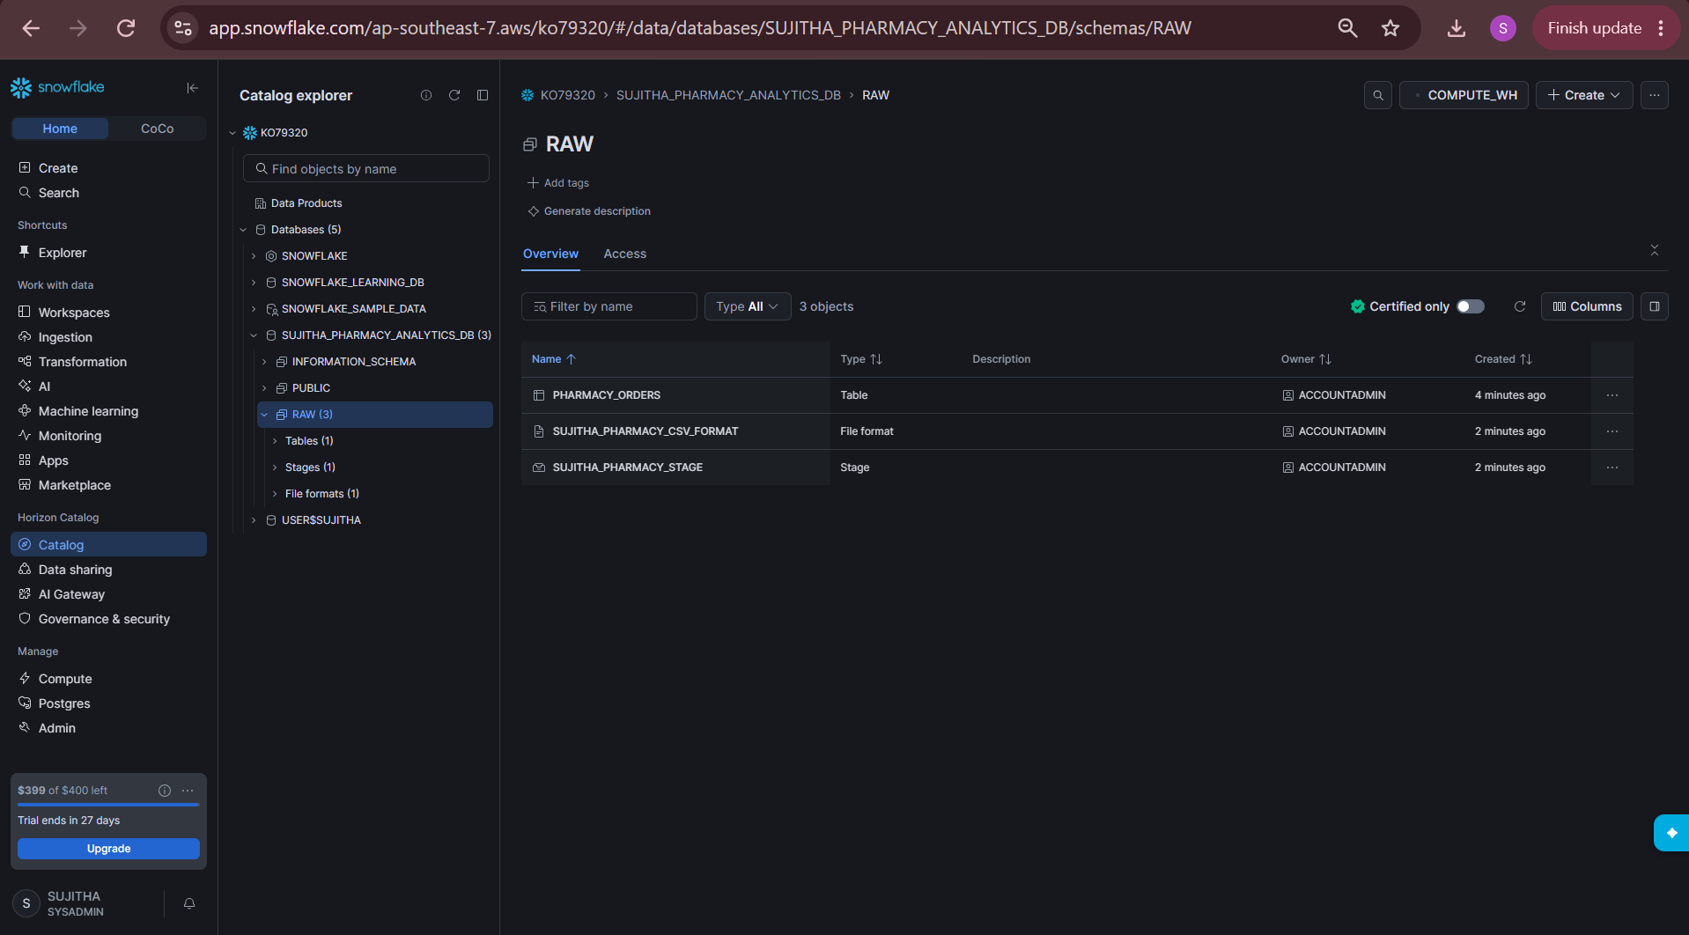
Figure 19: RAW schema showing table, file format and stage
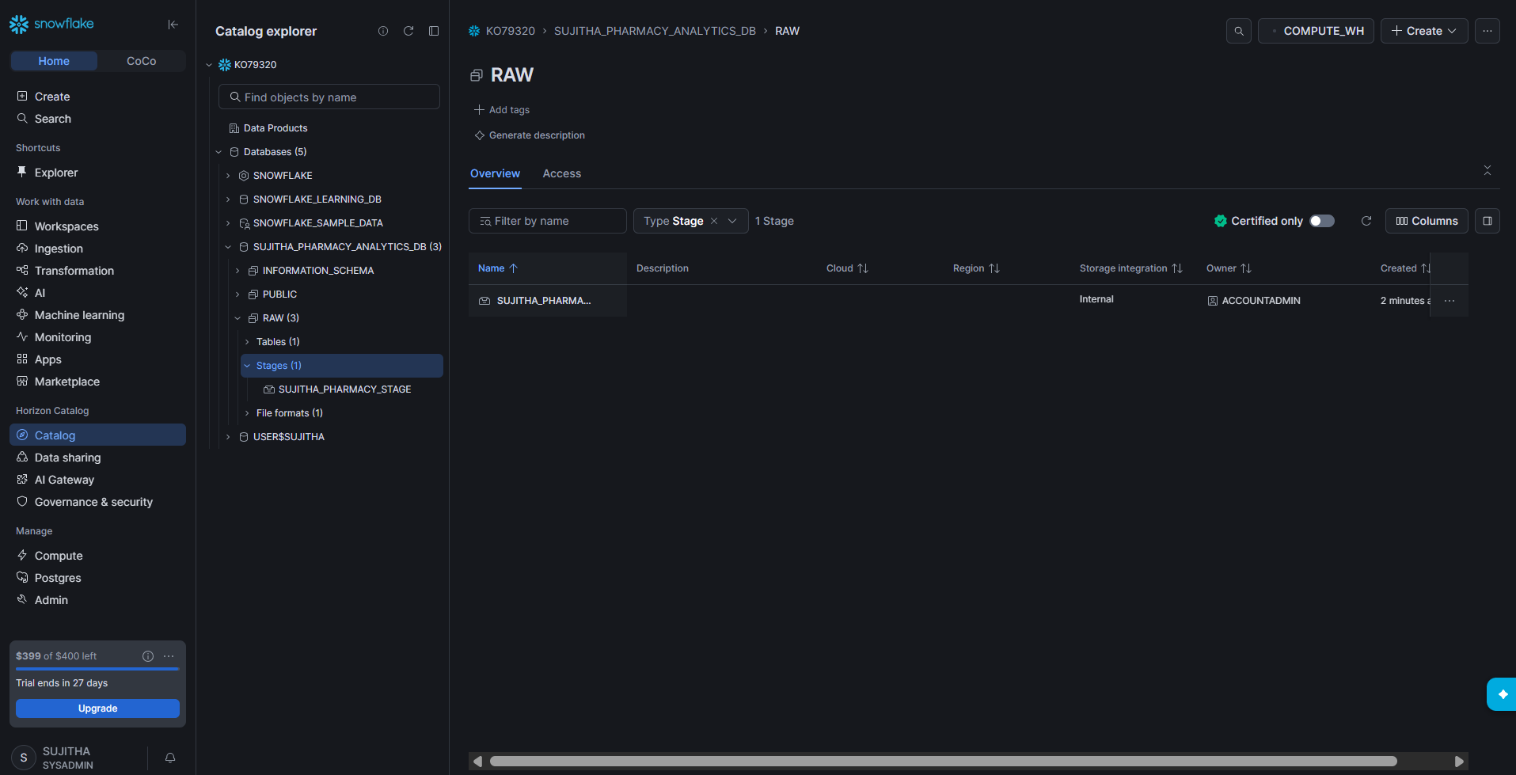
Figure 20: Stages list filtered by type
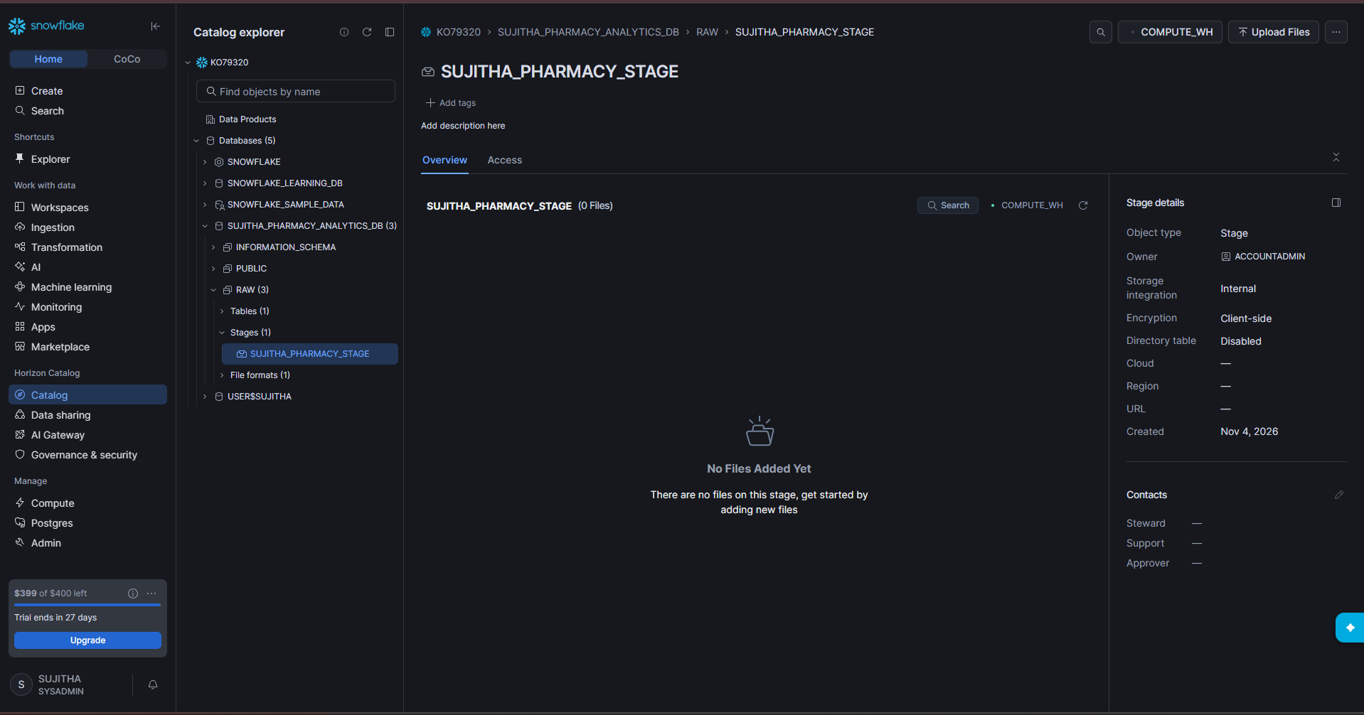
Figure 21: Empty stage – no files added yet

Step 9: Upload the Orders File to the Stage
1. On the stage page, click Upload Files (top right).
2. Drag in or browse to 01_pharmacy_orders.csv.
3. Check that Schema is SUJITHA_PHARMACY_ANALYTICS_DB.RAW and the stage is SUJITHA_PHARMACY_STAGE.
4. Leave the folder path empty and click Upload.
5. The message 1 files uploaded appears and the file is listed on the stage.
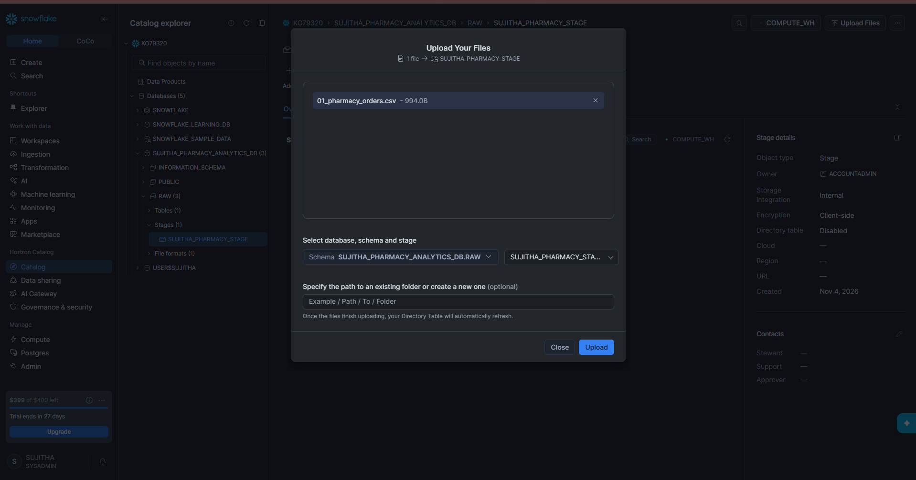
Figure 22: Upload Your Files window
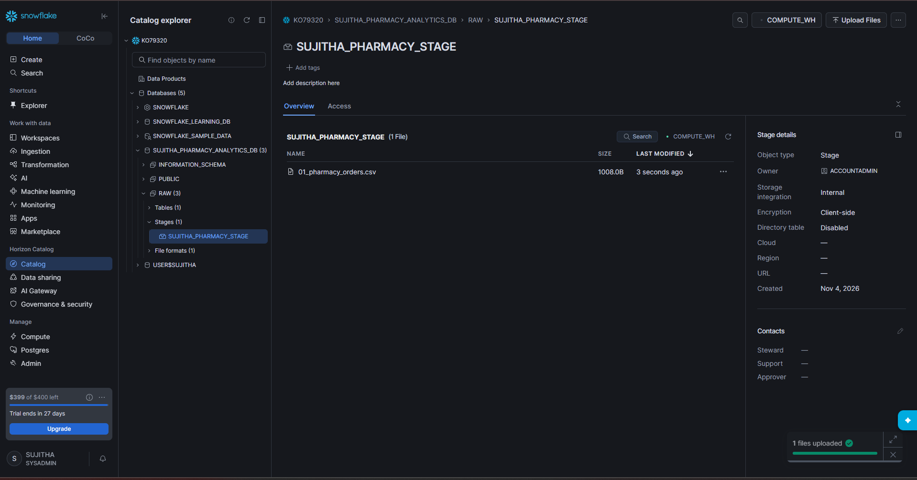
Figure 23: File uploaded to the stage

Step 10: List the Files in the Stage
1. Go back to the worksheet and run the LIST command.
2. It shows sujitha_pharmacy_stage/01_pharmacy_orders.csv with its size and upload time.
LIST @SUJITHA_PHARMACY_ANALYTICS_DB.RAW.SUJITHA_PHARMACY_STAGE;
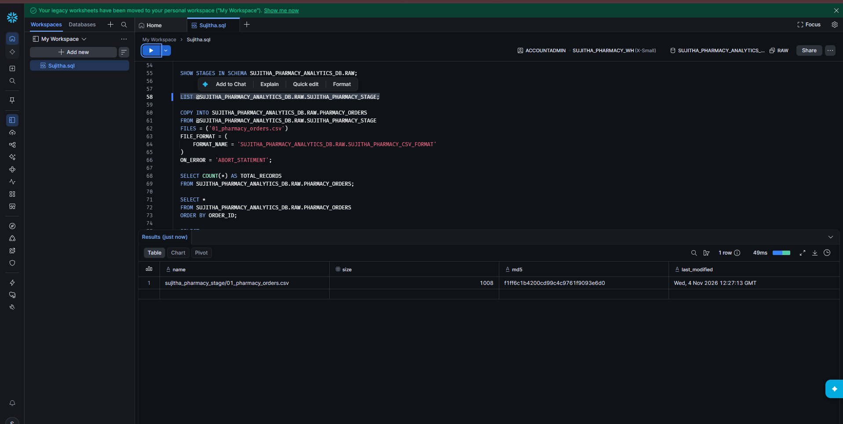
Figure 24: LIST result showing the uploaded file

Step 11: Load the Orders Data with COPY INTO
1. Run the COPY INTO statement to load the file from the stage into the table.
2. ON_ERROR = 'ABORT_STATEMENT' stops the load if any row has an error.
3. The result shows status LOADED, rows_parsed 20, rows_loaded 20 and errors_seen 0.
COPY INTO SUJITHA_PHARMACY_ANALYTICS_DB.RAW.PHARMACY_ORDERS
FROM @SUJITHA_PHARMACY_ANALYTICS_DB.RAW.SUJITHA_PHARMACY_STAGE
FILES = ('01_pharmacy_orders.csv')
FILE_FORMAT = (
FORMAT_NAME = 'SUJITHA_PHARMACY_ANALYTICS_DB.RAW.SUJITHA_PHARMACY_CSV_FORMAT'
)
ON_ERROR = 'ABORT_STATEMENT';
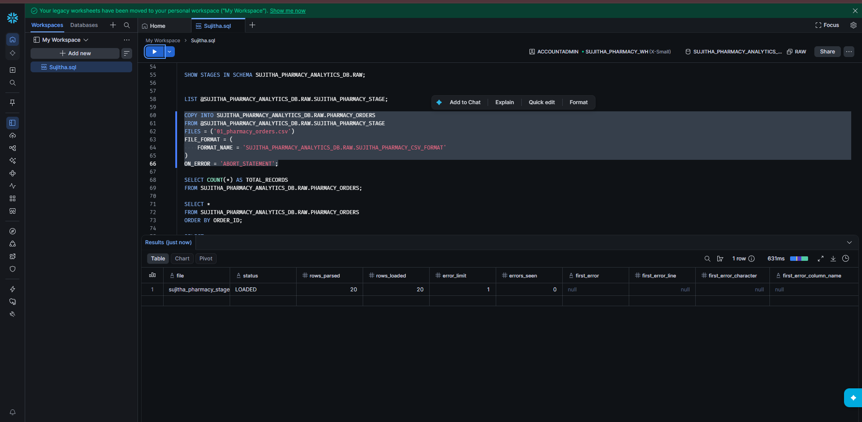
Figure 25: COPY INTO result – 20 rows loaded

Step 12: Verify the Orders Data
1. Count the records. The result is 20.
2. View all orders sorted by ORDER_ID.
3. Filter orders for Chennai. The result is 7 rows.
4. Calculate total orders and total revenue. The result is 20 orders and revenue 3972.00.
SELECT COUNT(*) AS TOTAL_RECORDS
FROM SUJITHA_PHARMACY_ANALYTICS_DB.RAW.PHARMACY_ORDERS;

SELECT *
FROM SUJITHA_PHARMACY_ANALYTICS_DB.RAW.PHARMACY_ORDERS
ORDER BY ORDER_ID;

SELECT *
FROM SUJITHA_PHARMACY_ANALYTICS_DB.RAW.PHARMACY_ORDERS
WHERE LOCATION = 'Chennai';

SELECT
COUNT(*) AS TOTAL_ORDERS,
SUM(QUANTITY * UNIT_PRICE) AS TOTAL_REVENUE
FROM SUJITHA_PHARMACY_ANALYTICS_DB.RAW.PHARMACY_ORDERS;
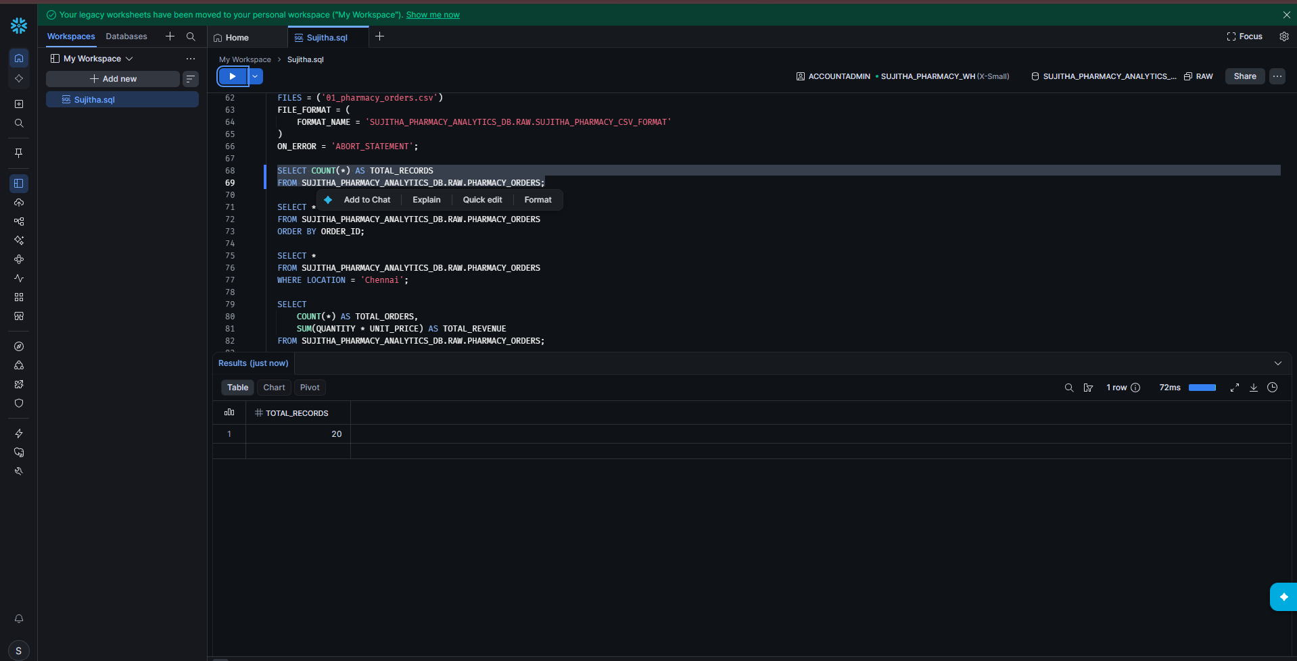
Figure 26: Total records = 20
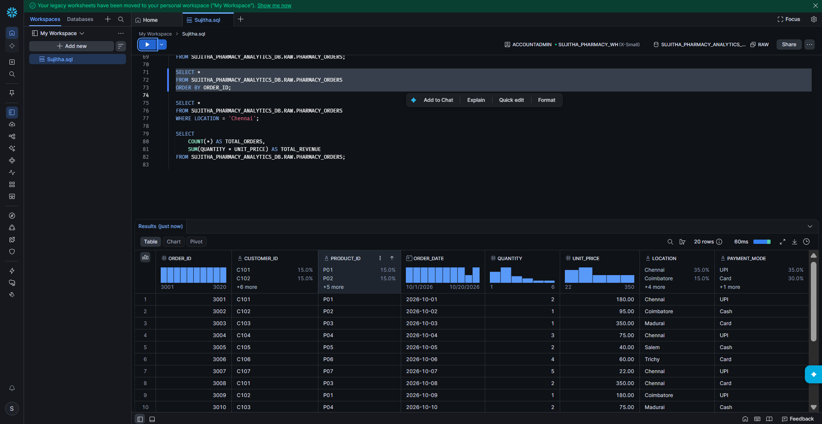
Figure 27: All orders sorted by ORDER_ID
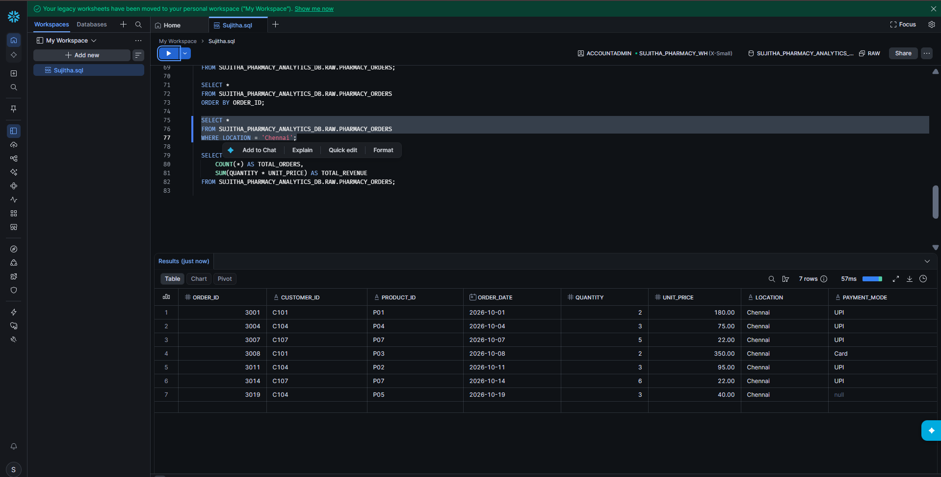
Figure 28: Orders from Chennai
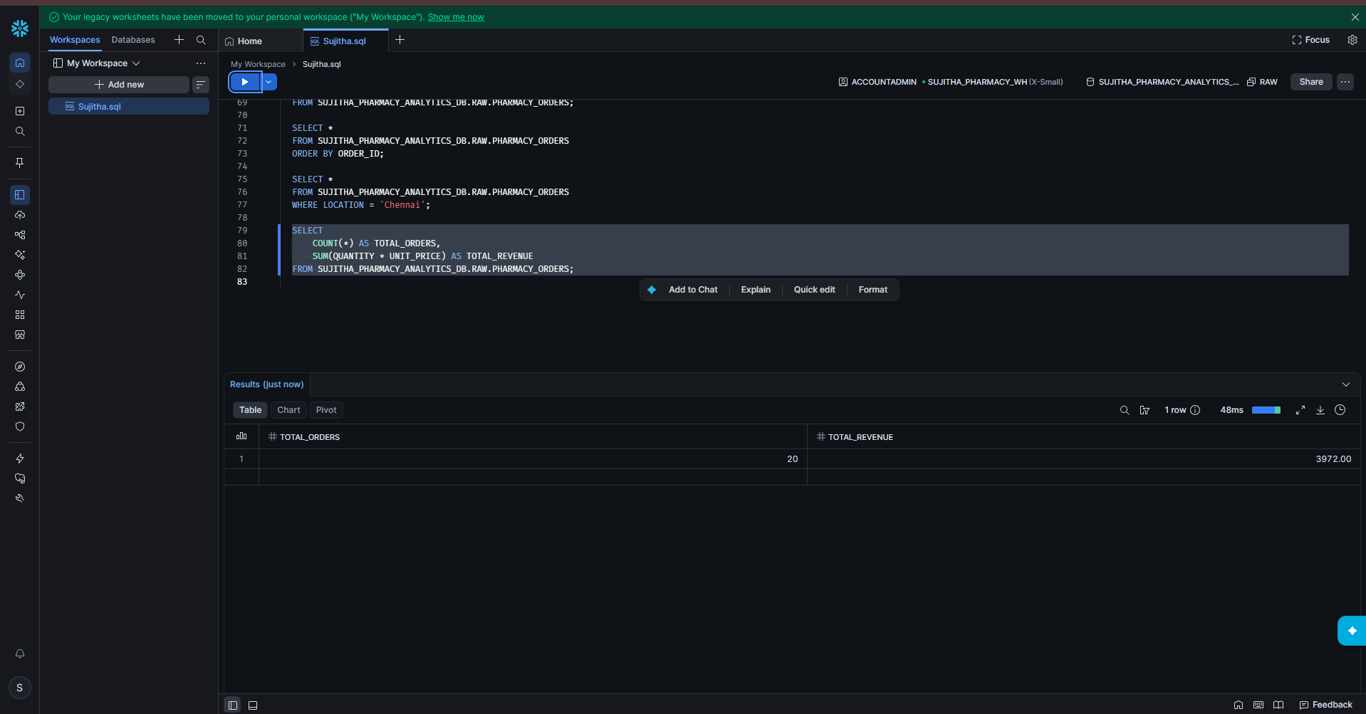
Figure 29: Total orders and total revenue

Part 3: Load the Customers Data

Step 13: Create the PHARMACY_CUSTOMERS Table
1. Run CREATE TABLE. The result shows: Table PHARMACY_CUSTOMERS successfully created.
2. Run SHOW TABLES and DESCRIBE TABLE to confirm the 4 columns.
CREATE TABLE IF NOT EXISTS PHARMACY_CUSTOMERS (
CUSTOMER_ID VARCHAR(20),
CUSTOMER_NAME VARCHAR(100),
CUSTOMER_TYPE VARCHAR(50),
CUSTOMER_CITY VARCHAR(100)
);

SHOW TABLES LIKE 'PHARMACY_CUSTOMERS'
IN SCHEMA SUJITHA_PHARMACY_ANALYTICS_DB.RAW;

DESCRIBE TABLE SUJITHA_PHARMACY_ANALYTICS_DB.RAW.PHARMACY_CUSTOMERS;
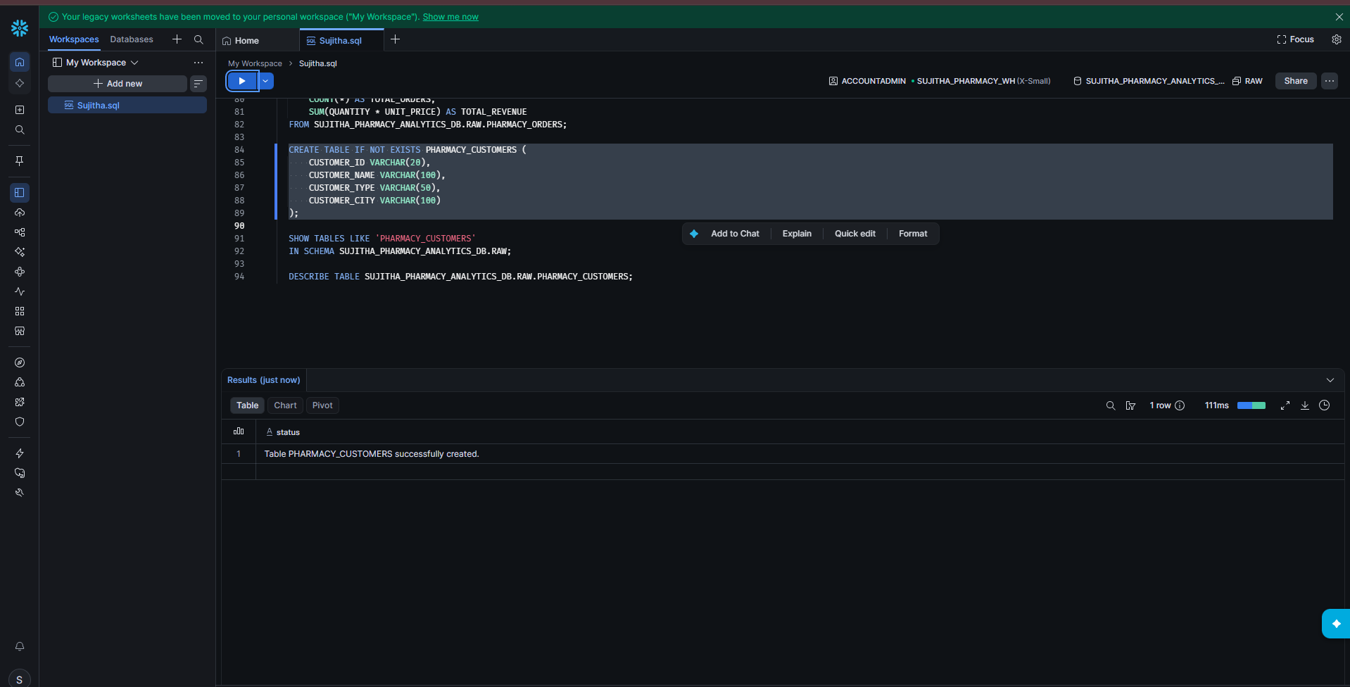
Figure 30: PHARMACY_CUSTOMERS table created
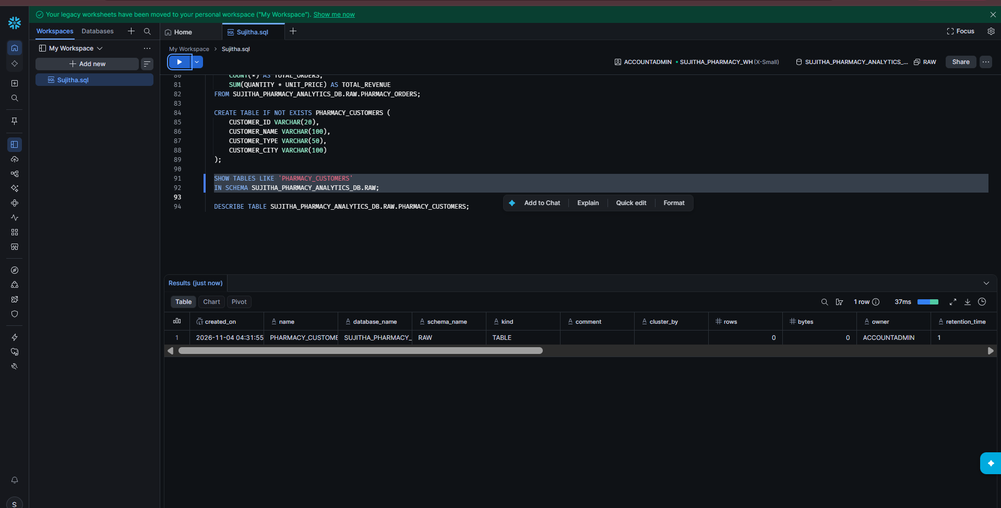
Figure 31: SHOW TABLES result
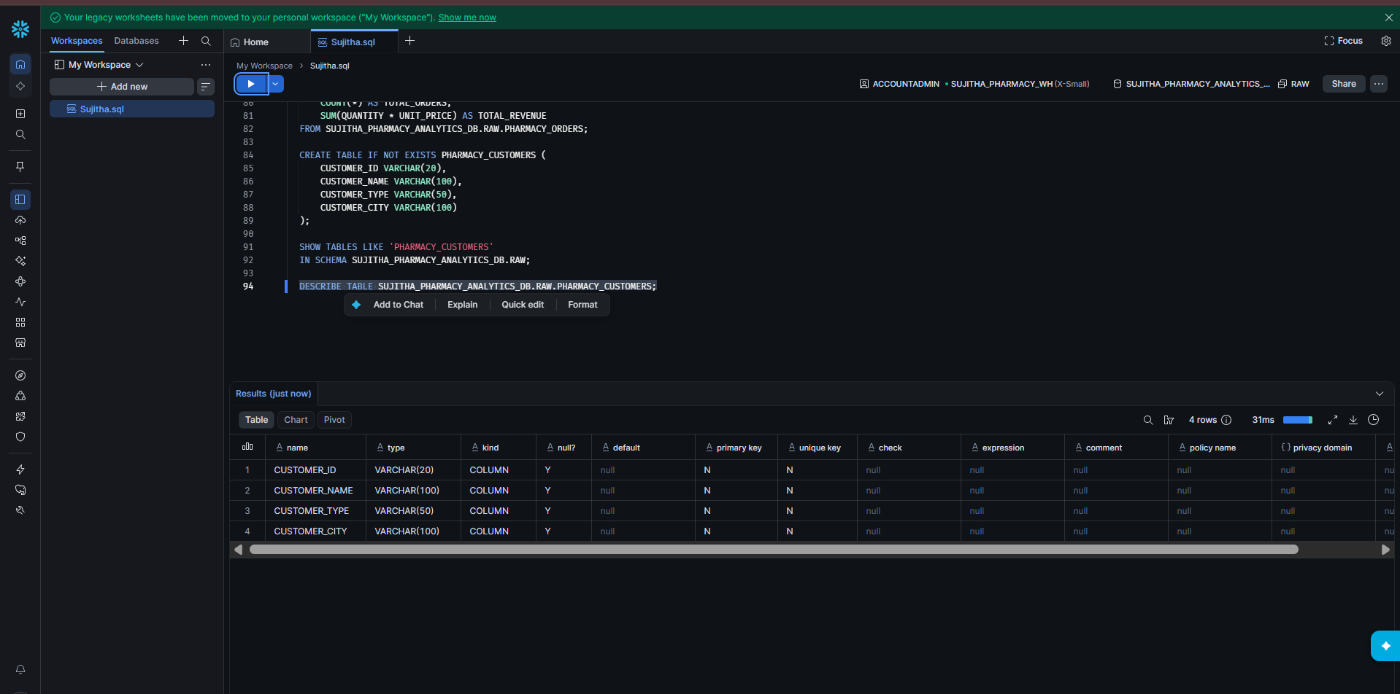
Figure 32: DESCRIBE TABLE result

Step 14: Upload the Customers File
1. Open Catalog > SUJITHA_PHARMACY_STAGE again.
2. Click Upload Files and upload the customers CSV file (02_pharmacy_customers_snowflake.csv).
3. The stage now lists two files.
4. In the worksheet, run LIST to confirm both files are in the stage.
LIST @SUJITHA_PHARMACY_ANALYTICS_DB.RAW.SUJITHA_PHARMACY_STAGE;
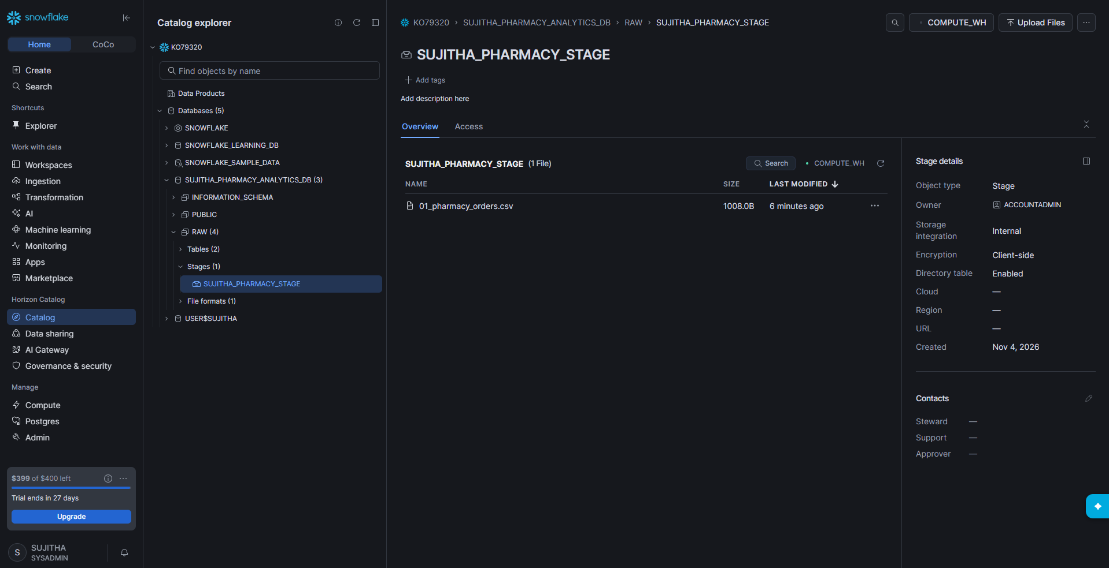
Figure 33: Stage before uploading the second file
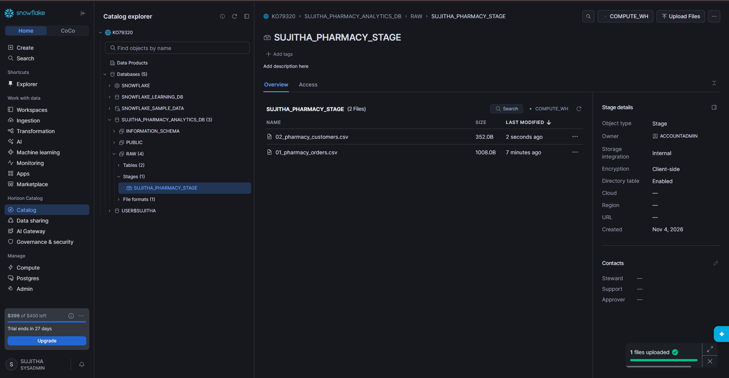
Figure 34: Stage after uploading the customers file
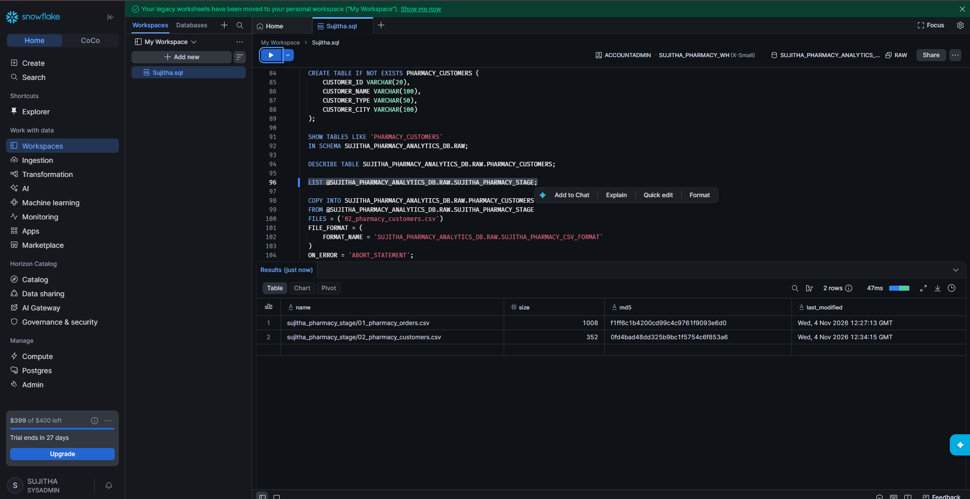
Figure 35: LIST result showing two files

Step 15: Load and Verify the Customers Data
1. Run COPY INTO. The result shows status LOADED with 8 rows loaded.
2. Count the customers. The result is 8.
3. View all customers sorted by CUSTOMER_ID.
COPY INTO SUJITHA_PHARMACY_ANALYTICS_DB.RAW.PHARMACY_CUSTOMERS
FROM @SUJITHA_PHARMACY_ANALYTICS_DB.RAW.SUJITHA_PHARMACY_STAGE
FILES = ('02_pharmacy_customers_snowflake.csv')
FILE_FORMAT = (
FORMAT_NAME = 'SUJITHA_PHARMACY_ANALYTICS_DB.RAW.SUJITHA_PHARMACY_CSV_FORMAT'
)
ON_ERROR = 'ABORT_STATEMENT';

SELECT COUNT(*) AS TOTAL_CUSTOMERS
FROM SUJITHA_PHARMACY_ANALYTICS_DB.RAW.PHARMACY_CUSTOMERS;

SELECT *
FROM SUJITHA_PHARMACY_ANALYTICS_DB.RAW.PHARMACY_CUSTOMERS
ORDER BY CUSTOMER_ID;
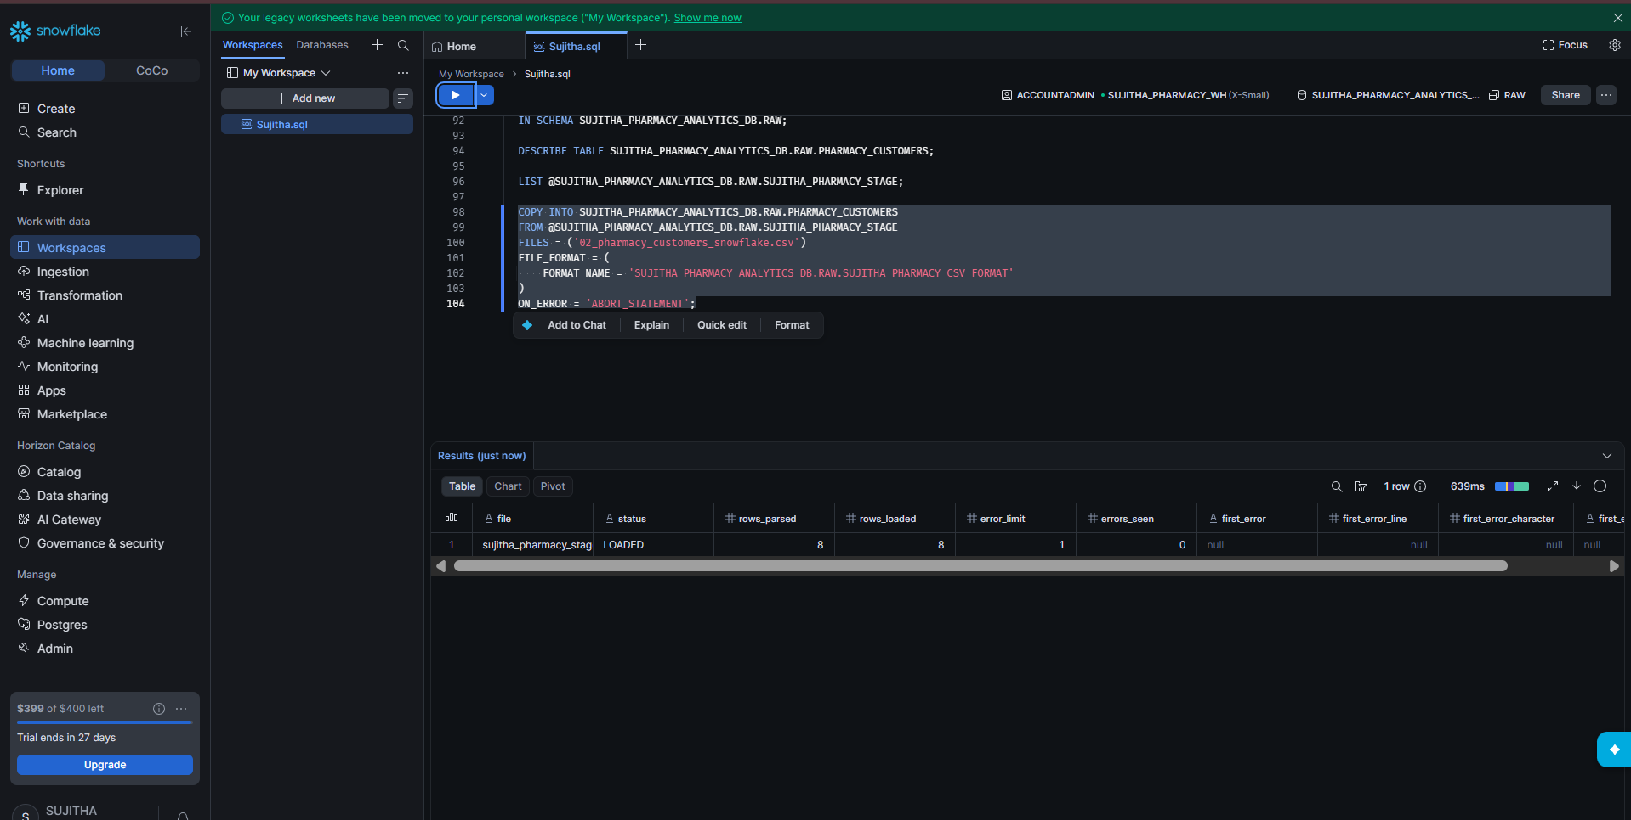
Figure 36: Customers loaded – 8 rows
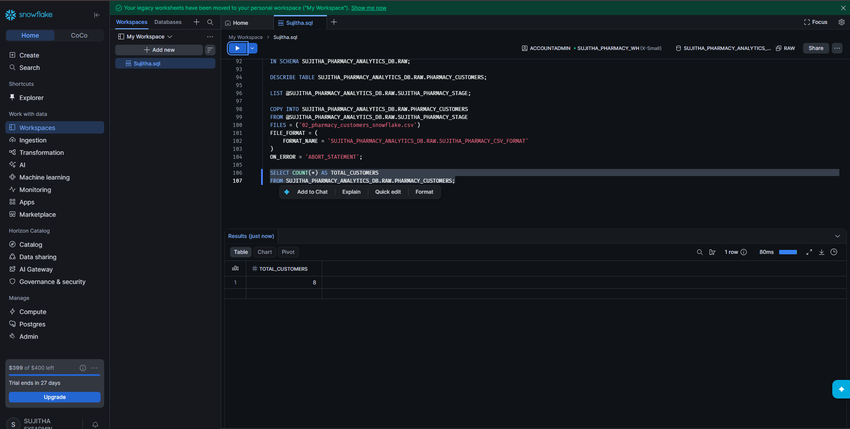
Figure 37: Total customers = 8
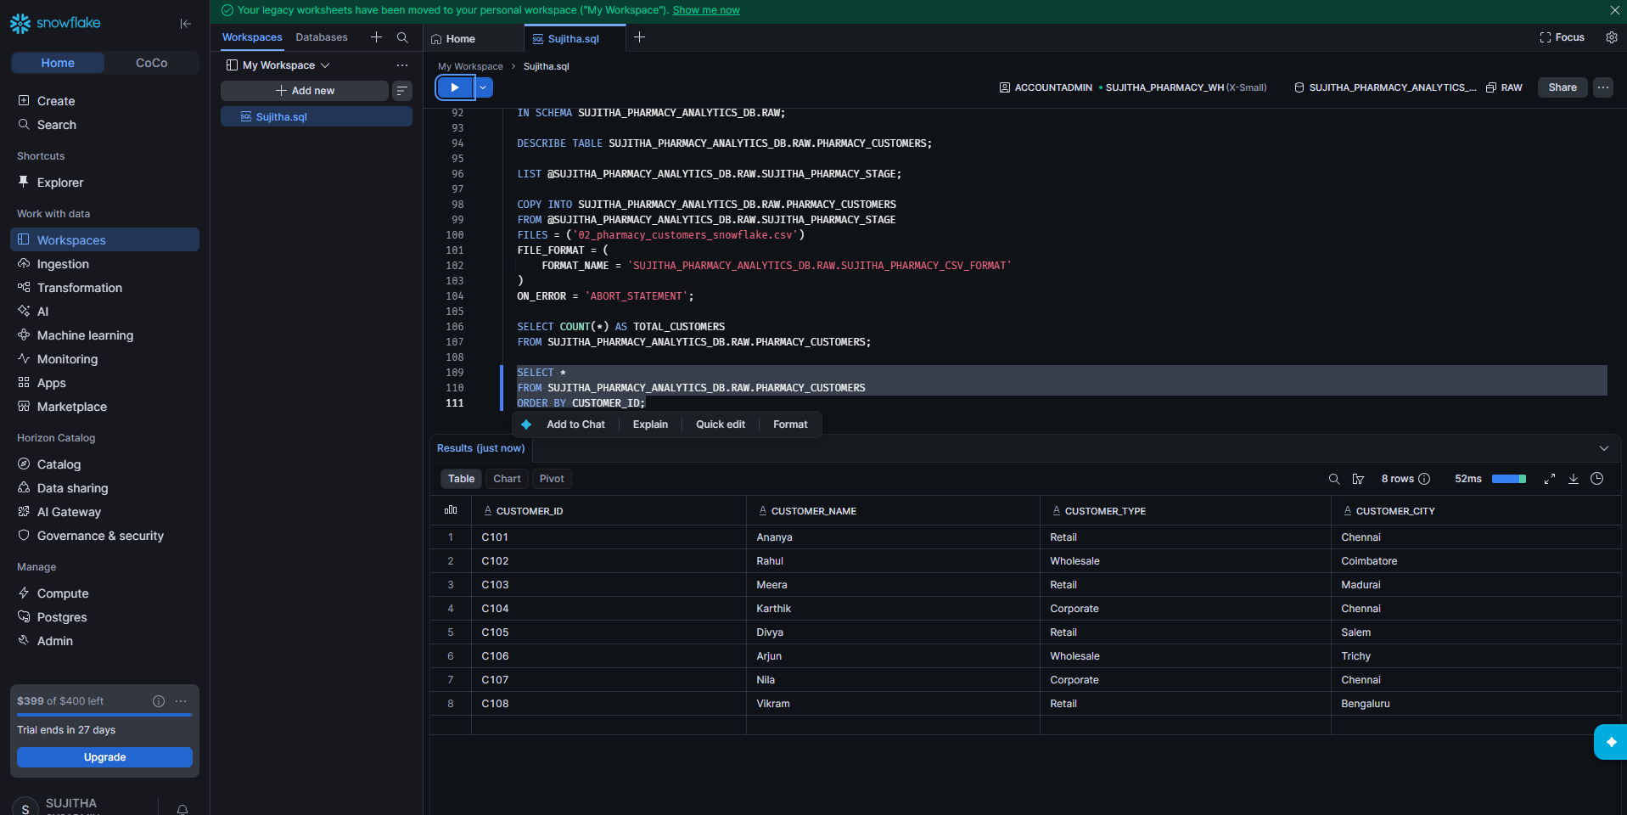
Figure 38: All customers

Part 4: Load the Products Data

Step 16: Create the PHARMACY_PRODUCTS Table
1. Run CREATE TABLE. The result shows: Table PHARMACY_PRODUCTS successfully created.
2. Run SHOW TABLES and DESCRIBE TABLE to confirm the 4 columns.
CREATE TABLE IF NOT EXISTS PHARMACY_PRODUCTS (
PRODUCT_ID VARCHAR(20),
PRODUCT_NAME VARCHAR(100),
CATEGORY VARCHAR(100),
UNIT_PRICE NUMBER(12,2)
);

SHOW TABLES LIKE 'PHARMACY_PRODUCTS'
IN SCHEMA SUJITHA_PHARMACY_ANALYTICS_DB.RAW;

DESCRIBE TABLE SUJITHA_PHARMACY_ANALYTICS_DB.RAW.PHARMACY_PRODUCTS;
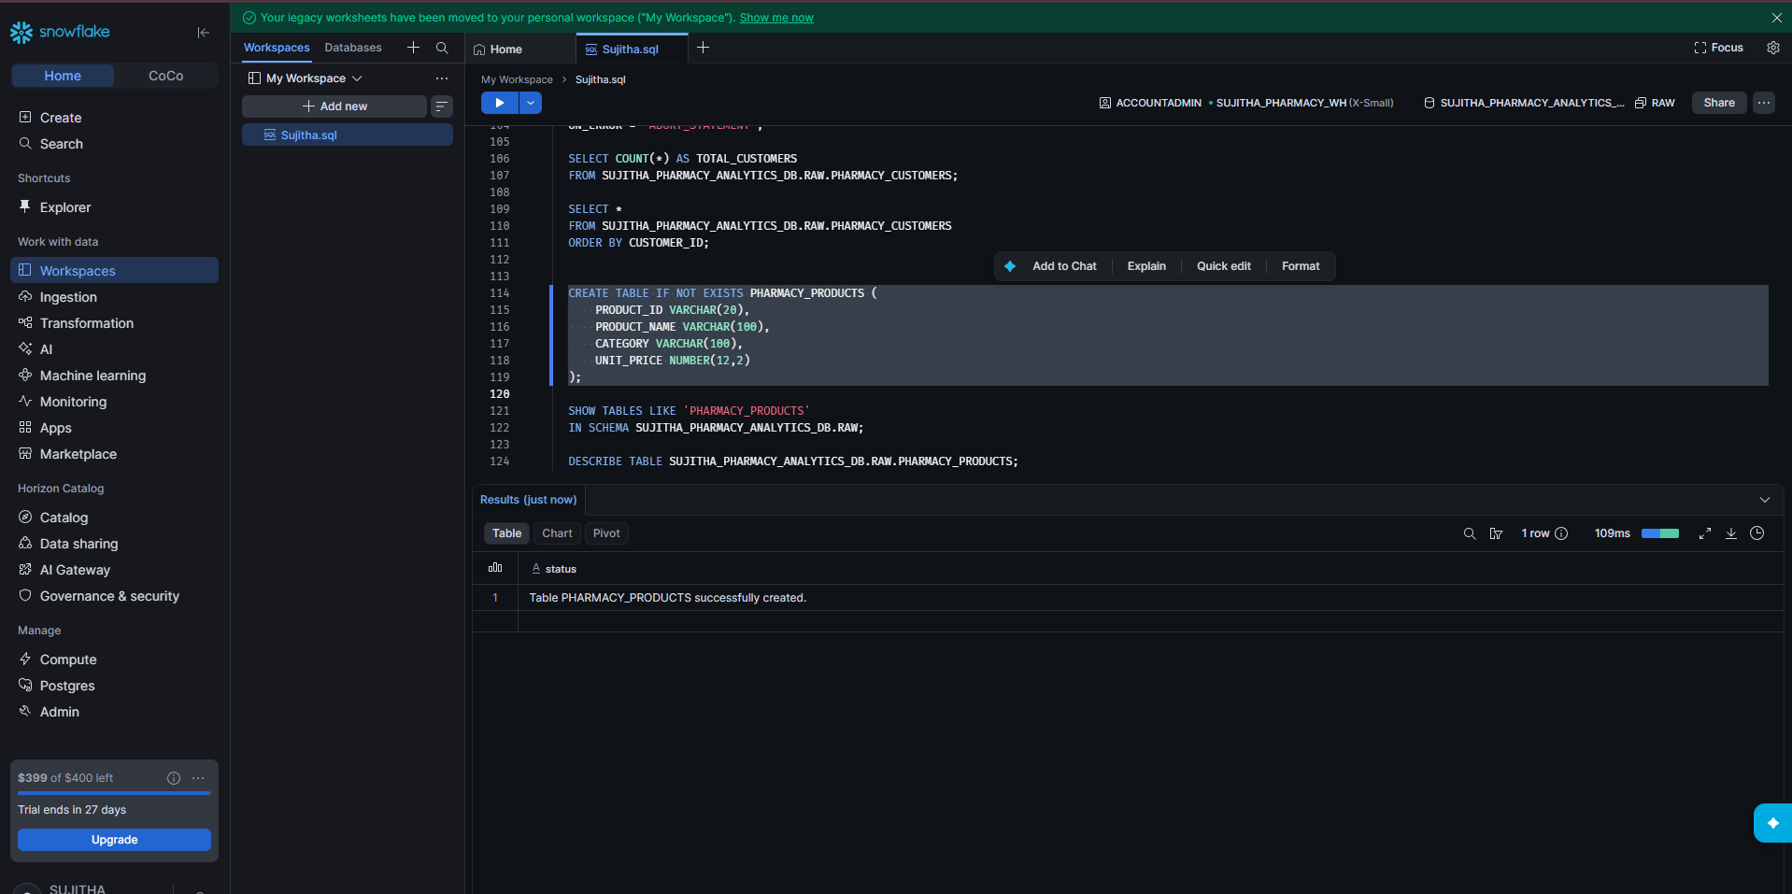
Figure 39: PHARMACY_PRODUCTS table created
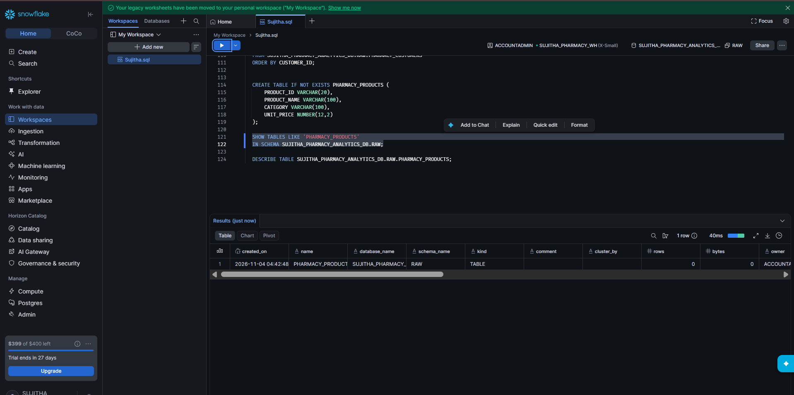
Figure 40: SHOW TABLES result
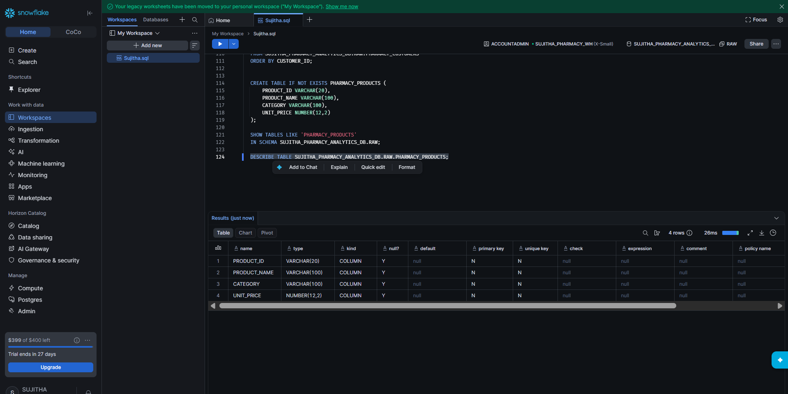
Figure 41: DESCRIBE TABLE result

Step 17: Upload the Products File
1. In Catalog, open SUJITHA_PHARMACY_STAGE and upload 03_pharmacy_products_snowflake.csv.
2. The stage now lists three files.
3. In the worksheet, run LIST to confirm all three files.
LIST @SUJITHA_PHARMACY_ANALYTICS_DB.RAW.SUJITHA_PHARMACY_STAGE;
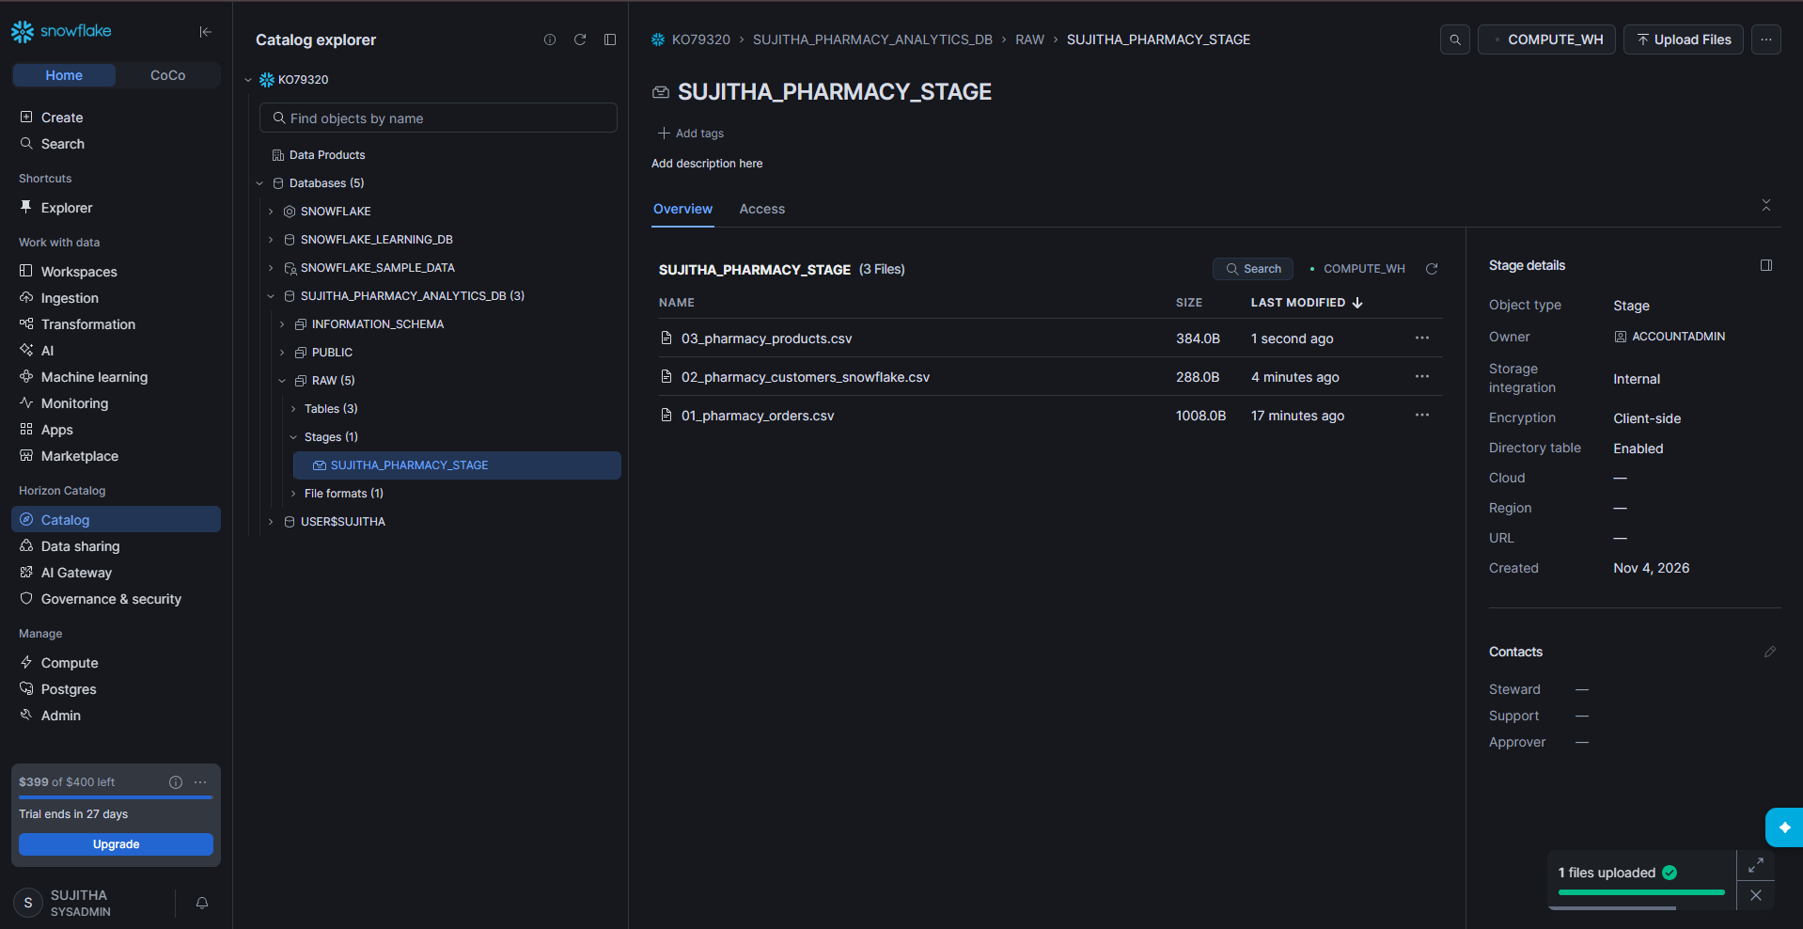
Figure 42: Stage with three files
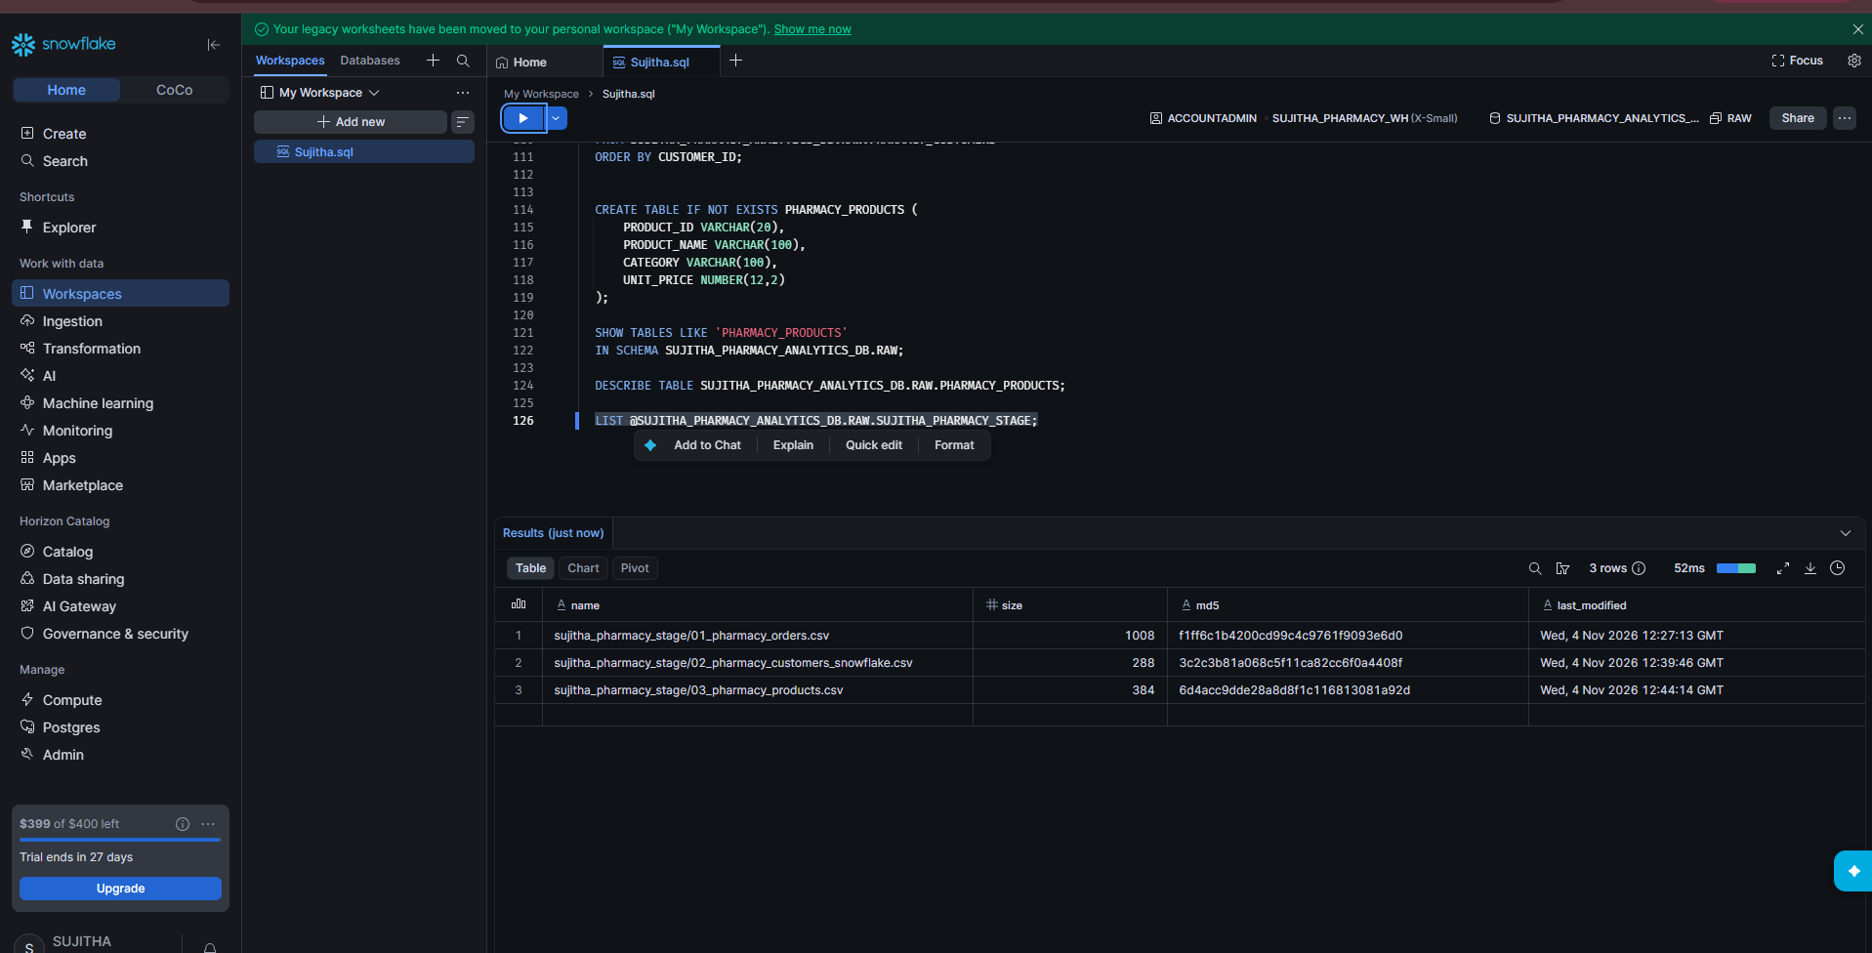
Figure 43: LIST result showing three files

Step 18: Load and Verify the Products Data
1. Run COPY INTO. The result shows status LOADED with 7 rows loaded.
2. Count the products. The result is 7.
3. View all products.
COPY INTO SUJITHA_PHARMACY_ANALYTICS_DB.RAW.PHARMACY_PRODUCTS
FROM @SUJITHA_PHARMACY_ANALYTICS_DB.RAW.SUJITHA_PHARMACY_STAGE
FILES = ('03_pharmacy_products_snowflake.csv')
FILE_FORMAT = (
FORMAT_NAME = 'SUJITHA_PHARMACY_ANALYTICS_DB.RAW.SUJITHA_PHARMACY_CSV_FORMAT'
)
ON_ERROR = 'ABORT_STATEMENT';

SELECT COUNT(*) AS TOTAL_PRODUCTS
FROM SUJITHA_PHARMACY_ANALYTICS_DB.RAW.PHARMACY_PRODUCTS;

SELECT *
FROM SUJITHA_PHARMACY_ANALYTICS_DB.RAW.PHARMACY_PRODUCTS;
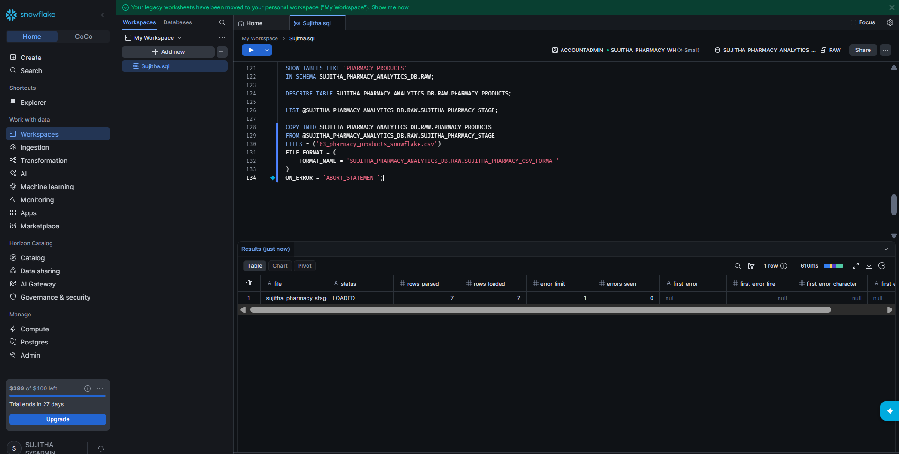
Figure 44: Products loaded – 7 rows
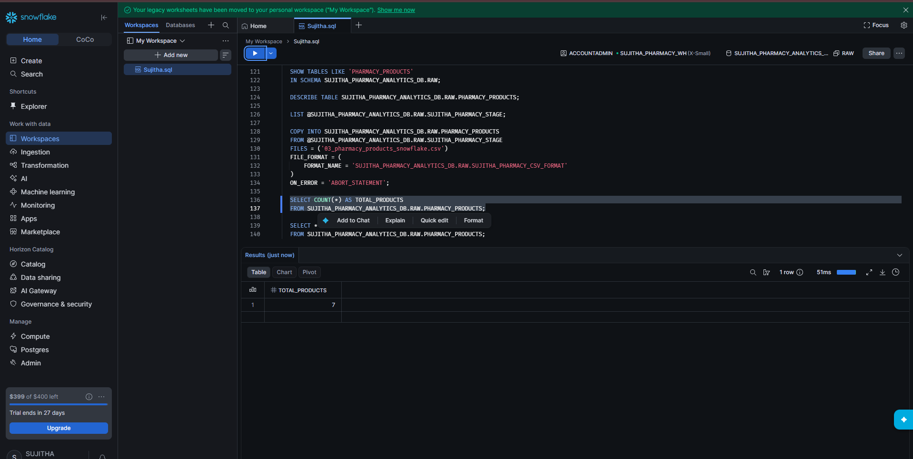
Figure 45: Total products = 7
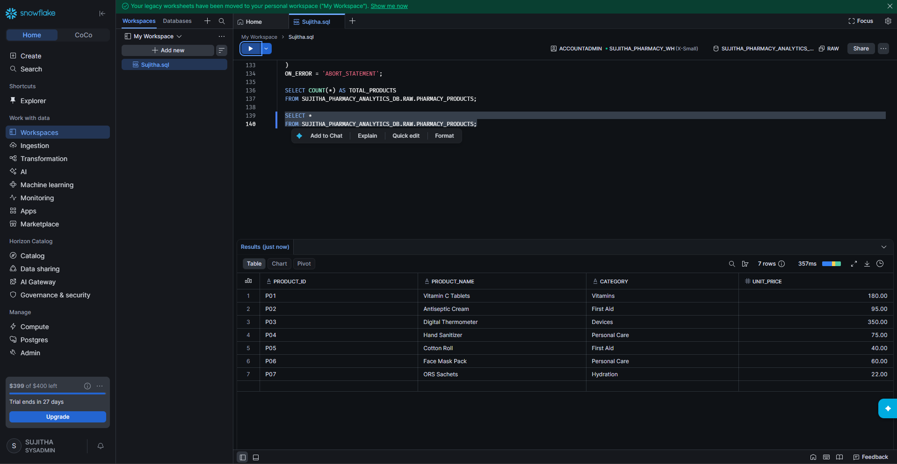
Figure 46: All products

Part 5: Data Quality Checks

Step 19: Count Records in All Tables
1. Run the UNION ALL query to see the row count of each table in one result.
2. Result: PHARMACY_ORDERS 20, PHARMACY_CUSTOMERS 8, PHARMACY_PRODUCTS 7.
SELECT 'PHARMACY_ORDERS' AS TABLE_NAME, COUNT(*) AS TOTAL_RECORDS
FROM SUJITHA_PHARMACY_ANALYTICS_DB.RAW.PHARMACY_ORDERS
UNION ALL
SELECT 'PHARMACY_CUSTOMERS', COUNT(*)
FROM SUJITHA_PHARMACY_ANALYTICS_DB.RAW.PHARMACY_CUSTOMERS
UNION ALL
SELECT 'PHARMACY_PRODUCTS', COUNT(*)
FROM SUJITHA_PHARMACY_ANALYTICS_DB.RAW.PHARMACY_PRODUCTS;
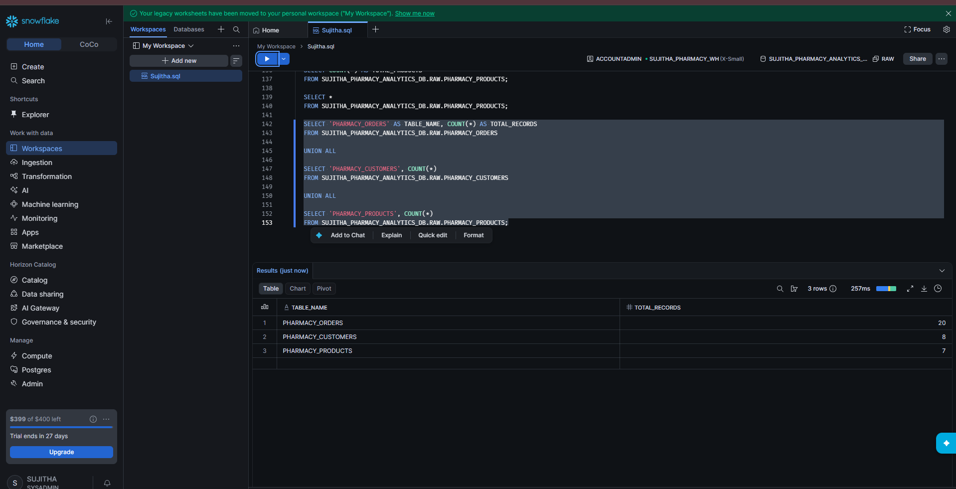
Figure 47: Record count of all three tables

Step 20: Check for NULL Values
1. Run the query to count NULL values in each column of PHARMACY_ORDERS.
2. Result: ORDER_DATE has 1 null, QUANTITY has 1 null, LOCATION has 2 nulls and PAYMENT_MODE has 2 nulls. The ID columns have no nulls.
SELECT
COUNT(*) AS TOTAL_RECORDS,
COUNT_IF(ORDER_ID IS NULL) AS NULL_ORDER_ID,
COUNT_IF(CUSTOMER_ID IS NULL) AS NULL_CUSTOMER_ID,
COUNT_IF(PRODUCT_ID IS NULL) AS NULL_PRODUCT_ID,
COUNT_IF(ORDER_DATE IS NULL) AS NULL_ORDER_DATE,
COUNT_IF(QUANTITY IS NULL) AS NULL_QUANTITY,
COUNT_IF(LOCATION IS NULL) AS NULL_LOCATION,
COUNT_IF(PAYMENT_MODE IS NULL) AS NULL_PAYMENT_MODE
FROM SUJITHA_PHARMACY_ANALYTICS_DB.RAW.PHARMACY_ORDERS;
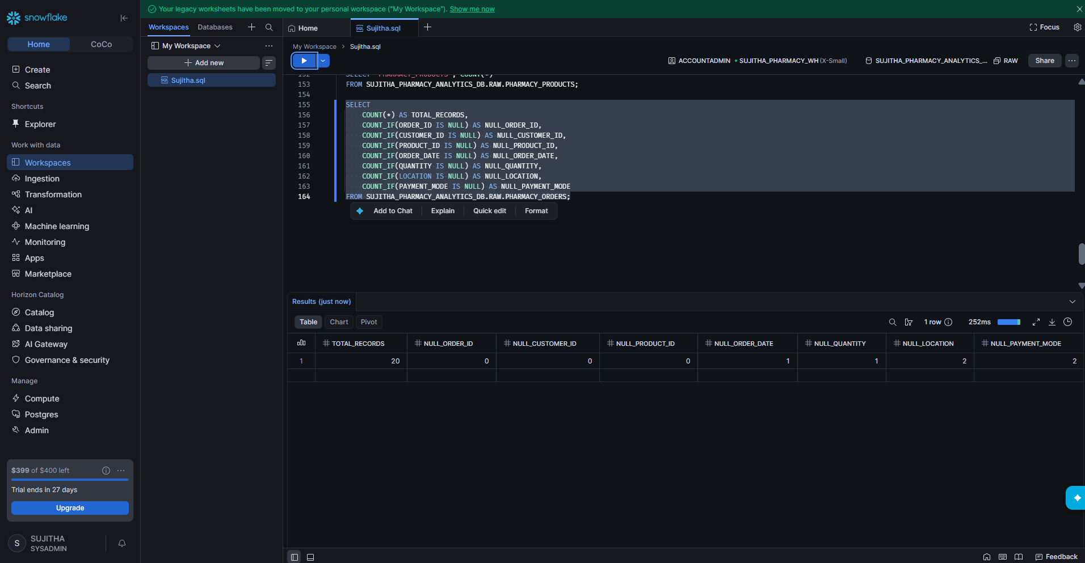
Figure 48: NULL value count per column

Step 21: Check for Empty Text Values
1. Run the query to count values that are only spaces or blank.
2. Result: EMPTY_LOCATION 0 and EMPTY_PAYMENT_MODE 0.
SELECT
COUNT_IF(TRIM(LOCATION) = '') AS EMPTY_LOCATION,
COUNT_IF(TRIM(PAYMENT_MODE) = '') AS EMPTY_PAYMENT_MODE
FROM SUJITHA_PHARMACY_ANALYTICS_DB.RAW.PHARMACY_ORDERS;
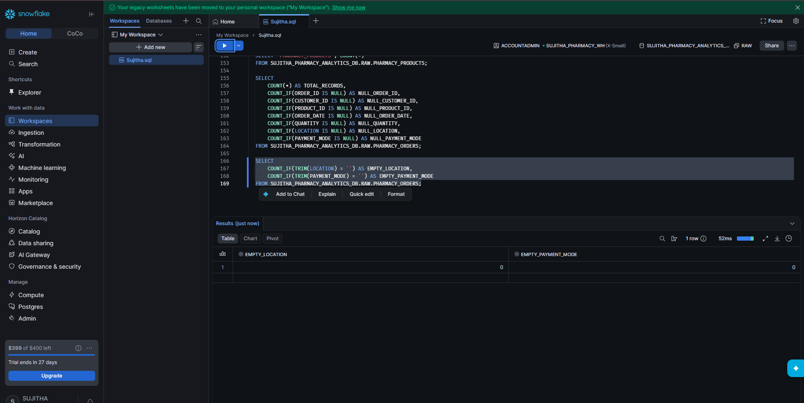
Figure 49: Empty value count

Step 22: View the Problem Rows
1. Run the query to list every row that has a missing or blank value.
2. Result: 5 rows (orders 3016 to 3020).
SELECT *
FROM SUJITHA_PHARMACY_ANALYTICS_DB.RAW.PHARMACY_ORDERS
WHERE ORDER_DATE IS NULL
OR QUANTITY IS NULL
OR LOCATION IS NULL
OR TRIM(LOCATION) = ''
OR PAYMENT_MODE IS NULL
OR TRIM(PAYMENT_MODE) = '';
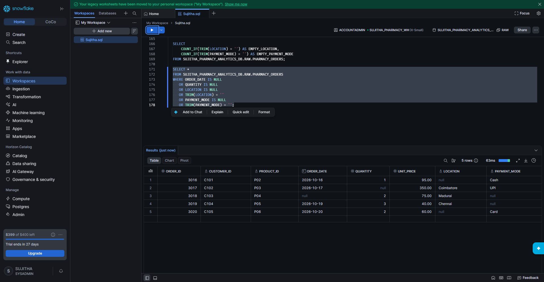
Figure 50: Rows with missing values

Step 23: Check for Duplicate Orders
1. Run the query to find any ORDER_ID that appears more than once.
2. Result: Query produced no results, so there are no duplicates.
3. Run the problem-rows query again to confirm the same 5 rows before cleaning.
SELECT
ORDER_ID,
COUNT(*) AS RECORD_COUNT
FROM SUJITHA_PHARMACY_ANALYTICS_DB.RAW.PHARMACY_ORDERS
GROUP BY ORDER_ID
HAVING COUNT(*) > 1;
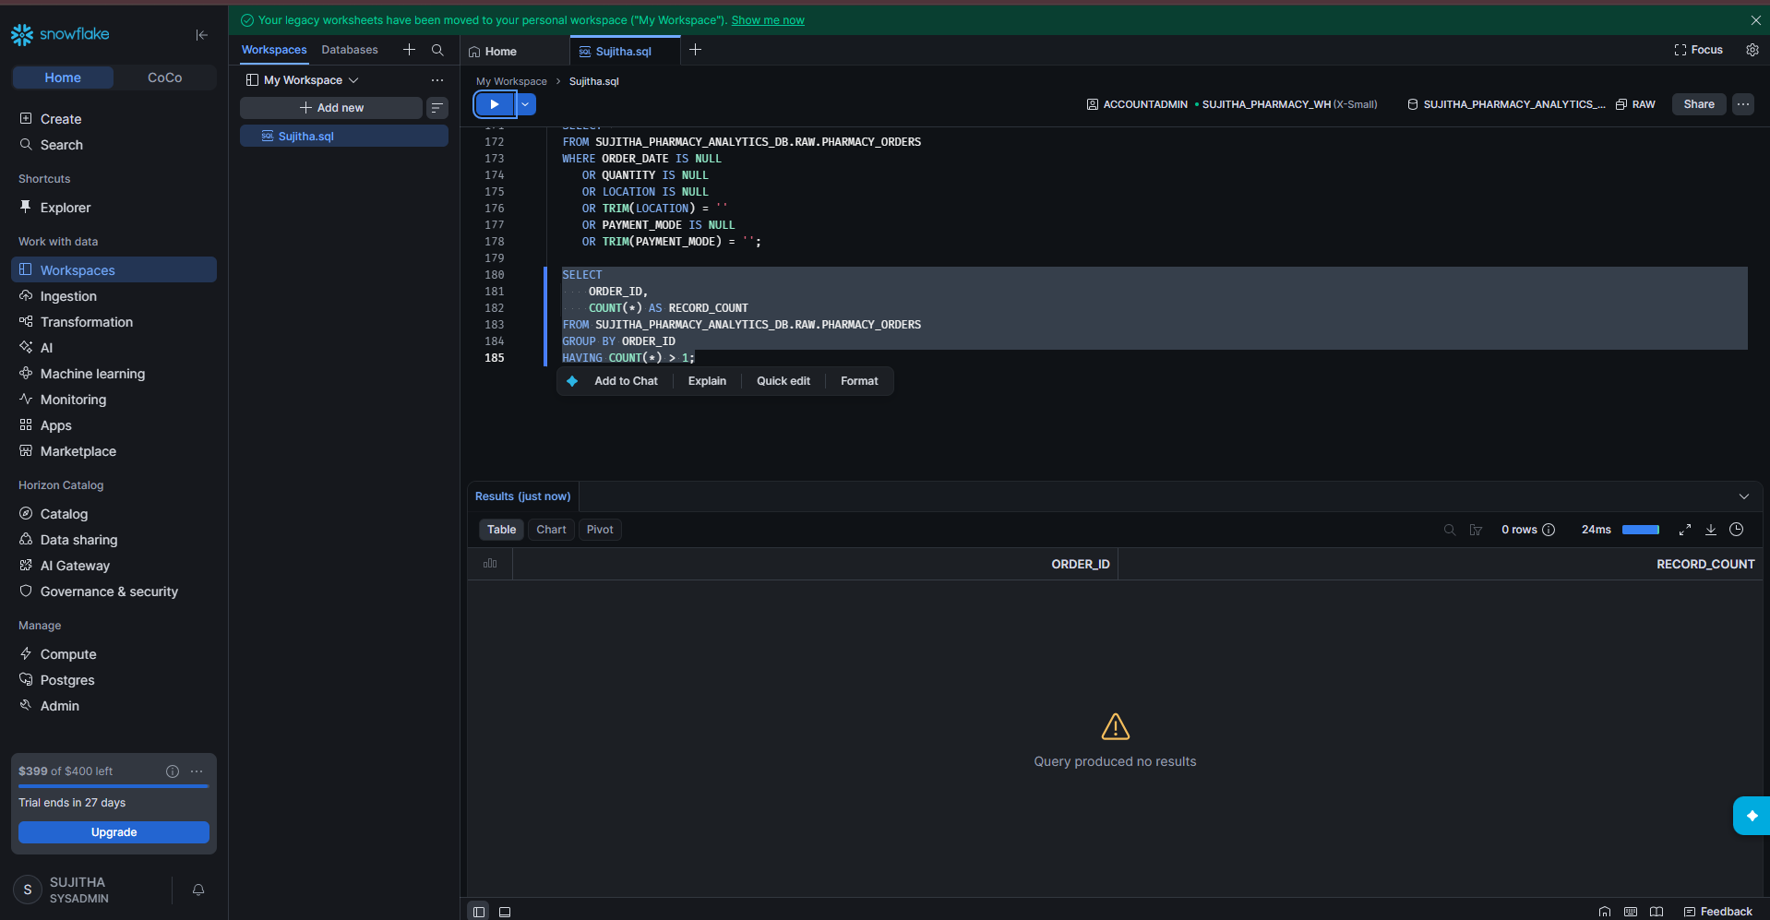
Figure 51: Duplicate check – no results
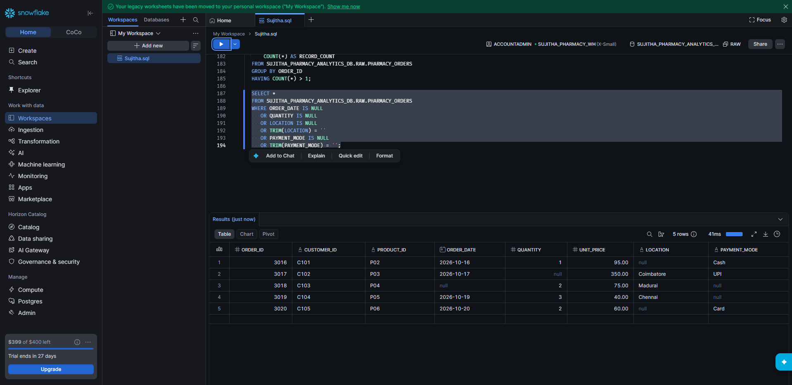
Figure 52: Problem rows checked again

Part 6: Clean and Transform the Data

Step 24: Create the Cleaned Orders Table
1. Run the CREATE OR REPLACE TABLE ... AS SELECT statement.
2. Missing QUANTITY is replaced with 0.
3. Missing or blank LOCATION and PAYMENT_MODE are replaced with 'UNKNOWN'.
4. The result shows: Table PHARMACY_ORDERS_CLEANED successfully created.
5. View the cleaned table sorted by ORDER_ID (20 rows).
CREATE OR REPLACE TABLE SUJITHA_PHARMACY_ANALYTICS_DB.RAW.PHARMACY_ORDERS_CLEANED AS
SELECT
ORDER_ID,
CUSTOMER_ID,
PRODUCT_ID,
ORDER_DATE,
COALESCE(QUANTITY, 0) AS QUANTITY,
UNIT_PRICE,
COALESCE(NULLIF(TRIM(LOCATION), ''), 'UNKNOWN') AS LOCATION,
COALESCE(NULLIF(TRIM(PAYMENT_MODE), ''), 'UNKNOWN') AS PAYMENT_MODE
FROM SUJITHA_PHARMACY_ANALYTICS_DB.RAW.PHARMACY_ORDERS;

SELECT *
FROM SUJITHA_PHARMACY_ANALYTICS_DB.RAW.PHARMACY_ORDERS_CLEANED
ORDER BY ORDER_ID;
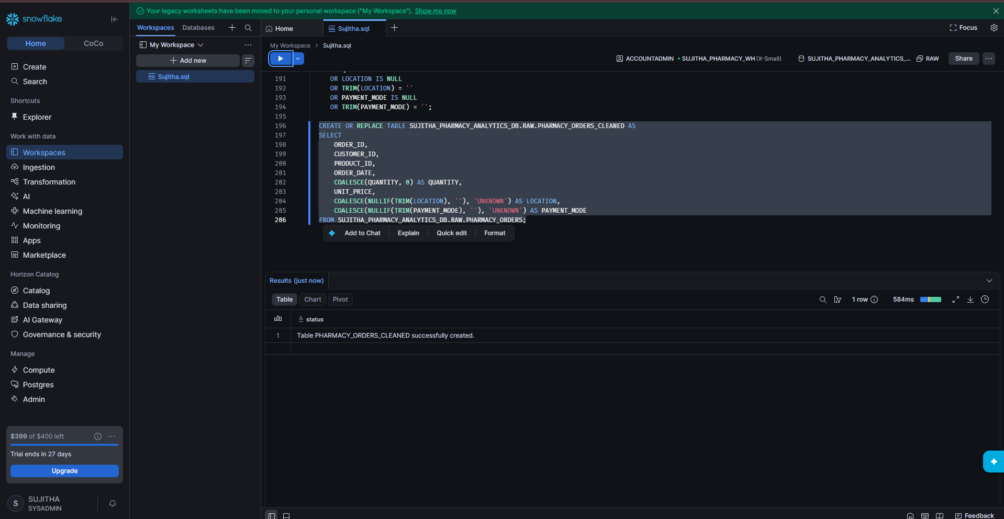
Figure 53: Cleaned table created
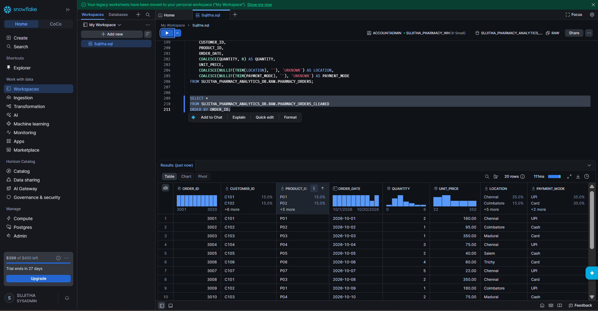
Figure 54: Cleaned orders data

Step 25: Verify the Cleaning
1. Run the check query on the cleaned table.
2. Result: NULL_QUANTITY 0, EMPTY_LOCATION 0, EMPTY_PAYMENT_MODE 0. NULL_ORDER_DATE is still 1 because dates were not filled in.
SELECT
COUNT_IF(QUANTITY IS NULL) AS NULL_QUANTITY,
COUNT_IF(LOCATION IS NULL OR TRIM(LOCATION) = '') AS EMPTY_LOCATION,
COUNT_IF(PAYMENT_MODE IS NULL OR TRIM(PAYMENT_MODE) = '') AS EMPTY_PAYMENT_MODE,
COUNT_IF(ORDER_DATE IS NULL) AS NULL_ORDER_DATE
FROM SUJITHA_PHARMACY_ANALYTICS_DB.RAW.PHARMACY_ORDERS_CLEANED;
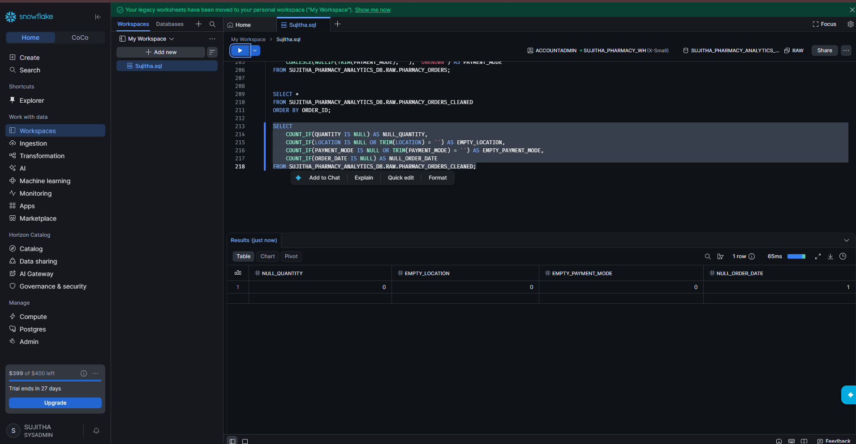
Figure 55: Cleaning check result

Step 26: Create the Transformed Sales Table
1. Run the CREATE OR REPLACE TABLE statement. It adds three new columns:
2. TOTAL_REVENUE = QUANTITY × UNIT_PRICE.
3. SALES_CATEGORY = HIGH if revenue is 500 or more, MEDIUM if 200 or more, otherwise LOW.
4. LOCATION_TYPE = METRO for Chennai, otherwise NON_METRO.
5. The result shows: Table PHARMACY_SALES_TRANSFORMED successfully created.
6. View the transformed table sorted by ORDER_ID.
CREATE OR REPLACE TABLE SUJITHA_PHARMACY_ANALYTICS_DB.RAW.PHARMACY_SALES_TRANSFORMED AS
SELECT
ORDER_ID,
CUSTOMER_ID,
PRODUCT_ID,
ORDER_DATE,
QUANTITY,
UNIT_PRICE,
LOCATION,
PAYMENT_MODE,
QUANTITY * UNIT_PRICE AS TOTAL_REVENUE,
CASE
WHEN QUANTITY * UNIT_PRICE >= 500 THEN 'HIGH'
WHEN QUANTITY * UNIT_PRICE >= 200 THEN 'MEDIUM'
ELSE 'LOW'
END AS SALES_CATEGORY,
CASE
WHEN LOCATION = 'Chennai' THEN 'METRO'
ELSE 'NON_METRO'
END AS LOCATION_TYPE
FROM SUJITHA_PHARMACY_ANALYTICS_DB.RAW.PHARMACY_ORDERS_CLEANED;

SELECT *
FROM SUJITHA_PHARMACY_ANALYTICS_DB.RAW.PHARMACY_SALES_TRANSFORMED
ORDER BY ORDER_ID;
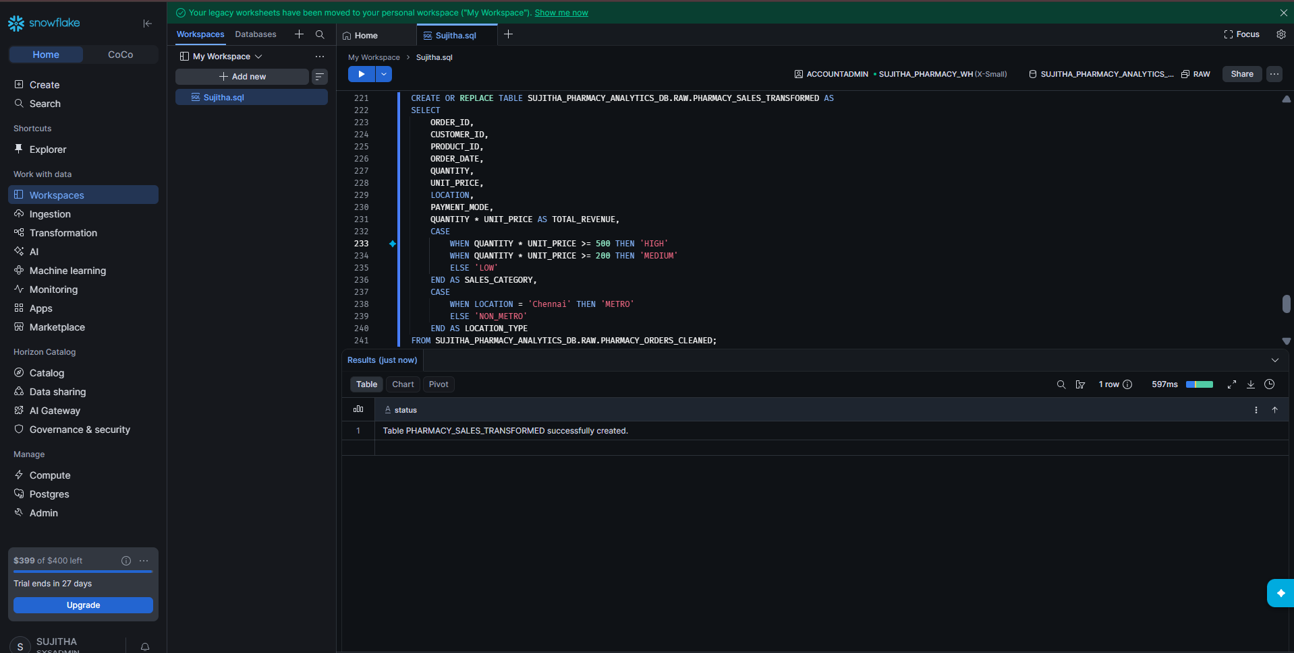
Figure 56: Transformed table created
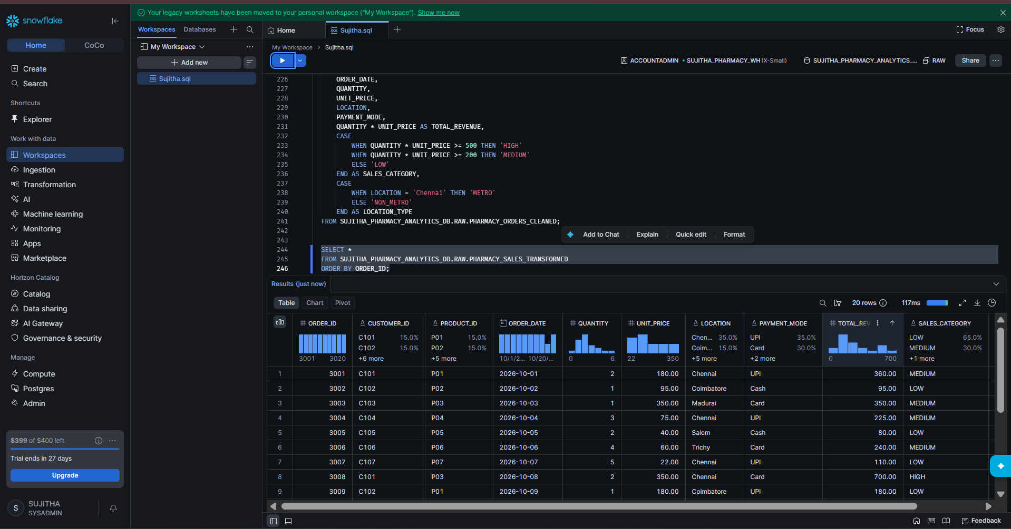
Figure 57: Transformed data with TOTAL_REVENUE and SALES_CATEGORY

Part 7: Analysis Queries

Step 27: Total Revenue
1. Run the query. The result is 3972.00.
SELECT
SUM(TOTAL_REVENUE) AS TOTAL_REVENUE
FROM SUJITHA_PHARMACY_ANALYTICS_DB.RAW.PHARMACY_SALES_TRANSFORMED;
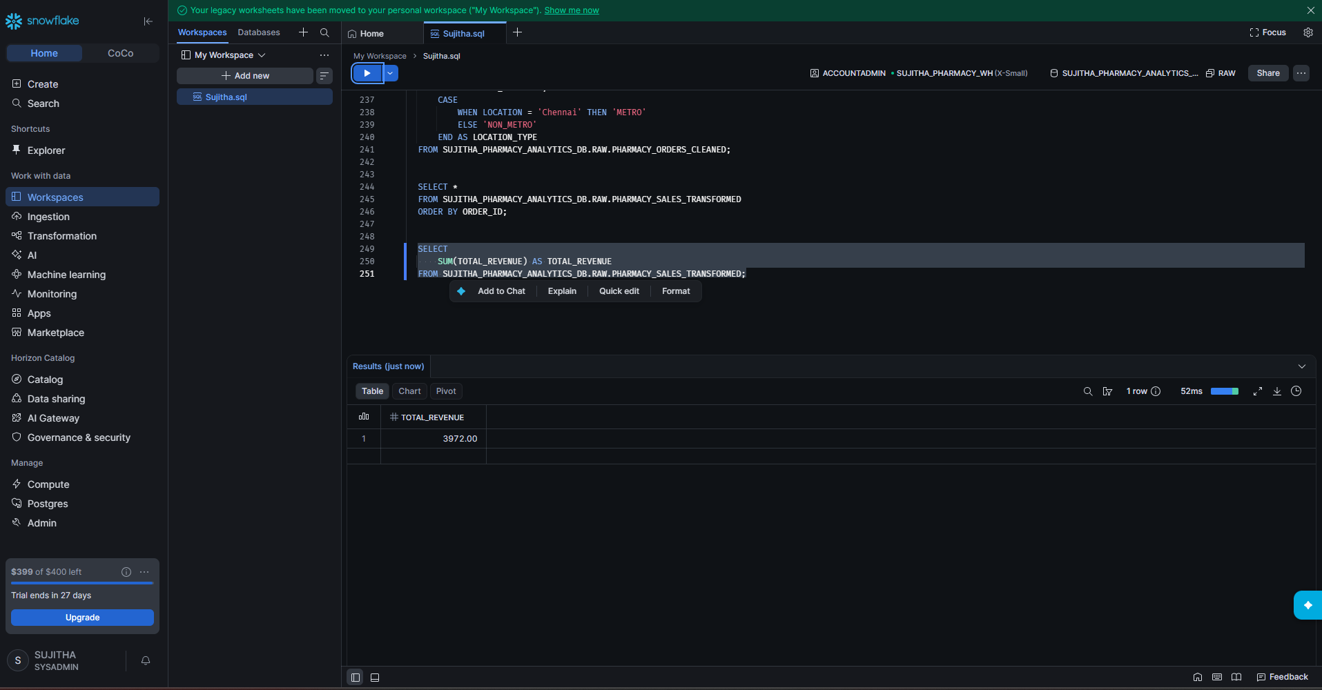
Figure 58: Total revenue

Step 28: Revenue by Sales Category
1. Run the GROUP BY query.
2. Result: MEDIUM – 6 orders, 1820.00; LOW – 13 orders, 1452.00; HIGH – 1 order, 700.00.
SELECT
SALES_CATEGORY,
COUNT(*) AS TOTAL_ORDERS,
SUM(TOTAL_REVENUE) AS REVENUE
FROM SUJITHA_PHARMACY_ANALYTICS_DB.RAW.PHARMACY_SALES_TRANSFORMED
GROUP BY SALES_CATEGORY;
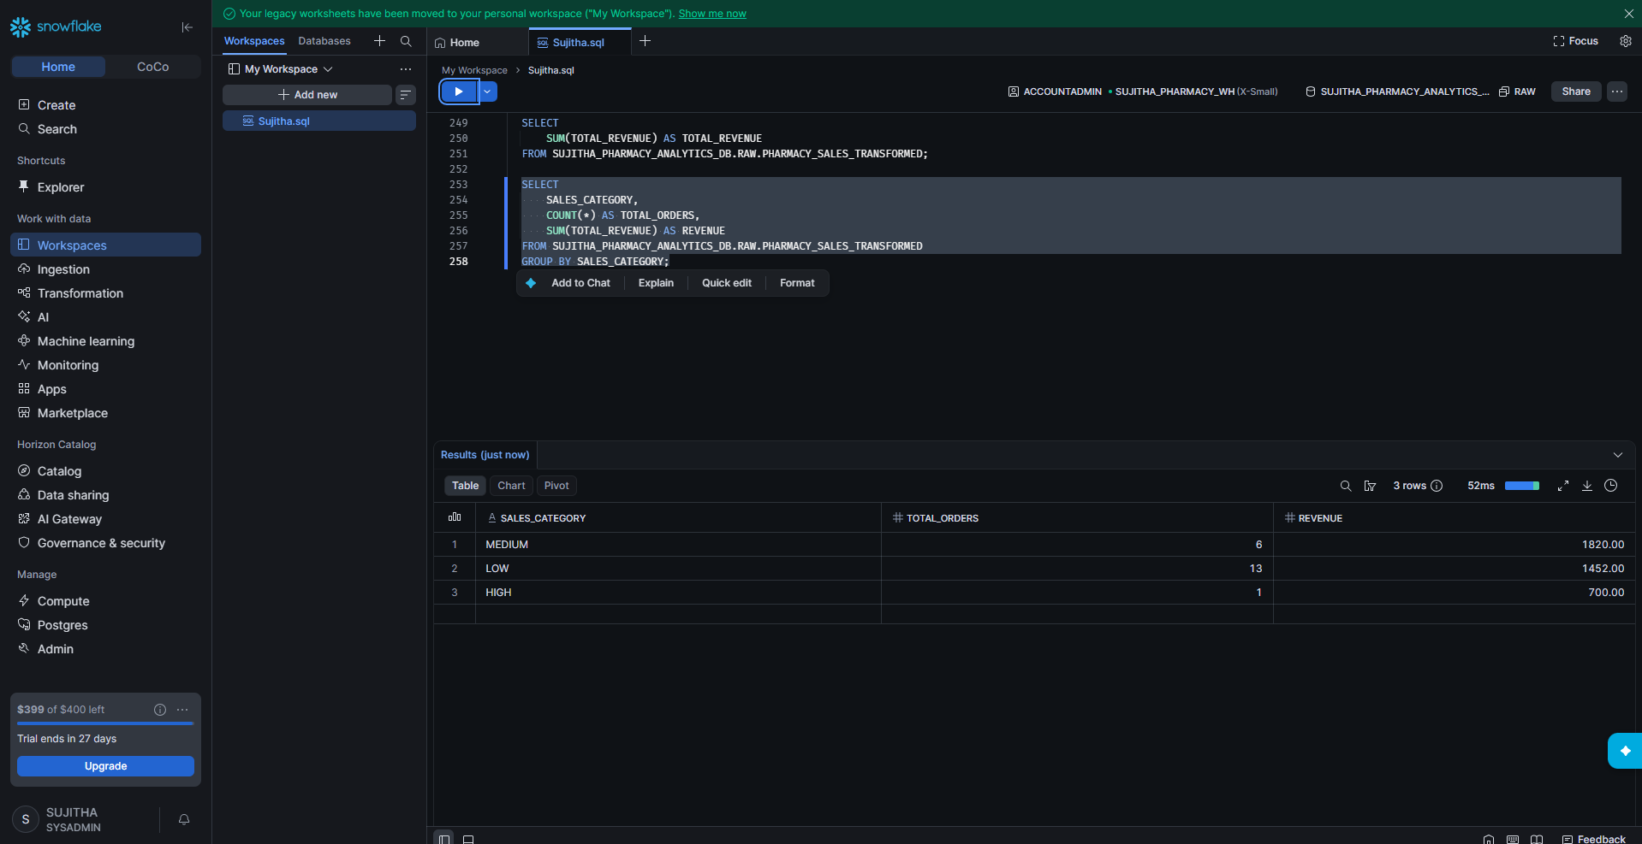
Figure 59: Revenue by sales category

Step 29: Orders from Chennai
1. Because the database and schema are already in use, the table name can be written without the full path.
2. Run the query. The result is 7 orders.
SELECT *
FROM PHARMACY_ORDERS
WHERE LOCATION = 'Chennai';
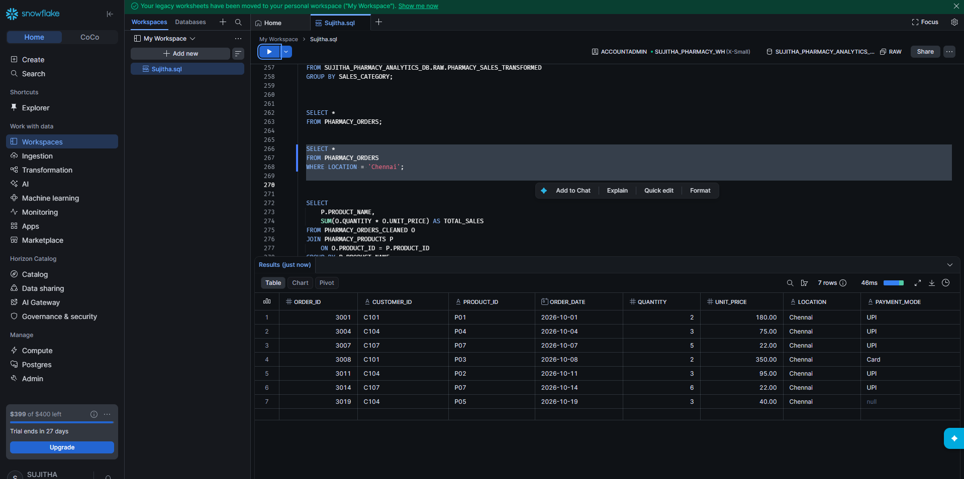
Figure 60: Chennai orders

Step 30: Total Sales by Product (JOIN)
1. Run the query that joins cleaned orders with products on PRODUCT_ID.
2. The result shows total sales for each of the 7 products. Digital Thermometer has the highest sales (1050.00).
SELECT
P.PRODUCT_NAME,
SUM(O.QUANTITY * O.UNIT_PRICE) AS TOTAL_SALES
FROM PHARMACY_ORDERS_CLEANED O
JOIN PHARMACY_PRODUCTS P
ON O.PRODUCT_ID = P.PRODUCT_ID
GROUP BY P.PRODUCT_NAME;
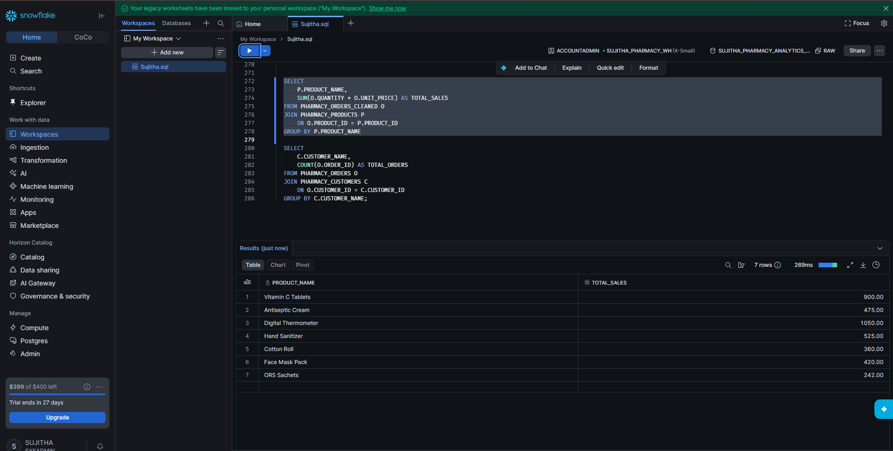
Figure 61: Total sales by product

Step 31: Total Orders by Customer (JOIN)
1. Run the query that joins orders with customers on CUSTOMER_ID.
2. The result shows the number of orders for each of the 8 customers.
SELECT
C.CUSTOMER_NAME,
COUNT(O.ORDER_ID) AS TOTAL_ORDERS
FROM PHARMACY_ORDERS O
JOIN PHARMACY_CUSTOMERS C
ON O.CUSTOMER_ID = C.CUSTOMER_ID
GROUP BY C.CUSTOMER_NAME;
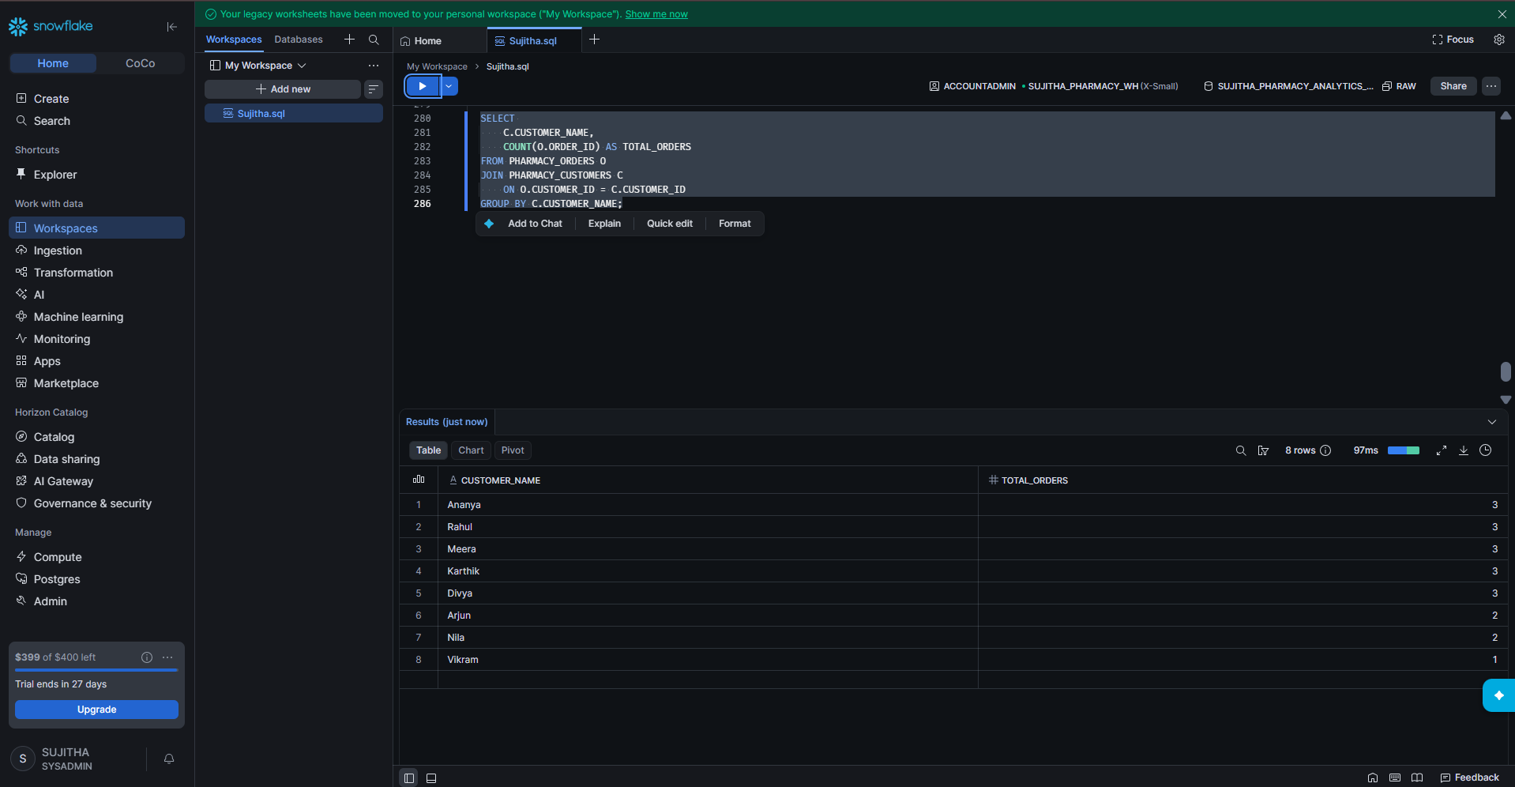
Figure 62: Total orders by customer

Part 8: Generate Sample Data

Step 32: Create a Table with Random Data
1. Run the query below. GENERATOR creates 10 rows, ROW_NUMBER gives each row an ORDER_ID, and UNIFORM creates a random QUANTITY (1 to 10) and UNIT_PRICE (100 to 1000).
2. The result shows: Table RANDOM_ORDERS successfully created.
3. View the table and count the rows. The result is 10.
CREATE OR REPLACE TABLE RANDOM_ORDERS AS
SELECT
ROW_NUMBER() OVER (ORDER BY SEQ4()) AS ORDER_ID,
UNIFORM(1, 10, RANDOM()) AS QUANTITY,
UNIFORM(100, 1000, RANDOM()) AS UNIT_PRICE
FROM TABLE(GENERATOR(ROWCOUNT => 10));

SELECT * FROM RANDOM_ORDERS;

SELECT COUNT(*) AS TOTAL_RECORDS
FROM RANDOM_ORDERS;
Note: The values are random, so your numbers will be different each time you run it.
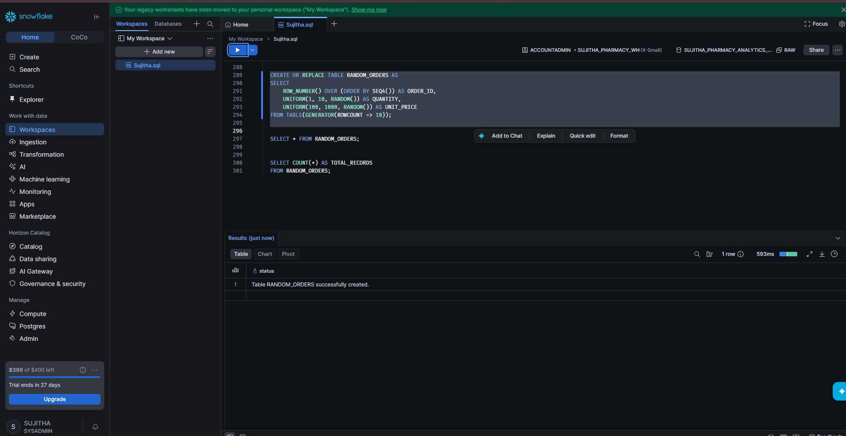
Figure 63: RANDOM_ORDERS table created
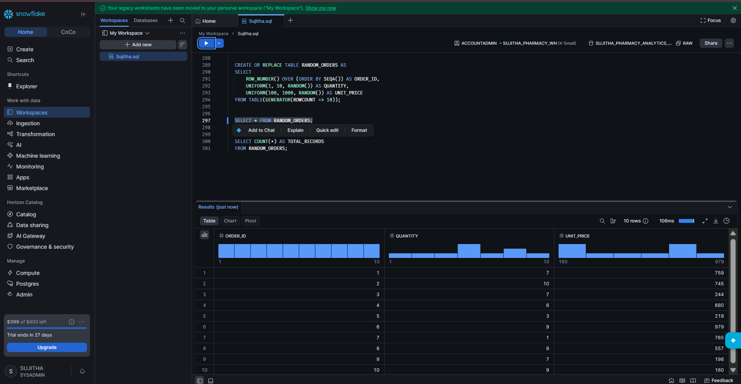
Figure 64: Random data
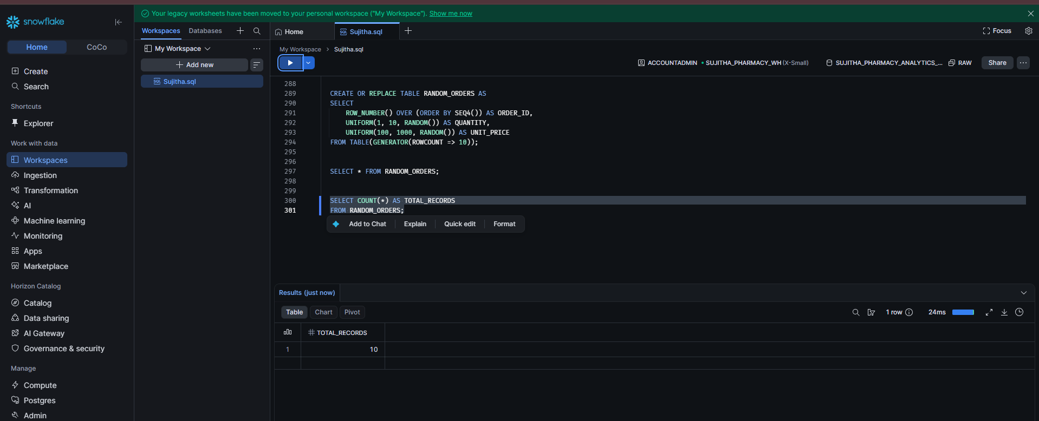
Figure 65: Total records = 10

Step 33: Filter the Random Data
1. Filter rows where QUANTITY is greater than 5.
2. Filter rows where UNIT_PRICE is between 200 and 700.
3. Run the Chennai filter on PHARMACY_ORDERS again to compare.
SELECT *
FROM RANDOM_ORDERS
WHERE QUANTITY > 5;

SELECT *
FROM RANDOM_ORDERS
WHERE UNIT_PRICE BETWEEN 200 AND 700;

SELECT *
FROM PHARMACY_ORDERS
WHERE LOCATION = 'Chennai';
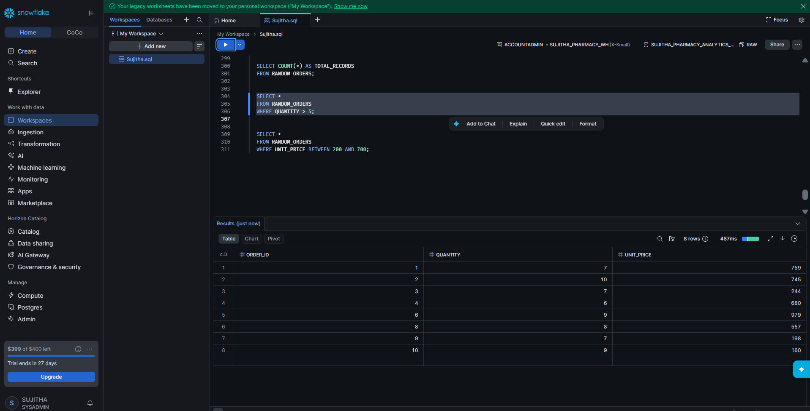
Figure 66: Rows with QUANTITY > 5
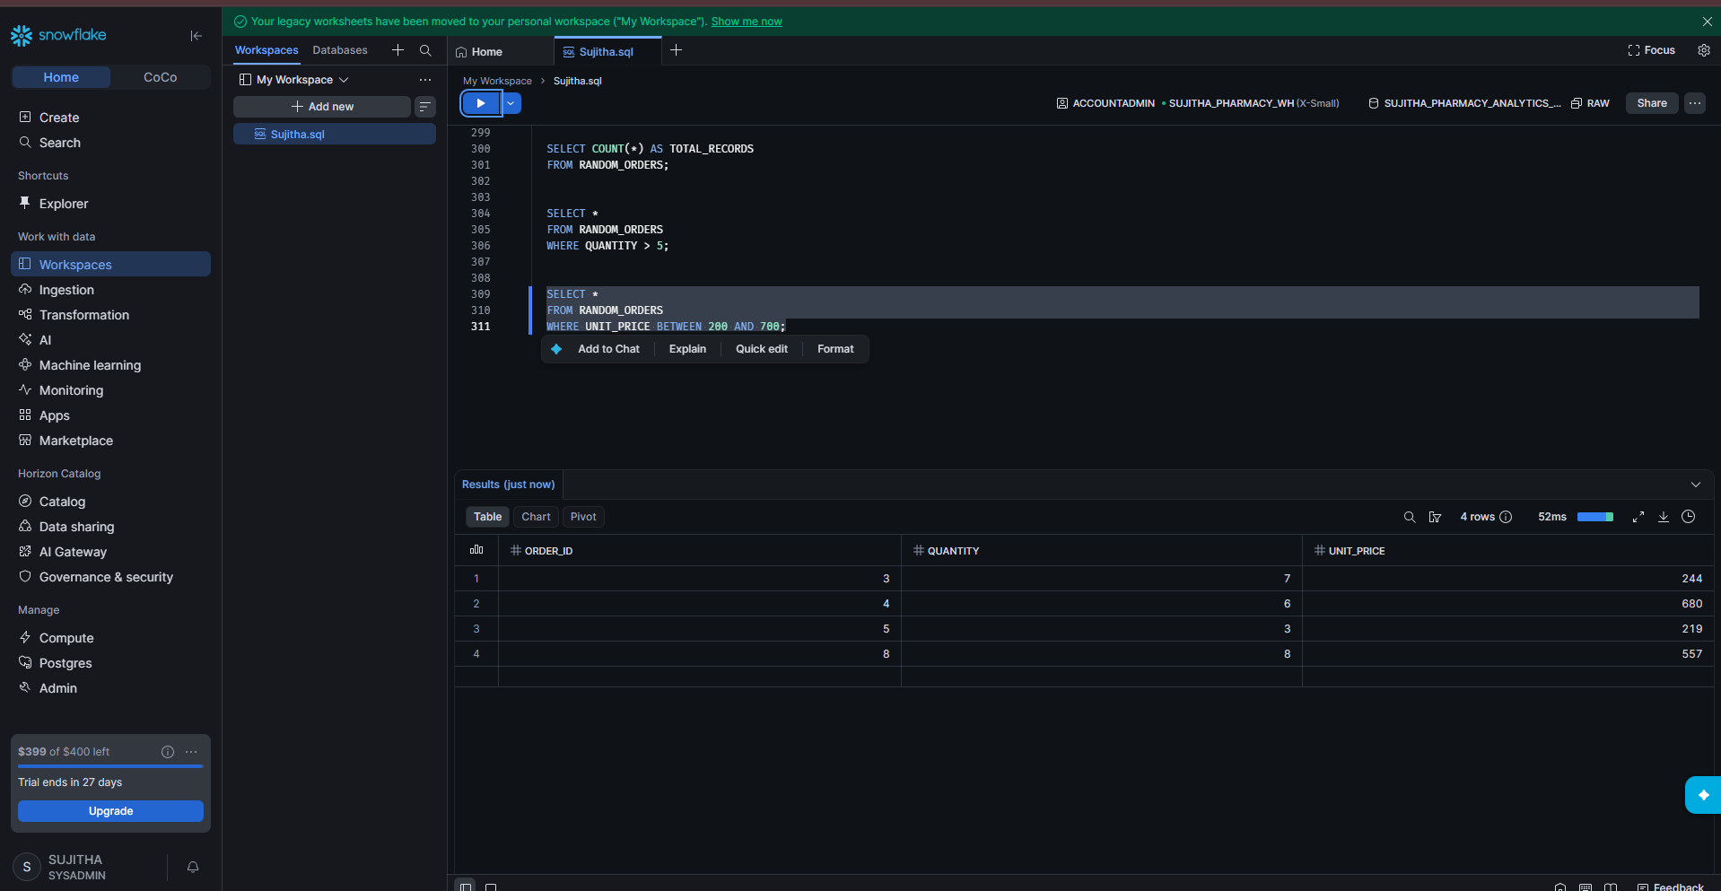
Figure 67: Rows with UNIT_PRICE between 200 and 700
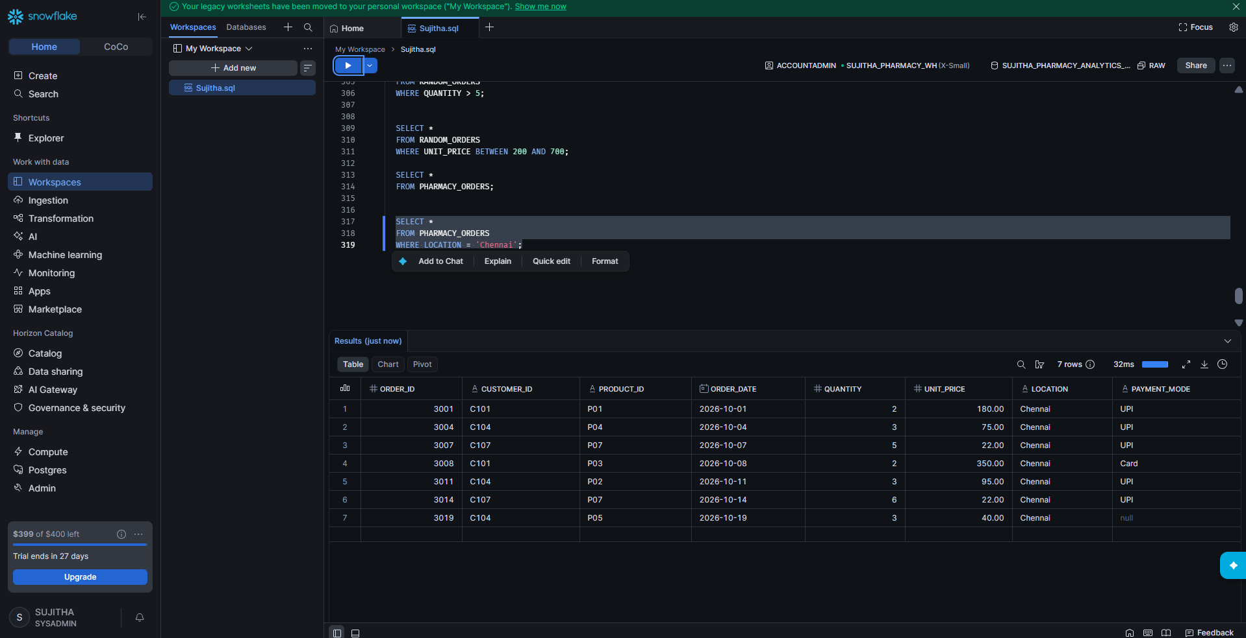
Figure 68: Chennai orders

Part 9: Monitor and Clean Up

Step 34: View Query History
1. In the left menu, click Monitoring > Query History.
2. Filter by User = SUJITHA and Last day.
3. The list shows every query that was run, with status, warehouse, duration and start time.
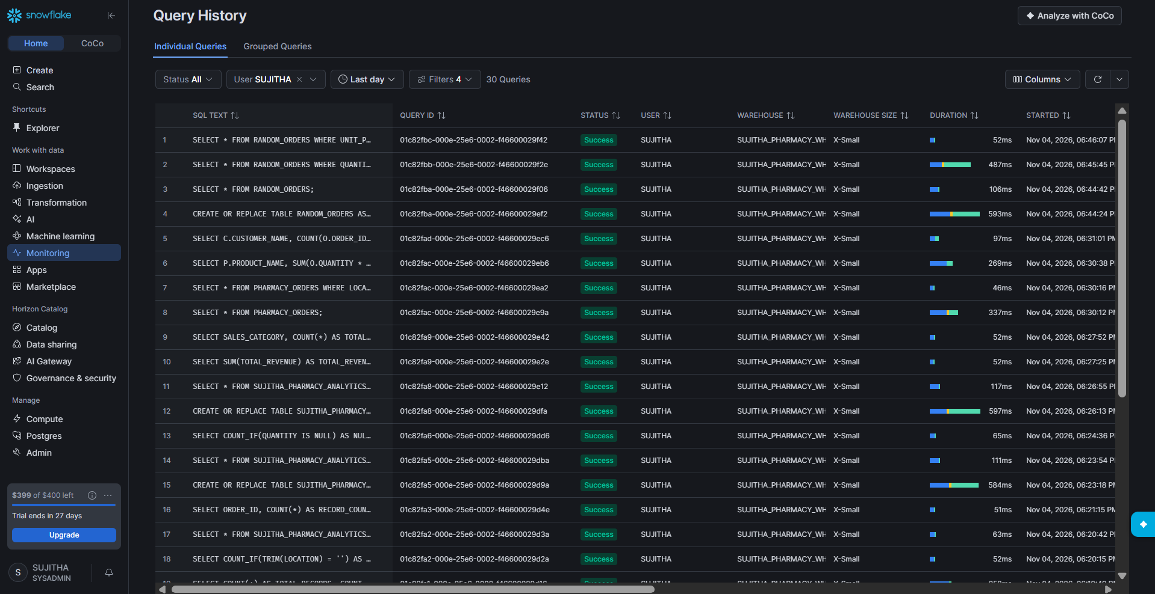
Figure 69: Query History

Step 35: Drop the Database and Warehouse
1. When the practice is finished, remove the objects to avoid using credits.
2. Run DROP DATABASE. The result shows: SUJITHA_PHARMACY_ANALYTICS_DB successfully dropped. This also removes the schema, tables, file format and stage inside it.
3. Run DROP WAREHOUSE. The result shows: SUJITHA_PHARMACY_WH successfully dropped.
DROP DATABASE IF EXISTS SUJITHA_PHARMACY_ANALYTICS_DB;

DROP WAREHOUSE IF EXISTS SUJITHA_PHARMACY_WH;
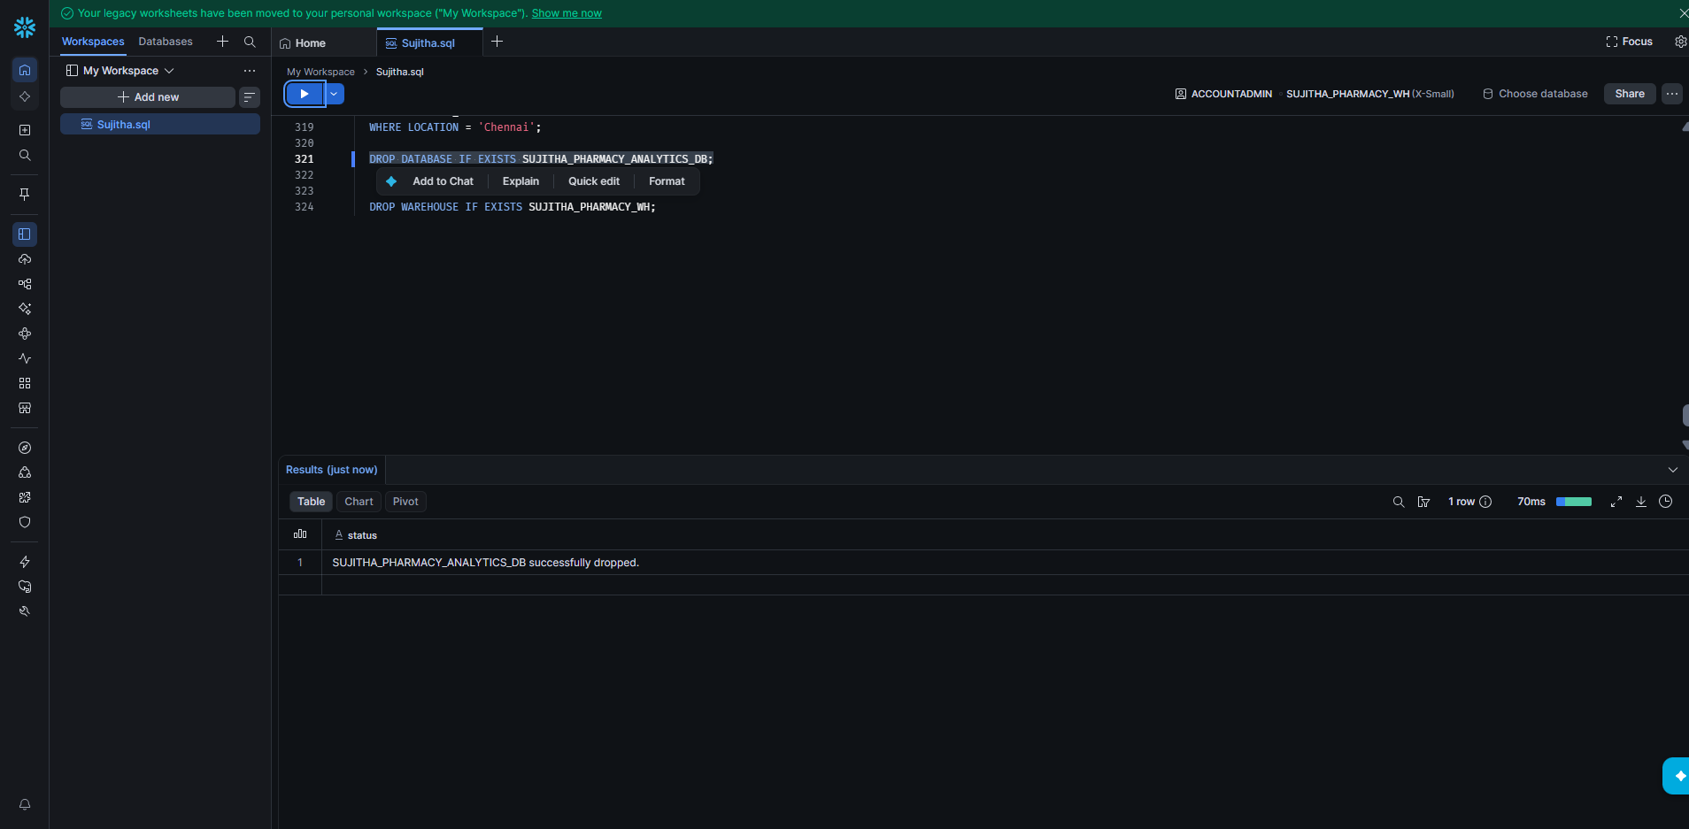
Figure 70: Database dropped
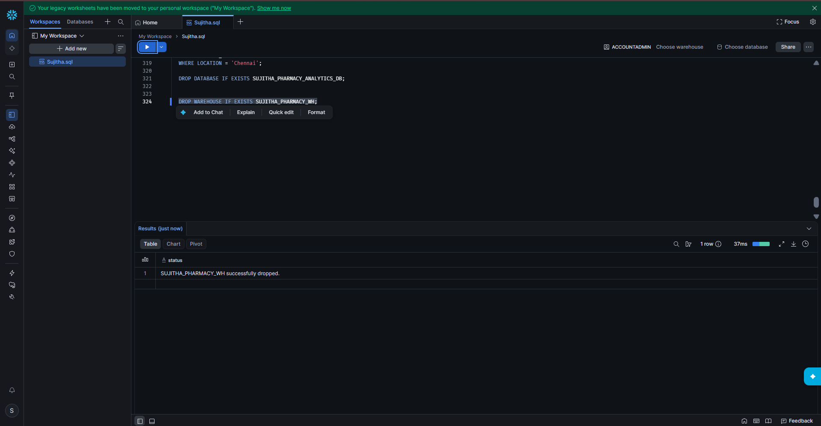
Figure 71: Warehouse dropped

Summary
- Created a database, RAW schema and X-Small warehouse.
- Created a CSV file format and an internal stage.
- Uploaded three CSV files to the stage and loaded them with COPY INTO (20 orders, 8 customers, 7 products).
- Checked data quality: NULL values, blank values and duplicates.
- Cleaned the orders data and built a transformed table with revenue, sales category and location type.
- Ran analysis queries including totals, GROUP BY and JOINs.
- Generated random sample data with GENERATOR.
- Reviewed Query History and dropped the database and warehouse.

