Day 12 – SQL Queries on Sales Data
  - Sales Database using MySQL Workbench

Objective
To create a sales database, insert order records, and practise SQL queries including multiple conditions, aggregate functions, GROUP BY with HAVING, CASE expressions, COUNT(DISTINCT), subqueries and the RANK() window function.

1. Database and Table Setup

Step 1: Create the Database, Table and Insert Sales Data
Aim: Create a sales database, define the sales_data table and load 15 order records.
Procedure:
1. Open MySQL Workbench and connect to the Local instance MySQL80.
2. Create the database day11_sales_db and select it with USE.
3. Create the sales_data table with the columns shown below.
4. Insert 15 order records using INSERT INTO ... VALUES.
5. Click the Execute (lightning) button or press Ctrl + Enter to run the query.
SQL Query:
CREATE DATABASE day11_sales_db;
USE day11_sales_db;
CREATE TABLE sales_data (
OrderID INT,
Product VARCHAR(100),
Category VARCHAR(100),
City VARCHAR(100),
OrderDate DATE,
Quantity INT,
UnitPrice DECIMAL(12,2)
);
INSERT INTO sales_data
(OrderID, Product, Category, City, OrderDate, Quantity, UnitPrice)
VALUES
(101, 'Laptop', 'Electronics', 'Chennai', '2026-10-01', 2, 50000),
(102, 'Mouse', 'Accessories', 'Chennai', '2026-10-02', 5, 500),
...
(115, 'Printer', 'Electronics', 'Mumbai', '2026-10-15', 2, 8000);
Output: Database and table created; 15 row(s) affected – Records: 15, Duplicates: 0, Warnings: 0.
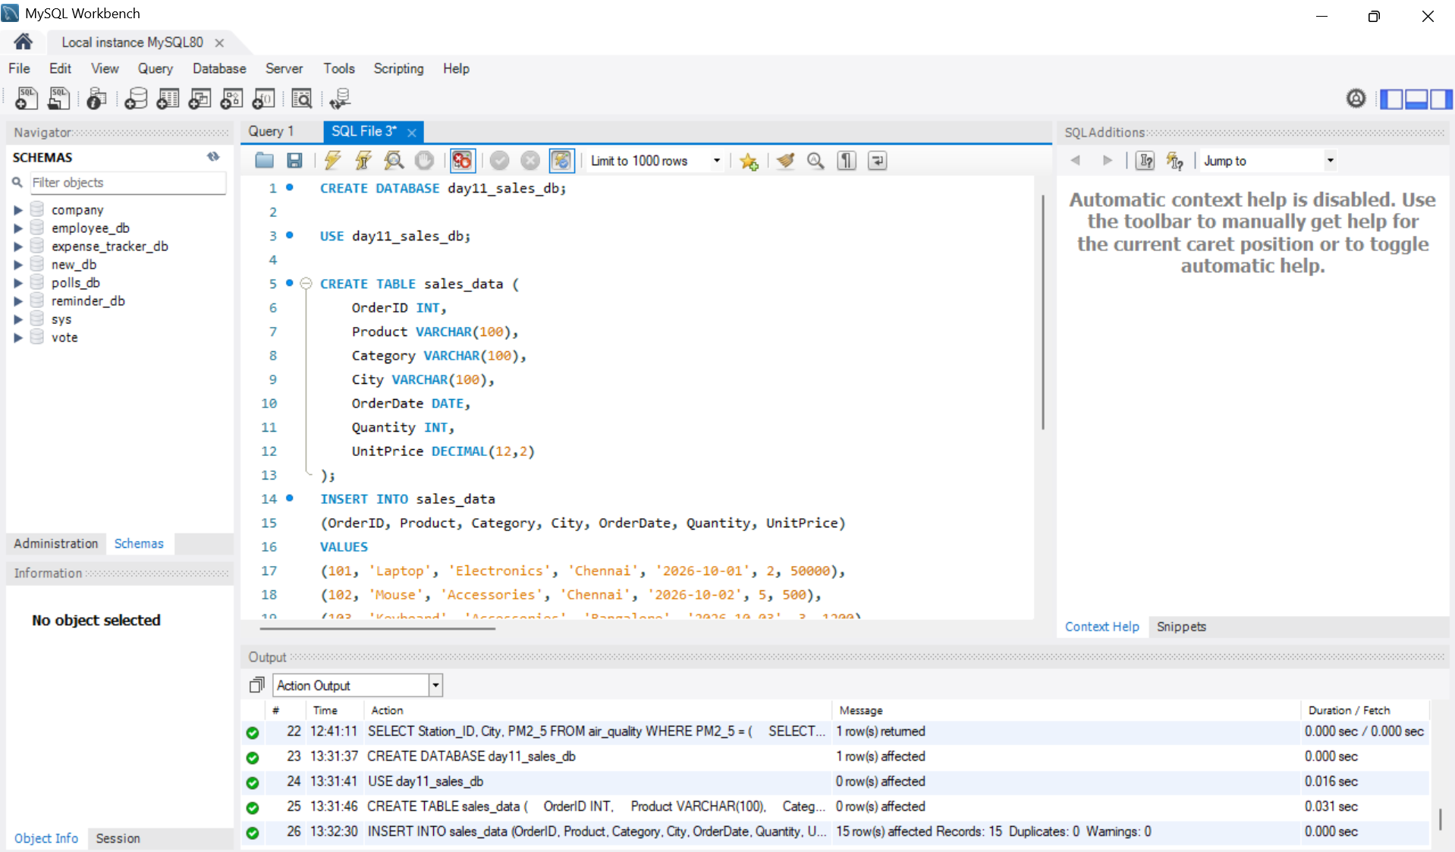
Figure 1: Output of Step 1

Step 2: View All Sales Records
Aim: Display every row stored in the sales_data table.
Procedure:
1. Type the SELECT * query.
2. Click the Execute (lightning) button or press Ctrl + Enter to run the query.
SQL Query:
SELECT * FROM sales_data;
Output: 15 rows returned in the Result Grid.
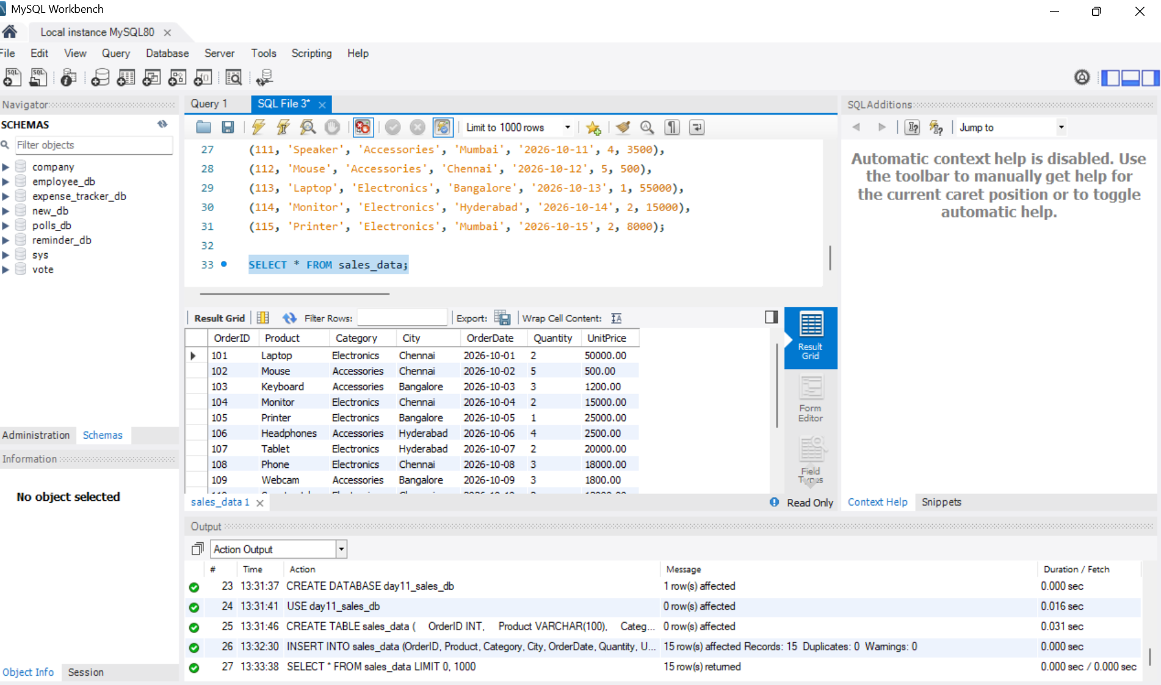
Figure 2: Output of Step 2

Step 3: Count the Total Number of Records
Aim: Use COUNT() to confirm how many orders were inserted.
Procedure:
1. Write the COUNT(*) query with the alias Total_Records.
2. Click the Execute (lightning) button or press Ctrl + Enter to run the query.
SQL Query:
SELECT COUNT(*) AS Total_Records
FROM sales_data;
Output: Total_Records = 15.
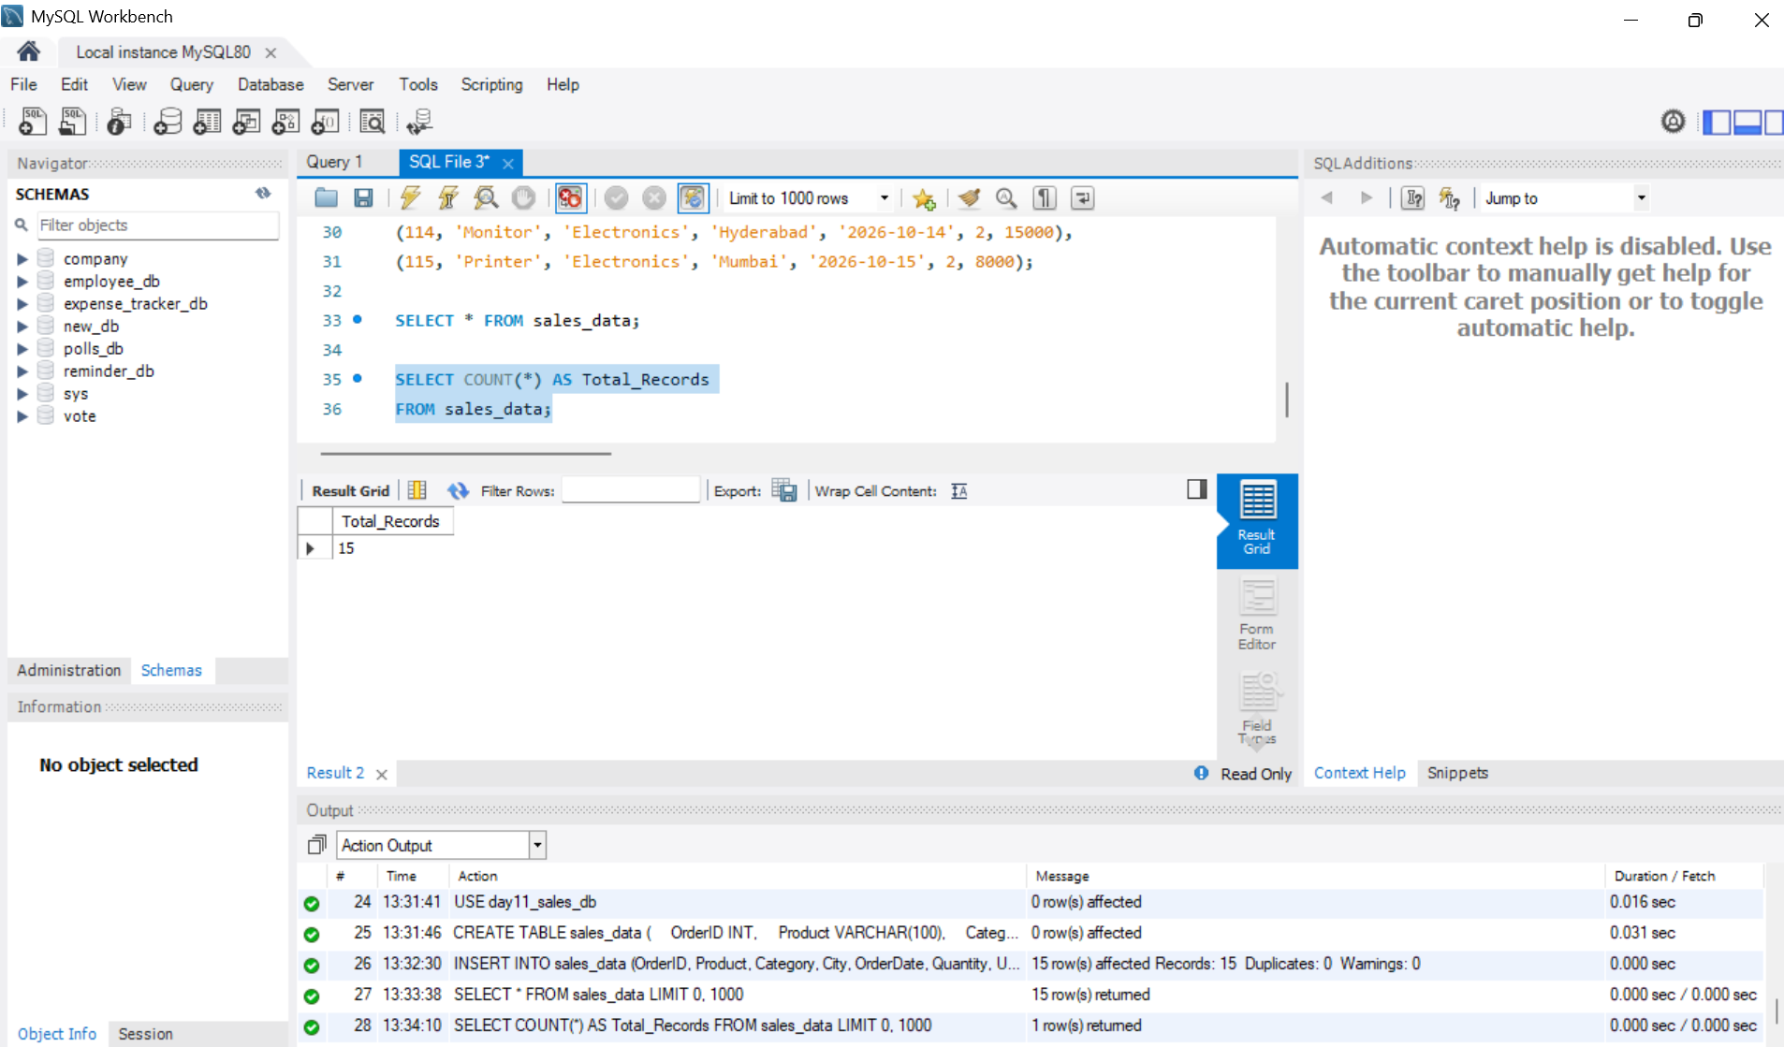
Figure 3: Output of Step 3

2. Filtering and Aggregation

Step 4: Filter with Multiple Conditions (AND) and Sort
Aim: Find Electronics orders from Chennai priced above 10,000, highest price first.
Procedure:
1. Combine three conditions in the WHERE clause using AND.
2. Sort the result with ORDER BY UnitPrice DESC.
3. Click the Execute (lightning) button or press Ctrl + Enter to run the query.
SQL Query:
SELECT *
FROM sales_data
WHERE Category = 'Electronics'
AND City = 'Chennai'
AND UnitPrice > 10000
ORDER BY UnitPrice DESC;
Output: 4 rows returned: Laptop, Phone, Monitor and Smartwatch.
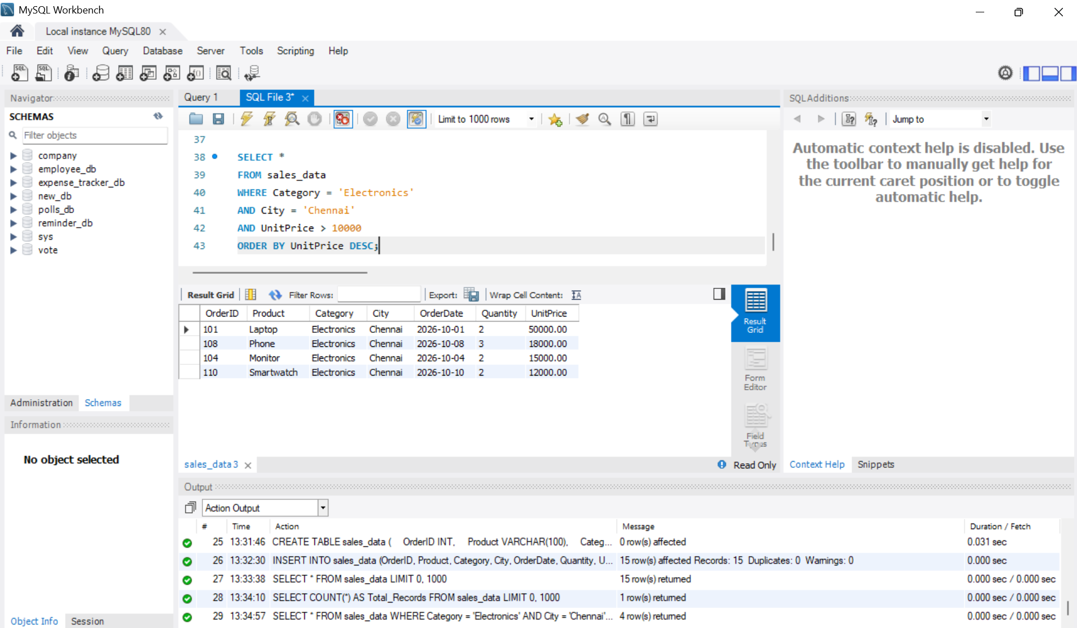
Figure 4: Output of Step 4

Step 5: Total Quantity and Average Price by Category
Aim: Use SUM() and AVG() with GROUP BY to summarise each category.
Procedure:
1. Use SUM(Quantity) AS Total_Quantity and AVG(UnitPrice) AS Average_Price.
2. Group the rows by Category.
3. Click the Execute (lightning) button or press Ctrl + Enter to run the query.
SQL Query:
SELECT
Category,
SUM(Quantity) AS Total_Quantity,
AVG(UnitPrice) AS Average_Price
FROM sales_data
GROUP BY Category;
Output: Electronics: 17 units, average price 24,222.22. Accessories: 24 units, average price 1,666.67.
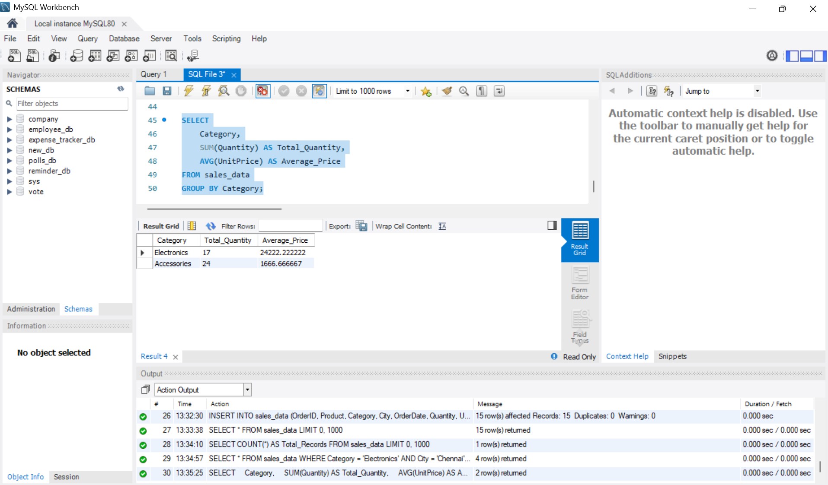
Figure 5: Output of Step 5

Step 6: Total Revenue by City Using HAVING
Aim: Calculate revenue (Quantity × UnitPrice) for each city and keep only cities above 50,000.
Procedure:
1. Calculate revenue with SUM(Quantity * UnitPrice).
2. Group the rows by City.
3. Filter the grouped result with HAVING Total_Revenue > 50000.
4. Click the Execute (lightning) button or press Ctrl + Enter to run the query.
SQL Query:
SELECT
City,
SUM(Quantity * UnitPrice) AS Total_Revenue
FROM sales_data
GROUP BY City
HAVING Total_Revenue > 50000;
Output: 3 rows returned: Chennai 213,000, Bangalore 89,000, Hyderabad 80,000.
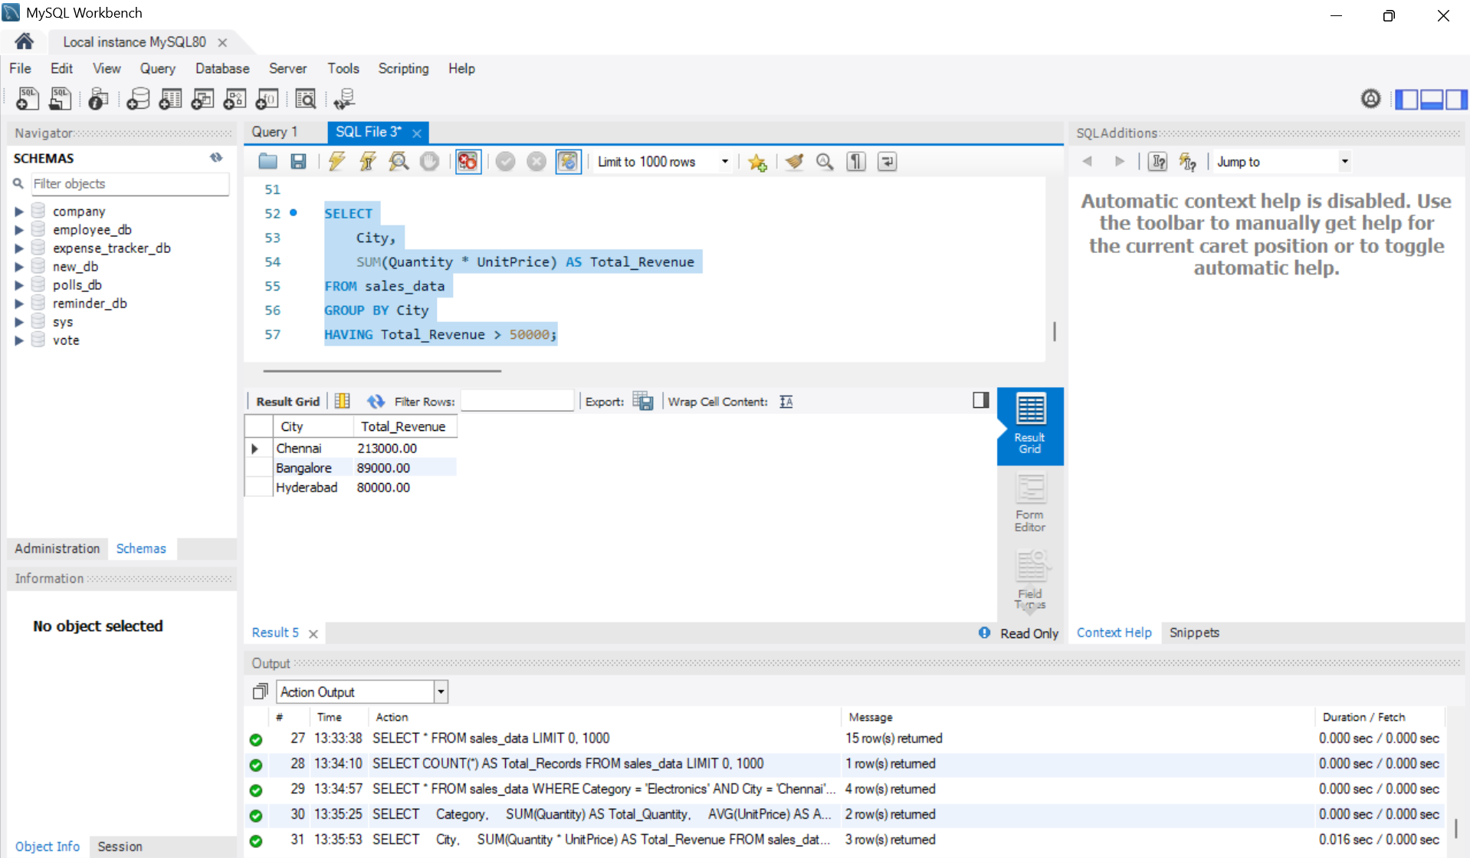
Figure 6: Output of Step 6

3. Advanced Queries

Step 7: Categorise Products Using CASE
Aim: Label each product as Premium, Mid Range or Budget based on its unit price.
Procedure:
1. Select Product and UnitPrice.
2. Add a CASE expression: 30,000 and above = Premium, 10,000 and above = Mid Range, otherwise Budget.
3. Name the new column Price_Category.
4. Click the Execute (lightning) button or press Ctrl + Enter to run the query.
SQL Query:
SELECT
Product,
UnitPrice,
CASE
WHEN UnitPrice >= 30000 THEN 'Premium'
WHEN UnitPrice >= 10000 THEN 'Mid Range'
ELSE 'Budget'
END AS Price_Category
FROM sales_data;
Output: 15 rows returned, each with its price category.
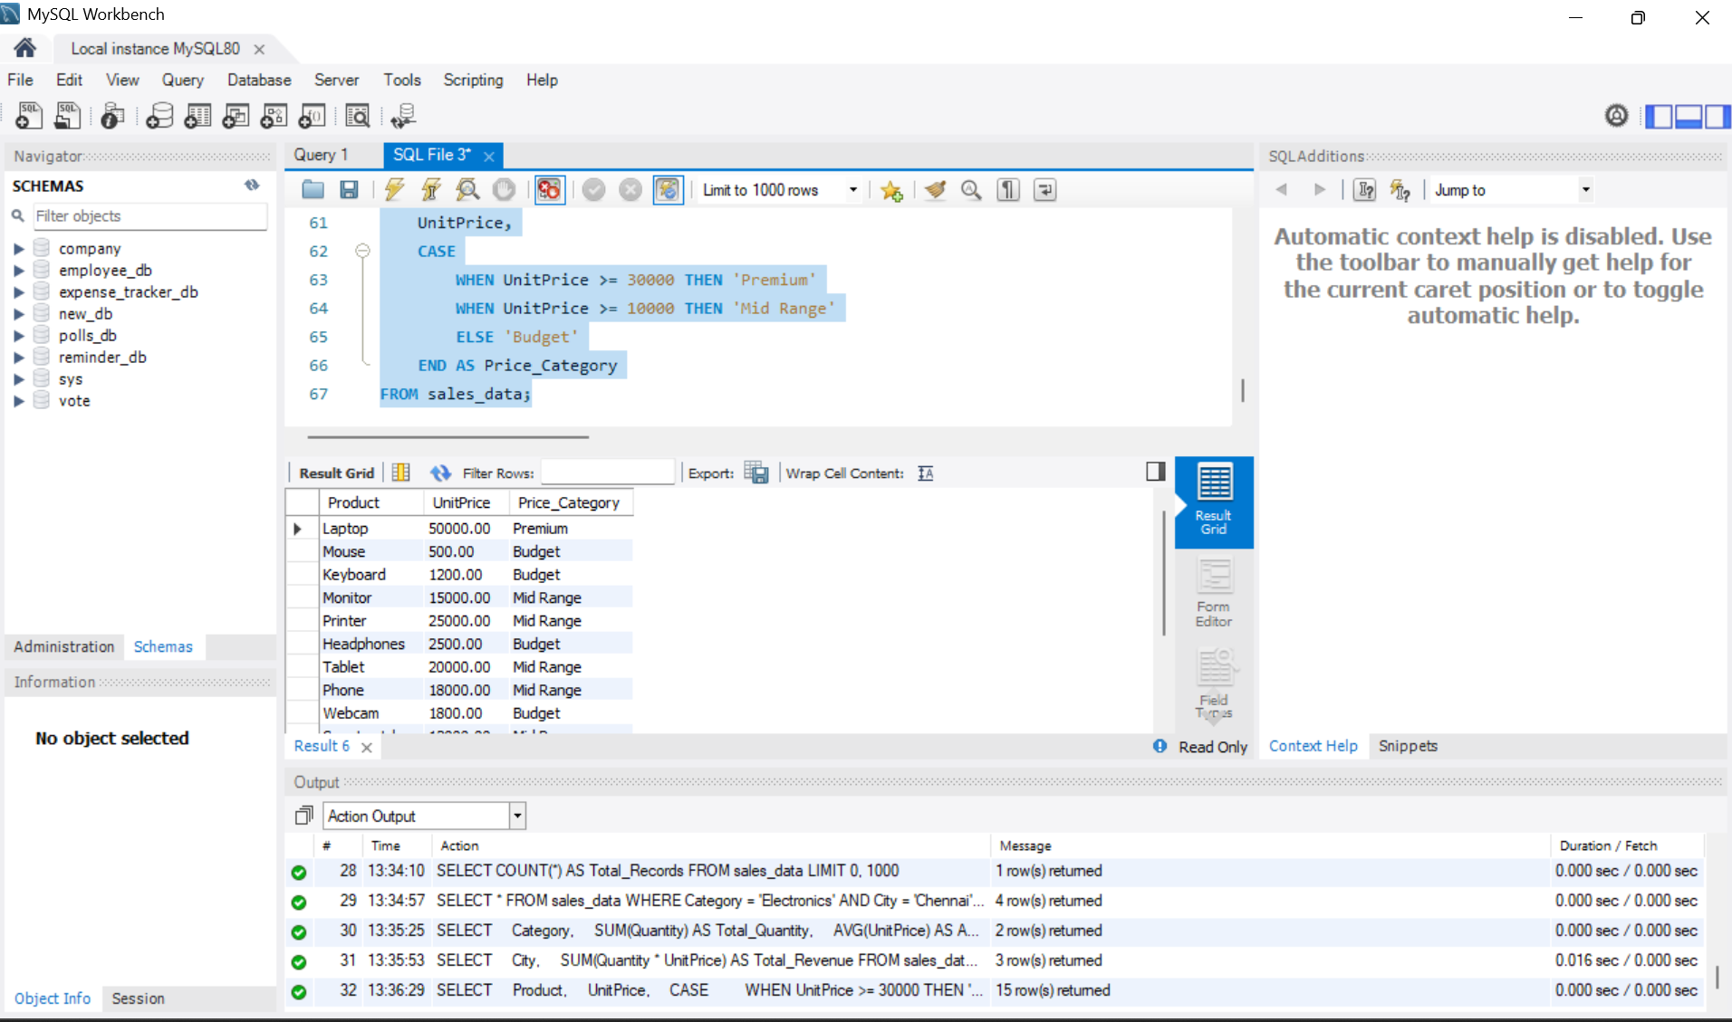
Figure 7: Output of Step 7

Step 8: Count Unique Values Using COUNT(DISTINCT)
Aim: Find how many different products and cities appear in the data.
Procedure:
1. Use COUNT(DISTINCT Product) and COUNT(DISTINCT City).
2. Click the Execute (lightning) button or press Ctrl + Enter to run the query.
SQL Query:
SELECT
COUNT(DISTINCT Product) AS Unique_Products,
COUNT(DISTINCT City) AS Unique_Cities
FROM sales_data;
Output: Unique_Products = 11, Unique_Cities = 4.
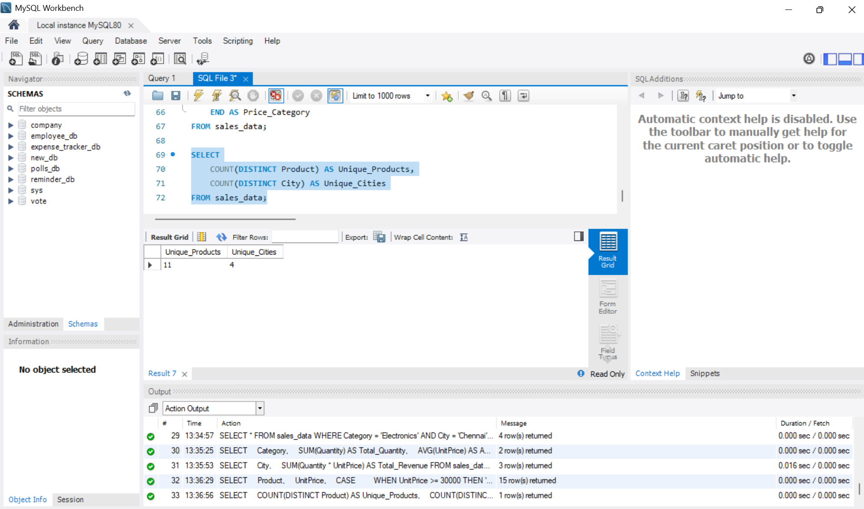
Figure 8: Output of Step 8

Step 9: Products Priced Above Average Using a Subquery
Aim: List products whose unit price is higher than the average unit price.
Procedure:
1. Write the inner query SELECT AVG(UnitPrice) FROM sales_data.
2. Use it in the WHERE clause of the outer query.
3. Click the Execute (lightning) button or press Ctrl + Enter to run the query.
SQL Query:
SELECT Product, UnitPrice
FROM sales_data
WHERE UnitPrice > (
SELECT AVG(UnitPrice)
FROM sales_data
);
Output: 5 rows returned: Laptop (50,000), Printer, Tablet, Phone and Laptop (55,000).
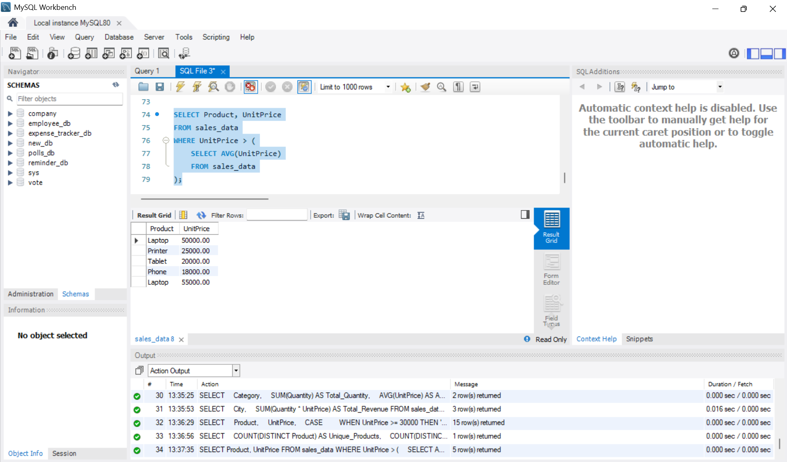
Figure 9: Output of Step 9

Step 10: Rank Products by Price Using RANK()
Aim: Use the RANK() window function to rank every order by unit price.
Procedure:
1. Select Product, City and UnitPrice.
2. Add RANK() OVER (ORDER BY UnitPrice DESC) AS Price_Rank.
3. Click the Execute (lightning) button or press Ctrl + Enter to run the query.
SQL Query:
SELECT
Product,
City,
UnitPrice,
RANK() OVER (
ORDER BY UnitPrice DESC
) AS Price_Rank
FROM sales_data;
Output: 15 rows returned. Equal prices share the same rank (both Monitors are rank 6), and the next rank is skipped (Smartwatch is rank 8).
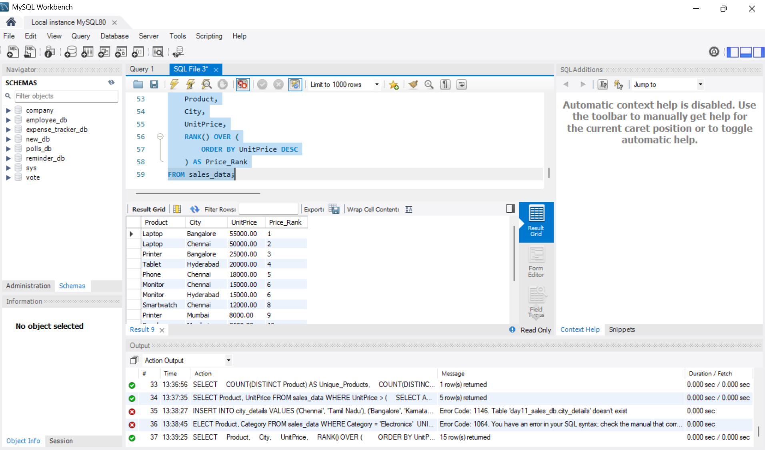
Figure 10: Output of Step 10

4. Summary
• Created the database day11_sales_db with the sales_data table and inserted 15 orders.
• Filtered data using WHERE with AND, and sorted it using ORDER BY.
• Summarised data with SUM, AVG and COUNT, grouped with GROUP BY and filtered groups with HAVING.
• Used CASE to categorise prices, COUNT(DISTINCT) for unique values, a subquery for above-average prices and RANK() to rank products.

