**SMART WATER FOUNTAIN**

**Introduction:**

By continuing the smart water fountain project using IOT based system and now we could develop this project by using web development technologies (HTML, CSS, JAVA script) to create a platform that displays real-time data and give an alerts and notifications if malfunction is detected. It allows users to track water flow rates and receive alerts for malfunctions.

**Water Fountain Status Platform:**

Purpose of the Platform: Learn how the water fountain status platform provides valuable information on the current state of water fountains.

**Web Development:**

**Use of Web Development Technologies:** Understand how HTML, CSS, and JavaScriptare used to build a robust and user-friendlyplatform.

**Front-End:** Use HTML, CSS, and JavaScript to create a user-friendly web interface. The front-end will display real-time data from the sensors and provide a user-friendly dashboard to monitor the water fountain.

**Back-End:** Develop a back-end server using technologies like Node.js, Python, or Ruby. This server will receive data from the IOT device and update the web interface in real-time.

**Database:** Store historical data in a database (e.g., MYSQL, MONGODB) for analysis and future reference. This can be useful for trend analysis and maintenance.

**Real-Time Updates:** Implement web- socket or server-sent events (SSE) to push real-time updates to the web interface as new sensor data is received.

**Alerts and Notifications:** Set up an alerting system to notify users in case of malfunction. This can be done through email, SMS, or push notifications.

**Sensors:**

**Water Flow Rate Sensor:** You can use a flow sensor (like a Hall-effect flow sensor) to measure the water flow rate. This sensor can be installed in the water supply line, and it will provide data on the rate at which water is flowing into the fountain.

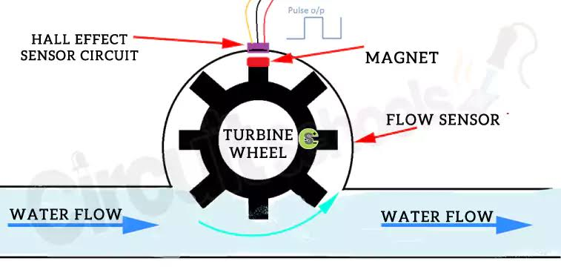

**Malfunction Sensors:** These could include various sensors like pressure sensors to detect pump failures, water level sensors to monitor the water level in the fountain, and temperature sensors to detect overheating. Each of these sensors will transmit data to the platform when an anomaly is detected.

**Data Transmission:**

**Microcontroller (IOT Device):** You'll need a microcontroller **(e.g., Arduino or Raspberry Pi)** to collect data from the sensors and transmit it to the web platform. These microcontrollers can be connected to the sensors and have Wi-Fi or Ethernet capabilities for data transmission.

**IOT Protocols:** You can use IOT protocols like MQTT or HTTP to send data from the microcontroller to the web platform. MQTT is particularly efficient for real-time data transmission.

**Data Visualization and User Interface:**

**Data Visualization:** See how the platform providesintuitive and visually appealingdata visualizations for easierinterpretation.

**User Interface Design:** Explore the importance of user friendly interfaces in ensuring aseamless user experience whileinteracting with the platform. Aesthetic IntegrationLearn how the platformseamlessly integrates with thesurrounding environment,enhancing the aesthetic.

**Malfunction Alerts:**

1. **Instant notifications:** Find out how the platform detects and sends alerts in case of any malfunction in water fountain .

**2. Efficient maintenance:** Learn how the system improves maintenance processes by providing timely information on malfunctions.

**3. Predictive analysis:** Get insights into how the platform can anticipate and prevent potential malfunctions to ensure uninterrupted functionality

**Benefits:**

* Efficient Monitoring and Maintenance.
* The platform enables efficient monitoring of water fountain status, streamlining maintenance efforts, and reducing downtime.
* It provides valuable insights to help optimize operations and minimize disruptions. Promoting Water Conservation By accurately tracking water flow rates and identifying malfunctions, the platform plays a crucial role in promoting water conservation.

* It allows for proactive measures to optimize water usage and reduce waste.
* General Public : Learn how the platform improves public safety, ensures access to clean water, and enhances the overall experience for the general public.