LABEVAL-1 CSE304-FODS

ROLLNO: CB.EN.U4CSE20226

1) Import data and save it in your disk space (1)

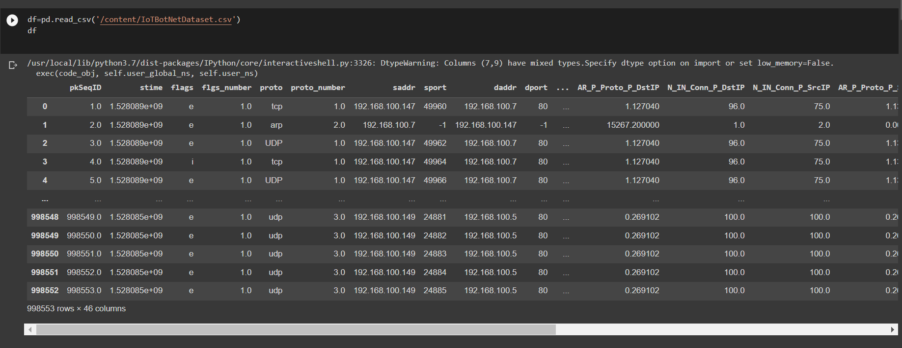

2) Drop the columns not required for your analysis. (1)

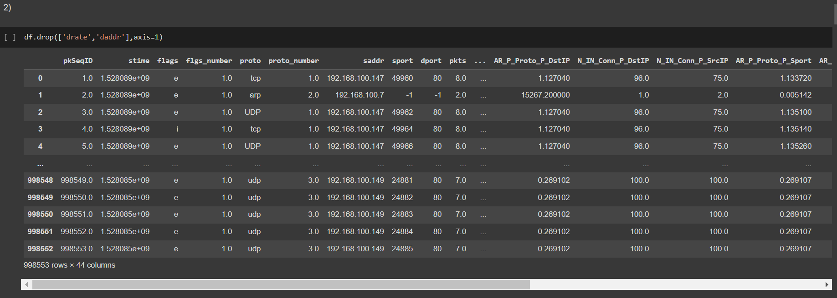

Here we have 44 columns so 2 columns we dropped

3) Do a missing value analysis and perform appropriate steps to correct them (2)

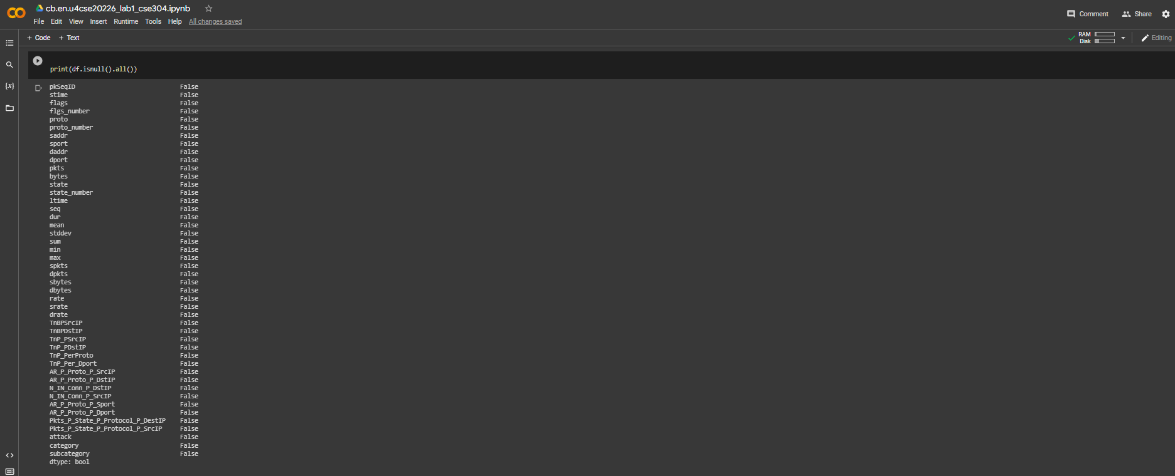

4) Perform an outlier analysis for any two columns (2)

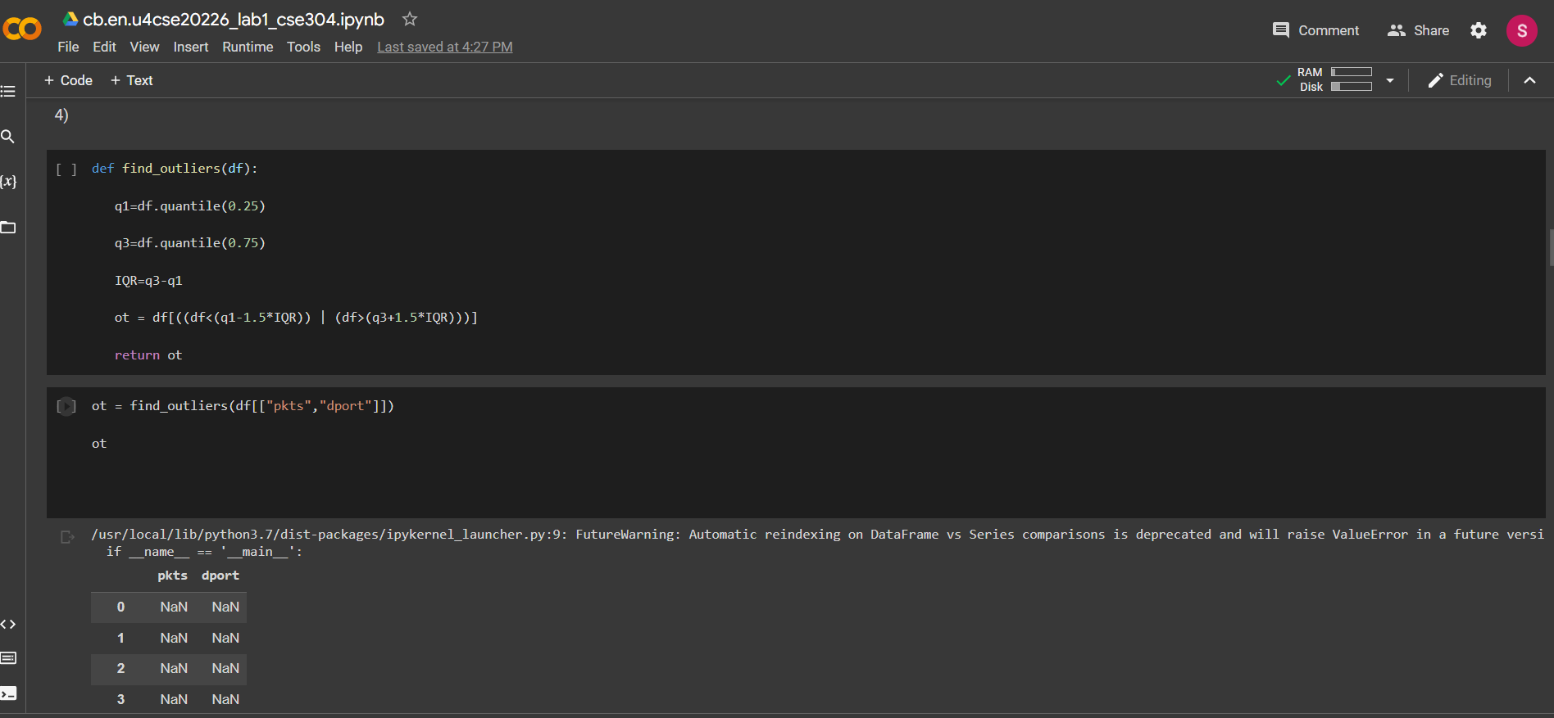

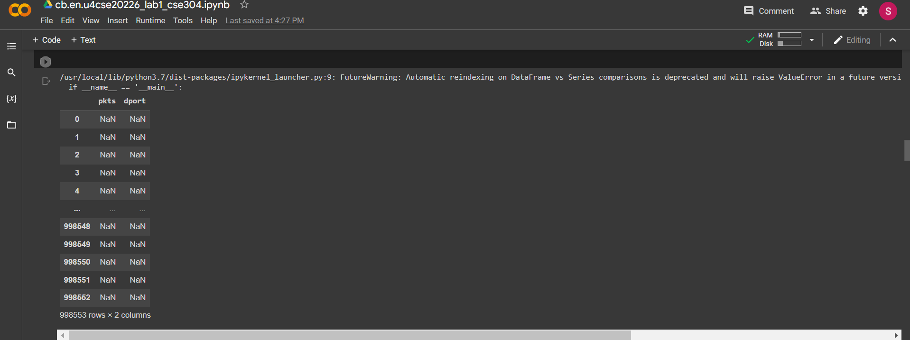

5) Do a correlation analysis of any two variables. (2)

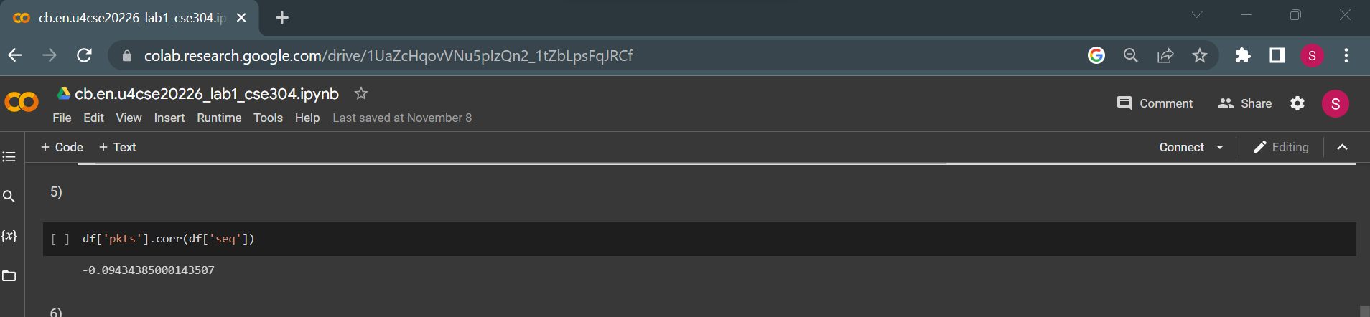

6) Describe the data (1).

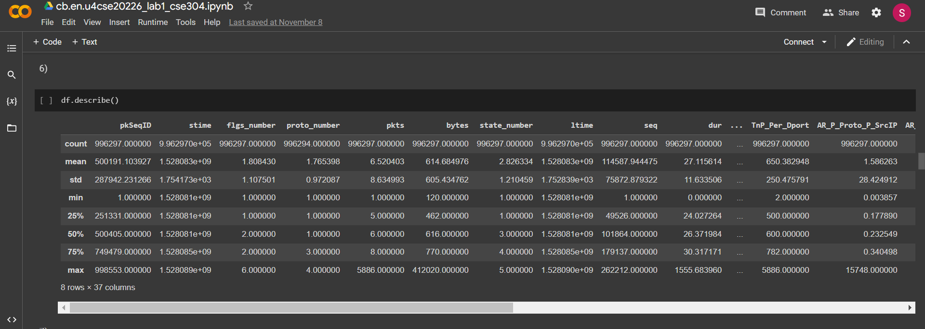

7) Display the first 3 rows (1).

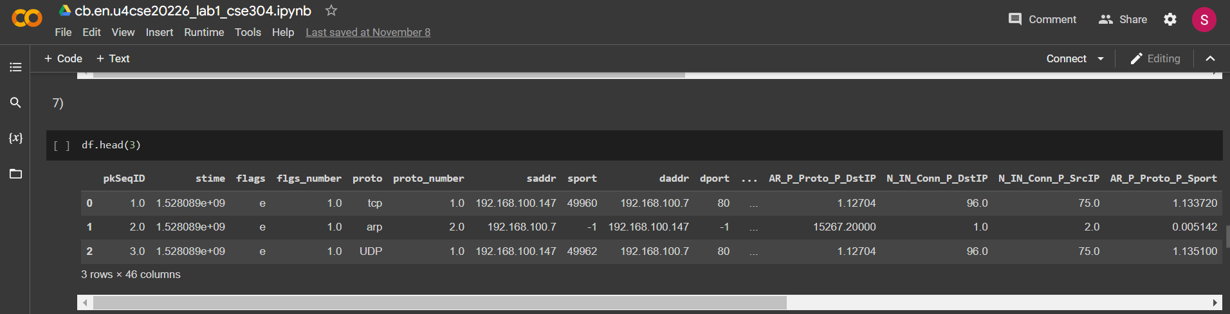

8) Display the last 4 rows(1)

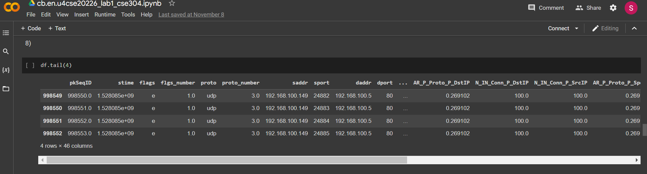

9) Locate the first row corresponding to the proto as “UDP” (2)

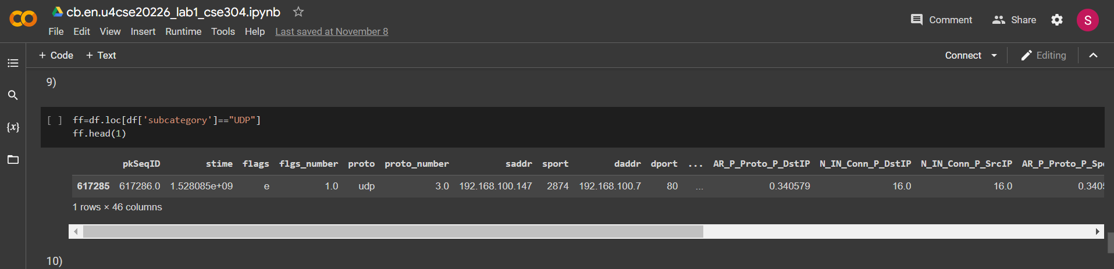

10) How many rows of data do you have? (1)

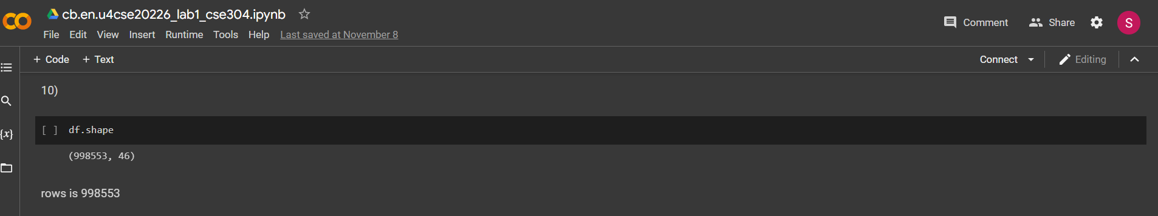

11) Display the first 5 columns of the first row (2)

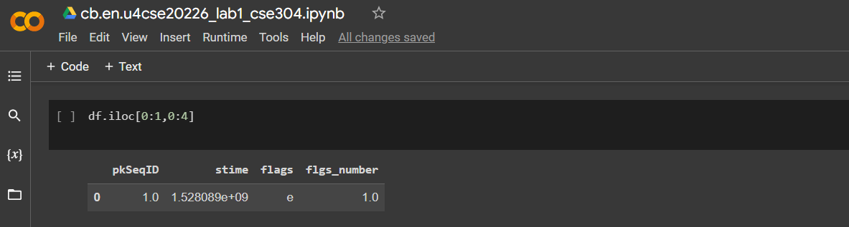

12) Count the number of packets affected based on flags as “i”(2)



13.Split the traffic based on traffic into two groups Group 1: pkts<=10 and Group 2:pkts>10 (2)

13Evaluate the characteristics of the packets distribution with mean and, deviation

1. Average packets for a given stime (b) Average sbytes for a given stime (c) Average dbytes for a given stime (2)

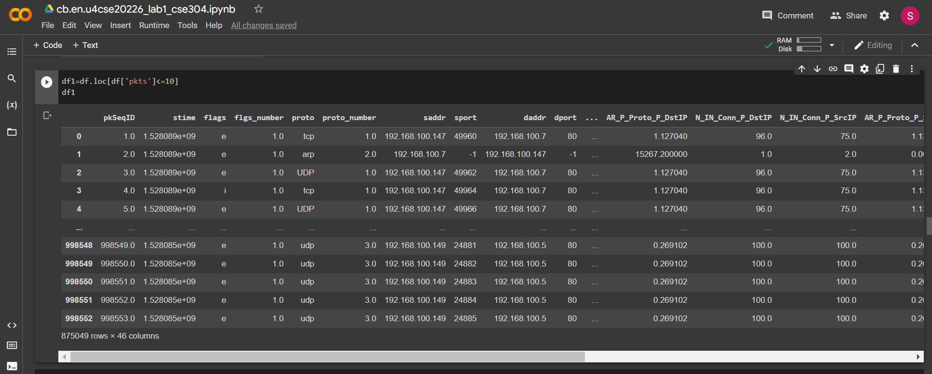

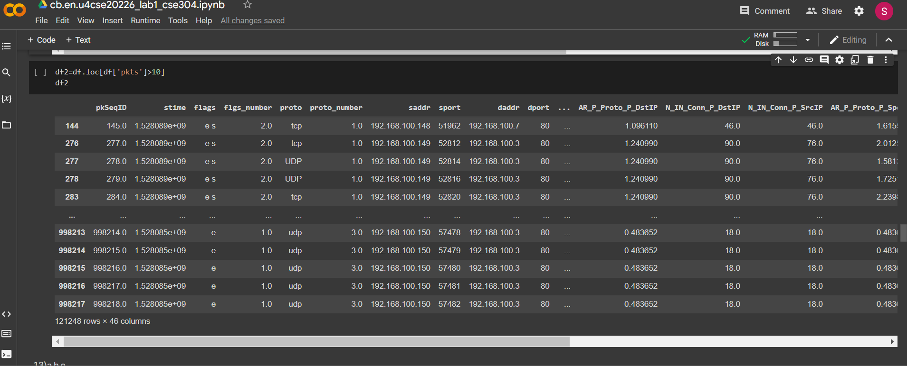

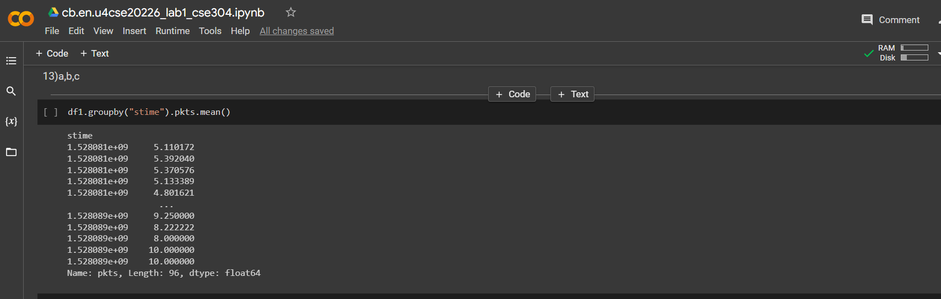

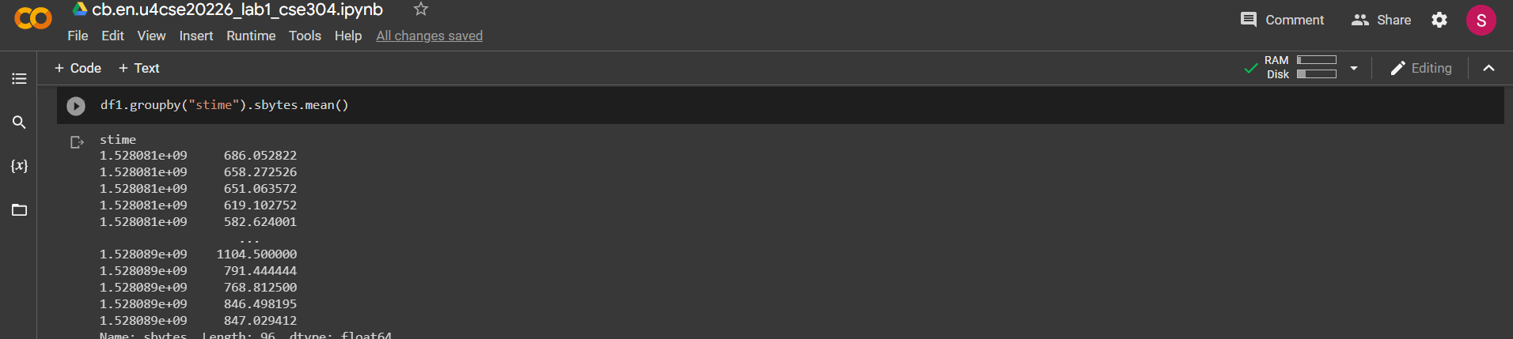

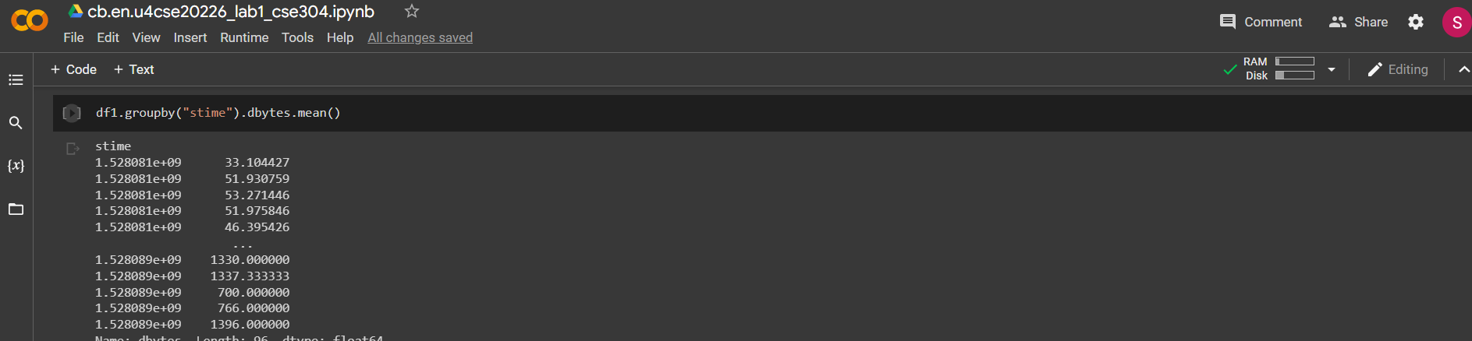

14) Compute the mean and the variance of " Pkts_PState_P_Protocol_P_DestIP” for subcategory as HTTP and TCP (1).

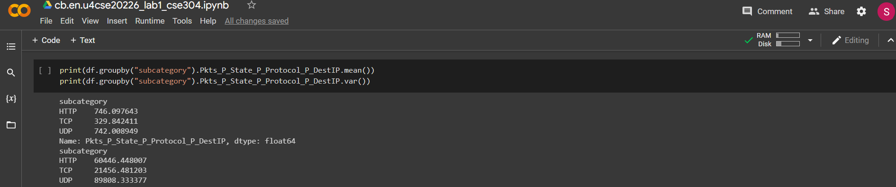

15) Draw a histogram for packets with stime as 1528088521, 1528088522., 1528088523. Histogram should be step-filled with bin of size 20. Find the skew of this distribution, and comment if it is positive or negative (5).

