1. **What is JIRA + AGILE**

JIRA is a management tool which is used for software development activity

1. **What is AGILE**

AGILE is a management activity which includes the step to step process of software development

1. **HOW TO CREATE A PROJECT IN JIRA**

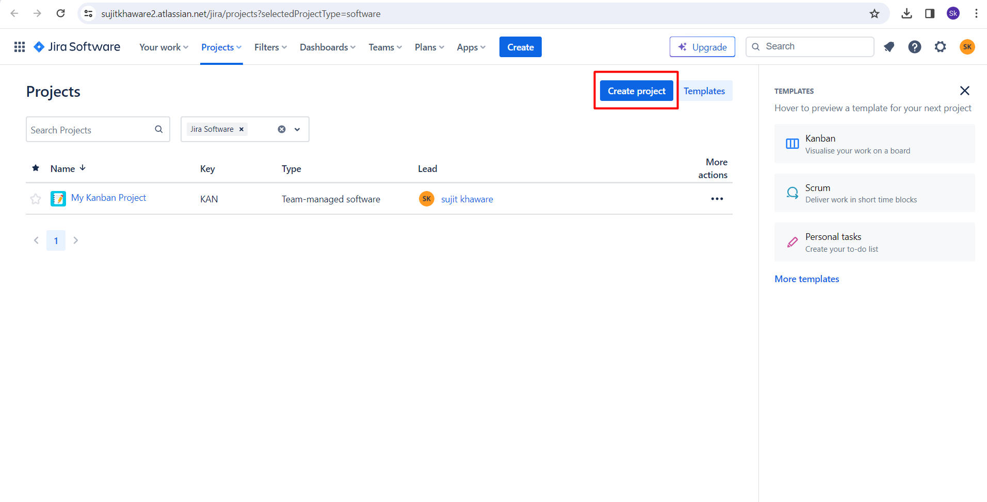

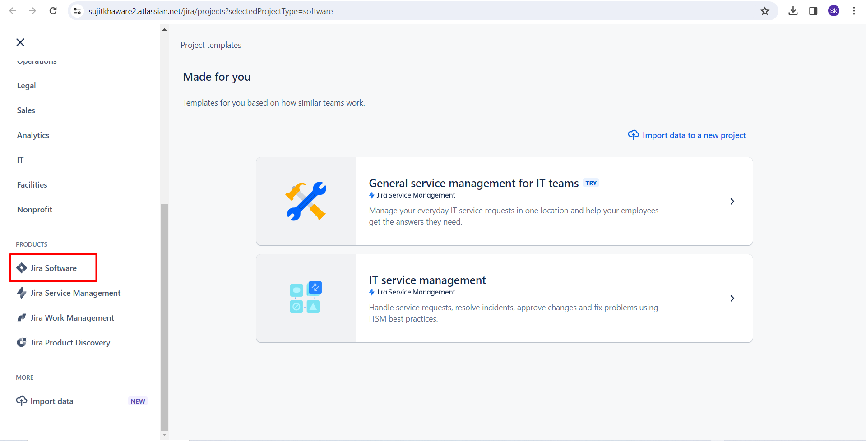

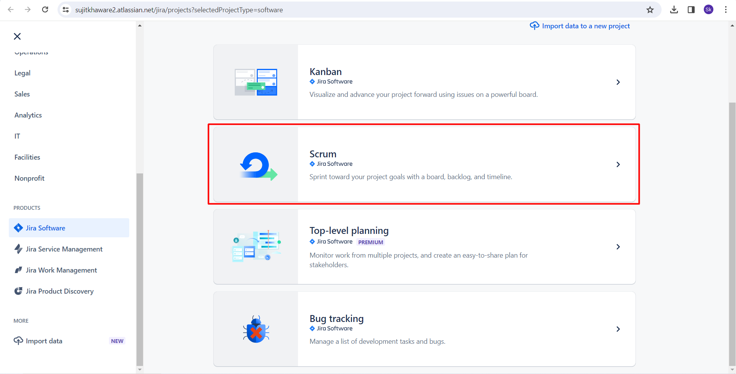

Select company managed project

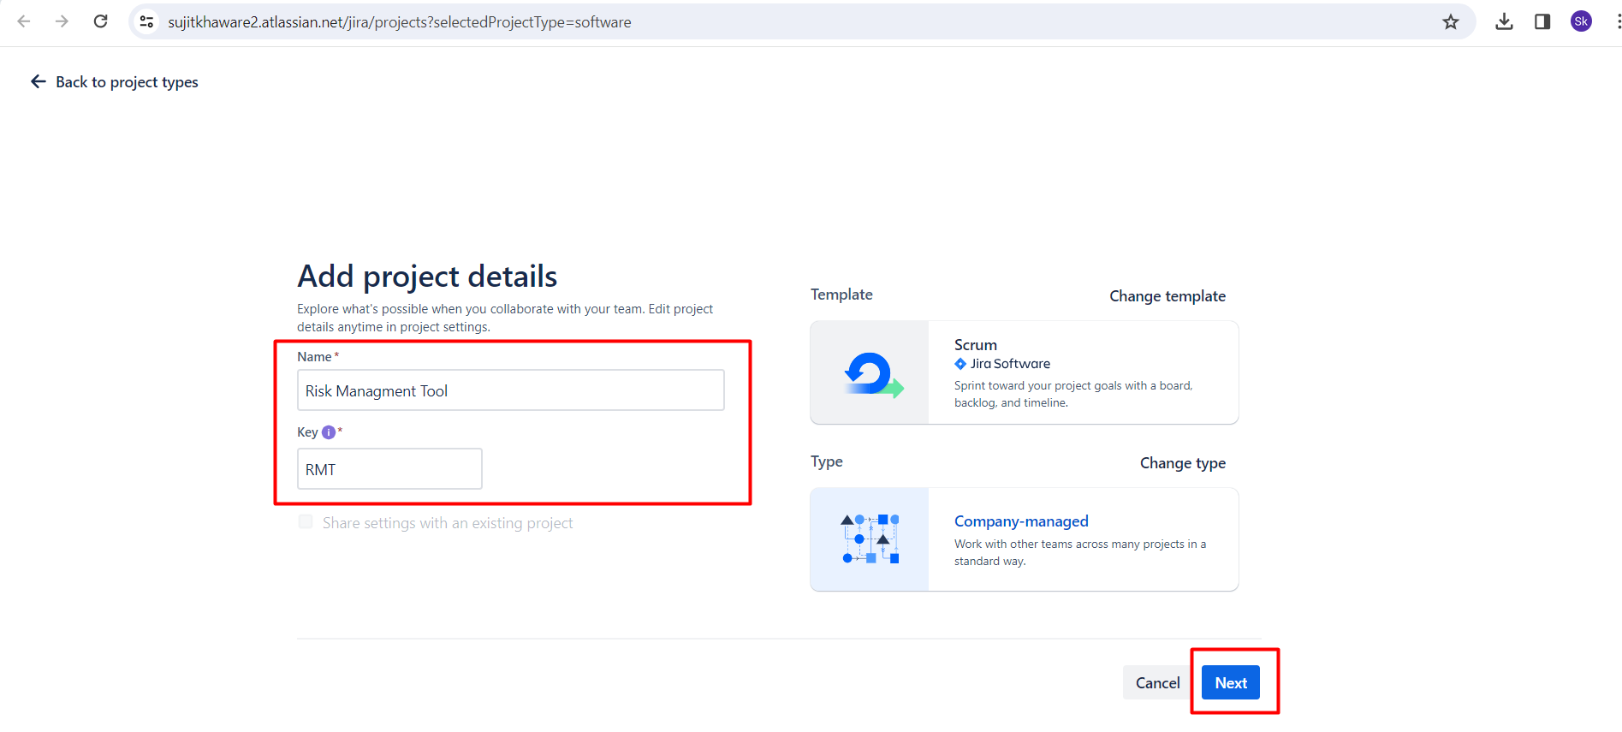

**NOW THE PROJECT IS CREATED**

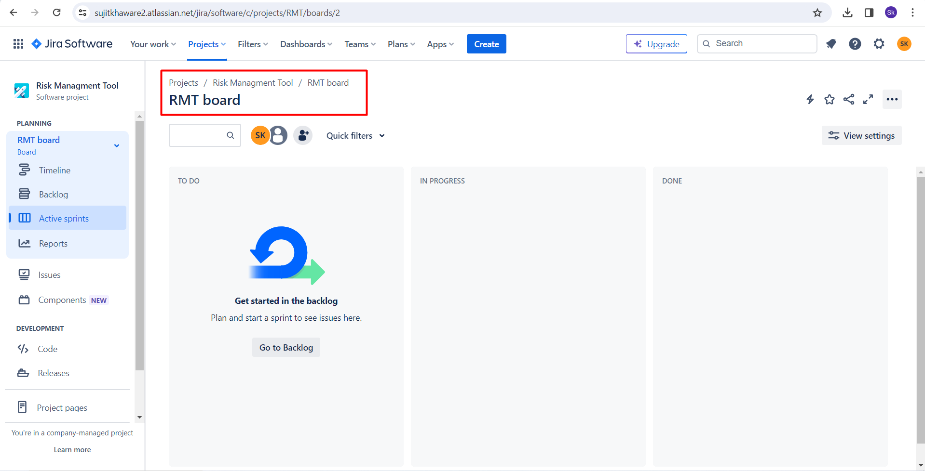

1. **WHAT IS EPIC**

Once the project has been created we need to put in the details for the epic

EPIC is a collection of user stories

EPIC example:

Login page

Payment Page

New request creation page

IT SHALL BE CREATED IN THE BACKLOG

It is the high level scenarios means the feature.

Go to backlog click on create

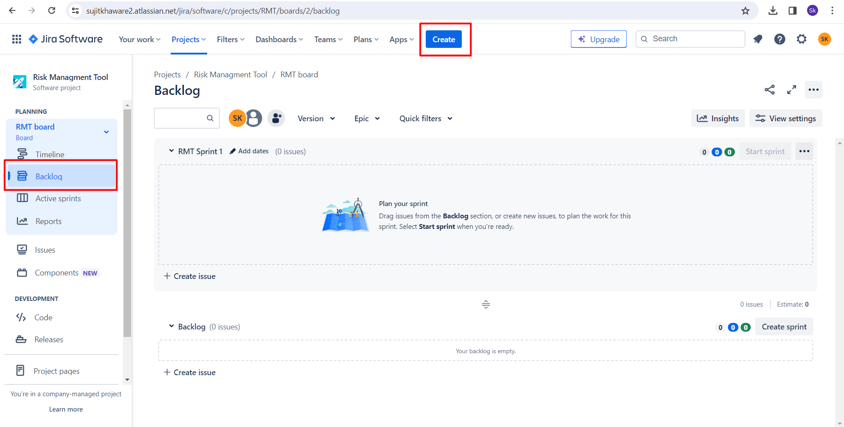

Select the project for which the EPIC needs to be created

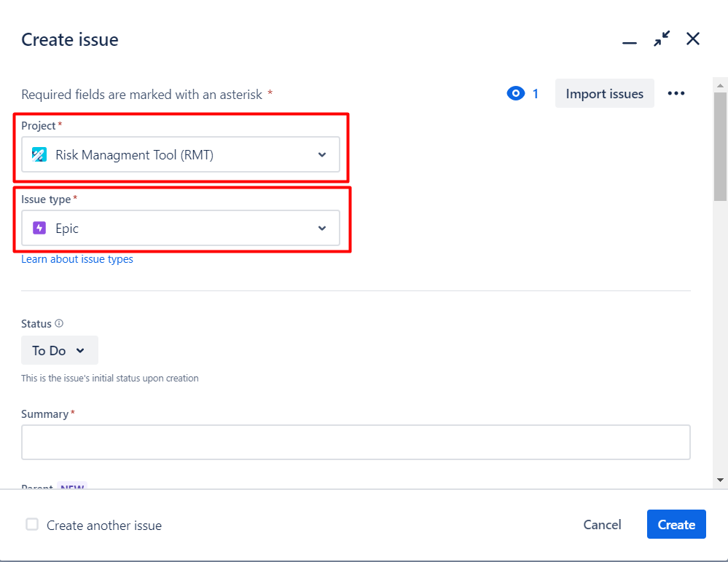

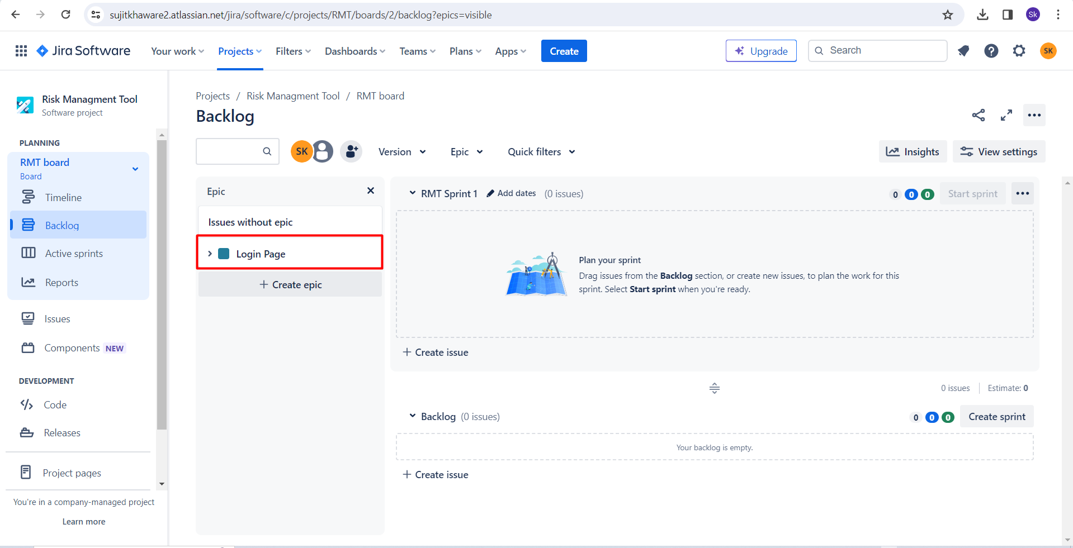

1. **WHAT IS USER STORIES?**

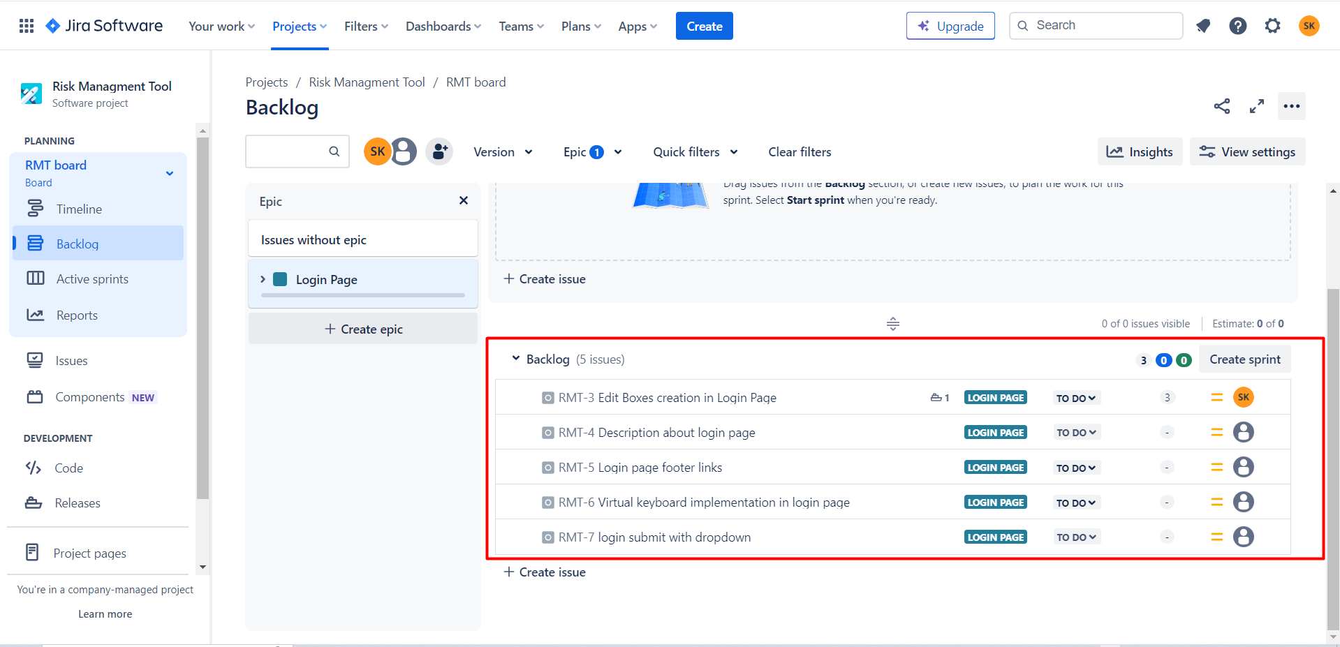

Users stories are been defined under the each epic

For example if there is a login page under that there are different features.

Such as fields, messages, footers link, checkbox, login button.

We shall divide each feature and make a story of it in the particular EPIC.

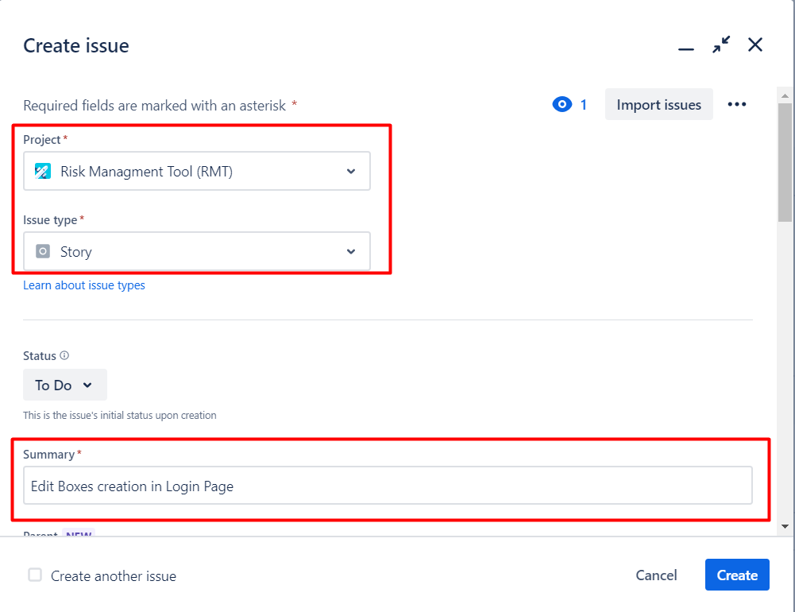

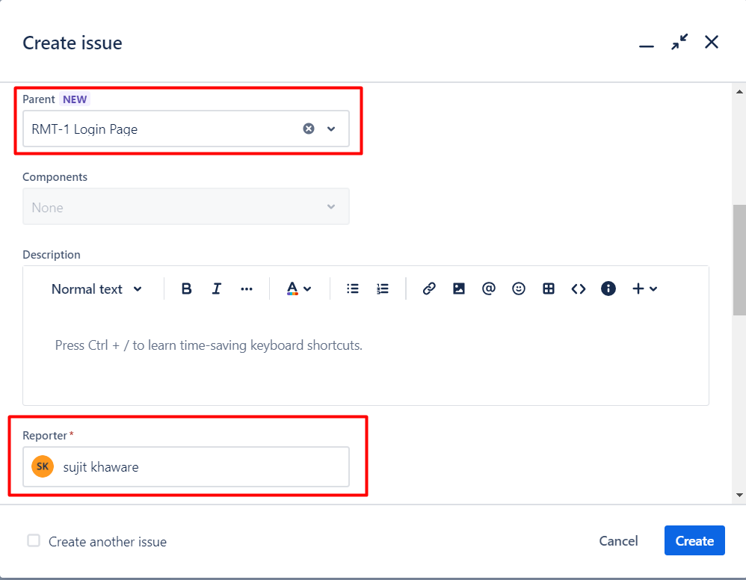

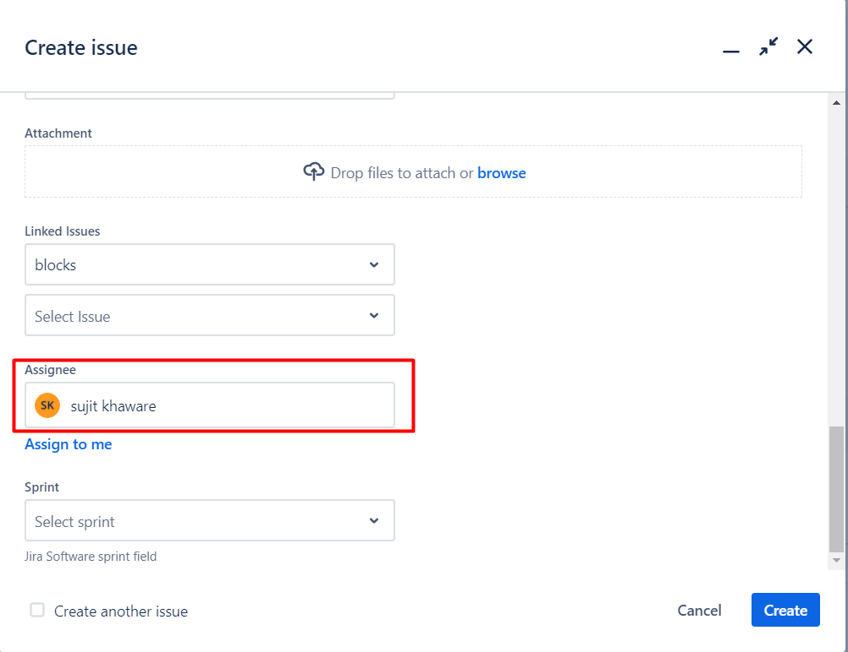

1. **WHAT ARE THE COMPONENT**

This is a term in JIRA. Which means the AGILE team.

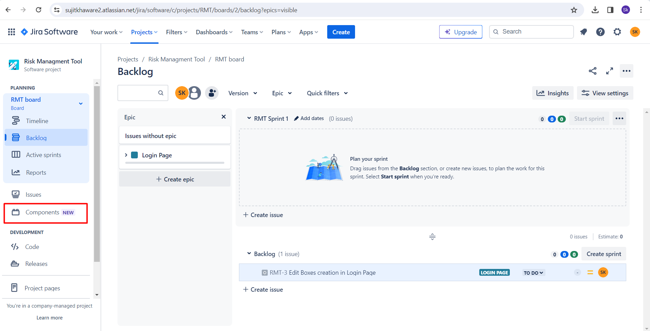

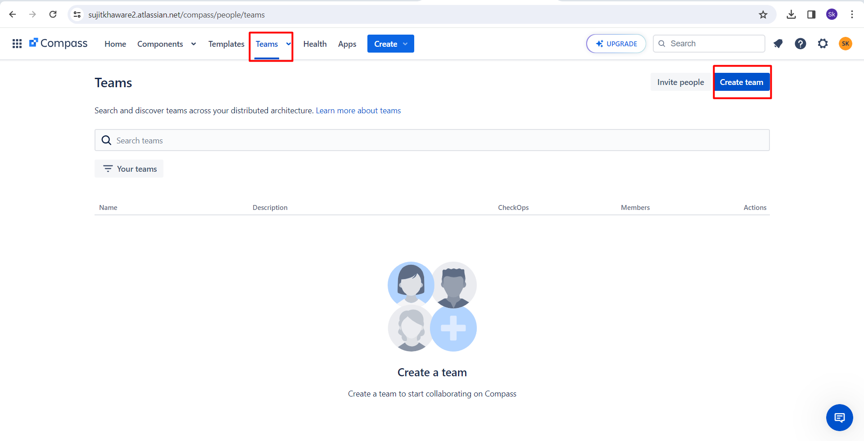

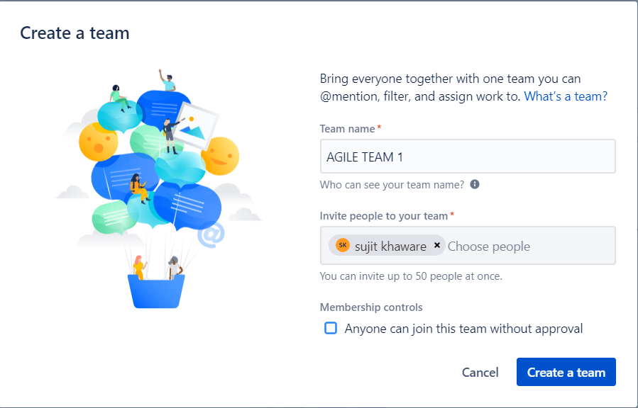

1. **WHAT IS STORIES POINTS?**

Generally we have the odd number like 1,3,5,8

If a person is working on a story for 3 days alone than it can be given as 3 pointer.

Like effort of one person per day is 1 pointer generally.

Whom shall decide the point everyone from the team. Scrum master role is here to tell the points of all the member.

How many days it takes to complete one story is a points. It differ from company to company.

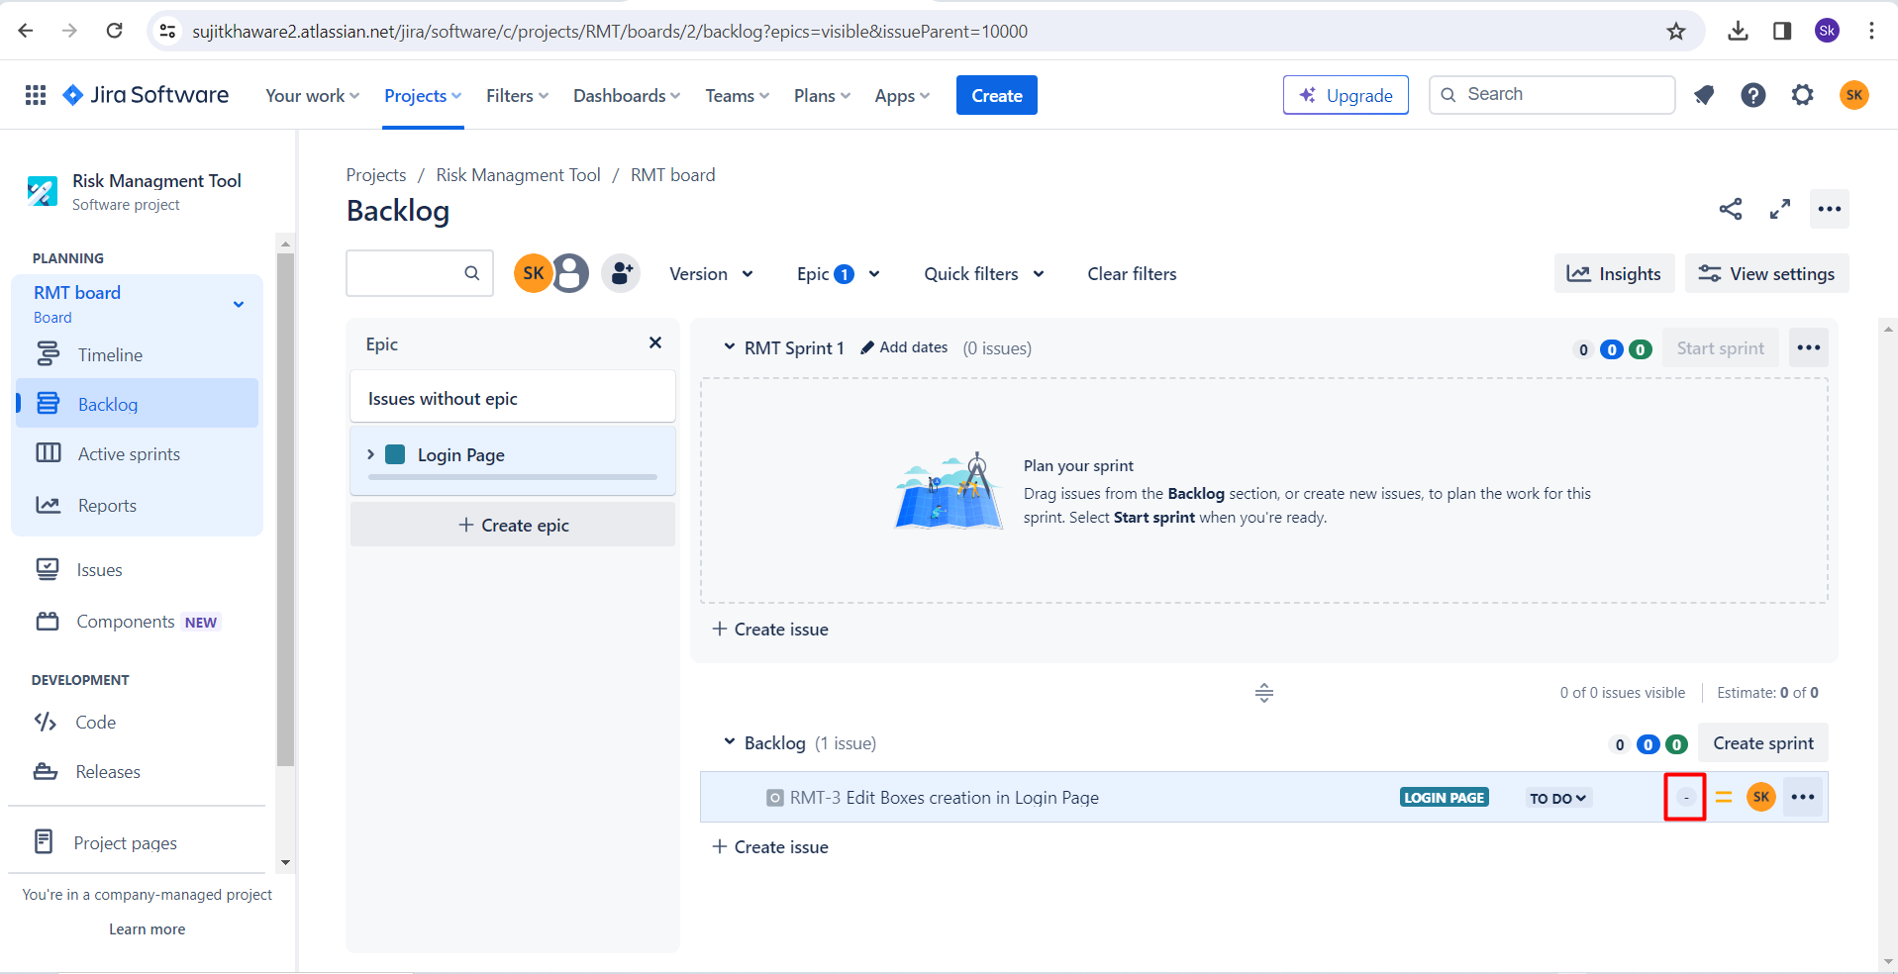

1. **WHAT IS RELEASE?**

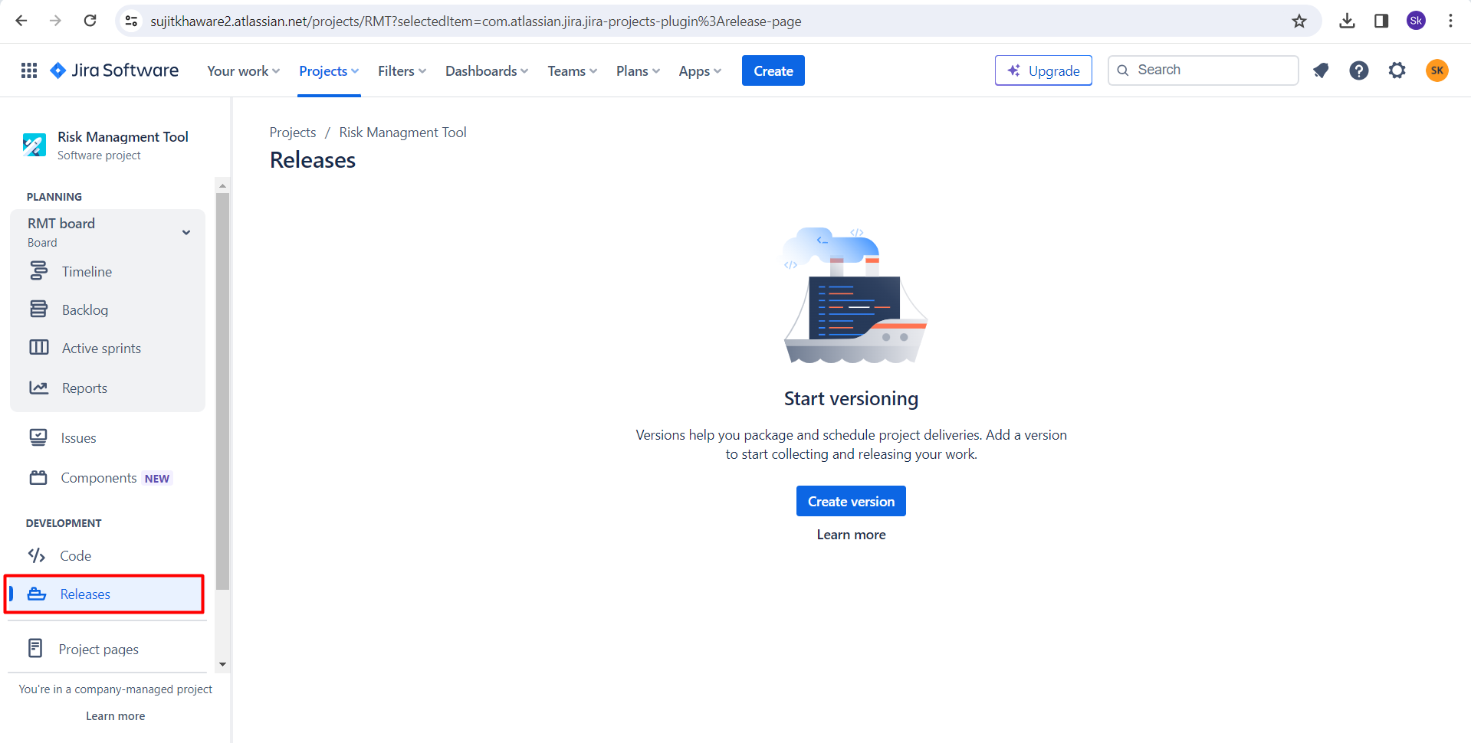

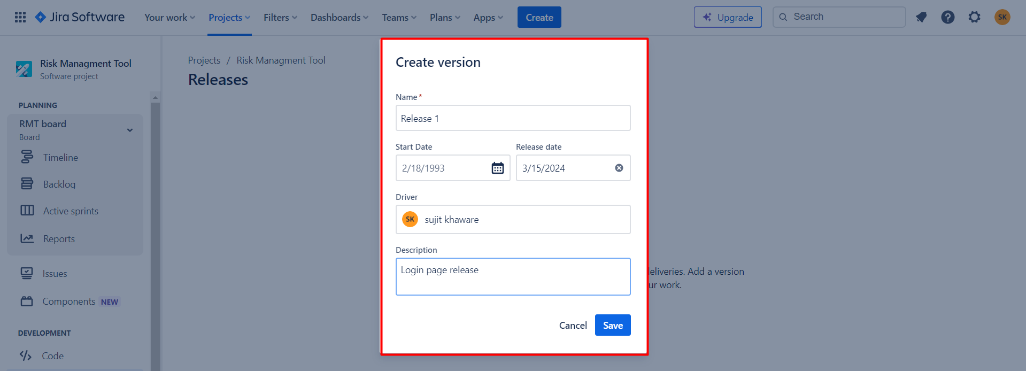

Now we have to tie each stories for which the release needs to be done on that day.

Go to ISSUES > Fix Versions > Assign the release.

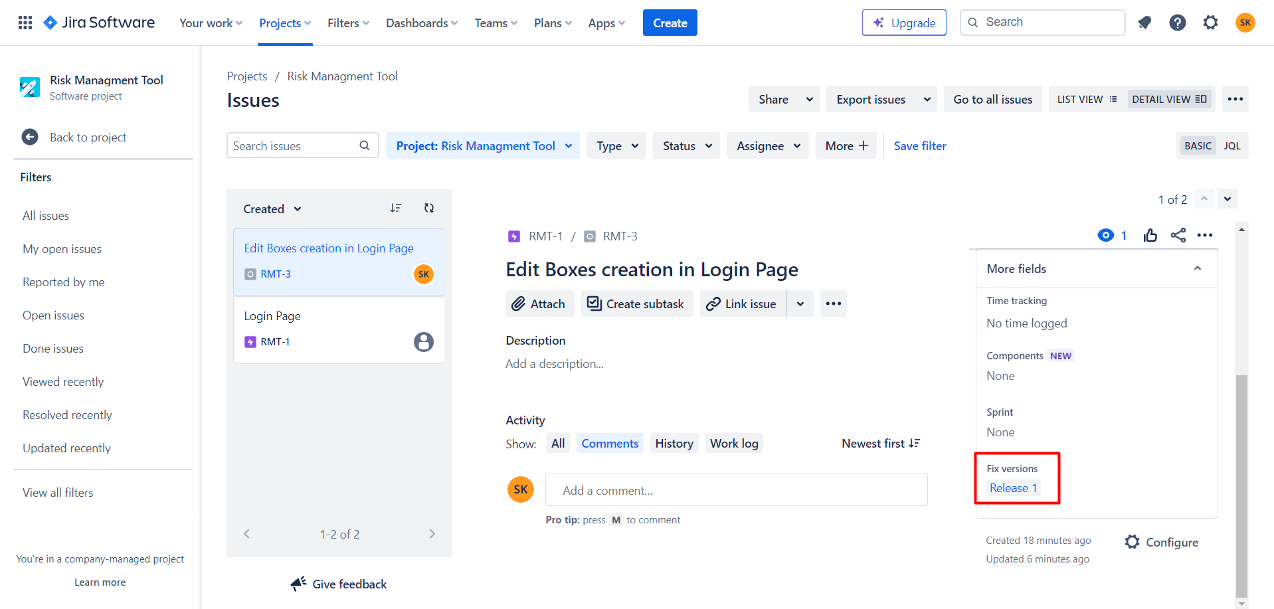

1. **What is description?**

We have to describe that what the user’s story is going to do in a short manner on high level.

It should be the customer or the client point of the view.

“As a client I should be able to enter my email and password in the login page, so that I can login.”

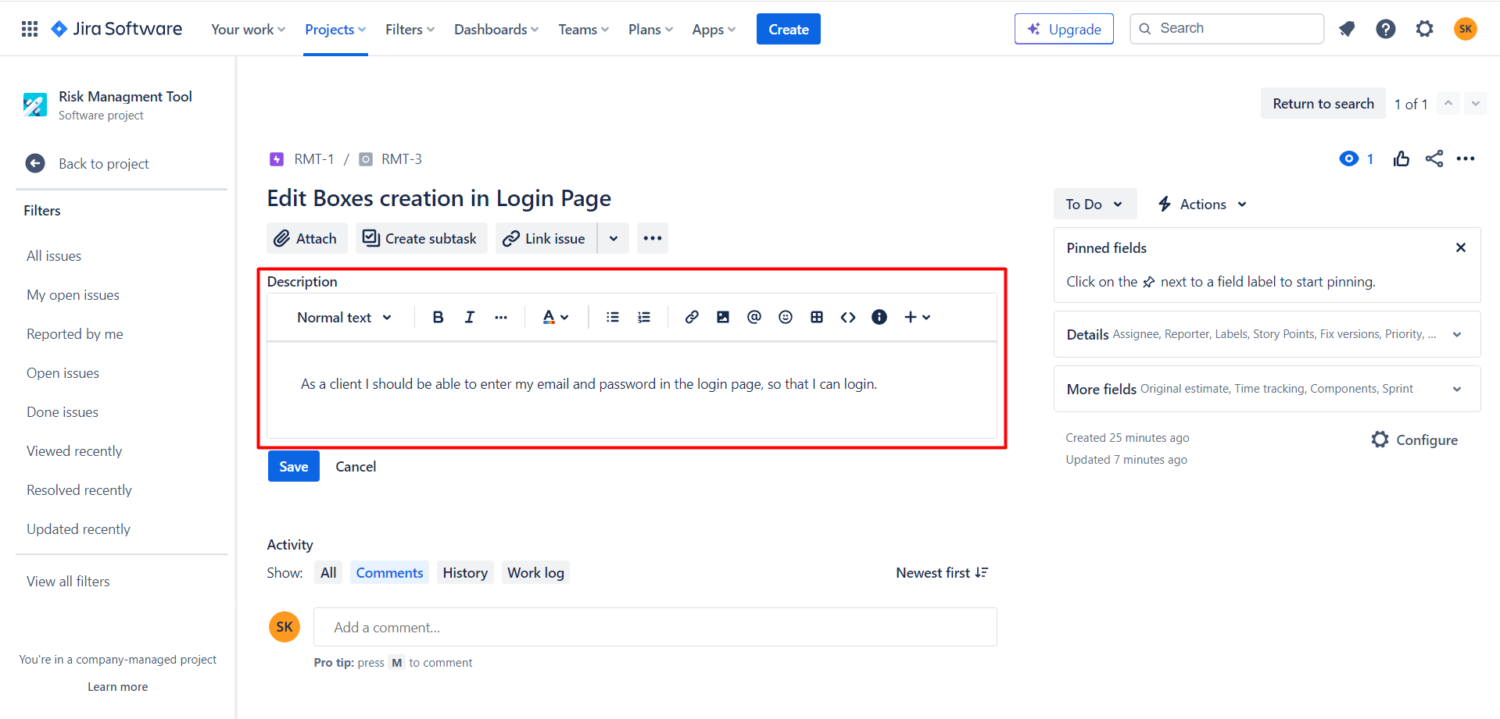

1. **WHAT IS BACKLOG REFINE MEETING?**

In that we have how to define the acceptance criteria, create sub-tasks for story, size the story based on its complexity, if the product owner have some of the screenshot for example how it shall be look or any document for the particular story he can attach the same.

Also we can comment on the story and tag the team member by @email id of team member.

Let say all the team mates meets in the room there a developers, testers, project manager, scrum master.

Product owner shall open each and every user stories and tell the business description.

There we will have to do the **acceptance critters.**

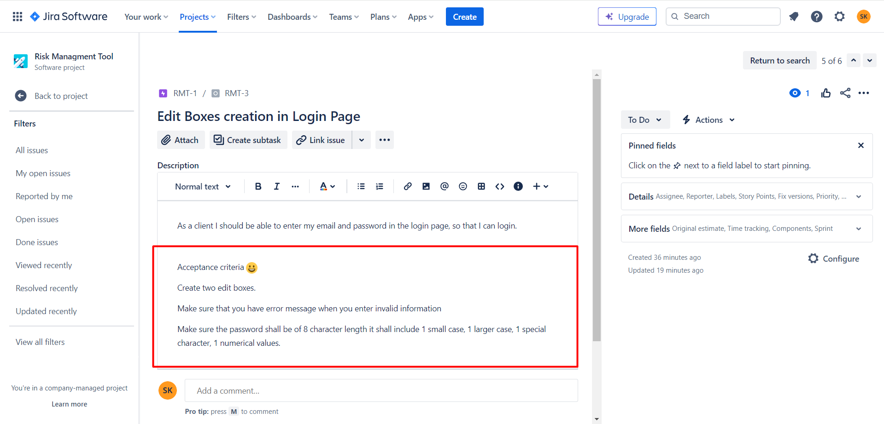

Create the SUB-TASK

Sub tasks are the high level task in which the development and testing needs to be done.

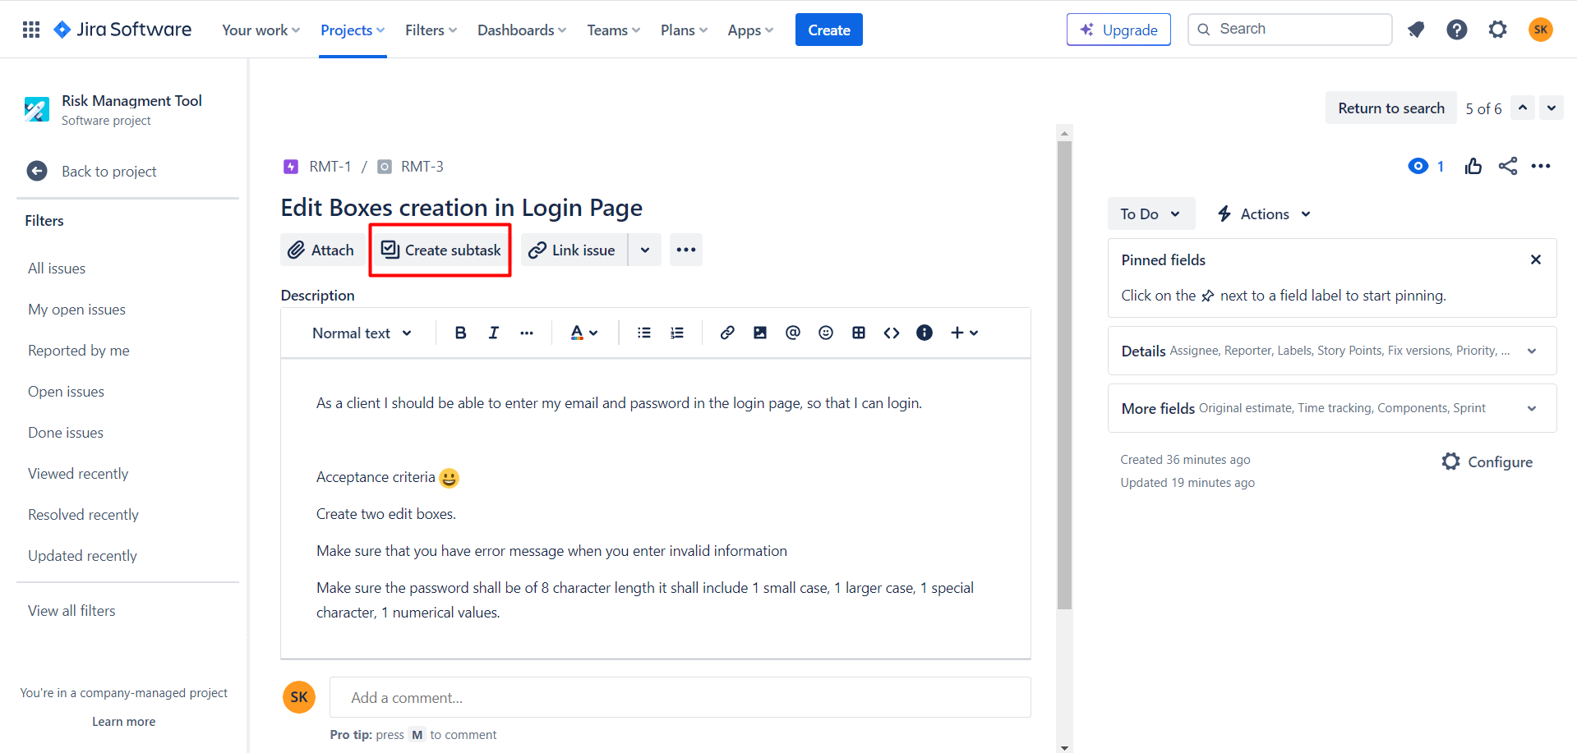

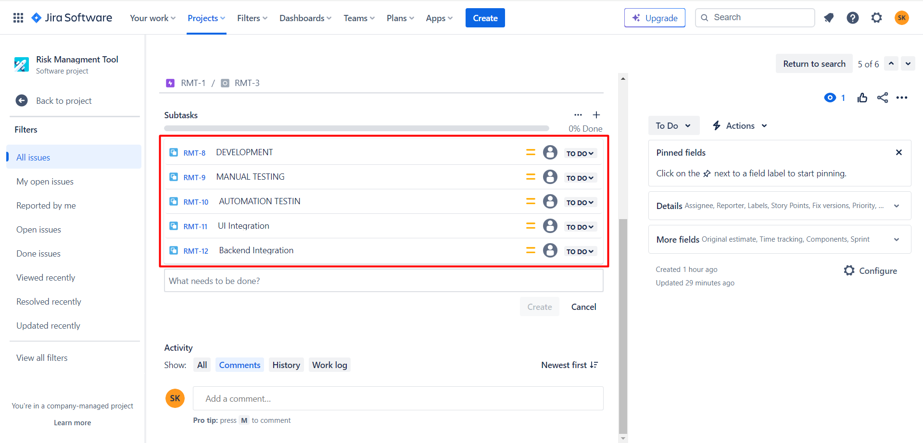

Product Backlog Refinement Overview

Detailed requirements analysis.

Splitting larger items into smaller ones (Epics to user stories)

Estimation of new items.

Re-estimating of existing items.

**It shall happen before the new sprint starts.**

**If the sprint is going on, then in the mid of the week there shall be a meeting for another sprint stories.**

1. **SPRINT**

Sprint, sprint planning, scrum board, stand ups, status of process, reports after sprint complete.

**Sprint –** If we have 25 login stories for the login page.

We have small deadlines.

Each sprint shall be divided in the pointers. It is generally of 2 weeks.

In that week we have to work on some specific stories by priority and complete it.

Shall release the stories when the sprint end.

**VELOCITY – Means how many points a team can do in a particular sprint.**

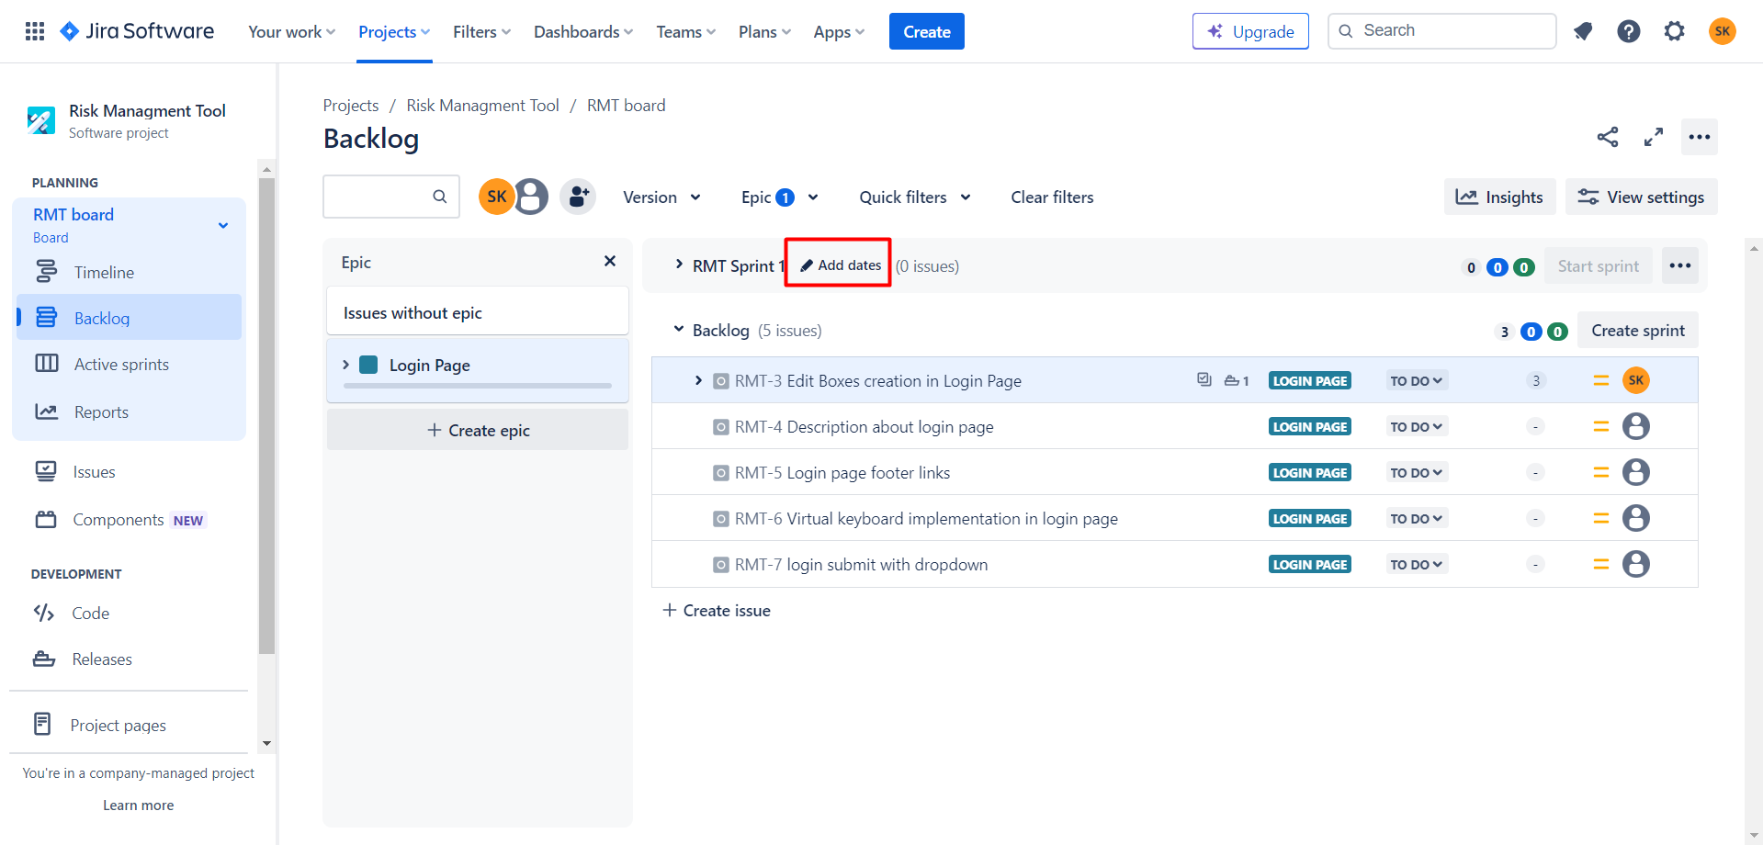

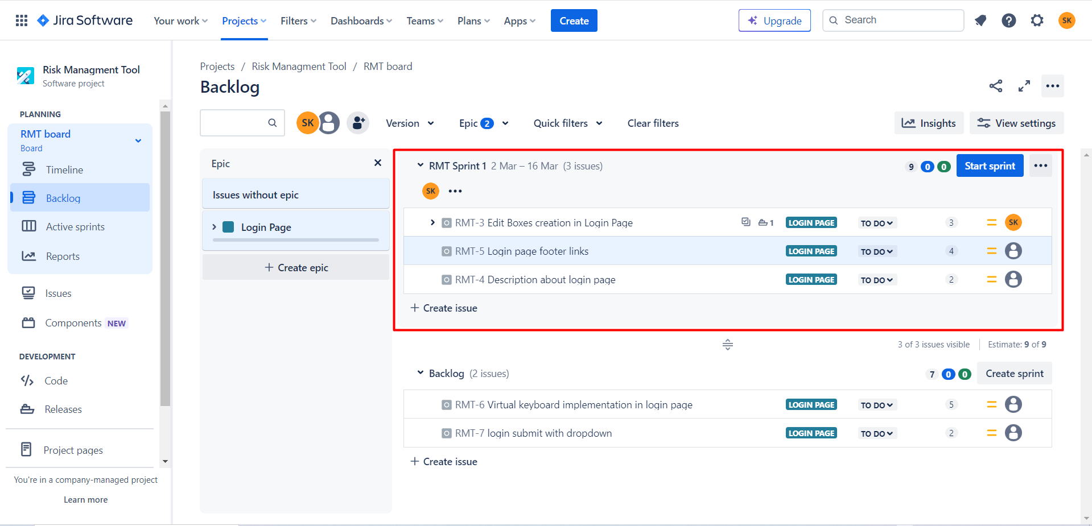

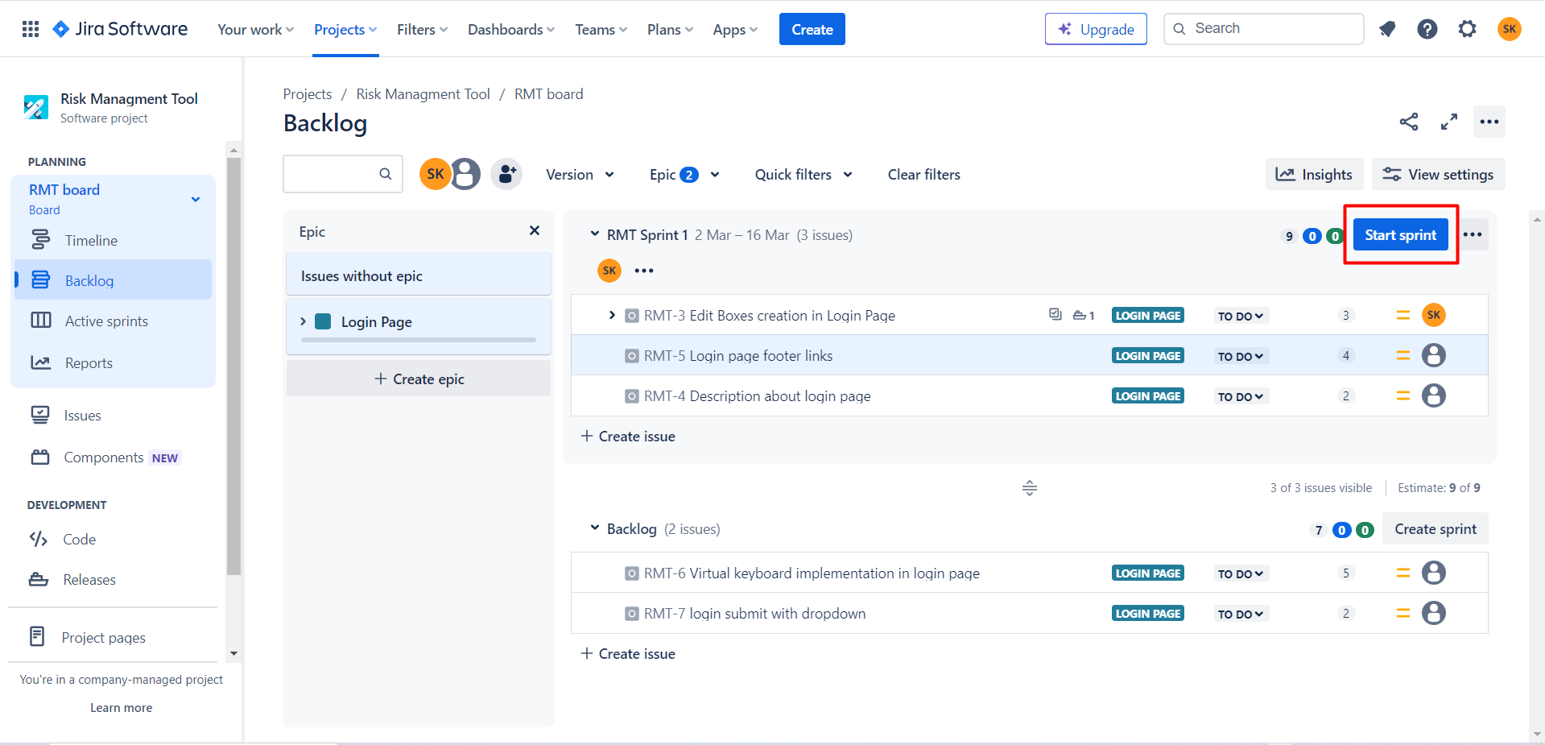

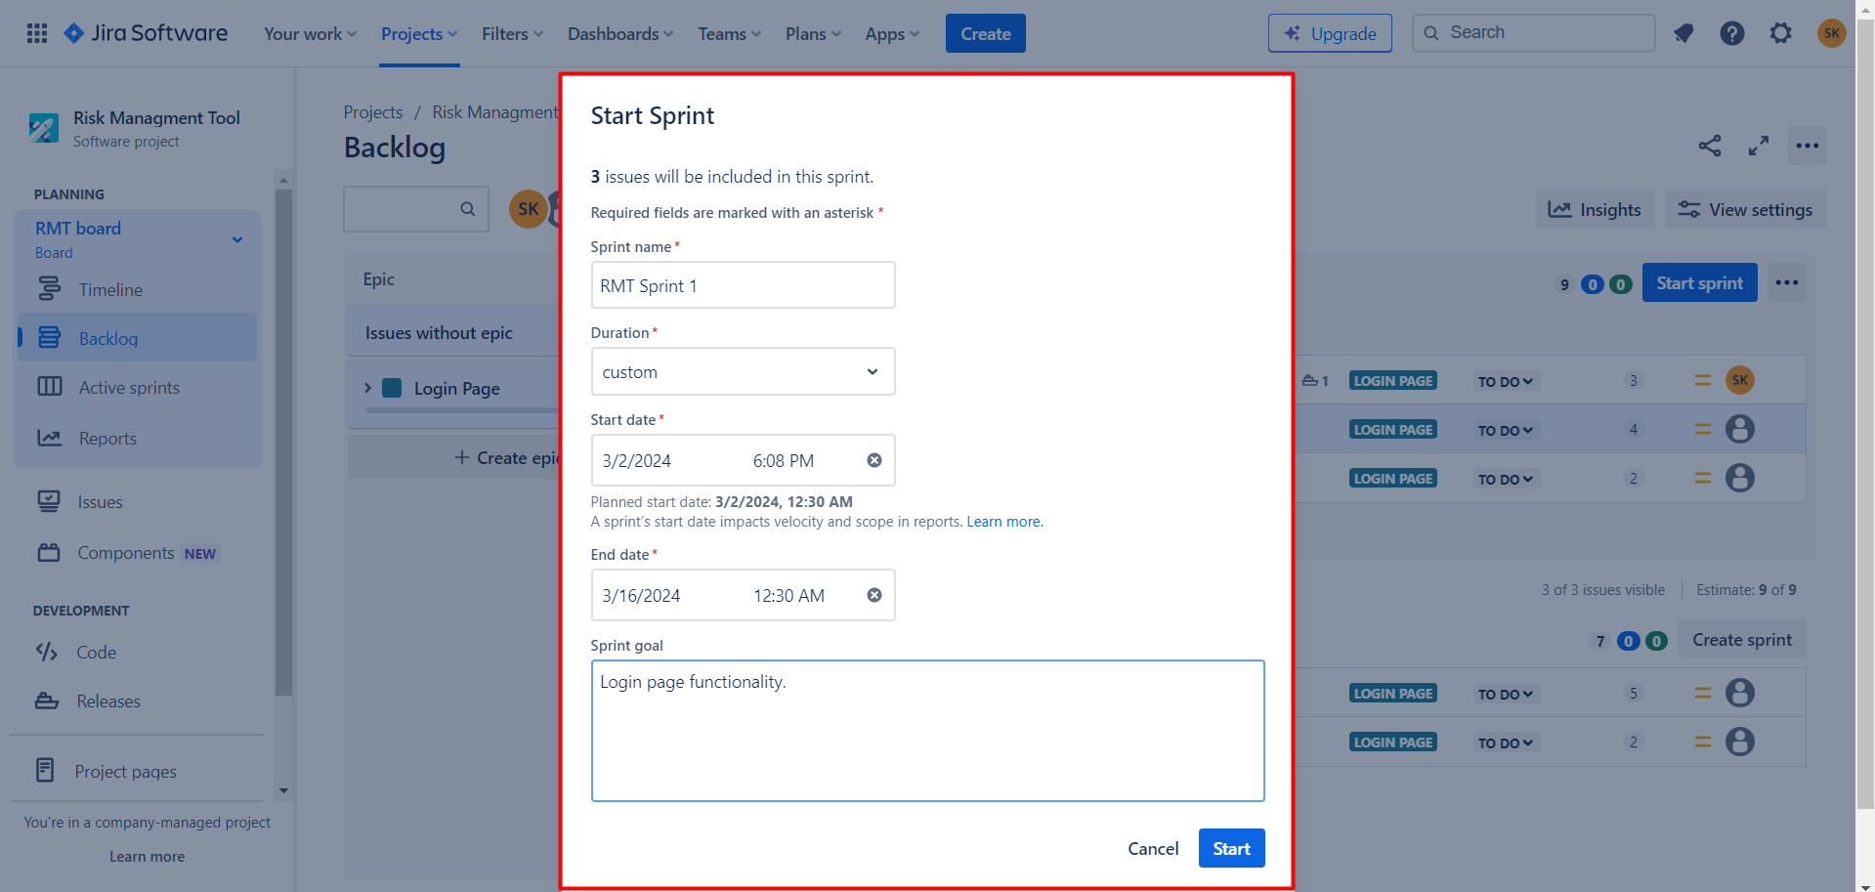

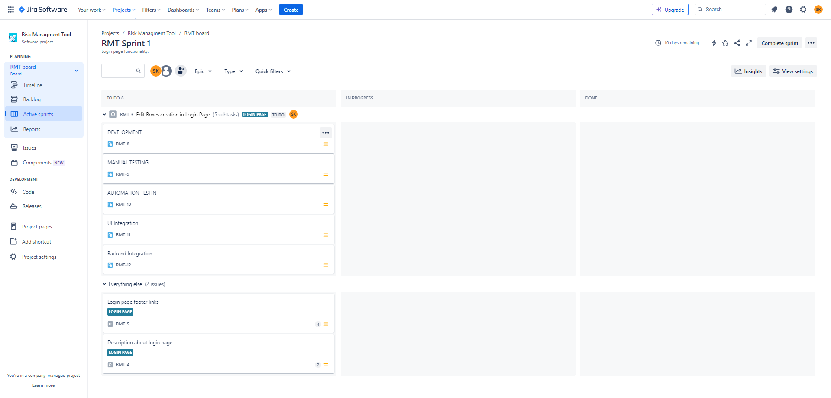

1. **What is reports**

**Mainly we have the burn down graph.**

1. **HOW to create the bug.**

