**A PROJECT REPORT**

**ON**

**“BANK MANAGEMENT SYSTEM”**

SUBMITTED BY:

**Sujit Ravindra More(2124UCEM1078)**

SUBJECT:

**Programming in Problem**

**Solving using C++**

Under the guidance of

**Miss. Ishwari Tirse**



**Department of Computer Science and Engineering Sanjivani Rural Education Society’s** **SANJIVANI UNIVERSITY**

**KOPARGAON – 423603, DIST : AHMEDNAGAR**

**2024-2025**

# INDEX

|  |  |  |
| --- | --- | --- |
| **SR. NO** | **CONTENT** | **PAGE NO.** |
| **1.** | **INTRODUCTION** | **3** |
| **2.** | **CODE** | **4** |
| **3.** | **OUTPUT** | **8** |
| **4.** | **CONCLUSION** | **10** |

**INTRODUCTION**

A Bank Management System is a software application that helps manage the daily operations of a Bank.The system allows banks to easily manage the Account, Create Account, Deposit, Withdraw, View Account as well as keep track of member information and transactions.

C++ is a popular choice for developing a Bank Management System due to its platform independence, object-oriented design, and large community of developers.

There are many benefits of a C++ Bank Management System, i.e.

Platform independence, Scalability, Security, Flexibility, etc.

# CODE

#include <iostream>

Using namespace std;

Class Account {

Public:

String accountHolder;

String accountNumber;

Double balance;};

Class BankManagementSystem {

Public:

Void createAccount(const string& holder, const string& number)

{

Accounts.push_back(Account(holder, number));

Cout << “Account created for: “ << holder;

Cout<< “ with account number: “ << number << endl;

}

Void deposit(const string& number, double amount) {

For (auto& account : accounts) {

If (account.accountNumber == number) {

Account.balance += amount;

Cout << “Deposited “ << amount;

Cout<< “ Account Number:” << number << endl;

Return;

}

}

Cout << “Account not found.”<<endl;

}

Void withdraw(const string& number, double amount) {

For (auto& account : accounts)

{

If (account.accountNumber == number) {

If (amount > account.balance) {

Cout << “Insufficient balance.\n”;

} else {

Account.balance -= amount;

Cout << “Withdrew “ << amount << “ from account “ << number << endl;

}

Return;

}

}

Cout << “Account not found.”<<endl;

}

Void viewAccount(const string& number) {

For (const auto& account : accounts) {

If (account.accountNumber == number) {

Cout << “Account Holder: “ << account.accountHolder<<endl;

Cout<< “ Account Number: “ << account.accountNumber<<endl;

Cout<< “Balance: “ << account.balance << endl;

Return;

}

}

Cout << “Account not found.”<<endl;

}

};

Int main() {

BankManagementSystem bms;

Int choice;

Do {

Cout << “Bank Management System”<<endl;

Cout << “1. Create Account”<<endl;

Cout << “2. Deposit”<<endl;

Cout << “3. Withdraw”<<endl;

Cout << “4. View Account”<<endl;

Cout << “5. Exit”<<endl;

Cout << “Enter your choice: “;

Cin >> choice;

Switch (choice) {

Case 1: {

String holder, number;

Cout << “Enter account holder name: “;

Cin >> holder;

Cout << “Enter account number: “;

Cin >> number;

Bms.createAccount(holder, number);

Break;

}

Case 2: {

String number;

Double amount;

Cout << “Enter account number to deposit to: “;

Cin >> number;

Cout << “Enter amount to deposit: “;

Cin >> amount;

Bms.deposit(number, amount);

Break;

}

Case 3: {

String number;

Double amount;

Cout << “Enter account number to withdraw from: “;

Cin >> number;

Cout << “Enter amount to withdraw: “;

Cin >> amount;

Bms.withdraw(number, amount);

Break;

}

Case 4: {

String number;

Cout << “Enter account number to view: “;

Cin >> number;

Bms.viewAccount(number);

Break;

}

Case 5:

Cout << “Exiting…”<<endl;

Break;

Default:

Cout << “Invalid choice, please try again.”<<endl;

}

} while (choice != 5);

Return 0;

}

# OUTPUT

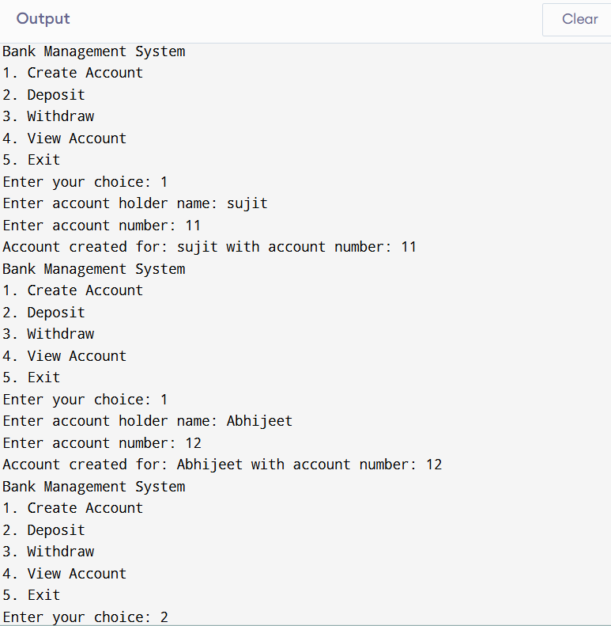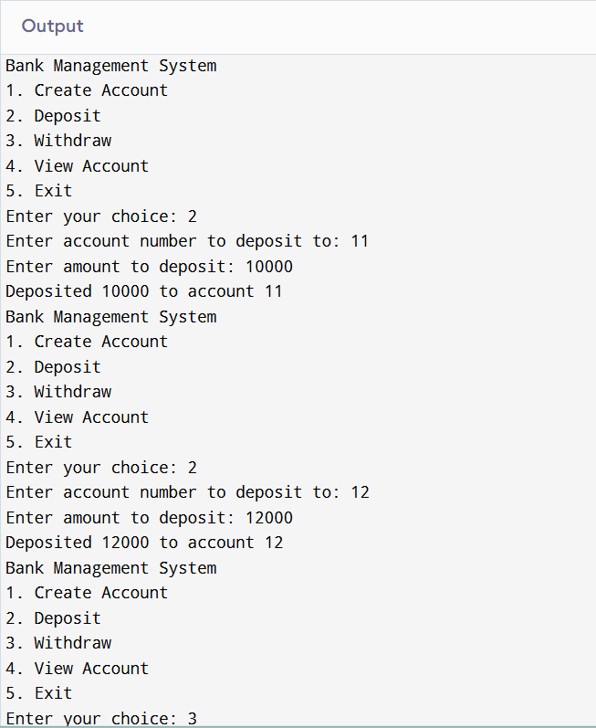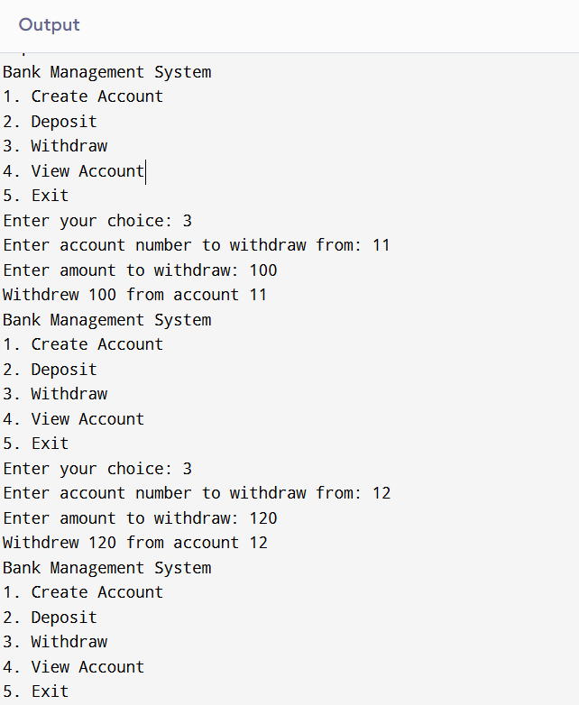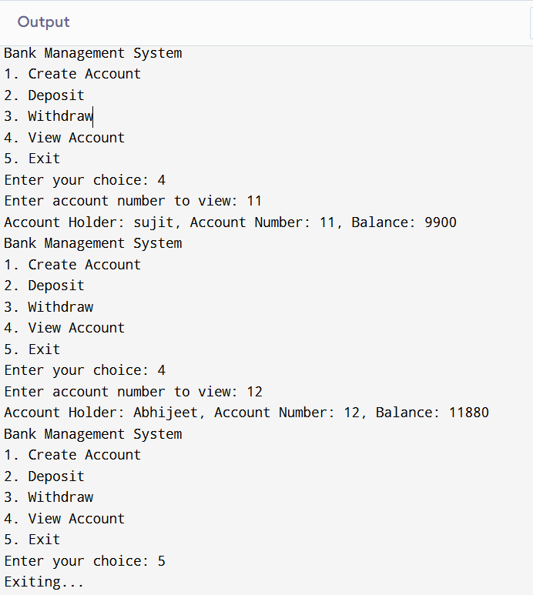

**CONCLUSION**

In conclusion, a Bank Management System in C++ is a comprehensive software application that can efficiently manage the daily operations of a Bank. With its robust features, scalability, and security, a CPP-based Bank Management System is an ideal choice for Banking of all sizes.