How did you collect API data?"
You can confidently answer:
"Instead of relying on a single endpoint, my ETL pipeline collects metadata from multiple REST endpoints, merges the responses, standardizes them into a common staging format, and produces a consolidated dataset."

Why only 30?
GitHub returns
30 repositories/page
by default.
This is called
Pagination
Enterprise APIs never return all records at once
Repository 1

Repository 2

...

Repository 30
….
…until all repositories are collected.
This prevents servers from crashing.
Every enterprise API works this way.

Why do APIs use Pagination?
Imagine Microsoft has 5,000 repositories.
Without pagination:
Client
│
▼
GitHub

↓

5000 repositories

↓

One Response (50–100 MB)
Problems:
- Slow response
- High memory usage
- Network congestion
- Server overload

- Viva Questions (You should know these)
- Q1. Why did we create transform scripts?
- Answer:
- Every data source has different columns.
- The transform layer converts every source into one common enterprise schema before merging.

- Q2. Why can't we merge directly?
- Answer:
- Because Windows, Linux, Database, and GitHub all have different structures.
- Transforming them first avoids column mismatch and many null values.

- Q3. Why create enterprise_metadata.csv?
- Answer:
- It provides one standardized dataset that can be used by ML, HDFS, Hive, Spark, and the Dashboard.

- Q4. Why use ETL?
- Answer:
- ETL combines data from multiple enterprise systems into one clean dataset.

This is the right question, and it's exactly the kind of thing a CDAC examiner or interviewer might ask.
If you just create features without understanding them, you'll struggle to explain your project. Let's understand them from an enterprise storage management perspective.

🏢 Imagine You Work at Microsoft
Microsoft has millions of files.
Examples:
HR/
Salary_2026.xlsx
Offer_Letters.docx

Finance/
Tax_Report_2025.pdf
Budget.xlsx

IT/
Windows_Server_Backup.zip

GitHub/
VSCode Repository
PowerToys Repository

Database
Employee Records
Payroll Tables
The company wants to reduce storage costs.
So they ask DataTierAI:
"Which data should stay on fast SSD storage (HOT), and which should be moved to cheaper storage (COLD/ARCHIVE)?"

🤔 How do humans decide?
A storage administrator doesn't randomly move files.
They ask questions like:
- Is the file new?
- Is it accessed every day?
- Is it business critical?
- Is it very large?
- Has anyone used it recently?
- Is it a backup?
Those questions become ML features.

Feature 1 — File Age
Question
How old is the file?
Formula:
Today's Date - Created Date
Example:
Created

2026-07-01

Today

2026-08-01

Age = 31 Days
Another file
Created

2018

Today

2026

Age = 8 Years
Which one is more likely to become ARCHIVE?
Obviously the 8-year-old file.

Why useful?
Generally:
Older File -> Less USED -> COLD Storage

Feature 2 — File Size
Example
10 KB

500 KB

50 MB

5 GB

800 GB
Why important?
Large files cost money.
Companies monitor large files carefully.
Sometimes:
Large + Unused
↓

Archive

Feature 3 — Size Category
Instead of
548975 KB
Convert to
Small

Medium

Large
Example
0-100 KB

↓

Small

100KB-100MB

↓

Medium

>100MB

↓

Large
ML understands categories better.

Feature 4 — Access Frequency ⭐⭐⭐
This is the most important feature.
You asked:
How do companies know this?
Excellent question.

Real Enterprise
Companies don't guess.
Windows Server keeps logs.
Example:
Monday

Salary.xlsx opened

Tuesday

Salary.xlsx opened

Wednesday

Salary.xlsx opened

Thursday

Salary.xlsx opened
Total
Opened 4 times
Another file
Backup_2018.zip

Opened

0 times
So
Salary.xlsx

Access Frequency = High

Backup.zip

Access Frequency = Zero

Where does this come from?
Examples:
Windows
File Server Logs
Linux
auditd

syslog

access.log
SharePoint
View Count

Download Count
AWS S3
CloudTrail Logs
Azure Blob
Storage Analytics
GitHub
Instead of access count, we use
Stars

Forks

Open Issues

Recent Commits
These act as a proxy for activity.

But in OUR Project?
We don't have access to Microsoft's real logs.
So we simulate.
Example
Access_Frequency = random.randint(1,100)
Later we can improve it.
For example:
GitHub

Stars = 20000

↓

Access Frequency = High

Feature 5 — Business Priority
Imagine
Salary.xlsx
If this disappears
Huge Problem.
Priority
High
Now
Wallpaper.jpg
Nobody cares.
Priority
Low
Where does priority come from?
Usually
ERP
Database
Employee
Manager
Business Rules
Exactly why your database already has
Priority

Feature 6 — Repository Popularity
GitHub gives
Stars

Forks
Example
Repository A
Stars

250000

Forks

50000
Repository B
Stars

5

Forks

1
Which one is more important?
Obviously Repository A.
We calculate
Popularity

=

Stars

+

Forks

Feature 7 — Activity Score
Repository
Stars

Forks

Open Issues
Formula
Example
Activity Score

=

Stars

+

Forks

+

Open Issues
Higher score
↓
Higher activity
↓
HOT

Feature 8 — Storage Tier (Target)
This is what ML predicts.
Example
Age

5 Days

Access

95

Priority

High

↓

HOT
Another
Age

7 Years

Access

1

Priority

Low

↓

ARCHIVE

How does ML learn?
Imagine we already know 10,000 examples.
Age | Access | Size | Priority | Tier
2 | 95 | Large | High | HOT
15 | 80 | Medium | High | HOT
400 | 10 | Small | Medium | COLD
2500 | 0 | Large | Low | ARCHIVE
Random Forest looks at thousands of examples and learns patterns like:
IF

Age > 1000

AND

Access < 5

↓

ARCHIVE
or
Age < 30

AND

Priority = High

↓

HOT
It learns these rules automatically from the data.

Old Approach (Rule-Based)
Your previous logic was something like:
Heat Score =

0.35 × Frequency
+0.25 × Recency
+0.20 × Query Hits
+0.10 × Users
+0.10 × Size

↓

HOT / WARM / COLD
This is a rule engine.
You manually decide:
- Frequency weight = 35%
- Recency = 25%
- Users = 10%
Then the computer simply calculates the score.
There is no learning.

Phase 1: Business Rule Engine
Use realistic enterprise rules to generate the initial labels.
For example:
Age > 365 days
AND
Priority = Low

↓

ARCHIVE
Priority = High
AND
Age < 30

↓

HOT
GitHub Stars > 10000

↓

HOT
Storage_Tier = HOT

↓

HOT
These are not random—they're based on business logic.
This creates an initial labeled dataset.

FEATURE ENGINERING

Feature 1 - File Age
TODAY - CREATED DATE

FEATURE2 - LAST MODIFIED DAYS
Today - Modified_Date

FEATURES3 – SIZECATEGORY
0 - 100 KB → Small

100 KB - 10 MB → Medium

>10 MB → Large

Feature 4 - Repository Activity
Only for GitHub
Formula
Stars

+

Forks

+

Open Issues
Purpose
Highly active repositories should stay on faster storage

Feature 5 - Business Criticality
Based on
Priority

High -3

Medium -2

Low -1

Feature 6 - Department Importance
Finance → 3

IT → 3

HR → 2

Marketing → 2

General → 1

This mapping can be changed later if business policies differ.

write feature_engineering.py in four small parts:
Part 1
- Load dataset
- Check columns
- Convert dates
Part 2
- Calculate all 10 features
Part 3
- Generate Storage_Label using business rules
Part 4
- Save feature_engineered_metadata.csv

Storage Tier | Short Definition
🔥 HOT | Frequently accessed and business-critical data stored on high-speed SSD for fast performance.
🟡 WARM | Occasionally accessed data stored on standard HDD with a balance of cost and performance.
❄️ COLD | Rarely accessed historical data stored on low-cost storage to reduce storage expenses.
📦 ARCHIVE | Very old or inactive data kept for long-term retention and compliance, accessed only when needed.

Feature | Max Score
Priority | 30
Activity | 25
File Age | 20
File Size | 10
Source | 10
Department | 5
Tota; 100

I strongly recommend we implement this improved scoring model instead of the current rule engine. It will produce a much better class distribution and a far more realistic enterprise AI pipeline.

Then the rules become much more realistic.

Access_Count > 4000 AND Priority = High ↓ HOT

Access_Count 1500–4000

↓

WARM

Access_Count 300–1500

↓

COLD

Access_Count < 300
AND
File Age > 365

↓

ARCHIVE

Why are HDFS and Hive needed?
Imagine Microsoft has:
100 TB of files
Can you train a model directly from:
C:\Users\Files\data.csv
❌ No.
The data must first be stored in a distributed system.
That's where HDFS comes in.
Enterprise Data
↓
HDFS
HDFS stores very large datasets across multiple machines.

Why Hive?
Suppose you want:
"How many HOT files are in Finance?"
Without Hive, you'd write Python code:
df[df["Department"]=="Finance"]
With Hive:
SELECT COUNT(*)
FROM enterprise_metadata
WHERE Department='Finance';
Business analysts can use SQL without writing Python.

Why Spark?
Suppose tomorrow your dataset grows from:
100,000
to
500 million
Pandas will struggle or run out of memory on one machine.
Spark distributes the work across a cluster.

In your current project
Your dataset has:
100,000 rows
Honestly?
You can train Random Forest directly with Pandas.
There is no technical necessity to use Hadoop, Hive, or Spark for a dataset of this size.

Then why include Big Data?
Because your project title is DataTierAI.
It is an Enterprise Data Lifecycle Analytics Platform, not just a Machine Learning project.
Your pipeline demonstrates that:
Enterprise Sources
↓
ETL
↓
HDFS
↓
Hive
↓
Spark
↓
Machine Learning
↓
Dashboard
This shows you understand how enterprise systems are built, even if the dataset is small enough that Pandas alone could handle it.
For our current dataset, direct training is technically possible. However, the goal of DataTierAI is to simulate an enterprise architecture. In production, data first enters HDFS for distributed storage, Hive provides SQL-based analytics, Spark performs large-scale processing, and only then is the processed data used for machine learning. We followed this architecture to make the solution scalable for much larger datasets.

What spark_etl.py will do
It will:
- ✅ Read enterprise_metadata from Hive
- ✅ Print schema
- ✅ Count rows
- ✅ Show top 10 records
- ✅ Calculate department-wise summary
- ✅ Calculate storage-tier summary
- ✅ Save processed data to HDFS
- ✅ Prepare the dataset for the ML stage

Spark Components (Short)
1. Spark Master
- Controls the Spark cluster.
- Assigns work to workers.
Think of it as: 👨‍💼 Manager

2. Spark Worker
- Executes the tasks given by the Master.
Think of it as: 👷 Employee

3. Driver Program
Your Python script.
Example:
spark.read.csv(...)
This tells Spark what to do.

4. Executor
Runs the actual computations on the worker.

Flow
Python Script
│
▼
Spark Master
│
▼
Spark Worker
│
▼
Read HDFS
│
▼
Process Data
│
▼
Save Result

Why not use Pandas?
Pandas | Spark
Small data | Huge data
Single machine | Cluster
RAM limitation | Distributed
Slower on very large datasets | Faster

spark_setup.py Purpose (for Viva)
Purpose:
- Start a Spark Session.
- Verify Spark is installed correctly.
- Display Spark configuration.
- Confirm the environment is ready for data processing.

Last SPRAK-ETL

Read data from HDFS
↓
Print Schema
↓
Count Total Records
↓
Check Null Values
↓
Department-wise Storage
↓
Storage Label Summary
↓
Compliance Summary
↓
Top 10 Largest Files
↓
Average Enterprise Score
↓
Save Processed Dataset

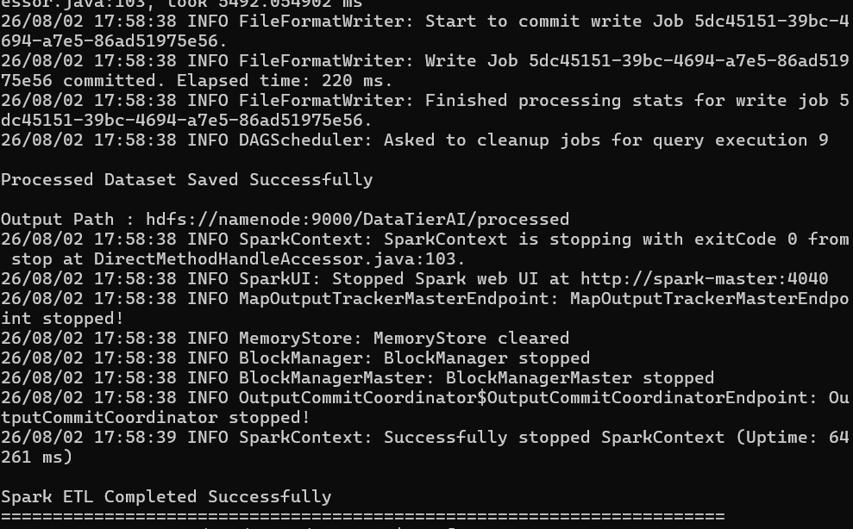

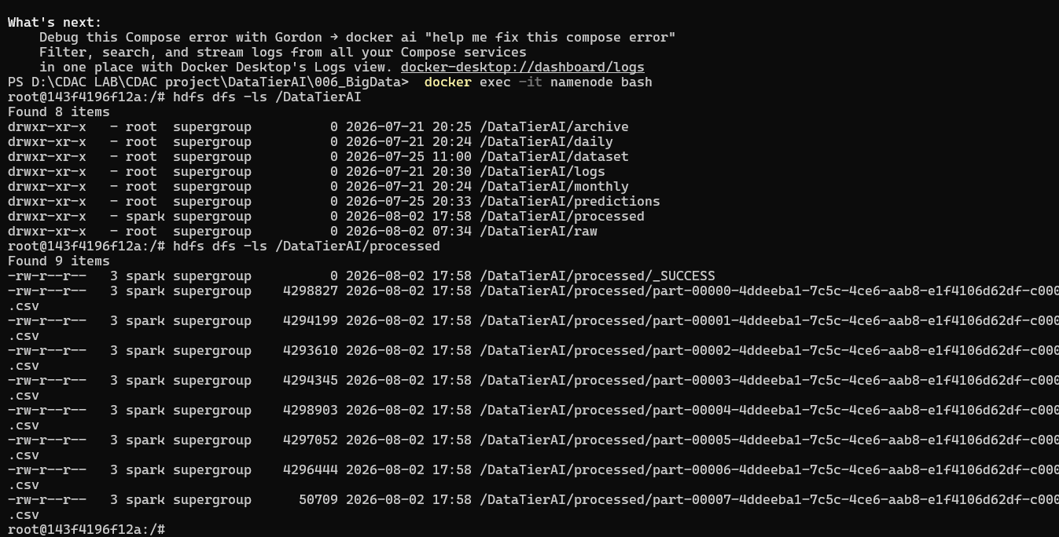

FEATURES
Department
Source
Extension_Type
Size_KB
File_Age_Days
Last_Modified_Days
Priority
Access_Count_30D
Unique_Users
Read_Count
Write_Count
Compliance
Retention_Years
Storage_Cost
Backup_Flag
Enterprise_Score

TRAGET
Storage_level

This is actually one of the best questions you've asked so far. 👍
You are noticing something that many beginners get confused about:
"Why are we cleaning the data again and again?"
The answer is we are NOT doing the same cleaning repeatedly. Every phase has a different purpose.

Complete DataTierAI Workflow
Raw Enterprise Data
│
▼
ETL
│
▼
Preprocessing
│
▼
Feature Engineering
│
▼
Enterprise Activity Generation
│
▼
Big Data (HDFS + Hive + Spark)
│
▼
Machine Learning
Now let's understand what each stage does.

1. ETL (Extract, Transform, Load)
Goal:
Collect data from different enterprise systems.
Input:
Windows
Linux
Database
GitHub
Output:
One Combined Dataset
Example:
Windows:
Employee.xlsx

Linux:
server.log

GitHub:
Repository Metadata
After ETL:
One CSV
ETL does NOT
❌ Remove null values
❌ Train ML
❌ Calculate features
It only collects and combines.

2. Preprocessing
Goal:
Make the raw dataset clean.
Here we do things like:
✅ Remove duplicate rows
✅ Fix missing values
✅ Convert date format
✅ Standardize column names
Example
Before
Created_Date

18/04/17

2017-04-18

18-Apr-17
After
2017-04-18
This is data cleaning.

3. Feature Engineering
Goal
Create new intelligent columns.
Example
Raw
Created_Date

2018-04-10
Feature
File_Age_Days = 3000
Raw
Stars

Forks

Open Issues
Feature
Activity Score
Raw
Priority
Department
Source
Feature
Enterprise Score
Here we are creating knowledge from data.

4. Enterprise Activity Generation
Goal
Create realistic enterprise usage.
Example
Earlier
Size_KB
Department
Priority
Now we generate
Access Count

Read Count

Write Count

Storage Cost

Compliance

Backup

Retention
Now the dataset looks like a real enterprise dataset.

5. Spark
This is where many people get confused.
Spark is NOT cleaning the data again.
Spark's job is:
Read Huge Dataset

↓

Distributed Processing

↓

Business Summary

↓

Analytics

↓

Prepared Dataset
Spark does
Department Summary

Storage Summary

Top Largest Files

Compliance Summary

Average Enterprise Score
Spark is about processing large data efficiently, not basic cleaning.

6. Machine Learning
Now comes the important part.
You asked:
"Why are we again filling null values and encoding?"
Because ML has different requirements.
Example
Suppose after Spark your dataset contains
Department

IT

HR

Finance
The ML algorithm cannot understand text.
So we convert
IT

↓

0

HR

↓

1

Finance

↓

2
This is Encoding.

Another example
Suppose one value becomes missing after exporting.
ML cannot train with NaN.
So
NaN

↓

Median

or

Mode
This is ML preprocessing, not ETL preprocessing.

Difference
Phase | Purpose
ETL | Collect data
Preprocessing | Clean raw data
Feature Engineering | Create intelligent features
Spark | Process large datasets and analytics
Machine Learning | Prepare data in a format algorithms can learn from

Simple Analogy
Imagine making tea ☕
ETL
Collect
Milk

Tea

Sugar

Preprocessing
Wash utensils
Measure ingredients

Feature Engineering
Add
Ginger

Cardamom
to improve the tea.

Spark
Cook tea for 10,000 people efficiently.

ML
Serve the tea in cups that customers can actually drink.

For Your Project
The preprocessing in ML is very small.
We are not repeating the entire preprocessing.
We are only doing:
- Convert categorical values into numbers (Encoding)
- Final missing value check (Safety check)
- Split features and target
- Train/Test split
These are mandatory ML preparation steps, not a repeat of your earlier preprocessing.

My recommendation for your project
To make your project look more professional, we can reduce the ML preprocessing because you've already done most of the work in earlier stages.
Instead of doing lots of cleaning again, we'll keep only:
Load Dataset
↓

Encode Categories

↓

Train/Test Split

↓

Train Models
This makes your pipeline cleaner and matches the story of your project: ETL and preprocessing handled the cleaning; ML focuses on learning. I actually recommend this approach for your DataTierAI project because it aligns better with the architecture you've already built.

X = X.drop(columns=[
"Enterprise_Score",
"Priority_Business_Score",
"Source_Business_Score",
"Department_Business_Score",
"Activity_Business_Score",
"Age_Score",
"Size_Score"
])

Now your model will have to learn from:
- Department
- File Size
- Access Count
- Read Count Why did you perform Hyperparameter Tuning if the accuracy didn't increase?
- You can answer:
- "Hyperparameter tuning is performed to optimize the model parameters and improve its ability to generalize. The objective is not only to increase accuracy but also to reduce overfitting and build a more stable model. In our case, the tuned model achieved almost the same performance, indicating that the original Random Forest was already close to optimal.

- Write Count
- Priority
- File Age
- Storage Cost

Why are only 3 features so important?
Your model is predicting Storage_Label. During training, it discovered that these features are the strongest indicators:
Feature | Importance | Why?
Read_Count | 35.6% | Frequently read files are usually HOT/WARM.
Access_Count_30D | 33.9% | Recent access is one of the biggest indicators of storage tier.
Write_Count | 28.4% | Frequently modified files tend to stay in hotter storage.
Together, these three features contribute about 98% of the model's decision-making.

Why are the others so small?
Features like:
- Department
- Priority
- Category
- Backup_Flag
- Size_Category
don't vary the target much in your dataset. The Random Forest found that splitting on them doesn't improve predictions much, so they receive very low importance.

Is this normal?
Yes. It's very common with tree-based models like Random Forest.
Often you'll see something like:
Feature A -> 70%
Feature B -> 20%
Feature C -> 8%
Everything else -> 2%
That doesn't mean the other features are "wrong"—it means they didn't provide much additional information beyond the strongest feat
The Random Forest model automatically identified that Read_Count, Access_Count_30D, and Write_Count have the highest predictive power for storage tier classification. The remaining features either have a weaker relationship with the target or contain information that overlaps with these dominant features, so their importance is much lower.

Why we started from ETL in Airflow
Because your 001_Data_Sources folder is not a processing stage. It is only used to create or simulate enterprise data.
For example:
- setup_windows.py → creates Windows files
- setup_linux.py → creates Linux files
- setup_database.py → creates the SQLite database
These scripts are run once (or only when you want fresh sample data).
After that, the pipeline always starts from ETL, because ETL reads the data already present in those sources.

• 01_Data_Sources is only for setting up the demo environment (creating sample Windows files, Linux files, and the demo database).
• In a real enterprise, those data sources already exist. Airflow doesn't create them—it collects data from them.

If you just want to start them again, run:
docker start airflow-webserver
docker start airflow-scheduler
or
docker compose up -d
this is the code to ruin the etl process
docker exec -it airflow-scheduler python /opt/airflow/scripts/run_etl.py

this is the codde to run the preprocess
docker exec -it airflow-scheduler python /opt/airflow/scripts/run_feature_eng.py

this is the code for the feteure
docker exec -it airflow-scheduler python /opt/airflow/scripts/run_spark.py

the code o f the ml to run the airflow
docker exec -it airflow-scheduler python /opt/airflow/scripts/run_ml.py

DBMS,PYTHON ,CLOUD , APEEND EXTEND ,S3,DROP DELETE TRUCATE ,PRIMARY KEYS JOINS LINUX 20 COMMAND

