Masterpiece

Project

Coding Academy by Orange

*Agriculture Website*

Sujoud Mohammad

18/8/2022

Table of content:

● INTRODUCTION PURPOSE.

● INTENDED AUDIENCE AND PERTINENT SECTIONS.

● PROJECT SCOPE.

● TECHNOLOGIES.

● REFERENCES

● DESCRIPTION

● OPERATING ENVIRONMENT

● FEATURES

● DOCUMENTATION

● FLOW CHART DIGRAM

● DATABASE SCHEMA

**INTRODUCTION PURPOSE**

• Reduce customer time and effort.

• Reducing the cost to the customer.

**INTENDED AUDIENCE AND PERTINENT SECTIONS.**

Farmers when the agricultural commercial site Falah is famous for selling modern agricultural machines and tools and all kinds of trees and plants, and also targets all people interested in decorating and weeding the home garden at an appropriate cost and competition.

**PROJECT SCOPE**

● An e-commerce website that sells agricultural tools, machines, plants and trees, and requires only an email and name to register to simplify our registration process.

● Allows the user to search for the product easily

● The customer can communicate with us by sending a message via the contact us page easily and payment is made upon receipt in the event of the completion of the purchase process.

**TECHNOLOGIES**:

● HTML.

● CSS.

● JS.

● PHP.

● LARAVEL FRAMEWORK 5.8.

● BOOTSTRAP.

● AJAX.

● SQL database.

**SKILLS USED:**

● Search skills.

● UX / UI.

● Time management.

● Visual Identity.

● Design Thinking.

● Communication Skills.

**REFERENCES:**

● HTML : <https://developer.mozilla.org/en-US/docs/Web/HTML>

● JS : <https://developer.mozilla.org/en-US/docs/Web/JavaScript>

● CSS : <https://developer.mozilla.org/en-US/docs/Web/CSS>

● PHP : <https://www.php.net/docs.php>

● LARAVEL 8: <https://laravel.com/> also am using YouTube and some of tutorials in google.

**DESCRIPTION**

PRODUCT PERSPECTIVE

● Users are offered different roles to use the app correctly Perspective, as a user who wants to complete the purchase, he must log in, and as a user who browses and wants to buy later, he can not register and the basket is saved so that he can return to it easily.

● Also, from a managerial perspective to adjust and control Purchasing process, purchasing management and users.

● User (visitors)

The user can browse the website and search for the product

Wanted and bough.

● Admin

Administrative dashboard gives access to admins. first must login

Delete/Edit/Add/ **User**

Delete/Edit/Add/ **Category**

Delete/Edit/Add/ **Products**

Delete/Edit/Add/ **Coupons**

Delete/View/Approvement **Comment**

View/Approvement **Order**

**OPERATING ENVIRONMENT**

Falah website and Dashboard is designed to run on all modern browsers Microsoft Edge, Google Chrome, Mozilla Firefox, Safari, Opera with an active internet connection.

**FEATURES**

**❖ Public site**

■ Login Page: Users must login using their email and password to access the public site.

■ Home page: During this page, the focus has been on shortening time and attracting the visitor's attention to make the purchase process easier, thus saving time and effort.

■ Offer section: Part of the permanent offers available.

■ Profile Screen shows the account information and all purchase added by the user. From this screen the user can view and delete their order, edit account information, logout.

**❖ Web Dashboard:**

■ Login Page Admin must login using their email and password to access the administrative dashboard.

■ Dashboard Page: Adding Admins At the top of this page, can find a form to add an admins.

■ Editing Admin can edit for any admin to change the type from admin to users.

■ Deleting Admins can delete admins

■ Deleting User Users using the public site can be deleted from this page by admins.

■ Viewing Order All orders by all users are shown in order to be monitored and controlled by admin.

**❖ Projects Features:**

■ The website implements SEO.

■ The website is fully responsive.

■ The website considers UX/UI design principles.

■ The website considers security by hashing strong passwords and

activating the authorization demanding the user’s role.

**DOCUMENTATION:**

All project files have been uploaded to GitHub and made available to all in order to share knowledge.

GitHub https: <https://github.com/Sujood-Mohammad/Project_10_masterpiece>

**FLOW CHART DIGRAM:**

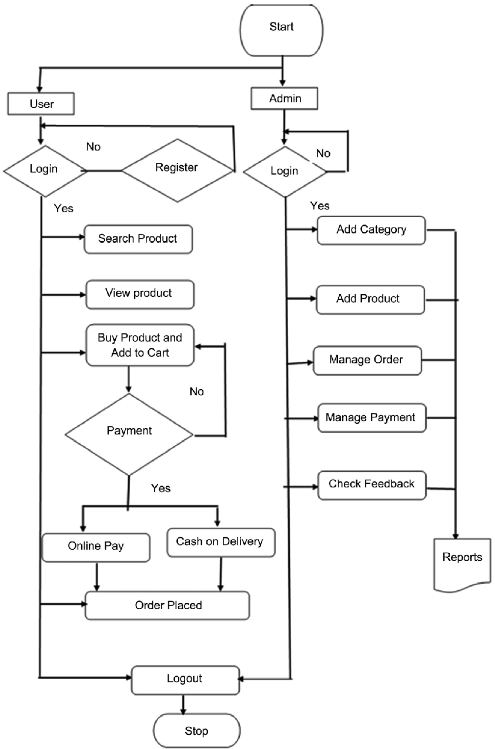

**DATABASE SCHEMA:**

