Ques: **Complete the below task:**

1. Explain the below AWS Architecture
2. Implement the same in the AWS(only do a proper connection between service)

**NOTE:** *Submission can be done by sharing the proper screenshots of implementation and doc for explanation!*

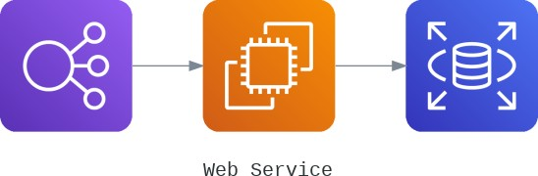

*Create ELB to route traffic to EC2 instances and Connect to AWS RDS from AWS EC2*

***Elastic Load Balancer-***

Elastic Load Balancing (ELB) automatically distributes incoming application traffic across multiple targets such as EC2 instances, containers, and IP addresses, in one or more Availability Zones.It monitors the health of its registered targets, and routes traffic only to the healthy targets.

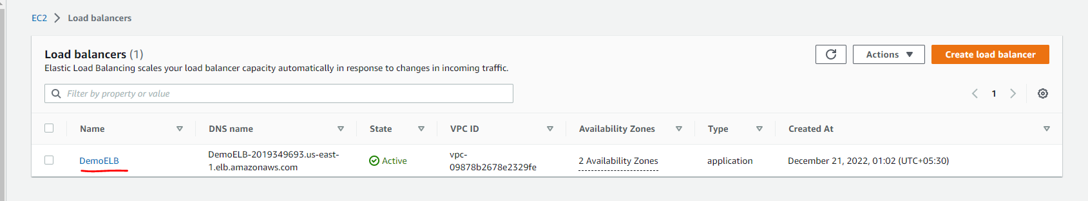

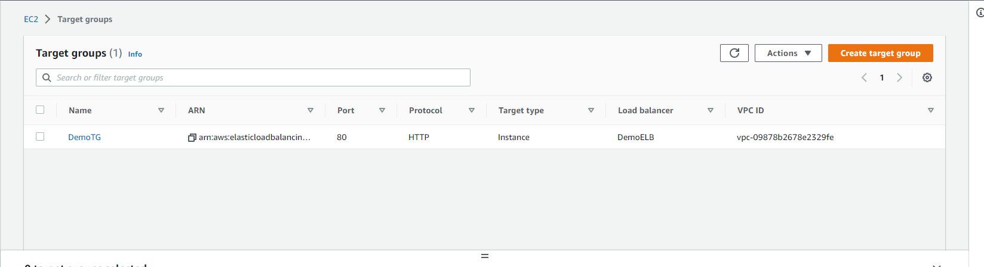

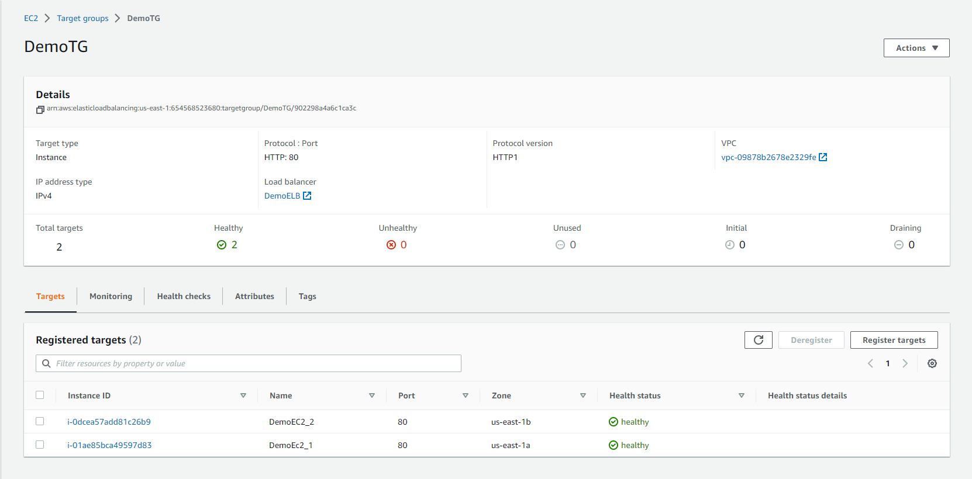

***EC2 Instance-***

An Amazon EC2 instance is a virtual server in Amazon's Elastic Compute Cloud (EC2) for running applications on the Amazon Web Services (AWS) infrastructure. It also allows the user to configure their instances as per their requirements i.e. allocate the RAM, ROM, and storage according to the need of the current task.EC2 offers security, reliability, high-performance and cost-effective infrastructure so as to meet the demanding business needs.

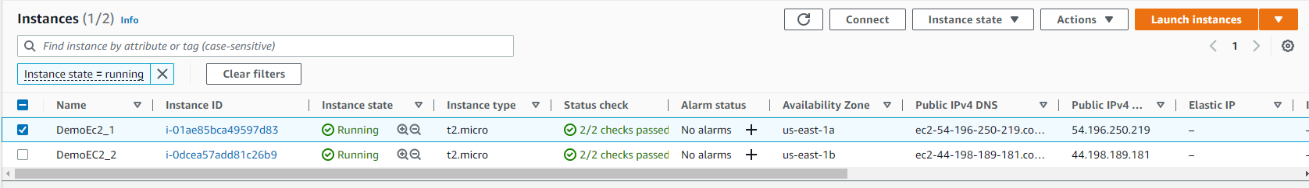

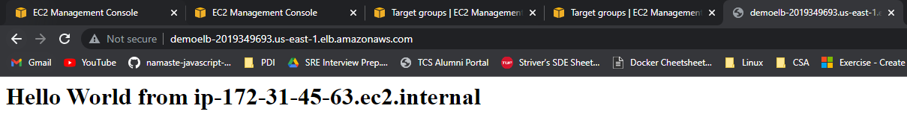

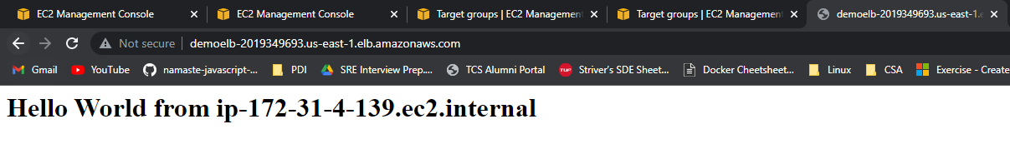

***RDS Database-***

Amazon Relational Database Service (RDS) is a managed SQL database service provided by Amazon Web Services (AWS).It’s a managed DB service for DB use SQL as a query language.

RDS is a managed service provide automated provisioning, OS patching, continuous backup and restore to specific time stamp. Its increase read performance by implementing read replicas. Perform disaster recovery using Multi-AZ setup.

