**~~~~~~~~~~~~~~~~~~~~~~~~~~~~~~~ Name- SUKAINA INAM NAQVI Examination Roll Number- 20020570033**

**Semester -III**

**Subject- Operating System Practical Exam Outputs**

**~~~~~~~~~~~~~~~~~~~~~~~~~~~~~~~**

**Question 1:-**

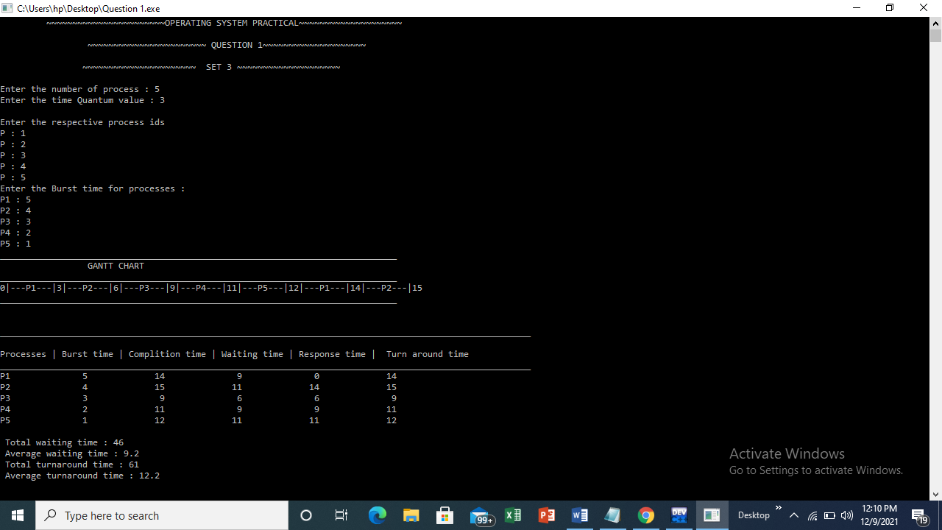

**Question 2:-**

