RAMANUJAN COLLEGE

# UNIVERSITY OF DELHI



**CORE- COMPUTER GRAPHICS**

**PRACTICAL FILE**

**SUBMITTED TO:** Mr. Arun Agarwal

**SUBMITTED BY:** Sukaina Inam Naqvi **ROLL NO –** 20201426

**Examination Roll No.-** 20020570033

## B.Sc. (H) Computer Science | Vi Semester



|  |  |
| --- | --- |
| **S.No.** | **CONTENTS** |
| 1 | **BRESENHAM’S LINE DRAWING ALGORITHM** |
| **2** | **MID POINT CIRCLE DRAWING ALGORITHM** |
| **3** | **COHEN AND SUTHERLAND LINE CLIPPING ALGORITHM** |
| **4** | **SUTHERLAND HODGEMAN POLYGON CLIPPING ALGORITHM** |
| **5** | **POLYGON SCAN LINE FILLING ALGORITHM** |
| **6** | **APPLYING 2D TRANSFORMATIONS 2D OBJECT** |
| **7** | **APPLYING 3D TRANSFORMATIONS 3D OBJECT** |
| **8** | **HERMITE AND BEZIER CURVE** |

**Q1 Write a program to implement Bresenham’s line drawing algorithm.**

**Code:-**

#include <cmath>

#include <cstdlib>

#include <graphics.h>

#include <iostream>

using namespace std;

void bresenhamLine(int x0, int y0, int x1, int y1, int val)

{

if (x0 == x1 && y0 == y1)

{

putpixel(x1, y1, val);

}

else

{

int dx = x1 - x0;

int dy = y1 - y0;

float m = float(dy) / (float)(dx);

if (m >= 1 || m <= 0)

{

cout << "ERROR: Slope must be between 0 and 1." << endl;

exit(1);

}

int d = 2 * dy - dx;

int del_E = 2 * dy;

int del_NE = 2 * (dy - dx);

int x = x0;

int y = y0;

putpixel(x, y, val);

while (x < x1)

{

if (d <= 0)

{

d += del_E;

x += 1;

}

else

{

d += del_NE;

x += 1;

y += 1;

}

putpixel(x, y, val);

}

}

return;

}

int main(void)

{

int x0, y0, x1, y1;

cout << "Enter Left Endpoint (x0 y0): ";

cin >> x0 >> y0;

cout << "Enter Right Endpoint (x1 y1): ";

cin >> x1 >> y1;

cout << "Drawing Line..." << endl;

int gd = DETECT, gm;

initgraph(&gd, &gm, NULL);

bresenhamLine(x0, y0, x1, y1, WHITE);

delay(5e3);

closegraph();

cout << "Finished..." << endl;

return 0;

}

**Output:-**

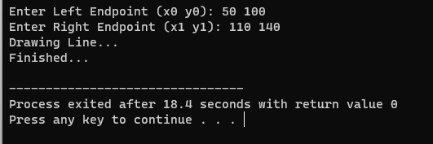

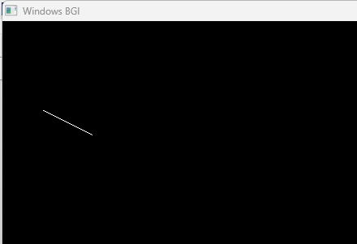

**Q2.Write a program to implement mid-point circle drawing algorithm.**

**Code:-**

#include<iostream>

#include<graphics.h>

#include<math.h>

using namespace std;

void circlePlotPoints (int, int, int, int); int xmid,

ymid;

void circleMidpoint(int xCenter, int yCenter, int radius)

{

int x = 0; int y =

radius; int p = 1 - radius;

//circlePlotPoints (x, y, xCenter, yCenter);

while (x <= y) {

circlePlotPoints (x, y, xCenter, yCenter);

if (p < 0)

{

p += (2*x)+1;

}

else

{

p +=(2*(x-y))+1;

y--;

}

x++ ;

}

}

void circlePlotPoints(int x, int y, int xCenter, int yCenter)

{

putpixel (xCenter + x, yCenter + y, YELLOW);

putpixel (xCenter - x, yCenter + y, YELLOW);

putpixel (xCenter + x, yCenter - y, YELLOW);

putpixel (xCenter - x, yCenter - y, YELLOW);

putpixel (xCenter + y, yCenter + x, YELLOW);

putpixel (xCenter - y, yCenter + x, YELLOW);

putpixel (xCenter + y, yCenter - x, YELLOW);

putpixel (xCenter - y, yCenter - x, YELLOW);

}

int main()

{

int x , y;

float r;

int gd = DETECT , gm;

initgraph(&gd, &gm, (char*)"");

cout<<" Mid-point Circle Algorithm \n\n";

cout<<" Enter the x co-ordinate of centre : ";

cin>>x;

cout<<"\n Enter the y co-ordinate of centre : ";

cin>>y;

cout<<"\n Enter the radius : ";

cin>>r;

xmid = getmaxx()/2;

ymid = getmaxy()/2;

line(xmid , 0 , xmid , getmaxy());

line(0 , ymid , getmaxx() , ymid);

circleMidpoint(x + xmid , ymid - y , r);

getch();

closegraph();

return 0;

}

**Output:-**

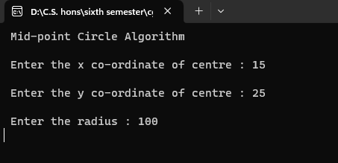

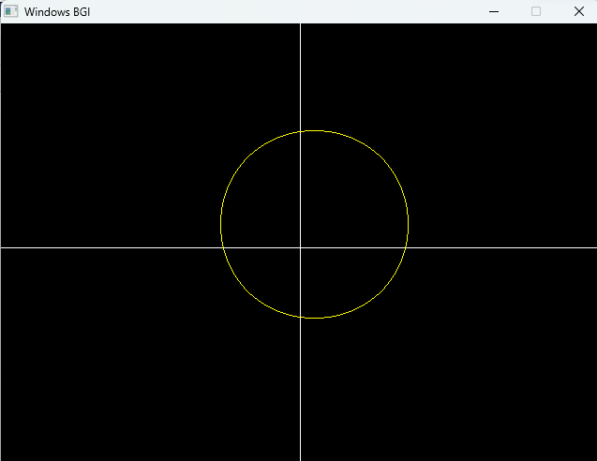

**Q3 Write a program to implement Cohen-Sutherland Line Clipping algorithm.**

**Code:-**

#include <bits/stdc++.h>

#include <graphics.h>

using namespace std;

int xmin, xmax, ymin, ymax;

struct lines {

int x1, y1, x2, y2;

};

int sign(int x)

{

if (x > 0)

return 1;

else

return 0;

}

void clip(struct lines mylines)

{

int bits[4], bite[4], i, var;

setcolor(YELLOW);

bits[0] = sign(xmin - mylines.x1);

bite[0] = sign(xmin - mylines.x2);

bits[1] = sign(mylines.x1 - xmax);

bite[1] = sign(mylines.x2 - xmax);

bits[2] = sign(ymin - mylines.y1);

bite[2] = sign(ymin - mylines.y2);

bits[3] = sign(mylines.y1 - ymax);

bite[3] = sign(mylines.y2 - ymax);

string initial = "", end = "", temp = "";

for (i = 0; i < 4; i++) {

if (bits[i] == 0)

initial += '0';

else

initial += '1';

}

for (i = 0; i < 4; i++) {

if (bite[i] == 0)

end += '0';

else

end += '1';

}

float m = (mylines.y2 - mylines.y1) / (float)(mylines.x2 - mylines.x1);

float c = mylines.y1 - m * mylines.x1;

if (initial == end && end == "0000") {

line(mylines.x1, mylines.y1, mylines.x2, mylines.y2);

return;

}

else {

for (i = 0; i < 4; i++) {

int val = (bits[i] & bite[i]);

if (val == 0)

temp += '0';

else

temp += '1';

}

if (temp != "0000")

return;

for (i = 0; i < 4; i++) {

if (bits[i] == bite[i])

continue;

if (i == 0 && bits[i] == 1) {

var = round(m * xmin + c);

mylines.y1 = var;

mylines.x1 = xmin;

}

if (i == 0 && bite[i] == 1) {

var = round(m * xmin + c);

mylines.y2 = var;

mylines.x2 = xmin;

}

if (i == 1 && bits[i] == 1) {

var = round(m * xmax + c);

mylines.y1 = var;

mylines.x1 = xmax;

}

if (i == 1 && bite[i] == 1) {

var = round(m * xmax + c);

mylines.y2 = var;

mylines.x2 = xmax;

}

if (i == 2 && bits[i] == 1) {

var = round((float)(ymin - c) / m);

mylines.y1 = ymin;

mylines.x1 = var;

}

if (i == 2 && bite[i] == 1) {

var = round((float)(ymin - c) / m);

mylines.y2 = ymin;

mylines.x2 = var;

}

if (i == 3 && bits[i] == 1) {

var = round((float)(ymax - c) / m);

mylines.y1 = ymax;

mylines.x1 = var;

}

if (i == 3 && bite[i] == 1) {

var = round((float)(ymax - c) / m);

mylines.y2 = ymax;

mylines.x2 = var;

}

bits[0] = sign(xmin - mylines.x1);

bite[0] = sign(xmin - mylines.x2);

bits[1] = sign(mylines.x1 - xmax);

bite[1] = sign(mylines.x2 - xmax);

bits[2] = sign(ymin - mylines.y1);

bite[2] = sign(ymin - mylines.y2);

bits[3] = sign(mylines.y1 - ymax);

bite[3] = sign(mylines.y2 - ymax);

}

initial = "", end = "";

for (i = 0; i < 4; i++) {

if (bits[i] == 0)

initial += '0';

else

initial += '1';

}

for (i = 0; i < 4; i++) {

if (bite[i] == 0)

end += '0';

else

end += '1';

}

if (initial == end && end == "0000") {

line(mylines.x1, mylines.y1, mylines.x2, mylines.y2);

return;

}

else

return;

}

}

int main()

{

int gd = DETECT, gm;

xmin = 40;

xmax = 100;

ymin = 40;

ymax = 80;

initgraph(&gd, &gm, NULL);

line(xmin, ymin, xmax, ymin);

line(xmax, ymin, xmax, ymax);

line(xmax, ymax, xmin, ymax);

line(xmin, ymax, xmin, ymin);

struct lines mylines[4];

mylines[0].x1 = 30;

mylines[0].y1 = 65;

mylines[0].x2 = 55;

mylines[0].y2 = 30;

mylines[1].x1 = 60;

mylines[1].y1 = 20;

mylines[1].x2 = 100;

mylines[1].y2 = 90;

mylines[2].x1 = 60;

mylines[2].y1 = 100;

mylines[2].x2 = 80;

mylines[2].y2 = 70;

mylines[3].x1 = 85;

mylines[3].y1 = 50;

mylines[3].x2 = 120;

mylines[3].y2 = 75;

for (int i = 0; i < 4; i++) {

line(mylines[i].x1, mylines[i].y1,

mylines[i].x2, mylines[i].y2);

delay(1000);

}

for (int i = 0; i < 4; i++) {

clip(mylines[i]);

delay(1000);

}

delay(4000);

getch();

closegraph();

return 0;

}

**Output:-**

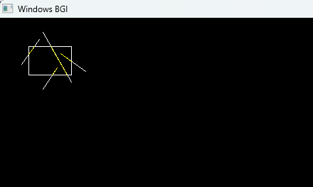

**Q4 Write a program to implement Sutherland Hodgeman Clipping program.**

**Code:-**

#include<iostream>

#include<conio.h>

#include<graphics.h>

using namespace std;

#define round(a) ((int)(a+0.5))

int k;

float xmin,ymin,xmax,ymax,arr[20],m;

void

clipl(float x1,float y1,float x2,float y2)

{

if(x2-x1)

m=(y2-y1)/(x2-x1);

else

m=100000;

if(x1 >= xmin && x2 >= xmin)

{

arr[k]=x2;

arr[k+1]=y2;

k+=2;

}

if(x1 < xmin && x2 >= xmin)

{

arr[k]=xmin;

arr[k+1]=y1+m*(xmin-x1);

arr[k+2]=x2;

arr[k+3]=y2;

k+=4;

}

if(x1 >= xmin && x2 < xmin)

{

arr[k]=xmin;

arr[k+1]=y1+m*(xmin-x1);

k+=2;

}

}

void clipt(float x1,float y1,float x2,float y2)

{

if(y2-y1)

m=(x2-x1)/(y2-y1);

else

m=100000;

if(y1 <= ymax && y2 <= ymax)

{

arr[k]=x2;

arr[k+1]=y2;

k+=2;

}

if(y1 > ymax && y2 <= ymax)

{

arr[k]=x1+m*(ymax-y1);

arr[k+1]=ymax;

arr[k+2]=x2;

arr[k+3]=y2;

k+=4;

}

if(y1 <= ymax && y2 > ymax)

{

arr[k]=x1+m*(ymax-y1);

arr[k+1]=ymax;

k+=2;

}

}

void clipr(float x1,float y1,float x2,float y2)

{

if(x2-x1)

m=(y2-y1)/(x2-x1);

else

m=100000;

if(x1 <= xmax && x2 <= xmax)

{

arr[k]=x2;

arr[k+1]=y2;

k+=2;

}

if(x1 > xmax && x2 <= xmax)

{

arr[k]=xmax;

arr[k+1]=y1+m*(xmax-x1);

arr[k+2]=x2;

arr[k+3]=y2;

k+=4;

}

if(x1 <= xmax && x2 > xmax)

{

arr[k]=xmax;

arr[k+1]=y1+m*(xmax-x1);

k+=2;

}

}

void clipb(float x1,float y1,float x2,float y2)

{

if(y2-y1)

m=(x2-x1)/(y2-y1);

else

m=100000;

if(y1 >= ymin && y2 >= ymin)

{

arr[k]=x2;

arr[k+1]=y2;

k+=2;

}

if(y1 < ymin && y2 >= ymin)

{

arr[k]=x1+m*(ymin-y1);

arr[k+1]=ymin;

arr[k+2]=x2;

arr[k+3]=y2;

k+=4;

}

if(y1 >= ymin && y2 < ymin)

{

arr[k]=x1+m*(ymin-y1);

arr[k+1]=ymin;

k+=2;

}

}

int main()

{

int gd=DETECT,gm,n,poly[20];

initgraph(&gd,&gm,(char*)"");

float xi,yi,xf,yf,polyy[20];

cout<<"Coordinates of rectangular clip window :\nxmin,ymin:";

cin>>xmin>>ymin;

cout<<"xmax,ymax:";

cin>>xmax>>ymax;

cout<<"\n\nPolygon to be clipped :\nNumber of sides :";

cin>>n; cout<<"Enter the coordinates :";

int i;

for(i=0;i < 2*n;i++)

cin>>polyy[i];

polyy[i]=polyy[0];

polyy[i+1]=polyy[1];

for(i=0;i < 2*n+2;i++)

poly[i]=round(polyy[i]);

setcolor(RED);

rectangle(xmin,ymax,xmax,ymin);

cout<<"\t\tUNCLIPPED POLYGON";

setcolor(WHITE);

fillpoly(n,poly);

getch();

cleardevice();

k=0;

for(i=0;i < 2*n;i+=2)

clipl(polyy[i],polyy[i+1],polyy[i+2],polyy[i+3]);

n=k/2;

for(i=0;i < k;i++)

polyy[i]=arr[i];

polyy[i]=polyy[0];

polyy[i+1]=polyy[1];

k=0;

for(i=0;i < 2*n;i+=2)

clipt(polyy[i],polyy[i+1],polyy[i+2],polyy[i+3]);

n=k/2;

for(i=0;i < k;i++)

polyy[i]=arr[i];

polyy[i]=polyy[0];

polyy[i+1]=polyy[1]; k=0;

for(i=0;i < 2*n;i+=2)

clipr(polyy[i],polyy[i+1],polyy[i+2],polyy[i+3]);

n=k/2;

for(i=0;i < k;i++)

polyy[i]=arr[i];

polyy[i]=polyy[0];

polyy[i+1]=polyy[1];

k=0;

for(i=0;i < 2*n;i+=2)

clipb(polyy[i],polyy[i+1],polyy[i+2],polyy[i+3]);

for(i=0;i < k;i++)

poly[i]=round(arr[i]);

if(k)

fillpoly(k/2,poly);

setcolor(RED);

rectangle(xmin,ymax,xmax,ymin);

cout<<"\tCLIPPED POLYGON";

getch();

closegraph();

}

**Output:-**

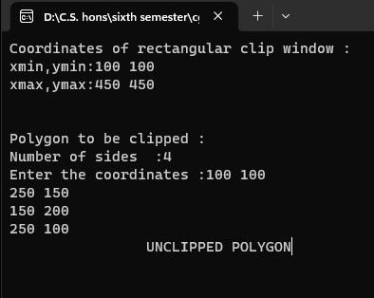

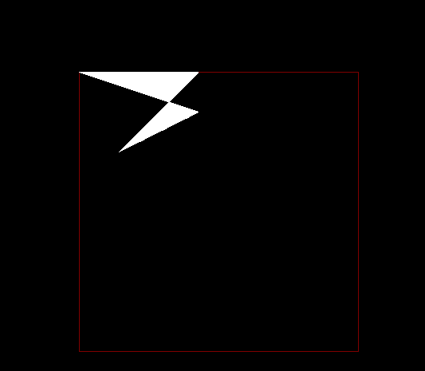

**Q5 Write a program to implement Scan-Line Polygon fill algorithm.**

**Code:-**

#include<iostream>

#include<conio.h>

#include<graphics.h>

using namespace std;

struct edge

{

int x1,y1,x2,y2,flag;

};

int main()

{

int gd=DETECT,gm,n,i,j,k;

edge ed[10], temped;

float dx,dy,m[10],x_int[10],inter_x[10];

int x[10],y[10],ymax=0,ymin=480,yy,temp;

initgraph(&gd,&gm,"");

cout<<"Enter the no. of vertices of the polygon : ";

cin>>n;

cout<<"\nEnter the vertices :- \n";

for(i=0;i<n;i++)

{

cout<<"P"<<i+1<<" : ";

cin>>x[i]>>y[i];

if(y[i]>ymax)

ymax=y[i];

if(y[i]<ymin)

ymin=y[i];

ed[i].x1=x[i];

ed[i].y1=y[i];

}

for(i=0;i<n-1;i++)

{

ed[i].x2=ed[i+1].x1;

ed[i].y2=ed[i+1].y1;

ed[i].flag=0;

}

ed[i].x2=ed[0].x1;

ed[i].y2=ed[0].y1;

ed[i].flag=0;

for(i=0;i<n;i++)

{

if(ed[i].y1 < ed[i].y2)

{

temp=ed[i].x1;

ed[i].x1=ed[i].x2;

ed[i].x2=temp;

temp=ed[i].y1;

ed[i].y1=ed[i].y2;

ed[i].y2=temp;

}

}

for(i=0;i<n;i++)

{

line(ed[i].x1, ed[i].y1,ed[i].x2,ed[i].y2);

}

for(i=0;i<n-1;i++)

{

for(j=0;j<n-1;j++)

{

if(ed[j].y1<ed[j+1].y1)

{

temped=ed[j];

ed[j]=ed[j+1];

ed[j+1]=temped;

}

if(ed[j].y1==ed[j+1].y1)

{

if(ed[j].y2<ed[j+1].y2)

{

temped=ed[j];

ed[j]=ed[j+1];

ed[j+1]=temped;

}

if (ed[j].y2==ed[j+1].y2)

{

if(ed[j].x1<ed[j+1].x1)

{

temped=ed[j];

ed[j]=ed[j+1];

ed[j+1]=temped;

}

}

}

}

}

for(i=0;i<n;i++)

{

dx=ed[i].x2-ed[i].x1;

dy=ed[i].y2-ed[i].y1;

if(dy==0)

{

m[i]=0;

}

else

{

m[i]=dx/dy;

}

inter_x[i]=ed[i].x1;

}

yy=ymax;

while(yy>ymin)

{

for(i=0;i<n;i++)

{

if(yy>ed[i].y2 && yy<=ed[i].y1)

{

ed[i].flag=1;

}

else

{

ed[i].flag=0;

}

}

j=0;

for(i=0;i<n;i++)

{

if(ed[i].flag==1)

{

if(yy==ed[i].y1)

{

x_int[j]==ed[i].x1;

j++;

if(ed[i-1].y1==yy && ed[i-1].y1<yy)

{

x_int[j]=ed[i].x1;

j++;

}

if(ed[i+1].y1==yy && ed[i+1].y1<yy)

{

x_int[j]=ed[i].x1;

j++;

}

}

else

{

x_int[j]=inter_x[i]+(-m[i]);

inter_x[i]=x_int[j];

j++;

}

}

}

for(i=0;i<j;i++)

{

for(k=0;k<j-1;k++)

{

if(x_int[k]>x_int[k+1])

{

temp=(int)x_int[k];

x_int[k]=x_int[k+1];

x_int[k+1]=temp;

}

}

}

for(i=0;i<j;i=i+2)

{

line((int)x_int[i],yy,(int)x_int[i+1],yy);

}

yy--;

delay(10);

}

getch();

return 0;

}

**Output:-**

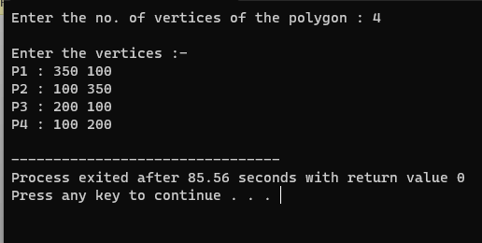



**Q6 Write a program to apply various 2D transformations on 2D object (use homogeneous objects).**

**Code:-**

#include <conio.h>

#include <iostream>

#include <graphics.h>

using namespace std;

int c = 400;

class point

{

public:

float x,y;

};

class matrix

{

private:

point p[20];

point t[2];

point pp[1];

int points;

public:

void read()

{

setcolor(2);

cout<<"Enter no. of points : ";

cin>>points;

cout<<"\nCAUTION : Enter value between 0 and 400 for x and y values!!!\n";

cout<<"\nEnter coordinates :-\n";

for(int i=0;i<points;i++)

{

cout<<"Enter P"<<i+1<<" : ";

cin>>p[i].x>>p[i].y;

}

}

void readT()

{

cout<<"\nEnter Transformation matrix (2X2) :- \n";

for(int i=0;i<2;i++)

cin>>t[i].x>>t[i].y;

}

void transform()

{

setcolor(3);

for(int i=0;i<points;i++)

{

pp[0].x = p[i].x*t[0].x + p[i].y*t[1].x;

pp[0].y = p[i].x*t[0].y + p[i].y*t[1].y;

p[i].x = (int)(pp[0].x);

p[i].y = (int)(pp[0].y);

}

}

void draw()

{

for(int i=0;i<points;i++)

line(c+p[i].x, c-p[i].y, c+p[(i+1)%points].x, c-p[(i+1)%points].y);

}

void show()

{

cout<<endl;

for(int i=0;i<points;i++)

cout<<p[i].x<<" "<<p[i].y<<endl;

}

};

void printaxis()

{

setcolor(YELLOW);

line(c,0,c,c*2);

line(0,c,c*2,c);

for(int i=50;i<c*2;i+=50) line(c-10,i,c+10,i);

for(int i=50;i<c*2;i+=50) line(i,c-10,i,c+10);

setcolor(WHITE);

}

int main()

{

initwindow(c*2,c*2);

printaxis();

matrix m;

m.read();

m.show();

m.draw();

m.readT();

m.transform();

m.show();

m.draw();

getch();

return 0;

}

**Output:-**

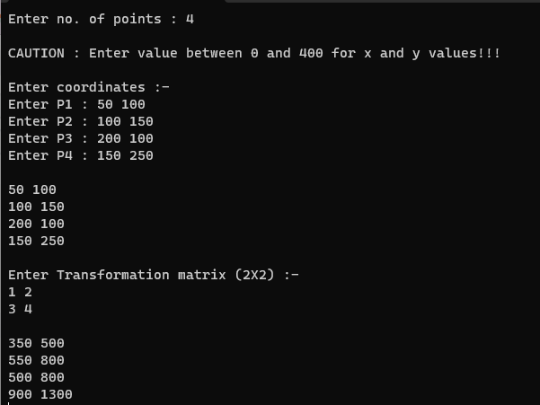

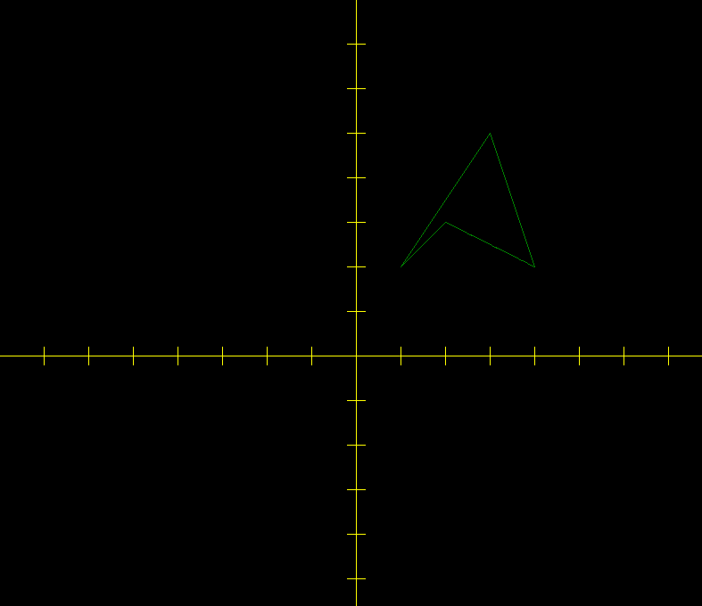

**Q7 Write a program to apply various 3D transformations on a 3D object and then apply parallel and perspective projection on it.**

**Code:-**

#include<iostream>

#include<math.h>

#include<conio.h>

#include<graphics.h>

using namespace std;

class matrix

{

int nodes[10][4];

float T[4][4];

int size;

public:

matrix(int s)

{

size = s;

cout << "\nThe number of nodes are : \n" << size;

for(int i =0;i<size;++i)

nodes[i][3] = 1;

}

void input()

{

cout << endl;

for(int i=0;i<size;++i)

{

cout << "Enter P" << i<<" : ";

for(int j=0;j<3;++j)

cin >> nodes[i][j];

}

cout << "\nBefore\n";

drawMy(nodes);

cout << endl;

}

void drawMy(int x[][4])

{

cout << "\nTransformation"<<endl;

for(int i=0;i<size;++i)

{

line(200 + x[i%size][0],200 + x[i%size][1], 200 + x[(i+1)%size][0],200 + x[(i+1)%size][1]);

}

cout << endl;

}

void rotation()

{

setcolor(RED);

for(int i=0;i<size;++i)

{

for(int j=0;j<4;++j)

{

cout << nodes[i][j] << " ";

}

cout << endl;

}

int angle;

cout << "Enter angle along x axis : ";

cin >> angle;

float r = angle*(3.14/180);

float T[4][4];

T[0][0] = 1;

for (int i=1;i<=3;++i)

T[0][i] = 0;

for(int i=1;i<=3;++i)

T[i][0] = 0;

T[3][1] = 0;

T[3][2] = 0;

T[3][3] = 1;

T[0][3] = 0;

T[1][3] = 0;

T[2][3] = 0;

T[1][1] = cos(r);

T[1][2] = sin(r);

T[2][1] = -1*sin(r);

T[2][2] = cos(r);

for(int i=0;i<4;++i)

{

for(int j=0;j<4;++j)

{

cout << T[i][j] << " ";

}

cout << endl;

}

float rr[3][4];

int n = size;

cout << "\nSize is : " << n << endl;

for(int i=0;i<n;i++)

for(int j=0;j<4;j++)

rr[i][j]=0;

for(int i=0;i<size;i++)

{

for(int j=0;j<4;j++)

{

rr[i][j] = 0;

for(int k=0;k<4;k++)

rr[i][j] += nodes[i][k]*T[k][j];

}

}

cout << endl;

for(int i=0;i<size;++i)

{

for(int j=0;j<4;++j)

cout << rr[i][j] << " ";

cout << endl;

}

for(int i=0;i<size;++i)

{

line(round(200 + rr[i%size][0]),round(200 + rr[i%size][1]), round(200 + rr[(i+1)%size][0]),round(200 + rr[(i+1)%size][1]));

}

}

};

int main()

{

int gdriver = DETECT, gmode;

initgraph(&gdriver, &gmode, "");

matrix m(3);

m.input();

m.rotation();

getch();

return 0;

}

**Output:-**

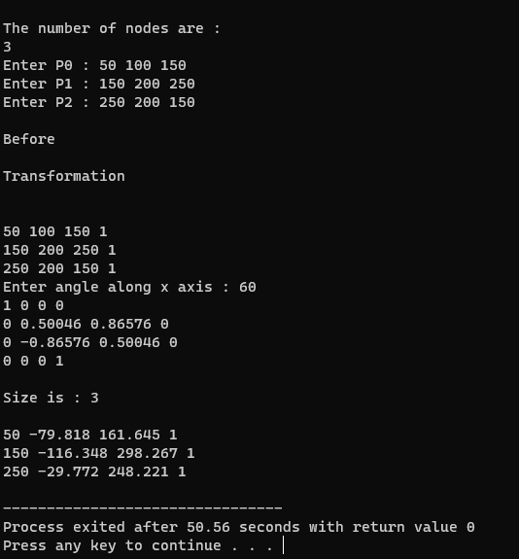

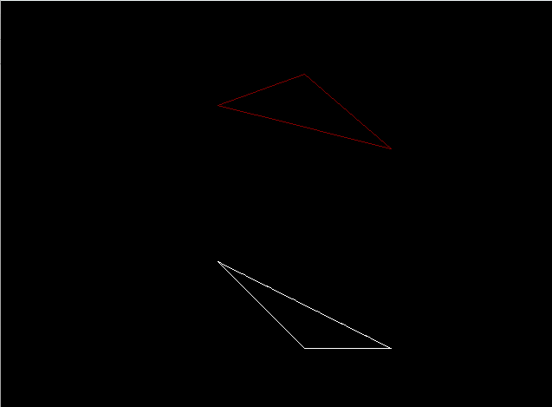

**Q8 Write a program to draw Hermite/Bezier curve.**

**Code:-**

#include<stdio.h>

#include<graphics.h>

#include<iostream>

#include<conio.h>

#include<stdlib.h>

#include<math.h>

void bezier(int x[4], int y[4])

{

double t;

for(t=0.0;t < 1.0;t+=0.0005)

{

double xt=pow(1-t,3)*x[0]+3*t*pow(1-t,2)*x[1]+3*pow(t,2)*(1-t)*x[2]+pow(t,3)*x[3];

double yt=pow(1-t,3)*y[0]+3*t*pow(1-t,2)*y[1]+3*pow(t,2)*(1-t)*y[2]+pow(t,3)*y[3];

putpixel(xt,yt,BLUE);

}

for(int i=0;i < 4;i++)

putpixel(x[i],y[i],YELLOW);

getch();

closegraph();

return;

}

int main()

{

int gdriver = DETECT, gmode, errorcode;

initgraph(&gdriver, &gmode, "..\\bgi");

errorcode = graphresult();

if (errorcode != grOk)

{

printf("Graphics error: %s\n", grapherrormsg(errorcode));

printf("Press any key to halt:");

getch();

exit(1);

}

int x[4],y[4];

int i;

std::cout<<"Enter x and y coordinates"<<std::endl;

for(i=0;i < 4;i++)

{

std::cin>>x[i];

std::cout<<std::endl;

std::cin>>y[i];

}

bezier(x,y);

}

**Output:-**

