RAMANUJAN COLLEGE

UNIVERSITY OF DELHI



**Core:** **Internet Technologies**

**Practical File**

**SUBMITTED TO:** Dr. Kamlesh Raghuvanshi

**SUBMITTED BY:** Sukaina Inam Naqvi

**ROLL NO –** 20201426

**Examination Roll No.-** 20020570033

B.Sc. (H) Computer Science |   V Semester

Practical 1

1.Display your systems IP Address, Subnet mask using ipconfig, and find out the network address and the maximum number of systems possible on your network and range of IP addresses available to these systems

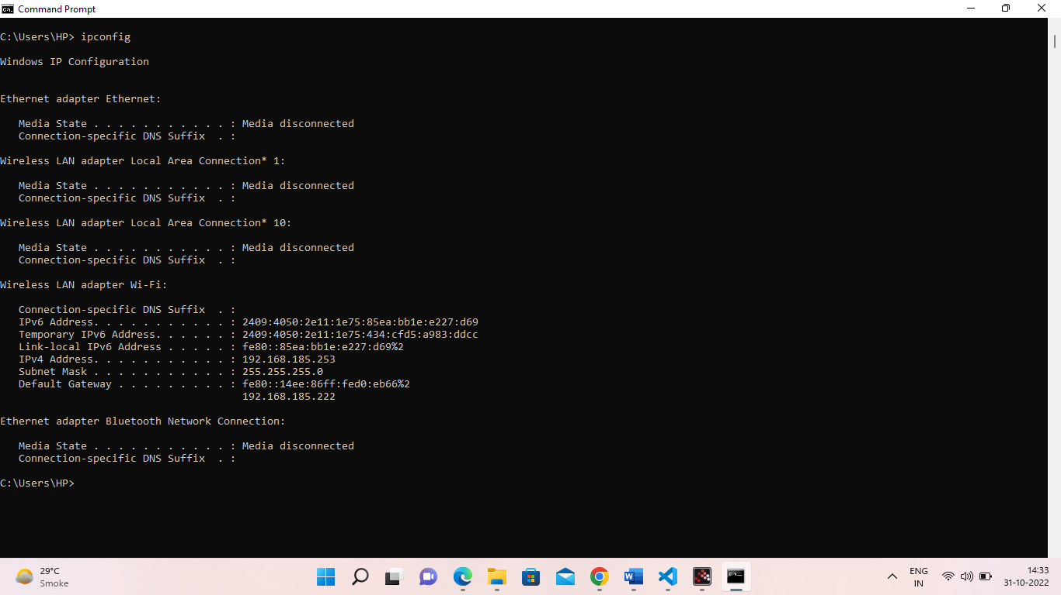

**● System IP Address: 192.168.43.165**

**● Subnet mask: 255.255.255.0**

**● Network ID: 192.168.43.0**

**● Broadcast ID: 192.168.43.255**

**● Maximum number of system possible on the network: 254**

**● Range of IP addresses: 192.168.43.0 to 192.168.43.255**

**● Class type: C**

Practical 2

With help of ping, check if you are connected to other systems of your network and find the route to connect to that system using tracert. List all the processes which are using ports for TCP protocol.

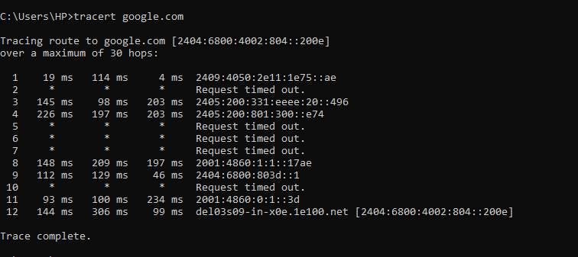

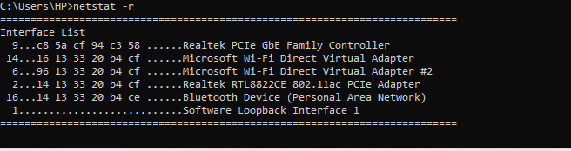

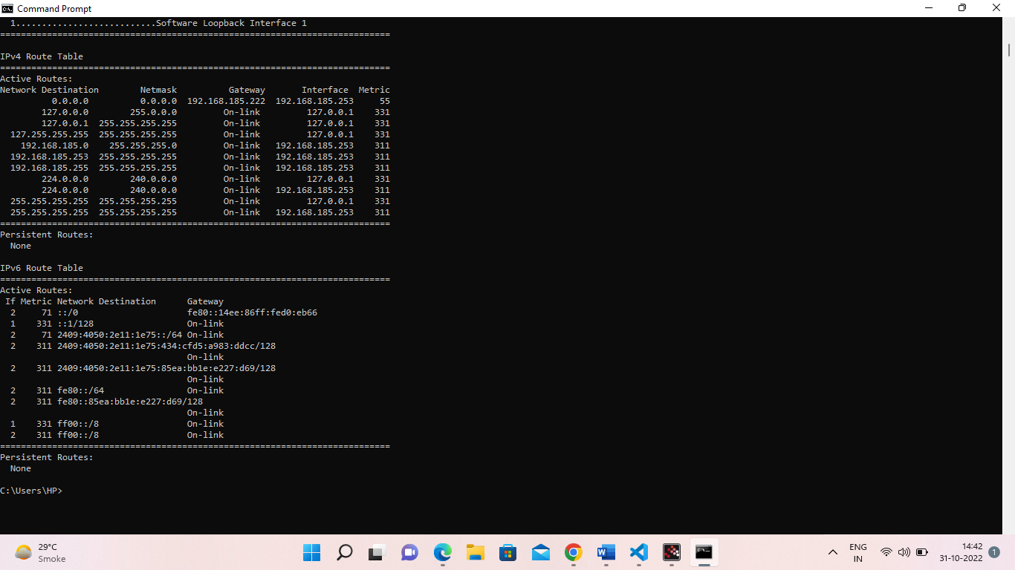

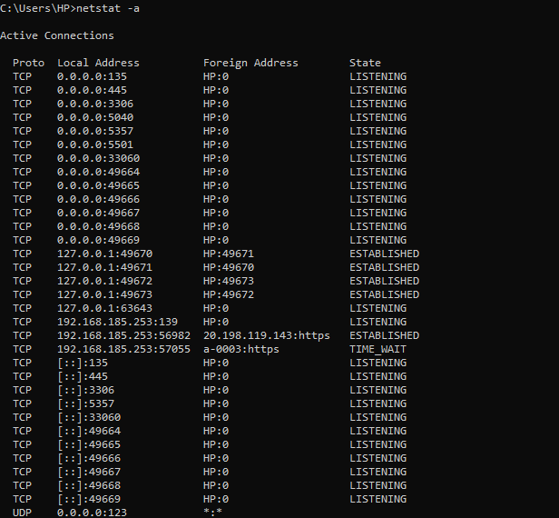

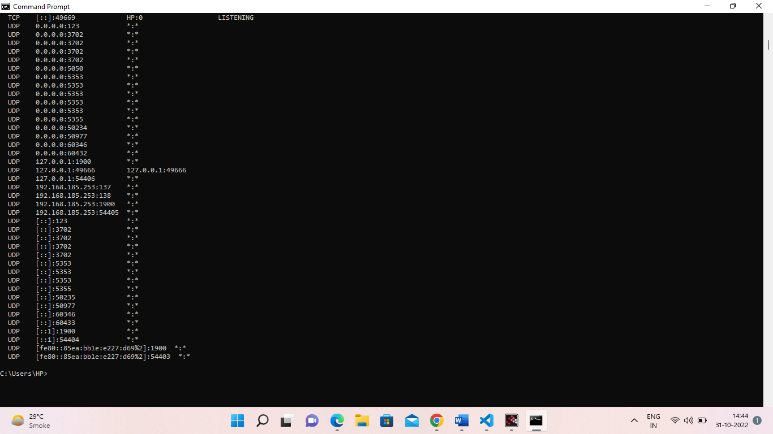

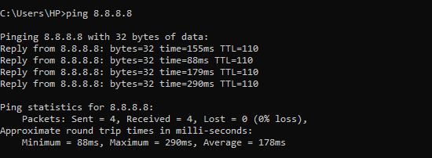

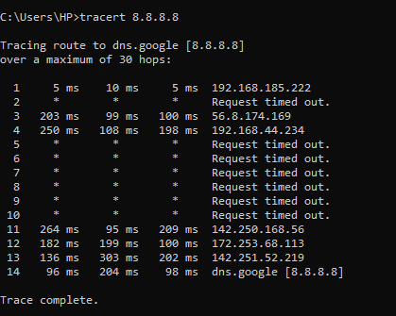

Practical 3

Create an HTML page that shows information about you, your course, hobbies, address, and your plans. Use CSS for styling of HTML page so that looks nice.

<!DOCTYPE html>

<html>

<head>

    <title>Practical 3</title>

    <meta charset="utf-8">

    <meta name="viewport" content="width=device-width, initial-scale=1.0">

    <style type="text/css">

        body{

            background: grey;

        }

        .container{

            width: 30%;

            min-width: 330px;

            margin: auto;

            margin-top: 10px;

            margin-bottom: 10px;

            background-image: url('https://encrypted-tbn0.gstatic.com/images?q=tbn:ANd9GcRgilZbOsXfG-KH8r99d0OKXkX9NI9Nyi-k5g&usqp=CAU');

            background-size: contain;

            border: 1px solid black;

            padding: 10px;

            border-radius: 8px;

        }

        .my-5{

            margin-top: 5px;

            margin-bottom: 5px;

        }

        .underline{

            text-decoration: underline;

        }

        .main{

            display: flex;

            flex-wrap: wrap;

        }

        .sub-head{

            font-weight: bold;

        }

    </style>

</head>

<body>

    <div class="main">

        <div class="container">

            <h1 class="my-5 underline">Sukaina Inam Naqvi</h1>

            <p>Bsc. Computer Science Hons.</p>

            <p>5th Sem, 3rd Year</p>

        </div>

        <div class="container">

            <p>

                <span class="underline sub-head">Hobbies:</span>

                <span> Watching movies, Travelling, Coding</span>

            </p>

            <p>

                <span class="underline sub-head">Address:</span>

                <span> SRS Residency Sector 88 ,Faridabad</span>

            </p>

        </div>

        <div class="container">

            <p>

                <span class="underline sub-head">Plans: </span>

                <ul>

                    <li>To be a great Web Designer</li>

                    <li>To find something innovative in the field of technology</li>

                    <li>Better world for all</li>

                </ul>

            </p>

        </div>

    </div>

</body>

</html>







Practical 4

Create an HTML page with the sole purpose to show multiplication tables of 2 to 10 (row-wise) created by JavaScript. Initially, the page is blank. With help of setInterval function print a row every 5 seconds in different colors and increasing font size.

<!DOCTYPE html>

<html>

<head>

  <title>Practical 4</title>

  <meta charset="utf-8">

  <style type="text/css">

    table{

      border: 1px solid black;

      border-collapse: collapse;

      width: 80%;

      margin: auto;

    }

    td,th{

      border: 1px solid black;

      padding: 5px;

      /* border-collapse: collapse; */

    }

    .center{

      text-align: center;

    }

  </style>

</head>

<body>

  <h1>Printing Table from 2 to 10</h1>

  <table class="center" id="content">

  </table>

  <script type="text/javascript">

    function getRandomColor() {

        var letters = '0123456789ABCDEF';

        var color = '#';

        for (var i = 0; i < 6; i++) {

          color += letters[Math.floor(Math.random() * 16)];

        }

      return color;

    }

    var tbl = document.getElementById('content');

    var number = 2;

    var abc = setInterval(printrow,5000);

    function printrow(){

      if (number == 10)

      {

        clearInterval(abc);

      }

      var result = "";

      for(var i = 1; i<= 10; i++){

        result = result + "<td>"+ number + "*" + i + "=" + number * i+"</td>";

      }

      number++;

      var row = document.createElement('tr');

      row.style.color= getRandomColor();

      row.style.fontSize = (number+10)+"px";

      row.innerHTML=result;

      tbl.append(row);

    }

  </script>

</body>

</html>

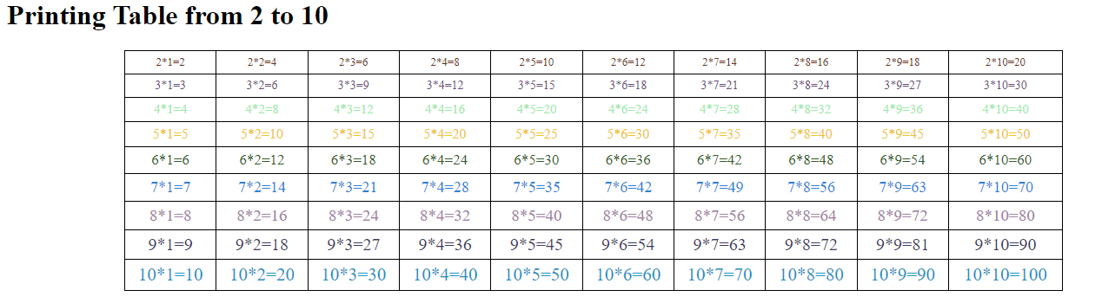

Practical 5

Create an HTML page with a paragraph written on it and under which 9 buttons are placed in a 3X3 grid. The first row is for buttons labeled with colors names Red, Green, and Blue, the second row with numbers 10, 20, 30, and the third row with different font names. Click event of each of the buttons should make the appropriate change in the style of paragraph.

<!DOCTYPE html>

<html>

<head>

    <title>Practical 5</title>

    <meta charset="utf-8">

    <style type="text/css">

        .btn-box{

            display: flex;

            flex-wrap: wrap;

            justify-content: space-around;

            border: 1px solid black;

            padding: 10px;

        }

        .color, .fontSize, .fontStyle{

            width: 30%;

            min-width: 350px;

            height: 35px;

            /*margin: auto;*/

            margin-bottom: 10px;

            border: 1px solid #F3F1F5;

            box-shadow: 4px 4px 5px #B42B51;

            border-radius: 10px;

            color: #F3F1F5;

            background-color: #420516;

            font-weight: bold;

            font-size: 15px;

        }

    </style>

</head>

<body>

    <h1>Changing style of Below given paragraph</h1>

    <p id="container">

        <l>Internet Technologies</l>

        <l>Practical Number 5</l>

        <l>Submitted By- Sukaina Inam Naqvi</l>

        <l>Roll no- 20201426 ||   20020570033</l>

        <l>V SEM , 3rd Year</l>

    </p>

    <div class="btn-box">

        <button class="color">Red</button>

        <button class="color">Blue</button>

        <button class="color">Green</button>

    </div>

    <div class="btn-box">

        <button class="fontSize">10</button>

        <button class="fontSize">20</button>

        <button class="fontSize">30</button>

    </div>

    <div class="btn-box">

        <button class="fontStyle">'Courier New', monospace</button>

        <button class="fontStyle">'Brush Script MT', cursive</button>

        <button class="fontStyle">Verdana, sans-serif</button>

    </div>

    <script type="text/javascript">

        var colors = document.getElementsByClassName("color");

        var fontSizes = document.getElementsByClassName("fontSize");

        var fontStyles = document.getElementsByClassName("fontStyle");

        var element = document.getElementById('container');

        for (var i = 0; i < colors.length; i++) {

            colors[i].addEventListener('click', changeColor);

        }

        for (var i = 0; i < fontSizes.length; i++) {

            fontSizes[i].addEventListener('click', changeFontSize);

        }

        for (var i = 0; i < fontStyles.length; i++) {

            fontStyles[i].addEventListener('click', changeFontStyle);

        }

        function changeColor(){

            // console.log(this.innerHTML);

            element.style.color = this.innerHTML;

        }

        function changeFontSize(){

            // console.log(this.innerHTML);

            element.style.fontSize = this.innerHTML + "px";

        }

        function changeFontStyle(){

            // console.log(this.innerHTML);

            element.style.fontFamily = this.innerHTML;

        }

    </script>

</body>

</html>

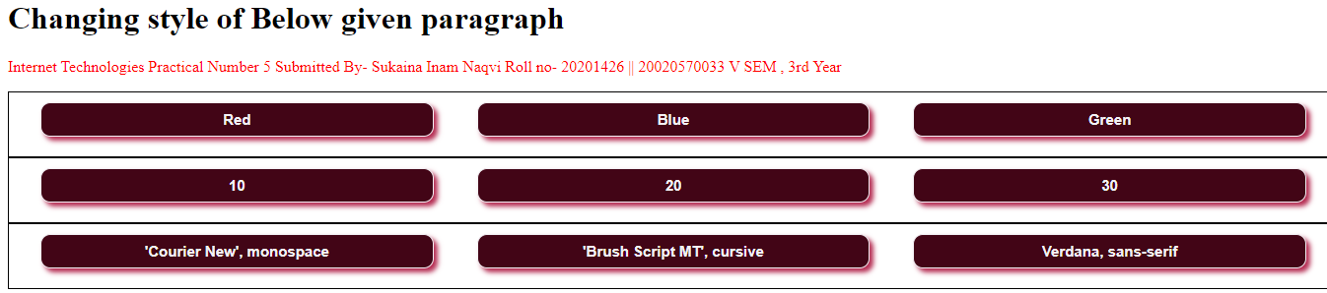

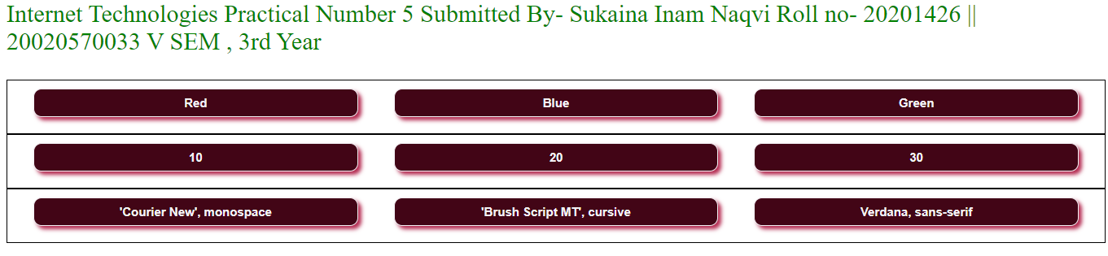

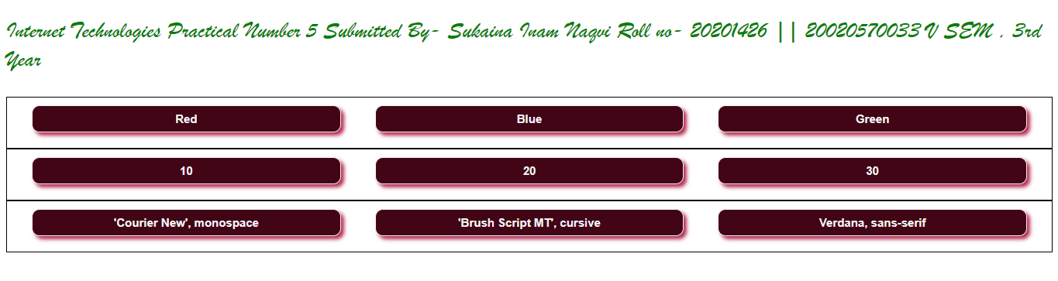

Practical 6

Create a form that takes data about a pet. The form must be well designed and should accept the pet’s name, age, weight, type, and what it likes most. At the submission of this form create a Pet object in JavaScript filled with these values and log that object and equivalent JSON on the console.

<!DOCTYPE html>

<html>

<head>

    <meta charset="utf-8">

    <title>Practical 6</title>

    <style type="text/css">

        .container{

*width*: 60%;

*margin*: auto;

*border*: 1px solid black;

*border-radius*: 8px;

*padding*: 50px;

        }

        .btn-submit{

*border-radius*: 5px;

*color*: white;

*background*: greenyellow;

*font-weight*: bold;

*font-size*: 1rem;

*margin*: 20px;

        }

        @media(*width*<=575){

            .container{

*width*: 84%;

            }

        }

    </style>

</head>

<body>

    <div class="container">

        <h1>Pet's Information</h1>

        <hr>

        <label for="name">Pet's Name: </label>

        <input type="text" name="name"><br><br>

        <label for="age">Age: </label>

        <input type="number" name="age">

        <label for="weight">Weight: </label>

        <input type="number" name="weight" class=""><br><br>

        <label for="type">Pet type: </label>

        <input type="text" name="type"><br><br>

        <label for="likes">Likes: </label>

        <input type="text" name="likes"><br>

        <button class="btn-submit" onclick="display()">Submit</button>

    </div>

    <script type="text/javascript">

*function* display(){

            // event.preventDafault();

*var* pet = {};

*var* input_fields = document.getElementsByTagName('input');

            for (*var* i = 0; i < input_fields.length; i++) {

                pet[input_fields[i].name] = input_fields[i].value;

            }

            console.log(pet);

        }

    </script>

</body>

</html>



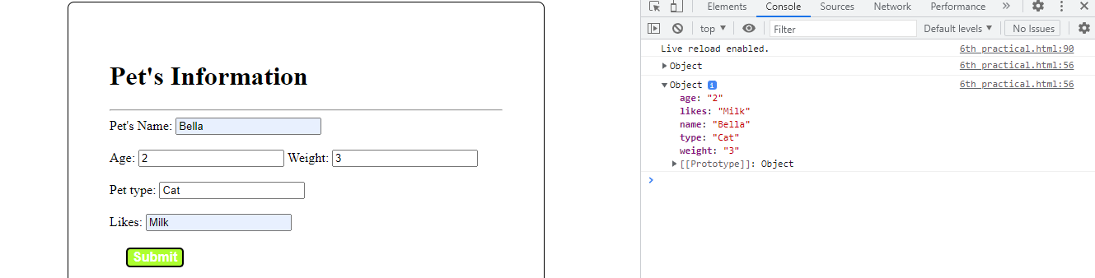

Practical 7

Store JSON data of few pets that you created in previous practical in a JSON file (copy from console output of previous program to a .json file). Using AJAX, load data from the file and display it in a presentable way using HTML and CSS.

<!DOCTYPE html>

<html lang="en">

<head>

    <meta charset="utf-8">

    <meta name="viewport" content="width=device-width, initial-scale=1.0" />

    <title>Practical 7</title>

    <style type="text/css">

        #pet-data {

*border*: 1px solid black;

*border-radius*: 10px;

*border-collapse*: collapse;

        }

        td {

*border*: 1px solid black;

*border-collapse*: collapse;

        }

        #btn-fetch {

*margin-top*: 20px;

*font-size*: 24px;

*font-weight*: bold;

*background-color*: black;

*color*: white;

*border-radius*: 8px;

        }

    </style>

</head>

<body>

    <div id="content">

    </div>

    <button id="btn-fetch">Fetch Data</button>

    <script src="https://ajax.googleapis.com/ajax/libs/jquery/3.5.1/jquery.min.js"></script>

    <script type="text/javascript">

*var* btnFetch = document.getElementById('btn-fetch');

*var* content = document.getElementById('content');

        btnFetch.addEventListener('click', () *=>* {

*const* xhr = new *XMLHttpRequest*();

            xhr.open("GET", "./pet.json", true);

            xhr.onload = () *=>* {

                console.log(xhr.responseText);

                renderHtml(JSON.parse(xhr.responseText));

            }

            xhr.send();

        });

*function* renderHtml(*data*) {

            content.innerHTML = "";

            for (*var* i = 0; i <= *data*.length; i++) {

*let* p = document.createElement('p');

*let* htmlpart = "";

                htmlpart += *data*[i].name + " is a " + *data*[i].type + " with age " + *data*[i].age + " years and weight " + *data*[i].weight + "kg and likes " + *data*[i].likes;

                p.innerHTML = htmlpart;

                content.append(p);

                // console.log(tr);

                htmlpart = "";

            }

        }

    </script>

</body>

</html>

Output

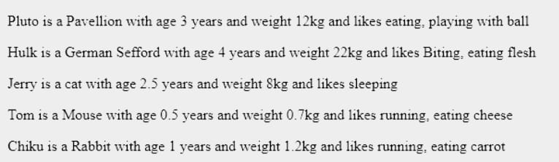

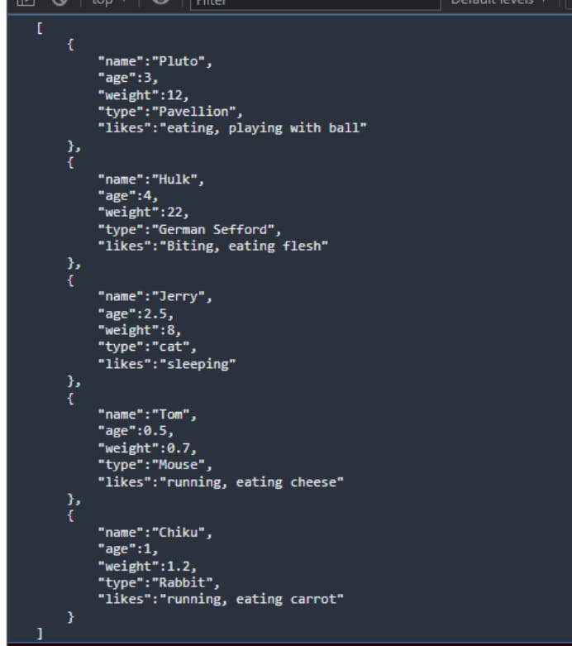

Practical 8

Create a plain HTML page for B.Sc. Hons CS course, mentioning details like fee, eligibility criteria, papers with names and credits, and future possibilities after the course. A button for styling should be there at bottom of the page. On clicking on this button JavaScript should redesign the complete page using jQuery in a nice presentable way.

<!DOCTYPE html>

<html>

<head>

    <meta charset="utf-8">

    <title>Practical 8</title>

    <style type="text/css">

        .container {

*width*: 70%;

*margin*: auto;

*align-items*: center;

*background-color*: #D9CAB3;

*padding-bottom*: 10px;

        }

        .info-table {

*width*: 80%;

*margin*: auto;

*border*: 3px solid black;

*border-collapse*: collapse;

*margin-top*: 2%;

*margin-bottom*: 2%;

        }

        .table-row {

*width*: 100%;

*margin*: auto;

        }

        .table-data {

*width*: 50%;

*border*: 2px solid white;

*border-collapse*: collapse;

        }

    </style>

</head>

<body>

    <div>

        <h1 class="heading">Bsc Hons Computer Science</h1>

        <table>

            <tr>

                <td>Fee</td>

                <td>33000</td>

            </tr>

            <tr>

                <td>Eligibility Criteria</td>

                <td>10-12 Pass</td>

            </tr>

            <tr>

                <td>Subjects and credit scores</td>

                <td>

                    <table>

                        <tr>

                            <th>Subject</th>

                            <th>Credit score</th>

                        </tr>

                        <tr>

                            <td>IT</td>

                            <td>6</td>

                        </tr>

                        <tr>

                            <td>Toc</td>

                            <td>6</td>

                        </tr>

                        <tr>

                            <td>DAV</td>

                            <td>4</td>

                        </tr>

                        <tr>

                            <td>DIP/Micro</td>

                            <td>4</td>

                        </tr>

                    </table>

                </td>

            </tr>

            <tr>

                <td>Future Opportunities</td>

                <td> Web Designing, Coding</td>

            </tr>

        </table>

    </div

    <button id="btn-style">

        Style Page

    </button>

    <script src="https://ajax.googleapis.com/ajax/libs/jquery/3.5.1/jquery.min.js"></script>

    <script type="text/javascript">

        $(document).ready(*function* () {

            $('#btn-style').click(*function* () {

                $("div").addClass('container');

                $("table").addClass('info-table');

                $("tr").addClass('table-row');

                $("td").addClass('table-data');

                $(".heading").css({

                    "textAlign": 'center'

                });

            });

        });

    </script>

</body>

</html>

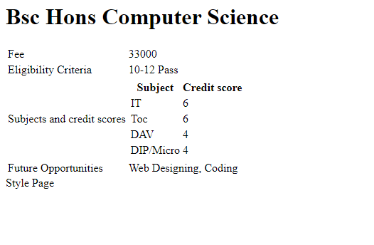

Practical 9

Create an HTML page for an image gallery which shows the use of BOOTSTRAP to rearrange and resize its contents on resizing the browser.

<!DOCTYPE html>

<html>

<head>

    <meta charset="utf-8">

    <meta name="viewport" content="width=device-width, initial-scale=1">

    <link rel="stylesheet" href="https://maxcdn.bootstrapcdn.com/bootstrap/3.4.1/css/bootstrap.min.css">

    <title>Practical 9</title>

    <style type="text/css">

        /*img{

            margin: 20px;

        }*/

    </style>

</head>

<body>

    <div class="jumbotron text-center">

      <h1>IMAGE GALLERY</h1>

      <p>Responsive Image gallery using bootstrap.</p>

    </div>

    <div class="container">

        <img class="col-sm-4" src="https://picsum.photos/200/"></img>

        <img class="col-sm-4" src="https://picsum.photos/200/"></img>

        <img class="col-sm-4" src="https://picsum.photos/200/"></img>

        <img class="col-sm-4" src="https://picsum.photos/200/"></img>

        <img class="col-sm-4" src="https://picsum.photos/200/"></img>

        <img class="col-sm-4" src="https://picsum.photos/200/"></img>

    </div>

    <script src="https://ajax.googleapis.com/ajax/libs/jquery/3.5.1/jquery.min.js"></script>

    <script src="https://maxcdn.bootstrapcdn.com/bootstrap/3.4.1/js/bootstrap.min.js"></script>

</body>

</html>

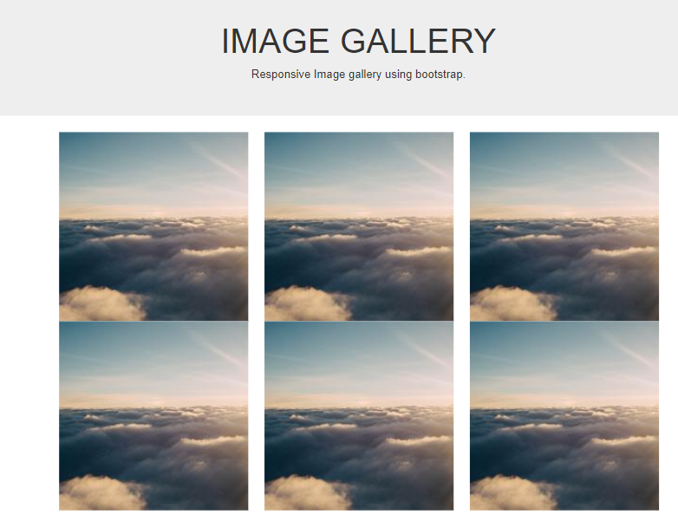

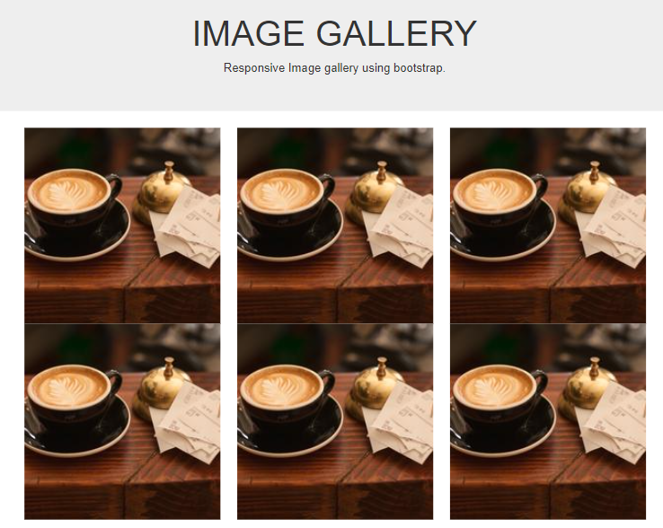

Practical 10

Create an HTTP server using Node.js which handles requests on port 10000 or a free port beyond 10000. Modify the server in such a way that opening localhost:10000 will display “Hello world, This is my Node.js server” on browser.

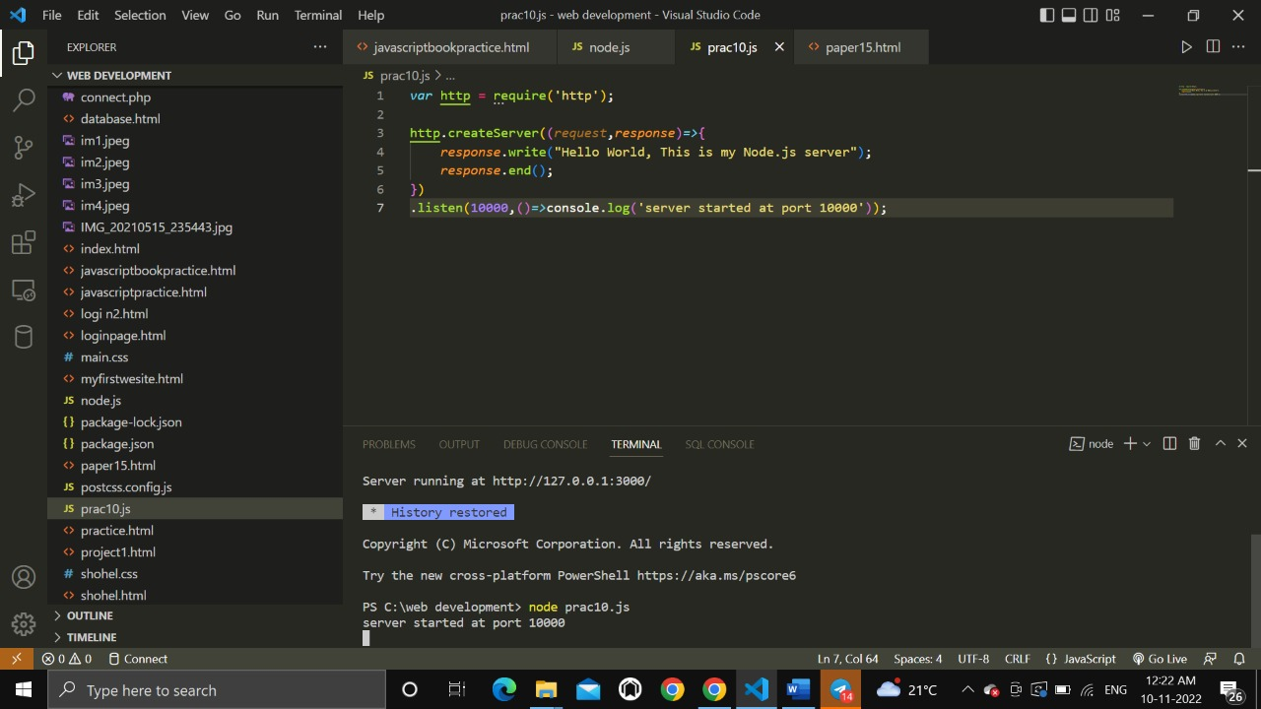

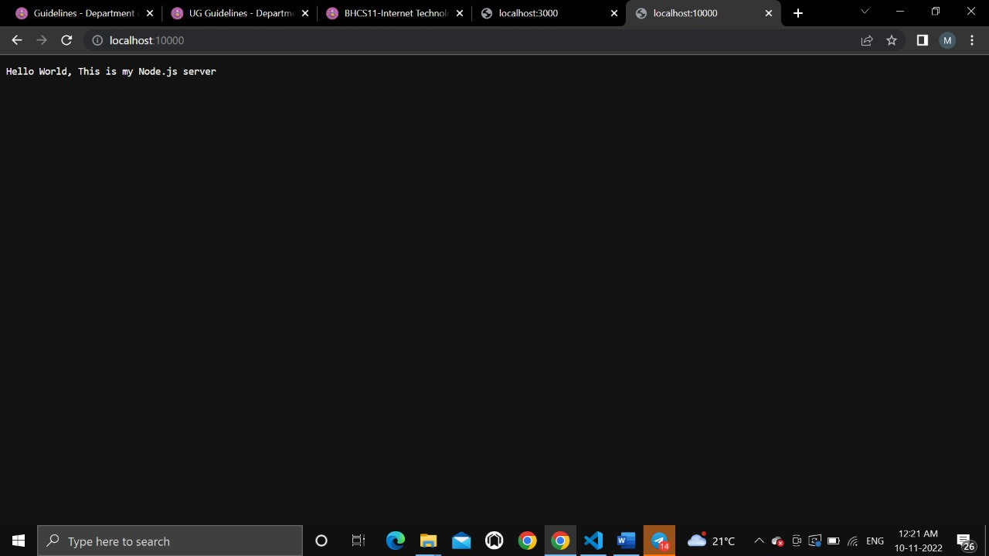

Practical 11

Create index.html file containing two forms for SignIn and SignUp. Submitting SignIn form should search for credentials in mysql database using server created in previous practical. On successful signin, a welcome page should be displayed. Submitting SignUp form should insert new entry for credentials in mysql database using server created in previous practical. On successful signup, user should be returned back to index.html.

Code:

<!DOCTYPE html>

<html lang="en">

  <head>

    <meta charset="UTF-8" />

    <meta http-equiv="X-UA-Compatible" content="IE=edge" />

    <meta name="viewport" content="width=device-width, initial-scale=1.0" />

    <title>SignIn-SignUp Form</title>

    <link rel="stylesheet" href="style.css" />

  </head>

  <body>

    <section class="container">

      <h2>SignIn Form</h2>

      <form class="form">

        <div>

          <label for="username">Username:</label>

          <input type="text" id="username" placeholder="Enter username" />

        </div>

        <div>

          <label for="password">Password:</label>

          <input type="password" id="password" placeholder="Enter password" />

        </div>

        <button class="submit-btn">Submit</button>

      </form>

    </section>

    <section class="container">

      <h2>SignUp Form</h2>

      <form class="form">

        <div>

          <label for="name">Name:</label>

          <input type="text" id="name" placeholder="Enter name" />

        </div>

        <div>

          <label for="email">E-mail:</label>

          <input type="email" id="email" placeholder="Enter e-mail" />

        </div>

        <div>

          <label for="new-username">Username:</label>

          <input

            type="text"

            class="new-username"

            placeholder="Create username"

          />

        </div>

        <div>

          <label for="new-password">Password:</label>

          <input

            type="password"

            id="new-password"

            placeholder="Enter password"

          />

        </div>

        <div>

          <label for="re-password">Password (confirm):</label>

          <input

            type="password"

            id="re-password"

            placeholder="Enter password again"

          />

        </div>

        <button class="submit-btn">Submit</button>

      </form>

    </section>

  </body>

</html>

CSS:

/*

SPACING SYSTEM (px)

2 / 4 / 8 / 12 / 16 / 24 / 32 / 48 / 64 / 80 / 96 / 128

FONT SIZE SYSTEM (px)

10 / 12 / 14 / 16 / 18 / 20 / 24 / 30 / 36 / 44 / 52 / 62 / 74 / 86 / 98

*/

/*

MAIN COLOR: #099268

GREY COLOR: #087f5b

ACCENT: #20c997, #e6fcf5

*/

* {

    margin: 0;

    padding: 0;

    box-sizing: border-box;

  }

  body {

    font-family: sans-serif;

    width: 850px;

    margin: 40px auto;

    display: grid;

    grid-template-columns: repeat(2, 1fr);

    column-gap: 40px;

    align-items: center;

  }

  .container {

    background-color: #e6fcf5;

    padding: 40px;

    border-radius: 30px;

    box-shadow: 0 20px 30px 0 rgb(0, 0, 0, 0.07);

  }

  .form {

    display: grid;

    grid-template-columns: 1fr;

    justify-items: start;

    align-items: center;

    row-gap: 30px;

  }

  h2 {

    background-color: #099268;

    display: inline-block;

    padding: 20px;

    border-radius: 20px;

    color: #e6fcf5;

    margin-bottom: 52px;

    word-spacing: 2px;

    letter-spacing: 0.5px;

  }

  .submit-btn {

    font-size: 18px;

    text-transform: uppercase;

    background-color: #099268;

    border: none;

    color: #fff;

    padding: 10px 20px;

    border-radius: 10px;

    align-self: end;

    letter-spacing: 2px;

  }

  .submit-btn:hover {

    background-color: #087f5b;

    cursor: pointer;

  }

  label {

    display: inline-block;

    margin-bottom: 8px;

    color: #20c997;

    letter-spacing: 0.5px;

    font-size: 16px;

  }

  .form input {

    padding: 10px;

    border-radius: 10px;

    width: 300px;

    height: 50px;

    border: none;

    font-size: 18px;

  }

