Download and install Anaconda Navigator
Open visual studio code from the Anaconda Navigator
Create a dlib environment using the terminal from visual studio code ( “ conda install -c conda-forge dlib “ ) note: it will take some time to finish creating
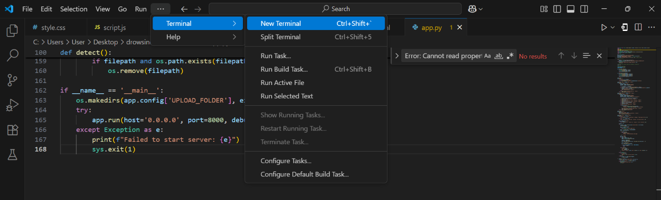

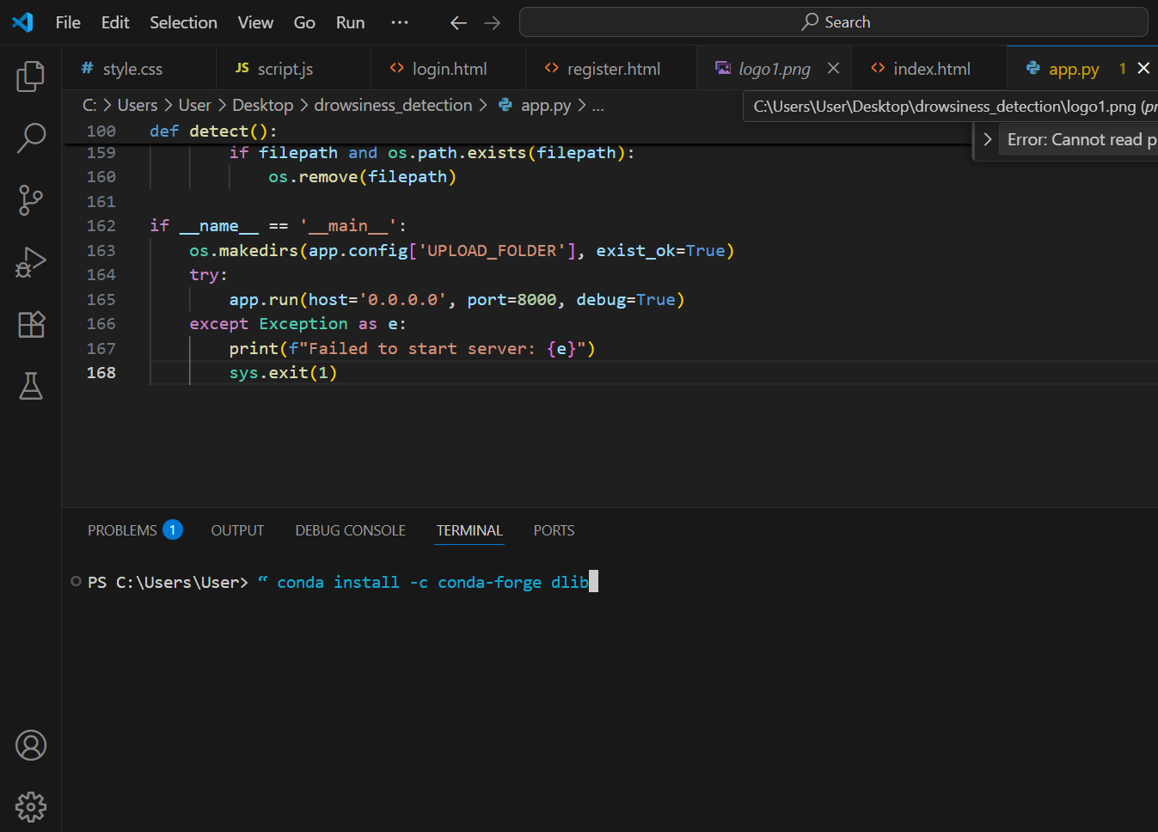
Install the libraries using the terminal from the vs code ( “pip install flask opencv-python dlib imutils scipy werkzeug” )
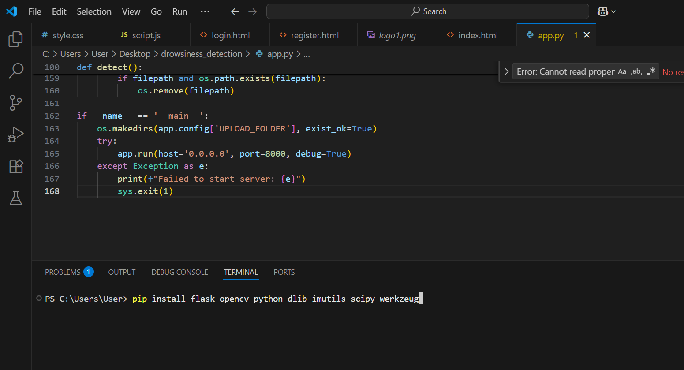
After installing the libraries, open and run the app.py
Open any web browser of your choice and paste ‘’ http://localhost:8000 “ it should open the app for you

Drowsiness Detection System Overview
This system uses computer vision and facial landmark detection to monitor a user's eyes and mouth in real-time or through uploaded images to detect signs of drowsiness. It alerts the user when drowsiness is detected, helping prevent accidents caused by fatigue (e.g., while driving or operating machinery).

How Detection Works
- Face Detection
  - Uses dlib’s HOG-based face detector to locate faces in the image/video feed.
- Facial Landmark Detection
  - Uses 68-point facial landmarks (via shape_predictor_68_face_landmarks.dat) to identify:
    - Eyes (Points 36-47)
    - Mouth (Points 48-67)
- Eye Aspect Ratio (EAR) Calculation
  - Measures eye openness using the formula:
text
EAR = (||p2-p6|| + ||p3-p5||) / (2 x ||p1-p4||)
  - If EAR < 0.25 → Eye is closed (drowsiness detected).
- Mouth Aspect Ratio (MAR) Calculation
  - Measures mouth openness using the formula:
text
MAR = (||p51-p59|| + ||p52-p58|| + ||p53-p57||) / (3 x ||p49-p55||)
  - If MAR > 0.5 → Mouth is open (possible yawning).
- Decision Making
  - If EAR is low (eyes closed) or MAR is high (yawning), the system triggers an alarm (sound + visual alert).

Key Features
Real-Time Camera Detection
- Uses webcam feed to continuously monitor for drowsiness.
- Updates detection results every second.
Image Upload Detection
- Users can upload images for analysis.
- Returns EAR/MAR metrics with drowsiness status.
User Authentication
- Secure login/registration with password hashing.
- Session management for logged-in users.
Technical Stack
- Backend: Flask (Python)
- Computer Vision: OpenCV + dlib
- Frontend: HTML, CSS, JavaScript
- Authentication: Werkzeug (password hashing)

How to Use
- Register/Login
  - Users must create an account to access detection features.
- Image Detection
  - Upload an image → System analyzes it for drowsiness.
- Real-Time Detection
  - Click "Start Camera" → System monitors via webcam.
  - Alerts appear if drowsiness is detected.
- Logout
  - Session ends, and the user returns to the login page.

