Jenkins

It is a java application and used for CI/CD.

Download:

Step 1: Go to <https://www.jenkins.io/>. Click Download

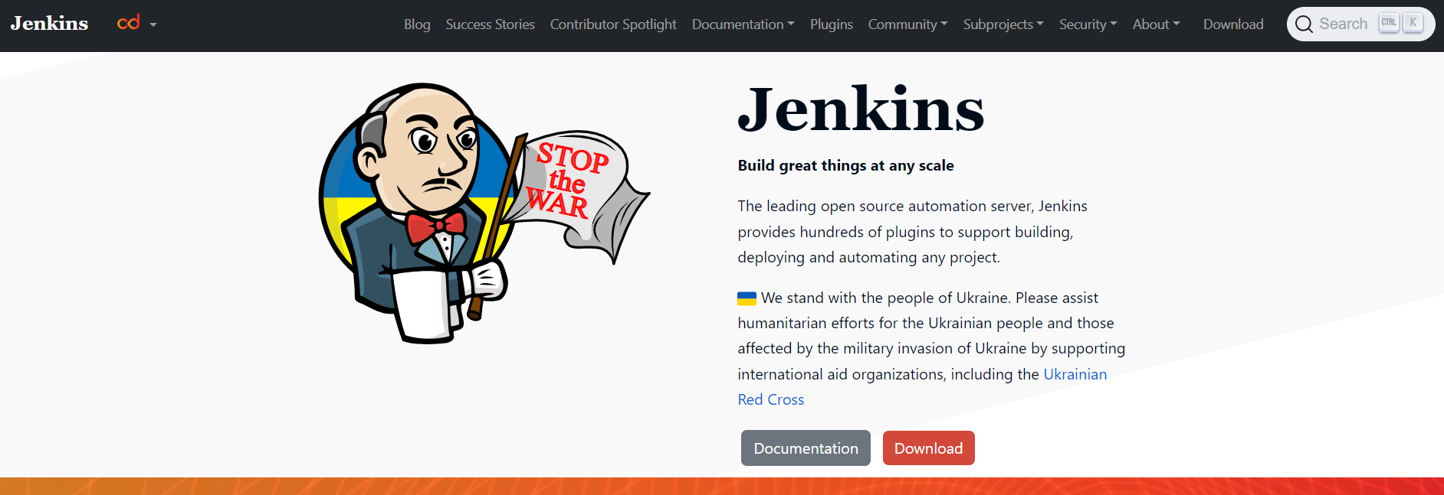

Step 2: Download Jenkins ‘Generic Java package’. I prefer to download LTS package (It is a stable one).

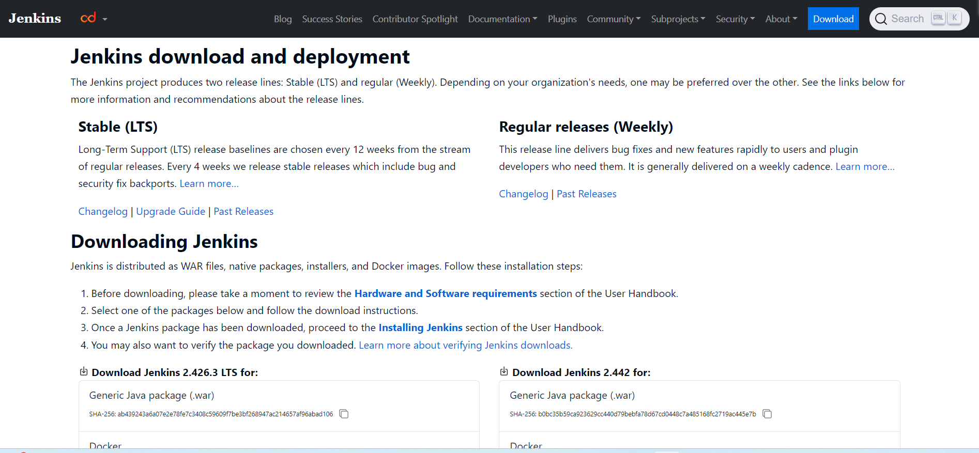

Step 3: Select your desired path after downloading and save the Jenkins.war file in your local system.

Step 4: Go to command prompt (Windows) | Terminal (IOS)

Go to the folder where the war file is saved. Then, type the command **java -jar Jenkins.war** and run it. IT will take a while to run the command. It gives an admin password. Note it down to use Jenkins the first time. The password will be saved in the mentioned path C:\Users\sukan\.jenkins\secrets

Jenkins password

5e12881d08ee4f95b6cd1a98b193f09e

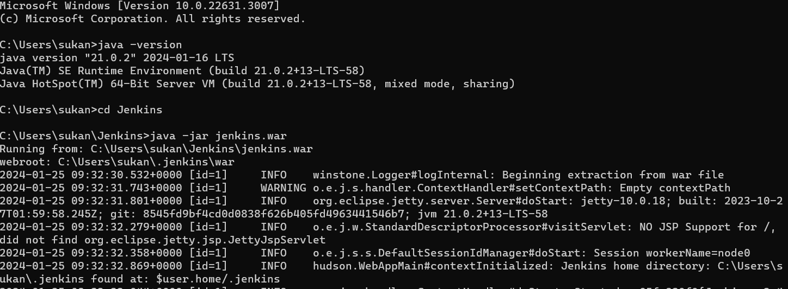

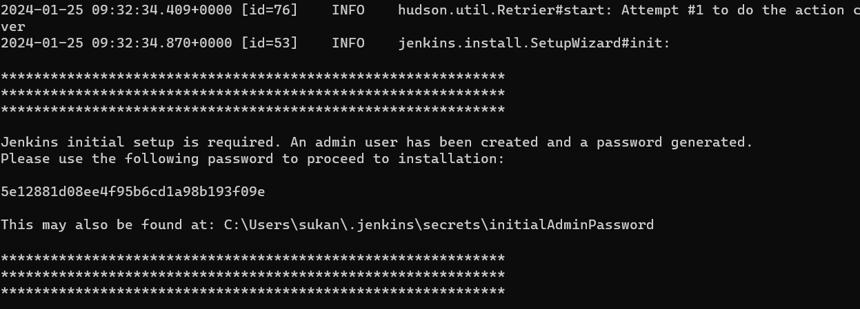

Step 5: Go to the browser and type <http://localhost:8080/> and enter. It asks for the password. Provide it and click Continue.

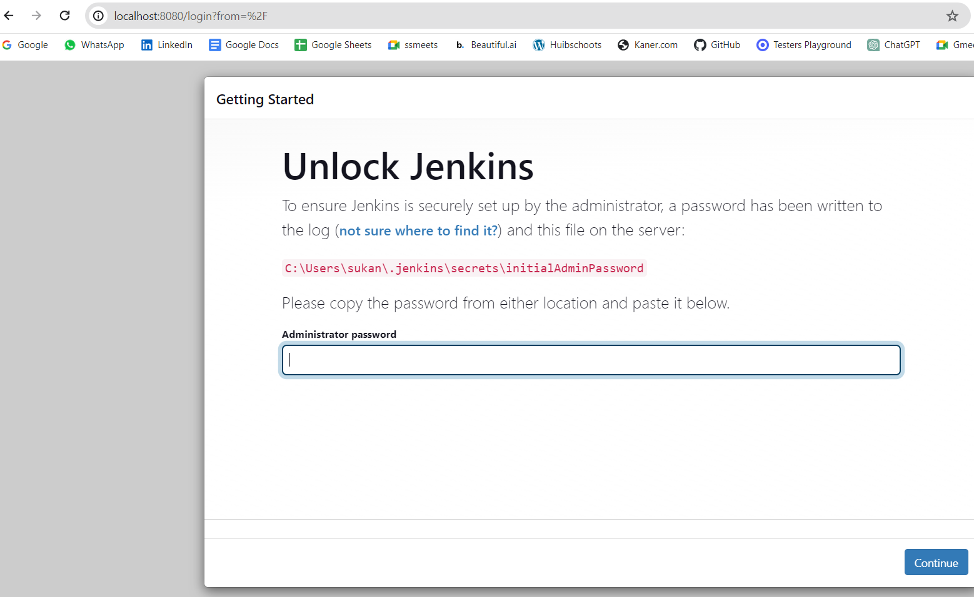

Step 6: Select Plugins to install

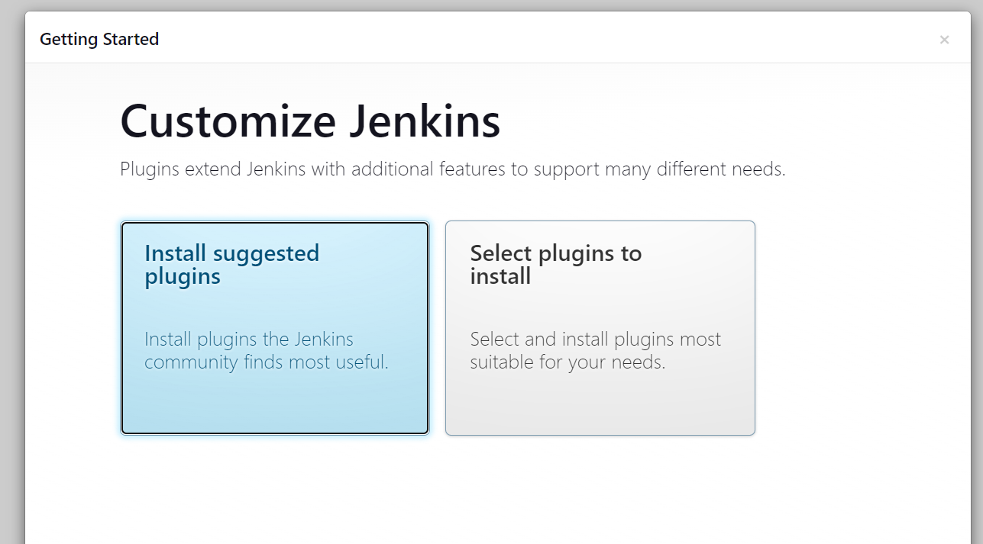

Step 7: Select the plugins and click install

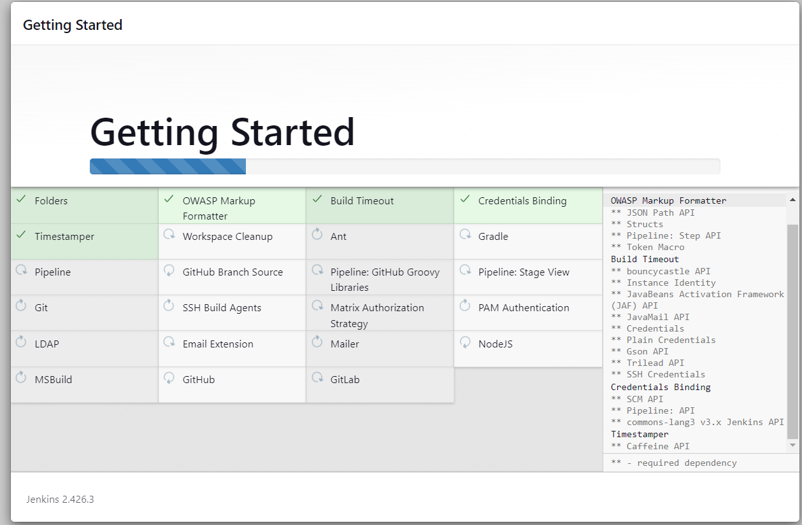

Step 8: After installing, it goes to the page where asks for credentials to create. You can select an admin user to proceed if you do not want to create a new id.

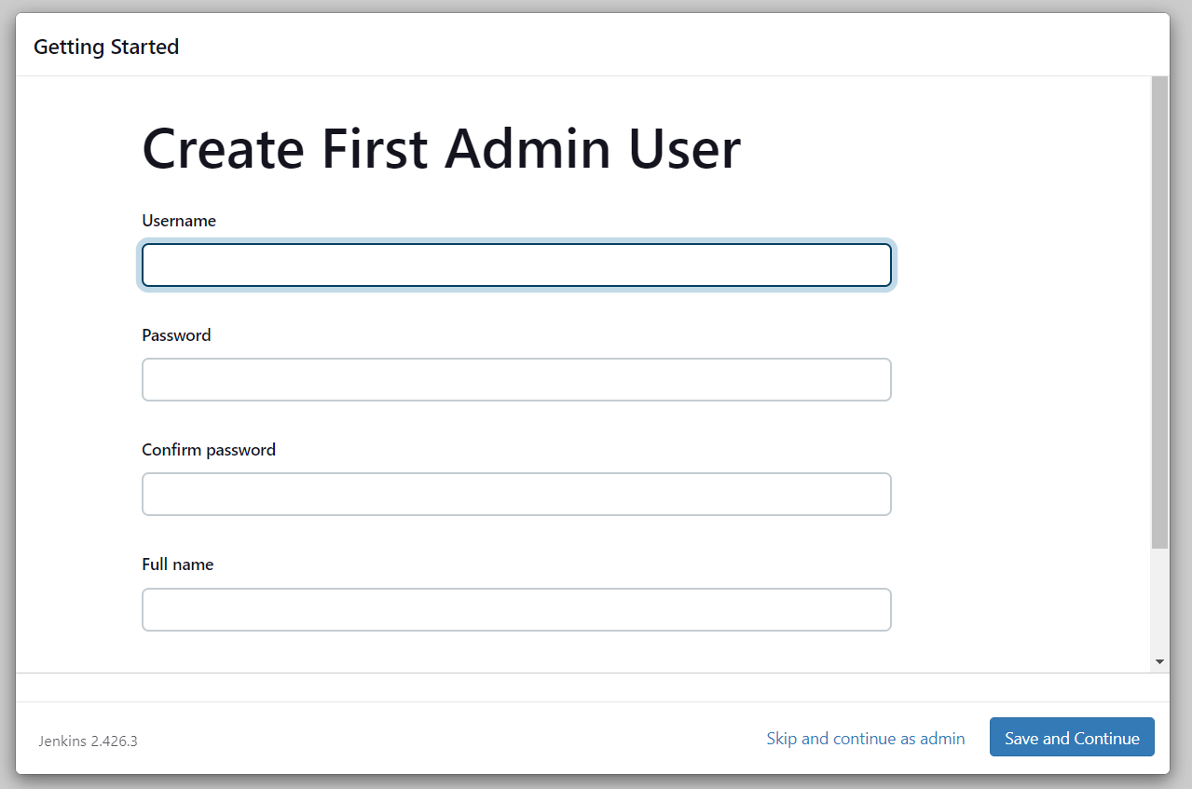

Step 9: Click Save and Finish

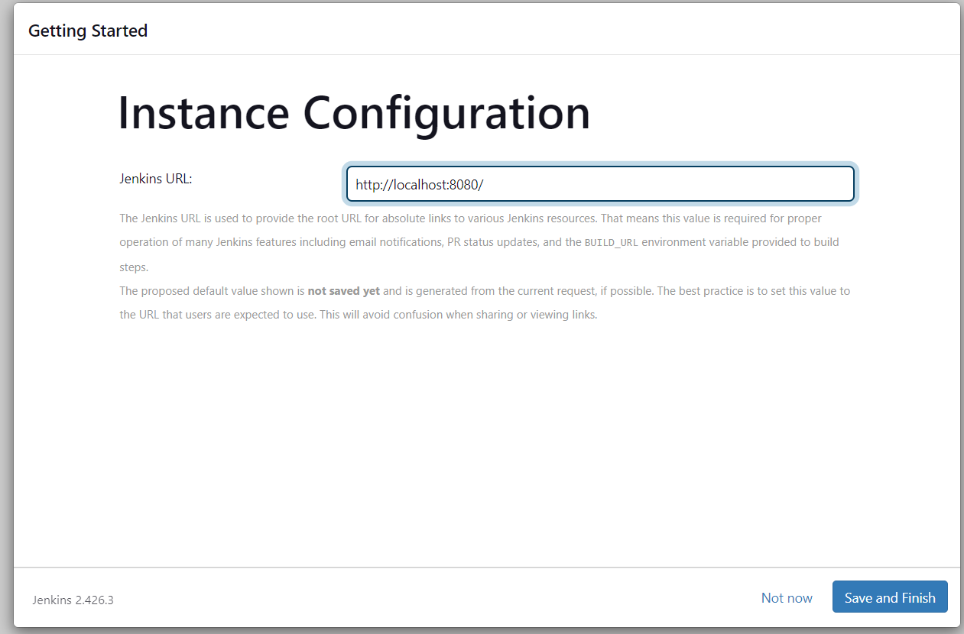

Step 10: Your Jenkins is ready now and start using Jenkins.

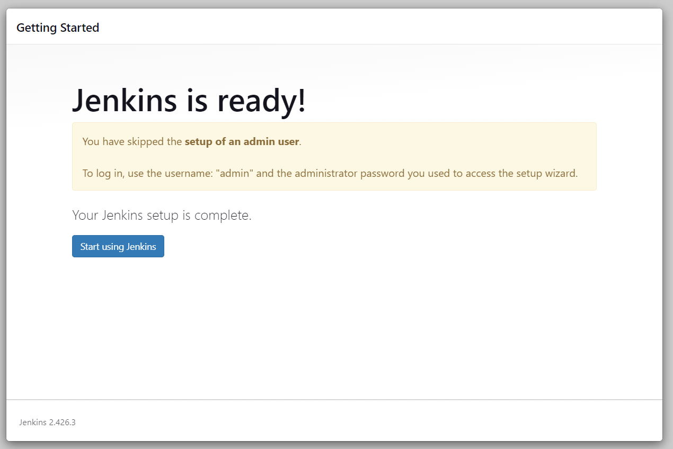

Step 11: This is the homepage after installing it

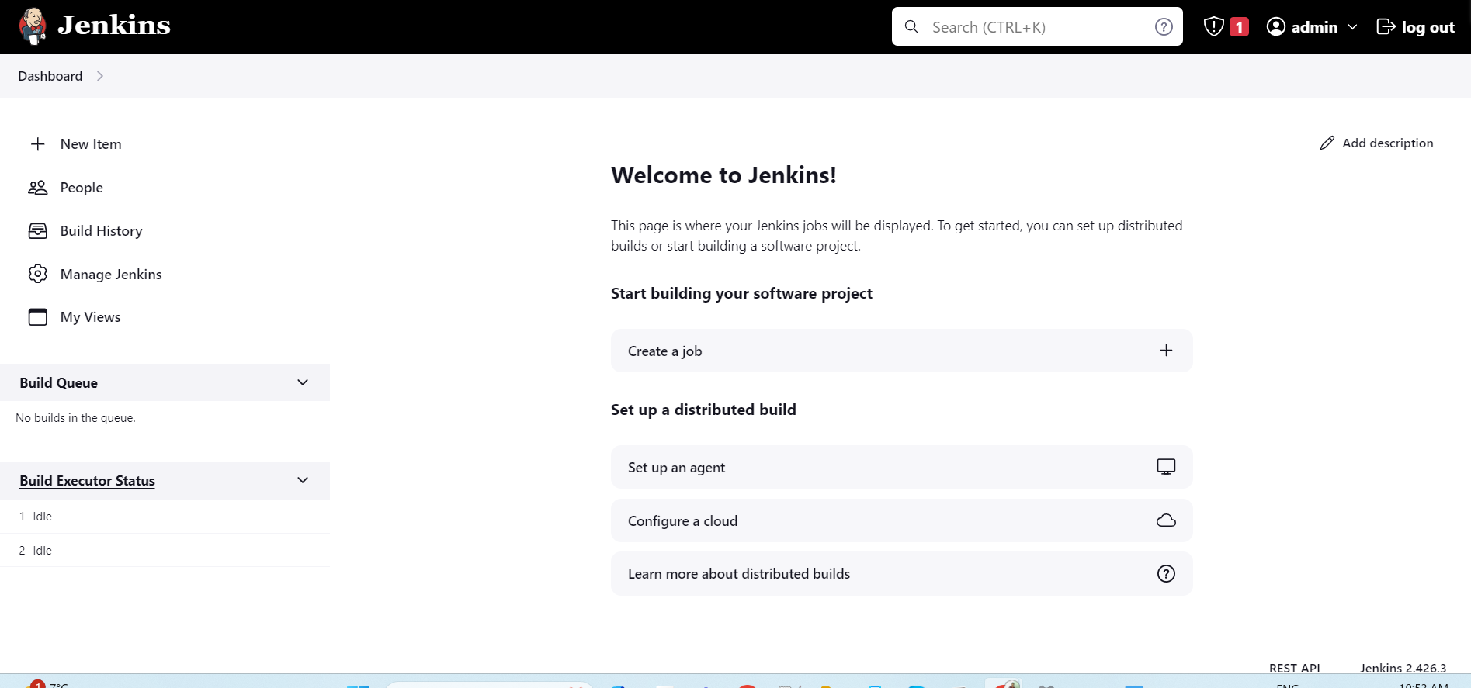

Step 12: All the Jenkin related plugins and folders will be in the available path

C:\Users\sukan\.jenkins