1. Create a folder.
2. Install NodeJS (<https://nodejs.org/en>) and verify in cmd as ***node -v***.
3. Install npm by using the command ***npm install -g npm*** and verify as ***npm -v*** (Check Environment variables for the path).

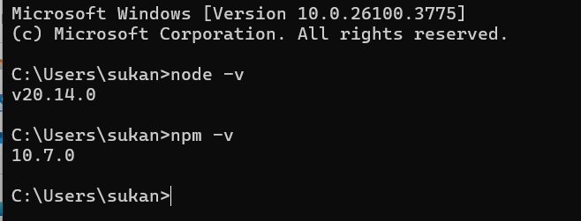

1. Install VS code (<https://code.visualstudio.com/download>)
2. Open the created folder from Step 1.
3. Install Playwright in the above folder path with the command ***npm init playwright@latest*** from the official documentation (<https://playwright.dev/docs/intro>).
4. To install Typescript: ***npm install -g typescript*** and ***npm install -g ts-node***
5. To create a typescript file: tsc –init
6. Install Code Runner in VS Code

**Resources:**

1. Playwright official website: <https://playwright.dev/docs/intro>
2. Playwright with JavaScript video from Mukesh Otwani: <https://www.youtube.com/watch?v=pq20Gd4LXeI&t=5019s>
3. Upload project to GitHub: <https://www.techielass.com/how-to-push-code-from-vs-code-to-github/>
4. NodeJS: (<https://nodejs.org/en>)
5. Visual Studio Code: <https://code.visualstudio.com/download>)

**Different ways to execute tests**

1. To run all tests in Tests folder
   1. Npx playwright test
2. To run all tests in different browsers parallely
   1. Npx playwright test --workers 3
3. To run in the browser (Headed mode). Usually playwright runs in headless mode
   1. Npx playwright test --headed
   2. add **Headless: false** in playwright.config.ts

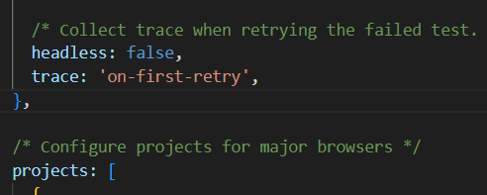

1. To run a specific test. Copy the relative path of a specific test and paste it in the command
   1. npx playwright test ./tests/firstTest.spec.ts
2. To run multiple spec files
   1. npx playwright test firstTest.spec.ts secondTest.spec.ts
   2. npx playwright test firstTest secondTest
3. To run a specific test function
   1. Npx playwright test -g ‘Second Test’
4. To run only in a specific browser
   1. Npx playwright test –project=chromium
5. To run the code in debug mode
   1. Npx playwright test –project=chromium --debug