- Create a folder.
- Install NodeJS (https://nodejs.org/en) and verify in cmd as node -v.
- Install npm by using the command npm install -g npm and verify as npm -v (Check Environment variables for the path).
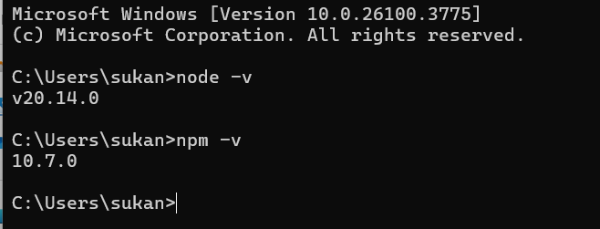
- Install VS code (https://code.visualstudio.com/download)
- Open the created folder from Step 1.
- Install Playwright in the above folder path with the command npm init playwright@latest from the official documentation (https://playwright.dev/docs/intro).
- To install Typescript: npm install -g typescript and npm install -g ts-node
- To create a typescript file: tsc –init
- Install Code Runner in VS Code
Resources:
- Playwright official website: https://playwright.dev/docs/intro
- Playwright with JavaScript video from Mukesh Otwani: https://www.youtube.com/watch?v=pq20Gd4LXeI&t=5019s
- Upload project to GitHub: https://www.techielass.com/how-to-push-code-from-vs-code-to-github/
- NodeJS: (https://nodejs.org/en)
- Visual Studio Code: https://code.visualstudio.com/download)

Different ways to execute tests
- To run all tests in Tests folder
  - Npx playwright test
- To run all tests in different browsers parallely
  - Npx playwright test --workers 3
- To run in the browser (Headed mode). Usually playwright runs in headless mode
  - Npx playwright test --headed
  - add Headless: false in playwright.config.ts
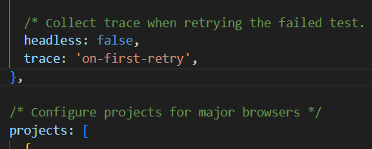
- To run a specific test. Copy the relative path of a specific test and paste it in the command
  - npx playwright test ./tests/firstTest.spec.ts
- To run multiple spec files
  - npx playwright test firstTest.spec.ts secondTest.spec.ts
  - npx playwright test firstTest secondTest
- To run a specific test function
  - Npx playwright test -g ‘Second Test’
- To run only in a specific browser
  - Npx playwright test –project=chromium
- To run the code in debug mode
  - Npx playwright test –project=chromium –debug
3 ways for Traceview
- In config file, comment retries and add 2 lines
  - Retries:1,
  - Timeout:5*1000,
After execution, in the report view, go to Retry -> click on Trace image at the bottom. Now trace view details will be shown.

- Command
  - npx playwright show-trace ./test-results/codeGenCode-test-chromium-retry1/trace.zip
- Go to trace.playwright.dev and drop the trace.zip file

To open DOM
- F12
- Right click the webpage and select Inspect
Locator strategies
- #id
- CSS [name=”user-name”]
- Xpath //input[@name=”user-name”]
- Playwright inspect await page.pause();
- Plugin – SelectorsHub, LetXpath

Automation testing websites
https://letcode.in/
https://the-internet.herokuapp.com/add_remove_elements/
https://sripriyakulkarni.com/
https://play1.automationcamp.ir/

Issues
If you have this error with different playwright version (now it’s modified)
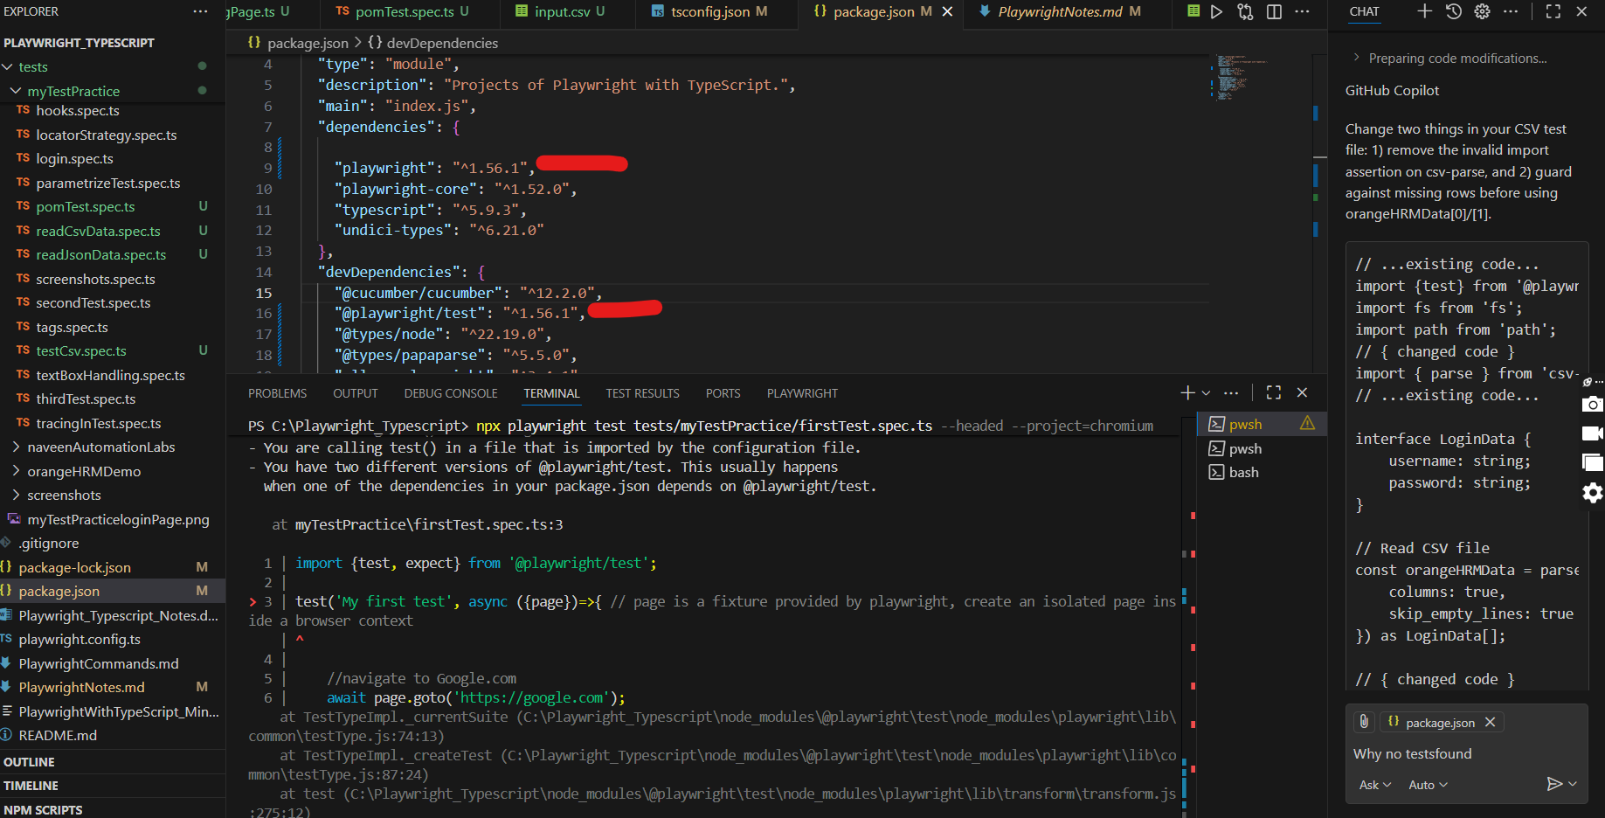
Run npm ls @playwright/test command to check if anything is duplicated
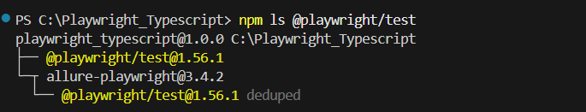
Change the version, delete node_modules and package-lock.json file. Install it again with “npm install” command.

