Accessibility testing tools home task

Create Word document with results of each point listed below. The link to the document on Sharepoint or the document itself must be attached to the module on the Learn portal.

Document format is up to you. It should be understandable and perceivable 🙂

Checklist with success criteria is here: <https://webaim.org/standards/wcag/checklist> (see A and AA levels).

:

1. Work with Audit tools
   1. Audit the page <https://www.epam.com/> (Desktop version) in Google Chrome dev tools Accessibility Audit.
   2. Install Siteimprove plugin in Google Chrome.
   3. Audit the <https://www.epam.com/> page in Siteimprove plugin (Uncheck Editor filter)
   4. Install WAVE plugin in Google Chrome.
   5. Audit the <https://www.epam.com/> page in WAVE plugin.
   6. In your homework document, provide a list of all the NOT met Success Criteria found by the three auditing tools.

For each analysis, provide data in format:

* Report screenshot,
* List of errors found.
  1. Are there any Success Criteria that you think are **misidentified** by the audit tools? Why do you think so?

:

1. Work with NVDA
   1. Install NVDA <https://www.nvaccess.org/download/>.
   2. Launch the Speech Viewer window.
   3. Open page <https://www.epam.com/> and Elements list (Insert + F7).
   4. Explore all categories of navigation elements

* links,
* headings,
* form elements,
* buttons,
* landmarks.

Provide elements with a11y issues in the following format:

* Name of the navigation element with a screenshot of the opened Elements list window
* The problems you have identified.

Additionally, you can list the Success Criteria that are not met because of these issues.

* 1. Read using Virtual cursor mode (hotkeys, elements list, not using tab) the OUR RESULTS section of the page <https://www.epam.com/>

The section located on <https://www.epam.com/>, contains “Learn more” button and several blocks with precentage of the growth statistics.

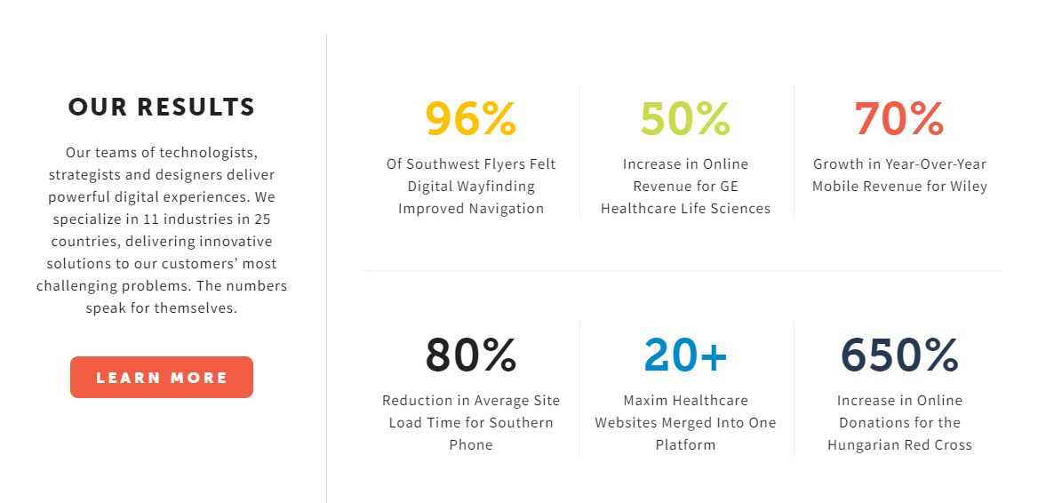

Provide logs from Speech Viewer window with navigation to and through the block in the homework document.

:

1. Work with contrast
   1. Audit the page contrast at <https://www.epam.com/> using each of the following tools:

* WAVE,
* Color contrast analyzer,
* Siteimprove

And provide the list of the contrast issues in the following format:

* Name of the tool,
* Screenshot of the report after analysis,
* Found contrast issues

Optional

1. Create fork of the repository <https://github.com/hamanovich/accessibility-training>. It will be used for further home tasks.
2. Explore UI components and perform audit using testing tools.