LiveRoom
User Manual
Role-based operating guide for Candidates, HR Interviewers, and Super Admin users
Document Scope
This manual explains how authenticated users operate LiveRoom: joining interviews, managing media controls, using AI transcription, reviewing verification videos, handling recovery states, and viewing the candidate portfolio after HR-adjourned approval.

Product | LiveRoom
Document Type | Professional User Manual
Audience | Candidates, HR Interviewers, Super Admins
Prepared Date | 28 Jul 2026

Contents
- 1. Product Overview
- 2. Roles and Permissions
- 3. Getting Started
- 4. Candidate User Guide
- 5. HR / Interviewer User Guide
- 6. Super Admin User Guide
- 7. Verification Video Workflow
- 8. AI Transcription Workflow
- 9. Recovery and Rejoin Behavior
- 10. Candidate Portfolio Page
- 11. Troubleshooting and Best Practices

1. Product Overview
LiveRoom is a realtime interview workspace that combines video calling, candidate verification video handling, and AI-assisted candidate speech transcription. The application is role-aware: each user sees only the workflows appropriate to their account role.
Area | Service Behavior
Authentication | Supabase Auth session is required before accessing the application.
Room management | Socket.IO handles create room, join room, leave room, recovery, and room-state broadcasts.
Live media | Agora RTC handles live microphone and camera transport.
Transcription | Deepgram receives candidate audio while HR-controlled transcription is active.
Verification media | Supabase Storage stores candidate uploads and HR recordings with signed URLs.
Permanent records | Supabase PostgreSQL stores profiles, interviews, videos, verification state, and transcript blocks.
Table 1. Platform services used by LiveRoom.

2. Roles and Permissions
The role assigned to a user account determines what actions are available after login. Users do not manually choose elevated permissions; the interface displays the server-authorized role.
Role | Primary Capabilities
Candidate | Joins or rejoins interviews, controls microphone/camera, uploads verification video, sees recording notice, and views portfolio after HR-adjourned approval.
HR / Interviewer | Selects candidates from the queue, conducts video interviews, starts/stops AI transcription, records candidate verification video, reviews uploads, approves/dismisses video, saves transcript, and ends the interview.
Super Admin | Observes active or recovering rooms without being visible to regular users; monitors room state and assists with oversight.
Table 2. User roles and primary capabilities.

3. Getting Started

3.1 Sign In
- Open the LiveRoom application URL provided by the administrator.
- Enter the registered email address and password.
- Wait for the application to load the server-authorized role and account display name.
- Confirm that the connection indicator shows the server is connected before joining a room.
Access Control Note
If a session expires or the same account signs in from another device, LiveRoom may redirect the user back to login for security.

4. Candidate User Guide

4.1 Join a New Interview
- Confirm that the account role shows Candidate.
- Enter or verify the display name.
- Select the preferred interview language: English, Tamil, or Hindi.
- Click Join a Room. LiveRoom creates a waiting room and places the candidate in the queue for an HR user with the matching language.

4.2 Rejoin an Active Recovery Interview
If the candidate leaves unexpectedly and HR keeps the room open, the candidate login page changes to a rejoin state. The screen displays that HR is waiting and provides a Rejoin Interview button. Selecting another language does not create a new meeting during recovery; the candidate returns to the same open room.

4.3 Candidate Media Controls
- Mute controls whether the candidate microphone is sent to the room.
- Camera controls whether the candidate video track is visible.
- Leave Room exits the interview. If HR keeps the room open, the candidate may be able to rejoin through recovery.

4.4 Upload Verification Video
- Wait until HR has joined the call and the verification section becomes available.
- Click Upload Verification Video.
- Choose a WebM or MP4 file up to 50 MB.
- Review the preview before saving.
- Click Save Upload to submit it for HR review.
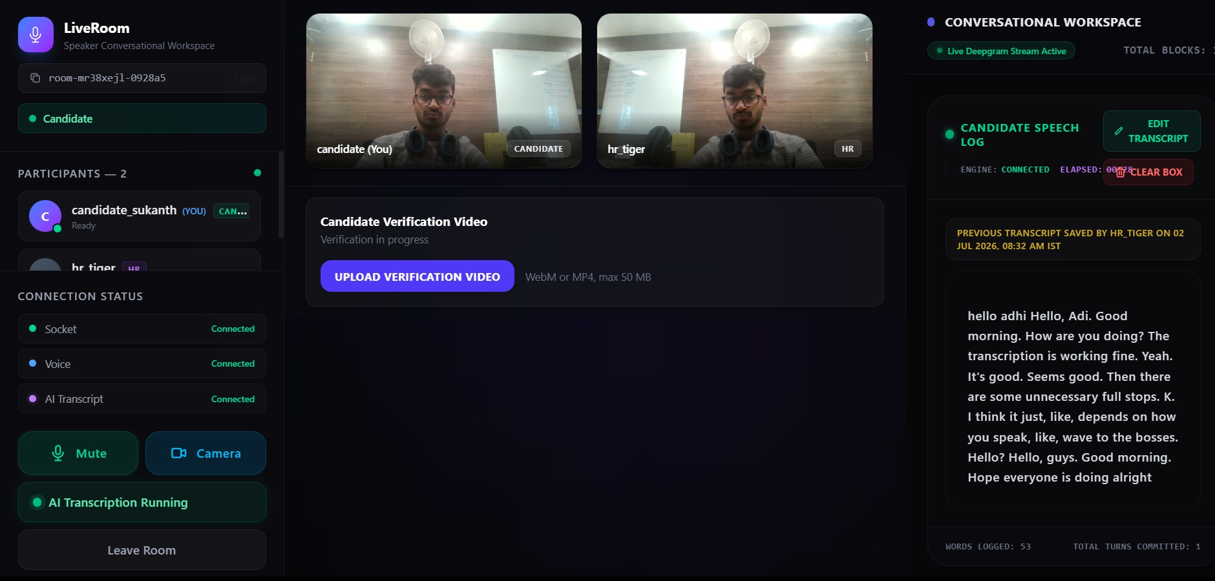
Figure 1. Candidate workspace showing verification upload access and active transcript panel.
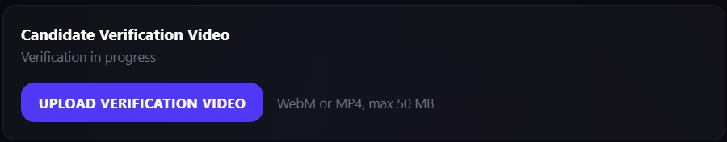
Figure 2. Candidate verification upload panel.

4.5 HR Recording Notice
When HR records the candidate for verification, the candidate receives a visible red recording notice. This notice is informational and remains visible while recording is active.

5. HR / Interviewer User Guide

5.1 Select a Candidate Room
- Sign in with an HR account.
- Review the candidate queue for the HR account language.
- Select a waiting or recovery room from the queue.
- Allow microphone and camera permissions when prompted by the browser.

5.2 Conduct the Interview
- Use the video strip to confirm both HR and candidate are present.
- Use Mute and Camera controls as required during the interview.
- Use Start Transcription to begin AI transcription of candidate speech.
- Use Stop to pause live transcription.
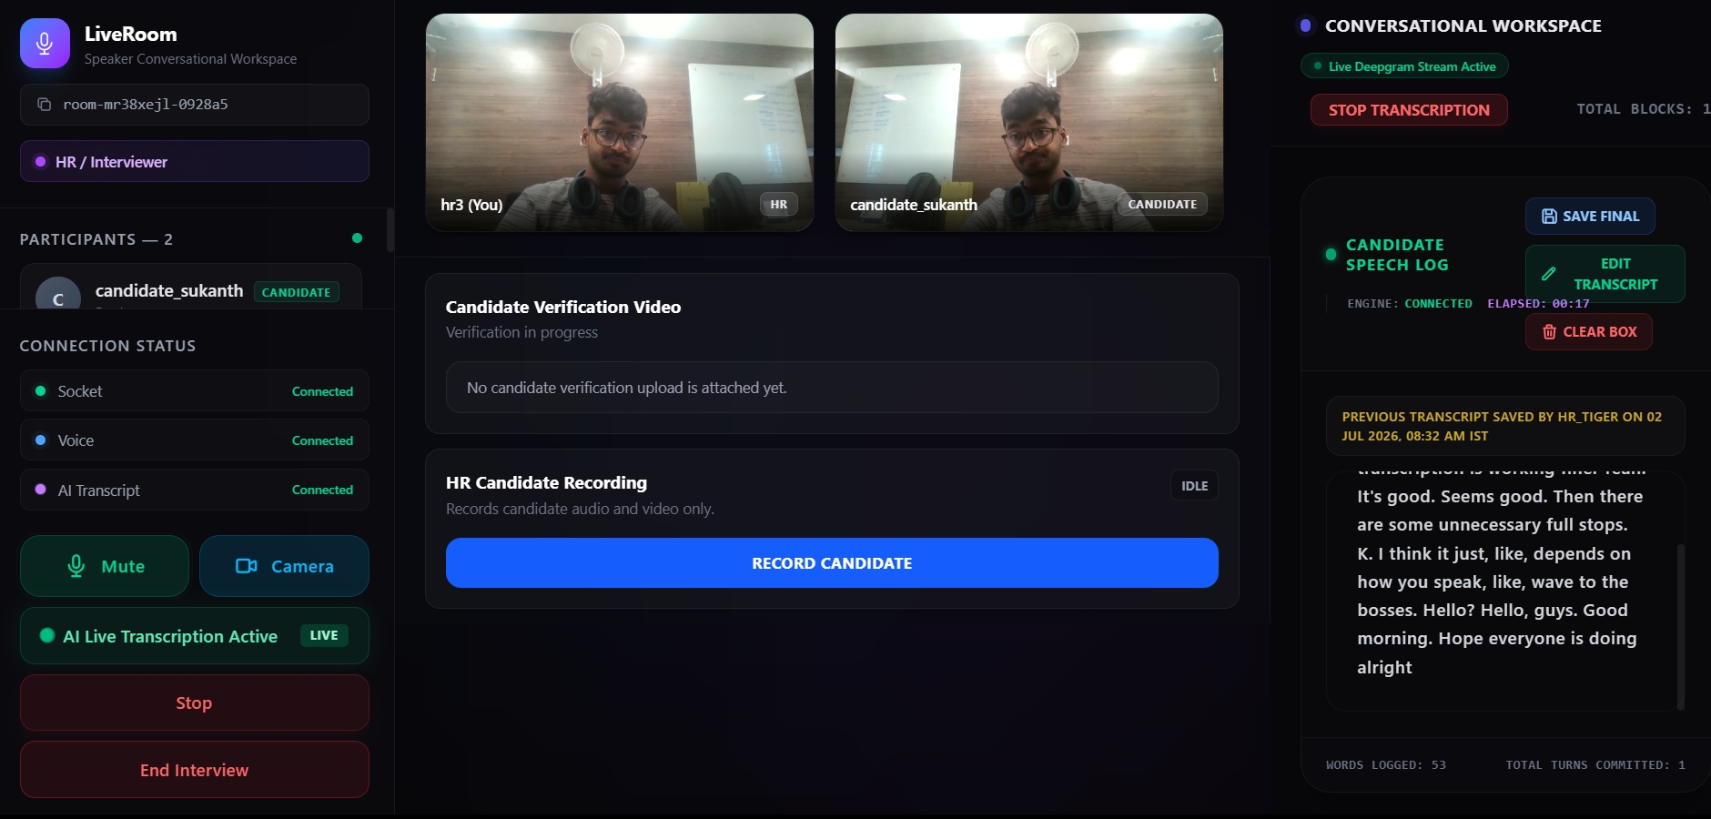
Figure 3. HR workspace with participant list, live video, verification panel, and transcript workspace.

5.3 Record Candidate Verification Video
- Confirm the candidate audio and video are available.
- Click Record Candidate in the HR Candidate Recording panel.
- Inform the candidate that the visible recording notice will appear on their screen.
- Click Stop Recording when finished.
- Review the preview and click Save to upload it for HR review.
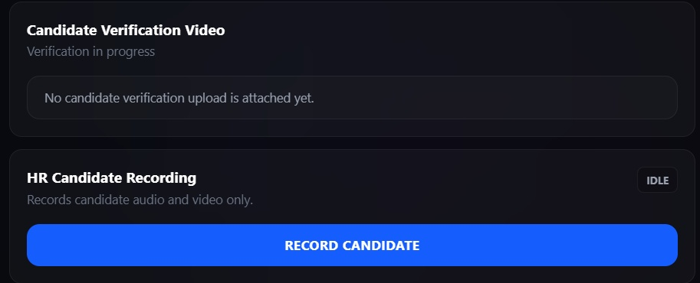
Figure 4. HR candidate recording and verification panel.

5.4 Review Verification Video
- Approve marks the candidate verification video as accepted.
- Dismiss archives the current video and lets the candidate submit another video while the interview is active.
- Reset Upload clears a stuck upload or pending upload when the system exposes a resettable video state.
Finalization Rule
The candidate portfolio is shown only after HR approves the video and deliberately ends the interview. Approval alone does not move the candidate into the final portfolio state.

5.5 Save Transcript and End Interview
- Review the Candidate Speech Log.
- Use Edit Transcript if final corrections are required.
- Click Save Final to persist the transcript.
- Click End Interview to adjourn the meeting. This closes the room and finalizes the candidate portfolio if the verification video was approved.

6. Super Admin User Guide
Super Admin users can observe active or recovering sessions without appearing to regular room participants. This role is designed for oversight, support, and troubleshooting rather than direct interview participation.
- View ongoing sessions from the room dashboard.
- Join as a silent observer when a room is full, recovering, or active.
- Observe participant and transcript state without enabling microphone controls.

7. Verification Video Workflow
State | Meaning
No Video Attached | Candidate has not uploaded a verification file and HR has not recorded one.
Uploading | A file row has been initialized and is waiting for storage upload completion.
Pending Review | The file has completed upload and is waiting for HR approval or dismissal.
Approved | HR approves the video. The portfolio still waits for HR to end the interview intentionally.
Portfolio Ready | The approved video belongs to an interview completed by HR with ended_reason = hr_ended.
Table 3. Candidate verification video lifecycle.

8. AI Transcription Workflow
AI transcription is controlled by HR. When enabled, only candidate speech is sent to the speech-to-text service. HR speech is intentionally not transcribed as candidate speech.
- Start Transcription begins the live candidate speech stream.
- Candidate Speech Log displays live and saved candidate transcript text.
- Edit Transcript allows authorized users to correct transcript text.
- Save Final stores the finalized transcript with the interview record.
- Clear Box removes current transcript contents from the active workspace when required.

9. Recovery and Rejoin Behavior
- If HR disconnects unexpectedly, the candidate is asked to wait during HR recovery.
- If the candidate disconnects, HR can wait for candidate recovery or end the interview after timeout.
- If HR deliberately ends the interview, the room closes as completed.
- If the room closes due to an unexpected timeout, portfolio display is not unlocked.
- If approval happened before an unintentional room closure, the system rolls back the unadjourned verification so the candidate can retry instead of being locked out.

10. Candidate Portfolio Page
After HR approves the verification video and deliberately ends the interview, the candidate no longer sees the standard join page after login. Instead, the candidate sees a portfolio display page containing the approved verification video and the latest stored transcript message.
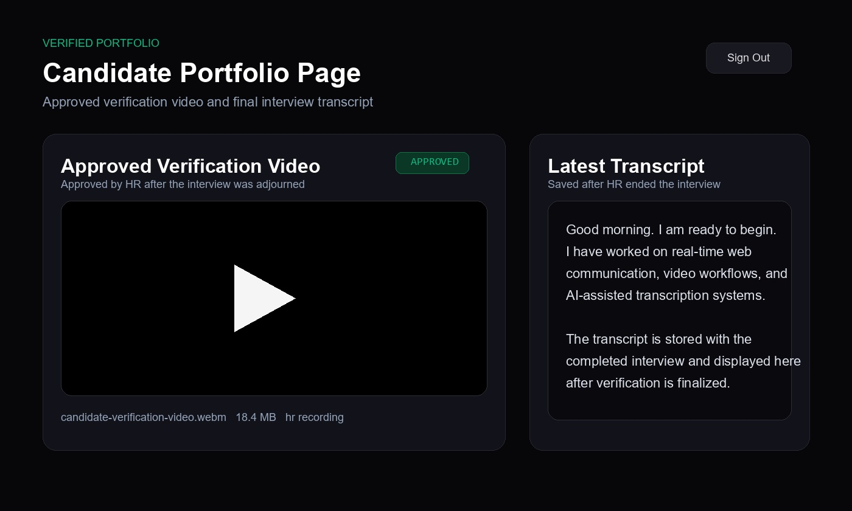
Figure 5. Candidate portfolio display after HR-approved and HR-adjourned verification.
Portfolio Unlock Condition
The candidate portfolio appears only when the approved video is linked to a completed interview that HR intentionally ended. Disconnect closures do not unlock this page.

11. Troubleshooting and Best Practices
Issue | Recommended Action
Cannot join room | Check login session, browser permissions, server connection indicator, and account role.
No candidate in HR queue | Confirm candidate selected the same language as the HR account and has joined the waiting room.
Upload unavailable | HR must be present and the interview session must be active before candidate upload is available.
Video stuck uploading | Use Reset Upload when available, then select and save the file again.
Transcript not updating | Confirm HR started transcription and candidate microphone permission is allowed.
Portfolio not shown | Confirm HR both approved the video and ended the interview intentionally.
Table 4. Common user issues and recommended actions.

Appendix A. Operational Notes
- Supported verification video formats: WebM and MP4.
- Maximum verification video size: 50 MB.
- Supported profile languages: English, Tamil, and Hindi.
- Normal rooms are designed for one candidate and one HR interviewer, with optional super admin observation.
- Candidate portfolio display depends on permanent Supabase records: candidate_verification, candidate_videos, and interviews.

