PROCEDURE

**Prerequisites:**

* Install XAMPP 7.2.34 / PHP 7.2.34 <https://www.apachefriends.org/download.html>
* Make sure you can send Gmail through localhost. <https://www.youtube.com/results?search_query=how+to+send+Gmail+through+localhost>

I recommend to watch this to get an idea <https://www.youtube.com/watch?v=dNTZ8X9Xk_Q>

Step 1:

Paste the **car rental folder** in XAMPP’s **htdocs** don’t change any folders inside it.

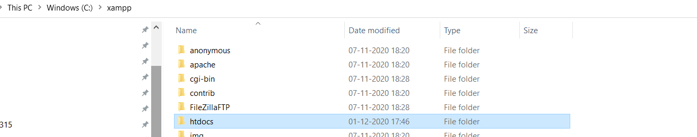



Step 2:

**Import** the **sql** file located in the carental folder into the php my admin panel (URL: <http://localhost/phpmyadmin>)

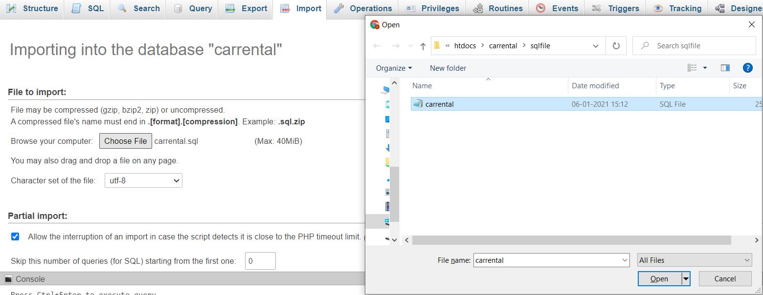

After selecting press **go** (scroll it) database will be created.

Step 3:

Access the webpage <http://localhost/carrental> and Enjoy.

Username : lokesh123 Password:hello@123

If you want me to make **explanation videos on files** that I made I am ready to do it, do mention in **Comments**.

I almost took a month to complete this project with my beginner knowledge. So, use this time to explore the things you like .