Name: G.Sukanya

College: Sri Padmavathi Mahila University

Assignment: 2

Rollno:2022MCA16029

BUTTON COMPONENT:

BUTTON JS:

import React from 'react'

function Button(props) {

const {children, style, onClick} = props

return (

<button style={style ? style : {background: 'blue', color: 'afff'}}

onClick={onClick}>{children}</button>

)

}

export default Button

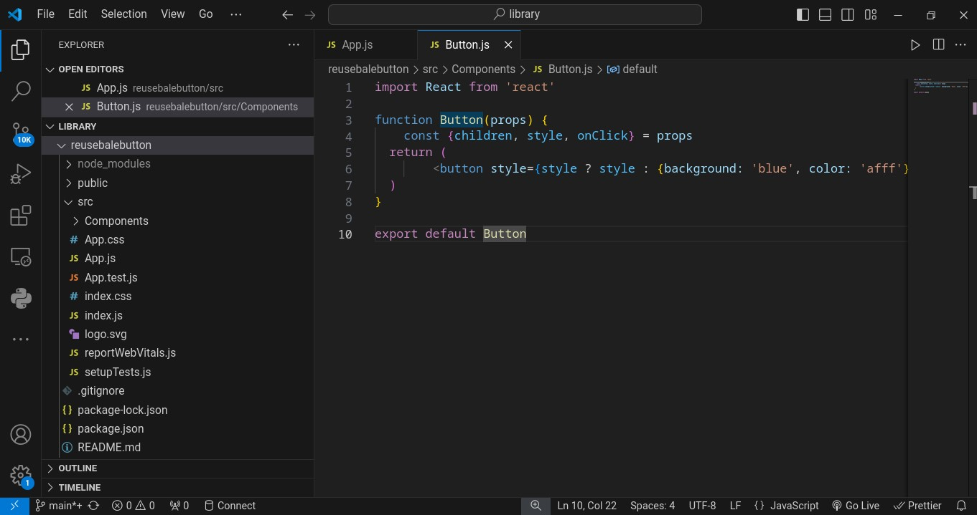

**Card.JSX**

import logo from './logo.svg';

import './App.css';

import Button from './Components/Button';

function App() {

return (

<div className="App">

<h1> Hello guys</h1>

<Button style= {{background : 'green',color: 'yellow'}} onClick={()=>{alert('button

clicked')}}>hello components</Button>

<Button onClick={()=>{alert('welcome')}}>hello components</Button>

<div>

);

}

export default App;

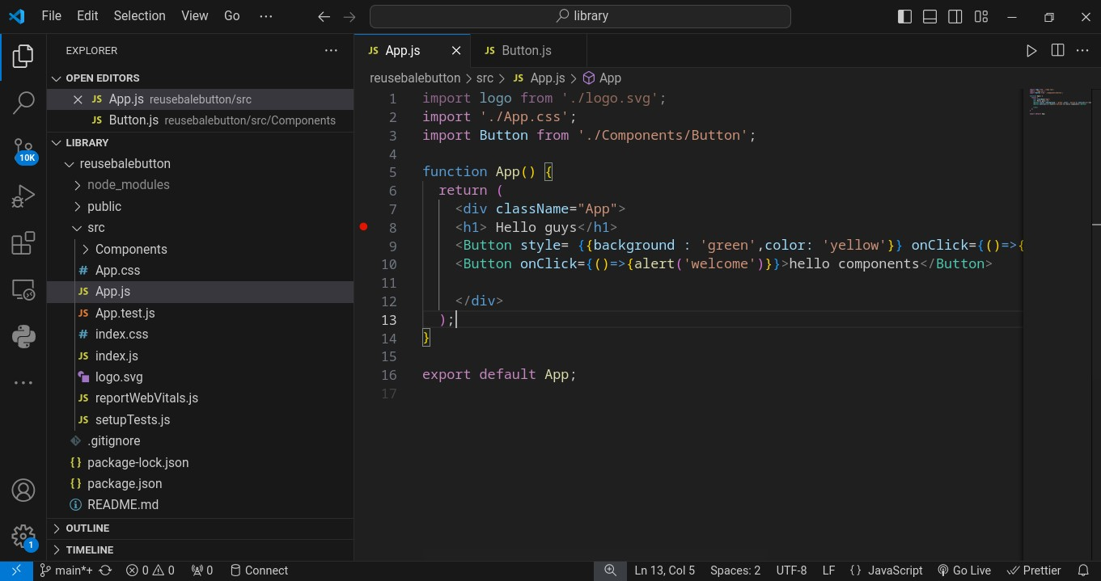

**OUTPUT:**

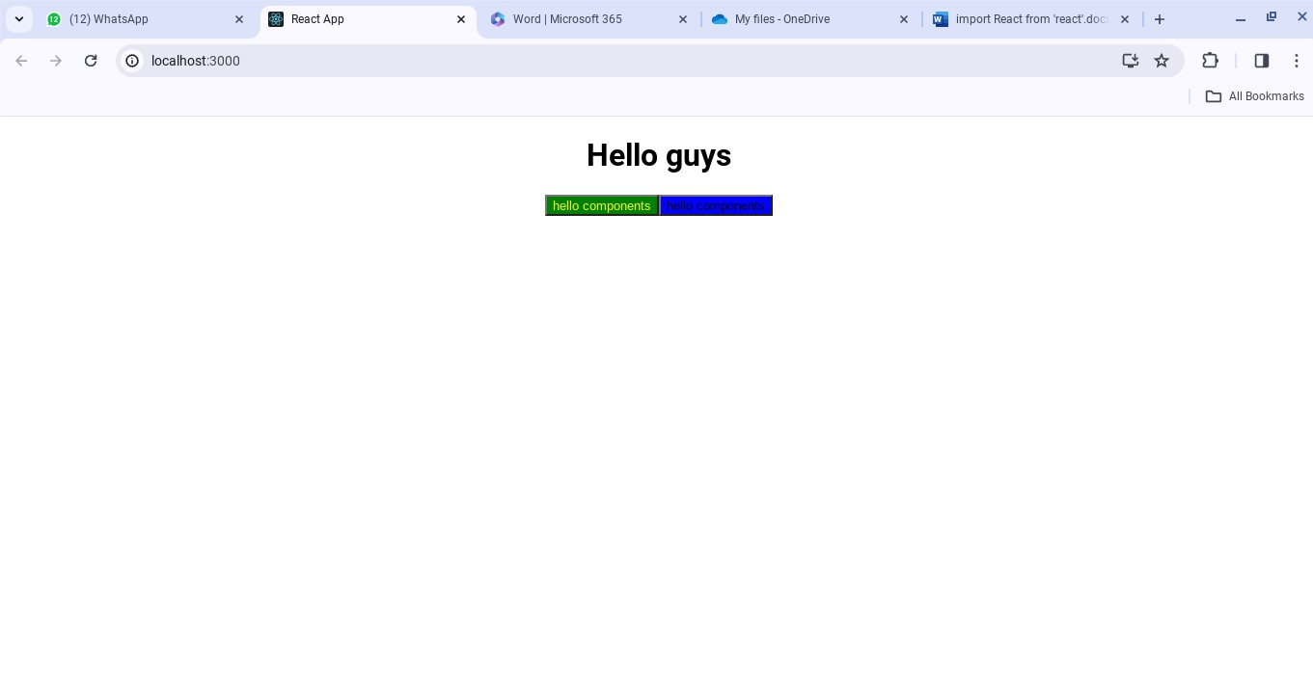

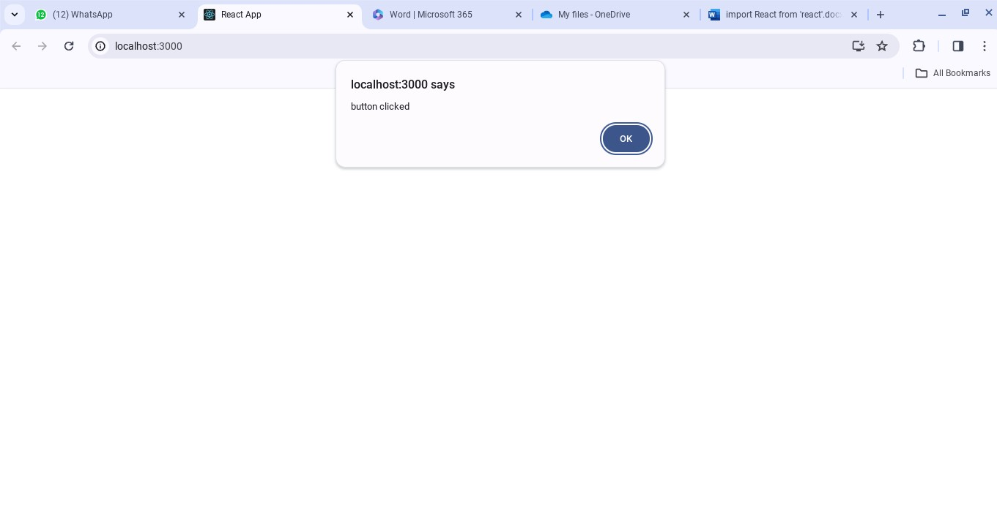

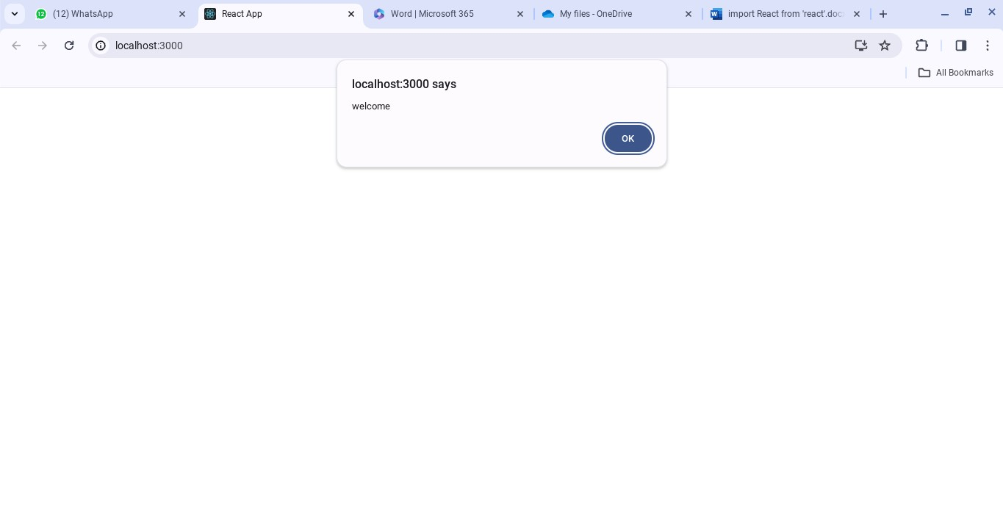

CARD COMPONENT:

CARD.CSS:

# .card-container {

# width: 15rem;

**border-radius: 1rem;**

**box-shadow: 0px10px8px#999;**

**display: flex;**

**flex-direction: column;**

**margin: 0.5rem;**

**background-color: white;**

**height: fit-content;**

**}**

**.card-img {**

**width: 100%;**

**border-radius: 1rem1rem00;**

**}**

# .card-title {

**margin: 0.5rem5%;**

**}**

# .card-description {

# margin: 0.5rem5%;

**}**

**.card-btn {**

**text-align: center;**

**width: 90%;**

**border-radius: 5px;**

**padding: 0.5rem1rem;**

**background-color: #2563eb;**

**color: white;**

**text-decoration: none;**

**margin: 0.5rem0.5rem;**

**}**

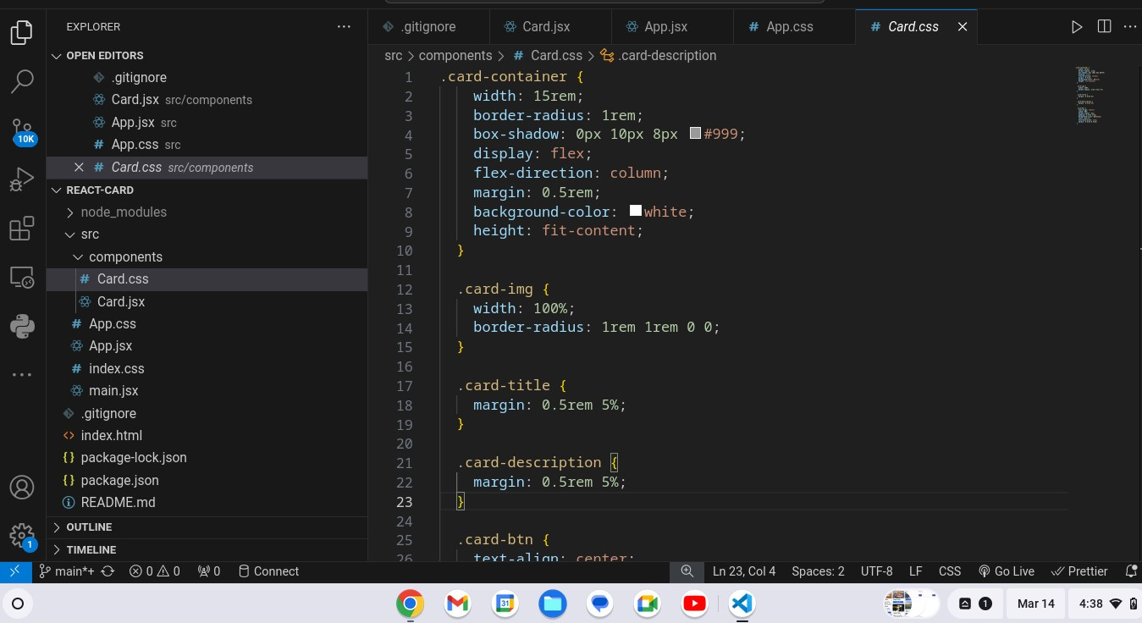

**CARD.JSX:**

import "./Card.css";

export const Card = ({

imgSrc,

imgAlt,

title,

description,

buttonText,

link,

}) => {

return (

<div className="card-container">

{imgSrc && imgAlt && (

<img src={imgSrc} alt={imgAlt} className="card-img" />

)}

{title &&<h1 className="card-title">{title}</h1>}

{description &&<p className="card-

description">{description}</p>}

{buttonText && link && (

<a href={link} className="card-btn">

{buttonText}

</a>

)}

</div>

);

};

APP.CSS:

**import'./App.css'**

**import { Card } from"./components/Card";**

**functionApp() {**

**return (**

# <divclassName="App">

**<divclassName="col">**

**<Card**

**imgSrc=**[**https://picsum.photos/id/201/300/200**](https://picsum.photos/id/201/300/200)

**imgAlt="Card Image 1"**

**title="Card Title"**

|  |  |
| --- | --- |
| **description="This is the card description section. You can add more details about the product here”** | |
|  |  |

## />

**<Card**

**imgAlt="Card Image 2"**

**title="Card Title"**

|  |  |
| --- | --- |
| **description="This is the card description section. You can add more details about the product here”** | |
|  |  |

**buttonText="Learn More"**

**link="card2"**

## />

**<Card**

**imgSrc=**[**https://picsum.photos/id/193/300/200**](https://picsum.photos/id/193/300/200)

**imgAlt="Card Image 3"**

|  |  |
| --- | --- |
| **description="This is the card description section. You can add more details about the product here”** | |
|  |  |

**buttonText="Learn More"**

**link="card2"**

**/>**

## </div>

**<divclassName="col">**

**<Card**

**imgSrc=**[**https://picsum.photos/id/211/300/200**](https://picsum.photos/id/211/300/200)

**imgAlt="Card Image 1"**

**title="Card Title"**

**buttonText="Learn More"**

**link="card1"**

### />

**<Card**

**imgSrc=**[**https://picsum.photos/id/250/300/200**](https://picsum.photos/id/250/300/200)

**imgAlt="Card Image 3"**

**title="Card Title"**

|  |  |
| --- | --- |
| **description="This is the card description section. You can add more details about the product here”** | |
|  |  |

**buttonText="Learn More"**

**link="card2"**

### />

**<Card**

**imgAlt="Card Image 3"**

|  |  |
| --- | --- |
| **description="This is the card description section. You can add more details about the product here”** | |
|  |  |

**link="card2"**

/>

</div>

**<divclassName="col">**

**<Card**

**imgSrc=**[**https://picsum.photos/id/106/300/200**](https://picsum.photos/id/106/300/200)

**imgAlt="Card Image 1"**

**buttonText="Learn More"**

**link="card1"**

### />

**<Card**

**imgSrc=**[**https://picsum.photos/id/193/300/200**](https://picsum.photos/id/193/300/200)

**imgAlt="Card Image 3"**

|  |  |
| --- | --- |
| **description="This is the card description section. You can add more details about the product here”** | |
|  |  |

**buttonText="Learn More"**

**link="card2"**

### />

**<Card**

**imgAlt="Card Image 3"**

|  |  |
| --- | --- |
| **description="This is the card description section. You can add more details about the product here”** | |
|  |  |

**buttonText="Learn More"**

**link="card2"**

### />

**<Card**

**imgAlt="Card Image 3"**

|  |  |
| --- | --- |
| **description=’’This is the card description section. You can add more details about the product here”** | |
|  |  |

**link="card2"**

**/>**

## </div>

## </div>

**);**

**}**

**exportdefaultApp;**

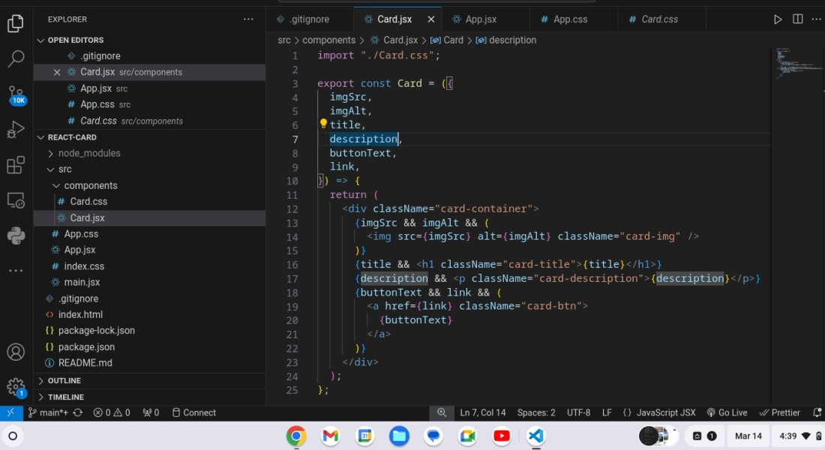

APP.CSS:

.App {

height: 100vh;

display: flex;

align-items: center;

justify-content: center;

background-color: #faf9f6;

}

.col {

height: 100%;

display: flex;

flex-direction: column;

align-items: flex-start;

}

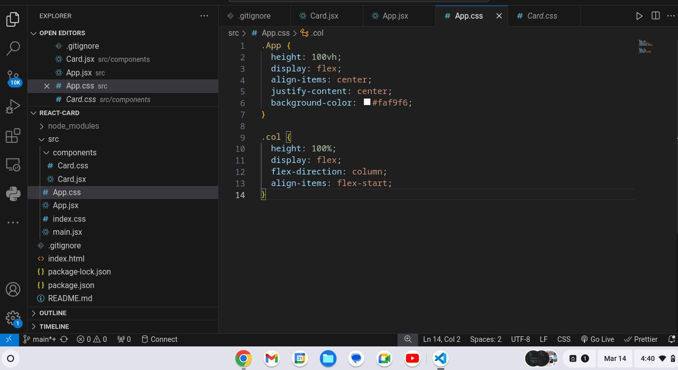

**OUTPUT:**

