Name : G.Sukanya

Roll No : 2022MCA16029

College : Sri Padmavati Mahila University

**Assignment:3** A RESTful API using express.js and create a database and index in MongoDB

**Source code:**

|  |
| --- |
| Const express=require('express'); const mongoose=require('mongoose'); const app=express(); constport=3001;  //MongoDB connection  Mongoose .connect('mongodb://localhost:27017/myDatabase', useNewUrlParser:  true, useUnifiedTopology: true }); const db = mongoose.connection; db.on('error', console.error.bind(console, 'MongoDB connection error:')); db.once('open', function() { console.log('Connected to MongoDB...');  });  // Define a schema for your data const Schema = mongoose.Schema; const exampleSchema = new  Schema({ name: String, age: Number, salary: Number, role: String  });  // Create a model based on the schema const Example= mongoose.model('Example', exampleSchema); // Express middleware for parsing JSON bodies app.use(express.json());  // Route to create a new example app.post('/examples', async (req, res) => { try {  Const example=await  Example.create(req.body);  res.status(201).json(example); } catch (err) { res.status(400).json({ message:err.message });  }  });  // Route to retrieve all examples where salary and role have values greater than 2 app.get('/examples', async (req, res) => { |

|  |
| --- |
| try { const examples= await  Example.find({  $and: [  { salary: { $gt:2 } }, // Salary greater than 2  { role: { $gt:2 } } // Role greater than 2  ] }); res.json(examples);  } catch (err) { res.status(500).json({ message: err.message });  }  });  // Route to retrieve a specific example by ID app.get('/examples/:id', async (req, res) => { try { const example =await Example.findById(req.params.id); if (!example) { return res.status(404).json({ message:'Example not found' });  } res.json(example); } catch (err)  { res.status(500).json({ message:err.message  });  }  });  // Route to update an example by ID app.put('/examples/:id', async  (req, res) => { try { const example= await  Example.findByIdAndUpdate(req.params.id, req.body, { new:true }); if (!example) {  return res.status(404).json({ message:'Example not found' });  }  res.json(example); } catch (err) { res.status(400).json({ message:err.message });  }  });  // Route to delete an example by ID  app.delete('/examples/:id', async (req, res) => { try { const example=await Example.findByIdAndDelete(req.params.id); if (!example) { return res.status(404).json({ message:'Example not found' });  } res.json({ message:'Example deleted successfully' });  } catch(err) { res.status(500).json({  message: err.message });  }  // Start the server app.listen(port, () => {  console.log(`Server is running on port ${port}`);  }); |

**OutPut:**

Post method:

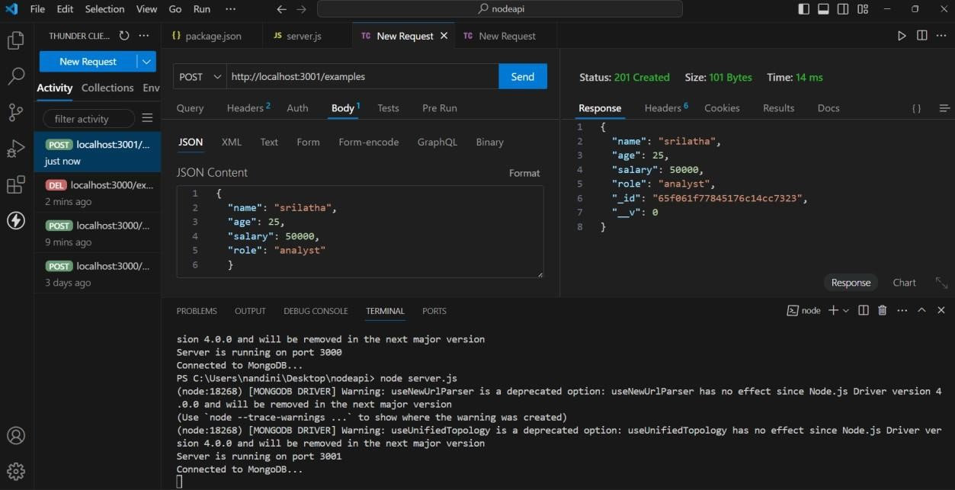

Get Method:

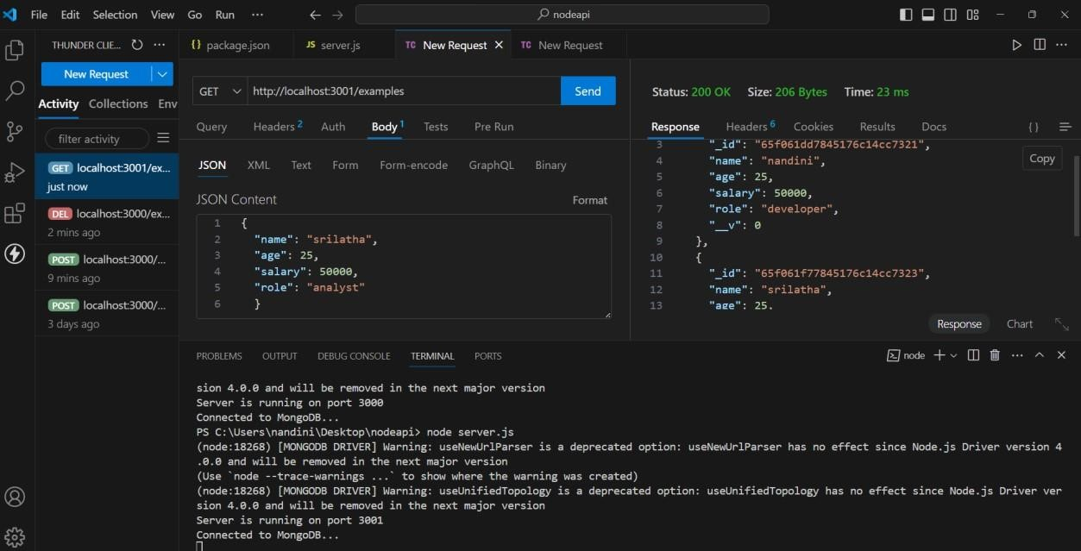

Put method:

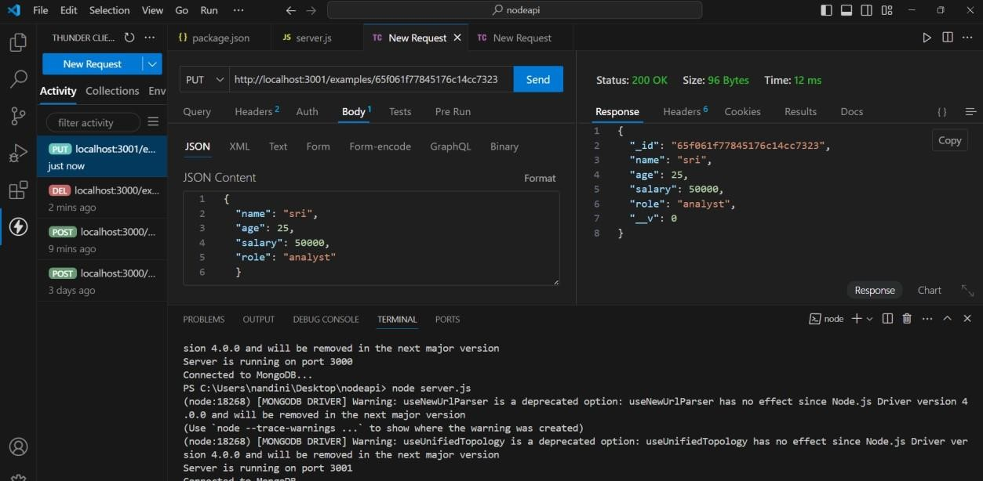

Delete method:

