Name : G.Sukanya

Roll.no : 2022MCA16029

College : Sri PadmavatiMahila University

Assignment 4 :Creating a Database Using MongoDB and Mongosh.

**1.InsertOne():**

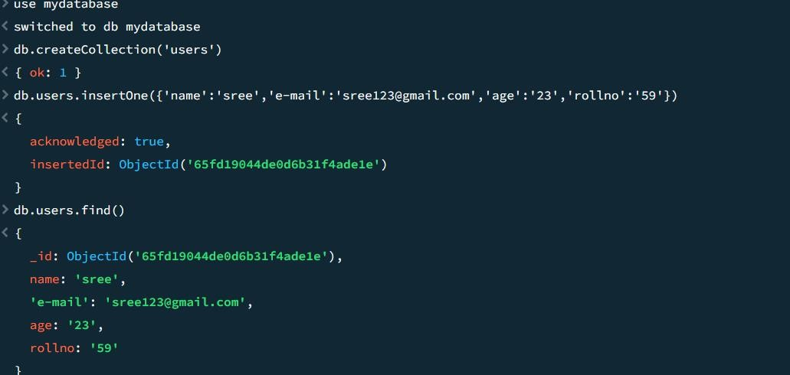

**Insert Many ():**

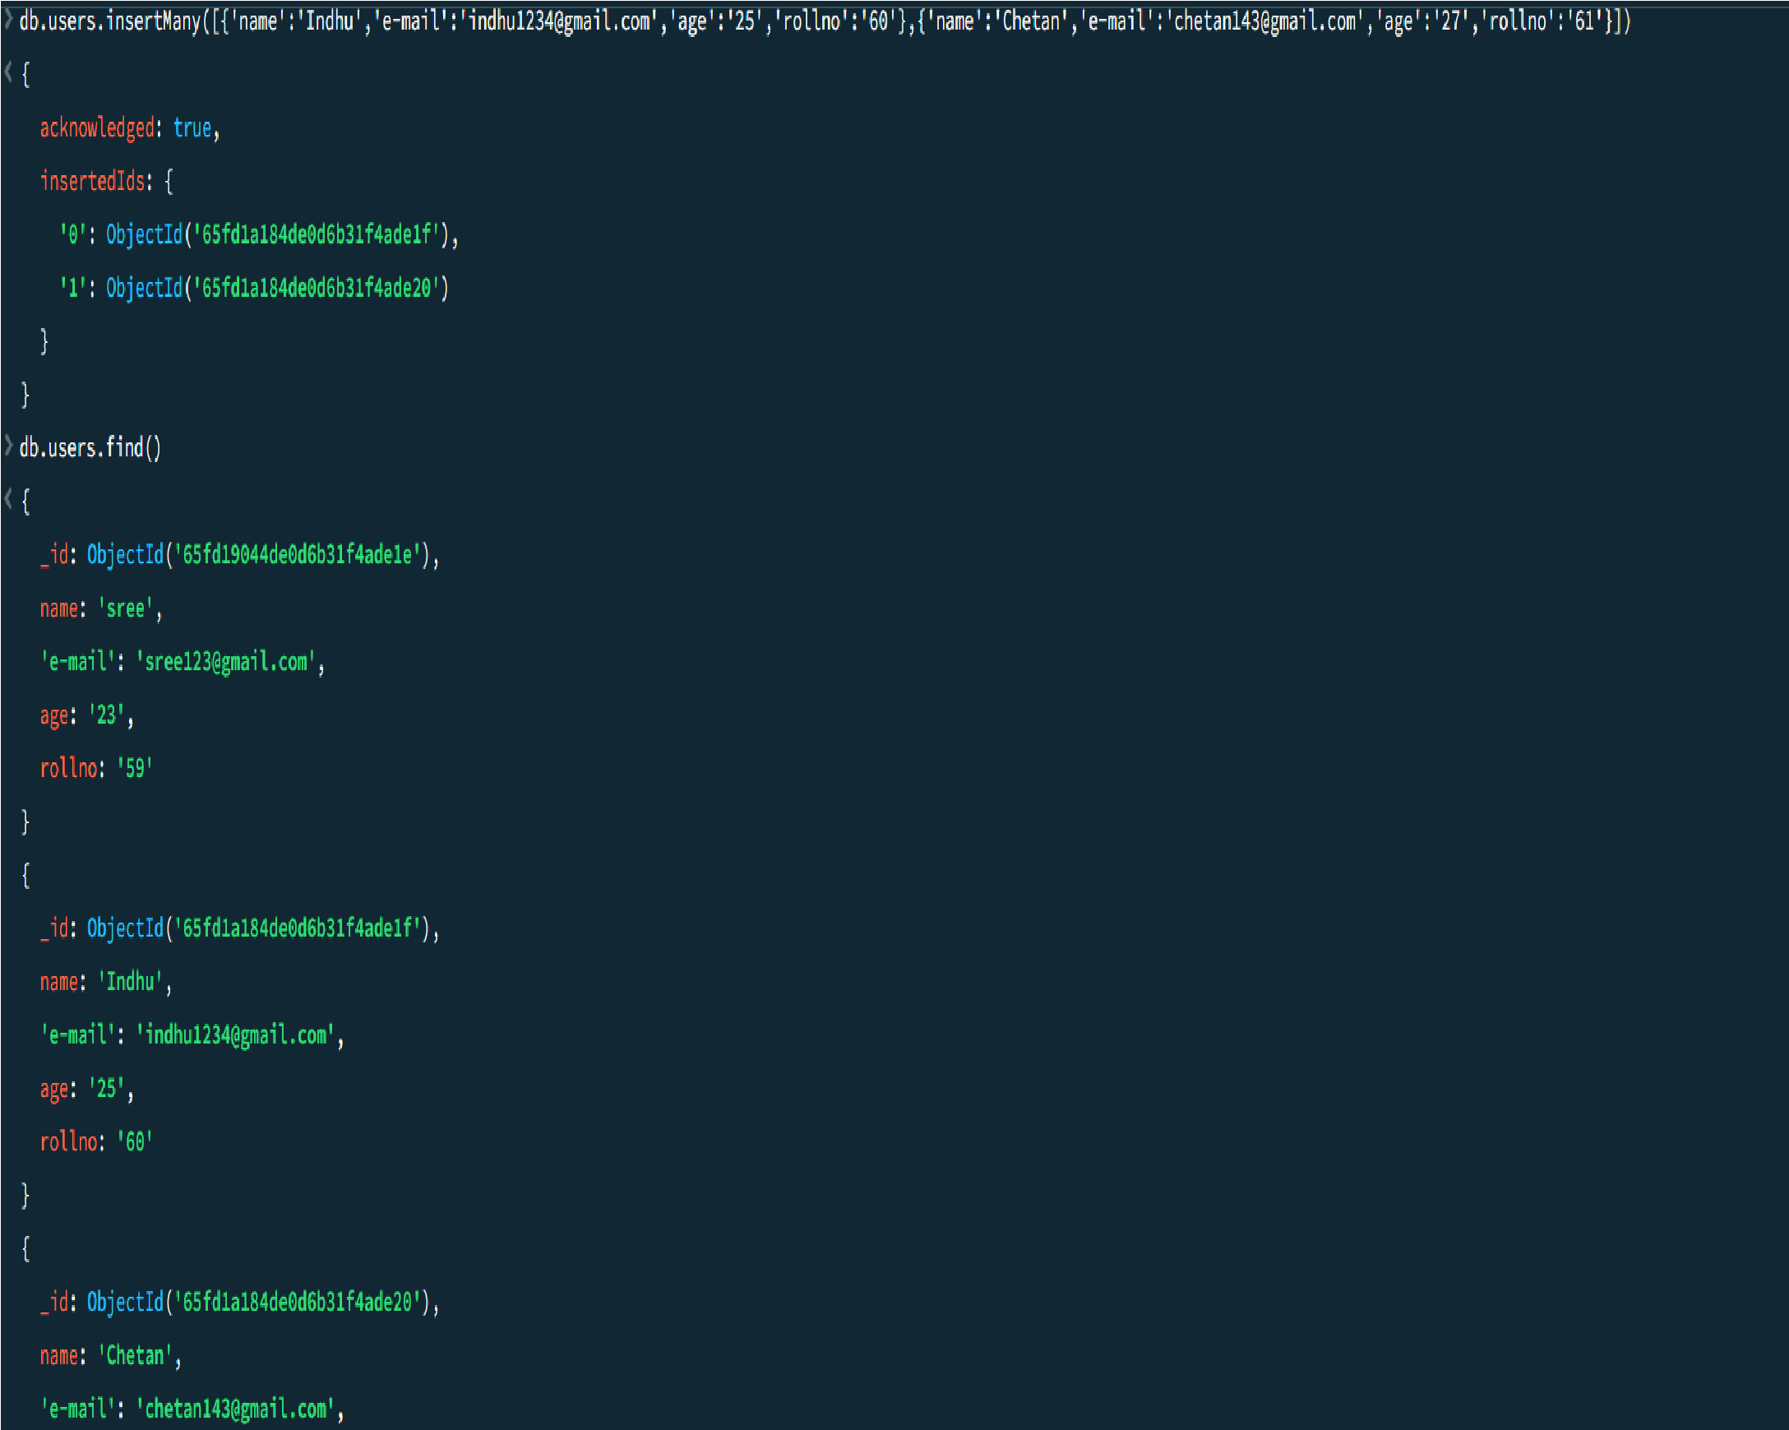

**2.Read():**

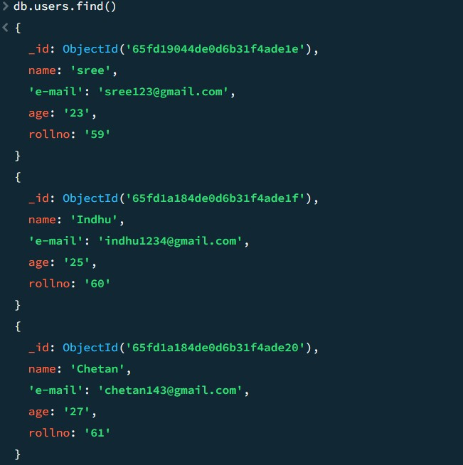

**3.Update():**

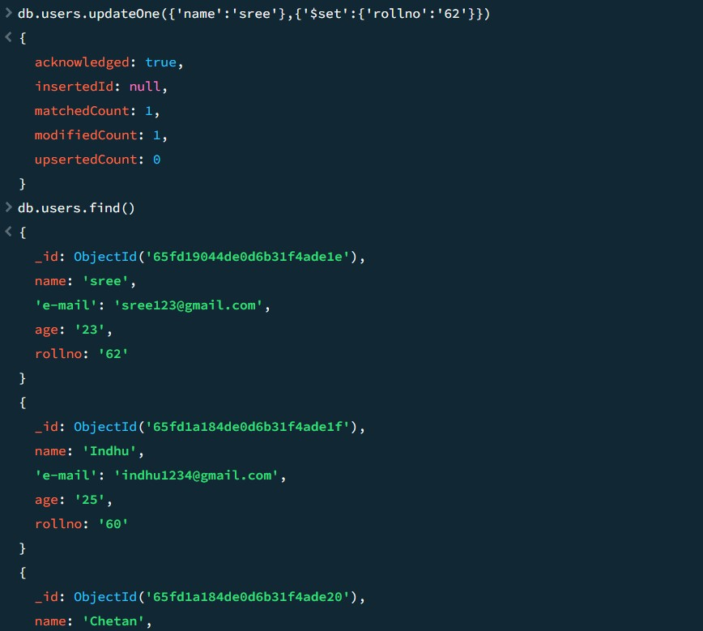

**4.Delete():**

**DeleteOne():**

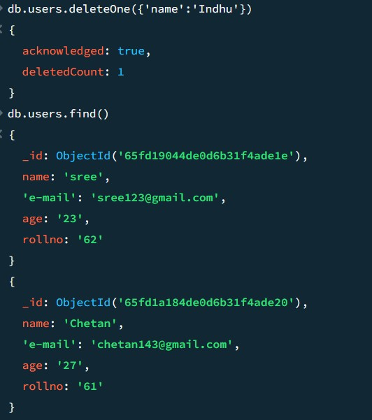

**DeleteMany():**

