1. A lake is currently stocked with 12,230 fish. Each year, the number of births per fish is 1.2 and number of deaths per fish is 0.7. Show that if 6,115 fish per year are harvested, the number of fish in the lake will stay constant.

2. The Gini index is a commonly used measure of a nation’s income inequality. If the income of n people is listed in increasing order (x₁ = smallest income, x_{n} = largest income), then the Gini index is defined by the formula
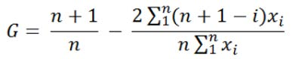

Set up a spreadsheet that determines the Gini index for a group of five people.

3. How can coffee shop determine how changes in price and unit cost affect the profit, if the demand curve or corresponding demand-slope and demand-intercept are given and also costs and respective prices are given.

4. You want to sum the sales in Arizona, California, Montana, New York, and New Jersey. Can you use a formula to compute total sales in a form such as AZ+CA+MT+NY+NJ instead of SUM(A21:A25) and still get the right answer?

5.

