

Ramakrishna Mission Vidyamandira

(An Autonomous College Under University of Calcutta)

Computer Science (Honors) Semester II 2024

Paper: 2CMSACOC1 Practical

|  |
| --- |
| **Submitted by** |
| Class Roll Number: 340  Registration Number:  B.Sc.  2th Semester  Batch: 2023-27 |

**INDEX**

|  |  |  |  |  |
| --- | --- | --- | --- | --- |
| **SI NO.** | **ASSIGNMNET STATEMENT** | **D-O-A** | **D-O-S** | **SIGNATURE** |
| **1.** | **Write a program to perform all insertion technique in a linear linked list.** |  |  |  |
| **2.** | **Write a program to perform all insertion technique in a circular linked list.** |  |  |  |
| **3.** | **Write a program to find odd number sum in a linked list.** |  |  |  |
| **4.** | **Write a program to perform polynomial addition of two linked list.** |  |  |  |

**Question 1:**

**Write a program to perform all insertion technique in a linear linked list.**

**Source code:**

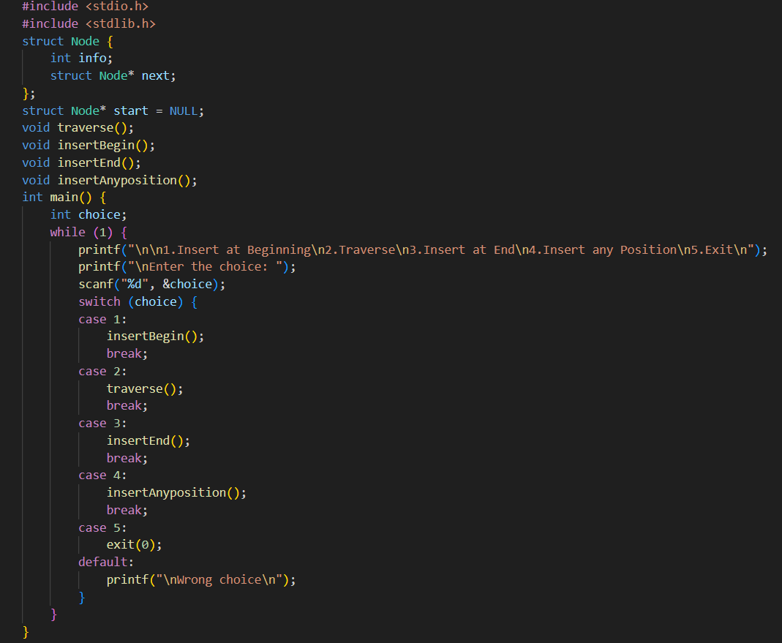

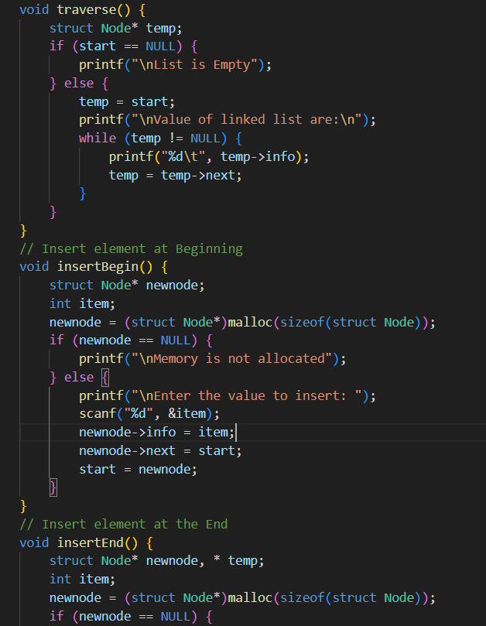

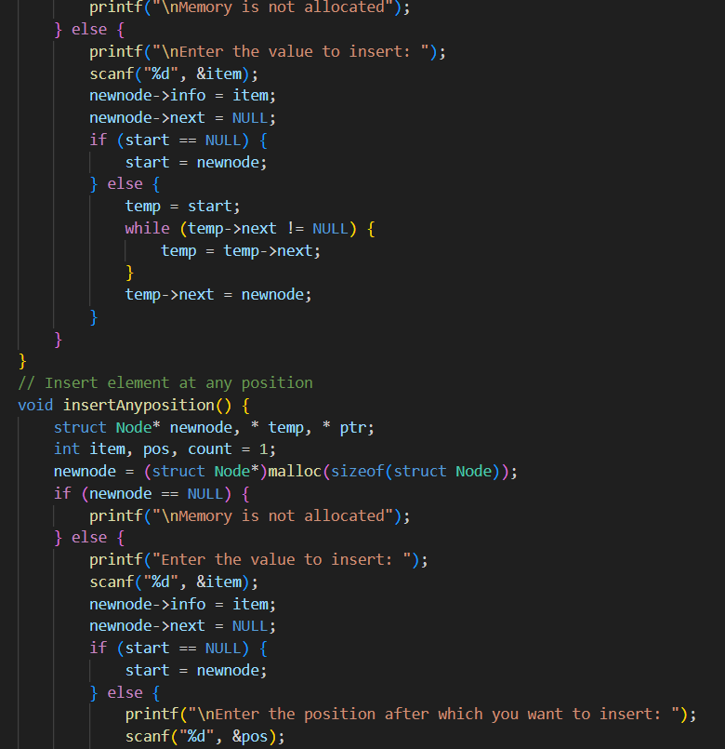

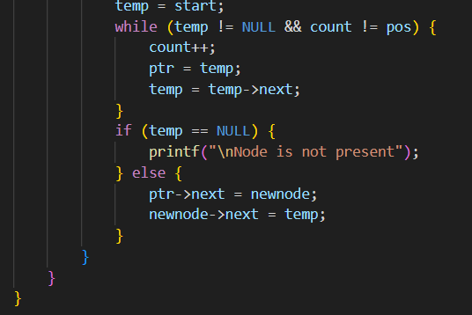

**Output:**

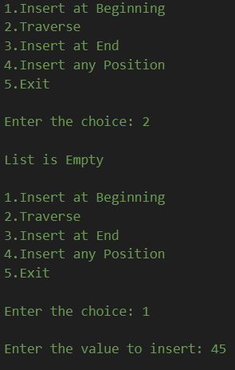

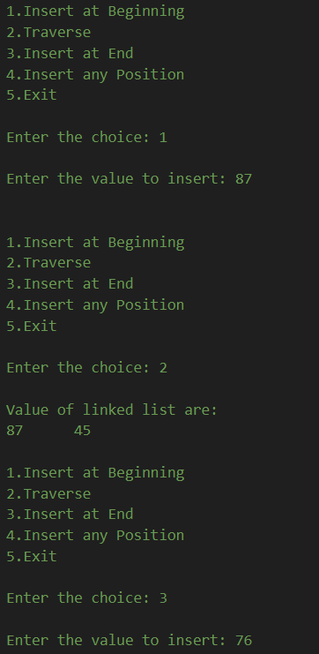

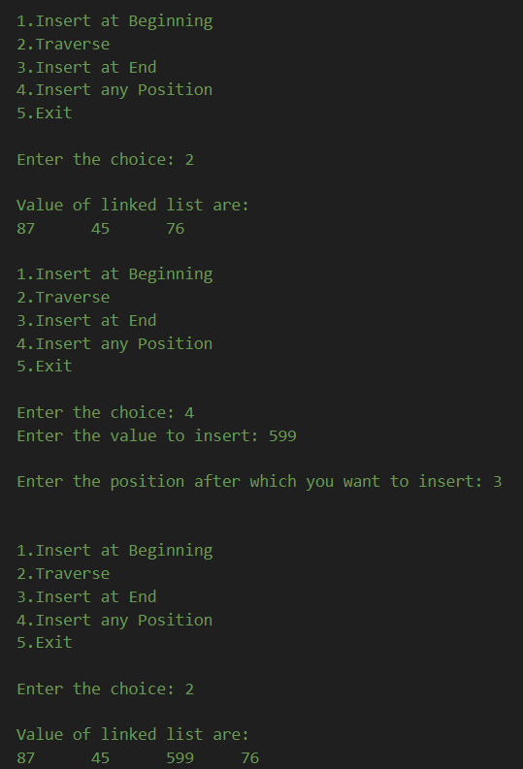

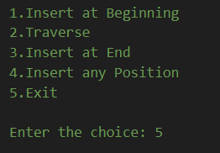

**Question 2:**

**Write a program to perform all insertion technique in a circular linked list.**

**Source code:**

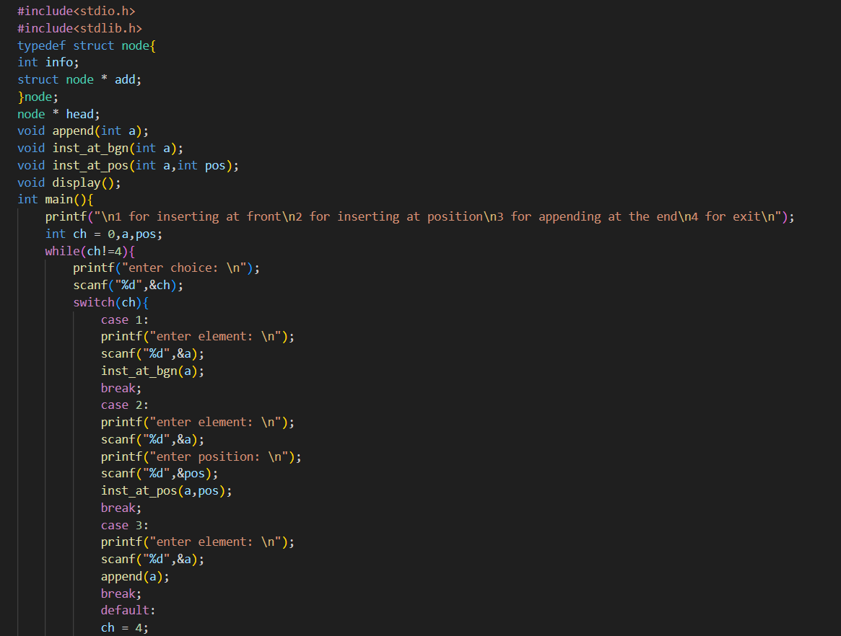

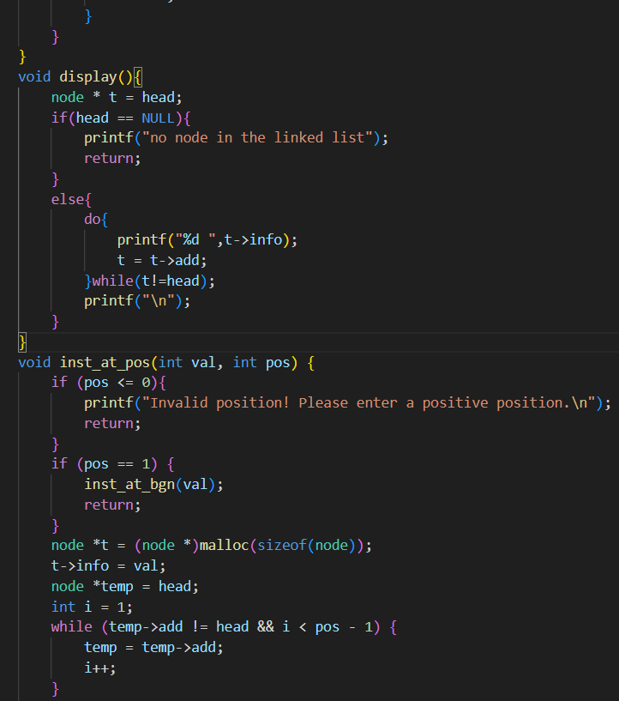

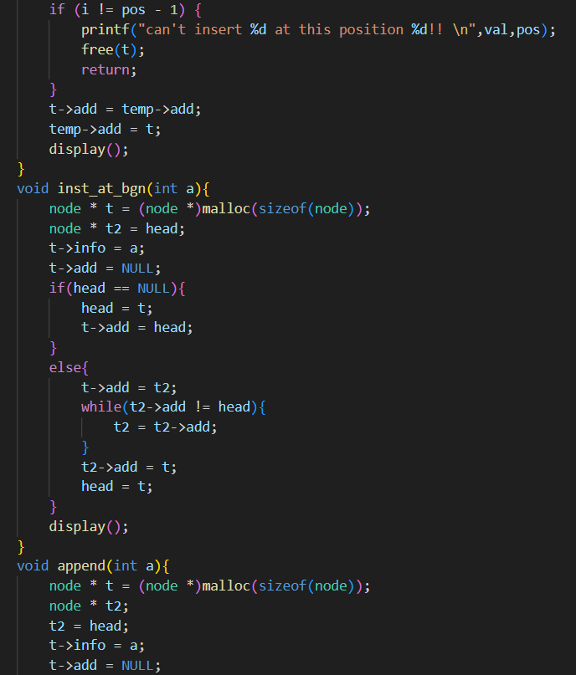

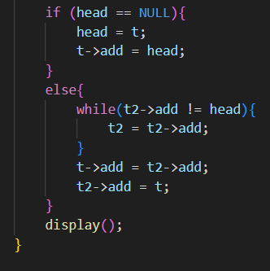

**Output:**

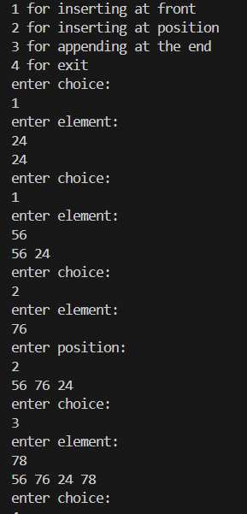

**Question 3:**

**Write a program to find odd number sum in a linked list.**

**Source code:**

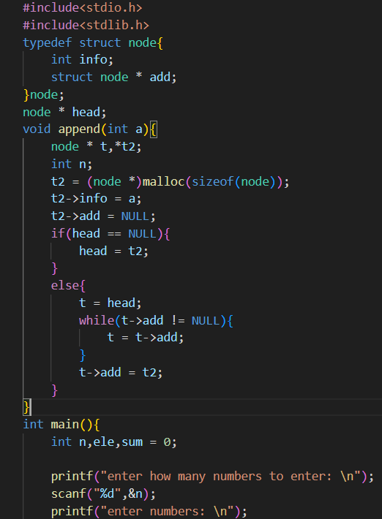

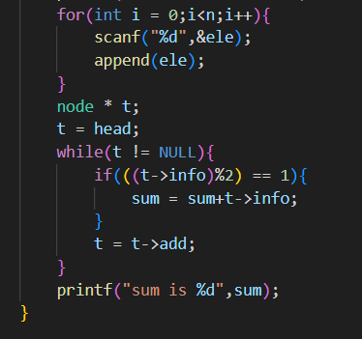

**Output:**

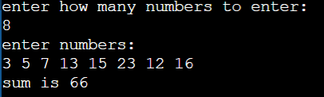

**4.Write a program to perform polynomial addition of two linked list.**

**Source code:**

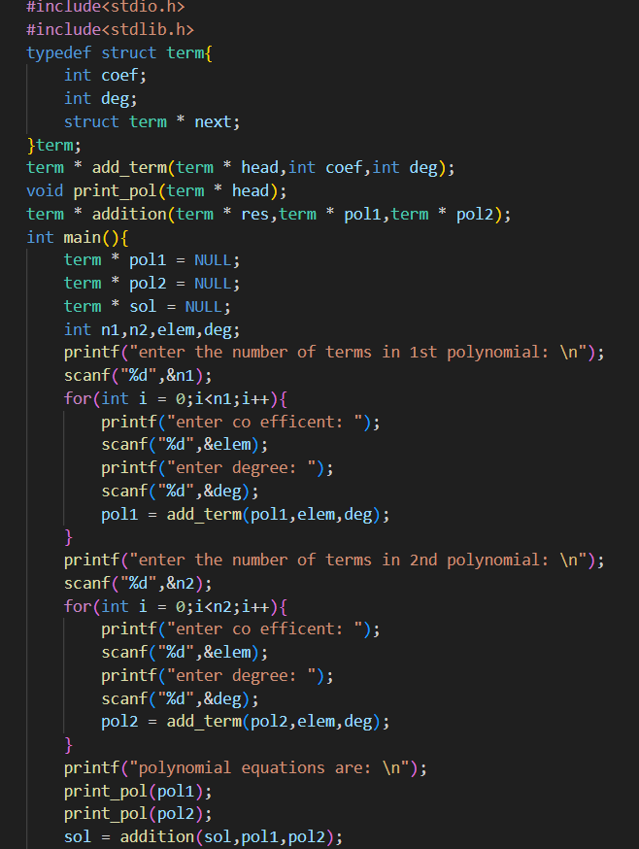

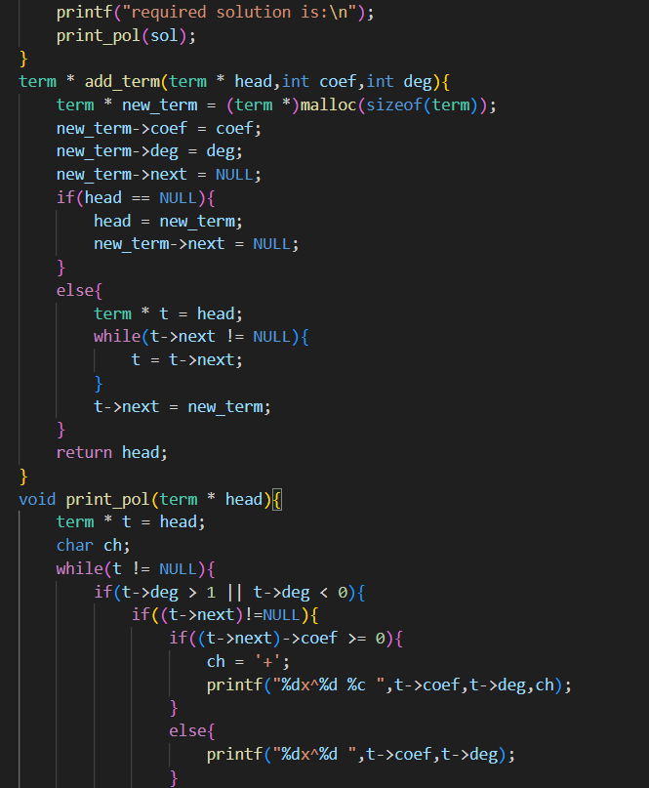

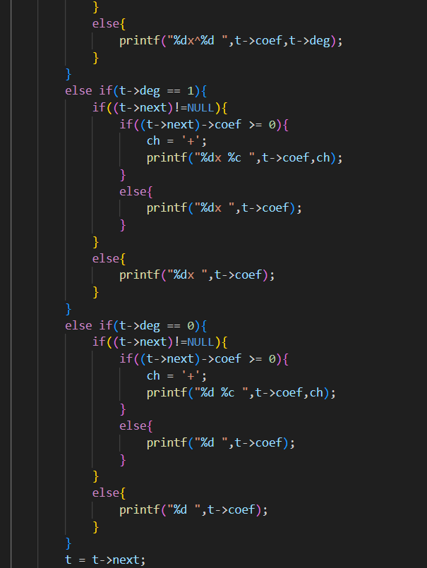

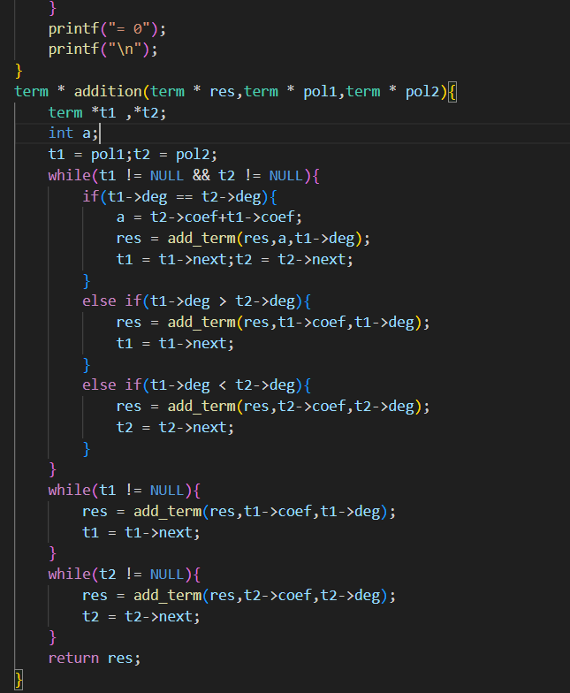

**Output:**

