

Ramakrishna Mission Vidyamandira

(An Autonomous College Under University of Calcutta)

Computer Science (Honors) Semester II 2024

Paper: 2CMSCOC 1 Practical

|  |
| --- |
| **Submitted by** |
| Class Roll Number: 340  Registration Number:  B.Sc.  2th Semester  Batch: 2023-27 |

|  |  |  |  |  |
| --- | --- | --- | --- | --- |
| **SI NO.** | **ASSIGNMNET STATEMENT** | **D-O-A** | **D-O-S** | **SIGNATURE** |
|  | Write a program to insert an element at desired position in an array. |  |  |  |
| 2. | Write a program to delete an element at desired position in an array. |  |  |  |
| 3. | Write a program a Sparse matrix as a user input and create Triplet. |  |  |  |
| 4. | Write a program to create a Stack and implement is operation push, pop, empty, full, peek and display. |  |  |  |
| 5. | Write a program infix to postfix. |  |  |  |
| 6. | Evaluating postfix Expression in Stack. |  |  |  |
| 7. | Write a program Tower of Hanoi. |  |  |  |
| 8. | Write a program a Linear Queue. |  |  |  |
| 9. | Write a program to implementation a Circular Queue. |  |  |  |
| 10. | Write a program to implement of insertion Sort. |  |  |  |
| 11. | Write a program to implement of Selection Sort. |  |  |  |
| 12. | Write a program to implement of Bubble Sort. |  |  |  |
| 13. | Write a program to implement of Linear Search. |  |  |  |
| 14. | Write a program to implement of Binary Search. |  |  |  |
| 15. | Create a Binary Tree and perfrom a Inorder Traversal. |  |  |  |
| 16. | Create a Binary Tree and perfrom a Preorder Traversal. |  |  |  |
| 17. | Create a Binary Tree and perfrom a Postorder Traversal. |  |  |  |
|  |  |  |  |  |
|  |  |  |  |  |
|  |  |  |  |  |
| NOTE: |  |  |  |  |
|  |  |  |  |  |

**INDEX**

**Question:1**

**Statement:** Write a program to insert an element at desired position in an array.

**Source Code:**

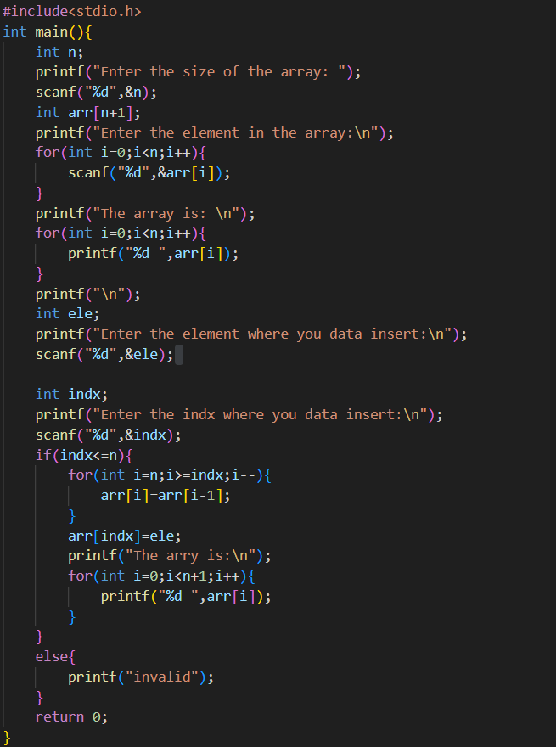

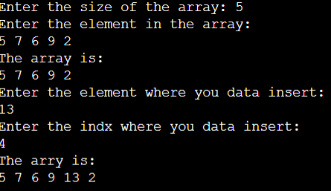**Output:**

**Question:2**

**Statement:** Write a program to delete an element at desired position in an array.

**Source Code:**

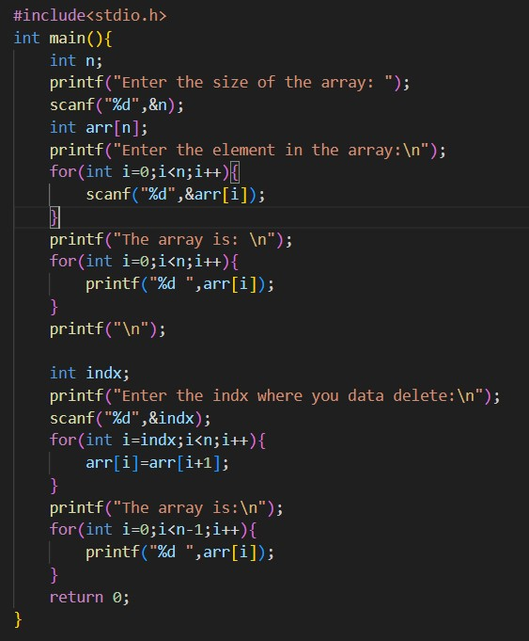

**Output:**

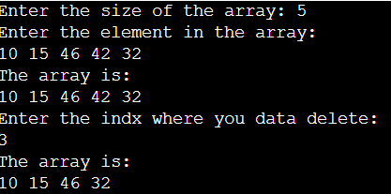

**Question:3**

**Statement:** Write a program a Sparse matrix as a user input and create Triplet.

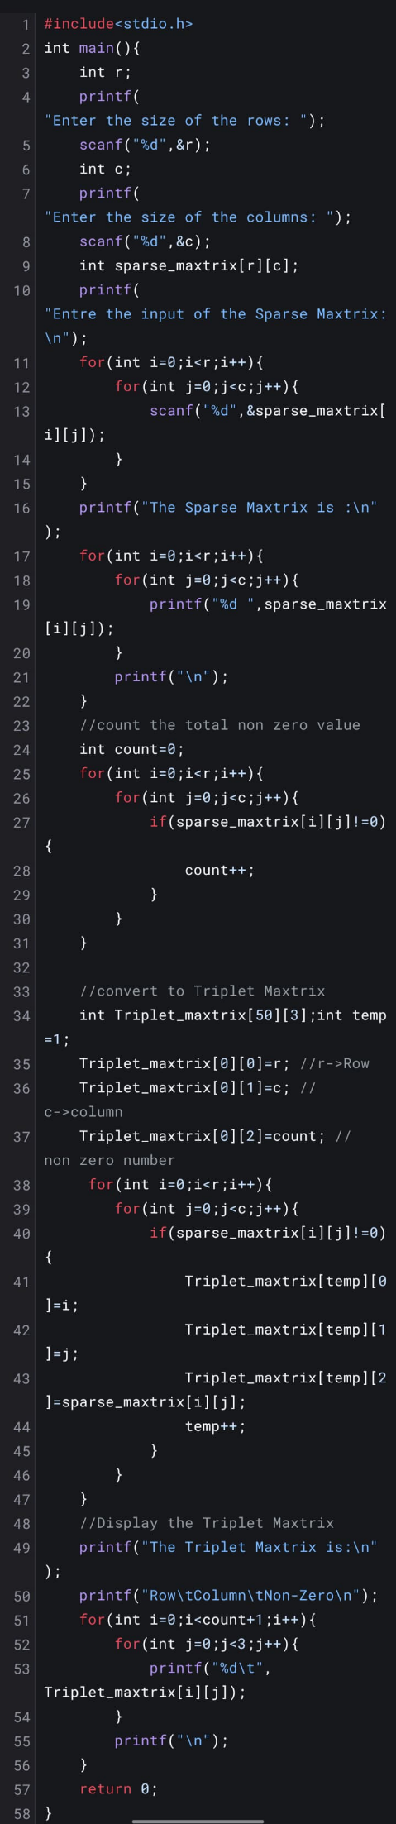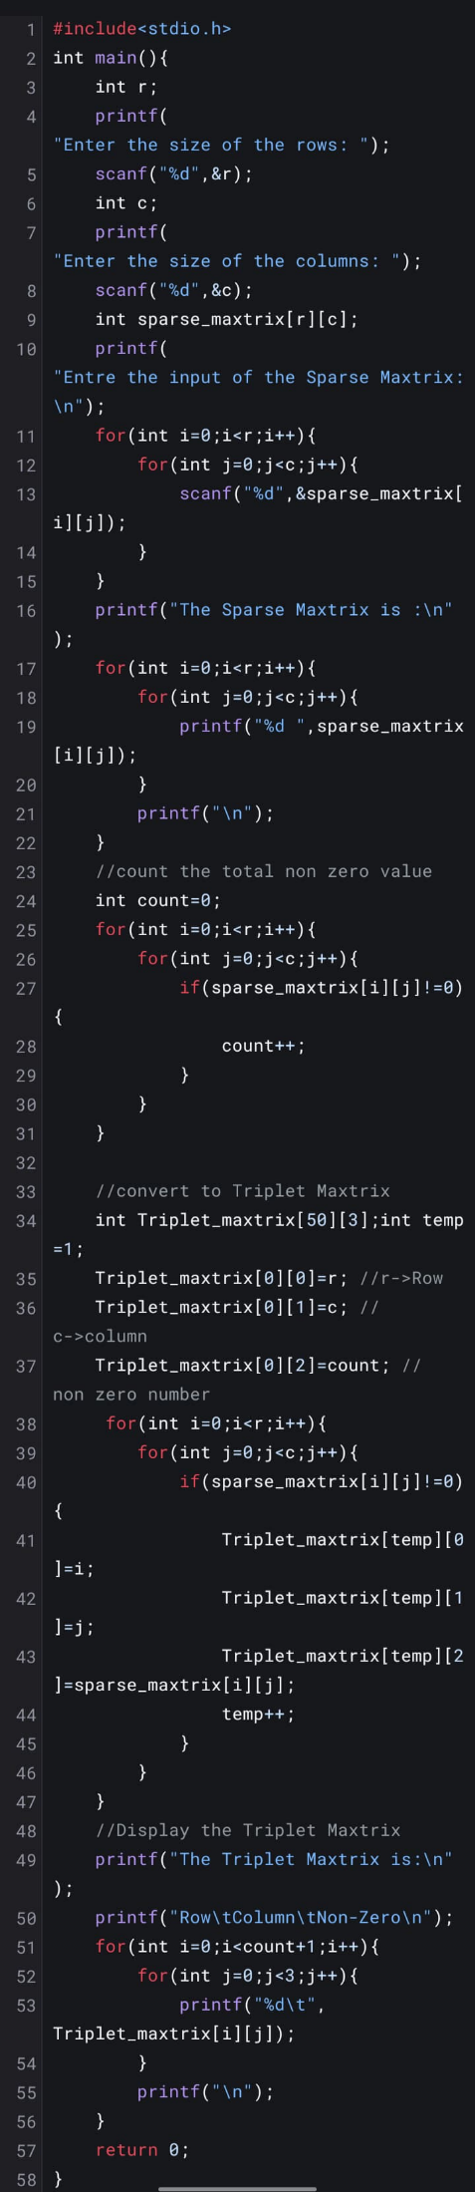**Source Code:**

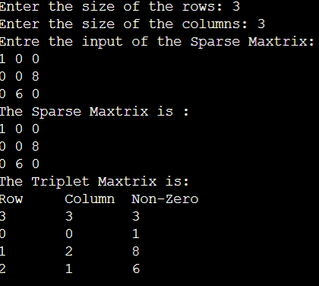**Output**

**Question:4**

**Statement:** Write a program to create a Stack and implement is operation push, pop, empty, full, peek and display.

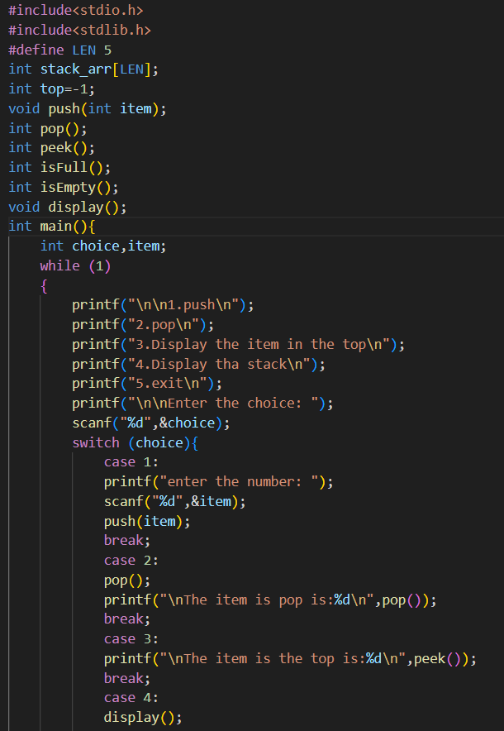**Source Code:**

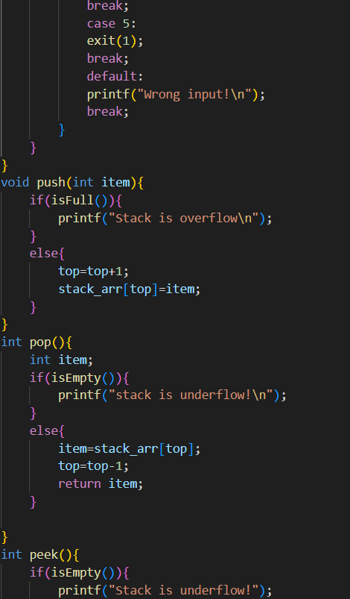

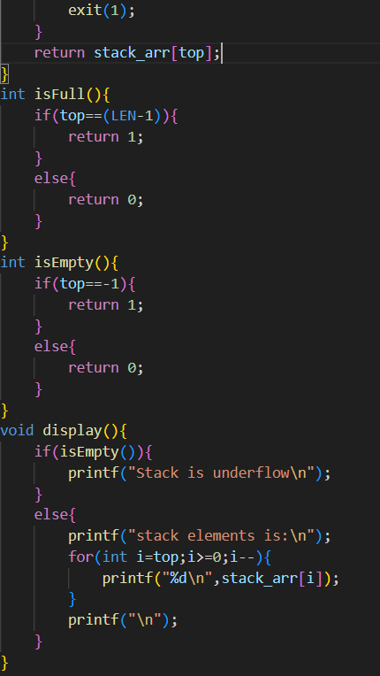

**Output:**

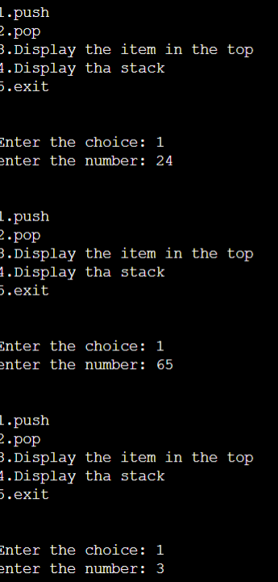

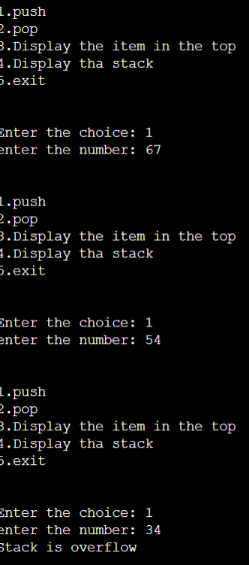

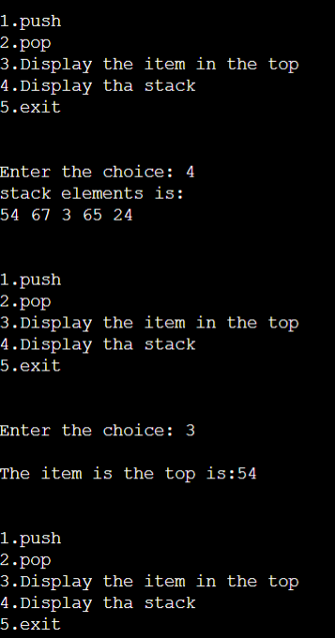

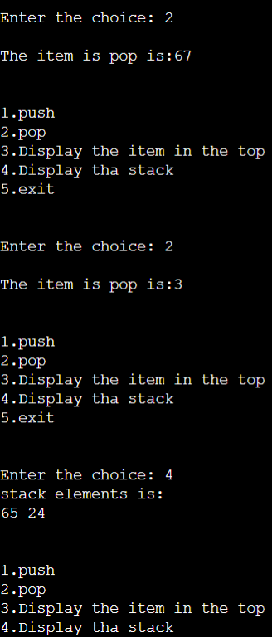

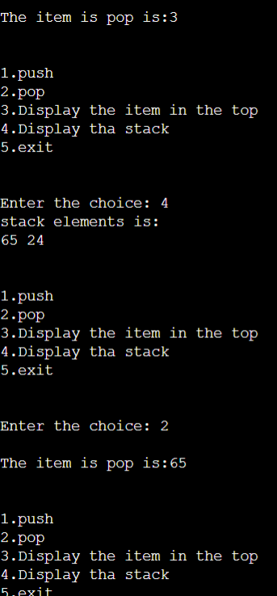

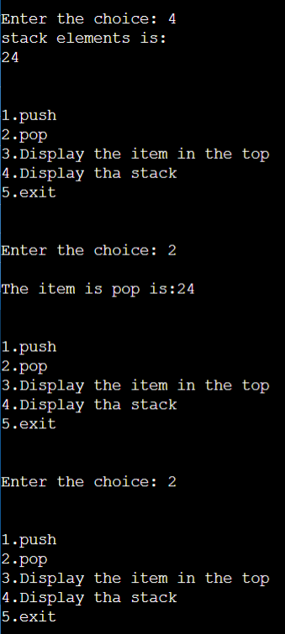

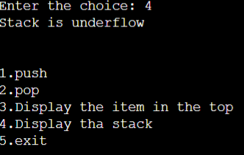

**Question:5**

**Statement:** Write a program infix to postfix.

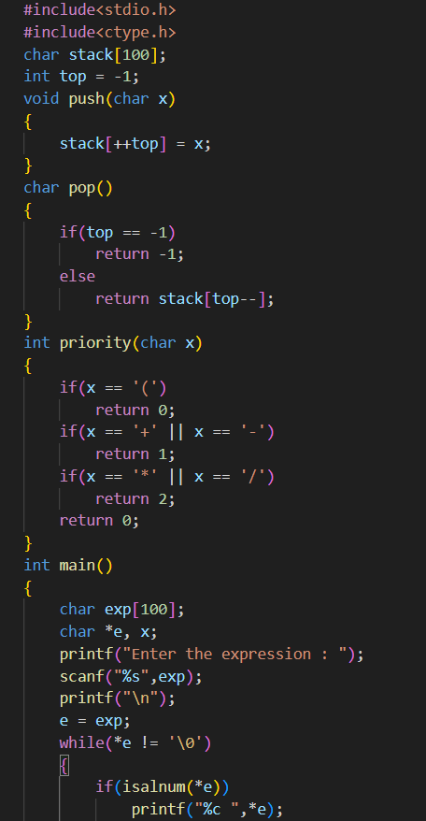**Source Code:**

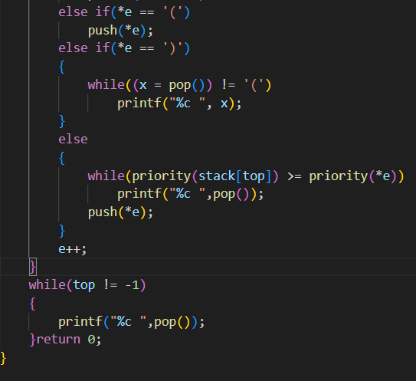

**Output:**

**Case-1:**

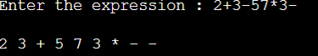

**Case-2:**

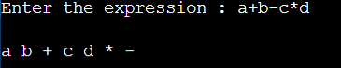

**Question:6**

**Statement:** Evaluating postfix Expression in Stack.

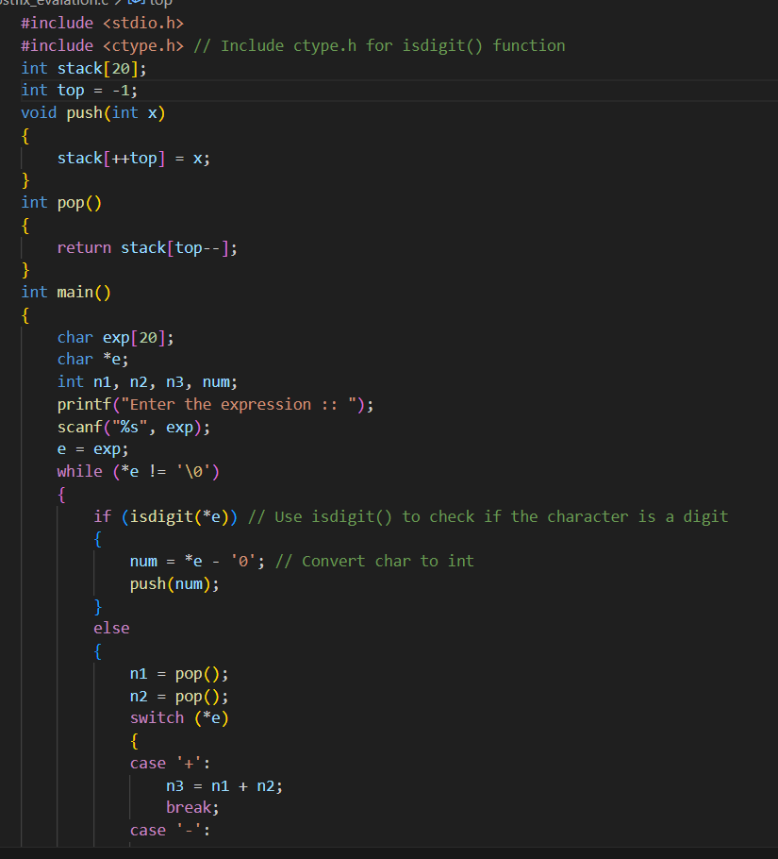**Source Code:**

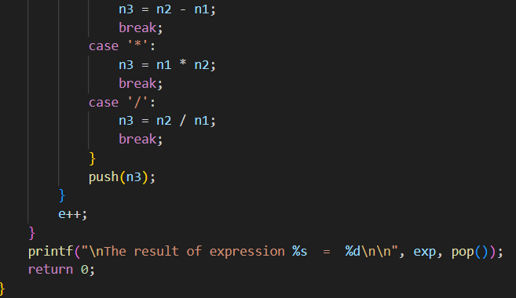

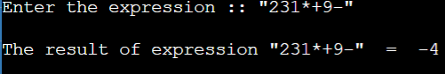**Output:**

**Question:7**

**Statement:** Write a program Tower of Hanoi.

**Source Code:**

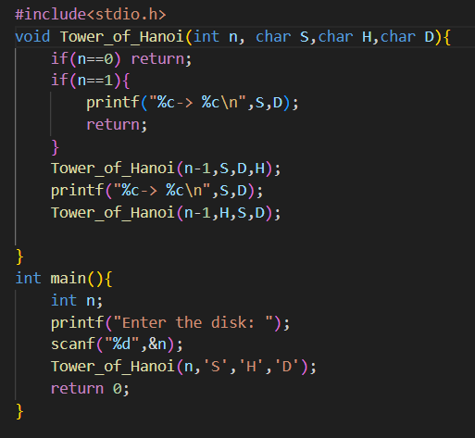

**Output:**

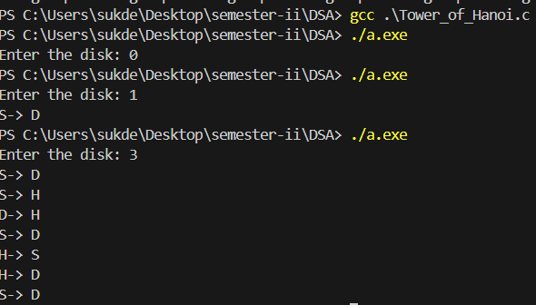

**Question:8**

**Statement:** Write a program a Linear Queue.

**Source Code:**

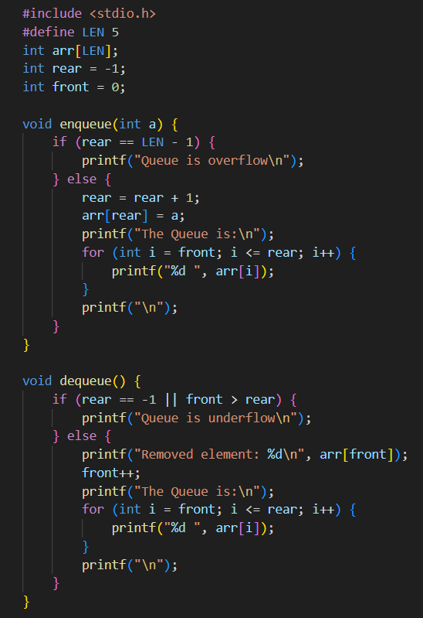

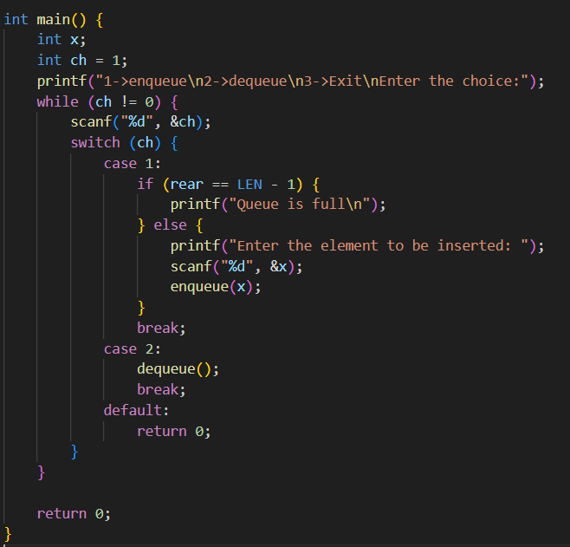

**Output:**

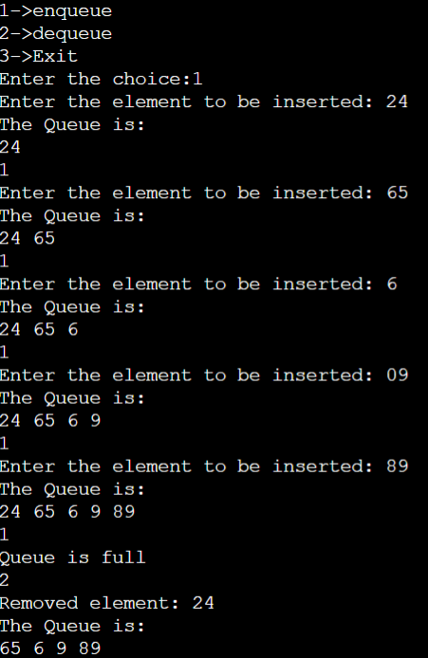

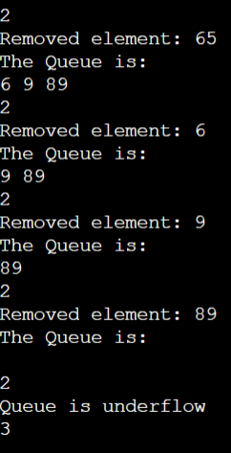

**Statement:** Write a program to implementation a Circular Queue.

**Source Code:**

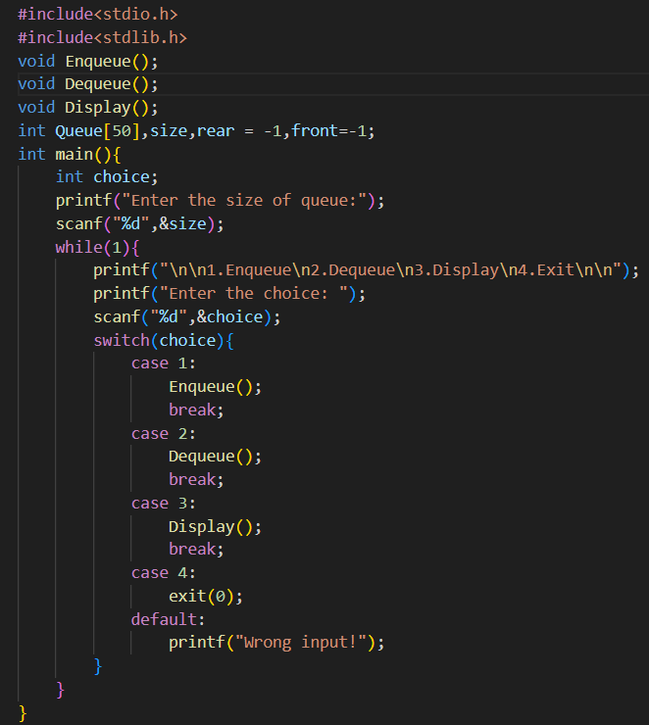

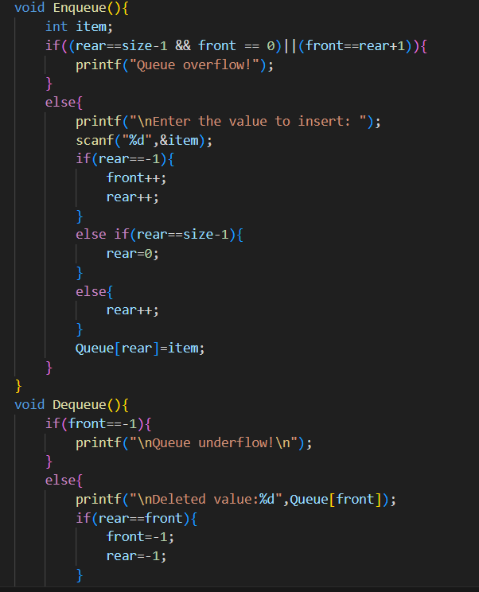

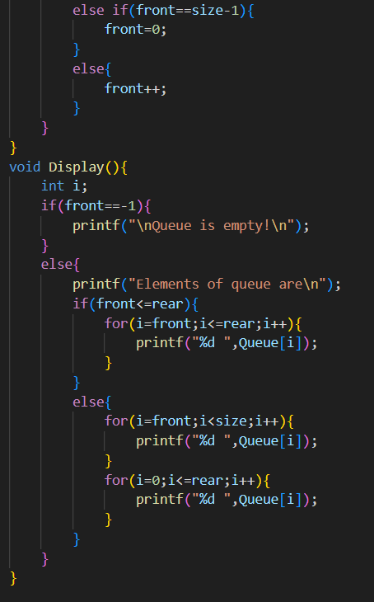

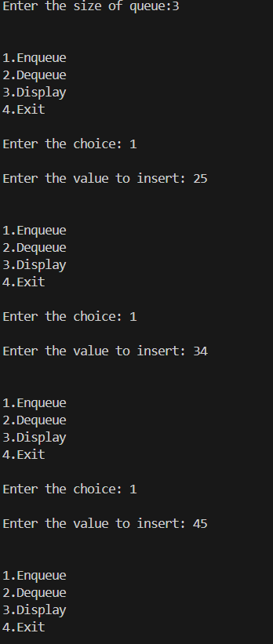**Output:**

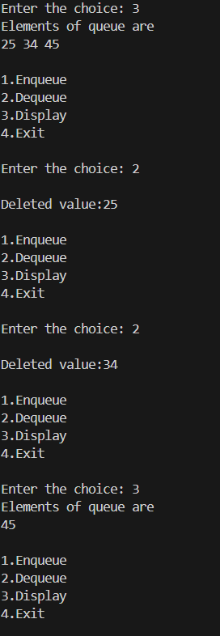

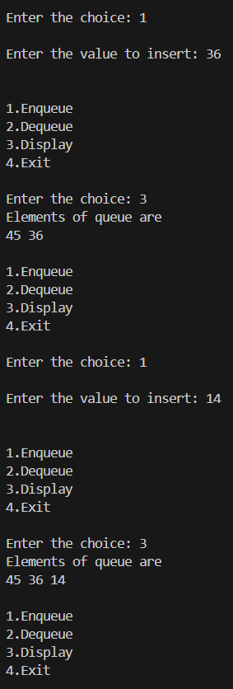

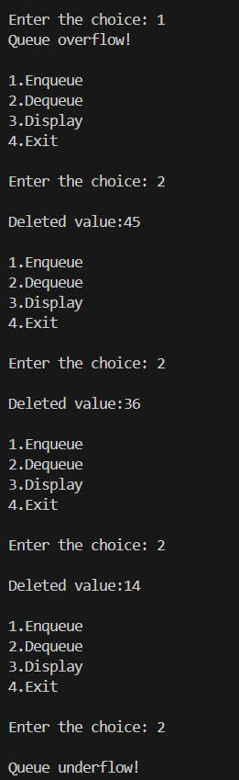

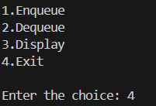

**Question:10**

**Statement:** Write a program to implement of insertion Sort.

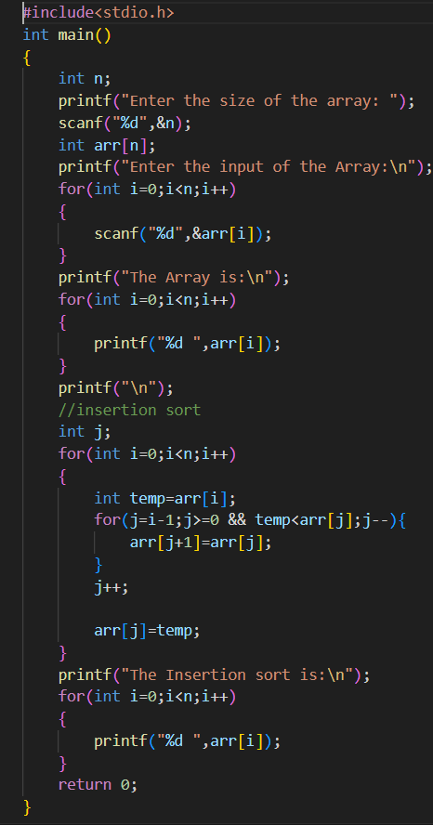**Source Code:**

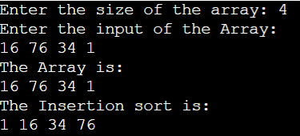**Output:**

**Question:11**

**Statement:** Write a program to implement of Selection Sort.

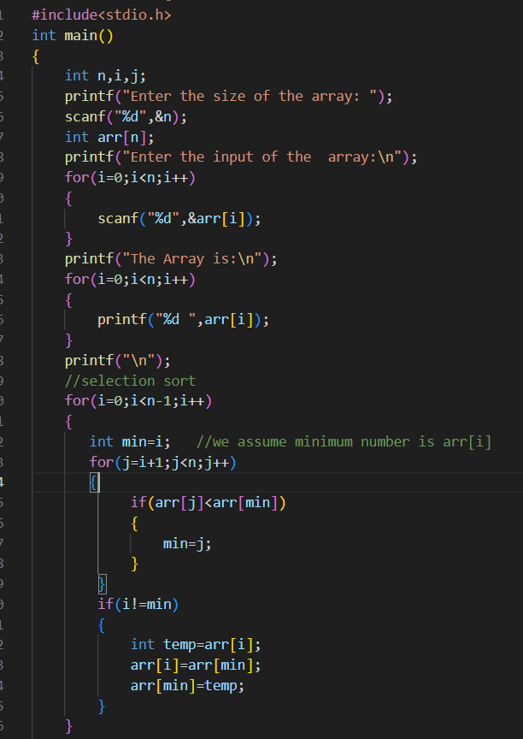**Source Code:**

**Output:**

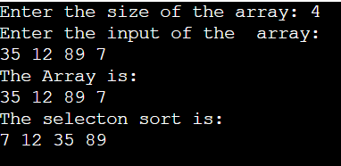

**Question:12**

**Statement:** Write a program to implement of Bubble Sort.

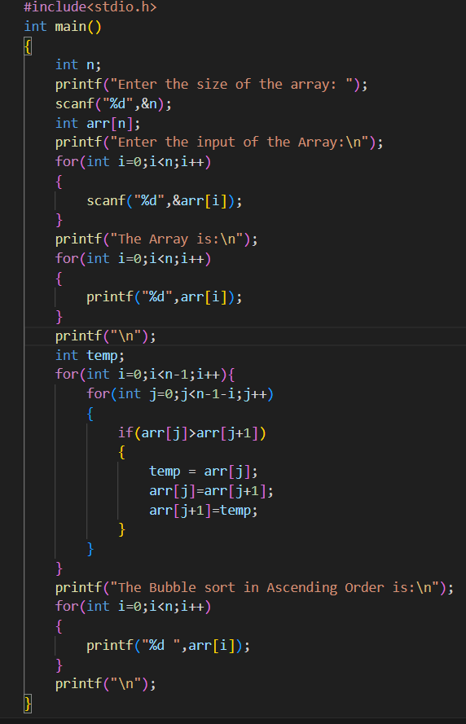**Source Code:**

**Output:**

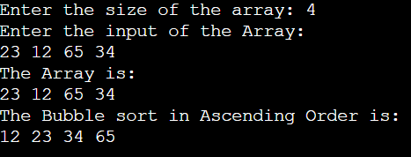

**Question:13**

**Statement:** Write a program to implement of Linear Search.

**Source Code:**

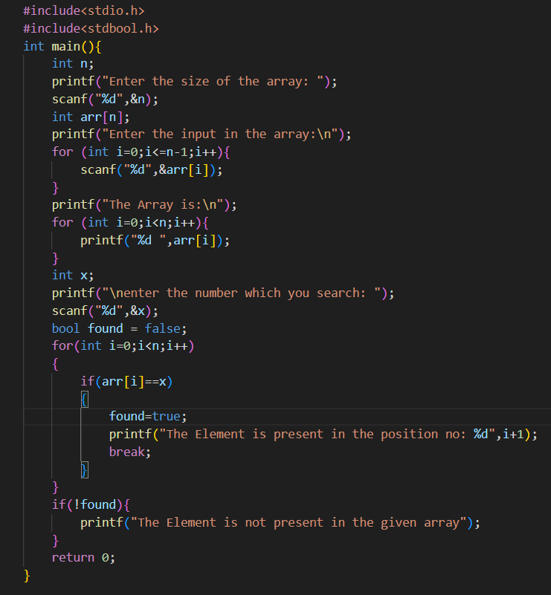

**Output:**

**Case-1:**

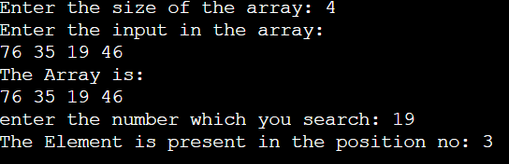

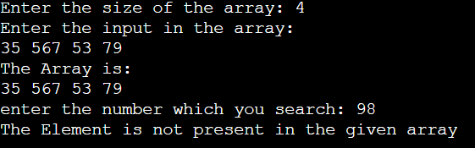**Case-2:**

**Question:14**

**Statement:** Write a program to implement of Binary Search.

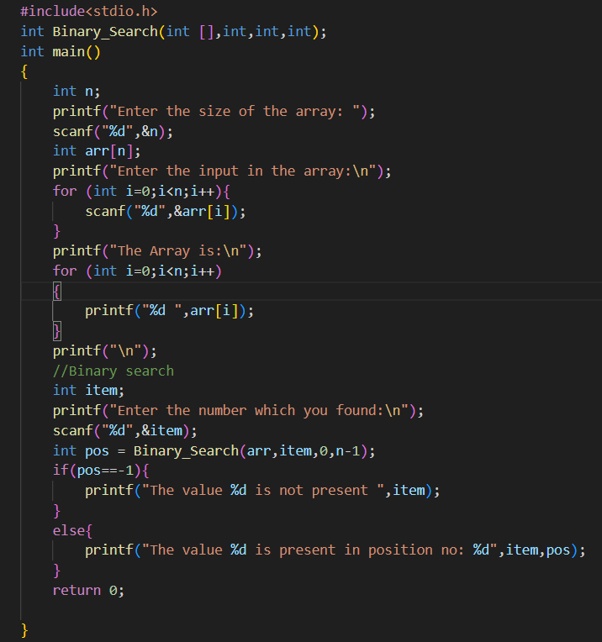**Source Code:**

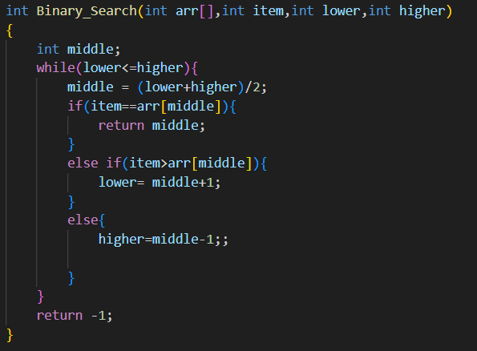

**Output:**

**Case-1:**

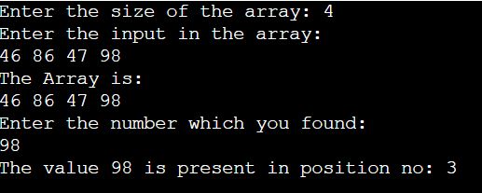

**Case-2:**

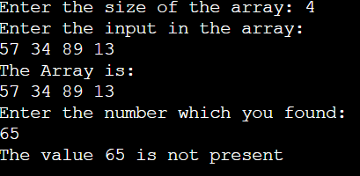

**Question:15**

**Statement:** Create a Binary Tree and perfrom a Inorder Traversal.

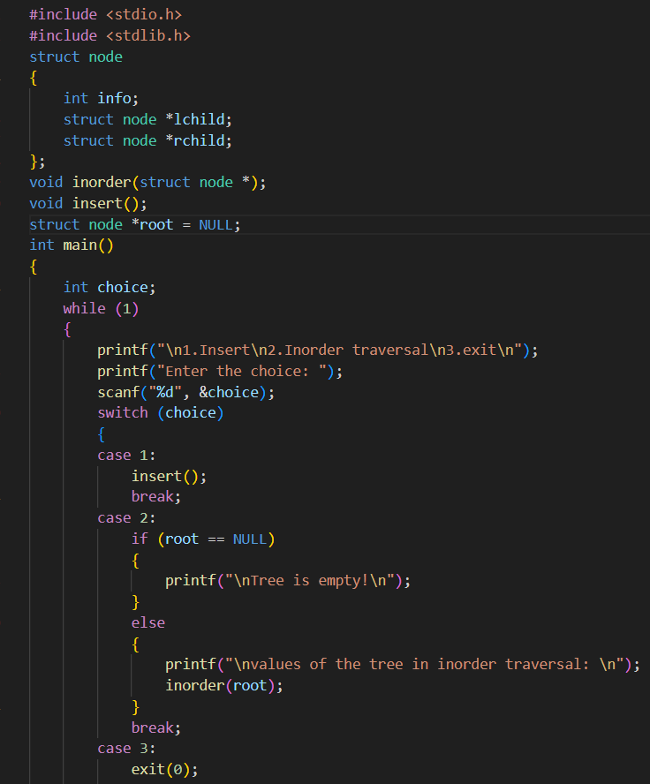**Source Code:**

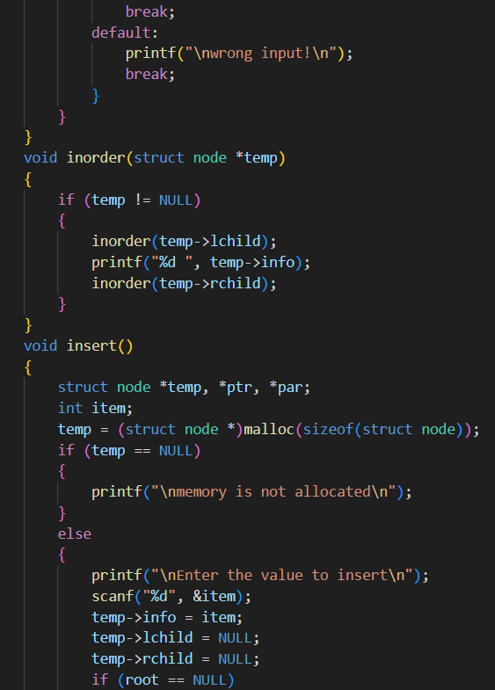

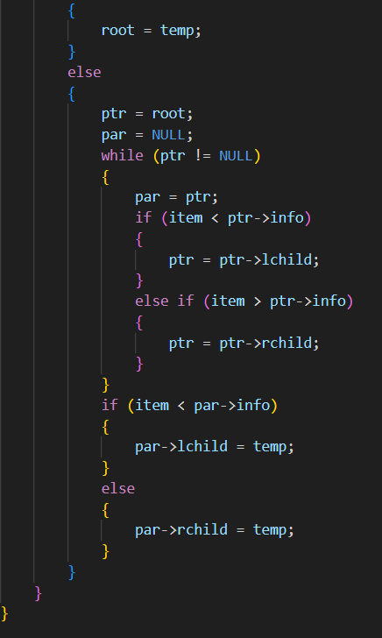

**Output:**

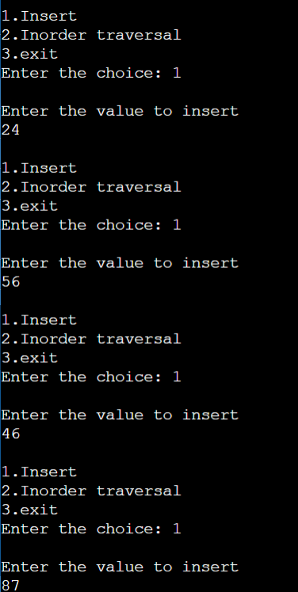

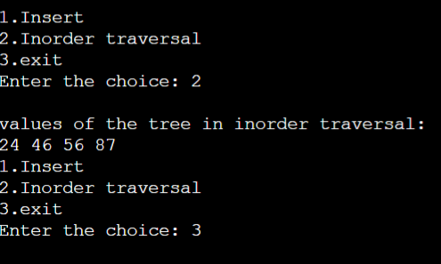

**Question:16**

**Statement:** Create a Binary Tree and perfrom a Preorder Traversal.

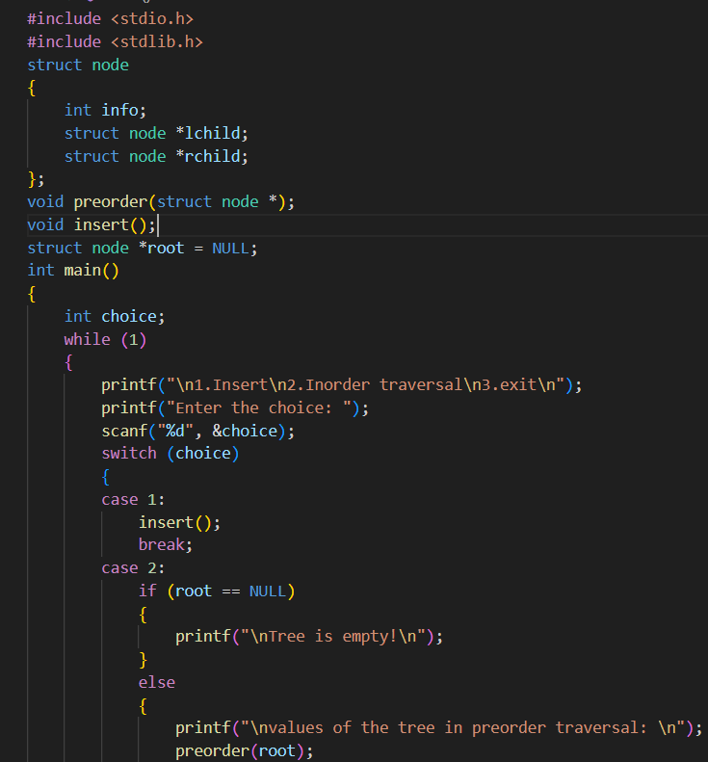**Source Code:**

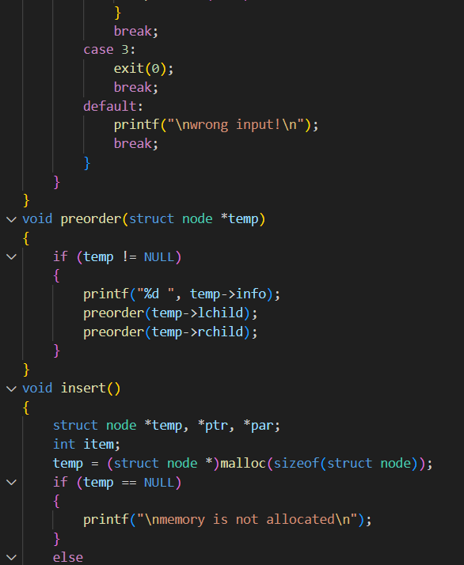

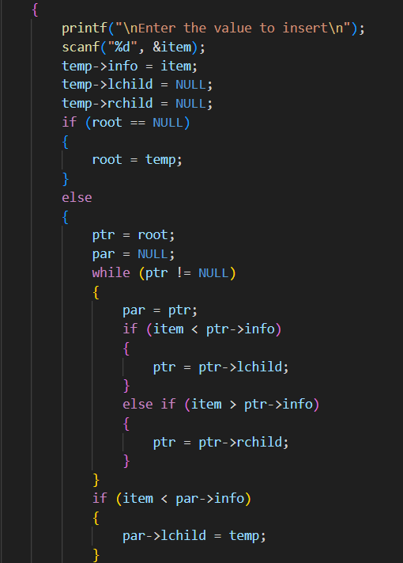

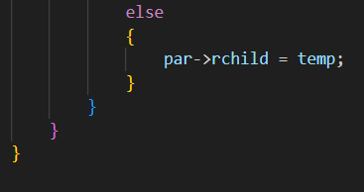

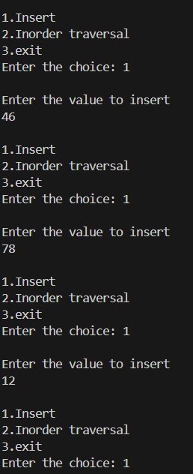**Output:**

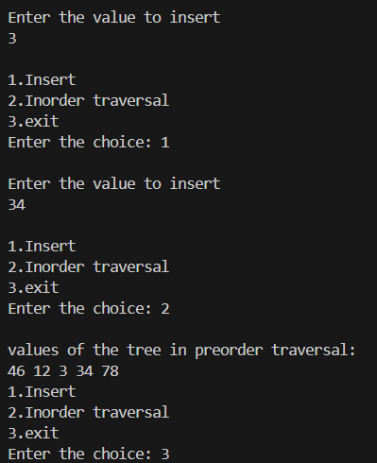

**Question:17**

**Statement:** Create a Binary Tree and perfrom a postorder Traversal.

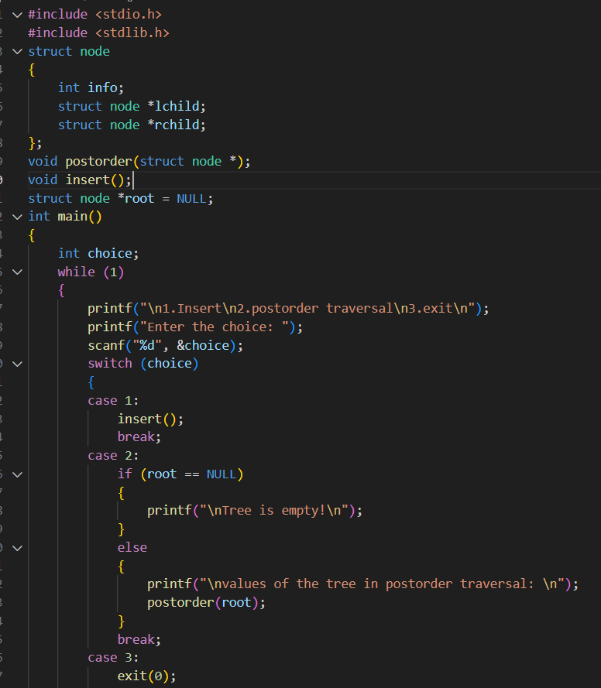**Source Code:**

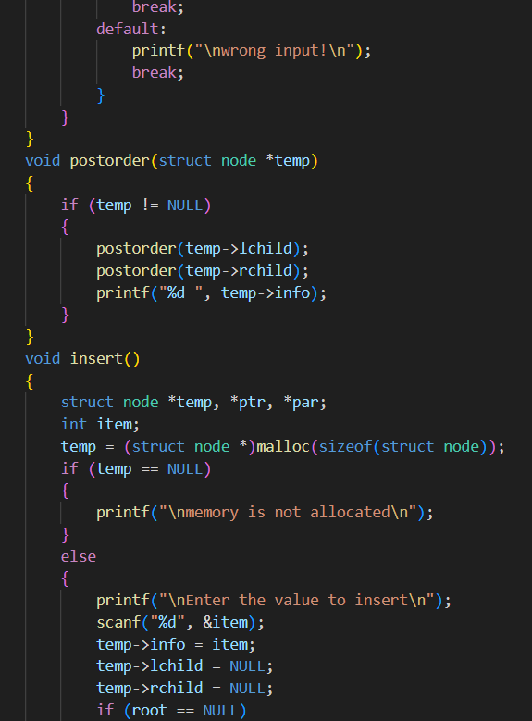

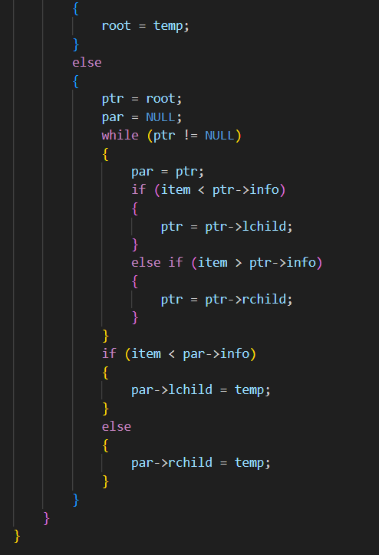

**Output:**

