Long Term Virtual Internship Program Front-End Development

ON CREATING ECOMMERCE-SHOE STORE APP

Submitted to:SmartInternz

Faculty mentor(s)Name:Dr.Y.Nagendra

Submitted by:Ravula Sukendrareddy

Shaik fazeel

Shaik mansoor basha

Shaik ashraf ali

College :sri venkateswara college of engineering



**CONTENTS**

* **TOPICS COVERED DURING INTERNSHIP**
* **What is front-end development**

* **About HTML**
* **About CSS**
* **About JAVASCRIPT**
* **Peripherals required for this project: VS CODE**
* **About project**
* **CONCLUSION**

* **TOPICS COVERED DURING INTERNSHIP**

1. Hypertext Markup Language (HTML):

the set of markup symbols or codes inserted into a file intended for display on the Internet

1. Cascading Style Sheets(CSS) :

Is used to set the style in web pages that contain HTML elements. It sets the background color, font-size, font-family, color, … etc. properties of elements on a web page

1. JavaScript (JS):

JavaScript is a programming language for the web. Its syntax is based on Java and C languages. Used in both the front-end and back-end of many platforms, JavaScript has become a standard. For every animated or interactive object you see online, chances are JavaScript is involved.

1. Bootstrap:

Bootstrap, in statistics, is a resampling technique that involves repeatedly sampling data points from a dataset with replacement to estimate the distribution and properties of a statistic or parameter without assuming a specific underlying population distribution. It's commonly used for constructing confidence intervals and assessing the robustness of statistical methods.

Angular is a TypeScript-based open-source web application framework primarily maintained by Google and a community of individual developers and corporations. It's used for building dynamic, single-page web applications (SPAs) with a focus on modularity and testability.

* 1. React JS:

React.js, often referred to as React, is an open-source JavaScript library for building user interfaces. It allows developers to create dynamic and efficient UI components for web applications, making it easier to manage and update complex user interfaces.

* 1. jQuery:

jQuery is a fast, small, and feature-rich JavaScript library that simplifies HTML document traversal and manipulation, event handling, and Ajax interactions for web development.

5

. Angular

:

**What is front-end development**

Definition: Front-end development, also known as client-side development, refers to the process of creating the user interface and user experience of a website or web application. It involves designing and coding the elements that users interact with directly in their web browsers.



Responsibilities: Front-end developers are responsible for translating design mockups and user interface concepts into functional web pages. This includes writing HTML, CSS, and JavaScript code to structure and style web content and add interactivity.

Key Skills: Front-end developers need strong skills in HTML for structuring content, CSS for styling, and JavaScript for adding interactivity. They also work with various front-end libraries and frameworks, such as React, Angular, or Vue.js, to streamline development.

User-Facing: Front-end development focuses on creating the visual aspects of a website or web app that users see and interact with directly. This includes the layout, typography, colors, buttons, forms, and animations.

#  About HTML

<!DOCTYPE html>

<html>

<head>

<title>Simple Web Page</title>

</head>

<body>

<h1>Welcome to My Web Page</h1>

<p>This is a basic example of an HTML webpage.</p>

</body>

</html>

EXPLAINATION:

<!DOCTYPE html>: This declares that the HTML version being used is HTML5.

<html>: The root element that encapsulates the entire HTML document.

<head>: Contains metadata about the webpage.

<title>Simple Web Page</title>: Sets the title of the webpage.

<body>: The main content of the webpage is placed within this element.

<h1>: Defines the main heading of the page.

<p>: Represents a paragraph of text.

❖ **About CSS**

CSS (Cascading Style Sheets) is a stylesheet language used to control the presentation and styling of HTML elements on a webpage. It allows you to define the layout, colors, fonts, and other visual aspects of your web content. Here's a brief explanation of CSS along with a small example:

Example: Styling a Simple HTML Page with CSS **HTML (index.html):**

<!DOCTYPE html>

<html>

<head>

<title>Styling with CSS</title>

<link rel="stylesheet" type="text/css" href="styles.css">

</head>

<body>

<h1>Welcome to My Website</h1>

<p>This is a paragraph of text.</p>

<p class="highlight">This is another paragraph with a class.</p>

</body>

</html>

**CSS (styles.css):**

/* CSS comments are enclosed in /* ... */ */ h1 { color: blue; font-size: 24px; text-align: center;

} p { font-family: Arial, sans-serif;

}

.highlight { background-color: yellow; font-weight: bold; }

Explanation:

**In the HTML file (index.html):**

<link rel="stylesheet" type="text/css" href="styles.css">: This line links to an external CSS file named "styles.css," which will be used to style the HTML content.

<h1>: Defines the main heading of the page.

<p>: Represents paragraphs of text.

<p class="highlight">: Represents a paragraph with a specific class name.

**In the CSS file (styles.css):**

CSS rules are enclosed in curly braces {} and consist of a selector and a declaration block.

The selector (e.g., h1, p, .highlight) selects HTML elements to apply styles to.

Properties and values within the declaration block define how the selected elements should be styled. color: Specifies the text color. font-size: Sets the font size. text-align: Aligns text. font-family: Defines the font family. background-color: Sets the background color. font-weight: Adjusts the font weight (bold).

This example demonstrates how CSS is used to style HTML elements. In this case, it makes the main heading blue, adjusts the font size and alignment, and applies a yellow background and bold text to paragraphs with the "highlight" class.

When you open the HTML file in a web browser, you will see the styled content according to the CSS rules defined in the external stylesheet.

❖ **About JAVASCRIPT**

JavaScript is a versatile programming language commonly used in web development to add interactivity and functionality to websites. It allows you to create dynamic and responsive web pages. Here's a brief explanation of JavaScript along with a small example:

Example: Adding JavaScript Interactivity to a Simple HTML Page

**HTML (index.html):**

<!DOCTYPE html>

<html>

<head>

<title>JavaScript Example</title>

</head>

<body>

<h1 id="heading">Click the Button</h1>

<button id="myButton">Change Text</button>

<script src="script.js"></script>

</body>

</html>

**JavaScript (script.js):**

**// JavaScript code to add interactivity**

**const heading = document.getElementById("heading"); // Select the heading element by its ID const button = document.getElementById("myButton"); // Select the button element by its ID**

**button.addEventListener("click", function() { heading.textContent = "Text Changed!"; // Change the text content of the heading heading.style.color = "red"; // Change the text color to red**

**});**

**Explanation:**

**In the HTML file (index.html):**

<h1 id="heading">: Defines a heading element with the ID "heading."

<button id="myButton">: Creates a button element with the ID "myButton."

<script src="script.js"></script>: Links to an external JavaScript file named "script.js" to add interactivity to the page.

**In the JavaScript file (script.js):**

JavaScript code is enclosed in <script> tags.

const heading and const button: These lines select HTML elements by their IDs using the getElementById method. This allows JavaScript to interact with these elements.

button.addEventListener("click", function() {...});: This code attaches an event listener to the button element. When the button is clicked, the function inside the event listener is executed.



heading.textContent = "Text Changed!";: This line changes the text content of the heading element to "Text Changed!" when the button is clicked.

heading.style.color = "red";: It changes the text color of the heading to red.

This example demonstrates how JavaScript can be used to add interactivity to a webpage. When you click the "Change Text" button, the text of the heading is updated, and its color changes to red. JavaScript allows you to respond to user actions and manipulate the content and behavior of a webpage dynamically.

❖ **Peripherals required for this project: VS CODE**

Visual Studio Code (VS Code) is a highly acclaimed code editor developed by Microsoft. It has gained widespread adoption within the developer community due to its exceptional features and versatility. Available for Windows, macOS, and Linux, VS Code is known for its exceptional speed and responsiveness, making it a favored choice for developers working with a variety of programming languages and technologies.

One of VS Code's standout features is its extensive extension ecosystem, allowing users to tailor their coding environment to specific needs. This rich library of extensions covers everything from language support to debugging tools, enabling developers to create a personalized and efficient workflow.

VS Code's support for numerous programming languages is another key strength. It provides features such as code autocompletion, syntax highlighting, and error checking, enhancing code quality and productivity. Integrated Git support simplifies version control tasks, and the built-in debugger assists with testing and troubleshooting code.

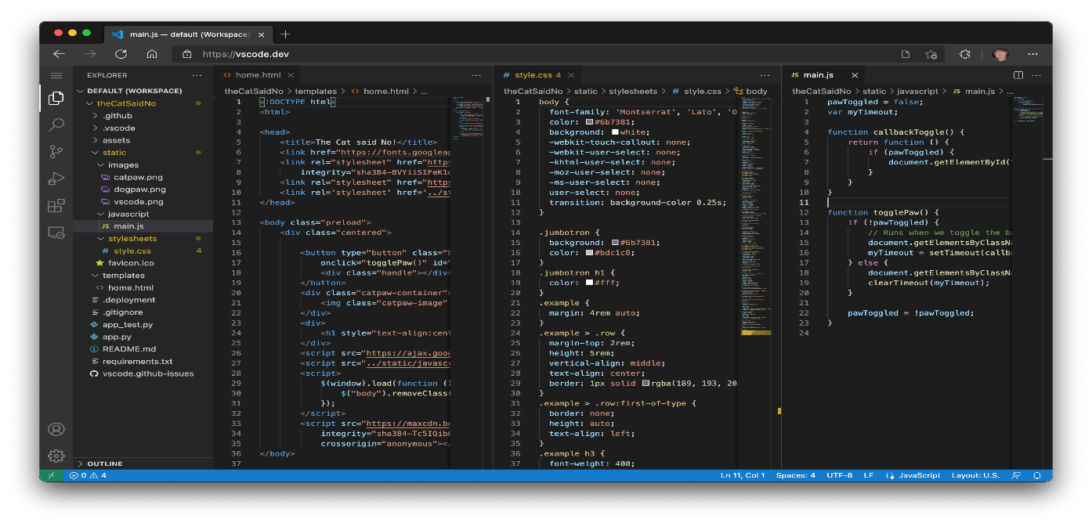

Additionally, the editor offers an integrated terminal, enabling developers to run commands and scripts without leaving the coding environment. This streamlines various development tasks and enhances productivity.

Whether you're a web developer, mobile app creator, data scientist, or DevOps engineer, VS Code's adaptability and performance make it an invaluable tool. Its active developer community ensures ongoing updates, bug fixes, and continuous improvement, making it a top choice for developers across diverse domains and skill levels.

❖ **About project**

The E-commerce: Shoe Store is a web application that provides the user to watch various shoes according to the categories like running, best performance shoes, etc. It allow users to move their shoes to the cart and accordingly shows how much items are their in there cart and shows price as well. Contains bootstrap items like carousels, cards, etc which can be helpful for and can be used to learn new things for future references.

**Technical Architecture:**

•

**index.html**

•

**style.css**

•

**script.js**



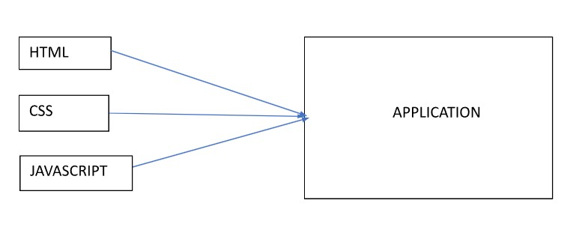

**Project Objectives:**

By the end of this project, you will:

* Create a user interface using HTML and CSS to display information about e-commerce product of shoes.
* Dynamically update the UI with the fetched shoes data which is coming from data present in script file.
* Allow users to add shoes in cart and can get how many shoes they have send to the cart.

## Set Up The Project Structure

Create a new project folder for the E commerce.

Inside the project folder, create the following files/folders:

❖ **CONCLUSION**

The E-Commerce app for shoes presents a promising venture in the world of online retail. With a user-friendly interface, comprehensive product listings, secure payment options, and an efficient checkout process, the app aims to provide an exceptional shopping experience for customers. Additionally, personalized recommendations and responsive design contribute to customer engagement and satisfaction.



To ensure the app's success, continuous updates, rigorous testing, and a focus on performance optimization will be essential. Moreover, maintaining a strong commitment to security, user data protection, and responsive customer support will build trust and loyalty among our clientele.

As the digital landscape evolves, the E-Commerce app for shoes is poised to adapt, incorporating emerging technologies and staying attuned to market trends. By combining functionality with aesthetics and convenience, the app aims to become a go-to destination for shoe enthusiasts, contributing to the growth and success of the online footwear market.

**Than**

**k**

**You**

