**DAY_18**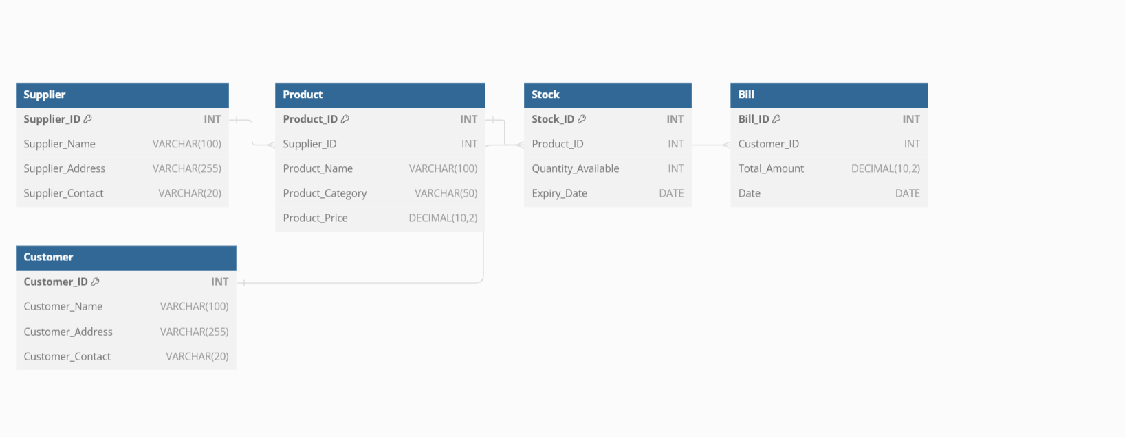

Supplier: Supplier_ID (PK), Supplier_Name, Supplier_Address, Supplier_Contact

Product: Product_ID (PK), Supplier_ID (FK), Product_Name, Product_Category, Product_Price

Stock: Stock_ID (PK), Product_ID (FK), Quantity_Available, Expiry_Date

Bill: Bill_ID (PK), Customer_ID (FK), Total_Amount, Date

Customer: Customer_ID (PK), Customer_Name, Customer_Address, Customer_Contact