**Sailors –Database:**

Schema:

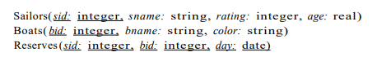

Tables:

