Customer Shopping Behaviour Analysis
Project Overview:
- This project focuses on analysing customer shopping behaviour and patterns using transactional data from over 40,000 purchases across various products, categories, and age groups. The objective is to clean, organize, and manage the data in a structured manner for future reference, and to derive actionable insights that can support and guide strategic business decisions.
Dataset Summary:
- Total Record Count: 40,000
- Column Count: 20
- Key Features:
  - Customer demographics (Age, Gender, Location, Subscription Status).
  - Purchase details (Item Purchased, Category, Purchase Amount, Season, Size, Colour).
  - Shopping behaviour (Discount Applied, Promo Code Used, Previous Purchases, Frequency of Purchases, Review Rating, Shipping Type).
  - Missing Data: 37 values in Review Rating column.
Exploratory Data Analysis using Python:
- We began with the data cleaning and preparation.
- Import the data into pandas using jupyter notebook.
- Check the sample data using df.head()
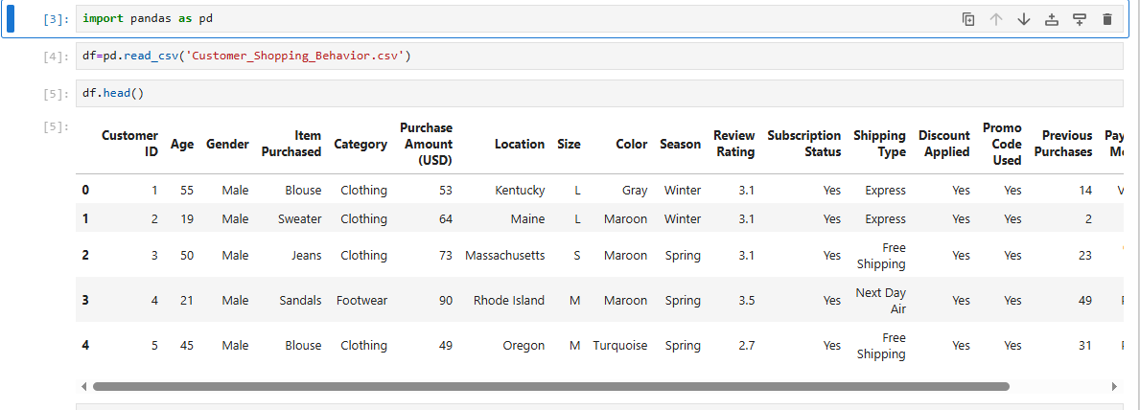
- Check the Average value by using this.
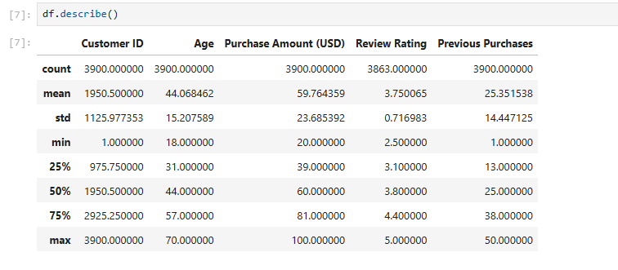
- Missing Data Handling:
- Identify the null columns and count. df.isnull().sum()
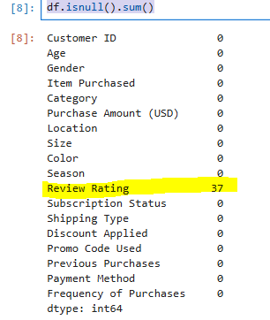
- We have found 37 null values in review rating column, that needs to be replaced with median value.
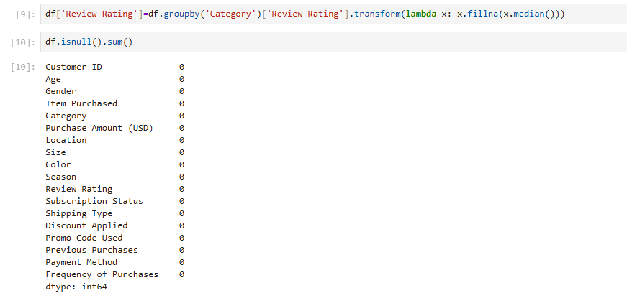
- Re-name the columns names in the correct way.
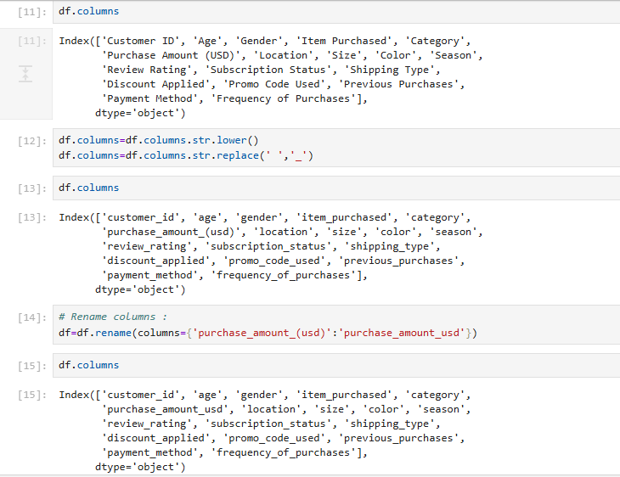
- Create new column “age_group” based on their numeric age value. This new column we will required while creating the report.
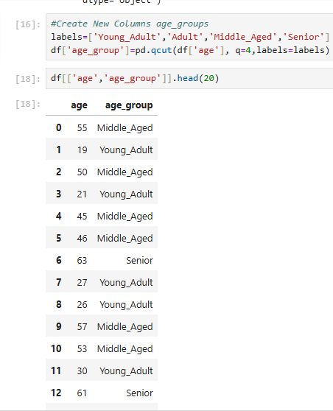
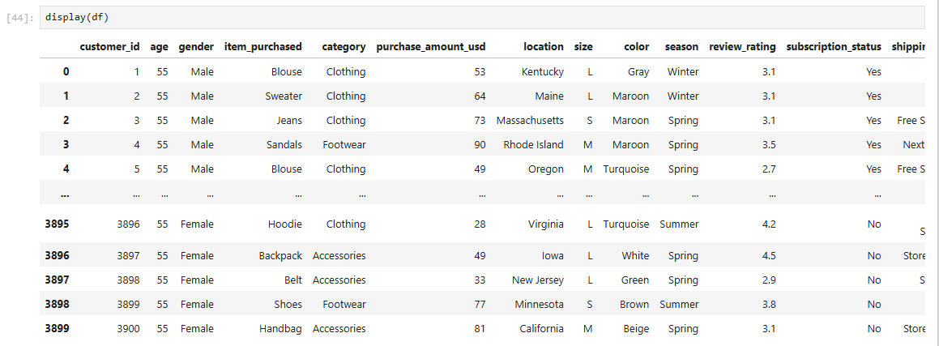
- Feature Engineering:

- Create one more column to maintain the days of purchase frequency.
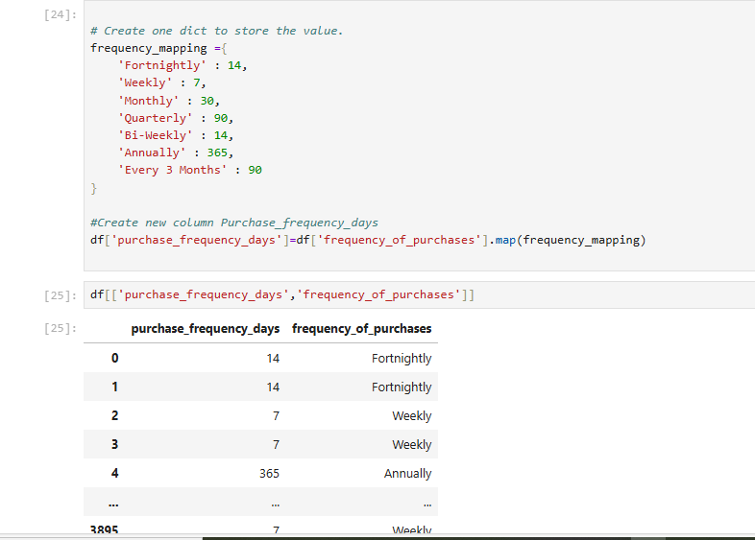
- Data Consistency Check: Verified if discount_applied and promo_code_used were redundant; dropped promo_code_used.

- Database Integration: Connected Python script to PostgreSQL and loaded the cleaned DataFrame into the database for SQL analysis.

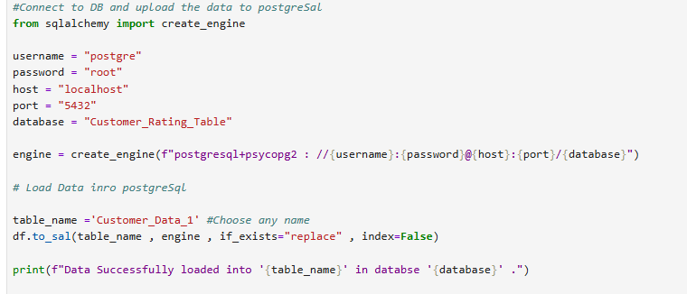

Data Analysis and some business questions by using postgreSql:
- Revenue by Gender: Calculate the total revenue generated by male and female customers.
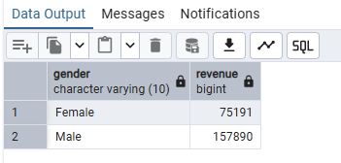
- High Spending Discount Users: Identify the customers used a discount but still spent more than the average purchase amount.
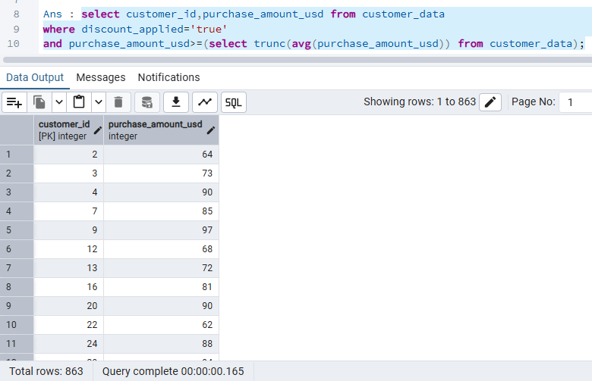
- Top 5 product with high rating: Identify the top 5 product with highest review rating?
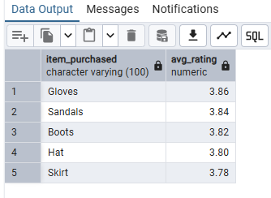
- Compare the average purchase amount between standard and express shipping.
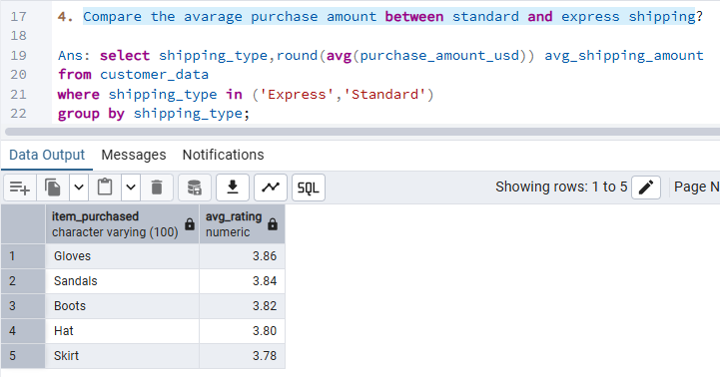
- Subscribed vs Non- Subscribed: Compare average spend and total revenue
between subscribed and non-subscribed customer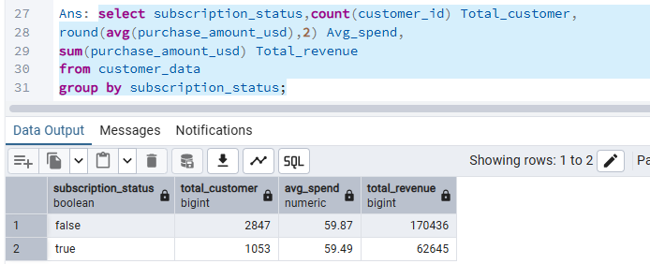
- Top 5 with highest discount: Identify the top 5 customer who has the highest discount.
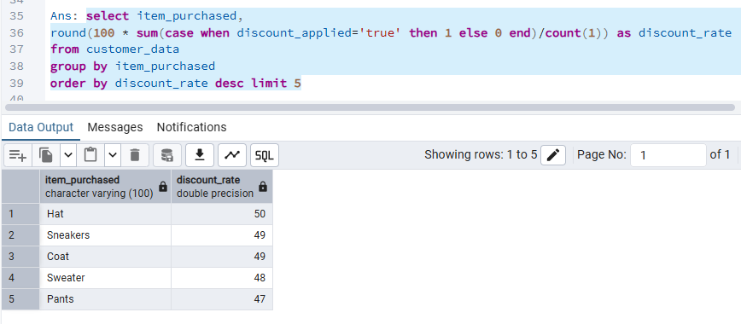
- Customer Segmentation: Classified customers into New, Returning, and Loyal segments based on purchase history.
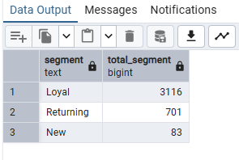
- Top 3 category per product: Identify the top 3 most purchased product within each category.
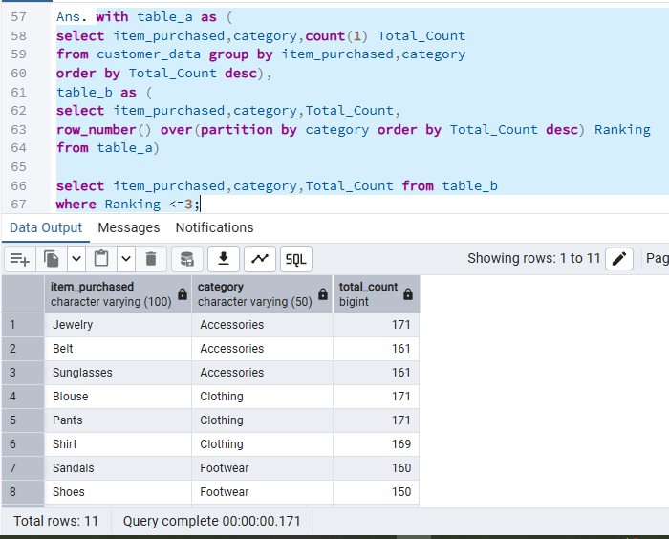
- Repeat buyers & Subscribers: Customers who are repeat buyers (more than 5 pervious purchase) also likely to subscribe.
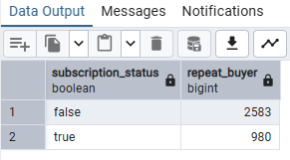
- Age group Contribution: Revenue contribution by age group.
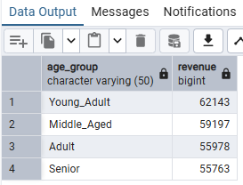

- Dashboard in Power BI:
- Finally, we built the dashboard using power BI to present the insights visually.

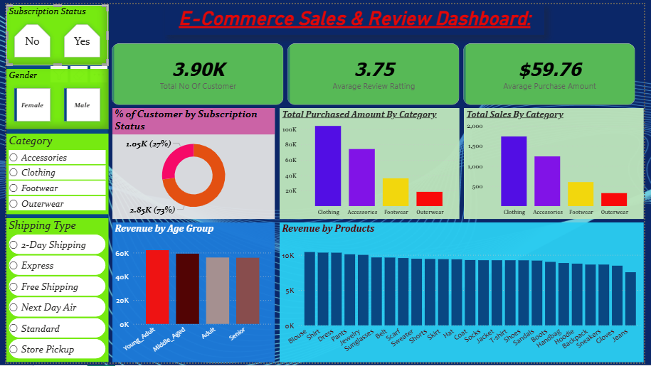

- Business Recommendations:

- Boost Subscriptions – Promote exclusive benefits for subscribers.
- Customer Loyalty Programs – Reward repeat buyers to move them into the “Loyal” segment.
- Review Discount Policy – Balance sales boosts with margin control.
- Product Positioning – Highlight top-rated and best-selling products in campaigns.
- Targeted Marketing – Focus efforts on high-revenue age groups and express-shipping users.

