# OSTL MINI PROJECT

# A Persionalized e-commerce Website

# Using Django Web Framework

Made by: Sukhada Prakash Morgaonkar (C21-70)

Chetna Deepak Nihalani (C21-78)

Melody Vilas Periera (C21-84)

**Problem Statement :** To make a personalized e-commerce Website using Django

Web FrameWork.

**E-commerce:**

Electronic commerce refers to the buying and selling of products or services over electronic systems such as the Internet and other computer networks. The Shopping Cart is very important feature used in e-commerce to assist people making purchases products online. It also includes the entire online process of developing, marketing, selling, delivering, servicing and paying for products and services. In order to purchase a shopping cart is provided to the user.The amount of trade conducted electronically has grown extraordinarily with widespread Internet usage. The use of commerce is conducted in this way, spurring and drawing on innovations in electronic funds transfer, supply chain management, Internet marketing, online transaction processing, electronic data interchange (EDI), inventory management systems, and automated data collection systems. The eCommerce site will let customers to view and order products online from any part of the world.

The main advantage of e-commerce over traditional commerce is the user can browse online shops, compare prices and order merchandise sitting at home on their PC. Secure registration and profile management facilities for Customers. Shopping Cart feature allows online shopping customers to “place” items in the cart. It Decreases the cost of creating, processing, distributing, storing and retrieving paper-based information. Expands the marketplace to national and international markets.  Upon “checkout” the software calculates as total for the order including shipping and handling postage, packing and taxes, if applicable. Reduces the time between the outlay of capital and the receipt of products and services.

The proposed system helps in building a website to buy, sell products or goods online using internet connection. Enables consumers to shop or do other transactions 24 hours a day, all year round from almost any location. It can be accessed over the Internet.   
Purchasing of goods online, user can choose different products based on categories , online payments , delivery services and hence covering the disadvantages of the existing system and making the buying easier and helping the vendors to reach wider market. It Provides consumers with more choices. Customer can purchase Products Online.

**This project is divided into 9 modules:**  
  
1. Registration Module: Pages inside : Login Page, Logout Page, Profile, Register Page.  
2. Products Browse Module  
3. Products Search Module : Options provided – Add to Cart, Add to Wishlist.   
4. Shopping cart Module: We can Edit, Delete items from the cart.  
5. Shipping & Billing Module  
6. Payment Module  
7. Admin User Management Module  
8. Admin Catalog Management Module

**Technology used in the Project:**

**HTML :** Page Layout has been designed in HTML.

Template folder has all the HTML pages stored.

HTML pages :

1. addProduct.html
2. companyProfile.html
3. login.html
4. deleteProduct.html
5. signup.html
6. viewProduct.html
7. productInfo.html
8. base.html
9. editProduct.html

**CSS :** CSS has been used for all the designing part.

CSS Library used is Materialize Theme.

**JavaScript :** All the validation task has been developed by JavaScript.

**Bootstrap :** Bootstrap is a free and open source front end development framework for the creation of websites and web apps. The Bootstrap framework is built on HTML, CSS, and JavaScript (JS).

**Python :** All the business logic has been implemented by Python.

**Python Imaging Library** (abbreviated as **PIL**) (in newer versions known as Pillow) is a free and open-source additional library for the Python **programming** language that adds support for opening, manipulating, and saving many different image file formats.

**pytz** brings the Olson tz database into Python. This library allows accurate and cross platform timezone calculations.

**Beautiful Soup** is a Python library for pulling data out of HTML and XML files. It works with your favorite parser to provide idiomatic ways of navigating, searching, and modifying the parse tree.

**Rake NLTK :** RAKE short for Rapid Automatic Keyword Extraction algorithm, is a domain independent keyword extraction algorithm which tries to determine key phrases in a body of text by analyzing the frequency of word appearance and its co-occurance with other words in the text.

**OpenCV**-Python is a library of Python bindings designed to solve computer vision problems. OpenCV-Python makes use of Numpy, which is a highly optimized library for numerical operations with a MATLAB-style syntax. All the OpenCV array structures are converted to and from Numpy arrays.

**MySQL :** MySQL Database has been used as database for the project.

The SQL Parser parses a SQL query in a string field. When parsing a query, the processor generates fields based on the fields defined in the SQL query and specifies the CRUD operation, table, and schema information in record header attributes.

**Django :** Project has been developed over the Django Framework. Django is an open source web application frame work which is written in Python.The primary goal of Django is to make the development of complex, data-based websites easier. Thus Django emphasizes the reusability and pluggability of components to ensure rapid developments. Django consists of three major parts: model, view and template.

**UML of the System:**

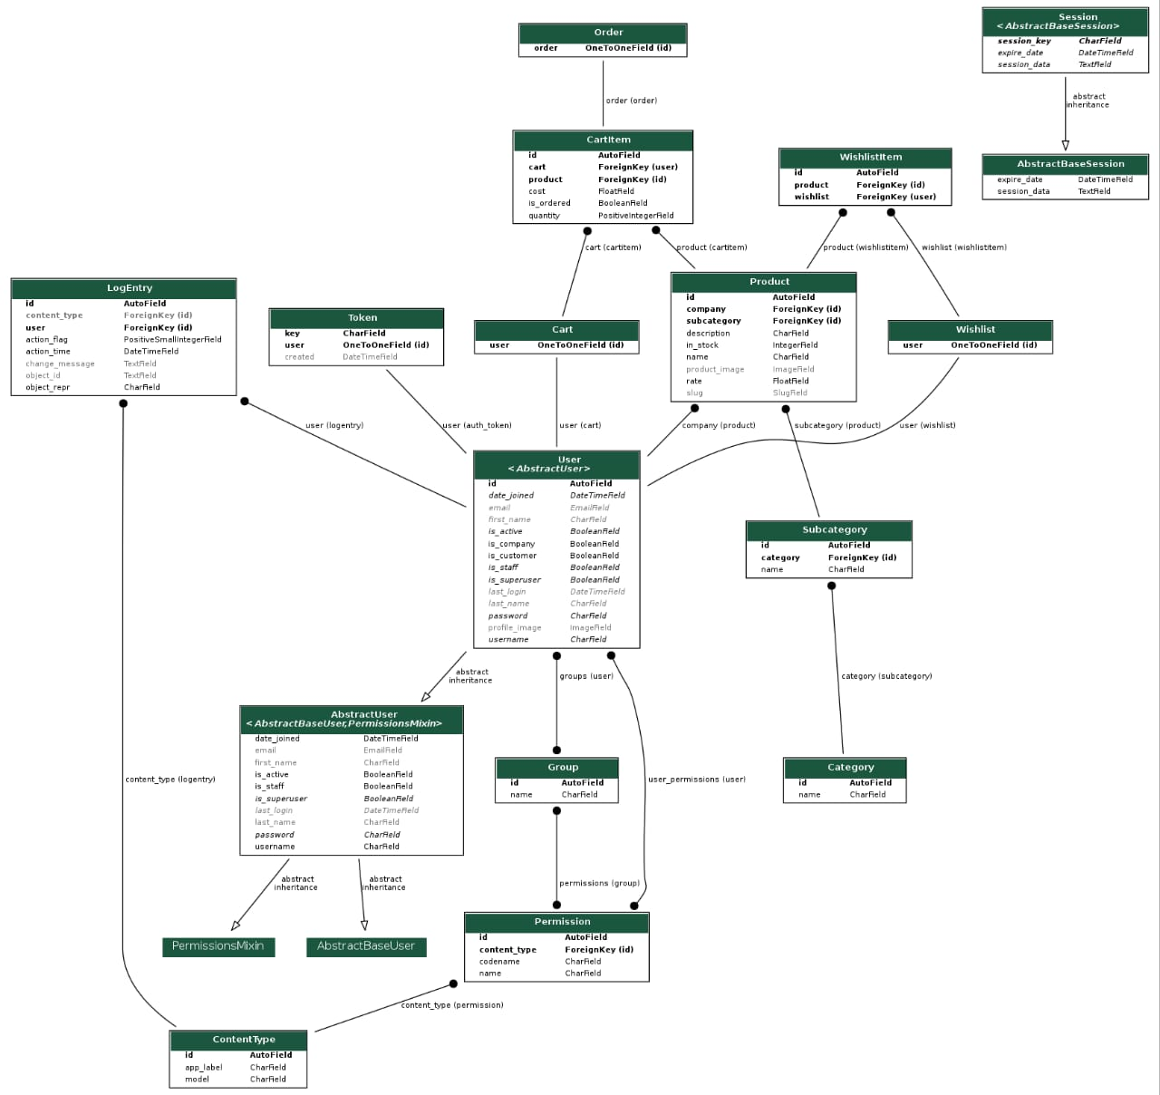

**Conclusion :** The Django framework gives us a simple and reliable way to create the e-commerce system. It provides powerful functionalities and concise syntax to help deal with the database, the web page and the inner logic. The experience of developing the group component in the system also helped us learning a lot of website development with Django.