Apache Server Log Analysis:
Problem Statement: The Apache services such as Hadoop, Spark, Tomcat, and Hive run on most data engineering servers throughout the world. All the services follow the same pattern because all are open source. You are a data engineer, who works for a start-up named Hadoop Analytics, which serves major clientele.

Upload the Server log to HDFS

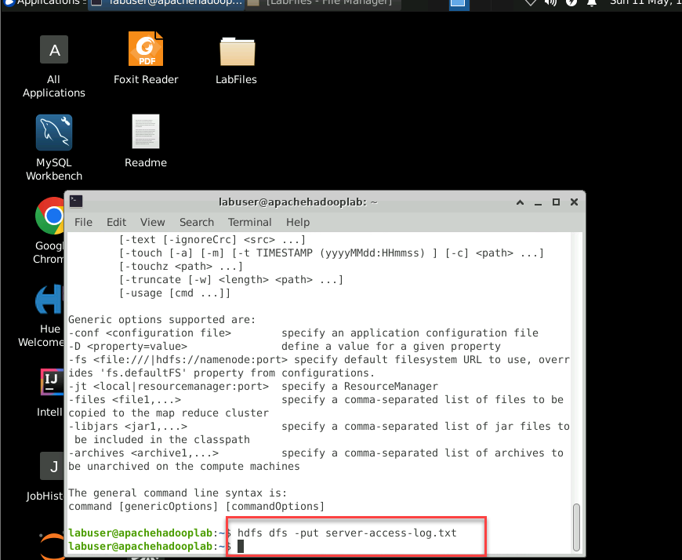

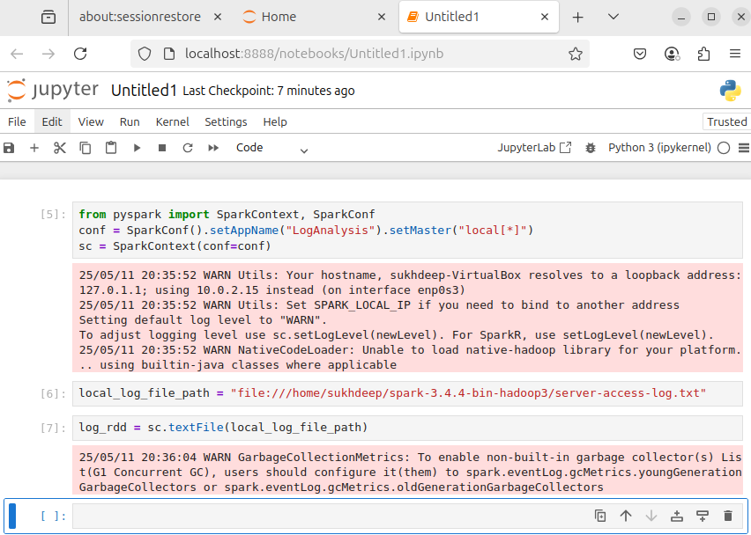

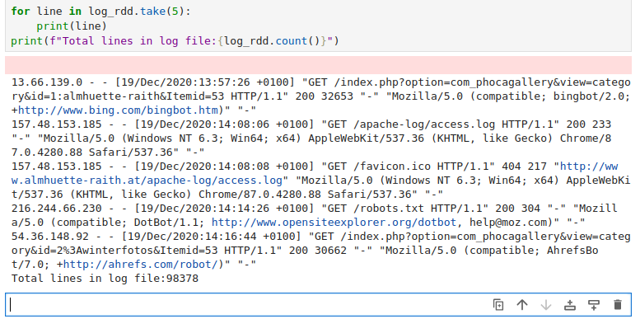

Split the line by space:
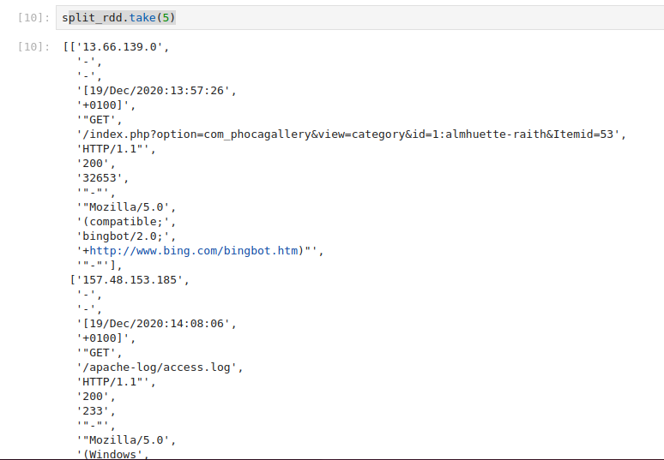

Extract status code from List
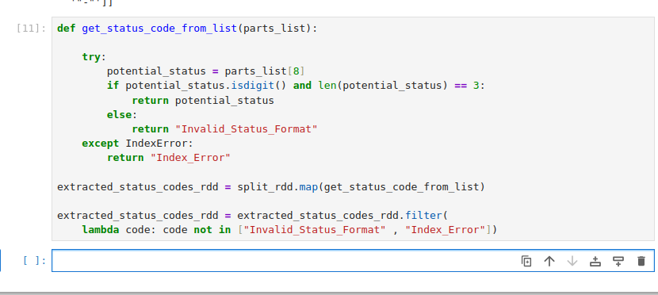

Now, Convert Each Extracted Status Code into a Tuple
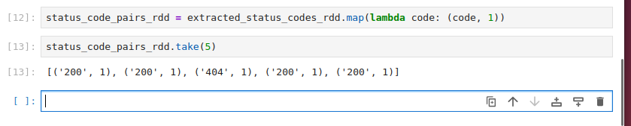
4. Apply reduceByKey to Count:
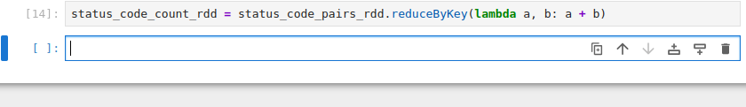

5. Display the Results:
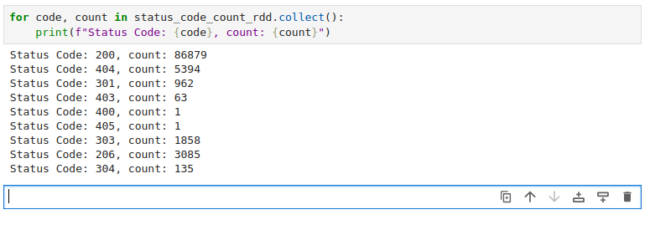

Task 2: To sort the result of Task 1 in descending order by request count.
1. Sort RDD using the sortBy function
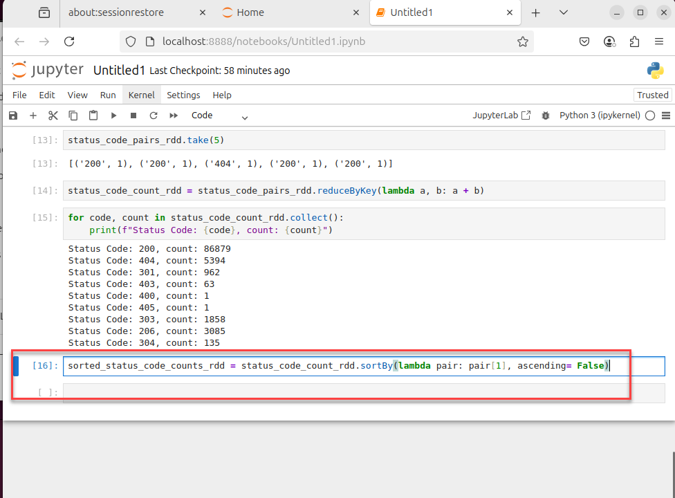
2. Display the sorted data stored in the RDD
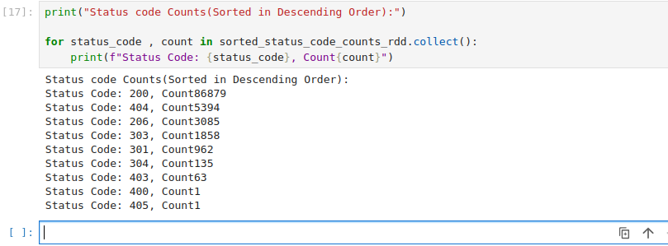

Task 3: Frequent visitor recognition
Aim: To identify the top 10 frequent visitors of the website
Steps to perform:
1. Read the log file as an RDD in pySpark
2. Identify the frequent visitors using the map function
3. Display the data stored in the RDD

Extract the IP address
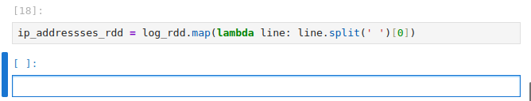
Map each IP to (ip_address, 1)
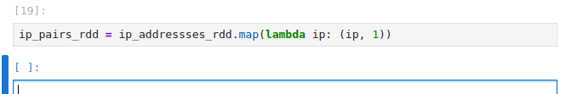

Count occurrences of each IP
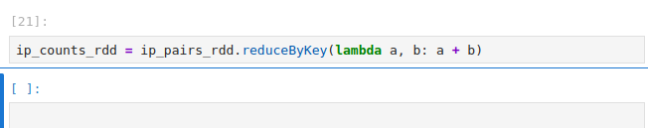

Sort by count in descending order to find the most frequent
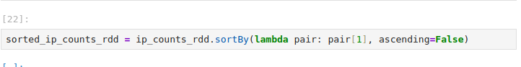

Take the top 10 frequent visitors
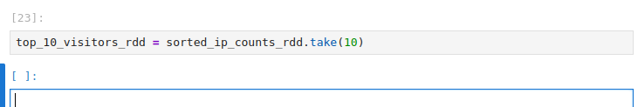

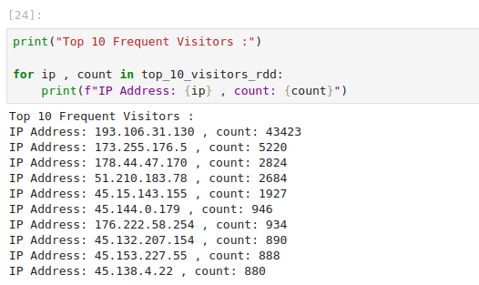

Task 4: Missing URL recognition
Aim: To identify the top 10 missing (does not exist) URLs
Steps to perform:
Define a function to parse log lines and extract URL and status code
This regex attempts to capture the request string (group 5) and status code (group 6)

# Group 5: Method (e.g., GET)
# Group 6: URL
# Group 7: Protocol (e.g., HTTP/1.1)
# Group 8: Status Code # Group 9: Bytes
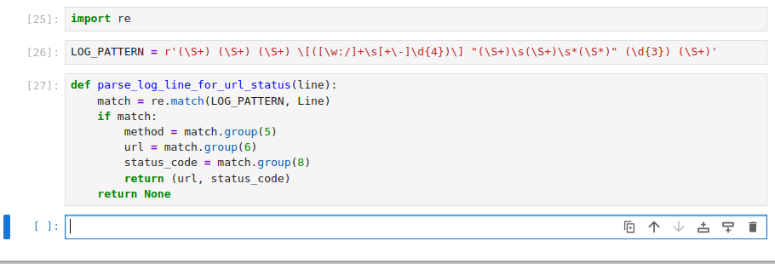

Apply the parsing function
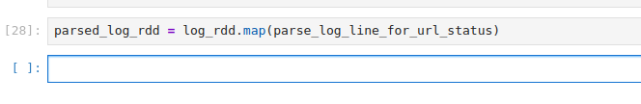

Filter out lines that didn't parse correctly

# Step 2b: Filter for 404 status codes
# parsed_log_rdd now contains tuples like ('/path/to/file.html', '200')
# or ('/missing/page.html', '404')

Now, extract only the URLs from the filtered RDD
Count occurrences of each missing URL
Reduce by key to get counts
Sort by count in descending order and take the top 10
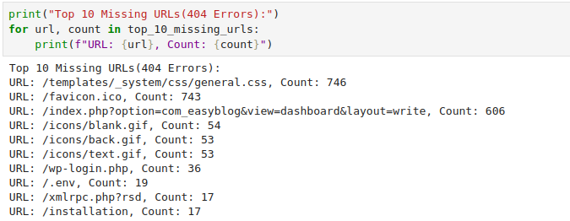

Task 5: Traffic recognition
Aim: To identify the traffic (total number of HTTP requests received per day)
Steps to perform:
Steps to perform: 1. Read the log file as an RDD in pySpark
2. Fetch the DateTime string and replace [ with blank
3. Get the Date string from the DateTime
4. Identify HTTP requests using the map function
5. Display the data stored in the RDD

Define a function to extract the date from the log line. The timestamp is typically enclosed in square brackets

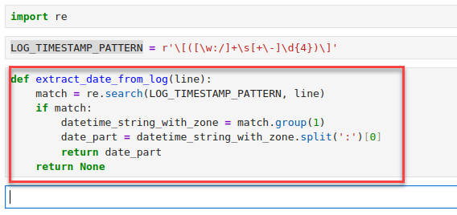
Apply the function to get an RDD of dates
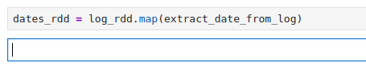
Filter out any lines where the date couldn't be extracted
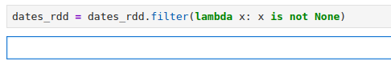

Step 4: Identify HTTP requests (count per day) by mapping to (date, 1) pairs
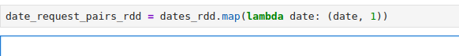
Reduce by key to get the total count of requests per date
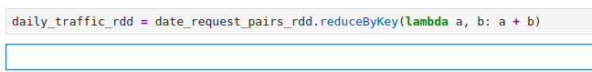

Step 5: Display the data
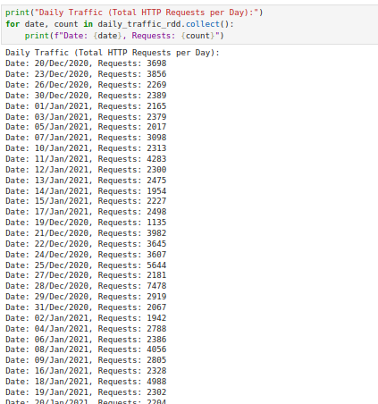

Task 6: Endpoint recognition
Aim: To identify the top 10 endpoints that transfer maximum content in megabytes
Steps to be perform:
- Read the log file as an RDD in pySpark
- Identify a maximum number of endpoints using the map function
- Display the data stored in the RDD

Defined a function to parse lines:
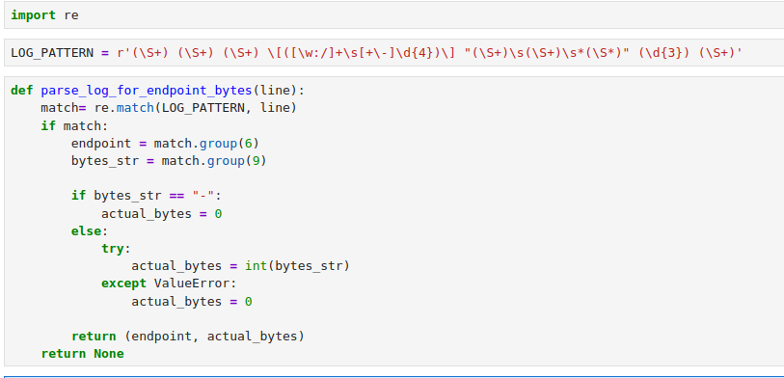

Apply parsing function
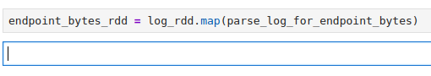
Filter out lines that didn't parse correctly or had no valid byte count
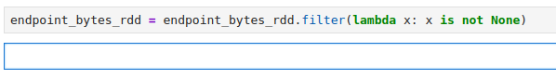
Step 2: Sum total bytes transferred for each endpoint
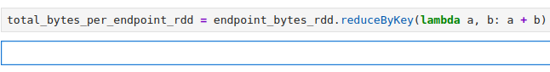
Step 2: Convert bytes to megabytes (MB)
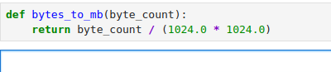

endpoint_megabytes_rdd will have (endpoint, total_mb)
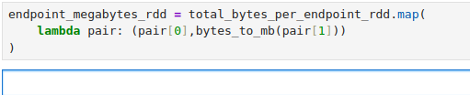
Step 2: Sort by megabytes transferred in descending order
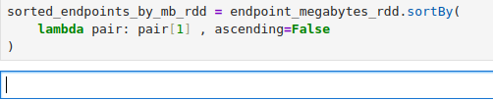
Take the top 10 endpoints
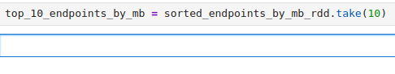
Step 3: Display the data
